**AGE OF EMPIRES II**

**ONLINE PORTAL**

**TEAM**

KRITIK MATHUR registration number: 140905586, roll number: 51

NIMISH AGRAWAL registration number: 140905596, roll number: 52

**PROBLEM STATEMENT**

To make a website for Age of Empires II players to come and search for players of their skill level or search for some information on Civilizations and Units of the game.

The website will be capable of finding a suitable match for a user from the database using the skill rating of the player. New players can be added or an existing player can be removed. An advanced search option with more filters is also available which can show player information based on its attributes.

The advanced search option is also available for searching specific units or civilization information.

FRONT ENDhtml, css, javascript

BACK END oracle 11g sql, python

**ASSUMPTIONS**

1. Each Player can have only one favorite Civilization.
2. Each Civilization can have only one Wonder.
3. Each Civilization can have only one Unique Unit.
4. Each Civilization can have multiple Buildings and one building can be available to multiple Civilizations.
5. Each Civilization can have multiple Units and one Unit can be available to multiple Civilizations.
6. Each Civilization can have multiple Researches and one Research can be available to multiple Civilizations.
7. A Research can reside in only one Building. A Building can house multiple researches.

Based on the above assumptions, we draw the ER Diagram.

**UI DESIGN**

The portal has been divided into 5 webpages.

The existing Users will be able to login into the portal from the **Home** page which looks like this**:**

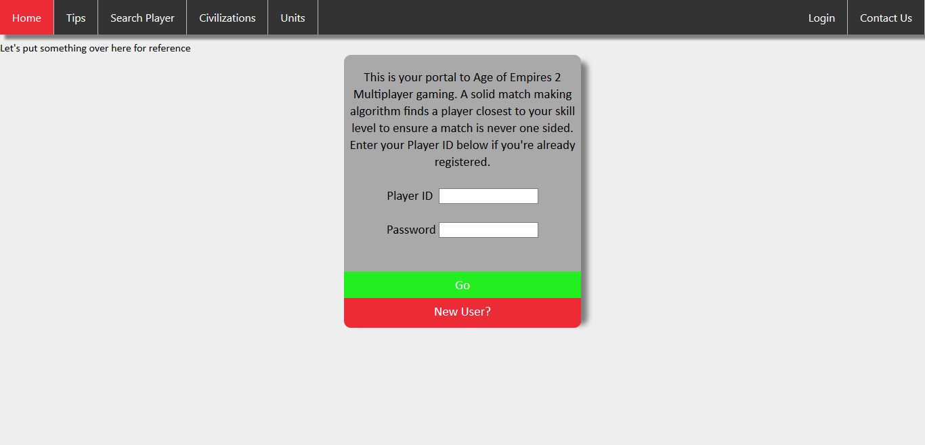

There is also provision for new Users for registering from the **Home** page.

The login simply requires a unique ***Player ID*** and their chosen ***password***.

Other pages included are:

* **Tips:** This page has been built keeping in mind the *n00bs*, i.e. the players who are new to the game. The page provides guidelines and instructions for various **ages** which will help the *n00bs* to take their game to the next level.

**Snippet:**

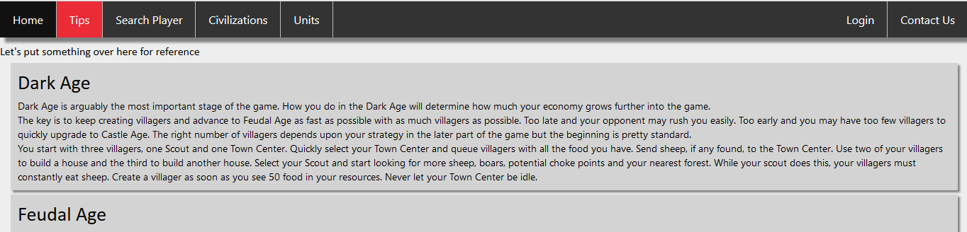

* **Search Player:** This page is helps the User search for other users in the existing database. The search functionality gives the user freedom to search another player on basis of their ratings, favorite civilizations, units, their date of birth, etc.

The aim is to provide the players the best possible playing experience against players of similar skill.

* **Civilizations:** This is an informative page which briefs the various civilizations available in the game.

The *civilization units, technologies, buildings,* etc. are all listed in a very user friendly fashion.

* **Units:** Like **Civilizations**, this page too is meant to provide users with in depth knowledge of the game. The **Units** page provides the data about each unit.

The data like unit's *HP, attack, speed,* etc. are all provided.

**SCHEMA**

# ENTITIES

UNIQUE_UNIT

UQ_NAME

HIT_POINTS

ATTACK

MELEE_ARMOUR

PIERCE_ARMOUR

RANGE

CIV_BUILDINGS

CIV_NAME

BUILD_NAME

RESEARCH

Res_name

description

building

CIVILIZATION

CIV_NAME

Uq_nAME

UNIQUE_TECH

w_NAME

CIV_UNITS

CIV_NAME

UN_NAME

PLAYER

Name

gamertag

date_of_birth

fav_civ

Played

won

rating

WONDER

W_NAME

LOCATION

UNIT

U_NAME

HIT_POINTS

ATTACK

MELEE_ARMOUR

PIERCE_ARMOUR

RANGE

CIV_RESEARCHES

CIV_NAME

RES_NAME

BUILDING

BUILD_NAME

HIT_POINTS

ATTACK

RANGE

**DDL**

create table unit(

un_name varchar(30) primary key, hit_points number(3, 0), attack number(2, 0), melee_armour number(2, 0), pierce_armour number(2, 0), range number(2, 0)

);

create table wonder(

w_name varchar(30) primary key, location varchar(30)

);

create table unique_unit(

uq_name varchar(30) primary key, hit_points number(3,0), attack number(2, 0), melee_armour number(2, 0), pierce_armour number(2, 0), range number(2, 0)

);

create table building(

build_name varchar(30) primary key, hit_points number(4, 0), attack number(2, 0), range number(2, 0)

);

create table civilization(

civ_name varchar(30) primary key, unique_unit varchar(30) references unique_unit(uq_name), unique_tech varchar(30), wonder varchar(30) references wonder(w_name)

);

create table research(

res_name varchar(30) primary key, description varchar(60), building varchar(30) references building(build_name)

);

create table player(

p_name varchar(30), gamertag varchar(20) primary key, date_of_birth varchar(9), civ_name varchar(30) references civilization(civ_name), played number(4, 0), won number(4, 0), rating number(4, 0)

);

create table civ_has_buildings(

civ_name varchar(30) references civilization(civ_name), build_name varchar(30) references building(build_name), primary key(civ_name, build_name)

);

create table civ_has_research(

civ_name varchar(30) references civilization(civ_name), res_name varchar(30) references research(res_name), primary key(civ_name, res_name)

);

create table civ_has_unit(

civ_name varchar(30) references civilization(civ_name), un_name varchar(30) references unit(un_name), primary key(civ_name, un_name)

);

**FUTURE CHANGES**

We aim to make the database more dynamic by making it change the values in tuples according to the result of the game, ratings based on the ELO rating system. We also expect to improve the UI to make it more user friendly and allow more robust searches.