SPEECH MASTER

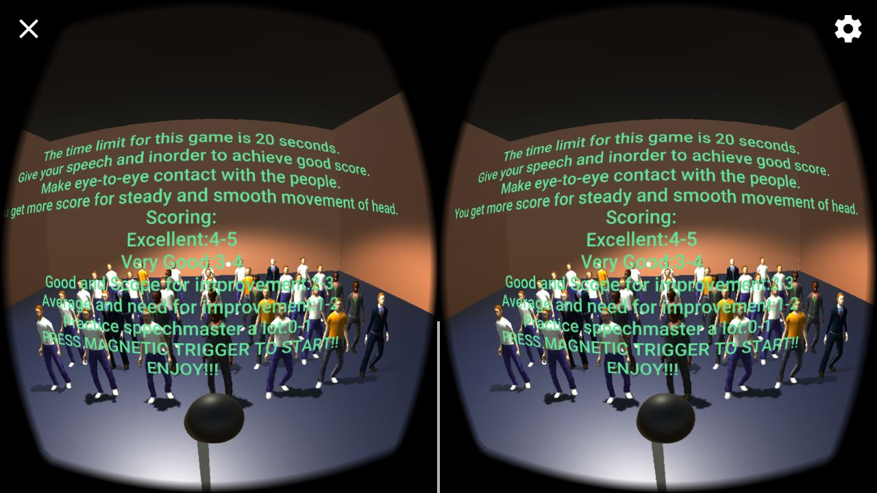 (Where Virtual Reality and Public speaking skills meet)

Game Design Document

Written by:-

**Akshay Pandita**

[akshaypandita20000@gmail.com](mailto:akshaypandita20000@gmail.com)

**Nimish Mangal**

[**nimish.mangal910@gmail.com**](mailto:nimish.mangal910@gmail.com)

**Himanshu Nagdive**

[**nagdive.himanshu@gmail.com**](mailto:nagdive.himanshu@gmail.com)

**Approach: .............................................................................................................................................................................**

Purpose:..........................................................................................................................................................................

Design Philosophy:!..........................................................................................................................................................

Our Target Market:!.........................................................................................................................................................

Our Ideals:!........................................................................................................................................................................

**General Information: ............................................................................................................................................................**

Genre:!..............................................................................................................................................................................

Single Player Campaign:!.................................................................................................................................................

Platforms:!..........................................................................................................................................................................

Game Objective:!.................................................................................................................................................................

Characters:!.........................................................................................................................................................................

**Player and Game Interaction: ..........................................................................................................................................**

1. **Approach:**

With every new project, there needs to be a purpose, a roadmap, a cohesive plan as to why, and how one can and will achieve one’s intended ideals. With this detailed document, I intend to emphasise why we are making Speech master, as well as how we are going to make it and what benefit will it have .

**1.1 Purpose:**

With Speech master, we aim to utilise VR technology to create a game which projects a state of utter immersion for the player to:

* See the world through the eyes of the protagonist (speaker in our case trying to improve his public speaking skills).
* Experience his eye contact with the audience.
* Judge and Improve his public speaking skills on the basis of his score
* Learn and try to improve the score by practicing till you reach your level best…

**1.2 Design Philosophy:**

In order to achieve a harmonious gaming experience, we will focus on the following two design fundamentals:

* Simplicity/Accessibility through gameplay and control design
* Virtual reality through character and narrative design
  1. **Our Target Market:**

For a player who is interested to improve his speaking skill and out-perform his stage fear and experience immersive VR-gaming.

**1.4 Our Ideals:**

As a team of student developers, we want to create a product which we all can be incredible proud of, a product we can showcase to others, and naturally, a product which others can wholeheartedly enjoy and cherish.

1. **General Information:**

**2.1 Genre:**

* Cinematic
* Virtual Reality

The chosen genre, enables us as developers to craft a convincing VR experience that has the potential to influence the hearts and minds of the participating gamer.

With Cinematic Virtual Reality, we have the ability to build an immersive world for the player to delve into and experience, as if that inhabited space were real and tangible.IT gives a real life public speaking experience.

**2.2 Single Player Campaign:**

* Speech Master is designed from the outset, to function as single player, gaming experience.
* Why single player?

The main motivation of the game is to do self-analysis. With each score the players get, he/she can analyse their speaking skill ability and try to improve upon it. Which is possible only through single player mode. Thus, the game is set only on single player mode.

**2.3 Platforms:**

* Android, iOS, windows smartphone supporting gyroscope. To play it on the smartphones, the phones must also have google cardboard as it provides better experience to the player of the VR gaming.

**2.4 Game Objective:**

Speech master is a simple yet useful game, as it deals with our own public speaking experience.

The end-game goal for Speech Master, can be described as the following:

* As the player, you need to stand in front of a mic, the player becomes the speaker.
* In front of the speaker will be audience which are all set to hear the the speech, try not to disappoint them.
* There is a 20s timer in which the player has to complete his speech.
* The player will be given score on the basis of how he interacts with the audience.
* Try to improve the score. With the score getting better the player learns to master his speaking skills in the real life

**2.5.1 Characters:**

Speech Master will wholeheartedly appear empty and hollow without its characters, the 3d audience which pave the way for real-life experience.

Given below is the description of the characters.

**Speaker**: The player standing on the stage who gives the speech in front of the audience.

**Audience:** Audience are the characters standing in front of the stage of the speaker ready to hear the speech of the speaker.

**2.6 Player Perspective:**

Speech Master will be experience through the:

* 1st person camera angle/perspective

The 1st person perspective is the chosen perspective as it possesses a greater gaming experience player when working with VR technology, than that of a 3rd person perspective. One descends easier into the body of the speaker and the world around you, by staging the game to be experienced through the eyes of the speaker. We want to establish a sense of connectedness between player and audience.

So, without any further ado, take an experience of the virtual reality through the speech master.

.

**2.12 Technology:**

* Unity 3D.
* Blender
* C#

**3 Player and Game Interaction:**

To successfully enjoy the entirety of immersive journey, the player needs to use the following input devices:

Magnetic Button Trigger of google cardboard

VR google cardboard

Any supporting platform

.