Practical Machine Learning

Data Cleaning:

Then the function cleanData will be used to clean data. This function turns the variable new_window from “yes” or “no” into “1” or “0” respectively. It converts the variable cvtd_timestamp into a time object and splits it into year, month, weekday, hour and minute variables.

Then all the columns with the most “NA” are droped from the dataframe. Columns X, user_name, raw_timestamp_part_1, raw_timestamp_part_2, cvtd_timestamp are also droped.

cleanData <- function(df) {

df$new_window <- ifelse(df$new_window=="yes", "1", "0") #convert new_window into "0" or "1"

df$cvtd_timestamp <- strptime(df$cvtd_timestamp, "%d/%m/%Y %H:%M") #convert cvtd_timestamp into a t df$year <- as.numeric(strftime(df$cvtd_timestamp, "%Y")) #creat a new feature year df$month <- as.numeric(strftime(df$cvtd_timestamp, "%m")) #creat a new feature month

df$weekday <- as.numeric(strftime(df$cvtd_timestamp, "%d")) #creat a new feature weekday

df$hour <- as.numeric(strftime(df$cvtd_timestamp, "%H")) #creat a new feature hour

df$minute <- as.numeric(strftime(df$cvtd_timestamp, "%M")) #creat a new feature minute

df <- df[,colSums(is.na(df)) < 1] #drop columns with the most "NA"

df <- subset(df, select=-c(X, user_name, raw_timestamp_part_1, raw_timestamp_part_2, cvtd_timestamp }

Data Exploration:

I used the featurePlot function to visualize the data. Here is an example of feature plots for the first 10 features in the data set:

1

library(caret)

featurePlot(x=data[,1:10],

y=data$classe,

plot="density",

scales=list(x=list(relation="free"),

y=list(relation="free")),

adjust=1.5,

pch="|",

layout=c(5,2),

auto.key=list(columns=3))

0.0000 0.0010 0.0020 | num_window
0.0000 0.0010 0.0020 | |||| | 0.00 0.02 0.04 0.06
0.0000 0.0010 0.0020 | |||| || | | |||| | 0.00 0.02 0.04 0.06
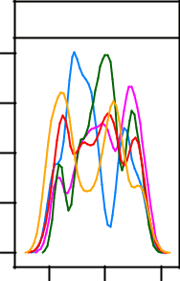
 |  | 0 | 500 1000
0.04 | accel_belt_x |  |  |  | 4 5
0.02 |  |  |  |  | 2 3
0.00 |  |  |  |  | 1
0.00 | | |  | || | | | |||||||| | | 0
0.00 | | | ||||||||||||||||| |||||||| || |||| |  |  | 0
 | −100 |  |  | 0 50
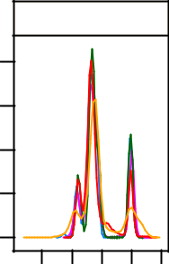

A
B
pitch_belt
 |  | 0.005 0.010
||||||||||| | |||| |||| |||||||||||| | | 0.000
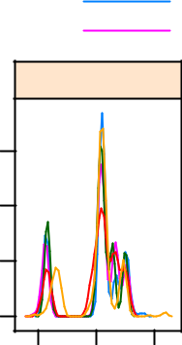

−50 |  | 0 | 50
gyros_belt_x
 |  |  |  | 10
 |  |  |  | 8
 |  |  |  | 6
 |  |  |  | 4
 |  |  |  | 2
||||||||||||||||||||||||||||||||||||||||||||||||||||| || |  |  |  | 0
−1 | 0 | 1 | 2
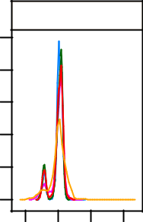

C |  |  |  | E
D
roll_belt |  |  |  | tal_accel_b
 |  |  | 0.08 |  |  |  | 0.010
 |  |  | 0.04 |  |  |  | 0.005
||||| |  | ||||||||| | 0.00 | |||||||||||| ||||||||||||||||| |  |  | 0.000
−50 | 50 150 |  |  | 0 102030
gyros_belt_y |  |  |  | gyros_belt_z |  |  | 10 12
 |  |  | 4 5 |  |  |  | 10 12
 |  |  | 3 |  |  |  | 8
 |  |  | 3 |  |  |  | 6
 |  |  | 2 |  |  |  | 4
 |  |  | 1 |  |  |  | 2
| ||||||||||||||||||||||||||||||||||||||||||||||| |  |  | 0 | |||||||||||||||||||||||||||||||||||||||||||||||||||||| |  |  | 0
−0.5 | 0.0 | 0.5 |  | −1 | 0 | 1
Feature
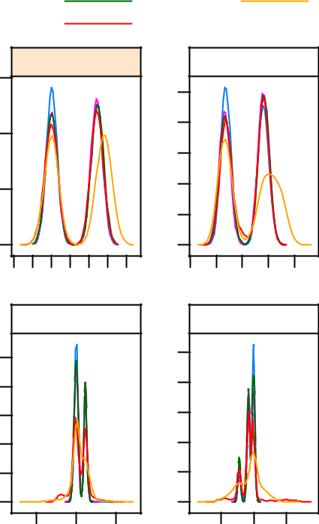

yaw_belt
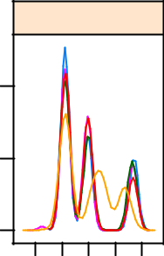

| | | | | | | ||
| | | | || || | | |||
−200 |  | 0100
new_window
| |  |  | |
0.0 |  | 0.5 | 1.0
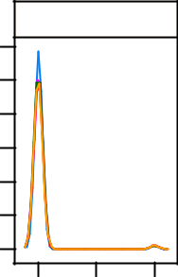

Training:

The function createDataPartition can be used to create a stratified random sample of the data into training and validation sets with 70% of the data in the training set and the rest in the validation set:

set.seed(1)

inTrain <- createDataPartition(y=data$classe, p=0.7, list=FALSE)

training <- data[inTrain,] #create training set

testing <- data[-inTrain,] #create validation set

The model is fitted using train from the caret library with the following parameters:

- method : argument specifies the type of training model.

2

- tuneGrid : a data frame with columns for each tuning parameter.

- trControl : used to specifiy the type of resampling.

– method : the resampling method to be used.

– number : number of cross-validation groups. This may also be an explicit list of integers that define the cross-validation groups.

#creat a tune grid.

grid <- expand.grid(cp=c(1:10)*0.01)

#fit the classification model

fit <- train(classe ~ ., data=training,

method="rpart",

tuneGrid=grid,

trControl=trainControl(method="cv", number=10))

Cross-Validation:

The training set ids resampled in the trainig step above using Cross-Validated (10 fold). The cross-validation results are given below:

From this model, I expect Out of Sample Error to be approximately 0.3 from the information below:

fit

- CART

- 13737 samples

- 59 predictors

- 5 classes: 'A', 'B', 'C', 'D', 'E'

- No pre-processing

- Resampling: Cross-Validated (10 fold)

- Summary of sample sizes: 12363, 12361, 12363, 12363, 12363, 12363, ...

- Resampling results across tuning parameters:

##
## | cp | Accuracy | Kappa | Accuracy SD | Kappa SD
## | 0.01 | 0.7 | 0.7 | 0.01 | 0.02
## | 0.02 | 0.7 | 0.6 | 0.01 | 0.01
## | 0.03 | 0.6 | 0.5 | 0.01 | 0.02
## | 0.04 | 0.5 | 0.4 | 0.03 | 0.04
## | 0.05 | 0.5 | 0.3 | 0.02 | 0.02
## | 0.06 | 0.4 | 0.2 | 0.05 | 0.08
## | 0.07 | 0.4 | 0.1 | 0.004 | 0.006
## | 0.08 | 0.4 | 0.1 | 0.004 | 0.006
## | 0.09 | 0.4 | 0.1 | 0.004 | 0.006
## | 0.1 | 0.4 | 0.1 | 0.004 | 0.006
##
- Accuracy was used to select the optimal model using the largest value.

- The final value used for the model was cp = 0.01.

3

plot(fit)
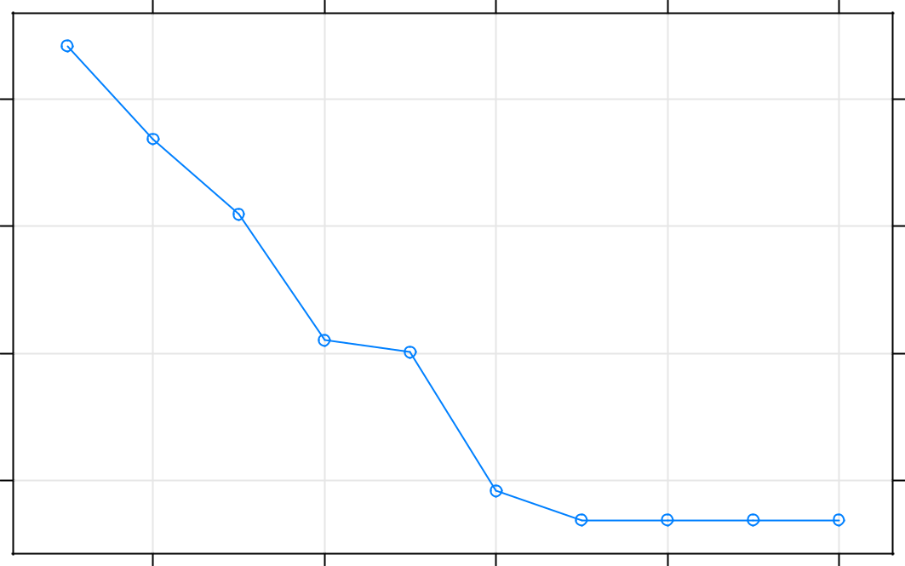

 | 0.7
(Cross−Validation) | 0.6
Accuracy | 0.5
 | 0.4
 | 0.02 | 0.04 | 0.06 | 0.08 | 0.10

Complexity Parameter

This is a visualisation for the “classification” tree produced by the model:

library(rattle)

fancyRpartPlot(fit$finalModel)

Predicting:

Using the model developed, I predict using the variable classe testPred <- predict(fit, testing)

From the Confusion Matrix we can calculate our Out of Sample Error as 24.84%:

Out of Sample Error = 1 - 0.7516

= 0.2484

confusionMatrix(testPred, testing$classe)

- Confusion Matrix and Statistics

- Reference

## Prediction |  | A | B | C | D | E
## | A 1451 |  | 134 | 25 | 51 | 83
## | B | 51 | 685 | 39 | 74 | 86
## | C | 31 | 130 | 840 | 51 | 53
## | D | 110 | 181 | 122 | 740 | 153
## | E | 31 | 9 | 0 | 48 | 707
##
- Overall Statistics

## | Accuracy | : | 0.752
## | 95% CI | : | (0.74, 0.763)
- No Information Rate : 0.284

- P-Value [Acc > NIR] : <2e-16

## Kappa : 0.686

5

- Mcnemar's Test P-Value : <2e-16

- Statistics by Class:

##
## | Class: A Class: B Class: C Class: D Class: E
## Sensitivity | 0.867 | 0.601 | 0.819 | 0.768 | 0.653
## Specificity | 0.930 | 0.947 | 0.945 | 0.885 | 0.982
## Pos Pred Value | 0.832 | 0.733 | 0.760 | 0.567 | 0.889
## Neg Pred Value | 0.946 | 0.908 | 0.961 | 0.951 | 0.926
## Prevalence | 0.284 | 0.194 | 0.174 | 0.164 | 0.184
## Detection Rate | 0.247 | 0.116 | 0.143 | 0.126 | 0.120
## Detection Prevalence | 0.296 | 0.159 | 0.188 | 0.222 | 0.135
## Balanced Accuracy | 0.899 | 0.774 | 0.882 | 0.826 | 0.818

6

