SAVEETHA SCHOOL OF ENGINEERING
SAVEETHA INSTITUTE OF MEDICAL AND TECHNICAL SCIENCES
COMPUTER SCIENCE AND ENGINEERING
CSA13 – THEORY OF COMPUTATION
ASSIGNMENT – 2
Name:NIMISHA VARMA.C Register No.: 192472295

Course Outcome: CO2

Question 1 (CO2, BTL4): Closure properties of regular languages
A class of languages is closed under an operation if applying that operation to languages in the class always produces a language in the same class. Regular languages are closed under complement, Kleene star, reversal and substitution. Each is proved below by construction.

1. Complement
Statement: If L is regular over Σ, then L̄ = Σ* − L is regular.
Proof: Let M = (Q, Σ, δ, q0, F) be a complete DFA accepting L. Construct M′ = (Q, Σ, δ, q0, Q − F), which has the same states and transitions but with final and non-final states interchanged. A string w ends in a final state of M′ exactly when it ends in a non-final state of M, so M′ accepts precisely the strings M rejects. Hence L̄ is regular.
Example: L = strings ending in 0 is regular, so the strings not ending in 0 (together with ε) are also regular.

2. Kleene star
Statement: If L is regular, then L* is regular.
Proof: Let R be a regular expression for L. Then R* is a regular expression for L*, so L* is regular. Automata construction: take an NFA N for L, add a new start state s which is also final, add an ε-transition from s to the old start state, and add ε-transitions from every old final state back to the old start state. The new NFA accepts ε and any concatenation of strings of L, which is L*.

3. Reversal
Statement: If L is regular, then L^R = { w^R : w ∈ L } is regular.
Proof: Take an NFA N for L with one final state (add ε-moves to a new single final state if necessary). Reverse the direction of every transition, make the old start state the only final state, and make the old final state the start state. The new automaton accepts w^R exactly when N accepts w. Using regular expressions: reverse(∅)=∅, reverse(ε)=ε, reverse(a)=a, reverse(R+S)=reverse(R)+reverse(S), reverse(RS)=reverse(S)reverse(R), reverse(R*)=(reverse(R))*. Hence L^R is regular.
Example: For L = (01)*0, the reversal is 0(10)*, which is regular.

4. Substitution
Statement: Let s be a substitution that maps every symbol a ∈ Σ to a regular language s(a). If L is regular, then s(L) is regular.
Proof: Let R be a regular expression for L, and let R_a be a regular expression for s(a). Replace every occurrence of each symbol a in R by the expression R_a. The result is again a regular expression, because it is built using only union, concatenation and star on regular expressions. It denotes s(L). Hence s(L) is regular.
Example: Let L = 0*1 and s(0) = a+b, s(1) = cd. Then s(L) is denoted by (a+b)*cd, which is regular.

Summary
Operation | Closed? / Key idea
Complement | Yes – swap final and non-final states of a complete DFA
Kleene star | Yes – new start state, ε-loops from finals to start
Reversal | Yes – reverse arrows, swap start and final states
Substitution | Yes – replace each symbol by a regular expression

Question 2 (CO2, BTL3): ε-NFA for (a+b)*(ab)*
The ε-NFA is built by Thompson’s construction. The expression is a concatenation of two parts: (a+b)* and (ab)*.

Step 1: Automaton for (a+b)*
- Build small NFAs for a (q2 → q3) and b (q4 → q5).
- Combine them with union: q1 has ε-moves to q2 and q4, and q3 and q5 have ε-moves to q6.
- Apply star: a new start state q0 and an exit state q7 are added. q0 has ε-moves to q1 and q7, and q6 has ε-moves back to q1 (repeat) and forward to q7 (exit).

Step 2: Automaton for (ab)*
- Concatenate a and b: q9 –a→ q10 –b→ q11.
- Apply star: a new start state q8 and final state q12 are added. q8 has ε-moves to q9 and q12, and q11 has ε-moves back to q9 and forward to q12.

Step 3: Concatenate both parts
Connect the exit state q7 of the first part to the start state q8 of the second part with an ε-transition. The start state is q0 and the only final state is q12.

Transition diagram
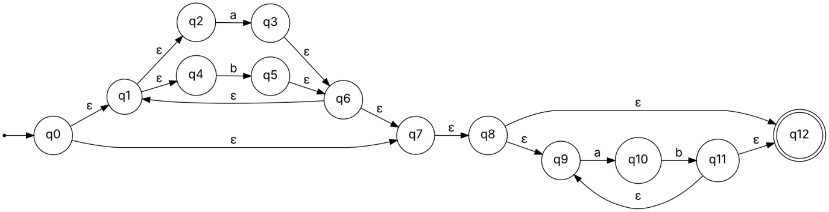

Transition table
State | a | b | ε
→ q0 | – | – | q1, q7
q1 | – | – | q2, q4
q2 | q3 | – | –
q3 | – | – | q6
q4 | – | q5 | –
q5 | – | – | q6
q6 | – | – | q1, q7
q7 | – | – | q8
q8 | – | – | q9, q12
q9 | q10 | – | –
q10 | – | q11 | –
q11 | – | – | q9, q12
* q12 | – | – | –

Check: The string “bab” is accepted: q0 –ε→ q1 –ε→ q4 –b→ q5 –ε→ q6 –ε→ q1 –ε→ q2 –a→ q3 –ε→ q6 –ε→ q1 –ε→ q4 –b→ q5 –ε→ q6 –ε→ q7 –ε→ q8 –ε→ q12. The string “abab” is also accepted, through the (ab)* part.

Question 3 (CO2, BTL3): Informal description of (0+1)*00

Breakdown of the expression
- (0+1)* – any string of 0s and 1s of any length, including the empty string.
- 00 – the fixed string “00” placed at the end.

Description
The expression denotes the set of all binary strings that end with two consecutive 0s. The prefix can be any string over {0,1}, but the last two symbols must both be 0. Strings with fewer than two symbols are not in the language.

Examples
Strings in the language: 00, 100, 000, 1100, 10100, 0000, 111100.
Strings not in the language: ε, 0, 1, 01, 10, 0010, 1001, 110.

Language in set notation
L = { w00 : w ∈ {0,1}* }

Question 4 (CO2, BTL4): Equal number of a’s and b’s is not regular
Language: L = { w ∈ {a,b}* : the number of a’s in w equals the number of b’s in w }.

Pumping lemma
If L is regular, there is a constant p ≥ 1 (the pumping length) such that every string w ∈ L with |w| ≥ p can be written as w = xyz satisfying: (1) |y| ≥ 1, (2) |xy| ≤ p, and (3) x y^i z ∈ L for every i ≥ 0.

Proof by contradiction
- Step 1: Assume L is regular. Let p be its pumping length.
- Step 2: Choose w = a^p b^p. It has p a’s and p b’s, so w ∈ L, and |w| = 2p ≥ p.
- Step 3: Write w = xyz with |xy| ≤ p and |y| ≥ 1. Since the first p symbols of w are all a’s, y consists only of a’s. Let y = a^k with k ≥ 1.
- Step 4: Pump with i = 2. The string x y² z = a^(p+k) b^p has p + k a’s but only p b’s.
- Step 5: Since k ≥ 1, the number of a’s is not equal to the number of b’s, so x y² z ∉ L. This contradicts condition (3).

Conclusion
The assumption that L is regular is false. Therefore the language of all strings with an equal number of a’s and b’s over {a,b} is not regular.
Remark: A finite automaton has only finitely many states and cannot count an unbounded number of a’s in order to compare them with the b’s that follow.

Question 5 (CO2, BTL3): Arden’s Theorem
Note: The automaton referred to in the question was not attached to my request, so the method is explained and applied to a standard three-state DFA below. To solve your own automaton, follow the same steps with its transitions.

Arden’s Theorem
Let P and Q be regular expressions over Σ, where P does not contain ε. Then the equation R = Q + RP has a unique solution R = QP*.

Procedure
- Write an equation for every state qi: qi = (sum of qj·a for each transition qj –a→ qi). Add ε to the equation of the start state.
- Substitute and simplify the equations step by step.
- Whenever an equation takes the form R = Q + RP, replace it with R = QP*.
- The required regular expression is the union of the expressions of all final states.

Example automaton
States q0 (start), q1 and q2 (final) over {a, b}, with transitions: q0 –a→ q1, q0 –b→ q0, q1 –a→ q1, q1 –b→ q2, q2 –a→ q1, q2 –b→ q0.
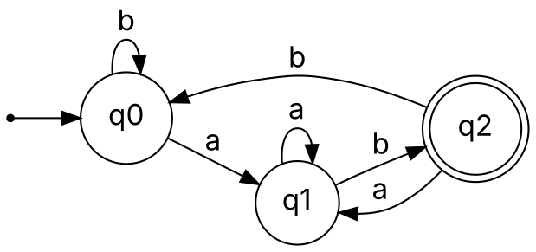

Step 1: Equations
q0 = ε + q0 b + q2 b … (1)
q1 = q0 a + q1 a + q2 a … (2)
q2 = q1 b … (3)

Step 2: Substitute (3) in (2)
q1 = q0 a + q1 a + q1 ba = q0 a + q1 (a + ba)
This has the form R = Q + RP with Q = q0 a and P = a + ba. By Arden’s Theorem:
q1 = q0 a (a + ba)* … (4)

Step 3: Find q2
q2 = q1 b = q0 a (a + ba)* b … (5)

Step 4: Substitute (5) in (1)
q0 = ε + q0 b + q0 a (a + ba)* b b
q0 = ε + q0 [ b + a (a + ba)* bb ]
Applying Arden’s Theorem with Q = ε and P = b + a(a+ba)*bb:
q0 = ε · [ b + a (a + ba)* bb ]* = [ b + a (a + ba)* bb ]*

Step 5: Final state expression
Since q2 is the only final state, the language is given by q2:
q2 = [ b + a (a + ba)* bb ]* a (a + ba)* b
Result: The regular expression for the automaton is (b + a(a+ba)*bb)* a (a+ba)* b, which is equivalent to (a+b)*ab, the set of all strings over {a,b} ending in “ab”.

