Data Analysis Report

Topic:- Analysis of the International Car Racing Organization and local governing car racing body with drivers and Winng journey at both levels.

Author:-Nimisha Vilayatarani

Matriculation No:-7219293

Github link:- **https://github.com/nimishavilayatrani/Home_Assigment1.git**

Date_of_Report:-19.04.2024

**Introduction:- FIA is a leading international car racing organization that governs various motorsport events worldwide. It consists of several member countries, each contributing to the global landscape of motorsport. FIC is a global organization that oversees both sports and mobility initiatives, including various motorsport events and activities. Within FIC, there are local federations representing different regions and countries**.

This is the list that we found from our first data source.

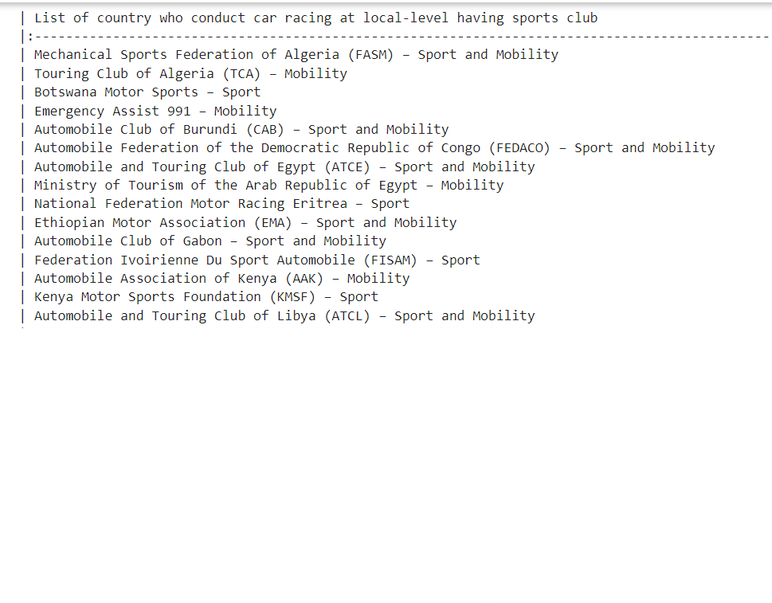

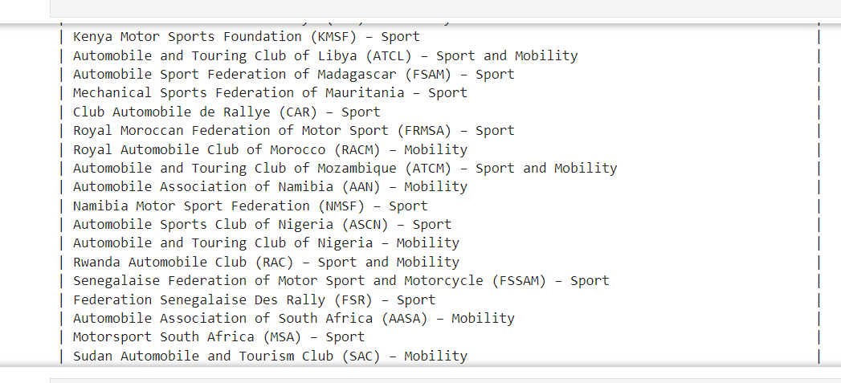

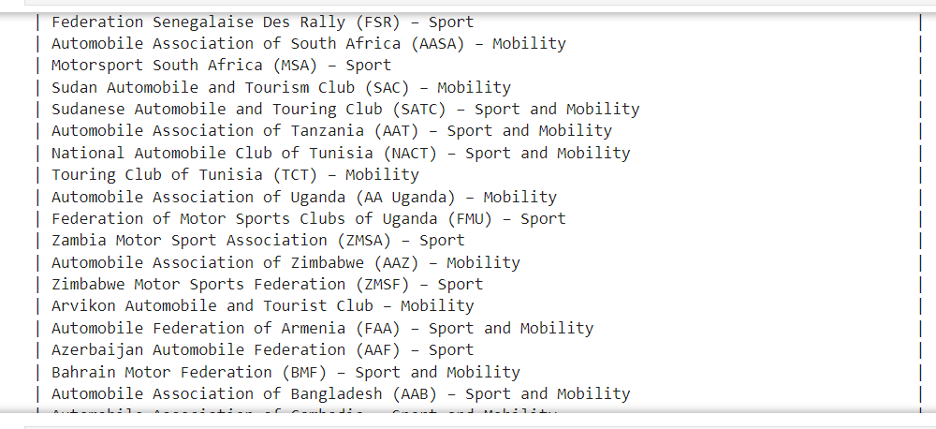

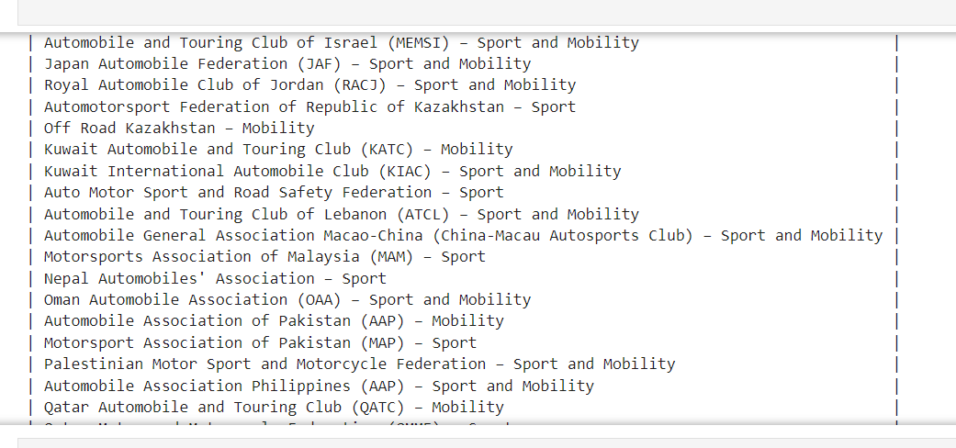

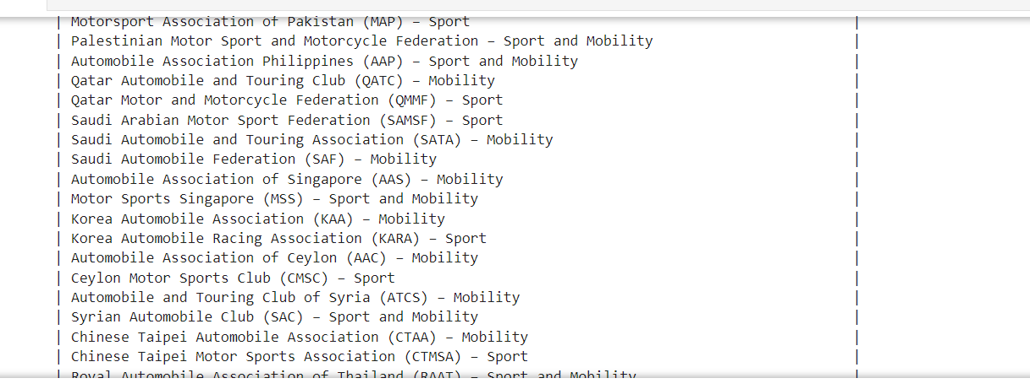

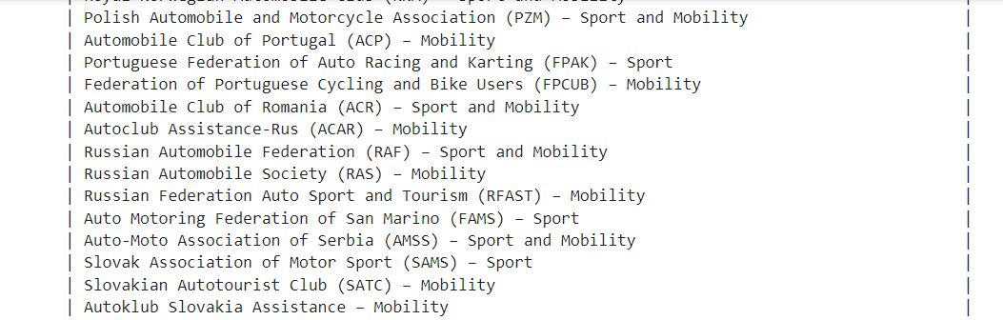

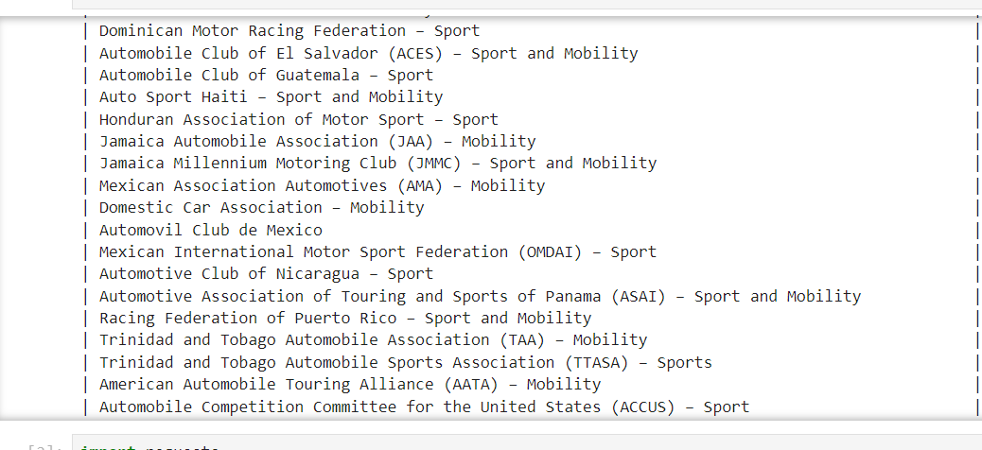

**Then by specifically analyzing the data of 2020 and 2021, we found that these clubs and local federations are combined based on the region and funding provided to them on the basis of region in other words In 2020 and 2021, FIC allocated funding to its member countries to support motorsport development and infrastructure. The analysis reveals that funding was primarily distributed across five key regions, as shown below:**

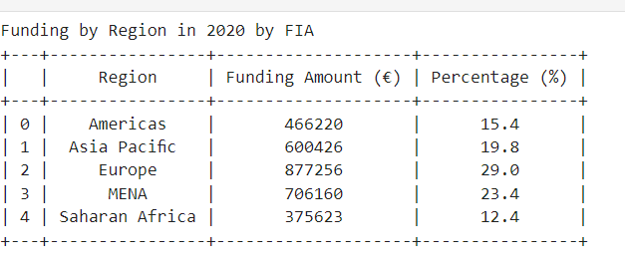

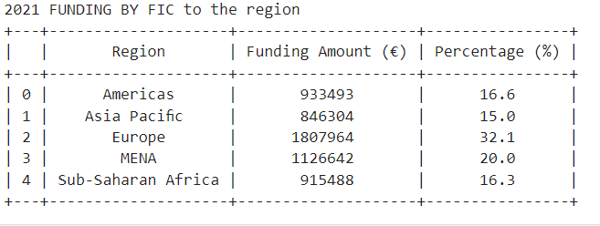

**When we merged both these tables for further analysis we found that.**

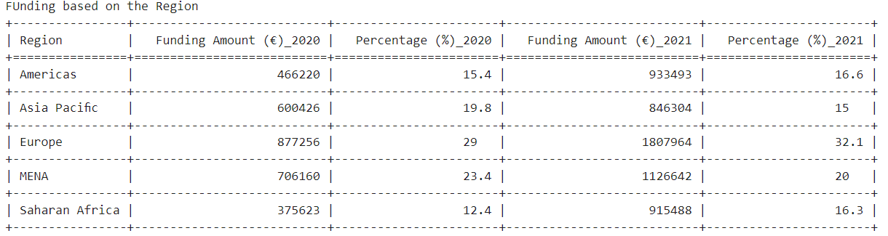

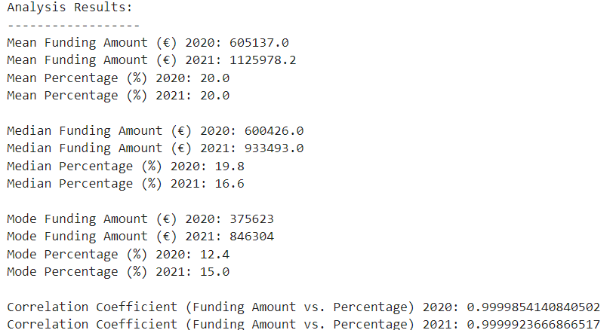

**It is very clear from the analysis that funding amount in 2021 is more than the 2020 in terms of mean, median, and mode at the same The funding amount allocated to different regions or categories correlates highly with the percentage of total funding for both 2020 and 2021. This indicates that the distribution of funding is consistent across different categories or regions relative to the total funding amount.**

**More with visual analysis.**

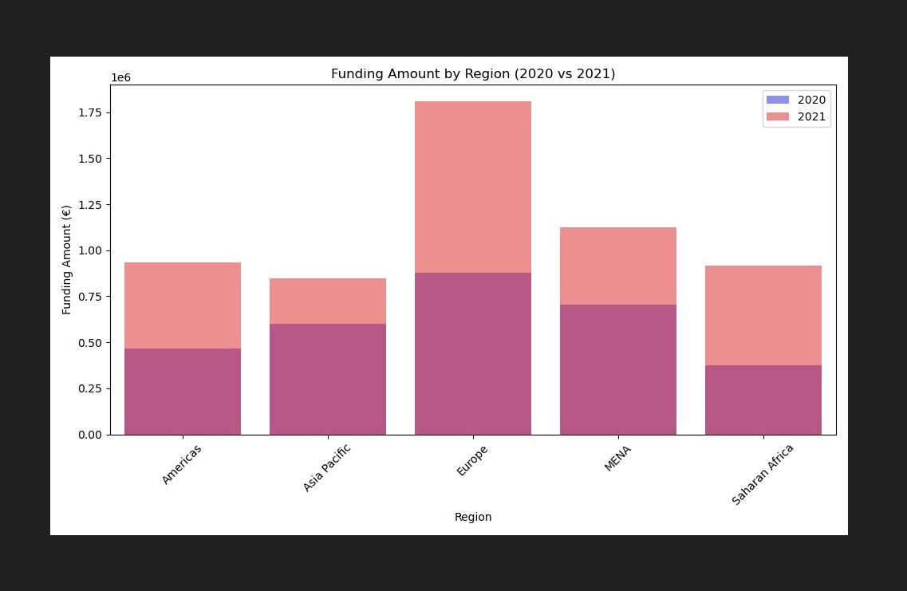

**Europe get the maximum amount of funding in both year. Asia pacific is stay at least corner.**

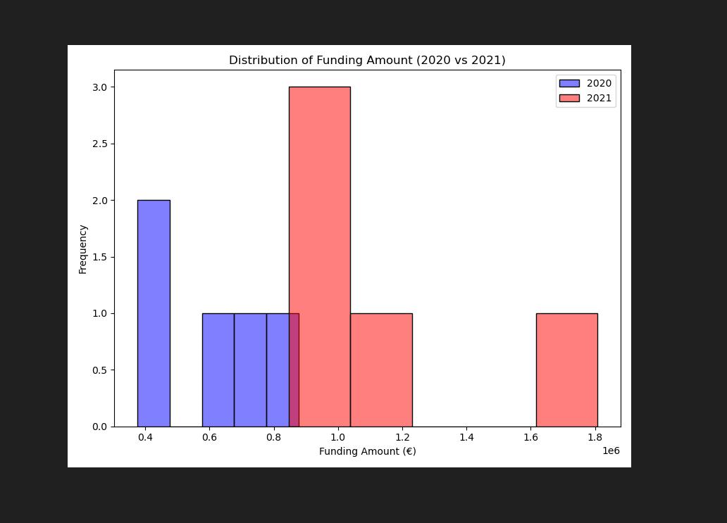

**This is very much clear with the above graph that funding in 2021 is more as compared to 2020**.

**There are other analyses also that funding is not only based on region but also there are other factors which describe the situation such as Safety', 'ASN Structure & Management', 'Motor Sport Development', 'Social Responsibility that are categories as pillar divisions here analysis is made also on both the phrases 2020 and 2021.Given below**

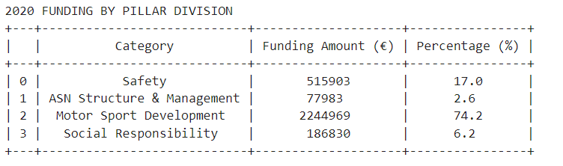

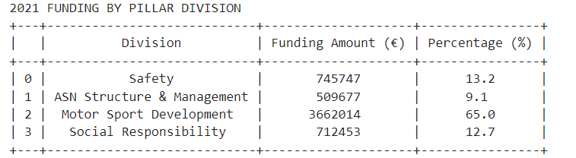

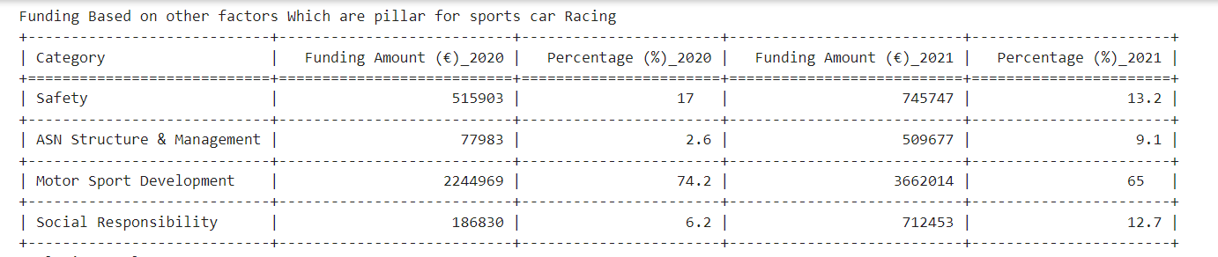

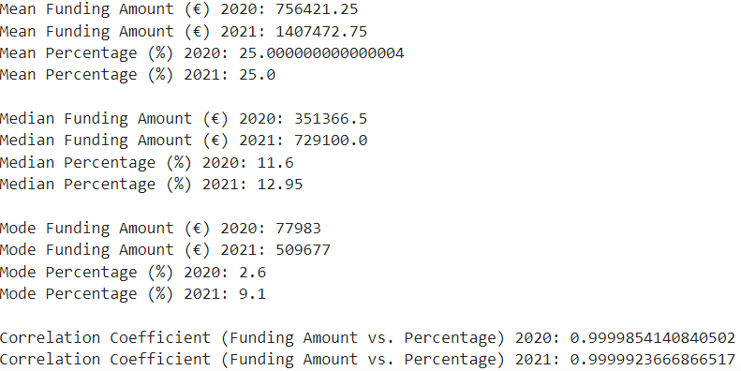

**For Mean Analysis in both years, when data compared:- The mean funding amount in 2021 (€1,407,472.75) significantly surpassed that of 2020 (€756,421.25), indicating a substantial increase in overall funding allocation.**

**For Median Analysis:- Similarly, the median funding amount in 2021 (€729,100.0) was notably higher than in 2020 (€351,366.5), suggesting a general upward trend in funding levels.**

**For Mode Analysis:- The mode funding amount in 2021 (€509,677) was substantially higher than in 2020 (€77,983), indicating a shift towards larger funding allocations being more common in 2021.**

**Overall Analysis:- Overall, while both the mean and median funding amounts experienced significant increases from 2020 to 2021, the proportionate allocation of funding remained relatively stable. This suggests that while more funding was allocated overall in 2021, the distribution pattern across categories or regions remained consistent with that of the previous year.**

**When visualize things through the graph below.**

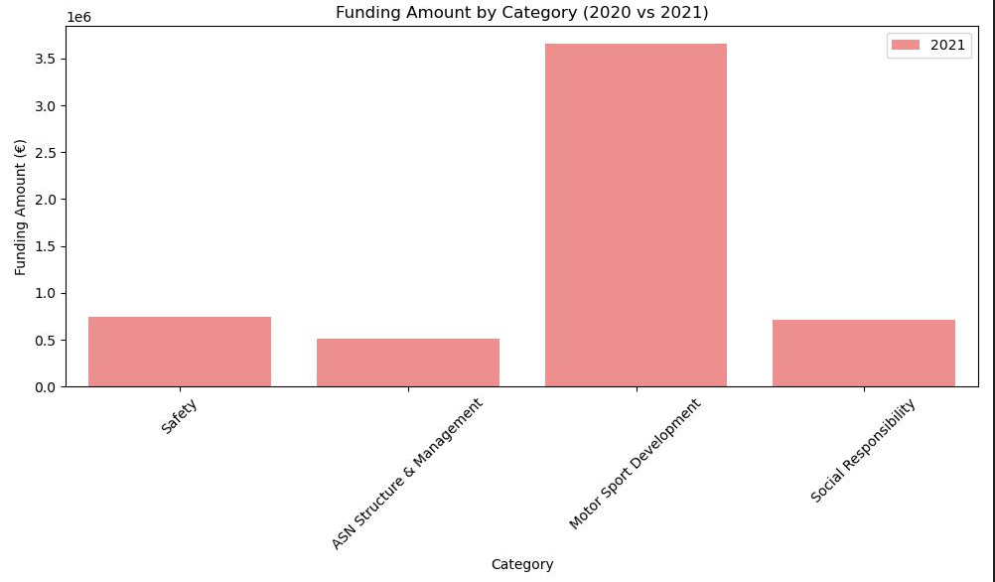

We can analyze that funding is utilized more for motorsport development rather than any other division when signifies the pillar division.

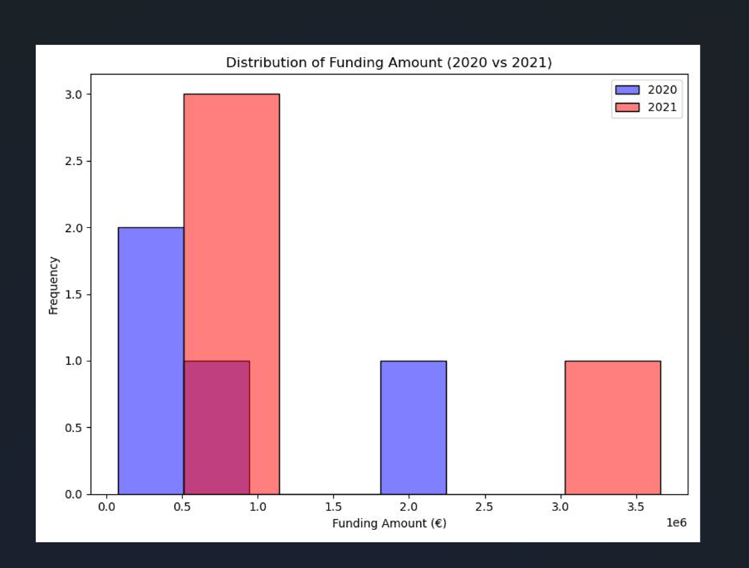

**We can conclude that funding was utilised more in 2021 when compared with 2020. For pillar division which are mentioned above.**

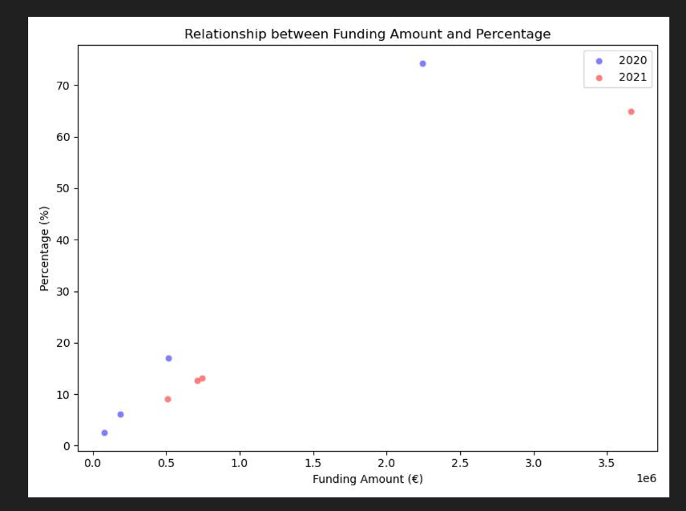

**There is a positive relation between the percentage of the overall fund and funding amount for each pillar division in 2020 and 2021 there is a positive relation between them which we already concluded with the correlation between the percentage which is overall and the funding amount in 2020 and 2021.**

In the next we found that.

**Here we analysis from the data list of Driver and Engine they used with multiple other factors such as Laps and time intervals majorly it is found that the 3 major car Engine they are using such as Ferrari, Red Bull, and Mercedes these 3 engine most commonly found engine is Red Bull with this we also found that driver who win the race is also using engine of Ferrari in addition to this when we analysis the whole table it is found that Red bull engine is showing least time interval and fast racing mechanism.**

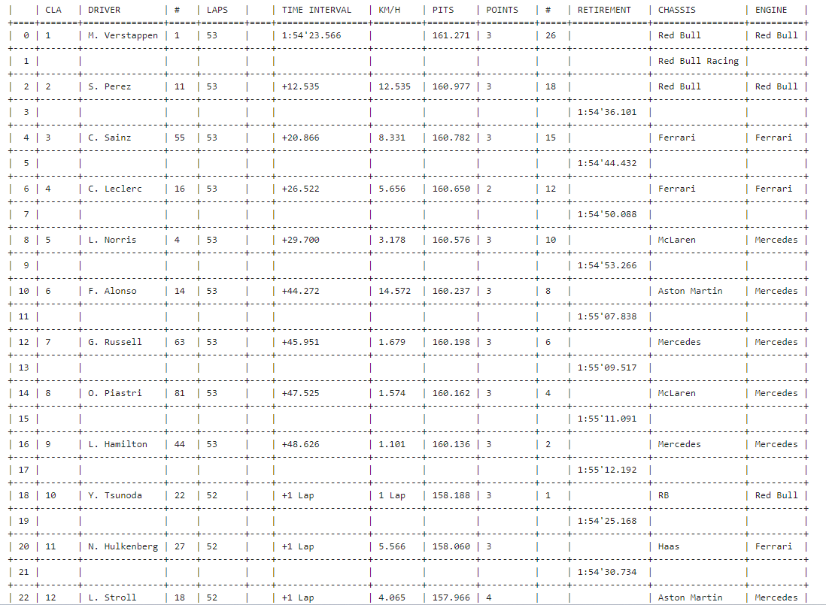

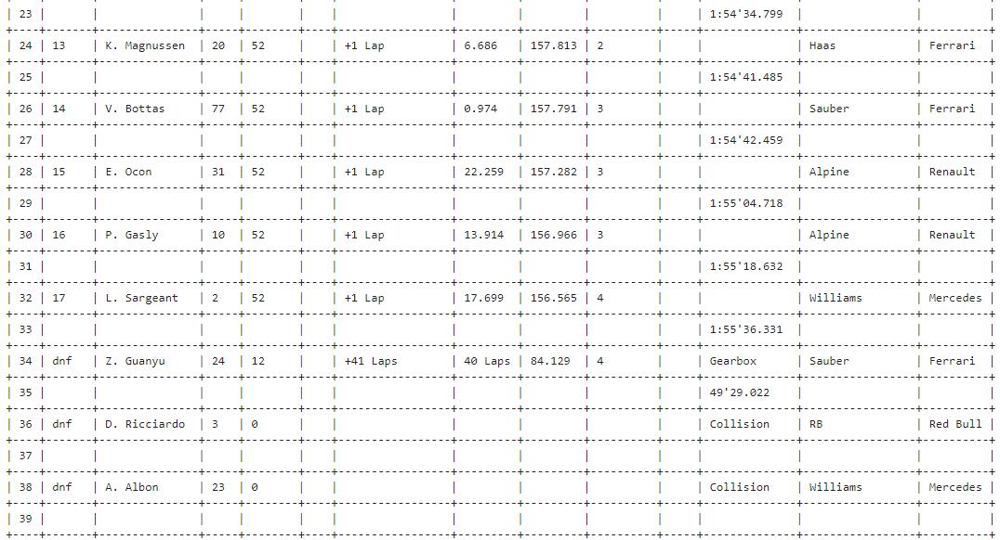

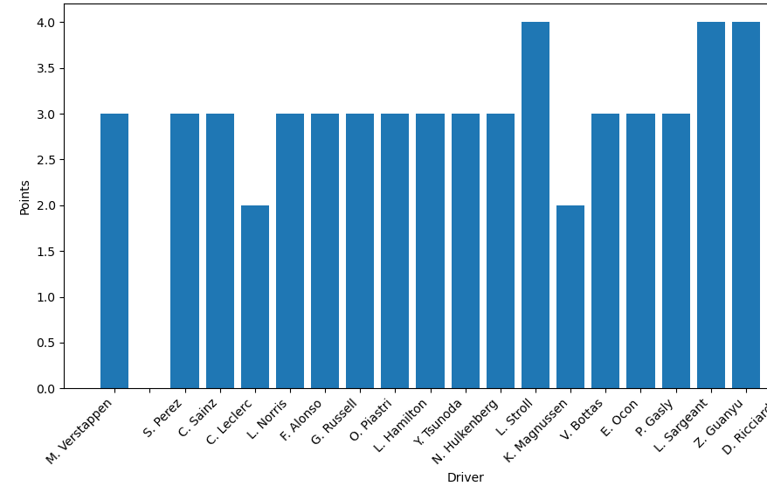

**The highest point made by three drivers L.stroll, L.sargeant, and Z.Guanyu we clearly see this with this analysis from the above list is L.stroll and l. Sargeant is using the engine of Mercedes and ZGuanyu is using the engine of a Ferrari. Overall both the engines equally performed well.**

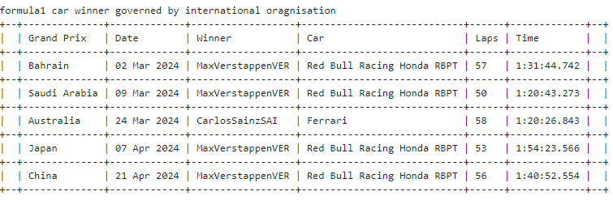

**Every year international governing organizations conduct a race called the Formula 1 car race here are the results for the analysis of the year 2024, the car that is mostly used for this race is “Red Bull Racing Honda RBPT”. These races mostly occur in the months of March and April. We also analysis that mostly time required for completion of this race in minutes is 80 and the driver from the Australia took the least time to completion**.

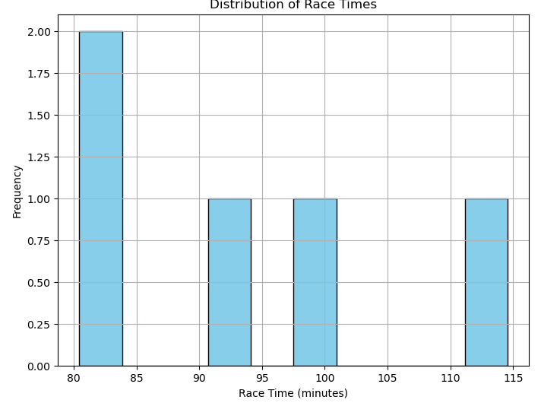

**We have a table of the races that are conducted on a local level with analysis of this can be concluded that the number of races conducted at the local level is more than international level as there are different groups and clubs for sports and mobility under the international organization FIC here are only a few results of only one of the local level sports organization which conduct races relatively in the same month as an international organization, in the month march April in addition to February.**

