

ME Assignment
Submitted by
Ishank Sharma - 1MS17IS050
Under the guidance of
Rajaram M Gowda
Professor
Information Science And Engineering

Teacher’s Signature

1- Line, functional and line-and-staff structures
The traditional line structure is organized in such a way that a president or CEO (Chief Executive Officer) is at the top. Then there are the directors or VPs (Vice-Presidents) of specific areas, followed by managers, and so on, until the operational personnel. This structure can be seen below:
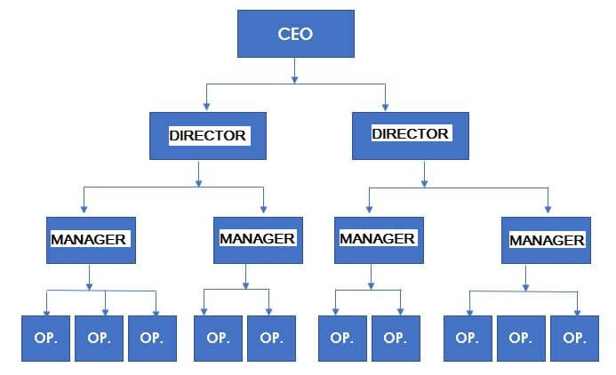
It’s a very rigid structure, with little information exchange, typical of bureaucratic companies in which there is little collaboration.

Appropriateness

Nowadays it’s unusual, but in the past it was practiced in military, religious, and even academic organizations. In this way, one area doesn’t interfere with the work of another, and the staff only obeys the ‘orders’ of the immediate superior.

Organizational structure example – Functional
The functional organizational structure derives from the line structure; the difference is that employees in an area need to report to all the directors.
For instance, an employee from the finance department may be called upon by the HR (Human Resource) manager to handle a matter related to this area. The IT (Information Technology) manager may do the same, and so forth.
It’s a way to avoid centralization and excessive specialization in tasks in your area.
Here’s what this hierarchy looks like:
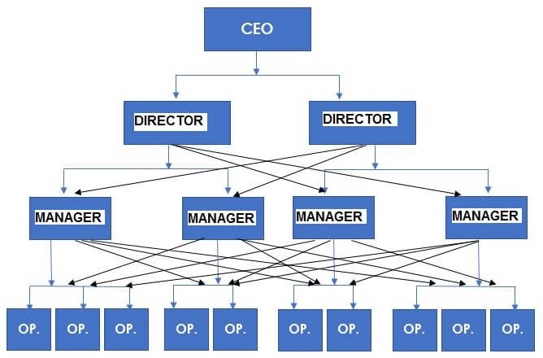
Today this is the most used structure in many companies and organizations, but this doesn’t mean it’s the best one.
Everything will depend on the relationship between managers and, especially, on the appropriate use of IT to aid in internal communication.
Appropriateness
This organizational structure example is suitable for small companies, such as manufacturing, hotels, medium-sized car repair shops, medical clinics, or other types of business where informal structures allow functional control over employees without generating conflicts between managers.

Organizational structure example – Line-and-staff
It’s similar to the line structure, except that in this case the staff advises, gives opinion, makes reports, authorizes and supports the organization.
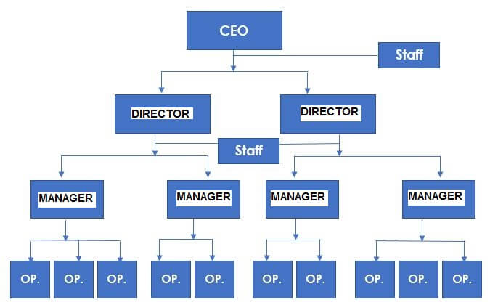

Appropriateness
Organizational structure examples of this type include insurance companies, engineering firms, law firms, regulatory agencies, etc. In other words, organizations that need isolated technical advice to assist employees who handle or manage the day-to-day operations on the front line.

2- Project-based structure
Highly dynamic and creative companies – such as software developers, architecture firms, special industrial equipment installation projects and event organization companies – typically use this structure. It’s characterized by a series of specialized employees, ready to compose a work team as needed.
In each project, these collaborators report to a different leader. Once they complete the project, a manager assigns them a new project and leader.
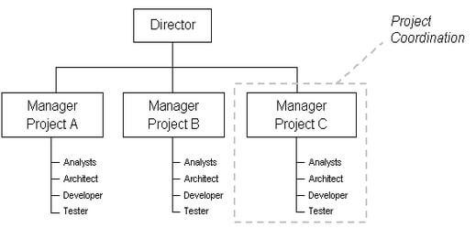

3- Matrix structures
This structure is widely used both by companies that are constantly launching new products and marketing campaigns, for example, and by companies that have project-based structures, but also believe that functional supervision is necessary and important.

An example of a business area that would benefit from this type of organizational hierarchy is consultancy for ERP Software installation.
Each project must occur independently. However, it’s important to have a senior manager of each department (finance, operations, HR, marketing, etc.) to check if everything is in accordance with the company’s policies and level of services.
