ITM SKILLS UNIVERSITY
School of Future Tech
Java Programming
Case Study / Problem Statement
CASE STUDY NO. 139
Machine Maintenance Scheduler
A Java Swing Application
Submitted by
Detail | Information
Name | Nimish Bordiya
Roll Number | 150096725027
Programme | B.Tech CSE (2025-29), Semester III
School | School of Future Tech
University | ITM Skills University
Subject | Java Programming

1. Introduction
A factory depends on its machines running without interruption. Preventive maintenance (servicing machines before they fail) reduces breakdowns, but it only works if every machine, technician, service task and repair is tracked properly. This project is a Java desktop application, built with Java Swing, that helps a factory keep this information in one place.

1.1 Problem Statement
A factory wants to maintain preventive-maintenance schedules for machines, record service tasks, assign technicians, and track breakdown and repair history.

2. Objectives
- Maintain machine and technician records.
- Schedule maintenance tasks.
- Track due dates.
- Record repairs.
- Generate maintenance history.

3. Expected Outcomes
- Provide a functional Java prototype for the machine maintenance scheduler.
- Support accurate record creation, update, search, and status management.
- Demonstrate appropriate Java Collections and object-oriented design.
- Handle invalid input and important business-rule conditions safely.
- Provide clear GUI-based interaction and useful application summaries.

4. Java Concepts Used and Justification
The problem statement requires OOP, Interfaces, HashMap and ArrayList. The table below shows where each is used and why it was the right choice.
Concept | Where it is used | Justification
OOP (abstract class, inheritance, encapsulation) | BaseRecord is the parent of Machine and Technician. Fields are private with getters. | Machine and Technician share an ID and a name, so the common part is written once. Private fields stop other classes from changing data without validation.
Interfaces | Identifiable (anything with an ID) and RecordManager (add, update, find, getAll, search). | They define reusable contracts. Any new record manager must follow the same behaviour, which keeps the design consistent.
HashMap | MapManager stores Machines and Technicians with the ID as the key. | Lookup, duplicate-ID check and update by ID are fast and need no looping through a list.
ArrayList | Maintenance tasks and repair records are kept in ArrayLists. | Tasks and repairs are added over time and need an order (for example by due date). ArrayList grows dynamically and is easy to sort.
Exception handling | MaintenanceException is thrown for invalid input and rule violations. | Errors are caught and shown as a friendly message, so the program does not crash.
File handling | Data is saved to and loaded from maintenance_data.txt. | Records are not lost when the program is closed.
Swing GUI | MainFrame with tabs, forms, tables and buttons. | Gives clear, easy interaction without typing commands.

5. System Design

5.1 Architecture
The program is divided into layers so that the screen code and the rules are kept apart:
- GUI layer (MainFrame): shows tabs, forms and tables, and passes user input to the service.
- Service layer (MaintenanceService): contains all business rules, the ArrayLists and the file save/load code.
- Manager layer (MachineManager, TechnicianManager): store records in HashMaps.
- Model layer (Machine, Technician, MaintenanceTask, RepairRecord): plain classes that hold the data.

5.2 Classes
Class / Interface | Type | Purpose
Identifiable | Interface | Contract for any record with an ID.
RecordManager | Interface | Contract for add, update, find, getAll and search.
BaseRecord | Abstract class | Common ID and name with validation.
Machine | Class (extends BaseRecord) | Machine with location and status (Active, Under Repair, Out of Service).
Technician | Class (extends BaseRecord) | Technician with phone number and specialization.
MaintenanceTask | Class | A scheduled service task with due date; status is Scheduled, Overdue or Completed.
RepairRecord | Class | A breakdown and its repair details; status is Open or Repaired.
MapManager | Abstract generic class | HashMap-based add, update, find and search.
MachineManager, TechnicianManager | Classes | Add the search fields specific to machines and technicians.
MaintenanceService | Class | Business rules, history, summary and file handling.
MaintenanceException | Custom exception | Reports invalid input and rule violations.
MainFrame | GUI class | The Swing window with all tabs.

5.3 Modules
Module (tab) | What it does
Machines | Add and update machines, search by ID, name, location or status, and manage machine status.
Technicians | Add and update technicians and search by ID, name, phone or specialization.
Maintenance Tasks | Schedule a task for a machine, assign a technician, set a due date, view days left, filter by status, and mark a task completed.
Repairs | Report a breakdown (machine becomes Under Repair), then record the repair (machine becomes Active again).
History | Shows maintenance tasks and repairs together for one machine or for all machines, newest first.
Summary | Shows nine live counts: total, active, under repair and out-of-service machines, technicians, scheduled, overdue and completed tasks, and open breakdowns.

6. Business Rules and Validation
Rule | Result when broken
Machine and technician IDs must be unique. | Duplicate ID is rejected.
ID, name, location, task description and issue cannot be empty. | An error message is shown.
Technician phone number must be exactly 10 digits. | Record is rejected.
Dates must be in yyyy-MM-dd format. | An error message with an example is shown.
A task due date cannot be in the past. | Task is not scheduled.
A task cannot be scheduled for a machine that is Out of Service. | Task is not scheduled.
A breakdown date cannot be in the future. | Breakdown is not recorded.
A repair date cannot be before the breakdown date or in the future. | Repair is not recorded.
A technician must be selected for a task or repair. | An error message is shown.
An already completed task or repaired breakdown cannot be completed again. | An error message is shown.

7. Exception Handling
Every rule violation throws a MaintenanceException with a clear message. All button actions in the GUI run inside one common method that catches this exception and shows the message in a popup dialog. File problems (IOException) are also caught and reported. Because of this, wrong input never crashes the program.

8. Data Storage
All data is saved to a text file named maintenance_data.txt in the folder where the program is run. The file is saved automatically after every successful action and loaded when the program starts. Each record is one line with fields separated by the | character:
MACHINE|id|name|location|status
TECH|id|name|phone|specialization
TASK|id|machineId|techId|description|dueDate|completed|completedDate
REPAIR|id|machineId|issue|breakdownDate|repaired|techId|details|repairDate
A | typed inside a text field is saved as /, so it cannot break the file. A damaged line is skipped and the remaining records still load.

9. How to Run
1. Install JDK 8 or later and save the source file as MachineMaintenanceScheduler.java.
2. Compile: javac MachineMaintenanceScheduler.java
3. Run: java MachineMaintenanceScheduler
Start by adding at least one machine and one technician, then schedule tasks and record breakdowns and repairs.

10. Application Screenshots
The screenshots below show each tab of the running application as it appears when first started, before any records are added.
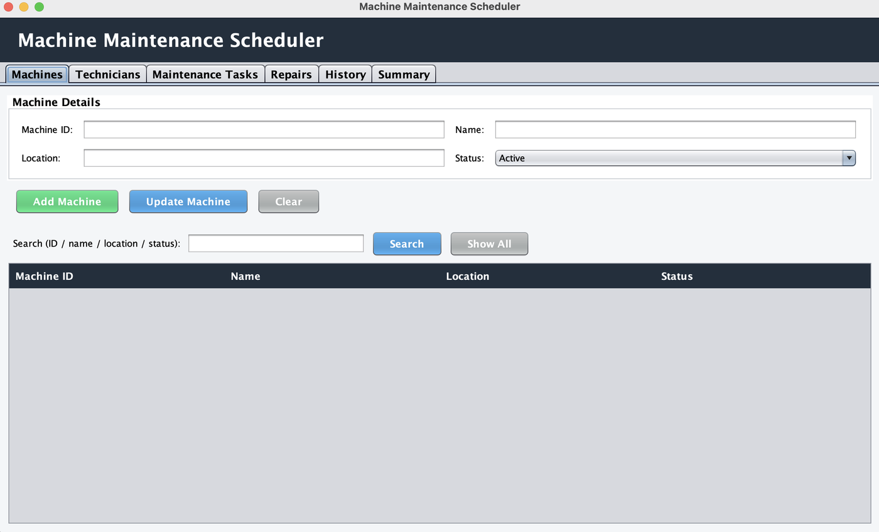
Figure 1: Machines tab
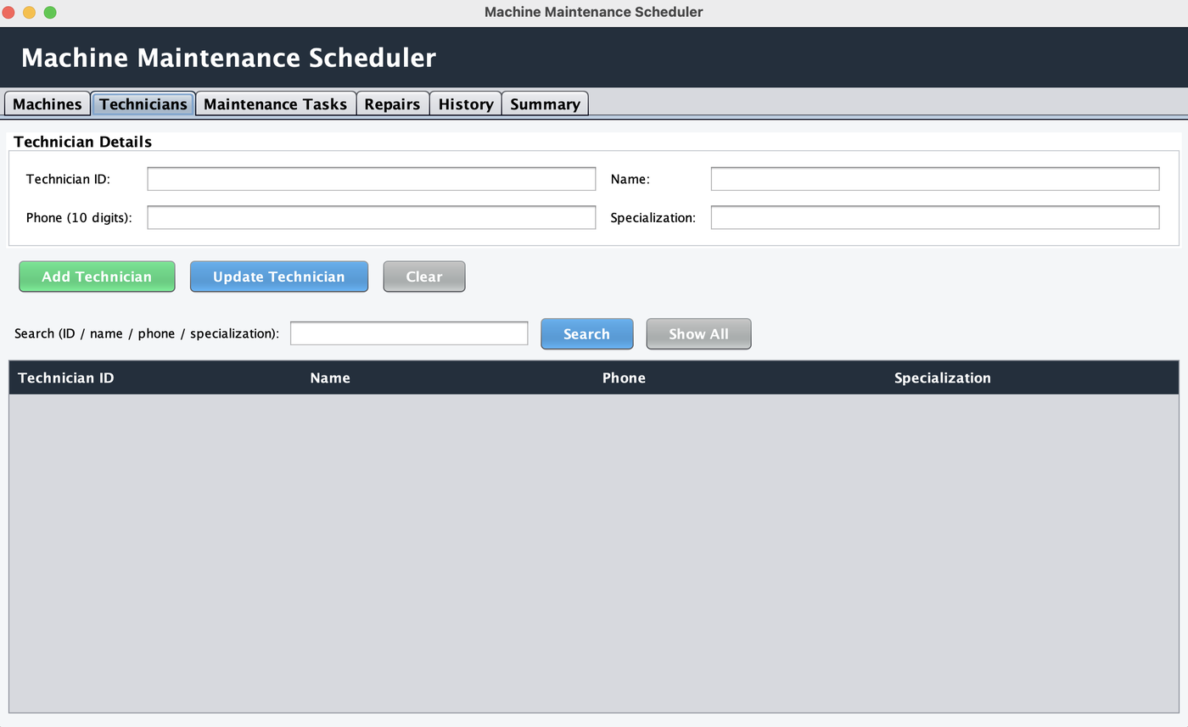
Figure 2: Technicians tab
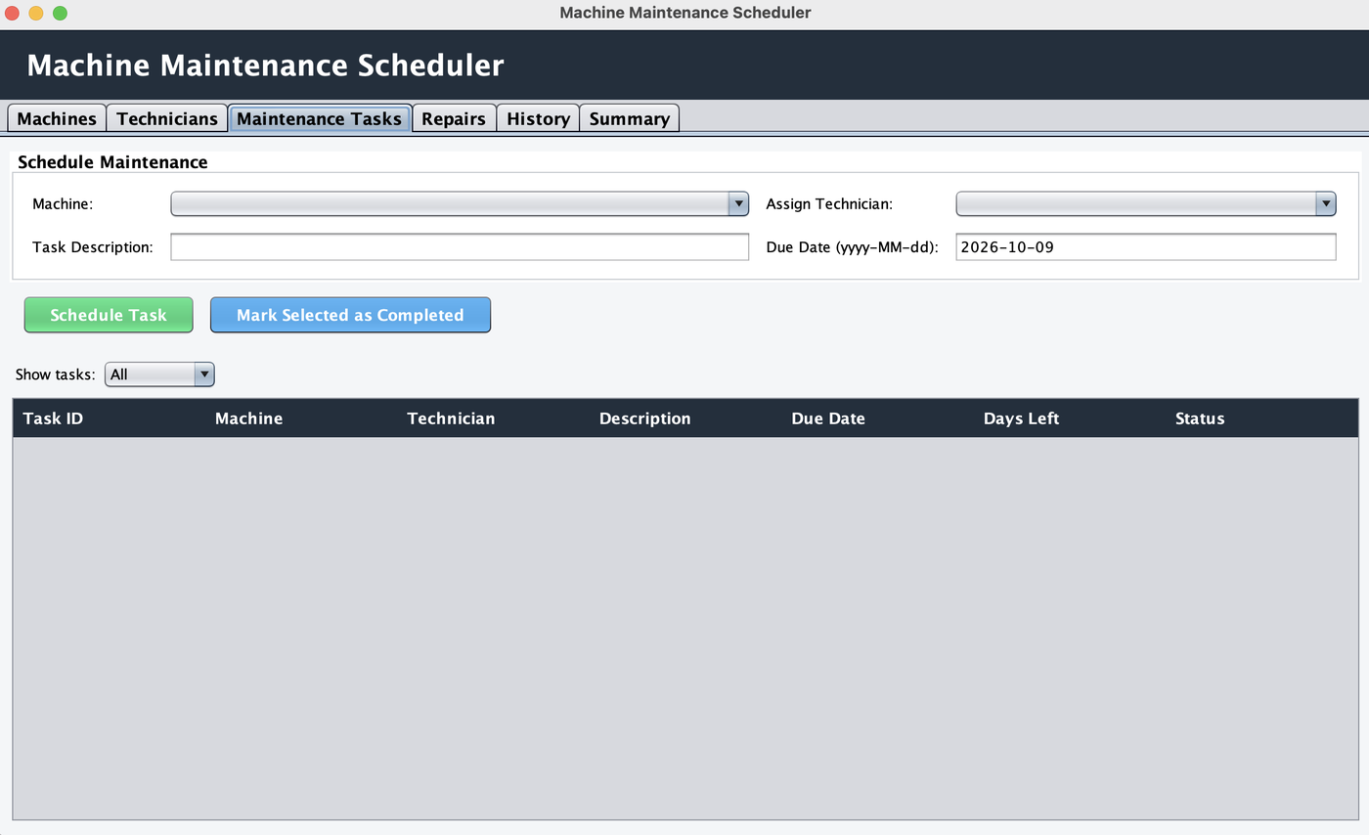
Figure 3: Maintenance Tasks tab
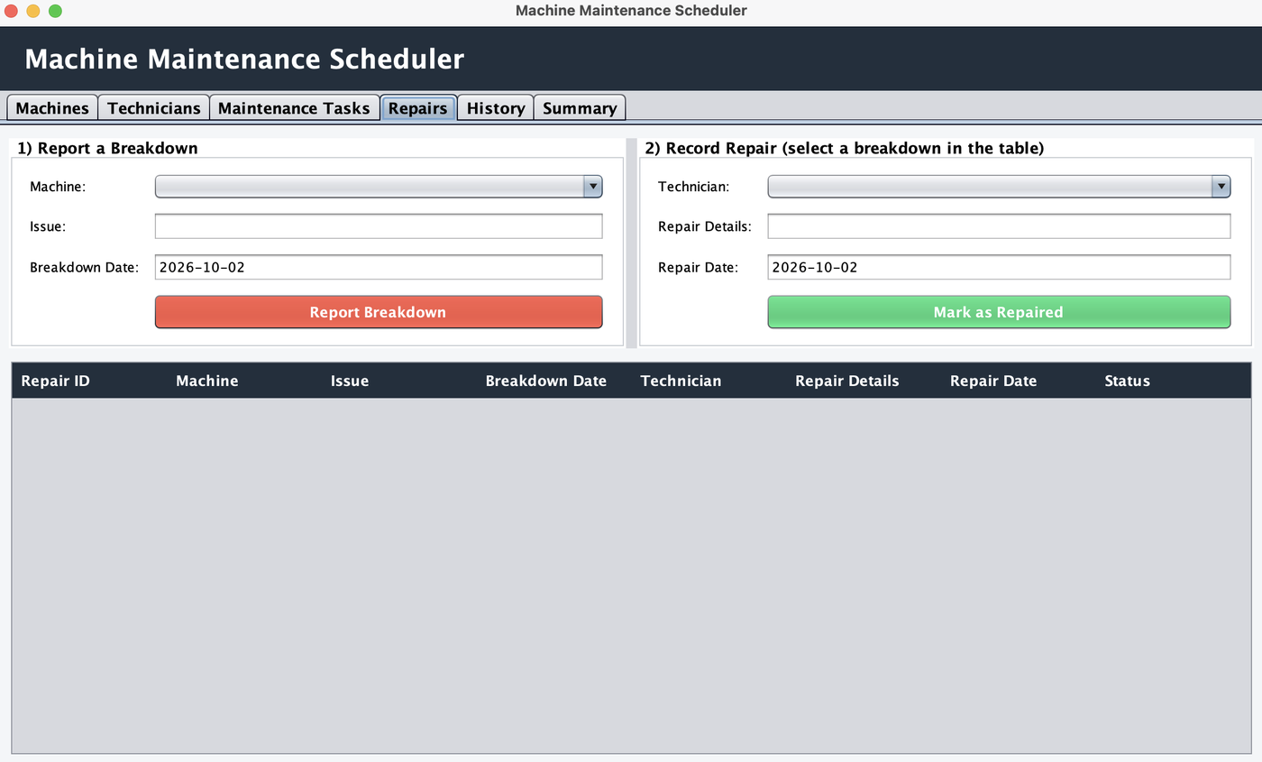
Figure 4: Repairs tab
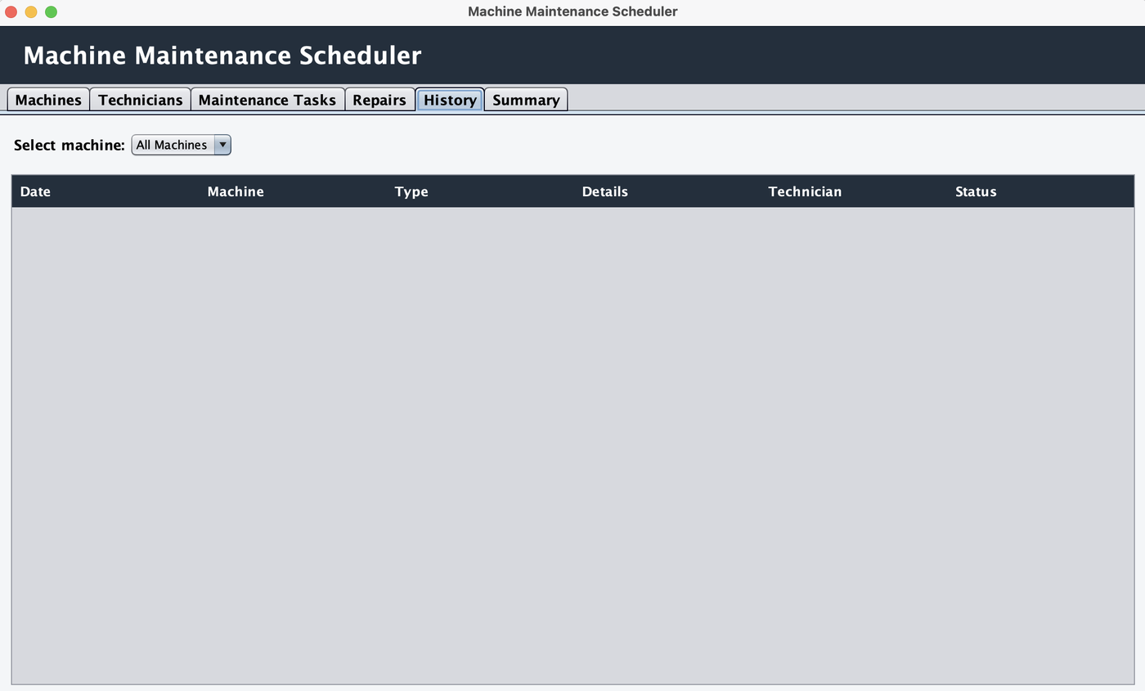
Figure 5: History tab
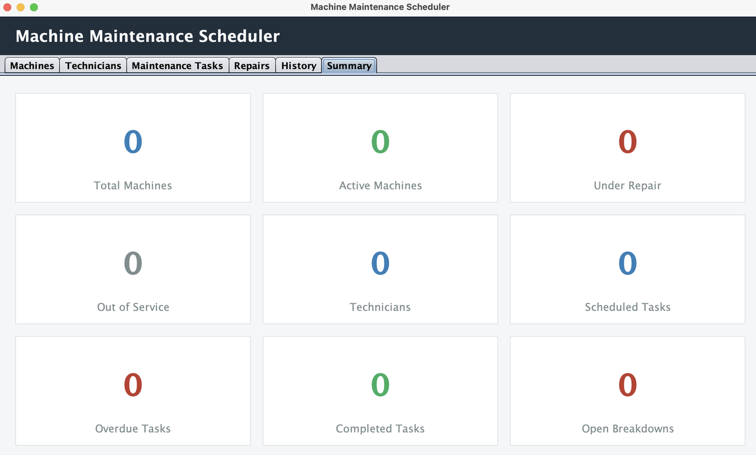
Figure 6: Summary tab

11. Requirement Coverage
Requirement from problem statement | How it is met
Maintain machine and technician records | Machines and Technicians tabs (add, update, search).
Schedule maintenance tasks and assign technicians | Maintenance Tasks tab.
Track due dates | Days Left column and automatic Overdue status.
Record repairs, track breakdown and repair history | Repairs tab and History tab.
Generate maintenance history | History tab, per machine or for all machines.
Status management | Machine, task and repair statuses change automatically as work is recorded.
OOP, Interfaces, HashMap, ArrayList | Section 4.
Handle invalid input and business rules safely | Sections 6 and 7.
GUI interaction and summaries | Swing tabs and the Summary tab.

12. Limitations and Future Scope
- Maintenance tasks can be completed but their due date cannot be edited after scheduling.
- Tasks and repairs can be filtered by status, but they do not have a text search like machines and technicians.
- Data is stored in a text file; a database such as MySQL could be used for larger factories.
- Future versions could add email or SMS reminders for due dates and reports exported to PDF.

13. Conclusion
The project demonstrates the practical application of core Java concepts, collections, validation, exception handling, and GUI programming in a machine maintenance scheduler. It meets the stated objectives by letting a factory keep machine and technician records, schedule tasks with due dates, record breakdowns and repairs, and view the complete maintenance history and summary in one application.

Appendix: Source Code (MachineMaintenanceScheduler.java)
/*
* ==========================================================================
* MACHINE MAINTENANCE SCHEDULER (Case Study No. 139)
* --------------------------------------------------------------------------
* How to run:
* javac MachineMaintenanceScheduler.java
* java MachineMaintenanceScheduler
*
* Java concepts used (as required by the problem statement):
* 1. OOP -> abstract class, inheritance, encapsulation
* 2. Interfaces -> Identifiable, RecordManager
* 3. HashMap -> fast lookup of Machines and Technicians by ID
* 4. ArrayList -> dynamic lists of Maintenance Tasks and Repair Records
* 5. Exceptions -> MaintenanceException for invalid input / rule breaks
* 5b. File I/O -> all data is saved to 'maintenance_data.txt' automatically
* 6. GUI -> Java Swing
*
* Modules:
* Machines | Technicians | Maintenance Tasks | Repairs | History | Summary
* ==========================================================================
*/

import javax.swing.*;
import javax.swing.border.*;
import javax.swing.table.*;
import java.awt.*;
import java.io.BufferedReader;
import java.io.File;
import java.io.FileReader;
import java.io.FileWriter;
import java.io.IOException;
import java.io.PrintWriter;
import java.time.LocalDate;
import java.time.format.DateTimeParseException;
import java.time.temporal.ChronoUnit;
import java.util.ArrayList;
import java.util.Comparator;
import java.util.HashMap;
import java.util.LinkedHashMap;
import java.util.List;
import java.util.Map;

/* ======================================================================
* MAIN CLASS - starts the application
* ====================================================================== */
public class MachineMaintenanceScheduler {
public static void main(String[] args) {
SwingUtilities.invokeLater(() -> {
// Use the nicer "Nimbus" look if available
try {
for (UIManager.LookAndFeelInfo info : UIManager.getInstalledLookAndFeels()) {
if (info.getName().equals("Nimbus")) {
UIManager.setLookAndFeel(info.getClassName());
break;
}
}
} catch (Exception ignored) { }
new MainFrame().setVisible(true);
});
}
}

/* ======================================================================
* 1. CUSTOM EXCEPTION
* Thrown whenever the user enters invalid data or breaks a business rule.
* ====================================================================== */
class MaintenanceException extends Exception {
MaintenanceException(String message) {
super(message);
}
}

/* ======================================================================
* 2. INTERFACES (reusable contracts)
* ====================================================================== */

// Anything that has a unique ID
interface Identifiable {
String getId();
}

// Contract for any class that manages a collection of records
interface RecordManager<T extends Identifiable> {
void add(T item) throws MaintenanceException; // create
void update(T item) throws MaintenanceException; // update
T find(String id); // fast lookup by ID
List<T> getAll(); // list everything
List<T> search(String keyword); // search
}

/* ======================================================================
* 3. MODEL CLASSES (OOP: abstract class + inheritance + encapsulation)
* ====================================================================== */

// Parent class: common data of Machine and Technician (ID + name)
abstract class BaseRecord implements Identifiable {
private final String id; // private = encapsulation
private final String name;

BaseRecord(String id, String name) throws MaintenanceException {
// Validation: ID and name must not be empty
if (id == null || id.trim().isEmpty())
throw new MaintenanceException("ID cannot be empty.");
if (name == null || name.trim().isEmpty())
throw new MaintenanceException("Name cannot be empty.");
this.id = id.trim().toUpperCase();
this.name = name.trim();
}

public String getId() { return id; }
public String getName() { return name; }

// Two records are equal if their IDs are equal (helps combo boxes keep selection)
@Override public boolean equals(Object o) {
return o instanceof BaseRecord && ((BaseRecord) o).id.equals(id);
}
@Override public int hashCode() { return id.hashCode(); }

// Text shown inside drop-down lists
@Override public String toString() { return id + " - " + name; }
}

// Machine = BaseRecord + location + status
class Machine extends BaseRecord {
private final String location;
private String status; // Active / Under Repair / Out of Service

Machine(String id, String name, String location, String status) throws MaintenanceException {
super(id, name);
if (location == null || location.trim().isEmpty())
throw new MaintenanceException("Location cannot be empty.");
this.location = location.trim();
this.status = status;
}

public String getLocation() { return location; }
public String getStatus() { return status; }
public void setStatus(String status) { this.status = status; }
}

// Technician = BaseRecord + phone + specialization
class Technician extends BaseRecord {
private final String phone;
private final String specialization;

Technician(String id, String name, String phone, String specialization) throws MaintenanceException {
super(id, name);
if (phone == null || !phone.trim().matches("\\d{10}"))
throw new MaintenanceException("Phone number must be exactly 10 digits.");
if (specialization == null || specialization.trim().isEmpty())
throw new MaintenanceException("Specialization cannot be empty.");
this.phone = phone.trim();
this.specialization = specialization.trim();
}

public String getPhone() { return phone; }
public String getSpecialization() { return specialization; }
}

// A scheduled preventive-maintenance (service) task
class MaintenanceTask implements Identifiable {
private final String id;
private final String machineId;
private final String technicianId;
private final String description;
private final LocalDate dueDate;
private boolean completed = false;
private LocalDate completedDate;

MaintenanceTask(String id, String machineId, String technicianId, String description, LocalDate dueDate) {
this.id = id;
this.machineId = machineId;
this.technicianId = technicianId;
this.description = description;
this.dueDate = dueDate;
}

public String getId() { return id; }
public String getMachineId() { return machineId; }
public String getTechnicianId() { return technicianId; }
public String getDescription() { return description; }
public LocalDate getDueDate() { return dueDate; }
public boolean isCompleted() { return completed; }
public LocalDate getCompletedDate() { return completedDate; }

public void markCompleted() {
completed = true;
completedDate = LocalDate.now();
}

// Used when loading from the text file
public void restoreCompleted(LocalDate date) {
completed = true;
completedDate = date;
}

// Status is calculated automatically from the due date
public String getStatus() {
if (completed) return "Completed";
if (dueDate.isBefore(LocalDate.now())) return "Overdue";
return "Scheduled";
}

// Days remaining until the due date (negative = late)
public long getDaysLeft() {
return ChronoUnit.DAYS.between(LocalDate.now(), dueDate);
}
}

// A breakdown + its repair
class RepairRecord implements Identifiable {
private final String id;
private final String machineId;
private final String issue;
private final LocalDate breakdownDate;
private String technicianId;
private String repairDetails;
private LocalDate repairDate;
private boolean repaired = false;

RepairRecord(String id, String machineId, String issue, LocalDate breakdownDate) {
this.id = id;
this.machineId = machineId;
this.issue = issue;
this.breakdownDate = breakdownDate;
}

public String getId() { return id; }
public String getMachineId() { return machineId; }
public String getIssue() { return issue; }
public LocalDate getBreakdownDate() { return breakdownDate; }
public String getTechnicianId() { return technicianId; }
public String getRepairDetails() { return repairDetails; }
public LocalDate getRepairDate() { return repairDate; }
public boolean isRepaired() { return repaired; }
public String getStatus() { return repaired ? "Repaired" : "Open"; }

// Called when the machine has been repaired
public void completeRepair(String technicianId, String details, LocalDate date) {
this.technicianId = technicianId;
this.repairDetails = details;
this.repairDate = date;
this.repaired = true;
}
}

/* ======================================================================
* 4. MANAGERS - use HashMap for fast key-based lookup
* ====================================================================== */

// Generic manager that stores records in a HashMap (key = ID)
abstract class MapManager<T extends BaseRecord> implements RecordManager<T> {

protected final HashMap<String, T> records = new HashMap<>();

public void add(T item) throws MaintenanceException {
if (records.containsKey(item.getId()))
throw new MaintenanceException("ID '" + item.getId() + "' already exists. Use a unique ID.");
records.put(item.getId(), item);
}

public void update(T item) throws MaintenanceException {
if (!records.containsKey(item.getId()))
throw new MaintenanceException("No record found with ID '" + item.getId() + "' to update.");
records.put(item.getId(), item);
}

// HashMap gives us instant lookup by ID
public T find(String id) {
return id == null ? null : records.get(id.trim().toUpperCase());
}

public List<T> getAll() {
List<T> list = new ArrayList<>(records.values());
list.sort(Comparator.comparing(BaseRecord::getId)); // keep tidy order
return list;
}

public List<T> search(String keyword) {
String k = keyword.trim().toLowerCase();
List<T> result = new ArrayList<>();
for (T item : getAll()) {
if (item.getId().toLowerCase().contains(k)
|| item.getName().toLowerCase().contains(k)
|| matchesExtra(item, k)) {
result.add(item);
}
}
return result;
}

// Each child class says which extra fields can be searched
protected abstract boolean matchesExtra(T item, String keyword);
}

class MachineManager extends MapManager<Machine> {
protected boolean matchesExtra(Machine m, String k) {
return m.getLocation().toLowerCase().contains(k) || m.getStatus().toLowerCase().contains(k);
}
}

class TechnicianManager extends MapManager<Technician> {
protected boolean matchesExtra(Technician t, String k) {
return t.getPhone().contains(k) || t.getSpecialization().toLowerCase().contains(k);
}
}

/* ======================================================================
* 5. SERVICE - all business rules live here (no GUI code)
* ====================================================================== */
class MaintenanceService {

final MachineManager machines = new MachineManager();
final TechnicianManager technicians = new TechnicianManager();

// ArrayLists: dynamic collections of records
final ArrayList<MaintenanceTask> tasks = new ArrayList<>();
final ArrayList<RepairRecord> repairs = new ArrayList<>();

private int taskCounter = 1; // used for auto IDs: T001, T002...
private int repairCounter = 1; // R001, R002...

// ---------- helper checks ----------
private Machine requireMachine(String id) throws MaintenanceException {
Machine m = machines.find(id);
if (m == null) throw new MaintenanceException("Please select a valid machine (add one in the Machines tab first).");
return m;
}

private Technician requireTechnician(String id) throws MaintenanceException {
Technician t = technicians.find(id);
if (t == null) throw new MaintenanceException("Please select a valid technician (add one in the Technicians tab first).");
return t;
}

private void requireText(String text, String fieldName) throws MaintenanceException {
if (text == null || text.trim().isEmpty())
throw new MaintenanceException(fieldName + " cannot be empty.");
}

// ---------- Maintenance tasks ----------
public void scheduleTask(String machineId, String techId, String description, LocalDate due)
throws MaintenanceException {
Machine m = requireMachine(machineId);
requireTechnician(techId);
requireText(description, "Task description");
if (due.isBefore(LocalDate.now()))
throw new MaintenanceException("Due date cannot be in the past.");
if (m.getStatus().equals("Out of Service"))
throw new MaintenanceException("Cannot schedule maintenance for a machine that is Out of Service.");

String id = String.format("T%03d", taskCounter++);
tasks.add(new MaintenanceTask(id, m.getId(), techId, description.trim(), due));
}

public void completeTask(String taskId) throws MaintenanceException {
for (MaintenanceTask t : tasks) {
if (t.getId().equals(taskId)) {
if (t.isCompleted()) throw new MaintenanceException("This task is already completed.");
t.markCompleted();
return;
}
}
throw new MaintenanceException("Task not found.");
}

// ---------- Breakdown & repair ----------
public void reportBreakdown(String machineId, String issue, LocalDate date) throws MaintenanceException {
Machine m = requireMachine(machineId);
requireText(issue, "Breakdown issue");
if (date.isAfter(LocalDate.now()))
throw new MaintenanceException("Breakdown date cannot be in the future.");

String id = String.format("R%03d", repairCounter++);
repairs.add(new RepairRecord(id, m.getId(), issue.trim(), date));
m.setStatus("Under Repair"); // machine status changes automatically
}

public void completeRepair(String repairId, String techId, String details, LocalDate date)
throws MaintenanceException {
RepairRecord r = null;
for (RepairRecord x : repairs) if (x.getId().equals(repairId)) r = x;
if (r == null) throw new MaintenanceException("Please select a breakdown from the table first.");
if (r.isRepaired()) throw new MaintenanceException("This breakdown is already repaired.");

requireTechnician(techId);
requireText(details, "Repair details");
if (date.isBefore(r.getBreakdownDate()))
throw new MaintenanceException("Repair date cannot be before the breakdown date.");
if (date.isAfter(LocalDate.now()))
throw new MaintenanceException("Repair date cannot be in the future.");

r.completeRepair(techId, details.trim(), date);

// If the machine has no other open breakdowns, make it Active again
Machine m = machines.find(r.getMachineId());
boolean stillOpen = false;
for (RepairRecord x : repairs) {
if (x.getMachineId().equals(m.getId()) && !x.isRepaired()) stillOpen = true;
}
if (!stillOpen && m.getStatus().equals("Under Repair")) m.setStatus("Active");
}

// ---------- Maintenance history ----------
// Each row: {date, machine, type, details, technician, status}
public List<Object[]> getHistory(String machineIdOrNull) {
List<Object[]> rows = new ArrayList<>();

for (MaintenanceTask t : tasks) {
if (machineIdOrNull != null && !t.getMachineId().equals(machineIdOrNull)) continue;
LocalDate date = t.isCompleted() ? t.getCompletedDate() : t.getDueDate();
rows.add(new Object[]{date, machines.find(t.getMachineId()), "Scheduled Maintenance",
t.getDescription(), technicians.find(t.getTechnicianId()), t.getStatus()});
}

for (RepairRecord r : repairs) {
if (machineIdOrNull != null && !r.getMachineId().equals(machineIdOrNull)) continue;
String details = r.getIssue() + (r.isRepaired() ? " >> Fix: " + r.getRepairDetails() : "");
Object tech = r.isRepaired() ? technicians.find(r.getTechnicianId()) : "-";
LocalDate date = r.isRepaired() ? r.getRepairDate() : r.getBreakdownDate();
rows.add(new Object[]{date, machines.find(r.getMachineId()), "Breakdown / Repair",
details, tech, r.getStatus()});
}

// newest first
rows.sort((a, b) -> ((LocalDate) b[0]).compareTo((LocalDate) a[0]));
return rows;
}

// ---------- Saving and loading (text file) ----------
// Every record is stored as one line, fields separated by "|"
// MACHINE|id|name|location|status
// TECH|id|name|phone|specialization
// TASK|id|machineId|techId|description|dueDate|completed|completedDate
// REPAIR|id|machineId|issue|breakdownDate|repaired|techId|details|repairDate

// Makes sure a text value cannot break our file format
private String clean(String s) {
return s == null ? "" : s.replace("|", "/").replace("\n", " ").replace("\r", " ");
}

public void saveToFile(String path) throws IOException {
try (PrintWriter out = new PrintWriter(new FileWriter(path))) {
for (Machine m : machines.getAll()) {
out.println("MACHINE|" + clean(m.getId()) + "|" + clean(m.getName()) + "|"
+ clean(m.getLocation()) + "|" + clean(m.getStatus()));
}
for (Technician t : technicians.getAll()) {
out.println("TECH|" + clean(t.getId()) + "|" + clean(t.getName()) + "|"
+ clean(t.getPhone()) + "|" + clean(t.getSpecialization()));
}
for (MaintenanceTask t : tasks) {
out.println("TASK|" + t.getId() + "|" + t.getMachineId() + "|" + t.getTechnicianId() + "|"
+ clean(t.getDescription()) + "|" + t.getDueDate() + "|" + t.isCompleted() + "|"
+ (t.getCompletedDate() == null ? "" : t.getCompletedDate()));
}
for (RepairRecord r : repairs) {
out.println("REPAIR|" + r.getId() + "|" + r.getMachineId() + "|" + clean(r.getIssue()) + "|"
+ r.getBreakdownDate() + "|" + r.isRepaired() + "|"
+ (r.getTechnicianId() == null ? "" : r.getTechnicianId()) + "|"
+ clean(r.getRepairDetails()) + "|"
+ (r.getRepairDate() == null ? "" : r.getRepairDate()));
}
}
}

public void loadFromFile(String path) throws IOException {
File file = new File(path);
if (!file.exists()) return; // first run: no file yet, nothing to load

try (BufferedReader reader = new BufferedReader(new FileReader(file))) {
String line;
while ((line = reader.readLine()) != null) {
if (line.trim().isEmpty()) continue;
String[] p = line.split("\\|", -1); // split the line at every "|"
try {
switch (p[0]) {
case "MACHINE":
machines.add(new Machine(p[1], p[2], p[3], p[4]));
break;
case "TECH":
technicians.add(new Technician(p[1], p[2], p[3], p[4]));
break;
case "TASK": {
MaintenanceTask t = new MaintenanceTask(p[1], p[2], p[3], p[4], LocalDate.parse(p[5]));
if (p[6].equals("true")) t.restoreCompleted(LocalDate.parse(p[7]));
tasks.add(t);
break;
}
case "REPAIR": {
RepairRecord r = new RepairRecord(p[1], p[2], p[3], LocalDate.parse(p[4]));
if (p[5].equals("true")) r.completeRepair(p[6], p[7], LocalDate.parse(p[8]));
repairs.add(r);
break;
}
default:
break;
}
} catch (Exception ex) {
// A damaged line is skipped so the rest of the data still loads
}
}
}

// Continue the auto-ID numbering after the loaded records
taskCounter = tasks.size() + 1;
repairCounter = repairs.size() + 1;
}

// ---------- Summary numbers ----------
public Map<String, Integer> getSummary() {
int active = 0, underRepair = 0, outOfService = 0;
for (Machine m : machines.getAll()) {
if (m.getStatus().equals("Active")) active++;
else if (m.getStatus().equals("Under Repair")) underRepair++;
else outOfService++;
}
int scheduled = 0, overdue = 0, completed = 0;
for (MaintenanceTask t : tasks) {
if (t.getStatus().equals("Scheduled")) scheduled++;
else if (t.getStatus().equals("Overdue")) overdue++;
else completed++;
}
int openBreakdowns = 0;
for (RepairRecord r : repairs) if (!r.isRepaired()) openBreakdowns++;

Map<String, Integer> s = new LinkedHashMap<>(); // keeps the order we insert
s.put("Total Machines", machines.getAll().size());
s.put("Active Machines", active);
s.put("Under Repair", underRepair);
s.put("Out of Service", outOfService);
s.put("Technicians", technicians.getAll().size());
s.put("Scheduled Tasks", scheduled);
s.put("Overdue Tasks", overdue);
s.put("Completed Tasks", completed);
s.put("Open Breakdowns", openBreakdowns);
return s;
}
}

/* ======================================================================
* 6. GUI - the main window (Swing)
* ====================================================================== */
class MainFrame extends JFrame {

// The service holds all data and rules
private final MaintenanceService service = new MaintenanceService();

// Colours used across the app
private static final Color DARK = new Color(33, 47, 61);
private static final Color BLUE = new Color(41, 128, 185);
private static final Color GREEN = new Color(39, 174, 96);
private static final Color RED = new Color(192, 57, 43);
private static final Color GREY = new Color(127, 140, 141);
private static final Color LIGHT = new Color(244, 246, 248);

// File where all data is saved (created next to the program)
private static final String DATA_FILE = "maintenance_data.txt";

private static final String[] MACHINE_STATUS = {"Active", "Under Repair", "Out of Service"};

// Used to stop listeners from reacting while we reload screens
private boolean refreshing = false;

// ---- Machines tab components ----
private JTextField mId, mName, mLocation, mSearch;
private JComboBox<String> mStatus;
private DefaultTableModel mModel;
private JTable mTable;

// ---- Technicians tab components ----
private JTextField tId, tName, tPhone, tSpec, tSearch;
private DefaultTableModel tModel;
private JTable tTable;

// ---- Tasks tab components ----
private JComboBox<Machine> kMachine;
private JComboBox<Technician> kTech;
private JTextField kDesc, kDue;
private JComboBox<String> kFilter;
private DefaultTableModel kModel;
private JTable kTable;

// ---- Repairs tab components ----
private JComboBox<Machine> rMachine;
private JTextField rIssue, rBreakDate, rDetails, rRepairDate;
private JComboBox<Technician> rTech;
private DefaultTableModel rModel;
private JTable rTable;

// ---- History tab components ----
private JComboBox<Object> hMachine;
private DefaultTableModel hModel;

// ---- Summary tab components ----
private final Map<String, JLabel> summaryLabels = new LinkedHashMap<>();

MainFrame() {
setTitle("Machine Maintenance Scheduler");
setDefaultCloseOperation(EXIT_ON_CLOSE);
setSize(1150, 700);
setLocationRelativeTo(null);
setLayout(new BorderLayout());

// Top banner
JLabel banner = new JLabel(" Machine Maintenance Scheduler");
banner.setFont(new Font("SansSerif", Font.BOLD, 24));
banner.setForeground(Color.WHITE);
banner.setOpaque(true);
banner.setBackground(DARK);
banner.setBorder(new EmptyBorder(14, 10, 14, 10));
add(banner, BorderLayout.NORTH);

// Tabs - one for each module
JTabbedPane tabs = new JTabbedPane();
tabs.setFont(new Font("SansSerif", Font.BOLD, 14));
tabs.addTab("Machines", buildMachinesTab());
tabs.addTab("Technicians", buildTechniciansTab());
tabs.addTab("Maintenance Tasks", buildTasksTab());
tabs.addTab("Repairs", buildRepairsTab());
tabs.addTab("History", buildHistoryTab());
tabs.addTab("Summary", buildSummaryTab());
tabs.addChangeListener(e -> refreshAll()); // refresh data whenever a tab is opened
add(tabs, BorderLayout.CENTER);

// Load previously saved data (if the file exists)
try {
service.loadFromFile(DATA_FILE);
} catch (IOException ex) {
JOptionPane.showMessageDialog(this, "Could not read " + DATA_FILE + ": " + ex.getMessage(),
"Load Error", JOptionPane.ERROR_MESSAGE);
}

refreshAll();
}

/* ------------------------------------------------------------------
* TAB 1: MACHINES (create, update, search, status management)
* ------------------------------------------------------------------ */
private JPanel buildMachinesTab() {
mId = new JTextField(10);
mName = new JTextField(15);
mLocation = new JTextField(15);
mStatus = new JComboBox<>(MACHINE_STATUS);
mSearch = new JTextField(20);

JPanel form = formPanel("Machine Details");
addField(form, 0, 0, "Machine ID:", mId);
addField(form, 1, 0, "Name:", mName);
addField(form, 0, 1, "Location:", mLocation);
addField(form, 1, 1, "Status:", mStatus);

JButton addBtn = button("Add Machine", GREEN);
JButton updateBtn = button("Update Machine", BLUE);
JButton clearBtn = button("Clear", GREY);

addBtn.addActionListener(e -> safely(() -> {
service.machines.add(new Machine(mId.getText(), mName.getText(), mLocation.getText(),
(String) mStatus.getSelectedItem()));
clearMachineForm();
refreshAll();
info("Machine added successfully.");
}));

updateBtn.addActionListener(e -> safely(() -> {
service.machines.update(new Machine(mId.getText(), mName.getText(), mLocation.getText(),
(String) mStatus.getSelectedItem()));
clearMachineForm();
refreshAll();
info("Machine updated successfully.");
}));

clearBtn.addActionListener(e -> clearMachineForm());

JPanel top = new JPanel(new BorderLayout());
top.add(form, BorderLayout.CENTER);
top.add(buttonRow(addBtn, updateBtn, clearBtn), BorderLayout.SOUTH);

// Table + search bar
mModel = newModel("Machine ID", "Name", "Location", "Status");
mTable = newTable(mModel);
colorStatusColumn(mTable, 3);

// Clicking a row copies it into the form (so it can be updated)
mTable.getSelectionModel().addListSelectionListener(e -> {
int row = mTable.getSelectedRow();
if (refreshing || e.getValueIsAdjusting() || row < 0) return;
mId.setText(str(mModel.getValueAt(row, 0)));
mName.setText(str(mModel.getValueAt(row, 1)));
mLocation.setText(str(mModel.getValueAt(row, 2)));
mStatus.setSelectedItem(str(mModel.getValueAt(row, 3)));
});

JButton searchBtn = button("Search", BLUE);
JButton showAllBtn = button("Show All", GREY);
searchBtn.addActionListener(e -> fillMachineTable(service.machines.search(mSearch.getText())));
showAllBtn.addActionListener(e -> { mSearch.setText(""); refreshAll(); });

return tabLayout(top, searchBar("Search (ID / name / location / status):", mSearch, searchBtn, showAllBtn),
new JScrollPane(mTable));
}

private void clearMachineForm() {
mId.setText(""); mName.setText(""); mLocation.setText("");
mStatus.setSelectedIndex(0);
mTable.clearSelection();
}

private void fillMachineTable(List<Machine> list) {
mModel.setRowCount(0);
for (Machine m : list) {
mModel.addRow(new Object[]{m.getId(), m.getName(), m.getLocation(), m.getStatus()});
}
}

/* ------------------------------------------------------------------
* TAB 2: TECHNICIANS (create, update, search)
* ------------------------------------------------------------------ */
private JPanel buildTechniciansTab() {
tId = new JTextField(10);
tName = new JTextField(15);
tPhone = new JTextField(15);
tSpec = new JTextField(15);
tSearch = new JTextField(20);

JPanel form = formPanel("Technician Details");
addField(form, 0, 0, "Technician ID:", tId);
addField(form, 1, 0, "Name:", tName);
addField(form, 0, 1, "Phone (10 digits):", tPhone);
addField(form, 1, 1, "Specialization:", tSpec);

JButton addBtn = button("Add Technician", GREEN);
JButton updateBtn = button("Update Technician", BLUE);
JButton clearBtn = button("Clear", GREY);

addBtn.addActionListener(e -> safely(() -> {
service.technicians.add(new Technician(tId.getText(), tName.getText(), tPhone.getText(), tSpec.getText()));
clearTechForm();
refreshAll();
info("Technician added successfully.");
}));

updateBtn.addActionListener(e -> safely(() -> {
service.technicians.update(new Technician(tId.getText(), tName.getText(), tPhone.getText(), tSpec.getText()));
clearTechForm();
refreshAll();
info("Technician updated successfully.");
}));

clearBtn.addActionListener(e -> clearTechForm());

JPanel top = new JPanel(new BorderLayout());
top.add(form, BorderLayout.CENTER);
top.add(buttonRow(addBtn, updateBtn, clearBtn), BorderLayout.SOUTH);

tModel = newModel("Technician ID", "Name", "Phone", "Specialization");
tTable = newTable(tModel);

tTable.getSelectionModel().addListSelectionListener(e -> {
int row = tTable.getSelectedRow();
if (refreshing || e.getValueIsAdjusting() || row < 0) return;
tId.setText(str(tModel.getValueAt(row, 0)));
tName.setText(str(tModel.getValueAt(row, 1)));
tPhone.setText(str(tModel.getValueAt(row, 2)));
tSpec.setText(str(tModel.getValueAt(row, 3)));
});

JButton searchBtn = button("Search", BLUE);
JButton showAllBtn = button("Show All", GREY);
searchBtn.addActionListener(e -> fillTechTable(service.technicians.search(tSearch.getText())));
showAllBtn.addActionListener(e -> { tSearch.setText(""); refreshAll(); });

return tabLayout(top, searchBar("Search (ID / name / phone / specialization):", tSearch, searchBtn, showAllBtn),
new JScrollPane(tTable));
}

private void clearTechForm() {
tId.setText(""); tName.setText(""); tPhone.setText(""); tSpec.setText("");
tTable.clearSelection();
}

private void fillTechTable(List<Technician> list) {
tModel.setRowCount(0);
for (Technician t : list) {
tModel.addRow(new Object[]{t.getId(), t.getName(), t.getPhone(), t.getSpecialization()});
}
}

/* ------------------------------------------------------------------
* TAB 3: MAINTENANCE TASKS (schedule tasks, assign technician, track due dates)
* ------------------------------------------------------------------ */
private JPanel buildTasksTab() {
kMachine = new JComboBox<>();
kTech = new JComboBox<>();
kDesc = new JTextField(25);
kDue = new JTextField(LocalDate.now().plusDays(7).toString(), 10); // default: 7 days from today
kFilter = new JComboBox<>(new String[]{"All", "Scheduled", "Overdue", "Completed"});

JPanel form = formPanel("Schedule Maintenance");
addField(form, 0, 0, "Machine:", kMachine);
addField(form, 1, 0, "Assign Technician:", kTech);
addField(form, 0, 1, "Task Description:", kDesc);
addField(form, 1, 1, "Due Date (yyyy-MM-dd):", kDue);

JButton scheduleBtn = button("Schedule Task", GREEN);
JButton completeBtn = button("Mark Selected as Completed", BLUE);

scheduleBtn.addActionListener(e -> safely(() -> {
Machine m = (Machine) kMachine.getSelectedItem();
Technician t = (Technician) kTech.getSelectedItem();
service.scheduleTask(m == null ? null : m.getId(), t == null ? null : t.getId(),
kDesc.getText(), parseDate(kDue.getText()));
kDesc.setText("");
refreshAll();
info("Maintenance task scheduled.");
}));

completeBtn.addActionListener(e -> safely(() -> {
int row = kTable.getSelectedRow();
if (row < 0) throw new MaintenanceException("Please select a task from the table first.");
service.completeTask(str(kModel.getValueAt(row, 0)));
refreshAll();
info("Task marked as completed.");
}));

kFilter.addActionListener(e -> { if (!refreshing) fillTaskTable(); });

JPanel top = new JPanel(new BorderLayout());
top.add(form, BorderLayout.CENTER);
top.add(buttonRow(scheduleBtn, completeBtn), BorderLayout.SOUTH);

kModel = newModel("Task ID", "Machine", "Technician", "Description", "Due Date", "Days Left", "Status");
kTable = newTable(kModel);
colorStatusColumn(kTable, 6);

JPanel filterBar = new JPanel(new FlowLayout(FlowLayout.LEFT));
filterBar.setBackground(LIGHT);
filterBar.add(new JLabel("Show tasks:"));
filterBar.add(kFilter);

return tabLayout(top, filterBar, new JScrollPane(kTable));
}

private void fillTaskTable() {
kModel.setRowCount(0);

// Sort by due date so the nearest deadline appears first
List<MaintenanceTask> sorted = new ArrayList<>(service.tasks);
sorted.sort(Comparator.comparing(MaintenanceTask::getDueDate));

String filter = (String) kFilter.getSelectedItem();
for (MaintenanceTask t : sorted) {
if (!filter.equals("All") && !t.getStatus().equals(filter)) continue;
String daysLeft = t.isCompleted() ? "-" : String.valueOf(t.getDaysLeft());
kModel.addRow(new Object[]{t.getId(), service.machines.find(t.getMachineId()),
service.technicians.find(t.getTechnicianId()), t.getDescription(),
t.getDueDate(), daysLeft, t.getStatus()});
}
}

/* ------------------------------------------------------------------
* TAB 4: REPAIRS (record breakdowns and repairs)
* ------------------------------------------------------------------ */
private JPanel buildRepairsTab() {
rMachine = new JComboBox<>();
rTech = new JComboBox<>();
rIssue = new JTextField(20);
rBreakDate = new JTextField(LocalDate.now().toString(), 10);
rDetails = new JTextField(20);
rRepairDate = new JTextField(LocalDate.now().toString(), 10);

// Left box: report a breakdown
JPanel breakForm = formPanel("1) Report a Breakdown");
addField(breakForm, 0, 0, "Machine:", rMachine);
addField(breakForm, 0, 1, "Issue:", rIssue);
addField(breakForm, 0, 2, "Breakdown Date:", rBreakDate);
JButton reportBtn = button("Report Breakdown", RED);
breakForm.add(reportBtn, gbc(1, 3));

// Right box: record a repair for the selected breakdown
JPanel repairForm = formPanel("2) Record Repair (select a breakdown in the table)");
addField(repairForm, 0, 0, "Technician:", rTech);
addField(repairForm, 0, 1, "Repair Details:", rDetails);
addField(repairForm, 0, 2, "Repair Date:", rRepairDate);
JButton repairBtn = button("Mark as Repaired", GREEN);
repairForm.add(repairBtn, gbc(1, 3));

reportBtn.addActionListener(e -> safely(() -> {
Machine m = (Machine) rMachine.getSelectedItem();
service.reportBreakdown(m == null ? null : m.getId(), rIssue.getText(), parseDate(rBreakDate.getText()));
rIssue.setText("");
refreshAll();
info("Breakdown recorded. Machine status changed to 'Under Repair'.");
}));

repairBtn.addActionListener(e -> safely(() -> {
int row = rTable.getSelectedRow();
if (row < 0) throw new MaintenanceException("Please select a breakdown from the table first.");
Technician t = (Technician) rTech.getSelectedItem();
service.completeRepair(str(rModel.getValueAt(row, 0)), t == null ? null : t.getId(),
rDetails.getText(), parseDate(rRepairDate.getText()));
rDetails.setText("");
refreshAll();
info("Repair recorded.");
}));

JPanel top = new JPanel(new GridLayout(1, 2, 10, 0));
top.add(breakForm);
top.add(repairForm);

rModel = newModel("Repair ID", "Machine", "Issue", "Breakdown Date", "Technician",
"Repair Details", "Repair Date", "Status");
rTable = newTable(rModel);
colorStatusColumn(rTable, 7);

JPanel panel = new JPanel(new BorderLayout(0, 10));
panel.setBorder(new EmptyBorder(12, 12, 12, 12));
panel.setBackground(LIGHT);
panel.add(top, BorderLayout.NORTH);
panel.add(new JScrollPane(rTable), BorderLayout.CENTER);
return panel;
}

private void fillRepairTable() {
rModel.setRowCount(0);
for (RepairRecord r : service.repairs) {
rModel.addRow(new Object[]{r.getId(), service.machines.find(r.getMachineId()), r.getIssue(),
r.getBreakdownDate(),
r.isRepaired() ? service.technicians.find(r.getTechnicianId()) : "-",
r.isRepaired() ? r.getRepairDetails() : "-",
r.isRepaired() ? r.getRepairDate() : "-",
r.getStatus()});
}
}

/* ------------------------------------------------------------------
* TAB 5: HISTORY (maintenance history per machine)
* ------------------------------------------------------------------ */
private JPanel buildHistoryTab() {
hMachine = new JComboBox<>();
hMachine.addActionListener(e -> { if (!refreshing) fillHistoryTable(); });

JPanel bar = new JPanel(new FlowLayout(FlowLayout.LEFT));
bar.setBackground(LIGHT);
JLabel label = new JLabel("Select machine:");
label.setFont(new Font("SansSerif", Font.BOLD, 14));
bar.add(label);
bar.add(hMachine);

hModel = newModel("Date", "Machine", "Type", "Details", "Technician", "Status");
JTable table = newTable(hModel);
colorStatusColumn(table, 5);

JPanel panel = new JPanel(new BorderLayout(0, 10));
panel.setBorder(new EmptyBorder(12, 12, 12, 12));
panel.setBackground(LIGHT);
panel.add(bar, BorderLayout.NORTH);
panel.add(new JScrollPane(table), BorderLayout.CENTER);
return panel;
}

private void fillHistoryTable() {
hModel.setRowCount(0);
Object selected = hMachine.getSelectedItem();
String machineId = (selected instanceof Machine) ? ((Machine) selected).getId() : null; // null = all machines
for (Object[] row : service.getHistory(machineId)) {
hModel.addRow(row);
}
}

/* ------------------------------------------------------------------
* TAB 6: SUMMARY (useful application summaries)
* ------------------------------------------------------------------ */
private JPanel buildSummaryTab() {
JPanel grid = new JPanel(new GridLayout(3, 3, 18, 18));
grid.setBorder(new EmptyBorder(25, 25, 25, 25));
grid.setBackground(LIGHT);

// Create one "card" for each summary number
for (String key : service.getSummary().keySet()) {
JLabel value = new JLabel("0", SwingConstants.CENTER);
value.setFont(new Font("SansSerif", Font.BOLD, 46));
value.setForeground(cardColor(key));

JLabel title = new JLabel(key, SwingConstants.CENTER);
title.setFont(new Font("SansSerif", Font.PLAIN, 16));
title.setForeground(GREY);

JPanel card = new JPanel(new BorderLayout());
card.setBackground(Color.WHITE);
card.setBorder(new CompoundBorder(new LineBorder(new Color(220, 224, 228), 1, true),
new EmptyBorder(15, 10, 15, 10)));
card.add(value, BorderLayout.CENTER);
card.add(title, BorderLayout.SOUTH);
grid.add(card);

summaryLabels.put(key, value);
}
return grid;
}

private Color cardColor(String key) {
if (key.equals("Under Repair") || key.equals("Overdue Tasks") || key.equals("Open Breakdowns")) return RED;
if (key.equals("Active Machines") || key.equals("Completed Tasks")) return GREEN;
if (key.equals("Out of Service")) return GREY;
return BLUE;
}

private void fillSummary() {
Map<String, Integer> data = service.getSummary();
for (Map.Entry<String, Integer> entry : data.entrySet()) {
summaryLabels.get(entry.getKey()).setText(String.valueOf(entry.getValue()));
}
}

/* ------------------------------------------------------------------
* REFRESH - reloads every table, drop-down and summary from the data
* ------------------------------------------------------------------ */
private void refreshAll() {
refreshing = true; // stop listeners while we reload

fillMachineTable(service.machines.getAll());
fillTechTable(service.technicians.getAll());

reloadCombo(kMachine, service.machines.getAll());
reloadCombo(kTech, service.technicians.getAll());
reloadCombo(rMachine, service.machines.getAll());
reloadCombo(rTech, service.technicians.getAll());

// History drop-down has an extra "All Machines" option at the top
Object oldSelection = hMachine.getSelectedItem();
hMachine.removeAllItems();
hMachine.addItem("All Machines");
for (Machine m : service.machines.getAll()) hMachine.addItem(m);
if (oldSelection != null) hMachine.setSelectedItem(oldSelection);

fillTaskTable();
fillRepairTable();
fillHistoryTable();
fillSummary();

refreshing = false;
}

// Reload a combo box but keep the previous selection if possible
private <T> void reloadCombo(JComboBox<T> box, List<T> items) {
Object old = box.getSelectedItem();
box.removeAllItems();
for (T item : items) box.addItem(item);
if (old != null) box.setSelectedItem(old);
}

/* ------------------------------------------------------------------
* SMALL HELPER METHODS (to keep the code above short and readable)
* ------------------------------------------------------------------ */

// An action that may throw our custom exception
private interface Action {
void run() throws MaintenanceException;
}

// Runs an action and shows a friendly error message if something is invalid
// After every successful action the data is saved to the text file
private void safely(Action action) {
try {
action.run();
service.saveToFile(DATA_FILE);
} catch (MaintenanceException ex) {
JOptionPane.showMessageDialog(this, ex.getMessage(), "Invalid Input", JOptionPane.WARNING_MESSAGE);
} catch (IOException ex) {
JOptionPane.showMessageDialog(this, "Could not save data: " + ex.getMessage(),
"Save Error", JOptionPane.ERROR_MESSAGE);
}
}

private void info(String message) {
JOptionPane.showMessageDialog(this, message, "Success", JOptionPane.INFORMATION_MESSAGE);
}

// Converts text like "2026-10-15" into a date (shows error if wrong format)
private LocalDate parseDate(String text) throws MaintenanceException {
try {
return LocalDate.parse(text.trim());
} catch (DateTimeParseException ex) {
throw new MaintenanceException("Invalid date. Please use the format yyyy-MM-dd (example: 2026-10-15).");
}
}

private String str(Object o) {
return o == null ? "" : o.toString();
}

// Table model that the user cannot edit directly
private DefaultTableModel newModel(String... columns) {
return new DefaultTableModel(columns, 0) {
@Override public boolean isCellEditable(int row, int col) { return false; }
};
}

// Styled table
private JTable newTable(DefaultTableModel model) {
JTable table = new JTable(model);
table.setRowHeight(28);
table.setFont(new Font("SansSerif", Font.PLAIN, 13));
table.setSelectionBackground(new Color(174, 214, 241));
table.setSelectionForeground(Color.BLACK);
table.setGridColor(new Color(225, 228, 232));
table.setSelectionMode(ListSelectionModel.SINGLE_SELECTION);

// Dark header with white bold text
table.getTableHeader().setDefaultRenderer(new DefaultTableCellRenderer() {
@Override
public Component getTableCellRendererComponent(JTable t, Object value, boolean selected,
boolean focus, int row, int col) {
super.getTableCellRendererComponent(t, value, selected, focus, row, col);
setOpaque(true);
setBackground(DARK);
setForeground(Color.WHITE);
setFont(new Font("SansSerif", Font.BOLD, 13));
setBorder(new EmptyBorder(0, 8, 0, 8));
return this;
}
});
table.getTableHeader().setPreferredSize(new Dimension(100, 32));
return table;
}

// Shows a status column in colour (red = problem, green = good, blue = pending)
private void colorStatusColumn(JTable table, int column) {
table.getColumnModel().getColumn(column).setCellRenderer(new DefaultTableCellRenderer() {
@Override
public Component getTableCellRendererComponent(JTable t, Object value, boolean selected,
boolean focus, int row, int col) {
super.getTableCellRendererComponent(t, value, selected, focus, row, col);
setFont(getFont().deriveFont(Font.BOLD));
if (!selected) {
String s = String.valueOf(value);
if (s.equals("Overdue") || s.equals("Under Repair") || s.equals("Open")) setForeground(RED);
else if (s.equals("Completed") || s.equals("Repaired") || s.equals("Active")) setForeground(GREEN);
else if (s.equals("Out of Service")) setForeground(GREY);
else setForeground(BLUE);
}
return this;
}
});
}

// Coloured button
private JButton button(String text, Color color) {
JButton b = new JButton(text);
b.setBackground(color);
b.setForeground(Color.WHITE);
b.setFont(new Font("SansSerif", Font.BOLD, 13));
b.setFocusPainted(false);
b.setCursor(Cursor.getPredefinedCursor(Cursor.HAND_CURSOR));
b.setPreferredSize(new Dimension(b.getPreferredSize().width + 20, 34));
return b;
}

private JPanel buttonRow(JButton... buttons) {
JPanel p = new JPanel(new FlowLayout(FlowLayout.LEFT, 10, 10));
p.setBackground(LIGHT);
for (JButton b : buttons) p.add(b);
return p;
}

private JPanel searchBar(String label, JTextField field, JButton... buttons) {
JPanel p = new JPanel(new FlowLayout(FlowLayout.LEFT, 8, 6));
p.setBackground(LIGHT);
p.add(new JLabel(label));
p.add(field);
for (JButton b : buttons) p.add(b);
return p;
}

// Form panel with a titled border
private JPanel formPanel(String title) {
JPanel p = new JPanel(new GridBagLayout());
p.setBackground(Color.WHITE);
TitledBorder border = BorderFactory.createTitledBorder(new LineBorder(new Color(200, 205, 210)), title);
border.setTitleFont(new Font("SansSerif", Font.BOLD, 14));
p.setBorder(new CompoundBorder(border, new EmptyBorder(6, 8, 6, 8)));
return p;
}

private GridBagConstraints gbc(int x, int y) {
GridBagConstraints c = new GridBagConstraints();
c.gridx = x;
c.gridy = y;
c.insets = new Insets(5, 6, 5, 6);
c.anchor = GridBagConstraints.WEST;
c.fill = GridBagConstraints.HORIZONTAL;
c.weightx = (x % 2 == 1) ? 1.0 : 0;
return c;
}

// Puts "label + field" into the form grid. col = 0 (left pair) or 1 (right pair)
private void addField(JPanel form, int col, int row, String label, JComponent field) {
form.add(new JLabel(label), gbc(col * 2, row));
form.add(field, gbc(col * 2 + 1, row));
}

// Standard layout of a tab: form on top, search bar, then table
private JPanel tabLayout(JPanel top, JPanel middleBar, JScrollPane table) {
JPanel center = new JPanel(new BorderLayout());
center.setBackground(LIGHT);
center.add(middleBar, BorderLayout.NORTH);
center.add(table, BorderLayout.CENTER);

JPanel panel = new JPanel(new BorderLayout(0, 5));
panel.setBorder(new EmptyBorder(12, 12, 12, 12));
panel.setBackground(LIGHT);
panel.add(top, BorderLayout.NORTH);
panel.add(center, BorderLayout.CENTER);
return panel;
}
}

