**Nimish Medatwal**

**102103579**

**Home Assignment- Computer Networks**

1. Network diagram for given case study:

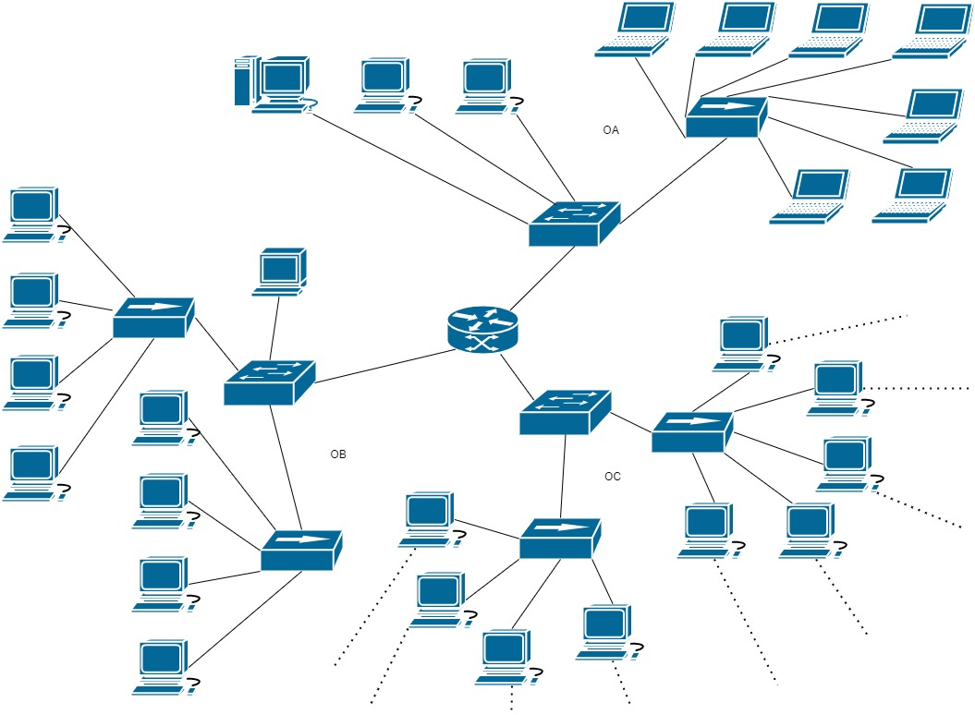

1. Network devices used in the network:

|  |  |
| --- | --- |
| **Type of device** | **Count** |
| Hub | 5 |
| Switch | 3 |
| Router | 1 |

1. Network configuration details:

|  |  |
| --- | --- |
| **Office-OA** | Identified Values |
| Network Address | 10.10.0.0 |
| Allocated subnet address and subnet mask | 10.10.0.0, 255.255.224.0 |
| Default gateway address | 10.10.1.0 |
| Valid host range | [10.10.1.0, 10.10.30.0] |
| Broadcast Address | 10.10.31.0 |

|  |  |
| --- | --- |
| **Office-OB** | Identified Values |
| Network Address | 195.168.1.0 |
| Allocated subnet address and subnet mask | 195.168.1.0, 255.255.255.0 |
| Default gateway address | 195.168.1.1 |
| Valid host range | [195.168.1.1, 195.168.1.254] |
| Broadcast Address | 195.168.1.255 |

|  |  |
| --- | --- |
| **Office-OC** | Identified Values |
| Network Address | 20.10.0.0 |
| Allocated subnet address and subnet mask | 20.10.0.0, 255.255.0.0 |
| Default gateway address | 20.10.1.0 |
| Valid host range | [20.10.0.1, 20.10.255.254] |
| Broadcast Address | 20.10.255.255 |

1. Network topology done in GNS3:

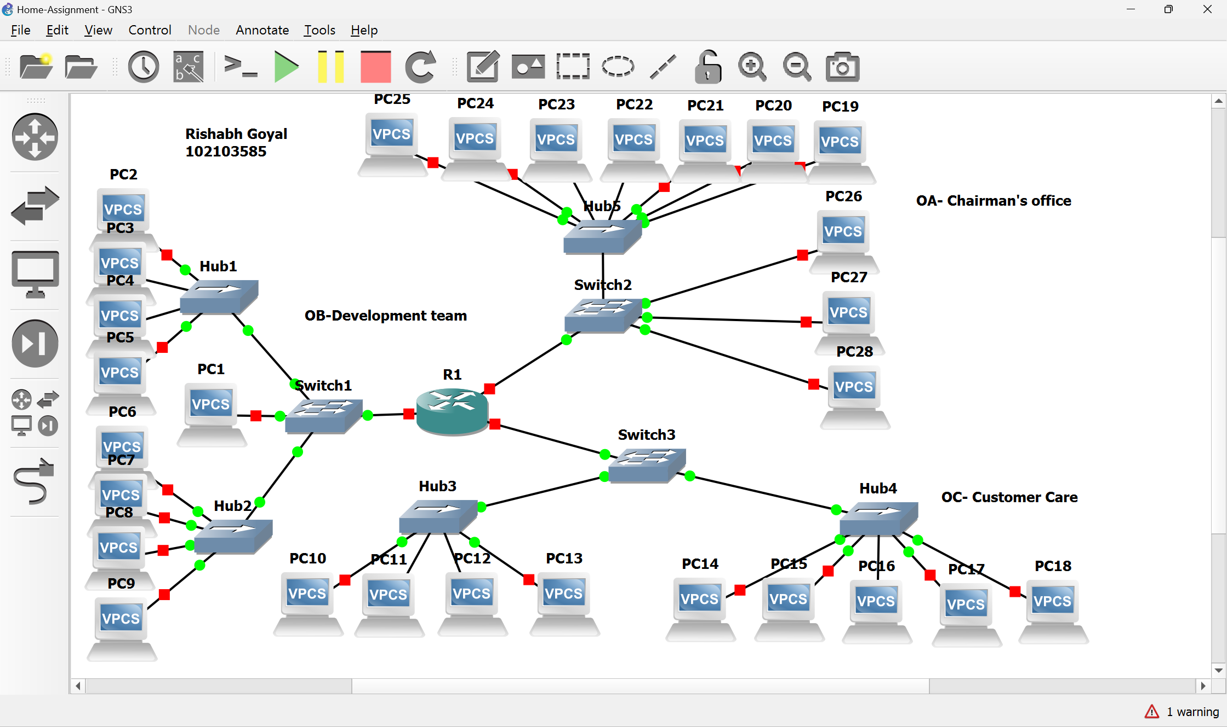

**Nimish Medatwal**

1. Configuration settings for hosts and router in simulation:

**Router configuration:**

Router port to office OA:

R1#config ter

R1(config)#interface fa2/0

R1(config-if)#ip address 10.10.0.1 255.255.224.0

R1(config-if)#no sh

Router port to office OB:

R1#config ter

R1(config)#interface fa0/0

R1(config-if)#ip address 195.168.1.1 255.255.255.0

R1(config-if)#no sh

Router port to office OC:

R1#config ter

R1(config)#interface fa2/0

R1(config-if)#ip address 20.10.1.0 255.255.0.0

R1(config-if)#no sh

**Configuration for terminal of the manager of the development team:**

PC1> ip 195.168.1.2/24 195.168.1.1

Checking for duplicate address...

PC1 : 195.168.1.2 255.255.255.0 gateway 195.168.1.1

PC1> ping 10.10.0.1

84 bytes from 10.10.0.1 icmp_seq=1 ttl=255 time=15.329 ms

84 bytes from 10.10.0.1 icmp_seq=2 ttl=255 time=15.350 ms

84 bytes from 10.10.0.1 icmp_seq=3 ttl=255 time=14.990 ms

84 bytes from 10.10.0.1 icmp_seq=4 ttl=255 time=15.960 ms

84 bytes from 10.10.0.1 icmp_seq=5 ttl=255 time=15.469 ms

**Configuration for terminal of the chairman, communicating with the development team manager:**

PC28> ip 10.10.0.2 10.10.0.1

Checking for duplicate address...

PC1 : 10.10.0.2 255.255.255.0 gateway 10.10.0.1

PC28> ping 195.168.1.2

195.168.1.2 icmp_seq=1 timeout

195.168.1.2 icmp_seq=2 timeout

84 bytes from 195.168.1.2 icmp_seq=3 ttl=63 time=30.310 ms

84 bytes from 195.168.1.2 icmp_seq=4 ttl=63 time=30.923 ms

84 bytes from 195.168.1.2 icmp_seq=5 ttl=63 time=30.472 ms

**Configuration for a customer care executive contacting the development team manager:**

PC13> ip 20.10.0.1/16 20.10.1.0

Checking for duplicate address...

PC1 : 20.10.0.1 255.255.0.0 gateway 20.10.1.0

PC13> ping 195.168.1.2

84 bytes from 195.168.1.2 icmp_seq=1 ttl=63 time=30.694 ms

84 bytes from 195.168.1.2 icmp_seq=2 ttl=63 time=30.598 ms

84 bytes from 195.168.1.2 icmp_seq=3 ttl=63 time=31.242 ms

195.168.1.2 icmp_seq=4 timeout

195.168.1.2 icmp_seq=5 timeout

1. Choosing a cloud service provider for virtualization and cloud-based storage involves considering various factors like reliability, security, scalability, pricing, and ease of use. IBM Cloud (Kyndryl), Amazon Web Services (AWS), and Google Cloud Platform (GCP) are all reliable and secure with strong scalability options. AWS is known for being cost-effective, while IBM Cloud (Kyndryl) is more expensive but prioritizes security and compliance. GCP and AWS are user-friendly, while IBM Cloud (Kyndryl) may require more training. Ultimately, the decision depends on the company's specific needs, including budget, security requirements, and ease of use.