**MC-pMBRT: multi-collimator proton minibeam radiotherapy with joint dose and PVDR optimization**

Weijie Zhang, Chao Wang, Xue Hong, Daniel Johnson, Gregory N Gan, Yuting Lin, and Hao Gao

Department of Radiation Oncology, University of Kansas Medical Center, USA

**Email:** [ylin4@kumc.edu](mailto:ylin4@kumc.edu)

**Abstract.**

**Purpose:** The clinical translation of proton minibeam radiation therapy (pMBRT) is non-trivial, for which the proper treatment planning technique remains an open question: on one hand, the uniform target dose is desirable for anti-tumor efficacy and the ease of clinical acceptance of pMBRT; on the other hand, high peak-to-valley dose ratio (PVDR) is desirable in organs-at-risk (OAR) for normal tissue sparing, which however can be challenging for these OAR distal to beam entrance or require patient-specific collimators. This work proposes a novel pMBRT treatment planning method that can achieve high PVDR at OAR and uniform dose at target simultaneously, via multi-collimator pMBRT (MC-pMBRT) treatment planning method with joint dose and PVDR optimization (JDPO).

**Methods:** MC-pMBRT utilizes a set of generic and premade multi-slit collimators with different center-to-center distances and does not need patient-specific collimators. The collimator selection per field is OAR-specific and tailed to maximize PVDR in OAR while preserving target dose uniformity. Then the inverse optimization method JDPO is utilized to jointly optimize target dose uniformity, PVDR, and other dose-volume-histogram based dose objectives, which is solved by iterative convex relaxation optimization algorithm and alternating direction method of multipliers.

**Results:** The need and efficacy of MC-pMBRT is demonstrated by comparing the single-collimator (SC) approach with the multi-collimator (MC) approach. While SC degraded either PVDR for OAR or dose uniformity for the target, MC provided a good balance of PVDR and target dose uniformity. The proposed JDPO method is validated in comparison with the dose-only optimization (DO) method for MC-pMBRT, in reference to the conventional (CONV) proton RT (no pMBRT). Compared to CONV, MC-pMBRT (DO and JDPO) preserved target dose uniformity and plan quality, while providing unique PVDR in OAR. Compared to DO, JDPO further improved PVDR via PVDR optimization during treatment planning.

**Conclusions:** A novel pMBRT treatment planning method called MC-pMBRT is proposed that utilizes a set of generic and premade collimators with joint dose and PVDR optimization algorithm to optimize OAR-specific PVDR and target dose uniformity simultaneously.

Key words: peak-to-valley dose ratio (PVDR), proton minibeam radiotherapy (pMBRT), spatially fractionated radiotherapy (SFRT), IMPT, treatment planning, inverse optimization

**1. Introduction**

Proton minibeam radiation therapy (pMBRT) [1,2] is a proton modality of spatially fractionated radiation therapy (SFRT) [3-5] with sub-millimeter beamlet width and very high therapeutic index compared to conventional radiation therapy (CONV). pMBRT currently utilizes a multi-slit collimator (MSC) of the sub-millimeter slits equally spaced a few millimeters (i.e., the center-to-center (ctc) distance) apart, for generating spatially modulated peak-valley dose (characterized by peak-valley dose ratio (PVDR)) in normal tissues, which then becomes the homogenous dose in tumor target due to multiple Coulomb scattering (MCS) [1,6-8].

Many preclinical studies have shown that pMBRT can substantially improve normal tissue sparing while maintain tumor control [9-17]. Although the exact radiobiological mechanism behind pMBRT is still unclear, it may involve the bystander effect [18], the cell migration [19], differential vascular effects [20] or/and the immunomodulation effects [21]. The therapeutic index of minibeam can be further enhanced when combined with particle therapy, which is likely due to immune activation [21,22]. The promising preclinical outcomes have generated great clinical interests for pMBRT [4].

Because the beam size of pMBRT is sub-millimeter and PVDR decreases with the irradiation depth due to MCS, a fundamental question to address for the clinical translation of pMBRT is whether sufficient PVDR still exists in depth where organs-at-risk (OAR) are located. This question has been partially addressed by pioneering pMBRT treatment planning studies in patients [7,23], in which the feasibility of pMBRT has been shown for relatively-shallow-situated brain tumors, with sufficient PVDR for OAR located 2-5 cm from the beam entrance, and preserved target dose uniformity, using a single MSC.

To fully address the aforementioned fundamental question for clinical pMBRT, this work will develop a new pMBRT treatment planning method to enable the uniform dose coverage of deep-situated tumor targets at the same time with sufficient PVDR at the desirable depths for OAR, e.g., 9-12 cm, which will be substantially deeper compared to existing methods [7,23]. Note that the ctc distance of MSC can be varied to tune PVDR for an OAR at a given depth to the target, which however can require one or a few patient-specific MSC to be manufactured and used for each patient. To get around this resource-demanding need for patient-specific MSC, a key innovation of our method is to plan instead with a set of generic and premade collimators, with the joint optimization of dose coverage and PVDR.

**2. Methods and Materials**

*2.1. Multi-collimator pMBRT (MC-pMBRT)*

We propose the multi-collimator (MC) approach for pMBRT treatment planning (Fig. 1). The collimators used this work have the slit size 0.4 mm and the ctc distance *Dctc* from 3 mm to 7 mm.

MC-pMBRT is motivated by the tradeoff between the achievable PVDR (e.g., quantified by the depth *dPVDR* at which sufficiently high PVDR can be obtained) in OAR and the desirable dose uniformity (e.g., quantified by the conformity index (CI)) in target. For a fixed slit size, the ctc distance can be varied to accommodate a needed *dPVDR* for certain OAR, which however also impacts CI, with a tradeoff: as *Dctc* increases, *dPVDR* increases, but CI decreases (Fig. 1(a)).

**Figure 1. Multi-collimator pMBRT.** (a) Tradeoff between the PVDR depth (*dPVDR*) in OAR and the conformity index (CI) for target. As *Dctc* increases, *dPVDR* increases, but CI decreases. (b) MC-pMBRT places a general-purpose collimator of varying Dctc for each field to achieve a desirable OAR-specific *dPVDR*, while optimizing target dose uniformity using multiple fields, for which planning dose objectives and PVDR objectives are jointly optimized during inverse optimization.

On the other hand, the patient-specific MSC is resource-demanding, e.g., in terms of manufacturing cost, patient-specific quality assurance and treatment planning setup. To address this practical issue, a key innovation of the proposed MC-pMBRT method is to utilize a set of generic and premade collimators for general-purpose pMBRT treatment planning (Fig. 1(b)), using a novel inverse optimization approach with the joint optimization of dose and PVDR: (1) the selection of MSC for each field is based on the distances from the beam entrance to the OAR of interest and the target respectively; (2) PVDR is maximized for each field at a desirable depth (corresponding to certain OAR) from the beam entrance; (3) the target dose coverage and the OAR dose sparing are optimized with respect to the total dose from all fields; (4) Both PVDR objectives and dose objectives are jointly optimized during the inverse optimization process of MC-pMBRT (Section 2.2).

*2.2. Joint dose and PVDR optimization (JDPO)*

In addition to MC-pMBRT, another innovation of this work is the joint dose and PVDR optimization (JDPO) during treatment planning. Note that JDPO was proposed to generate spatially modulated dose pattern of centimeter beamlet width [24], which however was not as well equally spaced as SFRT since JDPO was for general proton RT rather than for SFRT specifically. Here we develop a new JDPO approach for pMBRT that maximizes PVDR in terms of both amplitudes and frequencies for peak-valley dose pattern.

For the illustration purpose, let us first consider the conventional treatment planning method in which the dose-only objective (no PVDR objective) is optimized, i.e., dose-only optimization (DO). A general optimization formulation of DO is

.

In Eq. , *x* represents the proton spot weights to be optimized, *A* the dose influence matrix, *d* the 3D dose distribution, *G* the minimum-monitor-unit (MMU) threshold, and *f* the dose objective function. Here the dose objective consists of target/OAR-specfic planning objectives from dose-volume-histogram (DVH) based planning constraints [25,26]; the MMU constraint is enforced for plan deliverability, i.e., the weights of deliverable spots must be at least *G* [27].

Compared to DO Eq. (1) with the dose-only objective, JDPO also optimizes PVDR during treatment planning, i.e.,

.

The second objective term *g* in Eq. is to maximize the PVDR: *K* denotes the number of proton fields (i.e., beam angles) as the PVDR is characterized for each individual field and the PVDR objective is the sum from all fields with the weighting *wk* for the *k*th field; the PVDR regularization term *g(dk)* is with respect to *dk*, which consists of one or several beam-eye-view (BEV) dose planes at single or multiple depths from the *k*th beam angle; *Ik* is the linear interpolation operator that computes BEV dose planes *dk* from the 3D dose distribution *d*.

The PVDR regularization term *g(dk)* in this work is

.

In Eq. , ||·|| is the L1 norm, *wT* is the weight of the total variation (TV) term, and *T* is the linear TV operator, which is defined pointwise for a 2D dose plane indexed by *(i,j)* as

,

where the peak-valley dose modulation is along the direction of the index *i*.

*2.3. Solution algorithm*

For both DO and JDPO, the optimization of DVH-based dose objective can be solved by iterative convex relaxation (ICR) method [28-30] and the MMU constraint can be solved by post-processing [31-33] and MMU optimization method [27,34-37] (the latter is used in this work). The additional PVDR objective in JDPO can be solved by alternating direction method of multipliers (ADMM) [38,39], which has been used to solve various inverse optimization problems [40-44].

Here is a brief summary of the solution algorithm for solving JDPO Eq. . For the outer loop, the active voxel indices for dose penalization terms to be included in the dose objective are determined based on the satisfaction of target/OAR DVH constraints via ICR. For the inner loop, ADMM is used to handle the MMU constraint and L1-norm PVDR constraints, for which auxiliary variables are introduced to reformulate the MMU constraint and L1-norm PVDR objective to L2-norm objectives, which are convex and differentiable, with specific steps: (1) the spot weights are updated by solving a unconstrained least-square problem with convexized dose objective and L2-norm objectives from the MMU constraint and the PVDR objective via conjugate gradient method; (2) the MMU constraint is enforced by updating its auxiliary variable via the derived analytic formula (i.e., hard thresholding); (3) the PVDR objective is maximized by updating its auxiliary variable via the derived analytic formula (i.e., soft thresholding for L1 and TV respectively).

For the comparison purpose, DO is also solved through the same aforementioned solution algorithm for JDPO, which however does not have the steps related to the PVDR objective.

*2.4. Materials*

The need and efficacy of MC-pMBRT is demonstrated by comparing the single-collimator (SC) approach with the multi-collimator (MC) approach for pMBRT treatment planning (Section 3.1). A lung case (3 fields of 0º, 120º and 240º beam angles) is presented: (1) three SC plans are planned respectively using the collimator of 3mm, 5mm and 7mm ctc distance; (2) the MC plan is planned using the collimator of 3mm, 5mm and 7mm ctc distance respectively for the 0º, 120º and 240º field.

The proposed JDPO treatment planning method is validated in comparison with the DO treatment planning method for MC-pMBRT, in reference to the CONV proton plan (no pMBRT) (Section 3.2). Three clinical cases of conventional fractionation (2Gy per fraction) are presented, including abdomen, head-and-neck (HN), and lung. For MC-pMBRT, the ctc distance is (3 mm, 3mm,7 mm) respectively for (0º, 120º, 240º) in the abdomen case, and (3mm, 5mm, 5mm, 3mm) respectively for (45º, 135º, 225º, 315º) in the HN case; note that for the 120º field in the abdomen case, 1 cm range shifter is added for improving plan quality and PVDR and reducing the skin dose.

The PTV planning is considered in this work (without robust optimization). All plans are normalized to have D95=100% to PTV. To quantify the target dose coverage, the conformal index (CI) is defined as V1002/(V×Vʹ100) (V100: CTV volume receiving at least 100% of prescription dose; V: CTV volume; Vʹ100: total volume of receiving at least 100% of prescription dose; ideally CI=1). To quantify PVDR, we adopt the formula PVDR=D10/D80 [45], with *D10* and *D80* defined as the maximum dose that covers at least 10% and 80% of the entire volume respectively.

**3. Results**

*3.1. SC v.s. MC*

The quantitative comparisons between SC and MC are presented in Table 1 and the dose and DVH pots are presented in Fig. 2, which suggest that compared to SC, MC achieved a good balance of PVDR in depth and the uniformity of target dose (CI and max dose).

*3.1.1. PVDR*

The PVDR values in Table 1 show that PVDR of 12cm depth at 240° was small for 3mm and 5mm (1.7 and 2.0) compared with 7mm and MC (3.7 and 4.1); PVDR of 7cm depth at 120° was small for 3mm (2.0) compared with 5mm, 7mm and MC (3.3, 6.7 and 3.1); PVDR of 3cm depth at 0° was high for 3mm, 5mm, 7mm and MC (5.1, 10.8, 10.0 and 5.8). These comparisons suggest that MC improved PVDR from 3mm and 5mm, and had similar PVDR with 3mm at 0°, 5mm at 120° and 7mm at 240° respectively.

*3.1.2. Dose*

The dose parameters in Table 1 show that conformity index was small for 7mm (0.73) compared with 3mm, 5mm and MC (0.85, 0.8 and 0.83); MC had smaller max dose than 5mm and 7mm (from 124.1% to 129.1% and 141.6%) and better body mean dose than 3mm, 5mm and 7mm (from 4.1% to 4.6%, 4.8% and 5.1%).

**Table 1. SC v.s. MC.** The parameters include CI, max target dose Dmax, mean body dose Dbody, mean dose D and PVDR for BEV dose plane from (0º, 120º, 240º) respectively at the depth (3cm, 7cm, 12cm) from the beam entrance ((3cm, 5cm, 9cm) from the target). The dose quantities are in percentage of target prescription dose.

|  |  |  |  |  |
| --- | --- | --- | --- | --- |
|  | 3mm | 5mm | 7mm | MC |
| CI | 0.85 | 0.8 | 0.73 | 0.83 |
| Dmax | 119.8 | 129.1 | 141.6 | 124.1 |
| Dbody | 4.6 | 4.8 | 5.1 | 4.1 |
| D0° | 3.6 | 2.7 | 1.7 | 4.2 |
| PVDR3cm | 5.1 | 10.8 | 10.0 | 5.8 |
| D120° | 3.9 | 4.2 | 4.3 | 3.7 |
| PVDR7cm | 2.0 | 3.3 | 6.7 | 3.1 |
| D240° | 5.5 | 6.1 | 7.3 | 3.7 |
| PVDR12cm | 1.7 | 2.0 | 3.7 | 4.1 |

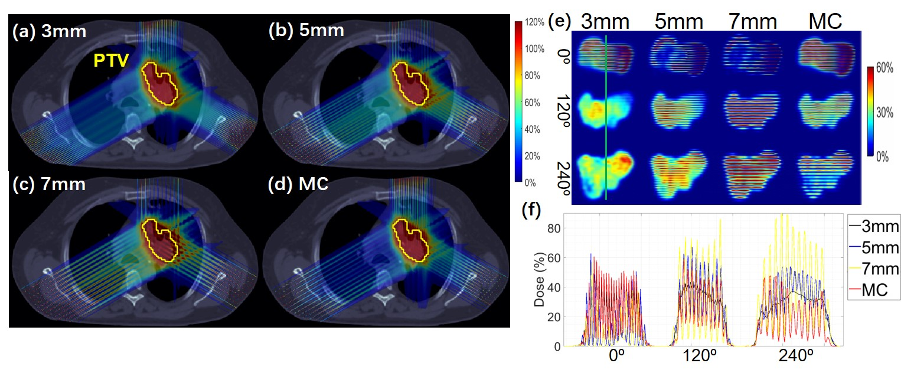

**Figure 2. SC v.s. MC.** (a)-(c): SC dose maps for 3, 5, 7mm ctc distance respectively; (d) MC dose map; (e): BEV 2D dose slices. (f): BEV 1D dose profiles. BEV dose slices are at 3cm depth from 0° beam and 7cm depth from 120° beam and 12cm depth from 240° beam.

*3.2. DO v.s. JDPO*

The quantitative comparisons between DO and JDPO in reference to CONV are presented in Table 2-4 and the dose and DVH pots are presented in Fig. 3-5.

*3.2.1. PVDR*

The comparison of PVDR values among CONV, DO and JDPO in Table 2-4 indicates DO greatly improved the PVDR from CONV and JDPO further improved the PVDR, i.e., an increase from CONV (1.7, 2.3, 1.8) to DO (3.7, 3.0, 2.8) and JDPO (3.9, 2.7, 3.1) for (0º, 120º, 240º) in abdomen, from CONV (2.1, 2.0, 1.8) to DO (5.5, 2.9, 3.5) and JDPO (5.8, 3.1, 4.1) for (0º, 120º, 240º) in lung, from CONV (4.0, 3.2, 3.1, 4.5) to DO (7.7, 6.5, 6.1, 8.3) and JDPO (7.7, 7.1, 6.3, 9.2) for (45º, 135º, 225º, 315º) in HN. The difference between peak and valley dose is also clear from the dose plots, i.e., DO (Figs. 3B, 4B, 5B) and JDPO (Figs. 3C, 4C, 5C) compared to CONV (Figs. 3A, 4A, 5A). Further comparisons in BEV plane dose plots (Figs. 3D, 4D, 5D) and 1D dose profile plots (Figs. 3E, 4E, 5E) also demonstrate improved PVDR from CONV to DO and JDPO.

*3.2.2. Dose*

The comparison of dose parameters for normal tissues (including body and OAR) in Table 2-4 indicates that DO had better or similar dose parameters compared with CONV and JDPO had better dose parameters compared with CONV and DO. For example, JDPO had slightly better body mean dose than DO and CONV for abdomen (from 4.1% to 4.4% and 4.5%) and lung (from 4.1% to 4.4% and 4.5%) and the same body mean dose for HN (from 0.8% to 0.8% and 0.8%). JDPO plan had better OAR mean dose than DO and CONV for large bowel (from 17.1% to 18.4% and 17.8%) and spinal cord (from 8.7% to 10.8% and 12.4%) in abdomen case, lung (from 8.3% to 9.0% and 9.3%) and esophagus (from 8.8% to 11.1% and 13.3%) in lung case, mandible (from 5.6% to 7.4% and 7.1%) and oral (from 4.6% to 5.7% and 5.4%) in HN case. On the other hand, DO had comparable OAR dose parameters with CONV. The DVH plots of different OARs (Figs. 3F, 3G, 4F, 4G, 5F, 5G) also demonstrate the advantages of DO and JDPO.

**Table 2. Abdomen.** The parameters include CI, max target dose Dmax, mean body dose Dbody, mean large bowel dose Dbowel, mean spinal cord dose Dcord, mean dose D and PVDR for BEV dose plane from (0º, 120º, 240º) respectively at the depth (4cm, 2cm, 9cm) from the beam entrance ((2cm, 2cm, 4cm) from the target). The dose quantities are in percentage of target prescription dose.

|  |  |  |  |
| --- | --- | --- | --- |
|  | CONV | DO | JDPO |
| CI | 0.93 | 0.9 | 0.9 |
| Dmax | 110.0 | 115.6 | 118.1 |
| Dbody | 4.5 | 4.4 | 4.1 |
| Dbowel | 17.8 | 18.4 | 17.1 |
| Dcord | 12.4 | 10.8 | 8.7 |
| D0° | 5.6 | 5.4 | 3.7 |
| PVDR4cm | 1.7 | 3.7 | 3.9 |
| D120° | 5.4 | 5.7 | 5.3 |
| PVDR2cm | 2.3 | 3.0 | 2.7 |
| D240° | 3.3 | 3.0 | 2.7 |
| PVDR9cm | 1.8 | 2.8 | 3.1 |

**Table 3. HN.** The parameters include CI, max target dose Dmax, mean body dose Dbody, mean mandible dose Dman, mean oral dose Doral, mean dose D and PVDR for BEV dose plane from (45º, 135º, 225º, 315º) respectively at the depth (2.5cm, 5cm, 5cm, 2.5cm) from the beam entrance ((2.5cm, 4cm, 4cm, 2.5cm) from the target). The dose quantities are in percentage of target prescription dose.

|  |  |  |  |
| --- | --- | --- | --- |
|  | CONV | DO | JDPO |
| CI | 0.77 | 0.7 | 0.68 |
| Dmax | 112.9 | 119.9 | 120.3 |
| Dbody | 0.8 | 0.8 | 0.8 |
| Dman | 7.1 | 7.4 | 5.6 |
| Doral | 5.4 | 5.7 | 4.6 |
| D45° | 1.3 | 1.2 | 1.1 |
| PVDR2.5cm | 4.0 | 7.7 | 7.7 |
| D135° | 0.9 | 0.9 | 1.0 |
| PVDR5cm | 3.2 | 6.5 | 7.1 |
| D225° | 0.9 | 1.0 | 1.0 |
| PVDR5cm | 3.1 | 6.1 | 6.3 |
| D315° | 1.2 | 1.1 | 1.0 |
| PVDR2.5cm | 4.5 | 8.3 | 9.2 |

**Table 4. Lung.** The parameters include CI, max target dose Dmax, mean body dose Dbody, mean lung dose Dlung, mean esophagus dose Deso, mean dose D and PVDR for BEV dose plane from (0º, 120º, 240º) respectively at the depth (3cm, 7cm, 12cm) from the beam entrance ((3cm, 5cm, 9cm) from the target). The dose quantities are in percentage of target prescription dose.

|  |  |  |  |
| --- | --- | --- | --- |
|  | CONV | DO | JDPO |
| CI | 0.87 | 0.85 | 0.83 |
| Dmax | 116.2 | 120.5 | 124.1 |
| Dbody | 4.5 | 4.4 | 4.1 |
| Dlung | 9.3 | 9.0 | 8.3 |
| Deso | 13.3 | 11.1 | 8.8 |
| D0° | 3.9 | 3.5 | 4.2 |
| PVDR3cm | 2.1 | 5.5 | 5.8 |
| D120° | 3.9 | 4.5 | 3.7 |
| PVDR7cm | 2.0 | 2.9 | 3.1 |
| D240° | 5.3 | 4.5 | 3.7 |
| PVDR12cm | 1.8 | 3.5 | 4.1 |

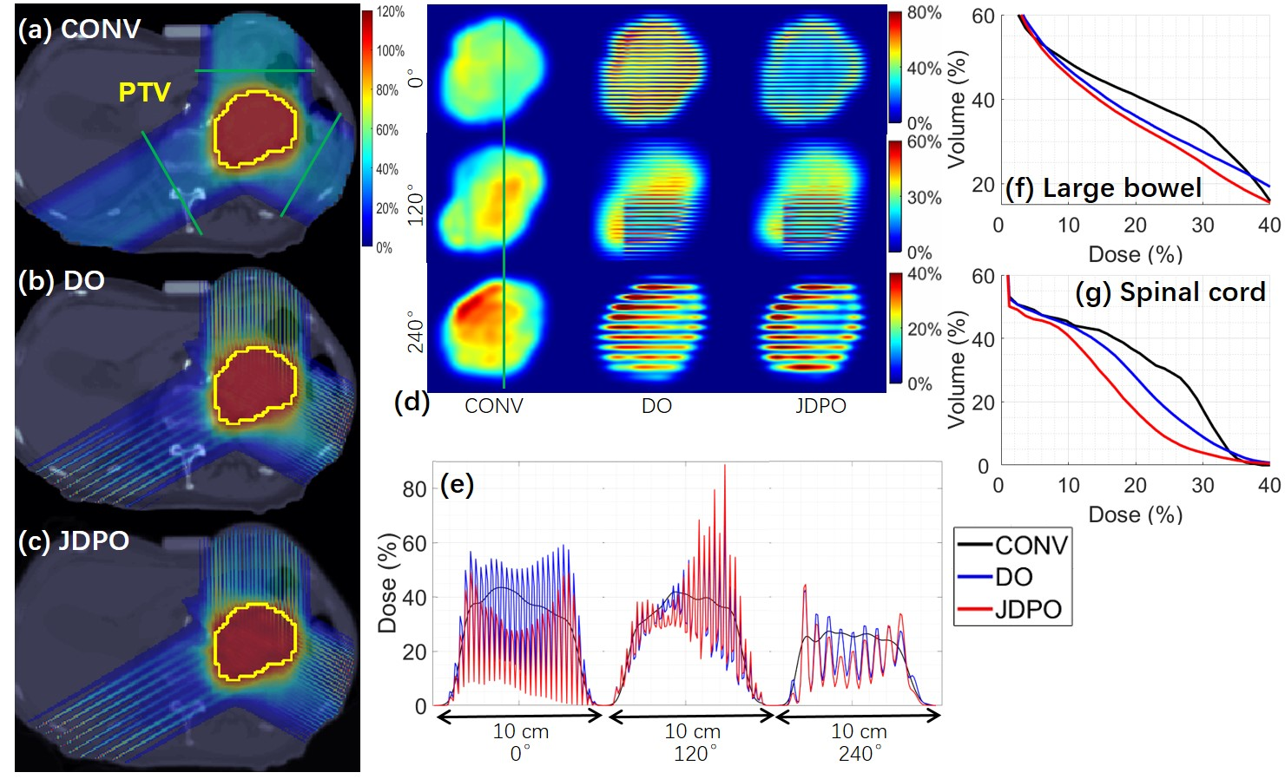

**Figure 3. Abdomen.** (a) CONV dose plot (b) DO dose plot; (c) JDPO dose plot; (d) plots of BEV dose slices at 4 cm depth from 0° beam, 2 cm depth from 120° beam, and 9 cm depth from 240° beam respectively (i.e., corresponding to green lines in (a)); (e) plots of BEV dose profiles (i.e., corresponding to green lines in (d)); (f) DVH for large bowel; (g) DVH for spinal cord.

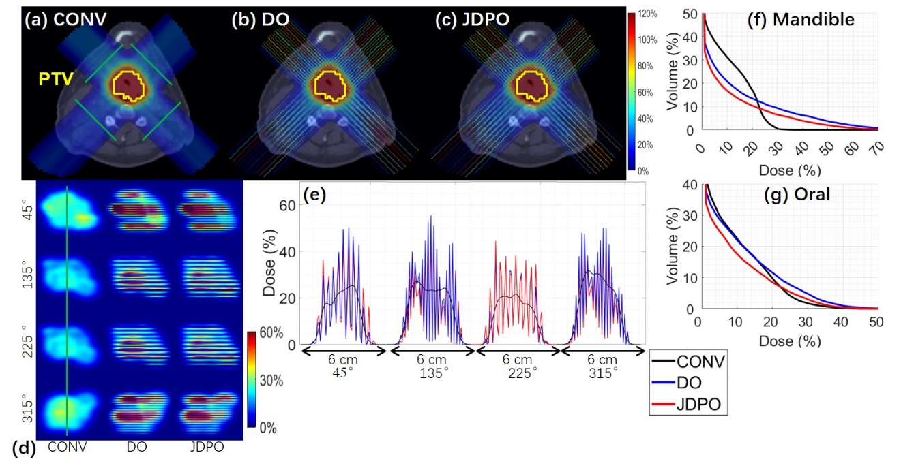

**Figure 4. HN.** (a) CONV dose plot (b) DO dose plot; (c) JDPO dose plot; (d) plots of BEV dose slices at 2.5 cm depth from 45° beam, 5 cm depth from 135° beam, 5 cm depth from 225° beam, and 2.5 cm depth from 315° beam respectively (i.e., corresponding to green lines in (a)); (e) plots of BEV dose profiles (i.e., corresponding to green lines in (d)); (f) DVH for mandible; (g) DVH for oral.

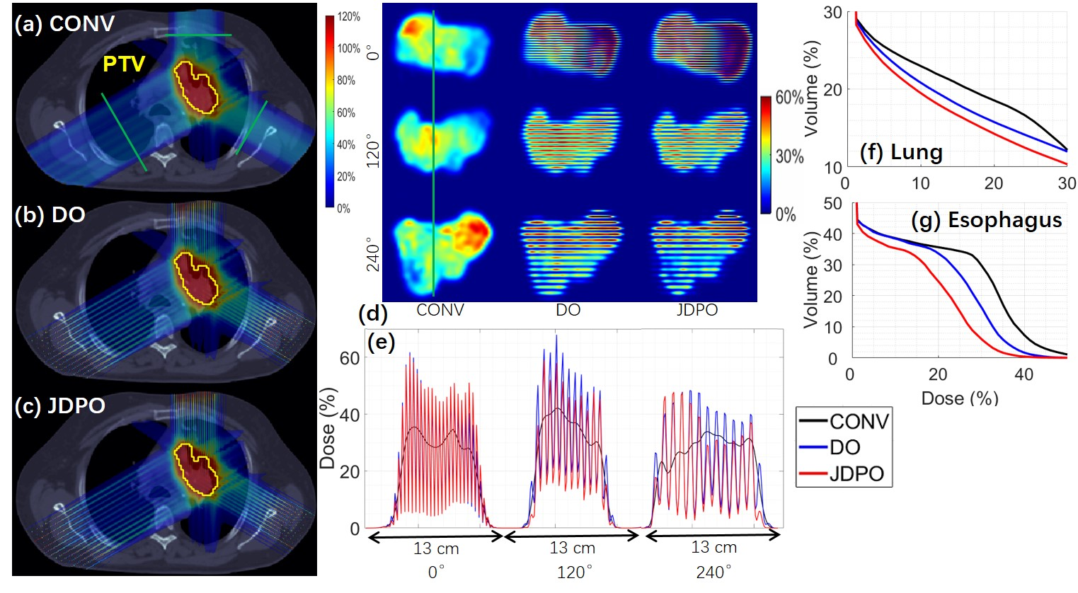

**Figure 5. Lung.** (a) CONV dose plot (b) DO dose plot; (c) JDPO dose plot; (d) plots of BEV dose slices at 3 cm depth from 0° beam, 7 cm depth from 120° beam, and 12 cm depth from 240° beam respectively (i.e., corresponding to green lines in (a)); (e) plots of BEV dose profiles (i.e., corresponding to green lines in (d)); (f) DVH for lung; (g) DVH for esophagus.

**4. Discussion**

MC-pMBRT in this work is with respect to the use of MSC of different ctc distances with a constat slit size. The selection of MSC is manual and empirical in this work: (1) Step 1: for each individual field, the optimal ctc distance is determined via the heuristic planning with each of all available ctc distances, which should have a balanced PVDR in OAR and target dose uniformity; (2) Step 2: the MC with pre-determined optimal ctc distances from Step 1, which can be different from field to field, are combined together for MC-pMBRT treatment planning. Empirically, we found that for 0.4mm slit size, a general rule of thumb is to set the ctc distance to 3mm for the shallow target (e.g., at 3 cm depth from the beam entrance), 7 mm for the deep target (e.g., at 9 cm depth from the beam entrance), and 5 mm otherwise.

However, neither this rule of thumb nor the aforementioned manual selection process is entirely optimal, because the optimal choice of a combination of MSC is not necessarily the combination of the optimal MSC for each field and is subject to the planning dose and PVDR objectives that are patient-specific and planning-specific. In the future work, we will improve the optimality and efficiency for MC-pMBRT by considering the automatic selection of MSC via optimization algorithms, for which mixed-integer programming [46], group-sparsity regularization [47], or orthogonal matching pursuit method [48] may be used.

During JDPO, the selection of BEV dose planes on which PVDR is optimized can impact the plan quality. The dose planes should not be too close to the target, as the target dose uniformity can be sacrificed (e.g., for large *wk*) or PVDR regularization has minimal effect (e.g., for small *wk*). For MC-pMBRT, it is recommended to select the BEV dose planes from different fields, with the similar ratio between the plane-to-beam-entrance distance and the plan-to-target distance, for the best utility of JDPO in terms of dose and PVDR quality. On the other hand, one should place the dose planes for PVDR optimization at/near the OAR of interest for the sparing purpose, e.g., spinal cord in the abdomen case, mandible in the HN case, and lung in the lung case as presented. Last but not the least, it is a tradeoff between dose optimization and PVDR optimization in terms of multi-criteria treatment planning during JDPO. An appropriate model of pMBRT-specific dose modifying factor will need to be developed to quantify the net change given the tradeoff, by combining PVDR and physical dose into one quantity, i.e., pMBRT effective dose, for which the development of biological models for FLASH [49,50] may be inspirational.

To validate pMBRT treatment planning in reference to CONV, only the conventional fractionation is considered in this work. However, the developed MC-pMBRT treatment planning methodology should be generally applicable to other scenarios such as hyper-fractionation, SBRT or SRS. On the other hand, we have only considered pMBRT of submillimeter slit size, which has demonstrated biological efficacy in preclinical studies [4]. However, the proposed MC-pMBRT method can be extended for general SFRT with millimeter or higher slit size [51,52].

The beam angles are empirically selected based on the rule of thumbs from clinical experiences. However, beam angle optimization [53-55] may be considered to further maximize the room for improving dose and PVDR at the same time.

In terms of OAR sparing, since pMBRT delivers uniform dose to the tumor target, the OAR surrounding the target is unlikely to have meaningful PVDR due to MCS and thus little additional biological sparing benefit from pMBRT. On the other hand, FLASH is exactly the opposite in the sense that the ultra-high dose rate often only occurs near the target and thus brings additional biological sparing benefit [56-58]. Therefore, pMBRT and FLASH can be perfectly complementary: (1) the use of pMBRT to further spare OAR that are not close to the target; (2) the use of FLASH to further spare OAR that are close to the target, for which the combined pMBRT and FLASH will be an interesting future direction to explore.

**5. Conclusion**

A novel pMBRT treatment planning method called MC-pMBRT is proposed that utilizes a set of generic and premade collimators with joint dose and PVDR optimization algorithm to optimize OAR-specific PVDR and target dose uniformity simultaneously.

**Acknowledgment**

The authors are very thankful to the valuable comments from reviewers. This research is partially supported by the NIH grants No. R37CA250921, R01CA261964, and a KUCC physicist-scientist recruiting grant.

**References**

[1] Prezado Y, Fois GR. Proton‐minibeam radiation therapy: a proof of concept. *Medical physics* 2013;40:031712.

[2] Zlobinskaya O, Girst S, Greubel C, et al. Reduced side effects by proton microchannel radiotherapy: study in a human skin model. *Radiation and environmental biophysics* 2013;52:123-133.

[3] Billena C, Khan AJ. A current review of spatial fractionation: Back to the future? *International Journal of Radiation Oncology* Biology* Physics* 2019;104:177-187.

[4] Prezado Y. Divide and conquer: spatially fractionated radiation therapy. *Expert reviews in molecular medicine* 2022;24:e3.

[5] Yan W, Khan MK, Wu X, et al. Spatially fractionated radiation therapy: History, present and the future. *Clinical and translational radiation oncology* 2020;20:30-38.

[6] Peucelle C, Nauraye C, Patriarca A, et al. Proton minibeam radiation therapy: Experimental dosimetry evaluation. *Medical physics* 2015;42:7108-7113.

[7] Ortiz R, Belshi R, De Marzi L, Prezado Y. Proton minibeam radiation therapy for treating metastases: A treatment plan study. *Medical Physics* 2023;50:2463-2473.

[8] De Marzi L, Nauraye C, Lansonneur P, et al. Spatial fractionation of the dose in proton therapy: Proton minibeam radiation therapy. *Cancer/Radiothérapie* 2019;23:677-681.

[9] Prezado Y, Jouvion G, Hardy D, et al. Proton minibeam radiation therapy spares normal rat brain: Long-Term Clinical, Radiological and Histopathological Analysis. *Scientific reports* 2017;7:14403.

[10] Lamirault C, Doyère V, Juchaux M, et al. Short and long-term evaluation of the impact of proton minibeam radiation therapy on motor, emotional and cognitive functions. *Scientific reports* 2020;10:13511.

[11] Girst S, Greubel C, Reindl J, et al. Proton minibeam radiation therapy reduces side effects in an in vivo mouse ear model. *International Journal of Radiation Oncology* Biology* Physics* 2016;95:234-241.

[12] Prezado Y, Jouvion G, Patriarca A, et al. Proton minibeam radiation therapy widens the therapeutic index for high-grade gliomas. *Scientific reports* 2018;8:16479.

[13] Prezado Y, Jouvion G, Guardiola C, et al. Tumor control in RG2 glioma-bearing rats: a comparison between proton minibeam therapy and standard proton therapy. *International Journal of Radiation Oncology* Biology* Physics* 2019;104:266-271.

[14] Sammer M, Dombrowsky AC, Schauer J, et al. Normal tissue response of combined temporal and spatial fractionation in proton minibeam radiation therapy. *International Journal of Radiation Oncology* Biology* Physics* 2021;109:76-83.

[15] Eley JG, Chadha AS, Quini C, et al. Pilot study of neurologic toxicity in mice after proton minibeam therapy. *Scientific reports* 2020;10:11368.

[16] Lamirault C, Brisebard E, Patriarca A, et al. Spatially modulated proton minibeams results in the same increase of lifespan as a uniform target dose coverage in F98-glioma-bearing rats. *Radiation Research* 2020;194:715-723.

[17] Sammer M, Zahnbrecher E, Dobiasch S, et al. Proton pencil minibeam irradiation of an in-vivo mouse ear model spares healthy tissue dependent on beam size. *PloS one* 2019;14:e0224873.

[18] Dilmanian FA, Qu Y, Feinendegen LE, et al. Tissue-sparing effect of x-ray microplanar beams particularly in the CNS: is a bystander effect involved? *Experimental hematology* 2007;35:69-77.

[19] Dilmanian FA, Button TM, Le Duc G, et al. Response of rat intracranial 9L gliosarcoma to microbeam radiation therapy. *Neuro-oncology* 2002;4:26-38.

[20] Bouchet A, Serduc R, Laissue JA, Djonov V. Effects of microbeam radiation therapy on normal and tumoral blood vessels. *Physica Medica* 2015;31:634-641.

[21] Potez M, Fernandez-Palomo C, Bouchet A, et al. Synchrotron microbeam radiation therapy as a new approach for the treatment of radioresistant melanoma: potential underlying mechanisms. *International Journal of Radiation Oncology* Biology* Physics* 2019;105:1126-1136.

[22] Tinganelli W, Durante M. Carbon ion radiobiology. *Cancers* 2020;12:3022.

[23] Lansonneur P, Mammar H, Nauraye C, et al. First proton minibeam radiation therapy treatment plan evaluation. *Scientific reports* 2020;10:7025.

[24] Zhang W, Li W, Lin Y, et al. TVL1-IMPT: optimization of peak-to-valley dose ratio via joint total-variation and LInternational Journal of Radiation Oncology* Biology* Physics1 dose regularization for spatially fractionated pencil-beam-scanning proton therapy. *International Journal of Radiation Oncology* Biology* Physics* 2023;115:768-778.

[25] Bortfeld T. Clinically relevant intensity modulation opitimization using physical criteria. XII International Conference on the Use of Computers in Radiation Therapy, 1997. Medical Physics Publishing. 1997.

[26] Wu Q, Mohan R. Algorithms and functionality of an intensity modulated radiotherapy optimization system. *Medical physics* 2000;27:701-711.

[27] Gao H, Clasie B, McDonald M, et al. Plan-delivery-time constrained inverse optimization method with minimum-MU-per-energy-layer (MMPEL) for efficient pencil beam scanning proton therapy. *Medical Physics* 2020;47:3892-3897.

[28] Gao H. Hybrid proton-photon inverse optimization with uniformity-regularized proton and photon target dose. *Physics in Medicine & Biology* 2019;64:105003.

[29] Li W, Lin Y, Li H, et al. An iterative convex relaxation method for proton LET optimization. *Physics in Medicine & Biology* 2023;68:055002.

[30] Li W, Zhang W, Lin Y, et al. Fraction optimization for hybrid proton-photon treatment planning. *Medical physics* 2023.

[31] Zhu X, Sahoo N, Zhang X, et al. Intensity modulated proton therapy treatment planning using single-field optimization: the impact of monitor unit constraints on plan quality. *Medical physics* 2010;37:1210-1219.

[32] Lin Y, Kooy H, Craft D, et al. A Greedy reassignment algorithm for the PBS minimum monitor unit constraint. *Physics in Medicine & Biology* 2016;61:4665.

[33] Gao H, Clasie B, Liu T, Lin Y. Minimum MU optimization (MMO): an inverse optimization approach for the PBS minimum MU constraint. *Physics in Medicine & Biology* 2019;64:125022.

[34] Albertini F, Gaignat S, Bosshardt M, Lomax AJ. Planning and optimizing treatment plans for actively scanned proton therapy. *Biomedical Mathematics: Promising Directions in Imaging, Therapy Planning, and Inverse Problems (ed 1) Madison: Medical Physics Pub Corp* 2009:1-18.

[35] Cao W, Lim G, Li X, et al. Incorporating deliverable monitor unit constraints into spot intensity optimization in intensity-modulated proton therapy treatment planning. *Physics in Medicine & Biology* 2013;58:5113.

[36] Shan J, An Y, Bues M, et al. Robust optimization in IMPT using quadratic objective functions to account for the minimum MU constraint. *Medical physics* 2018;45:460-469.

[37] Cai J-F, Chen RC, Fan J, Gao H. Minimum-monitor-unit optimization via a stochastic coordinate descent method. *Physics in Medicine & Biology* 2022;67:015009.

[38] Boyd S, Parikh N, Chu E, et al. Distributed optimization and statistical learning via the alternating direction method of multipliers. *Foundations and Trends® in Machine learning* 2011;3:1-122.

[39] Goldstein T, Osher S. The split Bregman method for L1-regularized problems. *SIAM journal on imaging sciences* 2009;2:323-343.

[40] Gao H. Robust fluence map optimization via alternating direction method of multipliers with empirical parameter optimization. *Physics in Medicine & Biology* 2016;61:2838.

[41] Lin B, Fu S, Lin Y, et al. An adaptive spot placement method on Cartesian grid for pencil beam scanning proton therapy. *Physics in Medicine & Biology* 2021;66:235012.

[42] Zhang G, Shen H, Lin Y, et al. Energy layer optimization via energy matrix regularization for proton spot-scanning arc therapy. *Medical Physics* 2022;49:5752-5762.

[43] Zhang W, Lin Y, Wang F, et al. Lattice position optimization for LATTICE therapy. *Medical Physics* 2023.

[44] Zhang G, Long Y, Lin Y, et al. A treatment plan optimization method with direct minimization of number of energy jumps for proton arc therapy. *Physics in Medicine & Biology* 2023;68:085001.

[45] Zhang H, Wu X, Zhang X, et al. Photon GRID radiation therapy: A physics and dosimetry white paper from the radiosurgery society (RSS) GRID/LATTICE, microbeam and FLASH radiotherapy working group. *Radiation research* 2020;194:665-677.

[46] Wolsey LA. Integer programming: John Wiley & Sons; 2020.

[47] Lin Y, Clasie B, Liu T, et al. Minimum-MU and sparse-energy-layer (MMSEL) constrained inverse optimization method for efficiently deliverable PBS plans. *Physics in Medicine & Biology* 2019;64:205001.

[48] Zhu YN, Zhang X, Lin Y, et al. An orthogonal matching pursuit optimization method for solving minimum-monitor-unit problems: Applications to proton IMPT, ARC and FLASH. *Medical Physics* 2023;50:4710-4720.

[49] Esplen N, Mendonca MS, Bazalova-Carter M. Physics and biology of ultrahigh dose-rate (FLASH) radiotherapy: a topical review. *Physics in Medicine & Biology* 2020;65:23TR03.

[50] Friedl AA, Prise KM, Butterworth KT, et al. Radiobiology of the FLASH effect. *Medical Physics* 2022;49:1993-2013.

[51] Charyyev S, Artz M, Szalkowski G, et al. Optimization of hexagonal-pattern minibeams for spatially fractionated radiotherapy using proton beam scanning. *Medical physics* 2020;47:3485-3495.

[52] Kim M, Hwang U-J, Park K, et al. Dose Profile Modulation of Proton Minibeam for Clinical Application. *Cancers* 2022;14:2888.

[53] Cao W, Lim GJ, Lee A, et al. Uncertainty incorporated beam angle optimization for IMPT treatment planning. *Medical physics* 2012;39:5248-5256.

[54] Gu W, O'Connor D, Nguyen D, et al. Integrated beam orientation and scanning-spot optimization in intensity-modulated proton therapy for brain and unilateral head and neck tumors. *Medical physics* 2018;45:1338-1350.

[55] Shen H, Zhang G, Lin Y, et al. Beam angle optimization for proton therapy via group-sparsity based angle generation method. *Medical Physics* 2023;50:3258-3273.

[56] Gao H, Lin B, Lin Y, et al. Simultaneous dose and dose rate optimization (SDDRO) for FLASH proton therapy. *Medical Physics* 2020;47:6388-6395.

[57] Lin Y, Lin B, Fu S, et al. SDDRO-Joint: simultaneous dose and dose rate optimization with the joint use of transmission beams and Bragg peaks for FLASH proton therapy. *Physics in Medicine & Biology* 2021;66:125011.

[58] Gao H, Liu J, Lin Y, et al. Simultaneous dose and dose rate optimization (SDDRO) of the FLASH effect for pencil-beam-scanning proton therapy. *Medical Physics* 2022;49:2014-2025.