Predicting Billboard Hits from Spotify Audio Features
Logistic Regression vs. Machine Learning Classifiers
DA 3014: Statistics Laboratory III, Assignment 3
Index Number: 24adaXXX
October 2026

Contents
1. Introduction 3
Part A: Dataset 3
A.1 Source and background 3
A.2 Response and covariates 3
Part B: Exploratory Data Analysis 4
B.1 Data cleaning and preprocessing 4
B.2 Distributions of all variables 4
B.3 Relationships between covariates and the response 6
B.4 Outliers, influential observations and unusual patterns 8
B.5 Variables expected to be most important 9
B.6 Train/test split 9
Part C: Logistic Regression 10
C.1 Full model 10
C.2 Three most significant predictors 10
C.3 Reduced model by feature selection 11
C.4 Adequacy and predictive performance of the final model 11
C.5 Influence diagnostics and sensitivity 13
Part D: Machine Learning Models 14
D.1 How the methods work (a) 14
D.2 Additional preprocessing (b) 14
D.3 Model tuning (c) 14
D.4 Predictive performance on the test data (d) 14
D.5 Evidence of overfitting (e) 15
D.6 Most important predictors (f) 16
Part E: Discussion 17
E.1 Do the ML models provide an advantage over logistic regression? 17
E.2 Which model would be recommended for deployment? 17
E.3 Were the EDA expectations supported? 18
E.4 Does the Random Forest identify the same important predictors as logistic regression? 19
E.5 Can the best model be improved by changing the classification threshold? 19
Conclusion 21
References 21

1. Introduction
This report compares a binary logistic regression model with two machine-learning classifiers (Random Forest and Gradient Boosting) for predicting whether a song becomes a Billboard Hot 100 hit, using Spotify audio features. The models are compared on predictive performance, the predictors they find important, and interpretability. All analyses were done in Python (pandas, statsmodels, scikit-learn). Every number, table and figure can be reproduced by running 24adaXXX_Code.ipynb top to bottom on 24adaXXX_Data.csv (fixed seed 42).

Part A: Dataset

A.1 Source and background
Dataset: The Spotify Hit Predictor Dataset (1960–2019), published on Kaggle by user theoverman (https://www.kaggle.com/datasets/theoverman/the-spotify-hit-predictor-dataset). It is a real-world secondary dataset. Track features were collected through the official Spotify Web API (via the spotipy library), and hit status comes from the Billboard Hot 100 weekly charts (via billboard.py).
The dataset was created to study whether a song's audio characteristics can predict commercial success. It has six files, one per decade (1960s–2010s). We combined them and added a decade covariate (0 = 2000s, 10 = 2010s, 60–90 = 1960s–1990s).

A.2 Response and covariates
- Response, `target` (binary): 1 = hit, meaning the track appeared in the Billboard Hot 100 at least once in that decade. 0 = flop: the track and its artist never charted in that decade, the track belongs to a non-mainstream / avant-garde genre with no charting songs, and it is available in the US market (author's criteria).
- Size: 41,106 rows. After removing 546 duplicate tracks, 40,560 remain (20,019 hits, 49.4%; 20,541 flops, 50.6%). This meets the 1,000–500,000 range.
- Covariates: 16 in total. 12 numerical and 4 categorical, a balanced mix that suits both logistic regression and tree models. The identifiers track, artist and uri are used only for de-duplication and then dropped.
Table 1. Variables used in the analysis.
Variable | Type | Description
danceability | Numeric (0–1) | Suitability for dancing (tempo, rhythm stability, beat strength)
energy | Numeric (0–1) | Perceived intensity and activity
loudness | Numeric (dB) | Average loudness of the track
speechiness | Numeric (0–1) | Presence of spoken words
acousticness | Numeric (0–1) | Confidence that the track is acoustic
instrumentalness | Numeric (0–1) | Likelihood that the track has no vocals
liveness | Numeric (0–1) | Probability that the track was recorded live
valence | Numeric (0–1) | Musical positiveness (happy vs. sad)
tempo | Numeric (BPM) | Estimated tempo
duration_ms | Numeric (ms) | Track length
chorus_hit | Numeric (s) | Estimated start time of the chorus
sections | Numeric (count) | Number of sections in the track
key | Nominal (12 levels) | Pitch class (0 = C, 1 = C♯, …, 11 = B)
mode | Binary | 1 = major, 0 = minor
time_signature | Nominal (5 levels) | Estimated beats per bar (0, 1, 3, 4, 5)
decade | Nominal (6 levels) | Decade of the source file
target | Binary (response) | 1 = hit, 0 = flop

Part B: Exploratory Data Analysis

B.1 Data cleaning and preprocessing
- Duplicates: 546 rows shared a Spotify uri with another row (the same track listed in two decade files). The first occurrence was kept, so no song can appear in both the training and test sets. 26 of the duplicated tracks had conflicting labels.
- Missing values: none in any column.
- Special values: 1 track has tempo = 0 and 3 have time_signature = 0 (Spotify's "could not be estimated" code). They are valid and were kept. A sensitivity analysis (C.5) shows that removing them changes nothing.
- Encoding: key, time_signature and decade were one-hot encoded with the first level as reference. mode is already 0/1.
- Scaling: numerical covariates were standardised (fitted on the training set only) for the logistic regression, so odds ratios are per 1 SD. Tree models use the unscaled data.

B.2 Distributions of all variables
Table 2. Numerical summaries of the 12 numerical covariates (n = 40,560).
Variable | Mean | SD | Median | Min | Max | Skew | % zero
danceability | 0.539 | 0.178 | 0.551 | 0.000 | 0.988 | −0.25 | 0.0
energy | 0.579 | 0.253 | 0.600 | 0.000 | 1.000 | −0.32 | 0.0
loudness (dB) | −10.25 | 5.33 | −9.28 | −49.25 | 3.74 | −1.41 | 0.0
speechiness | 0.073 | 0.086 | 0.044 | 0.000 | 0.960 | 4.59 | 0.0
acousticness | 0.366 | 0.340 | 0.261 | 0.000 | 0.996 | 0.48 | 0.0
instrumentalness | 0.156 | 0.305 | 0.0001 | 0.000 | 1.000 | 1.73 | 28.3
liveness | 0.202 | 0.173 | 0.132 | 0.013 | 0.999 | 2.12 | 0.0
valence | 0.542 | 0.268 | 0.557 | 0.000 | 0.996 | −0.18 | 0.0
tempo (BPM) | 119.3 | 29.1 | 117.5 | 0.0 | 241.4 | 0.48 | 0.0
duration (min) | 3.91 | 1.99 | 3.63 | 0.25 | 69.5 | 6.81 | 0.0
chorus_hit (s) | 40.1 | 19.0 | 35.9 | 0.0 | 433.2 | 2.22 | 0.4
sections | 10.5 | 4.9 | 10 | 0 | 169 | 6.05 | 0.0

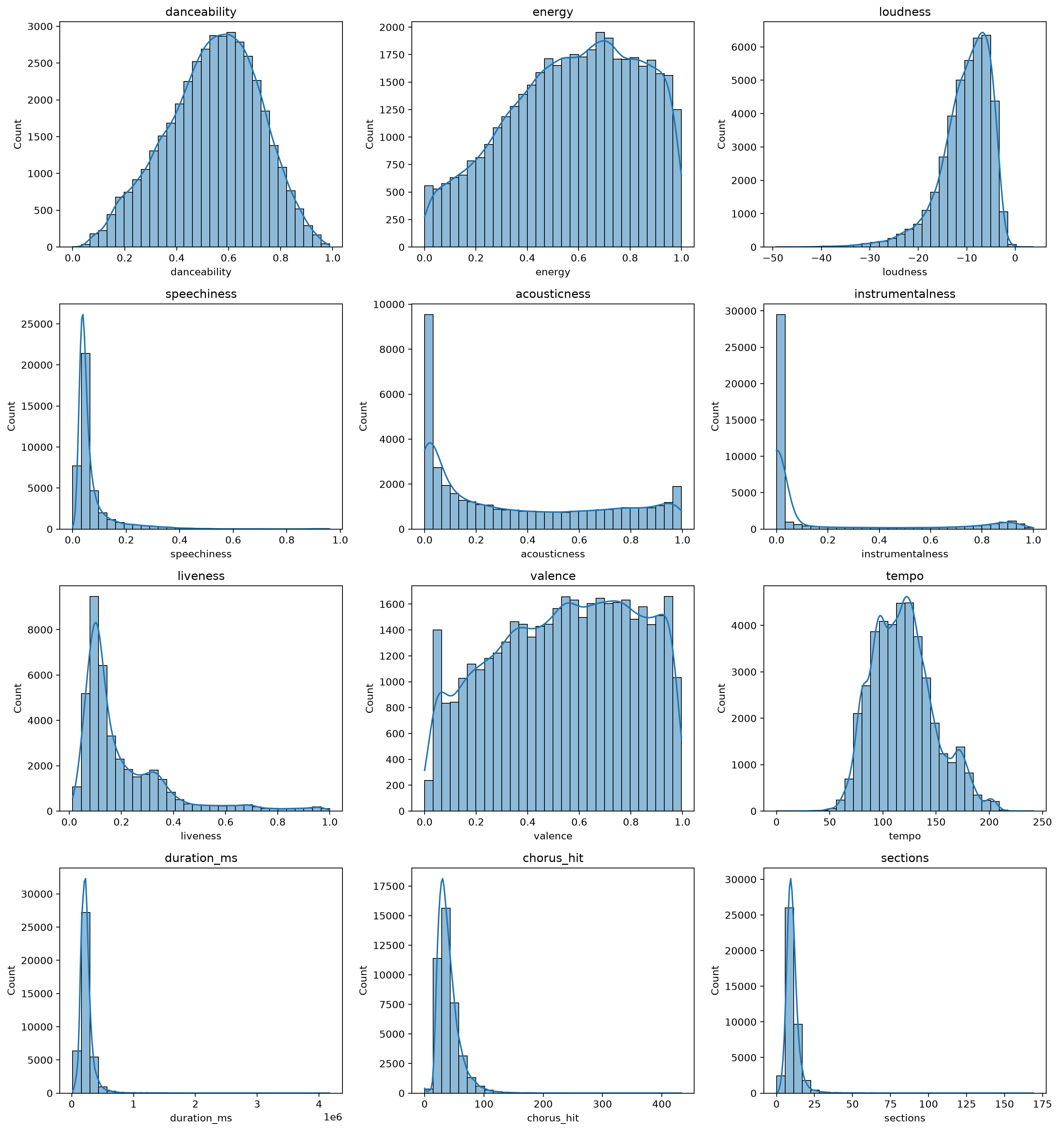
Figure 1. Histograms with kernel density of the numerical covariates.
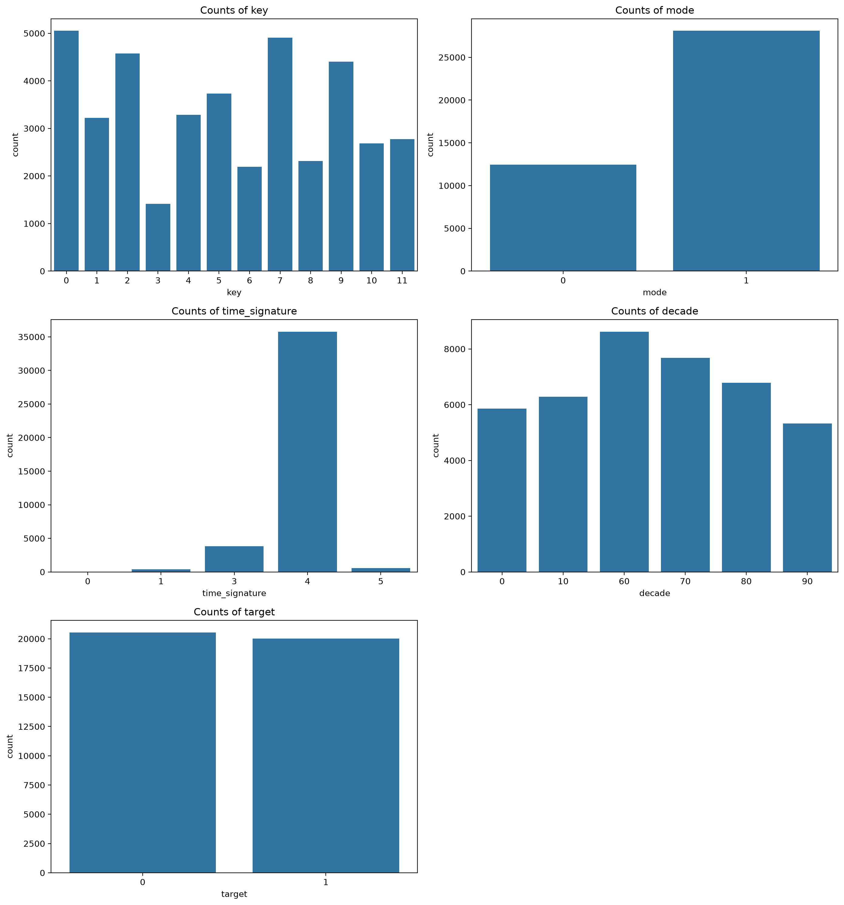
Figure 2. Frequencies of the categorical covariates and the response.
Findings. danceability, energy, valence and tempo are roughly symmetric. speechiness (skew 4.6), duration (6.8), sections (6.1), chorus_hit and liveness are strongly right-skewed, and loudness is left-skewed (−1.4). instrumentalness is zero-inflated: exactly 0 for 28% of tracks and below 0.001 for 59%. For the categorical variables, 69% of tracks are in a major key, 4/4 time dominates (35,784 tracks vs. 3,816 in 3/4, 588 in 5/4, 369 in 1/4 and 3 with value 0), and the decades are fairly even (5,330–8,622 tracks). The response is balanced (49.4% hits), so accuracy is a meaningful metric and no resampling is needed.

B.3 Relationships between covariates and the response
Numerical covariates were compared between hits and flops with the Mann-Whitney U test (no normality assumption, which suits the skewed variables), with the rank-biserial correlation r as effect size. Categorical covariates were tested with the χ² test of independence, with Cramér's V as effect size. With n ≈ 40,000 almost every p-value is tiny, so effect sizes are used to judge practical importance.
Table 3. Association of each covariate with the response, ordered by effect size.
Covariate | Test | p-value | Effect size | Magnitude | Direction for hits
instrumentalness | Mann-Whitney | < 10⁻³⁰⁰ | r = −0.480 | medium | lower
danceability | Mann-Whitney | < 10⁻³⁰⁰ | r = +0.392 | medium | higher
loudness | Mann-Whitney | < 10⁻³⁰⁰ | r = +0.285 | small | louder
valence | Mann-Whitney | < 10⁻³⁰⁰ | r = +0.279 | small | happier
acousticness | Mann-Whitney | 6×10⁻²⁴⁸ | r = −0.193 | small | lower
energy | Mann-Whitney | 1×10⁻¹⁹³ | r = +0.170 | small | higher
time_signature | χ² | 9×10⁻²⁰⁹ | V = 0.155 | small | 4/4: 52% hits vs. 19–31%
speechiness | Mann-Whitney | 6×10⁻¹⁵¹ | r = −0.150 | small | lower
mode | χ² | 6×10⁻⁵⁸ | V = 0.080 | negligible | major 52% vs. minor 43%
liveness | Mann-Whitney | 3×10⁻²⁸ | r = −0.063 | negligible | lower
key | χ² | 2×10⁻²⁶ | V = 0.061 | negligible | —
tempo | Mann-Whitney | 1×10⁻¹⁴ | r = +0.044 | negligible | —
chorus_hit | Mann-Whitney | 2×10⁻¹⁰ | r = −0.036 | negligible | —
sections | Mann-Whitney | 6×10⁻⁵ | r = +0.023 | negligible | —
duration_ms | Mann-Whitney | 2×10⁻⁴ | r = +0.021 | negligible | non-monotone (B.4)
decade | χ² | 0.476 | V = 0.011 | negligible | ≈ 50% hits in every decade

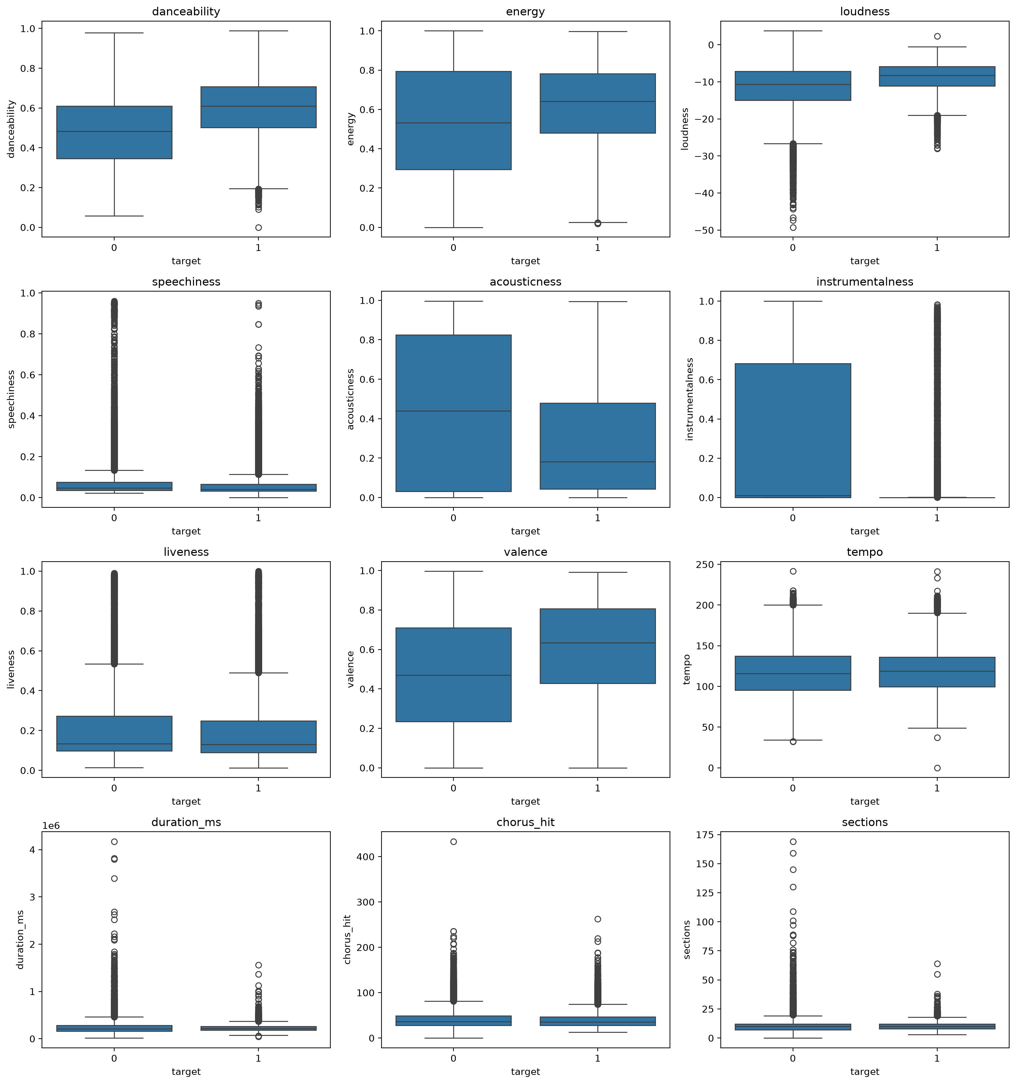
Figure 3. Boxplots of the numerical covariates by response (0 = flop, 1 = hit).
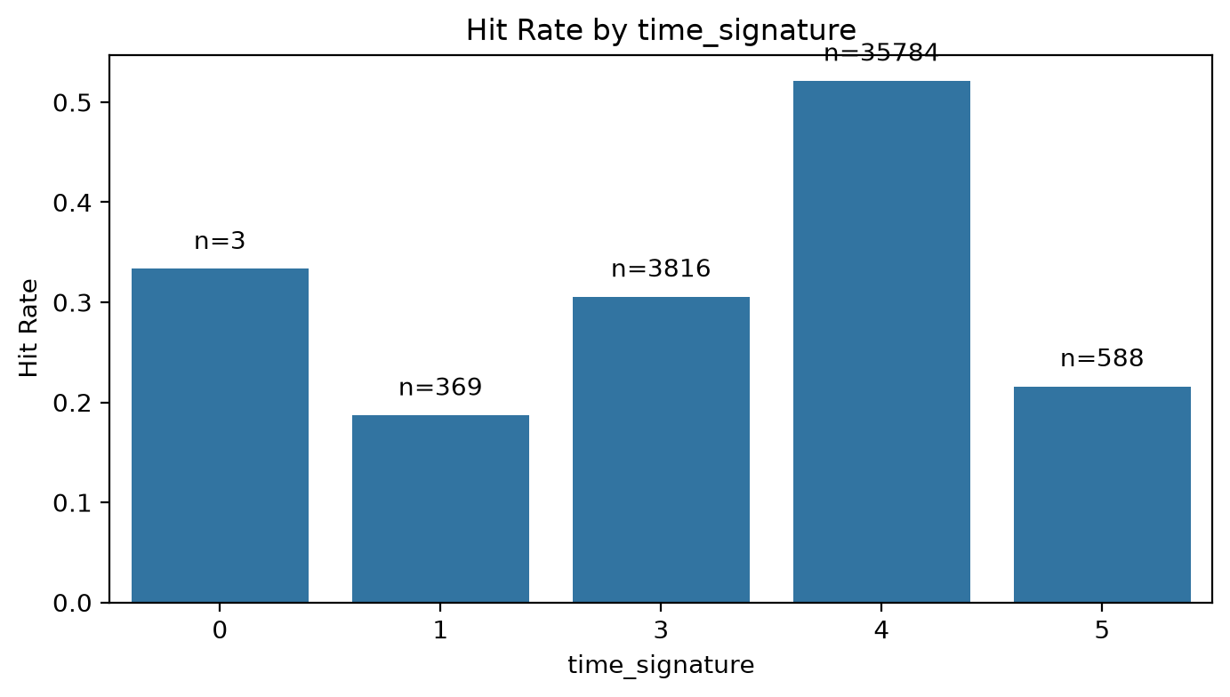
Figure 4. Hit rate by time signature (n per level shown).
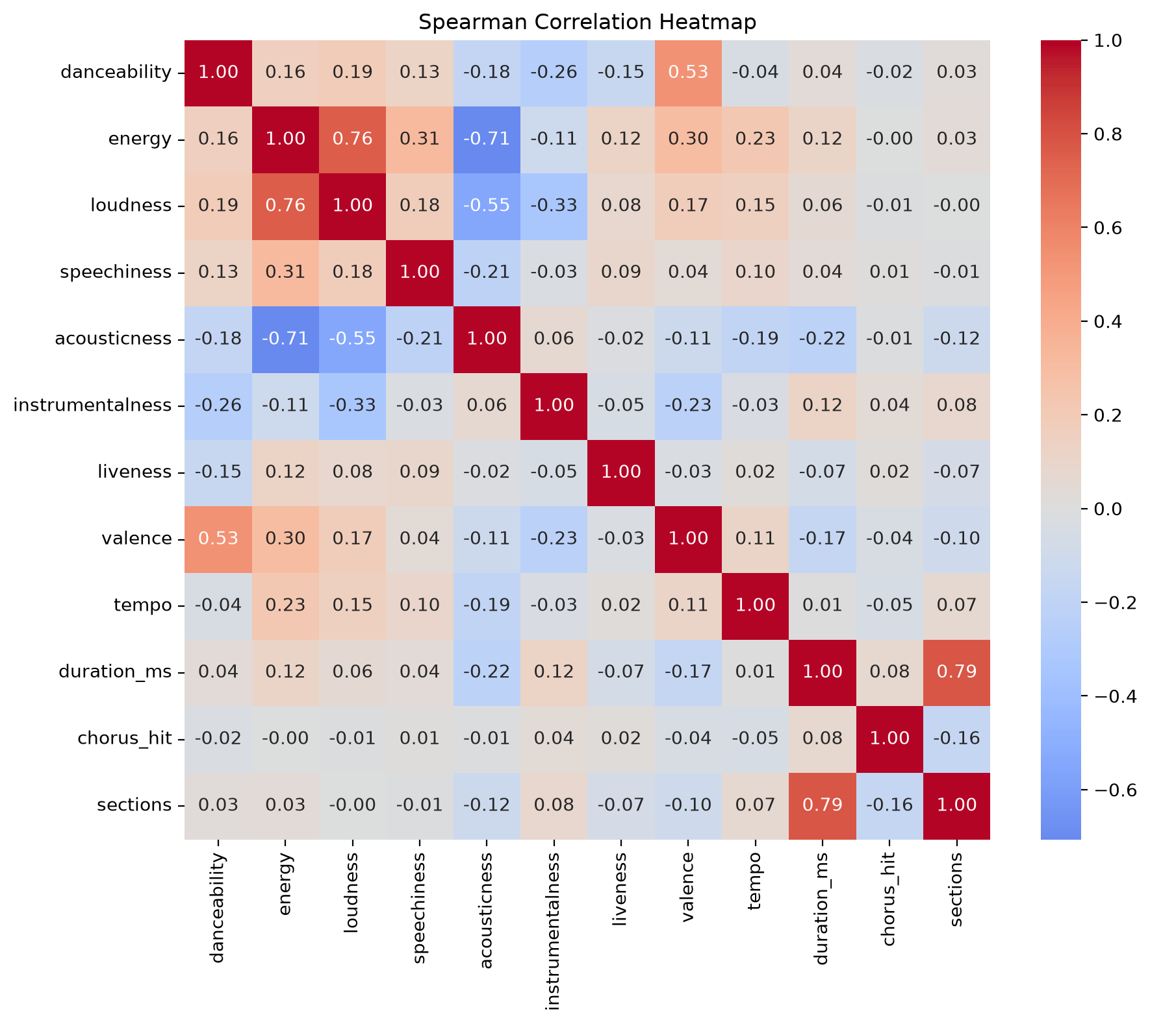
Figure 5. Spearman correlations between numerical covariates.
Findings. The clearest separators are instrumentalness (hits are almost always vocal) and danceability (hits are more danceable), followed by loudness, valence, acousticness and energy. decade is the only non-significant variable, because the dataset holds roughly 50% hits in every decade by design. Among the covariates, strong correlations exist between sections and duration (ρ = 0.79), energy and loudness (0.76), energy and acousticness (−0.71) and loudness and acousticness (−0.55). These matter for the logistic regression (B.4).

B.4 Outliers, influential observations and unusual patterns
Table 4. IQR outliers (1.5 × IQR rule) and variance inflation factors.
Variable | IQR outliers | % of rows | VIF
instrumentalness | 8,778 | 21.6 | 1.31
speechiness | 4,959 | 12.2 | 1.09
liveness | 2,662 | 6.6 | 1.09
duration_ms | 1,968 | 4.9 | 5.89
chorus_hit | 1,817 | 4.5 | 1.17
sections | 1,564 | 3.9 | 5.76
loudness | 1,329 | 3.3 | 2.97
tempo | 424 | 1.0 | 1.11
danceability / energy / acousticness / valence | 0–1 | ≈ 0 | 1.78 / 4.28 / 2.26 / 1.82

- Outliers: yes, but they are genuine. Many tracks are IQR outliers in the skewed variables (21.6% for instrumentalness, 12.2% for speechiness). They are real musical extremes, not errors: instrumental tracks, rap, live recordings, 10-minute songs. Removing them would bias the sample, so all are retained. Trees are robust to extreme x-values, and for the LR influence is assessed directly with Cook's distance (C.5).
- No influential observations. The largest Cook's distance in the logistic regression is 0.021, far below the usual 0.5–1 threshold, so no single track drives the fit.
- Unusual patterns that affect modelling: (i) the zero-inflated instrumentalness and (ii) a non-monotone duration effect: the hit rate is 10% for tracks under 2 min, about 58% at 3–5 min and 20% over 6 min. A linear logit cannot represent this shape, so tree models may gain an advantage. (iii) time_signature = 0 has only 3 tracks, which makes its dummy coefficients unstable.
- Multicollinearity: duration_ms (VIF 5.9) and sections (5.8) are collinear (ρ = 0.79), inflating their standard errors about 2.4×. All other VIFs are below 4.3. This is handled by feature selection in C.3.

B.5 Variables expected to be most important
Ranking each numerical covariate by its univariate AUC (how well it separates hits from flops on its own) and its effect size gives two expected key predictors:
- instrumentalness (AUC 0.740, r = −0.48). The median hit has instrumentalness 0.000 vs. 0.011 for flops. Chart music is overwhelmingly vocal, while the "flop" genres (ambient, avant-garde, electronic) are often instrumental.
- danceability (AUC 0.696, r = +0.39). The median hit scores 0.61 vs. 0.48 for flops, which fits the importance of rhythm and groove in popular music.
The two are only weakly correlated (ρ = −0.26), so each is expected to add separate information.

B.6 Train/test split
The cleaned data was split 80:20, stratified on the response (seed 42): 32,448 training and 8,112 test tracks, both with a 49.4% hit rate. All fitting, feature selection, tuning and threshold selection use the training data only. The test set is used once, for the final comparison.

Part C: Logistic Regression

C.1 Full model
A binary logistic regression, logit P(hit) = β₀ + βᵀx, was fitted by maximum likelihood (statsmodels Logit) to all 16 covariates (33 coefficients after dummy coding + intercept), with standardised numerical covariates. The model converged and is highly significant overall (likelihood-ratio χ² = 11,478 on 33 df, p < 0.001), with McFadden R² = 0.255.
Table 5. Full logistic regression model (training data, n = 32,448). Numerical covariates standardised; ORs per 1 SD. Reference levels: key 0 (C), time_signature 0, decade 2000s.
Term | Coef. | z | p-value | OR | 95% CI for OR
instrumentalness | −1.020 | −43.89 | < 0.001 | 0.361 | 0.345–0.377
danceability | 0.721 | 36.03 | < 0.001 | 2.056 | 1.977–2.138
acousticness | −0.620 | −28.69 | < 0.001 | 0.538 | 0.515–0.561
loudness | 0.708 | 24.07 | < 0.001 | 2.030 | 1.917–2.151
decade: 1960s | 1.088 | 19.46 | < 0.001 | 2.968 | 2.660–3.312
speechiness | −0.248 | −16.11 | < 0.001 | 0.780 | 0.757–0.804
energy | −0.465 | −15.83 | < 0.001 | 0.628 | 0.593–0.665
decade: 1970s | 0.759 | 14.37 | < 0.001 | 2.136 | 1.926–2.369
mode (major) | 0.405 | 13.29 | < 0.001 | 1.499 | 1.412–1.591
tempo | 0.095 | 6.69 | < 0.001 | 1.100 | 1.070–1.131
decade: 1980s | 0.280 | 5.41 | < 0.001 | 1.324 | 1.196–1.465
decade: 1990s | 0.197 | 3.72 | < 0.001 | 1.218 | 1.098–1.352
liveness | −0.049 | −3.61 | < 0.001 | 0.952 | 0.927–0.978
valence | −0.070 | −3.56 | < 0.001 | 0.932 | 0.897–0.969
decade: 2010s | −0.156 | −3.17 | 0.002 | 0.855 | 0.776–0.942
chorus_hit | −0.045 | −2.98 | 0.003 | 0.956 | 0.927–0.985
sections | −0.062 | −1.78 | 0.075 | 0.940 | 0.878–1.006
duration_ms | 0.004 | 0.11 | 0.914 | 1.004 | 0.935–1.078
key (11 dummies) | −0.14 to 0.39 | −2.60 to 6.00 | 7 of 11 < 0.05 | 0.87–1.48 | —
time_signature (4 dummies) | −2.63 to −1.93 | −1.82 to −1.34 | all > 0.05 | 0.07–0.14 | very wide (SE ≈ 1.44)
Intercept | 0.869 | 0.60 | 0.547 | — | —

Most audio features are significant. duration_ms and sections are not (collinear, see B.4), and the time_signature dummies have huge standard errors because their reference level contains only 3 tracks.

C.2 Three most significant predictors
Predictors were ranked by |z| (their p-values all underflow to 0):
Table 6. Interpretation of the three most significant predictors.
Predictor | 1 SD | OR per SD (95% CI) | Direction | Practical interpretation
instrumentalness | 0.306 | 0.36 (0.34–0.38) | negative | Holding all other features fixed, a 0.31 increase in instrumentalness cuts the odds of being a hit by about 64%. Songs with vocals are far more likely to chart.
danceability | 0.178 | 2.06 (1.98–2.14) | positive | A 0.18 increase (e.g. from 0.50 to 0.68) roughly doubles the odds of a hit, other things equal.
acousticness | 0.340 | 0.54 (0.52–0.56) | negative | A 0.34 increase in acousticness lowers the odds of a hit by about 46%. Given loudness, energy and decade, produced/electric sounds are favoured.

All three directions match the EDA, so the univariate patterns hold after adjusting for the other covariates.

C.3 Reduced model by feature selection
Procedure: backward elimination by the Bayesian Information Criterion (BIC). At each step every remaining variable was tried for removal (a categorical variable's dummies are removed together), and the removal that lowered BIC most was applied. The process stopped when no removal lowered BIC. BIC was preferred over AIC or p-value-based selection because its ln(n) penalty (≈ 10.4 per parameter here) favours parsimonious models that generalise, and it avoids the multiple-testing problems of stepwise p-values.
Table 7. Comparison of the full and reduced logistic regression models.
Measure | Full model | Reduced model
Variables removed | — | duration_ms, time_signature
Parameters | 34 | 29
Log-likelihood | −16,750.4 | −16,770.3
AIC | 33,568.7 | 33,598.7
BIC | 33,853.9 | 33,841.9
McFadden R² | 0.2552 | 0.2543
Test AUC | 0.8153 | 0.8147
LR test (full vs. reduced) | — | χ² = 39.9, df = 5, p = 1.5×10⁻⁷

Removing duration_ms and then time_signature lowered BIC from 33,854 to 33,842. This also removes the duration/sections collinearity and the unstable time-signature dummies. The reduced model has 14 variables and practically identical predictive performance (test AUC 0.8147 vs. 0.8153). The likelihood-ratio test still prefers the full model, but with 32,448 observations it detects differences too small to matter in practice. Since we want a parsimonious, stable model, the reduced model is the final logistic regression.

C.4 Adequacy and predictive performance of the final model
- Overall significance: LR χ² vs. the intercept-only model = 11,436 (p < 0.001). McFadden R² = 0.254 (values of 0.2–0.4 indicate a very good fit).
- Hosmer-Lemeshow test: χ² = 80.3 on 8 df, p ≈ 4×10⁻¹⁴. The HL test is known to reject even minor misfit at very large n, so calibration was also checked graphically.
- Calibration (test set): the calibration curve follows the diagonal closely up to about 0.8. In the top decile the model over-predicts (mean predicted 0.92 vs. observed 0.84). Brier score = 0.173.
- Linearity in the logit: the empirical-logit plots (decile bins) are close to linear for danceability. Loudness levels off above about −7 dB, and instrumentalness and acousticness are clearly non-linear. The linear-logit assumption therefore holds only approximately, a limitation of the LR.
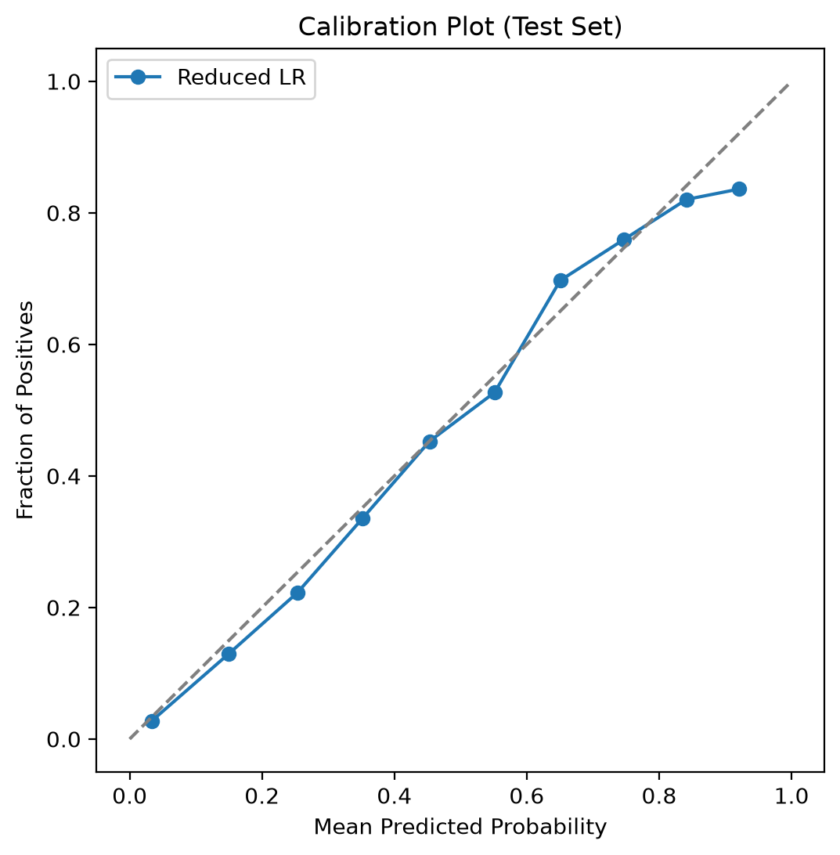
Figure 6. Calibration plot of the reduced logistic regression (test set).
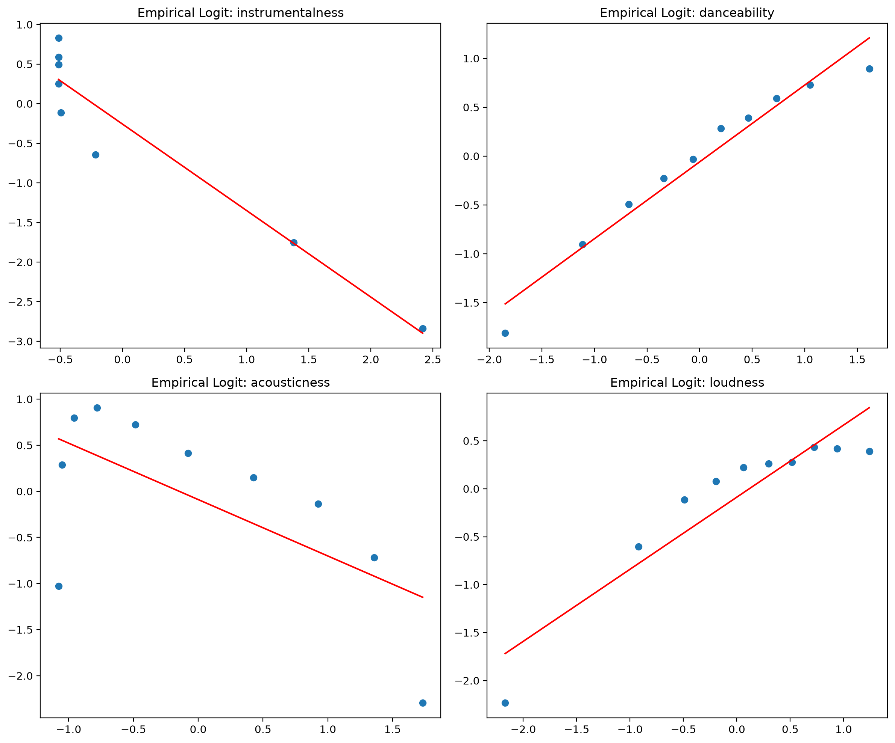
Figure 7. Empirical logit vs. standardised covariate (decile bins) for the four strongest predictors, with fitted line.
Table 8. Test-set performance of the final (reduced) logistic regression at threshold 0.5.
Accuracy | Precision | Recall | F1 | AUC | Log-loss | Brier | Train AUC
0.741 | 0.707 | 0.811 | 0.755 | 0.815 | 0.514 | 0.173 | 0.813

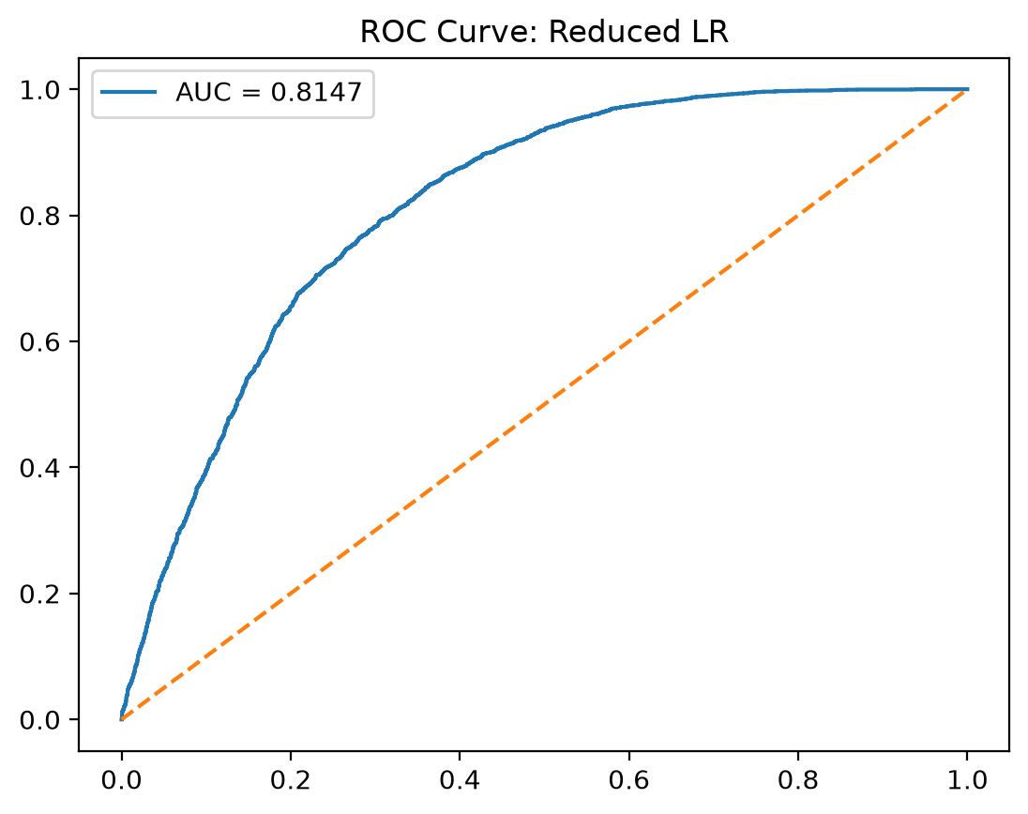
Figure 8. ROC curve of the reduced logistic regression (test AUC = 0.815).
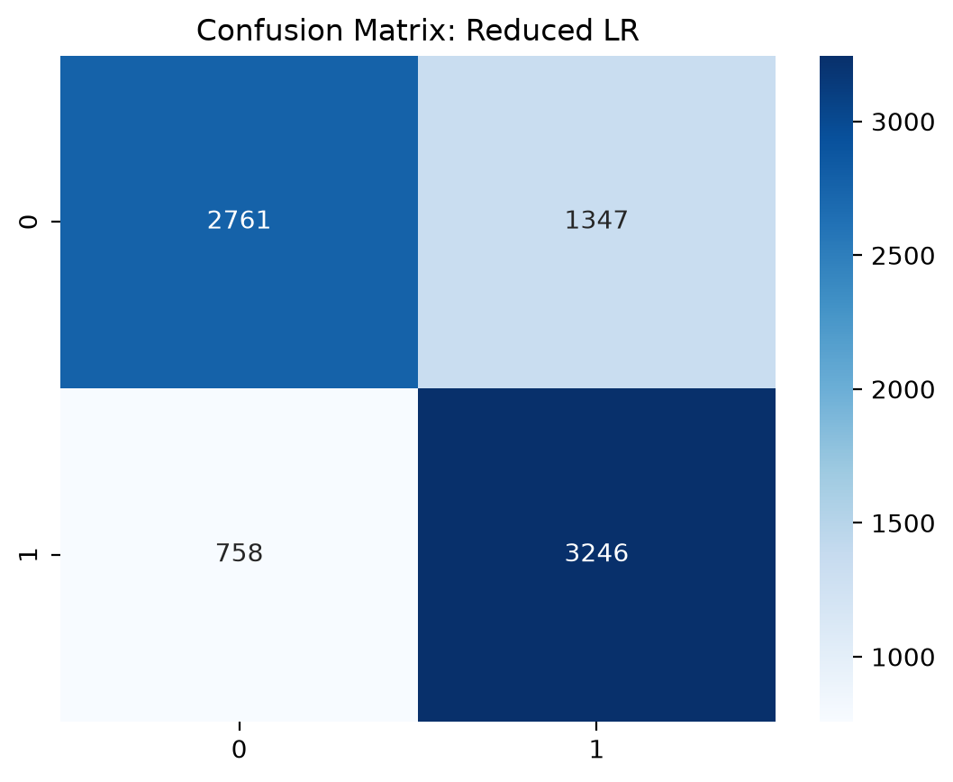
Figure 9. Confusion matrix of the reduced logistic regression (test set, threshold 0.5).
The model correctly classifies 74.1% of test tracks, with good discrimination (AUC 0.815). It finds 81% of hits (recall), but only 67% of flops are correctly rejected, so precision for hits is 0.71. Training and test AUC are the same (0.813 vs. 0.815), so there is no overfitting.

C.5 Influence diagnostics and sensitivity
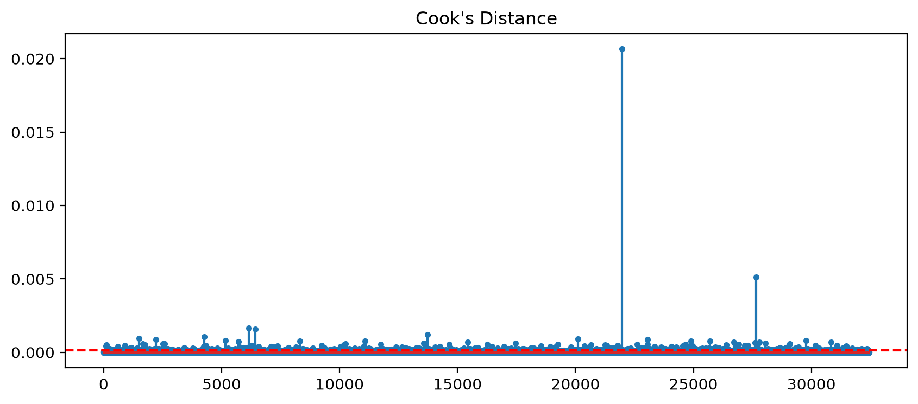
Figure 10. Cook's distance for the full logistic model (red line: 4/n).
988 training points (3.0%) exceed the rule-of-thumb 4/n = 0.00012. At this sample size that cut-off flags any poorly fitted point, and the maximum Cook's D is only 0.021, so no observation is individually influential. Refitting without all 988 points shifts the top-3 odds ratios by 16–46%. This is expected, because deleting the worst-fitted 3% of tracks artificially sharpens the separation. It does not show that the points are errors, so they are kept. Removing the 4 tracks with tempo = 0 or time_signature = 0 changes neither the test AUC (0.8147) nor any top-3 odds ratio (≤ 0.1%).

Part D: Machine Learning Models
Two ensemble tree methods were applied to the same training/test split: Random Forest (RF), as required, and Gradient Boosting (GB) (scikit-learn GradientBoostingClassifier). Both use all 16 covariates (the same dummy coding as the full LR).

D.1 How the methods work (a)
- Random Forest grows many decision trees, each on a bootstrap sample of the training data. At every split only a random subset of covariates (max_features) is considered. Individual deep trees have low bias but high variance. Averaging many weakly correlated trees keeps the low bias and greatly reduces variance. The predicted probability is the average of the trees' leaf class proportions. Rows left out of each bootstrap sample ("out-of-bag") give a built-in validation estimate.
- Gradient Boosting builds trees sequentially. Starting from a constant prediction, each new shallow tree is fitted to the negative gradient of the log-loss (the "pseudo-residuals") of the current ensemble, and its contribution is shrunk by a learning rate. Each tree therefore corrects the errors of the previous ones, mainly reducing bias. Subsampling the rows for each tree (subsample < 1) adds randomness that regularises the model.

D.2 Additional preprocessing (b)
Tree splits depend only on the order of values, so neither model needs standardisation, transformation of skewed variables or outlier treatment. Both models therefore use the unscaled design matrix. Categorical variables use the same one-hot encoding as the LR. There are no missing values, and the classes are balanced, so no class weights or resampling are needed. No feature selection was applied beforehand: both methods select variables implicitly and cope with correlated features.

D.3 Model tuning (c)
Hyper-parameters were tuned with `RandomizedSearchCV` on the training set only, using 5-fold stratified cross-validation (shuffled, seed 42) and ROC-AUC as the selection criterion (threshold-free and robust). Random search covers a wide grid efficiently: 30 RF configurations and 15 GB configurations (150 and 75 fits). The best configuration was then refitted on the full training set.
Table 9. Hyper-parameter search spaces and selected values.
Model | Hyper-parameter | Values searched | Selected | Role
RF | n_estimators | 100, 200, 300, 400 | 200 | number of trees
RF | max_depth | 20, 30, 40, None | None | tree depth limit
RF | min_samples_split | 2, 5, 10 | 2 | regularises splitting
RF | min_samples_leaf | 1, 2, 4 | 1 | smooths leaf probabilities
RF | max_features | sqrt, log2, 0.5 | sqrt | de-correlates trees
GB | n_estimators | 200, 300, 400 | 300 | boosting stages
GB | learning_rate | 0.03, 0.05, 0.1 | 0.05 | shrinkage
GB | max_depth | 5, 7, 9 | 7 | interaction depth
GB | subsample | 0.8, 1.0 | 0.8 | stochastic boosting

Best CV AUC: RF 0.880 (tuning time 7.4 min) and GB 0.889 (9.7 min). For both models the five best configurations lie within 0.001 AUC of each other, so the results do not depend on the exact hyper-parameters. RF chose fully grown trees (the standard RF setting), and GB chose the lower subsample value, so a slightly wider GB grid might gain a little.

D.4 Predictive performance on the test data (d)
Table 10. Test-set performance of the tuned models (threshold 0.5).
Model | Accuracy | Precision | Recall | F1 | AUC | Log-loss | Brier
Random Forest | 0.802 | 0.774 | 0.846 | 0.808 | 0.883 | 0.434 | 0.140
Gradient Boosting | 0.816 | 0.788 | 0.859 | 0.822 | 0.893 | 0.405 | 0.130

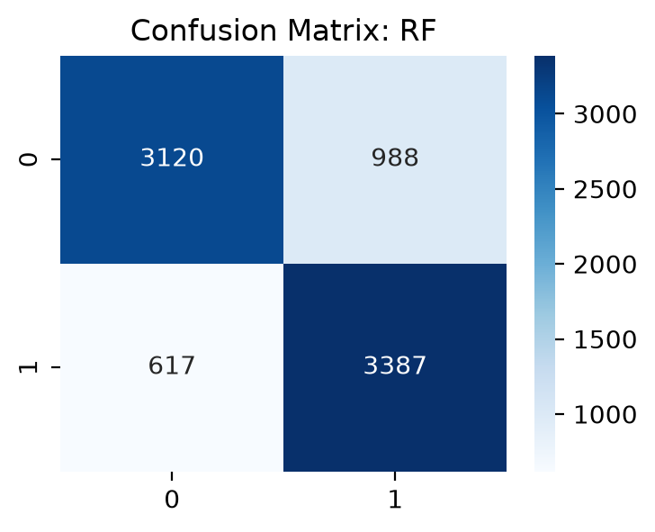
Figure 11. Confusion matrix: Random Forest (test set).
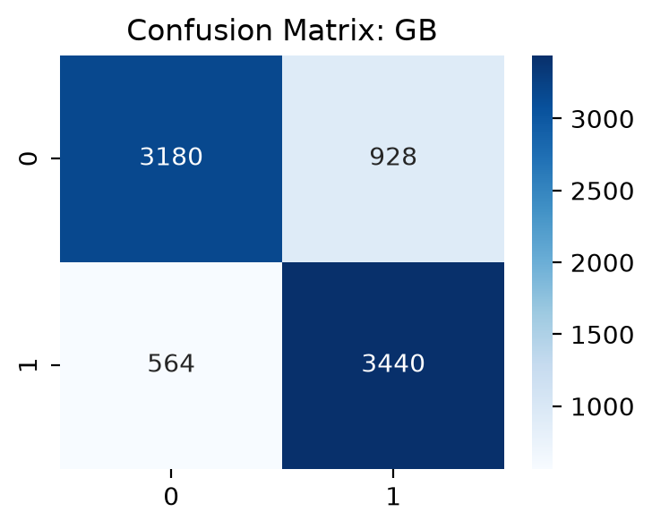
Figure 12. Confusion matrix: Gradient Boosting (test set).
Both models classify about 80–82% of test tracks correctly, with AUC of 0.88–0.89. Like the LR, they make more false positives (flops predicted as hits) than false negatives.

D.5 Evidence of overfitting (e)
Table 11. Training, cross-validation and test performance.
Model | Train acc. | Test acc. | Train AUC | CV AUC | Test AUC | Train − test AUC
LR (reduced) | 0.744 | 0.741 | 0.813 | 0.812 | 0.815 | −0.002
Random Forest | 1.000 | 0.802 | 1.000 | 0.880 | 0.883 | 0.117
Gradient Boosting | 0.905 | 0.816 | 0.972 | 0.889 | 0.893 | 0.079

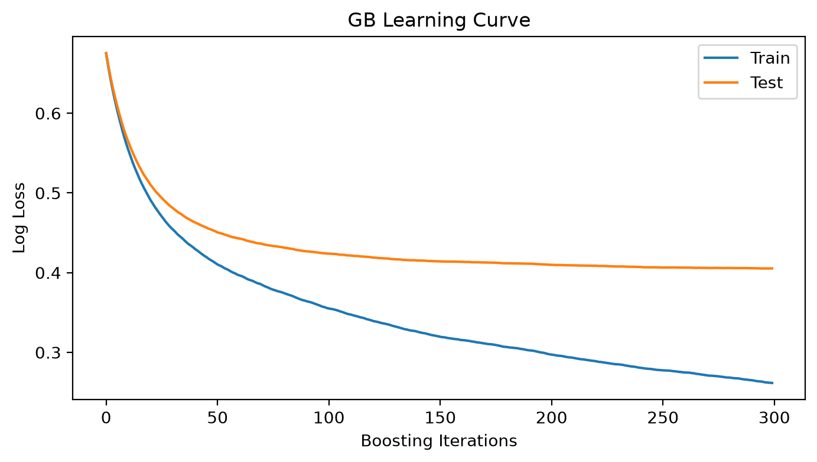
Figure 13. Gradient Boosting: training and test log-loss by boosting iteration.
- Random Forest: it fits the training data perfectly (train AUC 1.000). This is expected for fully grown trees and is not by itself a sign of harmful overfitting. What matters is that the out-of-sample estimates agree: CV AUC 0.880 ≈ test AUC 0.883 and OOB accuracy 0.800 ≈ test accuracy 0.802. The forest generalises exactly as cross-validation predicted.
- Gradient Boosting: there is a moderate train–test gap (0.972 vs. 0.893 AUC), but CV AUC (0.889) matches test AUC, and the test log-loss in the learning curve falls steadily and levels off at about 0.405 without rising by iteration 300. Extra trees have not started to hurt generalisation, so there is no evidence of harmful overfitting.
- Logistic regression: identical train and test performance. No overfitting.

D.6 Most important predictors (f)
Importance was measured with grouped permutation importance on the test set: the drop in AUC when a variable (all of its dummies together) is randomly shuffled, averaged over 10 repeats. Unlike impurity-based (Gini) importance, it reflects performance on unseen data and is not biased towards continuous, high-cardinality features. Grouping lets factors such as key and decade be judged as whole variables.
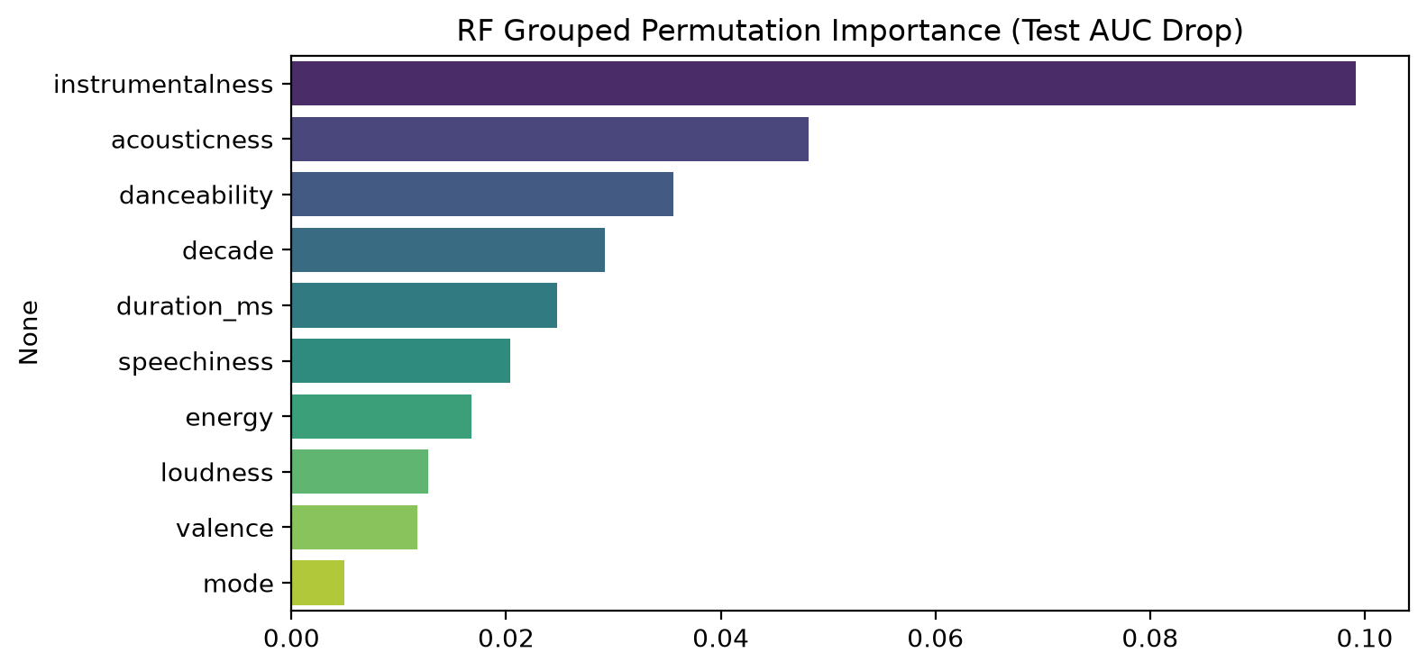
Figure 14. Random Forest: grouped permutation importance (drop in test AUC), top 10.
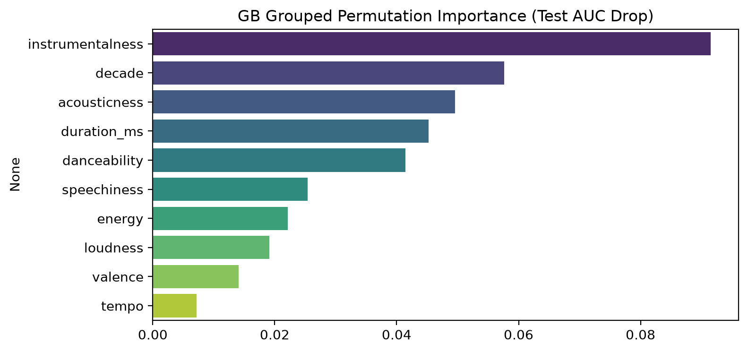
Figure 15. Gradient Boosting: grouped permutation importance (drop in test AUC), top 10.
Table 12. Top five predictors by grouped permutation importance (test-AUC drop).
Rank | Random Forest | Gradient Boosting
1 | instrumentalness (0.099) | instrumentalness (0.092)
2 | acousticness (0.048) | decade (0.058)
3 | danceability (0.036) | acousticness (0.050)
4 | decade (0.029) | duration_ms (0.045)
5 | duration_ms (0.025) | danceability (0.042)

Both ensembles agree that instrumentalness is by far the most important predictor, followed by acousticness, danceability, decade and duration. key, liveness, chorus_hit, sections and time_signature contribute almost nothing.

Part E: Discussion

E.1 Do the ML models provide an advantage over logistic regression?
Table 13. Test-set comparison of all three models, with 95% bootstrap confidence intervals (1,000 resamples).
Model | Accuracy [95% CI] | AUC [95% CI] | F1 | Log-loss | Brier
Logistic regression | 0.741 [0.731, 0.750] | 0.815 [0.805, 0.824] | 0.755 | 0.514 | 0.173
Random Forest | 0.802 [0.793, 0.811] | 0.883 [0.876, 0.890] | 0.808 | 0.434 | 0.140
Gradient Boosting | 0.816 [0.807, 0.825] | 0.893 [0.886, 0.900] | 0.822 | 0.405 | 0.130

Table 14. Paired bootstrap differences against logistic regression (same resampled test rows for every model).
Comparison | Δ AUC [95% CI] | Δ Accuracy [95% CI] | CI excludes 0?
GB − LR | +0.078 [0.071, 0.085] | +0.076 [0.066, 0.085] | yes, both
RF − LR | +0.068 [0.061, 0.075] | +0.062 [0.053, 0.071] | yes, both

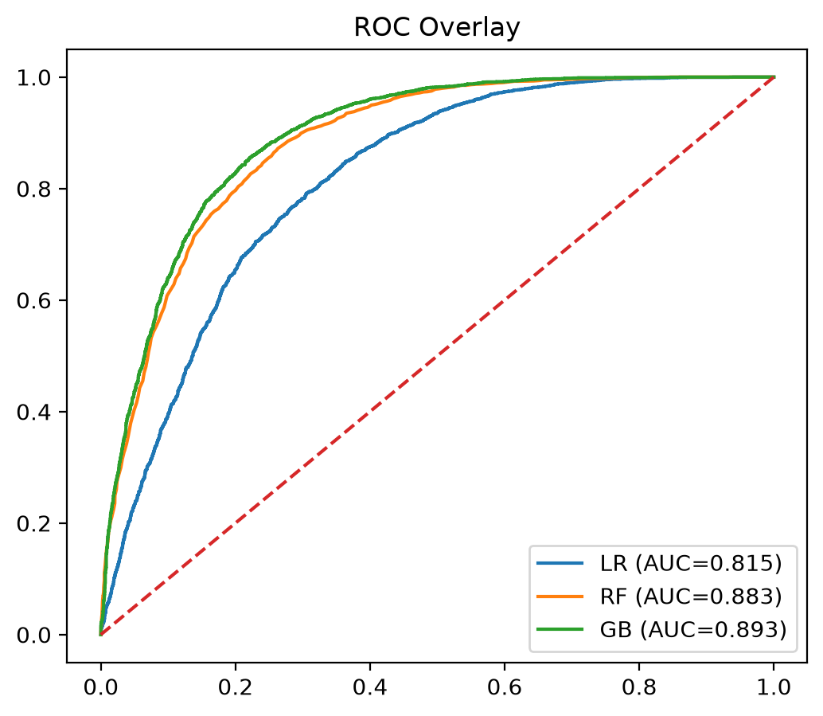
Figure 16. ROC curves of the three models on the test set.
Yes. Both ML models clearly beat the logistic regression on this dataset. They are better on every measure: discrimination (AUC +0.07 to +0.08), classification (accuracy +6 to +8 points, about 500–600 more test tracks classified correctly), and probability quality (log-loss and Brier score). The paired bootstrap confidence intervals for the AUC and accuracy differences are well away from zero, so the improvement is statistically significant, and the same ranking appears in 5-fold cross-validation (GB 0.889 > RF 0.880 > LR 0.812), so it is not specific to one split. The ROC curves of both ensembles lie above the LR curve at every false-positive rate.
The advantage comes from structure that the linear-logit model cannot represent: the non-linear effects found in the EDA and the C.4 diagnostics (zero-inflated instrumentalness, an inverted-U for duration, loudness levelling off) and interactions with era. For example, median acousticness of the songs is 0.68 in the 1960s but 0.06 in the 2000s, so what an "acoustic hit" looks like depends on the decade. Trees learn these effects automatically, while the LR would need hand-crafted splines and interaction terms.

E.2 Which model would be recommended for deployment?
Table 15. Deployment considerations (test set; timing on the training set of 32,448 rows).
Model | Test AUC | Test acc. | Brier | Training time | Prediction time / 1,000 rows | Interpretability
Logistic regression | 0.815 | 0.741 | 0.173 | 0.05 s | 1 ms | High (odds ratios)
Random Forest | 0.883 | 0.802 | 0.140 | 10.7 s | 64 ms | Low
Gradient Boosting | 0.893 | 0.816 | 0.130 | 45.7 s | 9 ms | Low

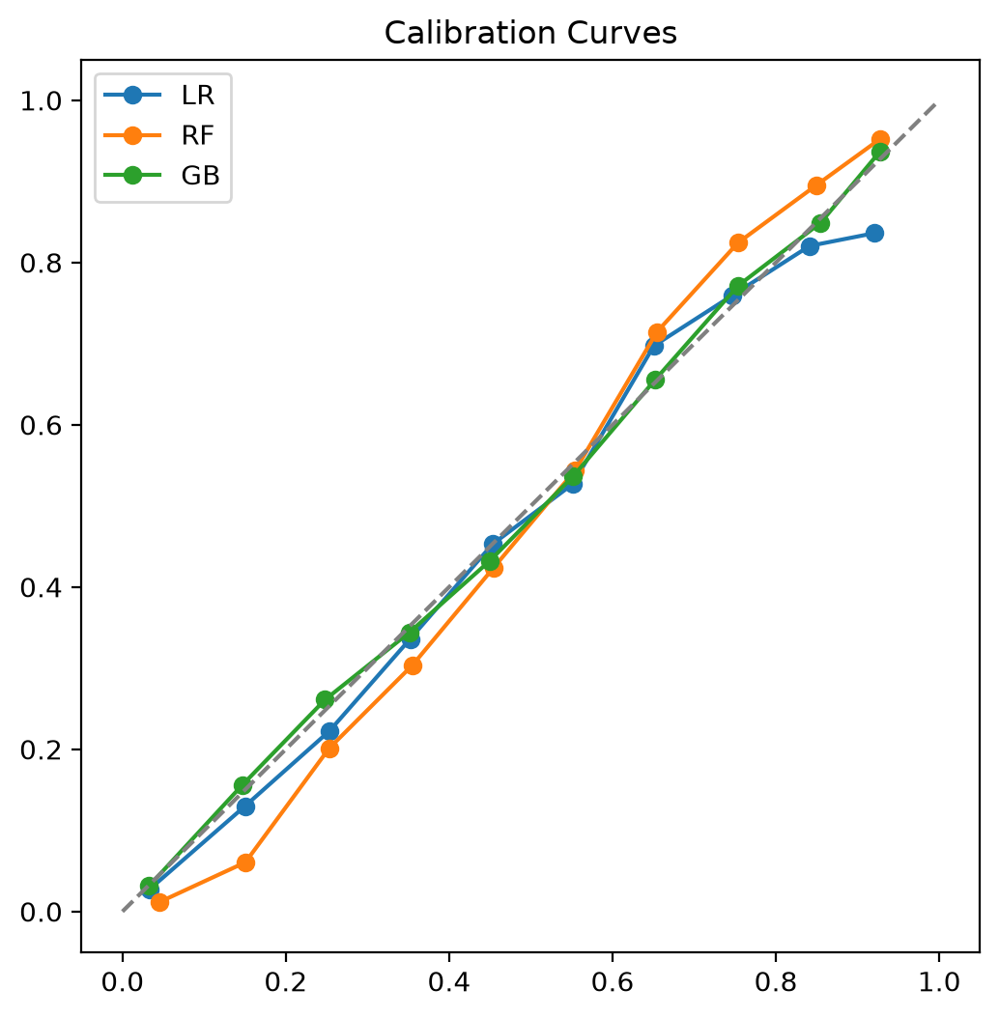
Figure 17. Calibration curves of the three models (test set).
Recommendation: Gradient Boosting, with the reduced logistic regression kept as an explanatory companion.
- Best predictions: GB has the best AUC, accuracy, F1 and CV AUC, and its advantage over the LR is significant (E.1).
- Most reliable probabilities: GB has the lowest Brier score, and its calibration curve lies on the diagonal. RF probabilities are pulled towards 0.5 (under-confident at the extremes), and the LR over-predicts in the top decile. This matters if the scores are used as hit probabilities, for example to rank songs for promotion.
- Practical cost is acceptable: scoring takes about 9 ms per 1,000 tracks (seven times faster than RF), and training takes under a minute, which is fine for periodic offline retraining.
- Interpretability trade-off: GB is not directly interpretable, but its important predictors agree with the LR's significant odds ratios on the main drivers (instrumentalness, danceability, acousticness). The LR's odds ratios can explain the patterns to stakeholders while GB produces the predictions. If transparent, auditable decisions were required, the LR would be preferred, at a cost of about 7.6 points of accuracy.
- Caveat: the flop class was sampled from niche genres by the dataset author, so the model partly learns "mainstream vs. niche". It would probably perform worse on mainstream songs that narrowly miss the chart.

E.3 Were the EDA expectations supported?
Table 16. Rank of the two expected predictors in each importance measure (1 = most important; 16 variables).
Variable | Univariate AUC | LR (LR-χ² drop) | RF permutation | GB permutation | Verdict
instrumentalness | 1 | 1 | 1 | 1 | Fully supported
danceability | 2 | 2 | 3 | 5 | Supported (top 3 in 3 of 4)

Yes. instrumentalness is the most important predictor in every analysis: univariate AUC, LR importance (OR 0.36 per SD, the largest |z|), and RF and GB permutation importance. danceability is 2nd in the univariate and LR rankings and 3rd for RF. It falls to 5th for GB, which gives more weight to variables with conditional or non-linear effects.
The EDA missed two predictors. decade looked irrelevant on its own (V = 0.01, p = 0.48) because every decade is about 50% hits by design, yet it is the 2nd most important variable for GB and strongly significant in the LR (1960s OR = 2.97 vs. the 2000s). It matters conditionally: the audio profile of a hit changes from era to era, so decade only becomes informative once the audio features are in the model. Similarly, duration_ms had a negligible univariate effect (r = 0.02) because its relationship with the response is an inverted-U, not monotone. The marginal univariate EDA therefore identified the strongest predictors correctly but underestimated variables whose effects are conditional or non-linear.

E.4 Does the Random Forest identify the same important predictors as logistic regression?
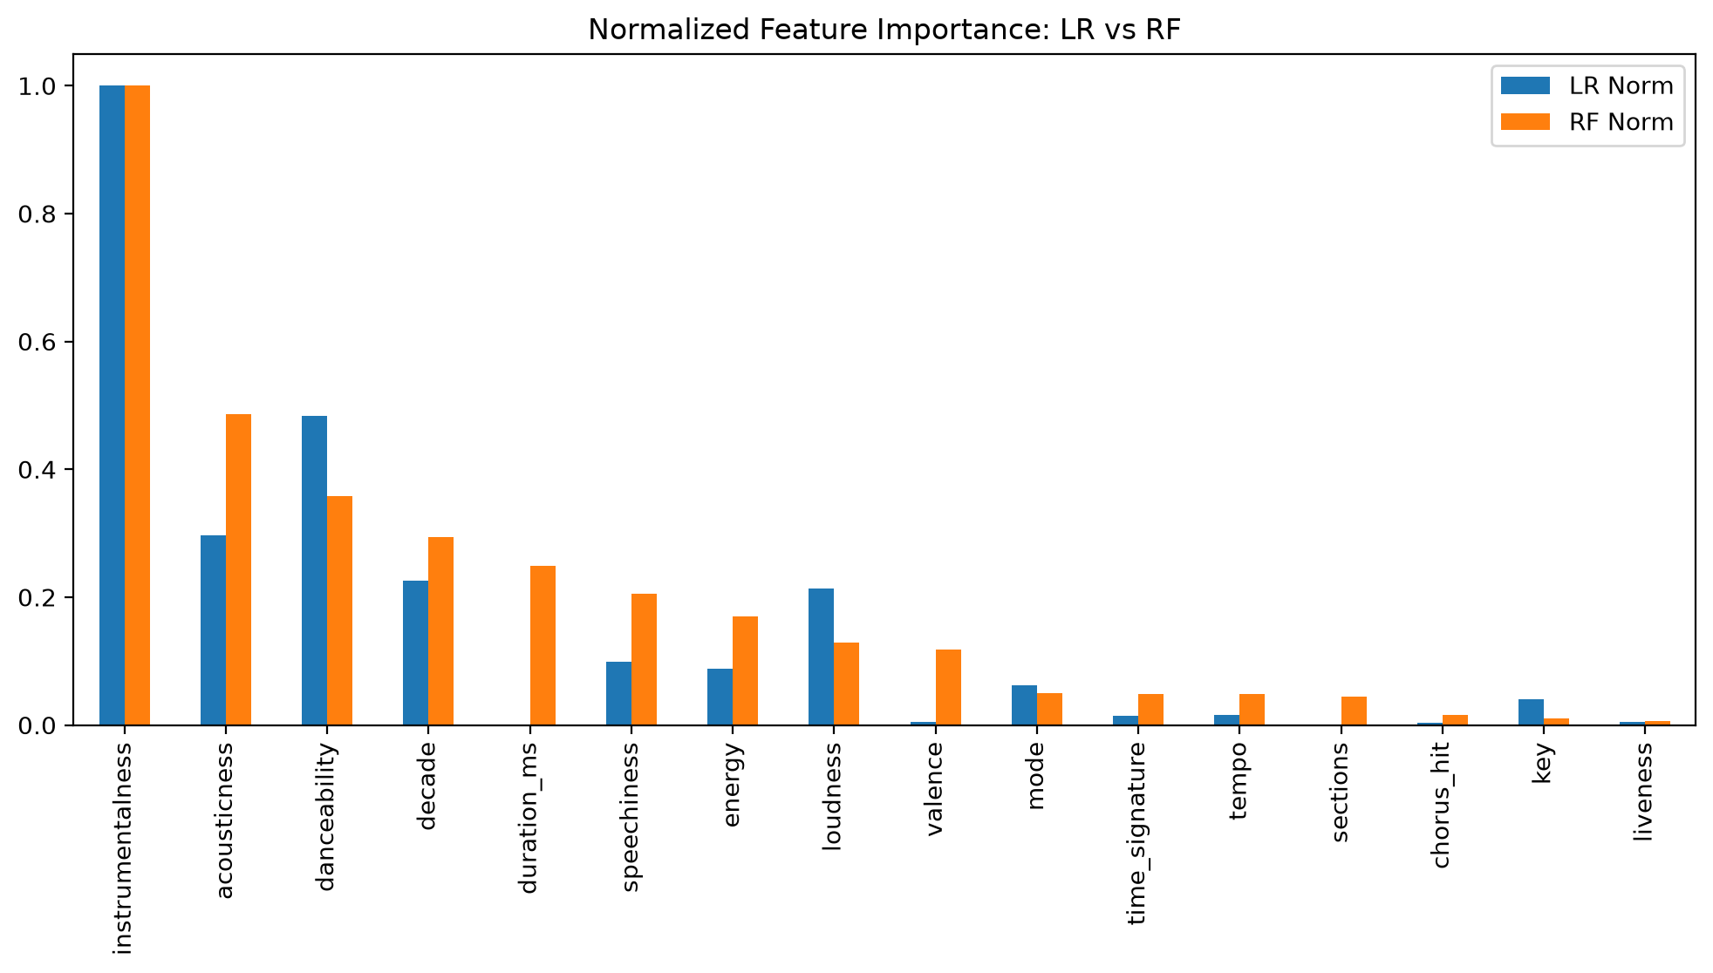
Figure 18. Normalised variable importance: logistic regression (likelihood-ratio χ² when the variable is dropped from the full model) vs. Random Forest (grouped permutation importance).
Largely yes, with differences that can be explained. The Spearman rank correlation between the two importance rankings is 0.69, and 4 of the top 5 overlap: instrumentalness (1st for both), danceability, acousticness and decade. Both models agree that key, liveness, chorus_hit, tempo and time_signature are unimportant.
- duration_ms is 5th for RF but has essentially zero importance in the LR (coefficient ≈ 0, p = 0.91, removed by BIC). Its effect is an inverted-U (hit rate 10% under 2 min, 58% at 3–5 min, 20% over 6 min). A single linear term averages this to zero, but tree splits capture it directly.
- loudness is in the LR top 5 but only 8th for RF. Loudness is strongly correlated with energy (ρ = 0.76) and acousticness (ρ = −0.55). The LR assigns the shared information to one coefficient, while the RF spreads the credit across the correlated features, so permuting any one of them costs little.
- valence carries some RF importance but almost none in the LR once danceability (ρ = 0.53) and energy are included. The RF uses it through interactions.
- key gets some LR importance from a few significant dummies (e.g. key 10, OR 1.48) but adds almost nothing to RF's predictive accuracy.
So the two methods agree on what matters most. The differences come from non-linearity, collinearity and interactions that the RF can use but a linear-logit model cannot.

E.5 Can the best model be improved by changing the classification threshold?
The best model (highest CV AUC) is Gradient Boosting. To avoid tuning on the test set, candidate thresholds (0.20–0.80) were evaluated on 5-fold out-of-fold predicted probabilities from the training data. F1 is maximised at t = 0.42, while Youden's J and accuracy are both maximised at t = 0.48, very close to the default 0.5. The F1-optimal threshold was then applied once to the test set, and the change was assessed with a paired bootstrap.
Table 17. Gradient Boosting test performance at different thresholds.
Threshold | Accuracy | Precision | Recall | F1 | Balanced acc.
0.30 | 0.795 | 0.727 | 0.937 | 0.819 | 0.797
0.40 | 0.809 | 0.756 | 0.905 | 0.824 | 0.810
0.42 (OOF F1-optimal) | 0.811 | 0.763 | 0.896 | 0.824 | 0.812
0.50 (default) | 0.816 | 0.788 | 0.859 | 0.822 | 0.817
0.60 | 0.812 | 0.818 | 0.797 | 0.807 | 0.812
0.70 | 0.787 | 0.850 | 0.691 | 0.762 | 0.786

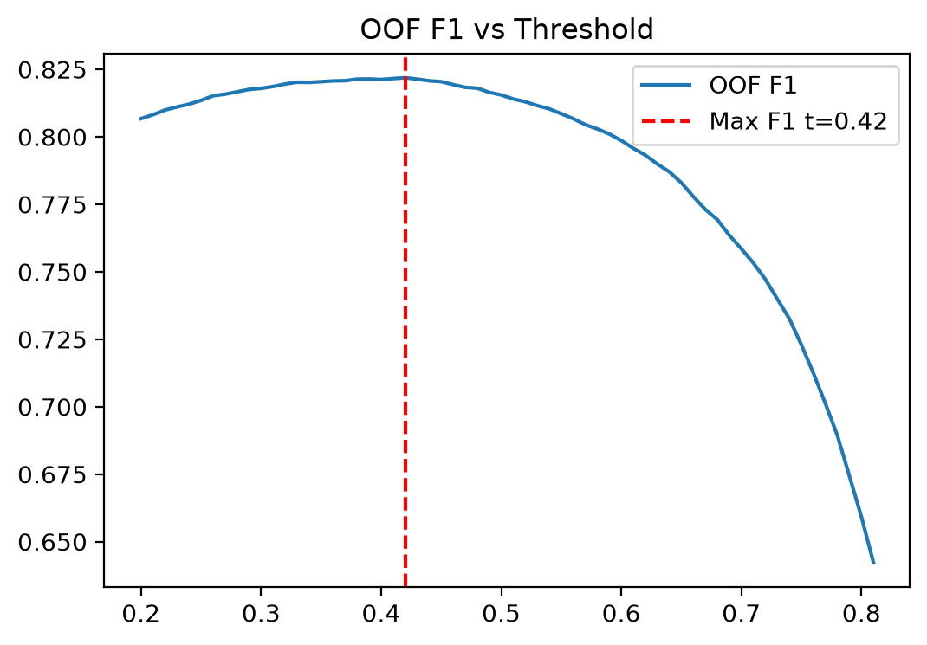
Figure 19. Out-of-fold F1 against threshold for Gradient Boosting (training data).
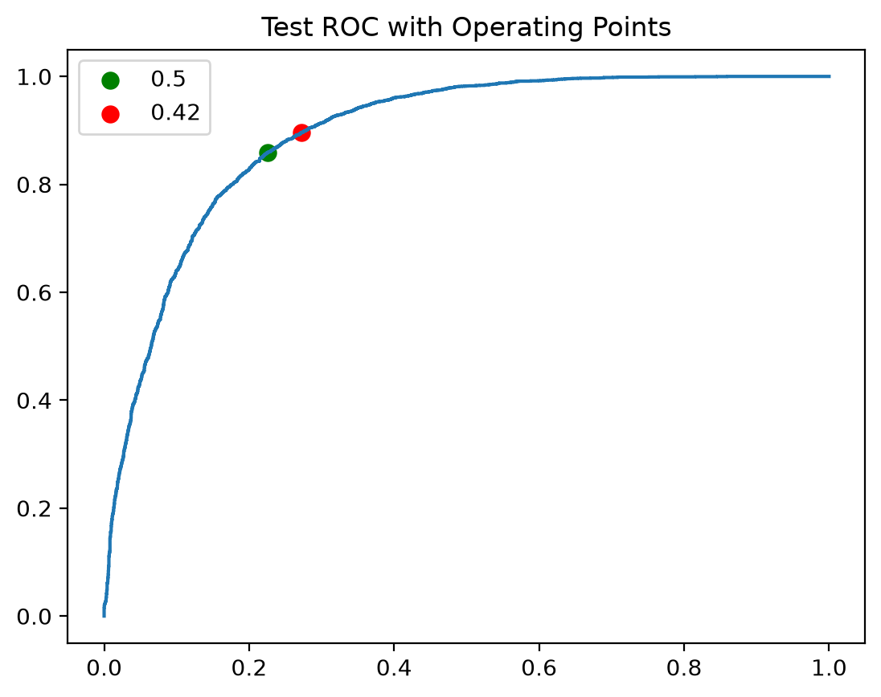
Figure 20. Test ROC curve of Gradient Boosting with the default (0.5) and F1-optimal (0.42) operating points.
Conclusion: no meaningful improvement. Moving to t = 0.42 changes test F1 by only +0.2 points (bootstrap 95% CI [−0.20, +0.61], which includes 0) and lowers accuracy by 0.5 points (CI [−0.96, −0.09], a significant loss). The default 0.5 is already essentially optimal for balanced objectives. This is expected because the classes are balanced (49.4% hits) and GB's probabilities are well calibrated, so 0.5 is the natural decision boundary. Moving the threshold only trades precision for recall along the same ROC curve and does not make the model better. A different threshold is justified only if the costs of errors are unequal. For example, a talent-scouting tool that must not miss potential hits could use t = 0.3 (recall 0.94, precision 0.73), while a decision to commit a large marketing budget could use t = 0.7 (precision 0.85, recall 0.69).

Conclusion
- The Spotify Hit Predictor data (40,560 tracks, 16 covariates) supports a clear comparison of a classical model with machine-learning models.
- The reduced logistic regression (BIC selection; 14 variables) is well specified overall (McFadden R² 0.25) and very interpretable, but its linear-logit assumption misses non-linear and era-dependent effects. Test accuracy is 0.741 and AUC 0.815.
- Random Forest (AUC 0.883) and especially Gradient Boosting (AUC 0.893, accuracy 0.816) are significantly better, show no harmful overfitting, and give the best-calibrated probabilities (GB). Gradient Boosting is recommended for deployment, with the LR as an explanatory companion.
- All models agree that instrumentalness (negative) and danceability (positive) are key predictors, as the EDA predicted. acousticness, decade and duration also matter, the last two in ways that a univariate EDA or a linear model does not reveal.
- Changing the classification threshold does not improve the best model for balanced objectives. Thresholds should be set from the business costs of each error type.

References
- theoverman (Kaggle user). The Spotify Hit Predictor Dataset (1960–2019). Kaggle. https://www.kaggle.com/datasets/theoverman/the-spotify-hit-predictor-dataset
- Spotify for Developers. Web API: audio features reference. https://developer.spotify.com/documentation/web-api
- Pedregosa, F. et al. (2011). Scikit-learn: Machine Learning in Python. Journal of Machine Learning Research, 12, 2825–2830.
- Seabold, S. & Perktold, J. (2010). statsmodels: Econometric and statistical modeling with Python. Proc. 9th Python in Science Conference.
- Hosmer, D. W., Lemeshow, S. & Sturdivant, R. X. (2013). Applied Logistic Regression (3rd ed.). Wiley.
- Breiman, L. (2001). Random Forests. Machine Learning, 45(1), 5–32.
- Friedman, J. H. (2001). Greedy function approximation: a gradient boosting machine. Annals of Statistics, 29(5), 1189–1232.

