This is SpringBoot Maven Project.

In STS tool import this project as maven..Right Click on Application.java –Run as a spring boot app

Used h2 database…

Once server started hit: <http://localhost:9090>

Application Flow:

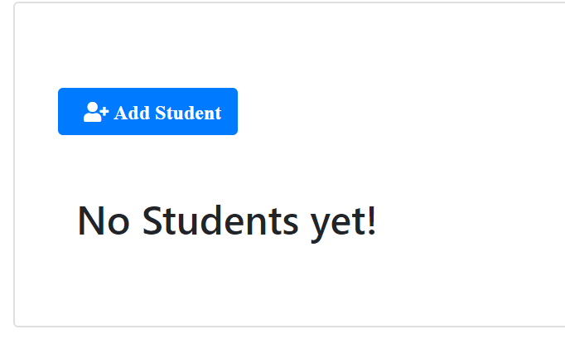

Click on add student:

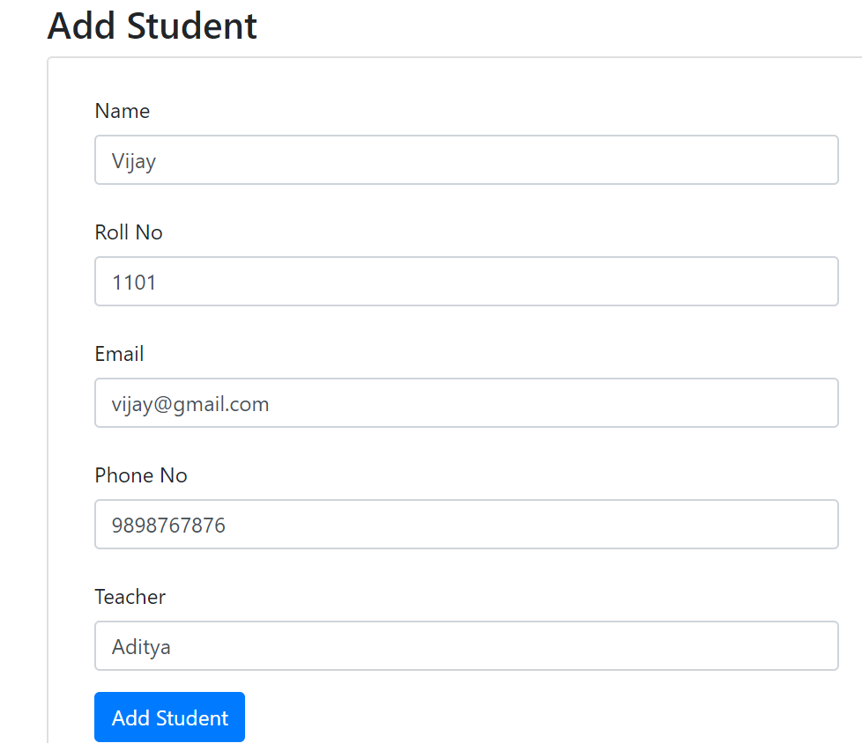

Update student: change surname

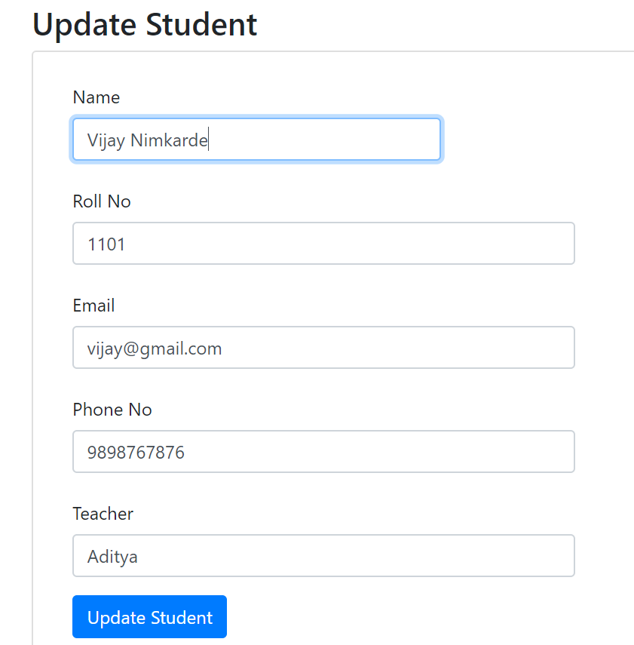

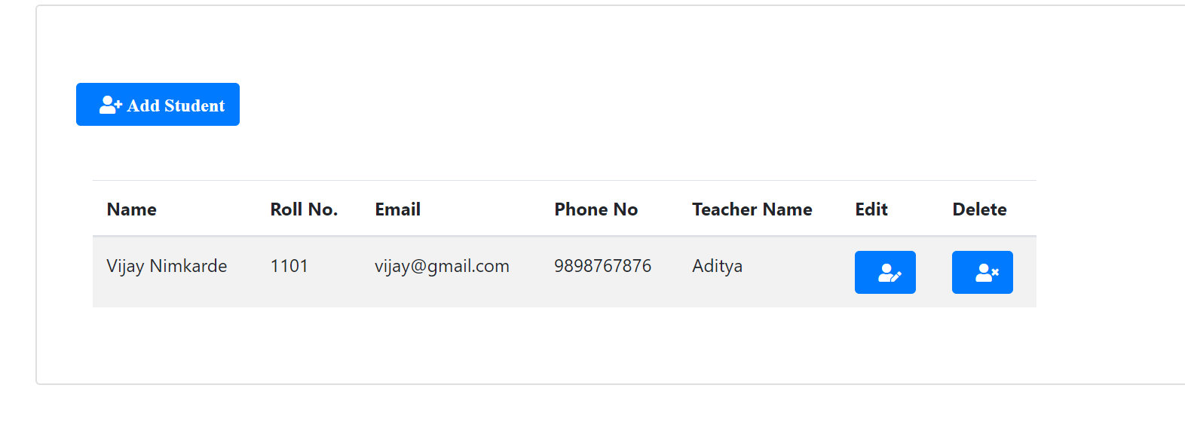

<http://localhost:9090/students/list>

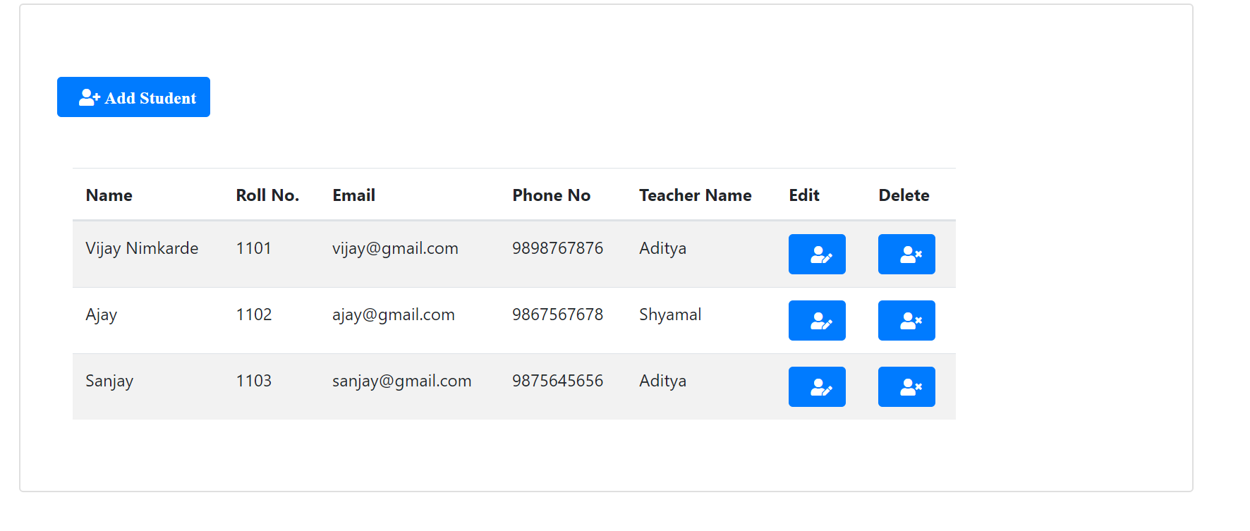

List of students by teacher name:

<http://localhost:9090/students/teacher/Shyamal>

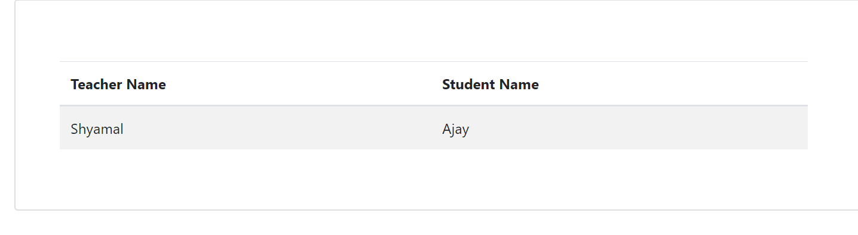

<http://localhost:9090/students/teacher/Aditya>

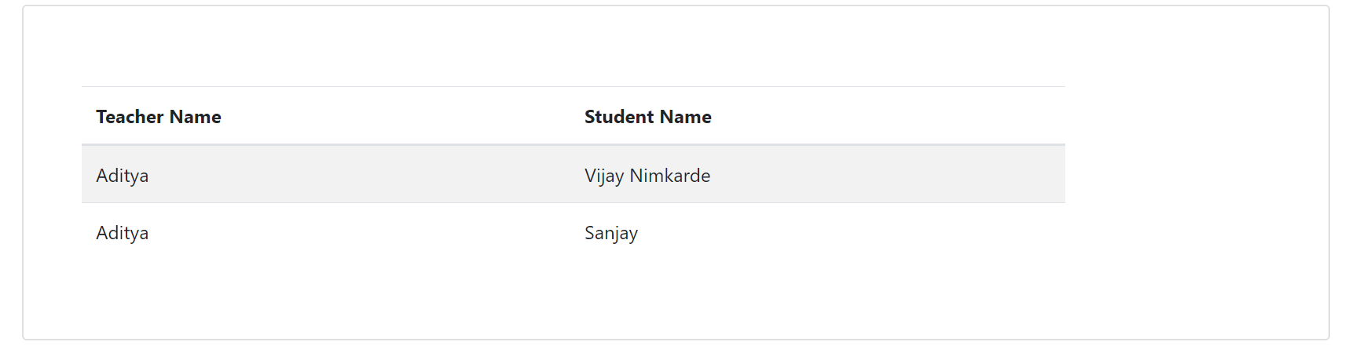

Techer management:

<http://localhost:9090/teachers/list>

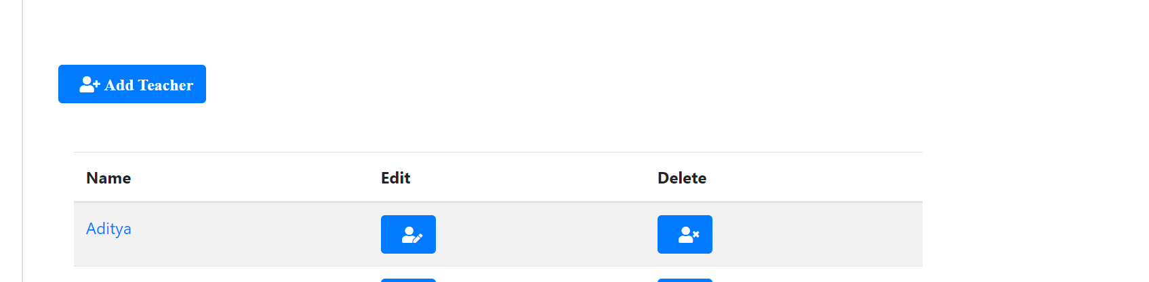

Add teacher:

<http://localhost:9090/teachers/signup>

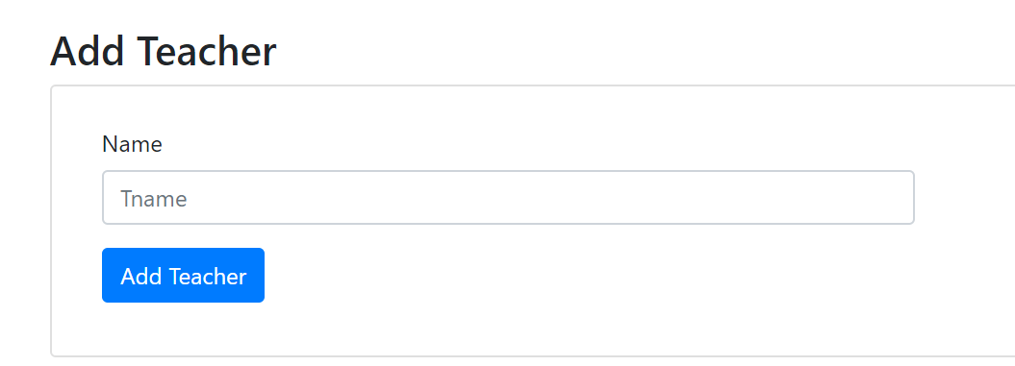

H2 DB Console: open in separate tab

<http://localhost:9090/h2-console/>

add jdbc url: jdbc:h2:mem:testdb

password is password

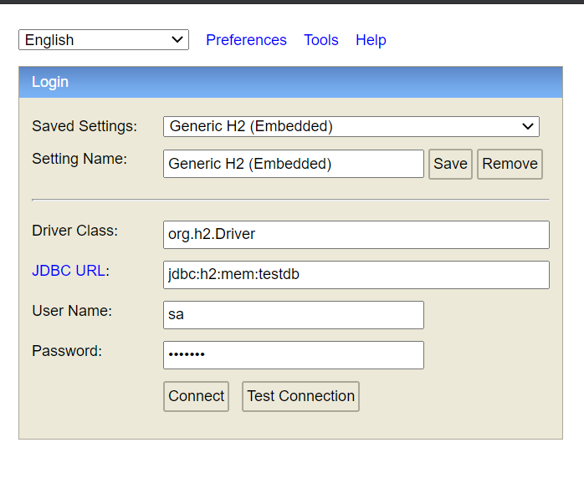

If you want to check in mysql database then follow below steps:

Uncomment properties in application.properties file…

It will work…before that in local, you need to create a **testdb** as mysql database.

Remaining things:

-Student profile and smtp email functionality

-Separate login for each teacher and student…

As shown above under one the scope of this project, we can add/manage teachers and students.

Let us know separate signup and login required for admin, teacher and student…or above done functionality is enough