1. The diagram below shows a dataset with 2 classes and 8 data points, each with only one feature value, labeled f. Note that there are two data points with the same feature value of 6. These are shown as two x’s one above the other.

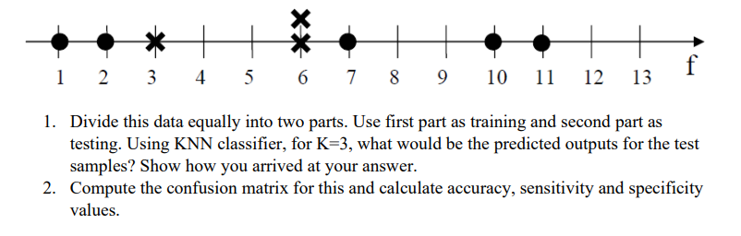

Give data

|  |  |
| --- | --- |
| value | output |
| 1 |  |
| 2 |  |
| 3 |  |
| 6 |  |
| 6 |  |
| 7 |  |
| 10 |  |
| 11 |  |

Training Data:

|  |  |
| --- | --- |
| Value | set |
| 1 |  |
| 2 |  |
| 3 |  |
| 6 |  |

Testing Data:

|  |  |
| --- | --- |
| Value | output |
| 6 |  |
| 7 |  |
| 10 |  |
| 11 |  |

Given k = 3

|  |  |  |
| --- | --- | --- |
| Value | set | distance |
| 1 |  | 5 |
| 2 |  | 4 |
| 3 |  | 3 |
| 6 |  | 0 |

If test data point is (6,0) and train data point is (1,0)

Distance = √[ (x2 – x1)^2 + (y2 – y1)^2]

= 5

If test data point is (6,0) and train data point is (2,0)

Distance = 4

If test data point is (6,0) and train data point is (3,0)

Distance = 3

If test data point is (6,0) and train data point is (6,0)

Distance = 0

Given k = 3

We are taking three near distances 0,3,4

2 -

1 -

|  |  |  |
| --- | --- | --- |
| Value | set | distance |
| 1 |  | 6 |
| 2 |  | 5 |
| 3 |  | 4 |
| 6 |  | 1 |

If test data point is (7,0) and train data point is (1,0)

Distance = √[ (x2 – x1)^2 + (y2 – y1)^2]

= 6

If test data point is (7,0) and train data point is (2,0)

Distance = 5

If test data point is (7,0) and train data point is (3,0)

Distance = 4

If test data point is (7,0) and train data point is (6,0)

Distance = 1

Given k = 3

We are taking three near distances 1,4,5

2 -

1 -

|  |  |  |
| --- | --- | --- |
| Value | set | distance |
| 1 |  | 9 |
| 2 |  | 8 |
| 3 |  | 7 |
| 6 |  | 4 |

If test data point is (10,0) and train data point is (1,0)

Distance = √[ (x2 – x1)^2 + (y2 – y1)^2]

= 9

If test data point is (10,0) and train data point is (2,0)

Distance = 8

If test data point is (10,0) and train data point is (3,0)

Distance = 7

If test data point is (10,0) and train data point is (6,0)

Distance = 4

Given k = 3

We are taking three near distances 4,7,8

2 -

1 -

|  |  |  |
| --- | --- | --- |
| Value | set | distance |
| 1 |  | 10 |
| 2 |  | 9 |
| 3 |  | 8 |
| 6 |  | 5 |

If test data point is (11,0) and train data point is (1,0)

Distance = √[ (x2 – x1)^2 + (y2 – y1)^2]

= 10

If test data point is (11,0) and train data point is (2,0)

Distance = 9

If test data point is (11,0) and train data point is (3,0)

Distance = 8

If test data point is (11,0) and train data point is (6,0)

Distance = 5

Given k = 3

We are taking three near distances 5, 8 , 9

2 -

1 -

Confusion matrix:

|  |  |  |
| --- | --- | --- |
|  | Negative | Positive |
| Negative | 1 | 0 |
| Positive | 3 | 0 |

negative -

Positive -

TN = 1

FN = 3

FP = 0

TP = 0

Accuracy = (TP+TN)/(P+N)

= (TP+TN)/(TP+FN+FP+TN)

= 1/(0+3+0+1)

= 0.25

Sensitivity or true positive rate (TPR) = TP/(TP+FN) = TP/P

= 0/(0+3)

= 0

Specificity or TNR = TN/(FP+TN) = TN/N

= 1/(0+1) =1

= 1