Open powershell:

PS C:\WINDOWS\system32> cd C:\Git\POCTestingExperienceFeedback\POCTestingExperienceFeedback\ClientApp\node_modules

PS C:\Git\POCTestingExperienceFeedback\POCTestingExperienceFeedback\ClientApp\node_modules> npm install react-helmet

C:\Users\patelN\RSInsightsDocs\ReactModal_Demo\ReactModal_Demo\ClientApp\node_modules

For modal

npm install react-bootstrap

npm install react-modal

npm i --save-dev eslint@5.0.0 typescript @typescript-eslint/eslint-plugin@1.13.0 @typescript-eslint/parser@1.13.0

npm i --save-dev eslint@6.8.0 typescript @typescript-eslint/eslint-plugin@2.34.0 @typescript-eslint/parser@2.34.0

npm i eslint-plugin-flowtype@3.13.0

npm install node-sass@4.14.1

Hiding the Survey Title

To hide the survey title from respondents:

1. Go to the **Design Survey** section of your survey.
2. In the left sidebar, click **OPTIONS**.
3. Click **Survey Title** to toggle the setting on and off.

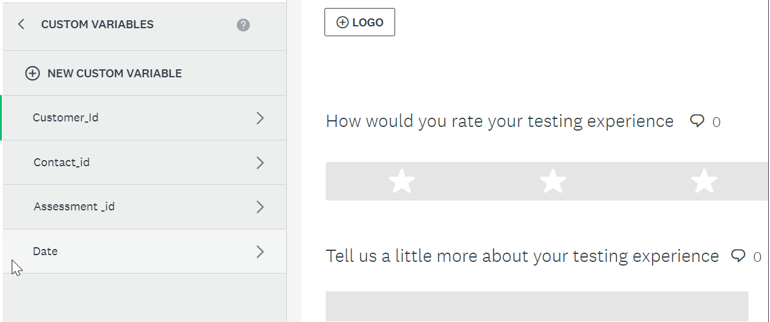

customerId

contactId

AssessmentId

Date