Analysis of Toys product category:

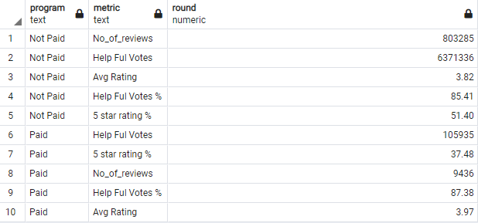

Observations:

1. Un-Paid reviews is showing significant increase 5 star rating showing its not biased based on the program. Even though the avg rating is higher on the Paid program indicating paid users are more likely to give good reviews.
2. No significant variance in the helpful vote % between paid program and unpaid. Indicating reviews are not biased and are equally helpful.

Analysis of Baby product category:

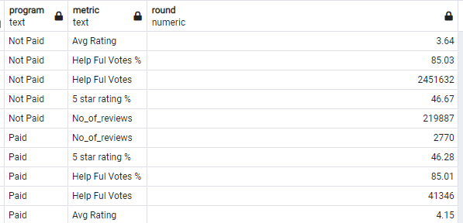

Observations:

1. 5 star rating % showing its not biased based on the program. Avg rating is higher on the Paid program indicating paid users are more likely to give good reviews.
2. No significant variance in the helpful vote % between paid program and unpaid. Indicating reviews are not biased and are equally helpful.