7/29/2021

**Performance Analysis Of Stock Market**

By

Nimmy Jose

Contents

Scope: 1

Analysis Performed: 1

Conclusion: 2

For the year 2014: 2

For the year 2015 3

For the year 2016 4

# Scope:

Create a VBA script to analyze the real stock market data for the year 2014-2016 and provide its performance analysis for each year.

# Analysis Performed:

Created VBA script to loop through given stock market data for the year 2014-2016 and create a view to summarize the performance.

1. Retrieved values for ticker symbol, volume of stock, open price and close price for all years(2014,2015,2016).
2. Created new table with columns like ticker symbol, volume of stock, yearly change and percent change.
3. Formatting was performed on yearly change and percent change column for appropriate representation of data.
4. Summarized the performance by finding stocks with the Greatest % Increase, Greatest % Decrease, and Greatest Total Volume.

# Conclusion:

Below are my findings on the Stock Market for the year 2014, 2015 and 2016:

## For the year 2014:

* Best performing stock was the ticker symbol ‘DM’ with an increase of 5581% in its value.
* Stock ‘CBO’ was the least performing stock which lost around 95% of its value.
* The stock ‘BAC’ was the most traded stock in that year.

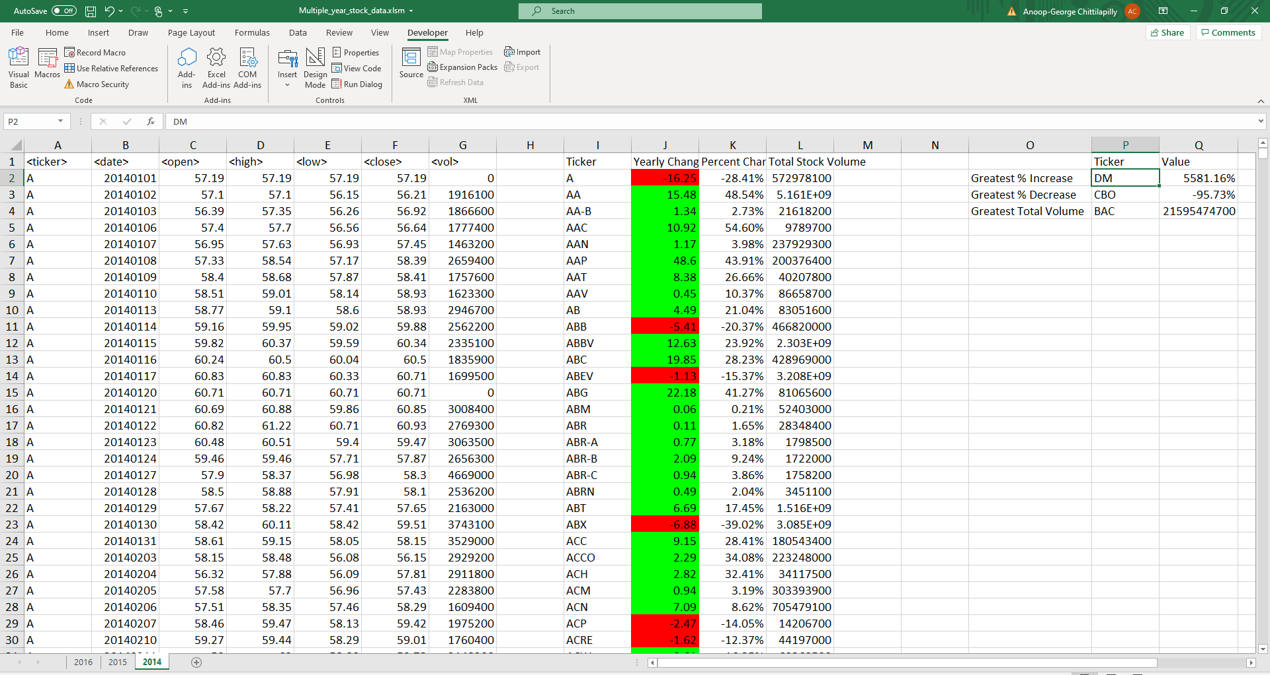

## For the year 2015

* Best performing stock was the ticker symbol ‘ARR’ with an increase of 491% in its value.
* Stock ‘KMI.W’ was the least performing stock which lost around 99% of its value.
* The stock ‘BAC’ was consistent and was the most traded stock in 2015 as well.

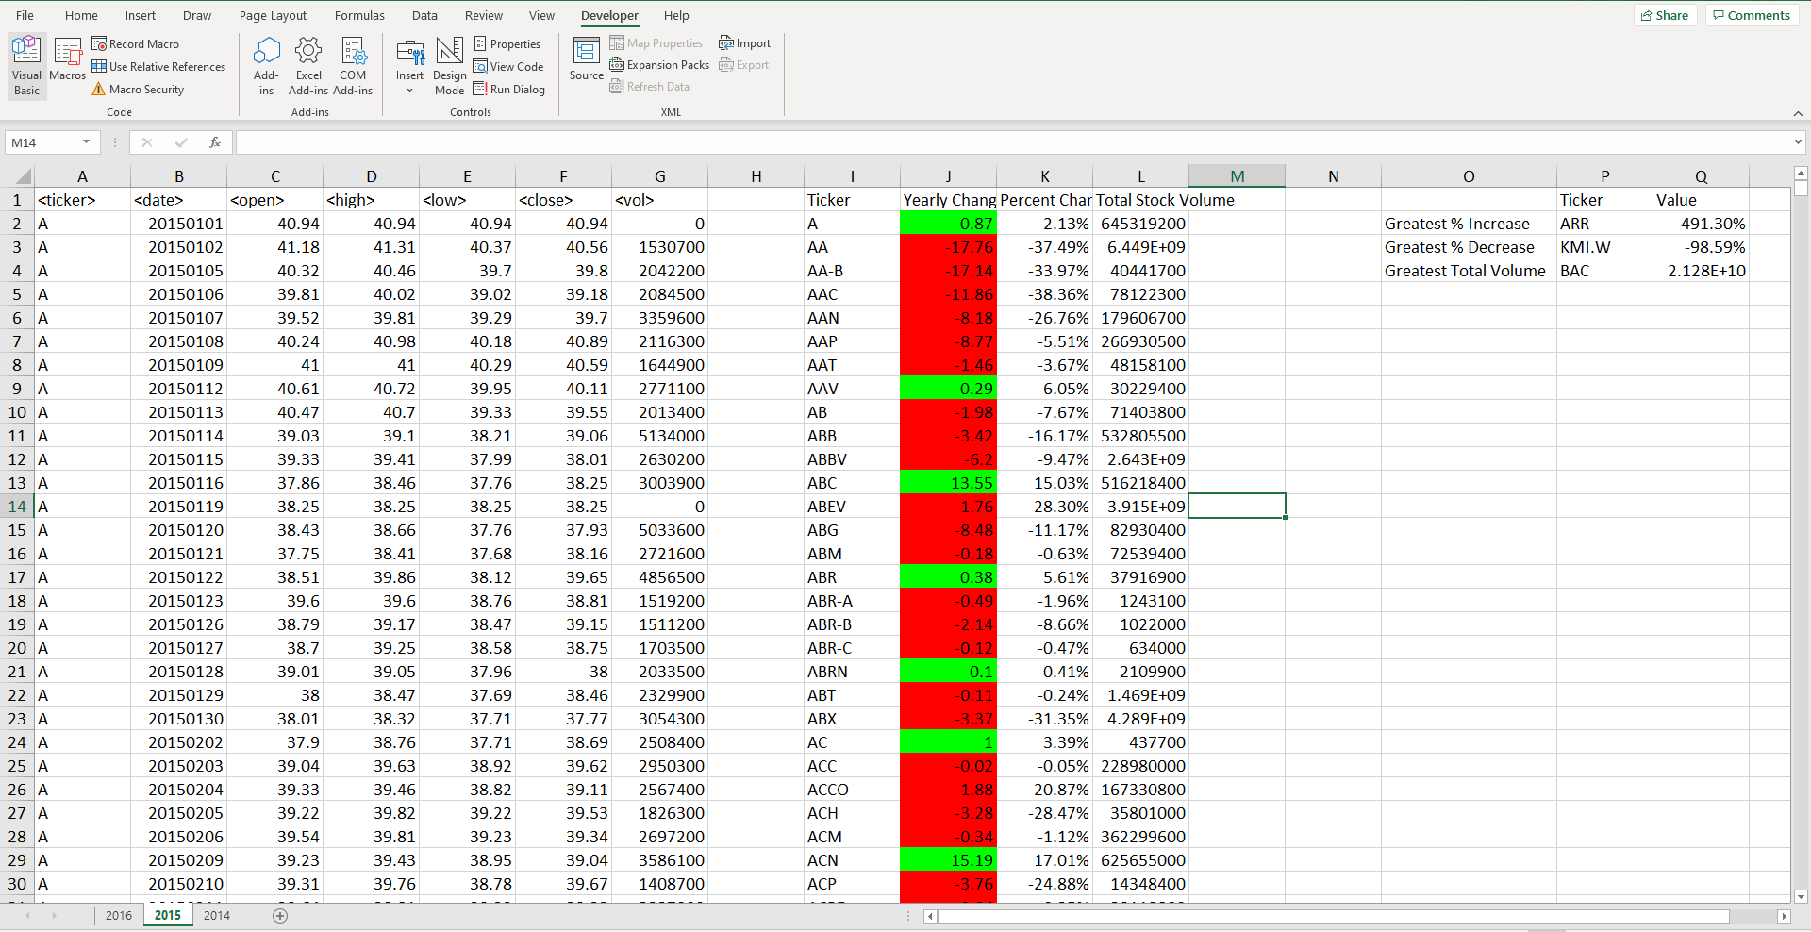

## For the year 2016

* The stock ‘SD’ was the best performing stock which increased its value by 11675%.
* Stock ‘DYN.W’ was the least performing stock which lost around 91% of its value.
* Through 2014-2016 ticker ‘BAC’ remained the stock with high trading volume.

