**C# Lab 04.**

**Question 01.**

**1. Create a C# Console application to convert user given Kilo Meter (km) Value to Meter (m) value. Take a separate Class call “ConvertValues” and inside the class create a method call kilometerTOmeter. (No return type No Parameter Method). And display the answer within the method. Then create an object in main Class (program class) and call the method. ConvertValues.cs** namespace ConsoleApp6

{

internal class ConvertValues

{

public void KilometerToMeter()

{

Console.Write("Enter the distance in kilometers: "); double kilometers = Convert.ToDouble(Console.ReadLine());

double meters = kilometers * 1000;

Console.WriteLine("The distance in meters is: " + meters);

Console.ReadKey();

}

}

}

**Program.cs** using System; using System.Collections.Generic; using System.Linq; using System.Text;

using System.Threading.Tasks;

namespace ConsoleApp6

{

internal class Program

{

static void Main(string[] args)

{

ConvertValues converter = new ConvertValues(); converter.KilometerToMeter();

}

}

}

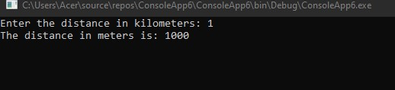

**2. Modify the same user defined method to method which accepts a parameter value. That parameter value is the user given Km value. (No return type with parameter method).**

**Display the answer by using the class object.**

**ConvertValues.cs** namespace ConsoleApp6

{

internal class ConvertValues

{

public void KilometerToMeter(double kilometers)

{

double meters = kilometers * 1000;

Console.WriteLine("The distance in meters is: " + meters);

}

}

}

**Program.cs** using System; using System.Collections.Generic; using System.Linq; using System.Text; using System.Threading.Tasks;

namespace ConsoleApp6

{

internal class Program

{

static void Main(string[] args)

{

Console.Write("Enter the distance in kilometers: "); double kilometers = Convert.ToDouble(Console.ReadLine());

ConvertValues converter = new ConvertValues(); converter.KilometerToMeter(kilometers);

Console.ReadKey();

}

}

}

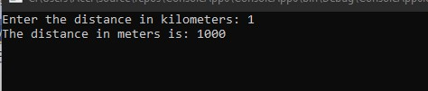

**3. Modify the same user defined method to method which accept a parameter and returns the answer at the end of the method. You should return the calculated Meter value at the end of the method. (With return type with parameter method). Display the answer by using object.**

**ConvertValues.cs**

namespace ConsoleApp6

{

public class ConvertValues

{

public double KilometerToMeter(double kilometers)

{

double meters = kilometers * 1000; return meters;

}

}

}

**Program.cs** using System; using System.Collections.Generic; using System.Linq; using System.Text; using System.Threading.Tasks;

namespace ConsoleApp6

{

internal class Program

{

static void Main(string[] args)

{

Console.Write("Enter the distance in kilometers: "); double kilometers = Convert.ToDouble(Console.ReadLine());

ConvertValues converter = new ConvertValues(); double meters = converter.KilometerToMeter(kilometers);

Console.WriteLine("The distance in meters is: " + meters);

Console.ReadLine();

}

}

}

