## Gift box

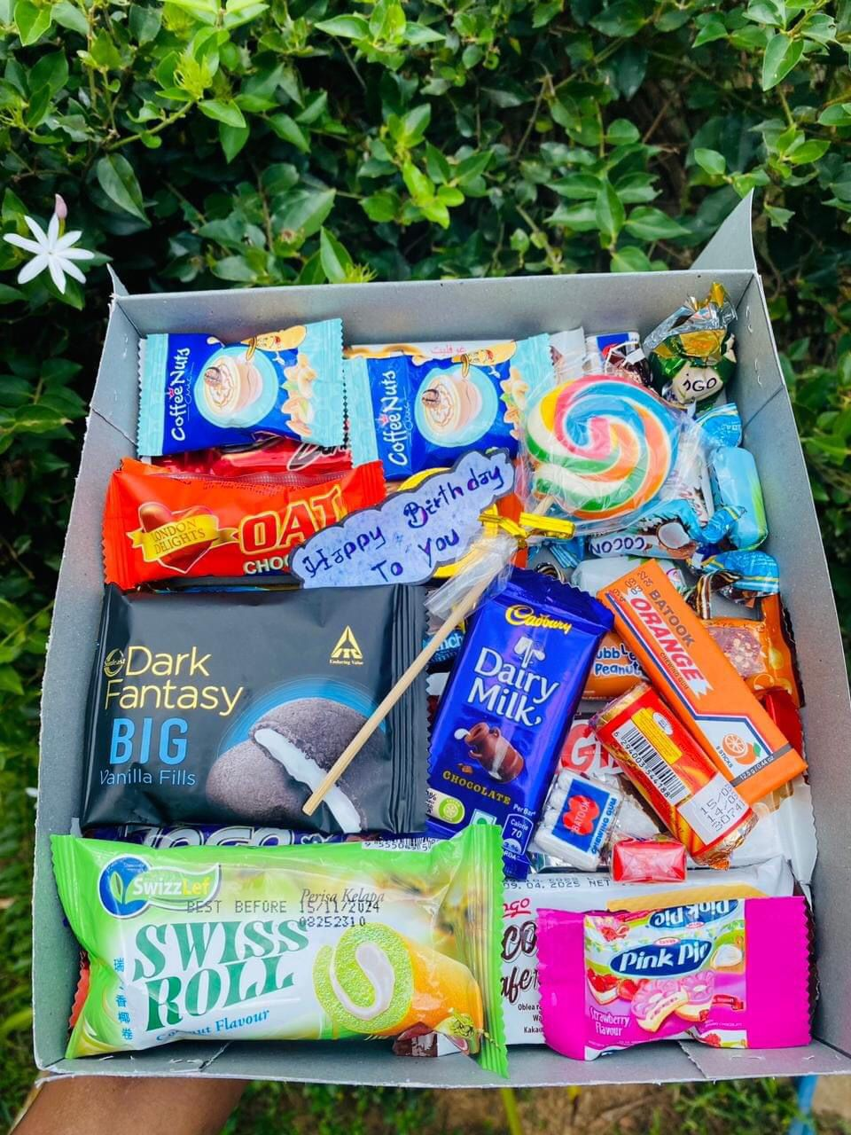

Price: RS.2000

Birthday gift pack



Price: Rs.2000

Little angle gift Box

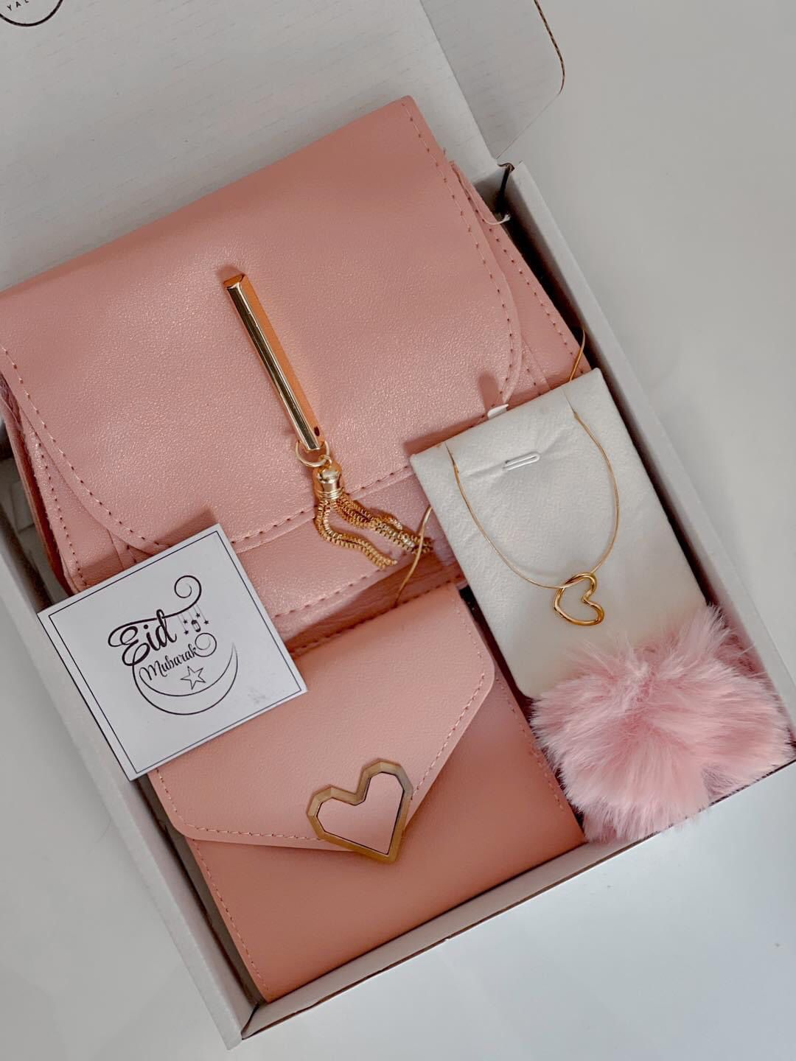

Price: Rs.1800

Pink Gift box

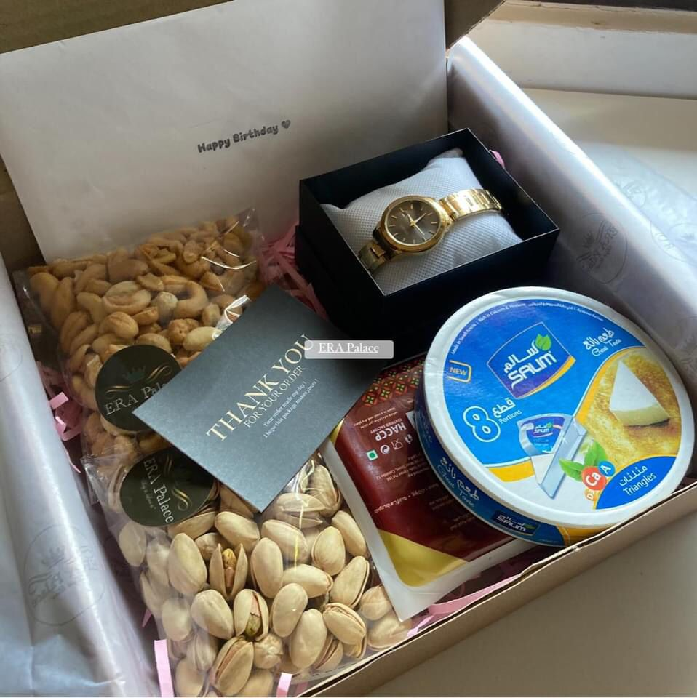

Price: Rs.3000

Foody Gift Box

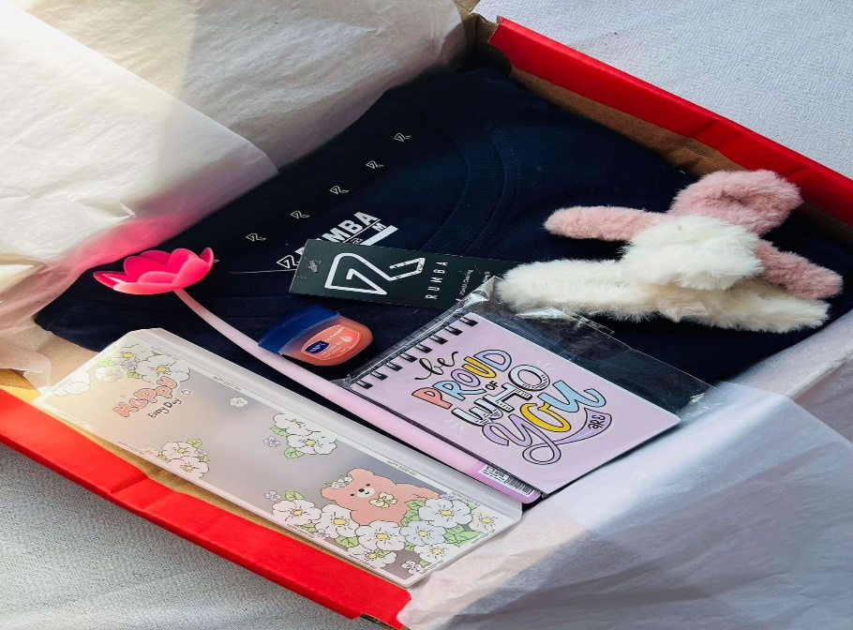

Price: Rs.2300

Valentine surprise box

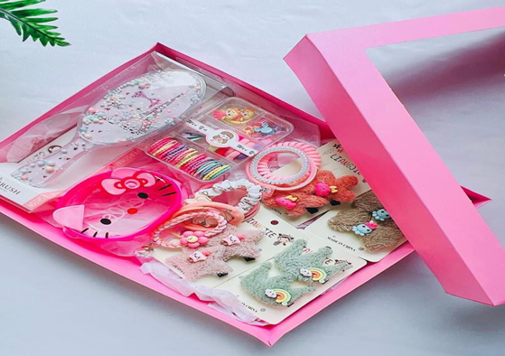

Price: Rs.1500

Stylish surprise box

## Dream catchers

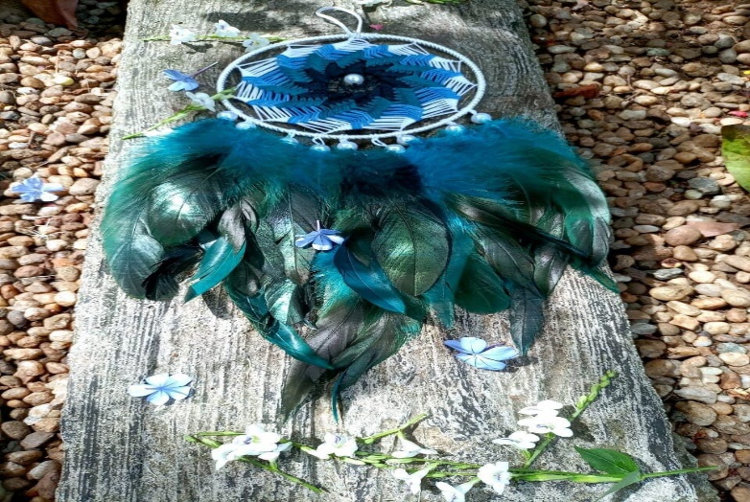

Price: Rs.800

Peacock circle

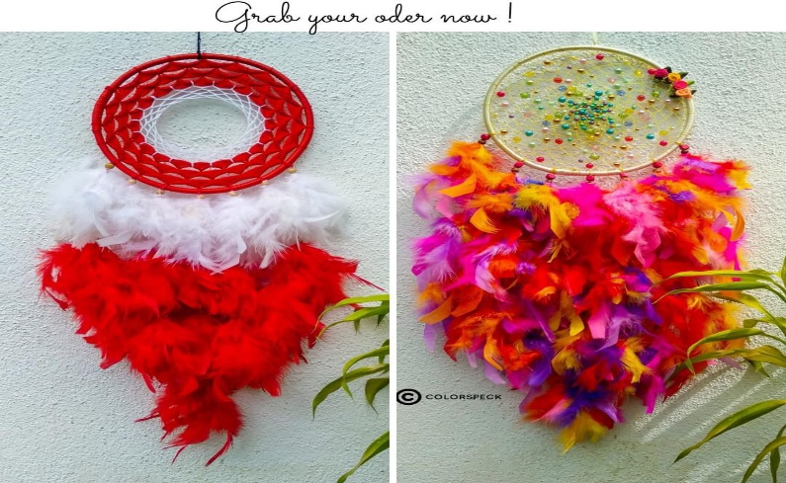

Price: Rs.950

More Feather

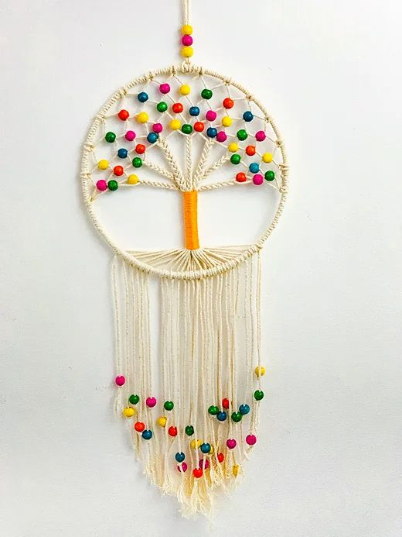

Price: Rs.900

Pearl tree

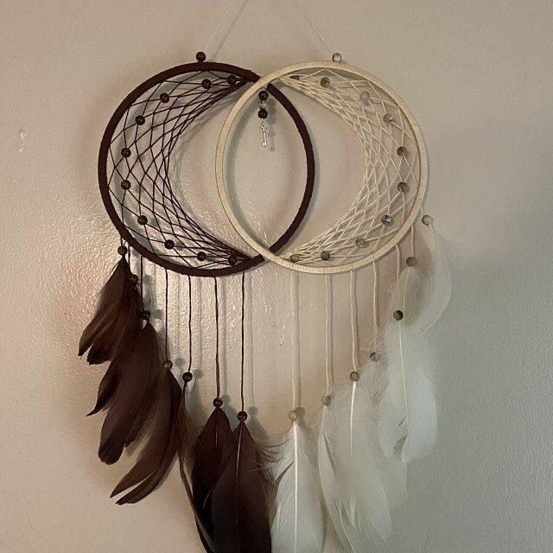

Price: Rs.950

Black and White dream catchers



Price : Rs. 950

Moon Dream catcher

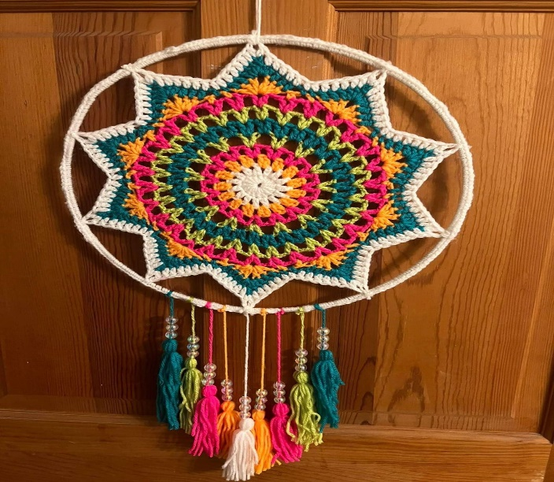

Price :Rs. 800

Wool Dream Catcher

## Teady bears



Price: Rs.2300

Teady Couple

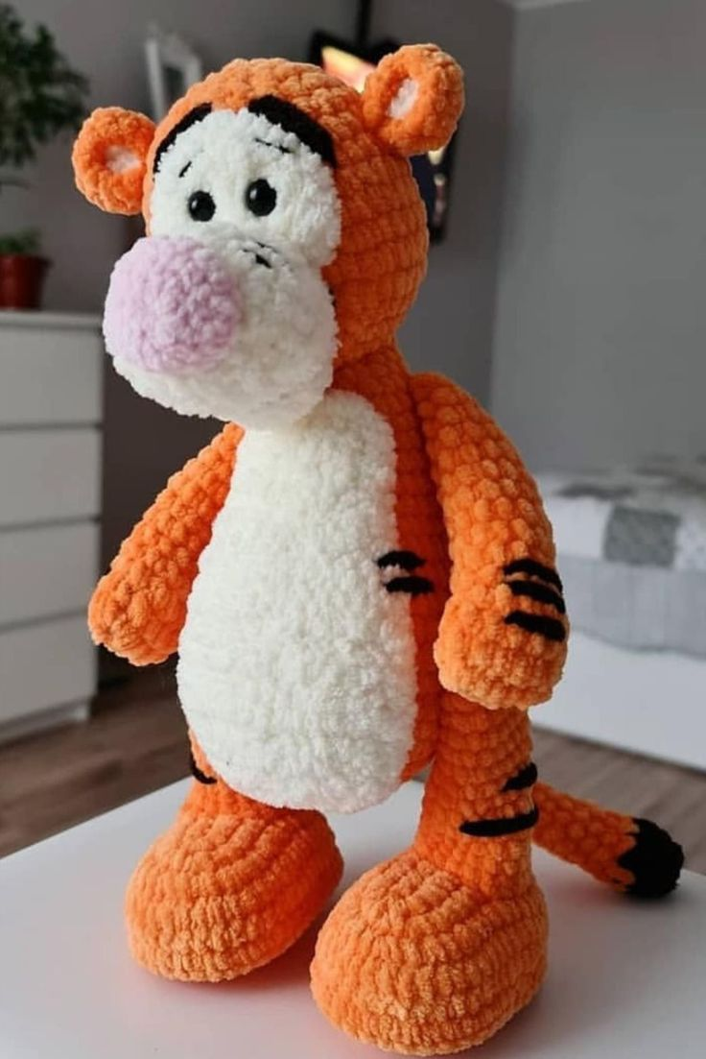

Price:Rs.2300

Crochet Tiger

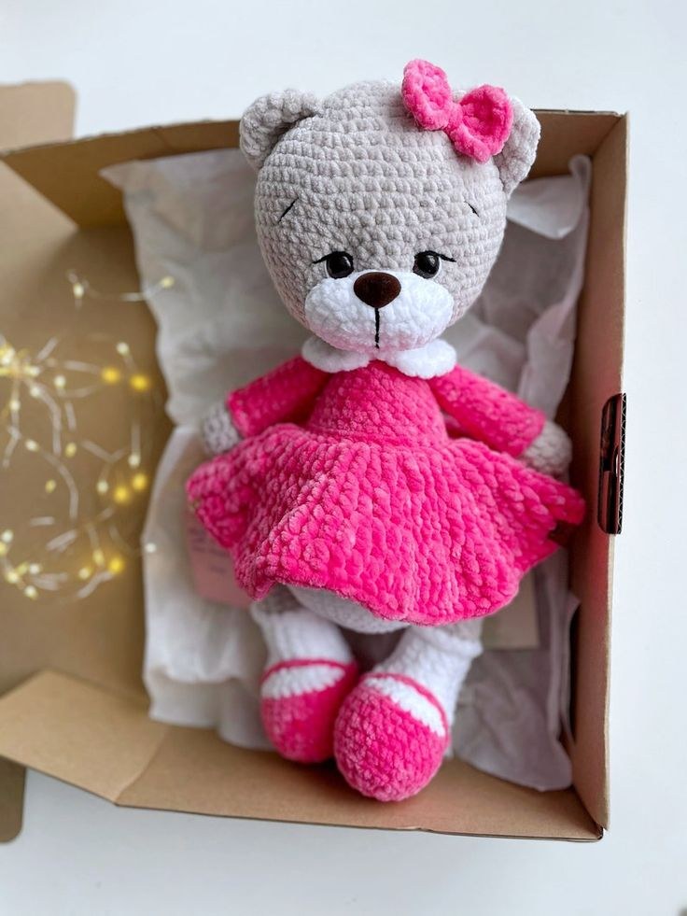

Price: Rs.2000

Pink teady girl

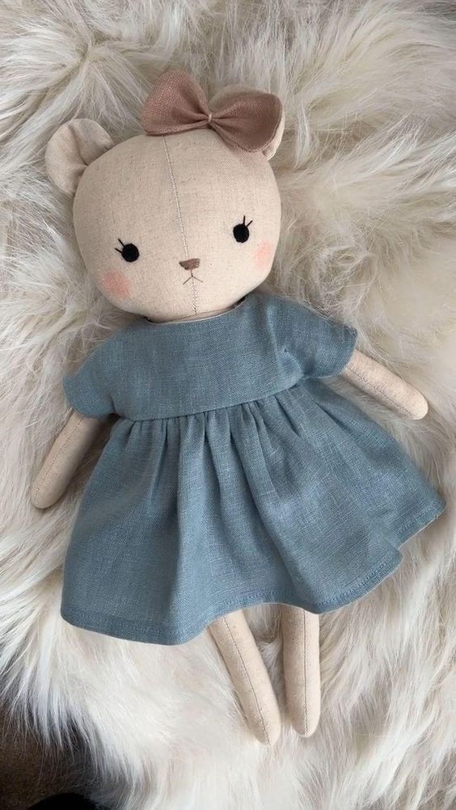

Price: Rs.2000

Bunny girl

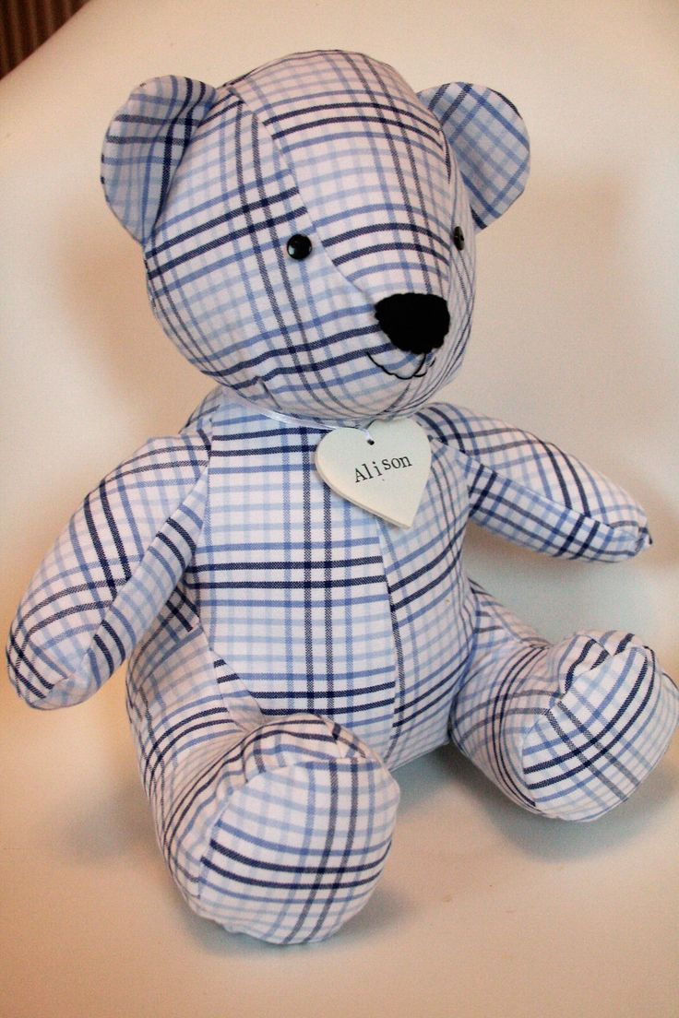

Price: Rs.1800

Cloth teady

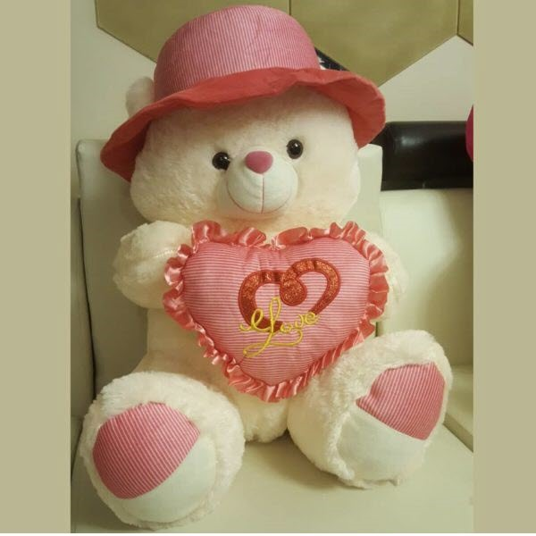

Price:Rs.1900

White love teady