Tazmin Somerville

Module 5.2 Assignment

Assignment: MySQL Functions

**String Function: CONCAT()**

* **Explanation**: The CONCAT() function is useful when you want to combine multiple strings or expressions into one. For instance, you can use it to combine a person’s first and last name into a full name.
* **Use Case**: To concatenate a user's first name and last name into a full name for display.
* **Alias**: Use "Full Name" as the alias.

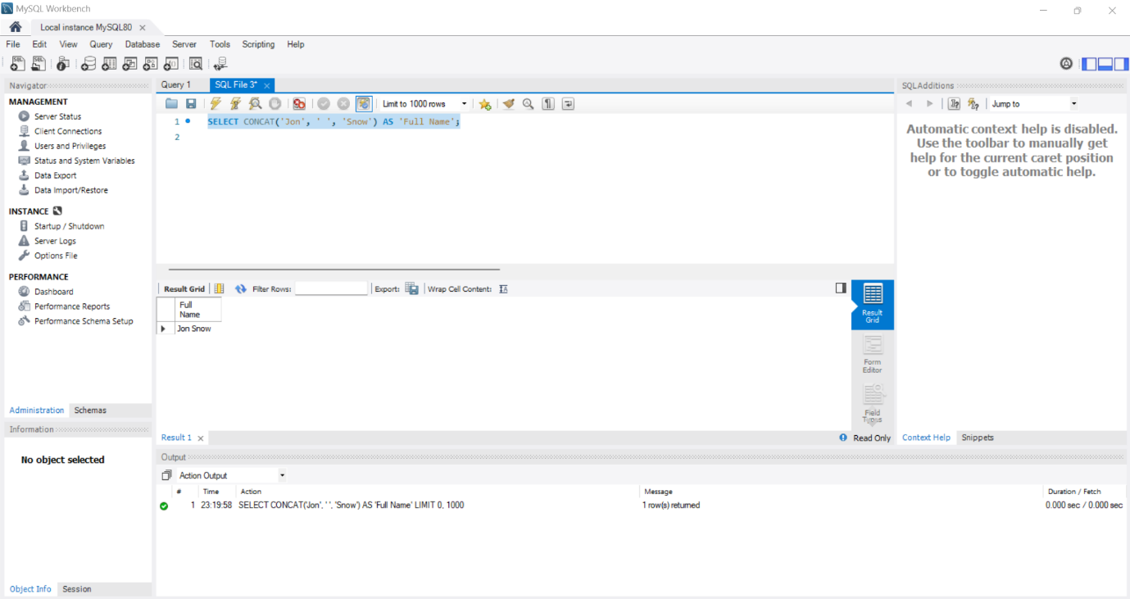

**Numeric Function: ROUND()**

* **Explanation**: The ROUND() function is helpful when dealing with numbers, especially for financial calculations. It allows you to round a number to a specified number of decimal places.
* **Use Case**: Rounding a product price or mathematical result to two decimal places.
* **Alias**: Use "Rounded Price" as the alias.

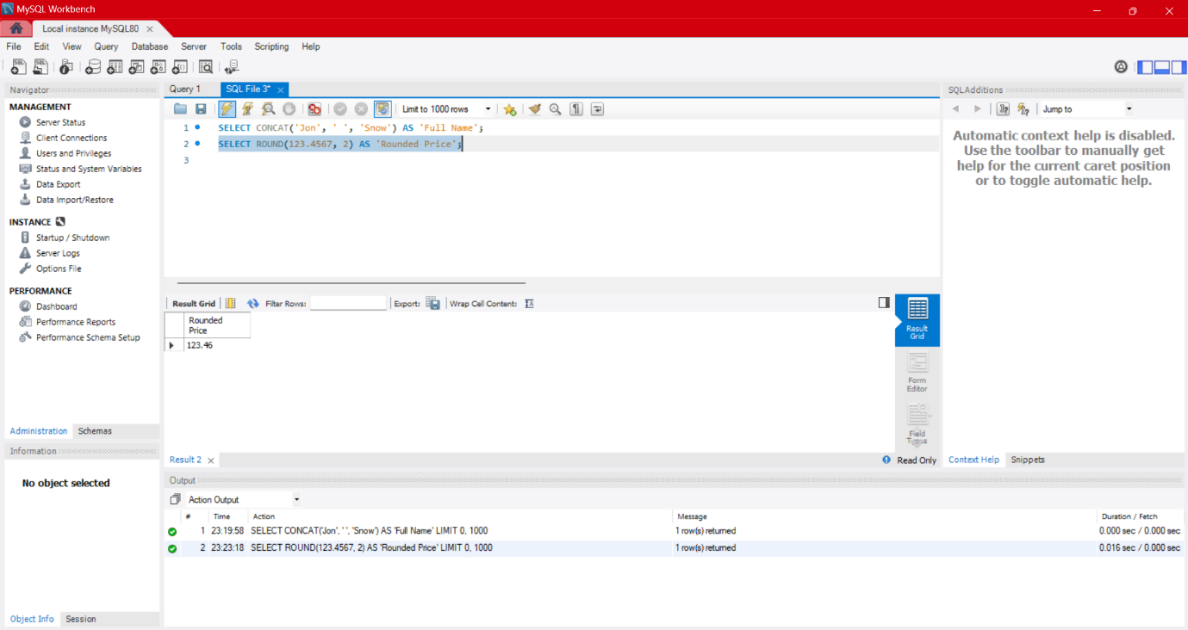

**Date Function: CURRENT_DATE()**

* **Explanation**: The CURRENT_DATE() function retrieves the current date in YYYY-MM-DD format. It’s useful for tracking dates such as when a record was created or updated.
* **Use Case**: Fetching the current date to log when a user made a request or placed an order.
* **Alias**: Use "Today’s Date" as the alias.

