C2- S2 - PRACTICE

# EXERCISE 1 – COUNTRIES

A country is described by

* Its name
* Its population (in millions)
* The capilat name
* The currency (dollar, riel..)

**Q1** Create a class **County** with all the required attributes

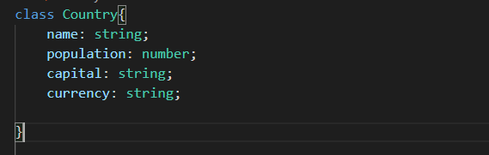

**Q2** Create 3 countries, following this table:

|  |  |  |  |
| --- | --- | --- | --- |
| Name | Population | Capital | currency |
| France | 70 | Paris | Euro |
| Cambodia | 17 | Phnom Penh | Riel |
| UK | 80 | London | Pound |

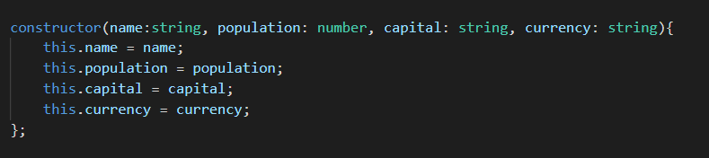

**Q3** Inside the class Country, create a method which return information about the country:

## - getInformation() : string

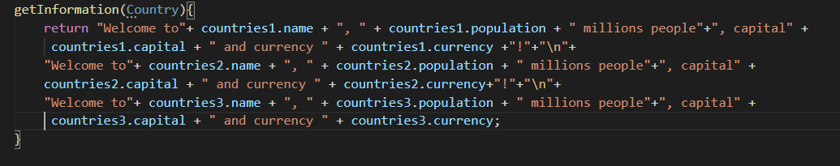

For example, for France country this method shall return:

Welcome to **France**, **70** millions people, cpital **Paris** and currency **Euro**!

# EXERCISE 2 – ALUMNI SALARY

We want to compute the salaries of fresh WEP alumni.

*Note : this is not real word, just for fun for this practice !*

WEP alumni can have different salaries, depending on their :

* Experience in **VueJS** number of years)
* Experience in **NodeJS** (numberof years)
* If they can code or not using **OOP**

|  |  |  |  |
| --- | --- | --- | --- |
| Eperience in VueJS | Eperience in Node JS | Can code OOP | SALARY |
| Less than a year | Less than a year | no | 250 |
| more than a year | Less than a year | no | 350 |
| more than a year | more than a year | no | 450 |
| more than a year | more than a year | yes | 700 |

**Q1** Create a class **WepAlumni** with all the required attributes to compute salary

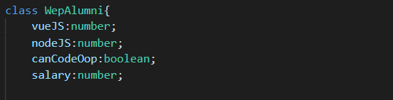

**Q2 Inside this class**, create a method to compute the salary of the alumni: this function should return the **appropriate salary**, based on the criteria specified above.

## getSalary() : number

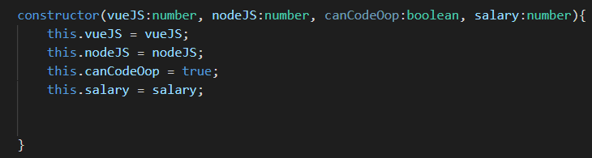

## 

**Q3** Test you code by **creating different alumni** and **check their returned salary**

|  |  |
| --- | --- |
| Alumni profile | Salary |
| 0.5 year experience in VueJS  0.5 year experience in VueJS  Can code in OOP | 250 |
| 1 year experience in VueJS  0.5 year experience in VueJS  Can code in OOP | 350 |
| 2 year experience in VueJS  2 year experience in VueJS  Cannot code in OOP | 450 |
| 2 year experience in VueJS  2 year experience in VueJS  Can code in OOP | 700 |

