5/14/2025

**Authors: Nimra, Lareb, and Zahira Supervisor: Dr. Sher Muhammad Doudpota**

Sukkur Iba university

**SentiView: Transforming Student Feedback into Insightful Visual Narratives While Preserving Sentiments**

**Final Project Report GenAI Semester Project**

## **Introduction**

Student feedback plays a crucial role while evaluating and improving teaching quality and course delivery. The evaluation process of faculty performance heavily relies on student opinions through feedback [1]. With the rise of digital learning platforms, vast amounts of textual reviews are collected, offering valuable insights if analyzed effectively. Traditional methods are time-consuming and prone to bias, highlighting the need for automated sentiment and aspect analysis[2]. Most existing methods focus on identifying overall sentiment independently without recognizing aspects such as teaching methods or subject knowledge within individual reviews[3]. In addition to that, direct sharing of harsh or aggressive comments with teachers can be discouraging, which may hinder constructive reflection[4]. To address these issues, it is important to not only extract useful insights from the feedback but also to present it in a tone that promotes growth and dialogue.

We have developed SentiView, a system that uses Large Language Models (LLMs) and natural language processing (NLP) to analyze student comments using aspect-based sentiment analysis (ABSA). Through an interactive web interface, SentiView delivers insights, extracts aspects (such as behavior and teaching methods) and their sentiments, and paraphrases harsh comments to keep it constructive.

## **Problem Statement**

Despite the availability of vast data for student feedback, institutions often lack efficient tools to process and visualize these responses in a format that highlights the most important aspects of teaching. Manual analysis fails to capture specific aspects and their related sentiments, such as teaching quality, clarity, and engagement. In addition, the direct sharing of overly harsh feedback may be discouraging for teachers. Hence, there is a clear need for an automated system that leverages LLMs to analyze student reviews and presents the results in an accessible and actionable format through an intuitive GUI.

## **Objectives**

The objectives of the project that have been achieved are

* Aspect-level sentiment analyzer system (e.g., teaching methods, knowledge) using large language models, preserving original meaning.
* Qualitative feedback analysis, overcoming manual challenges
* An interactive website for one-click exploration of teacher reviews by subject.
* Improved faculty assessment with detailed, actionable insights.

## **Methodology**

By utilizing the capabilities of lightweight Large Language Models (LLMs), we developed a novel way to do high-speed Aspect-Based Sentiment Analysis (ABSA), as shown in the workflow diagram (Figure 4.2) and the comprehensive methodology diagram (Figure 4.1) from the first proposal. In order to enable robust model training and evaluation, the process started with gathering student feedback from a variety of sources, such as the SIBA dataset [5], the AOH-Senti dataset [6]and other related datasets. These datasets provided labeled reviews with aspects and sentiments. The text data was preprocessed using normalization techniques such lowercasing and punctuation removal, as well as standardizing aspect categories (such as Teaching Pedagogy, Behavior, and Exam Assessment) with the "General" aspect class. The data was sourced from Excel/CSV and PDF files. In order to improve model performance and speed, the text data that came from Excel/CSV and PDF files as illustrated in Figure 4.2 was preprocessed using normalization techniques like lowercasing and punctuation removal, as well as standardizing aspect categories (such as Teaching Pedagogy, Behavior, and Exam Assessment). The "General" aspect class was excluded from training data because it 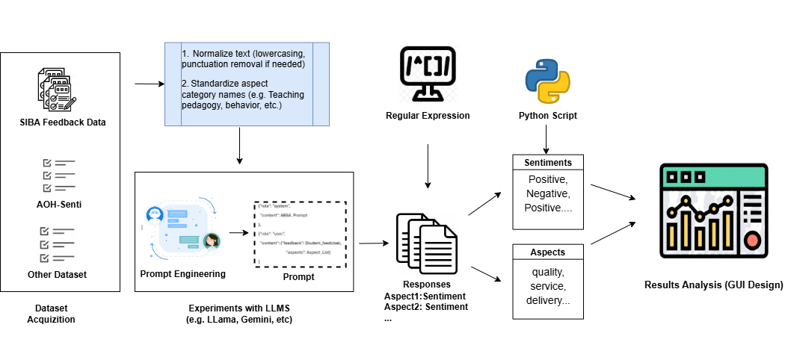was giving poor accuracy, and five distinct aspects were prioritized.

We experimented with four lightweight LLMs for ABSA: Ollama, Mistral, Qwen, and LLaMA. These were chosen for their effectiveness and minimal resource requirements, which ensured quick processing. We further refined and prompt-tuned the model, which was giving better accuracy by extracting aspects from feedback through prompt engineering. The Qwen model (Qwen 2.5 for initial experiments and fine-tuned Qwen 1.5 for improved results) achieved superior performance and faster inference. Outputs were refined by structuring responses into aspects using Python scripts and regular expressions.

Figure 4.1 Methodology Used

The GUI workflow illustrated in figure 4.2 entailed using a Streamlit frontend to upload student reviews in Excel/CSV and PDF files. The data was then transmitted as JSON to a Streamlit backend, where Ollama interacted with the LLM to extract aspects and important details without involving any external API calls for security. Insights into aspect patterns and feedback topics across several categories were made possible by the results being delivered and shown in the front-end using word clouds and bar charts for easy understanding. With real-time processing through a local LLM server accessible by Ngrok, the entire procedure made use of a cloud-hosted web interface. This ensured effective and dynamic visualizations to enable intuitive examination of feedback data with the least amount of delay. This methodology ensured good performance and speed due to lightweight models and practices that were demonstrated.

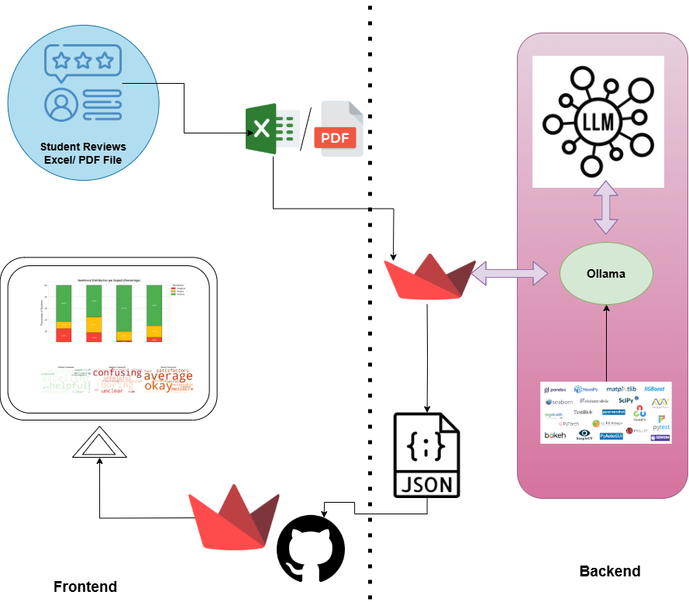

Figure 4.2 GUI Workflow

## **Implementation**

### **Data Acquisition**

We used SIBA [5] dataset, which was labeled with three sentiments (Positive, Negative, and Neutral) and six aspects (Teaching Pedagogy, Knowledge, Experience, Assessment, Behavior, and general) which contained 5,015 lines from 2,180 student reviews. To increase accuracy and processing speed, the "General" aspect was excluded.

### **Data Preprocessing**

To ensure dataset consistency, we used Python modules (pandas, nltk) to standardize aspect categories, lowercase the text data, and remove punctuation.

### **Aspect-Based Sentiment Analysis**

In order to extract aspect-sentiment pairs, we created an ABSA system employing LLMs (LLaMA, mistral,ollama, qwen ) and a unique prompt template. Accurate detection of aspects and sentiments was ensured by prompt engineering. Python scripts and regular expressions were used to process the outputs and organize the results into JSON format.

### **Web Interface Development**

We used Streamlit to create an interactive GUI for both the frontend and backend, taking advantage of its ease of use to facilitate quick development. Among the steps in the workflow were

* Using the file uploader on Streamlit to upload reviews in CSV or PDF format.
* Processing data in Streamlit, managing ABSA and paraphrasing activities using Ollama, and extracting PDF text with PDFplumber.
* Utilizing the wordcloud and plotly libraries, which are included in Streamlit's UI, to visualize data using bar charts and word clouds.

### **Implementation Details**

* **Frontend and Backend:** Streamlit was used in their development, and native components and custom CSS were used to create an intuitive user experience in accordance with the repository's styling guidelines.
* **File Input:** CSV and PDF uploads were supported, and pdfplumber was used to extract the PDF content. In contrast to what was suggested, Excel support was not provided.
* **Model Integration:** To ensure that no API-based models were used for confidentiality, Ollama, Mistral, Qwen (2.5 and refined 1.5), and LLaMA are used on a local machine that was accessible via Ngrok using transformers and ollama.
* **Visualization:** Plotly and Wordcloud were used to highlight feedback topics, while bar charts displayed the sentiment distribution by aspect.
* **Deployment:** Secure connection with the cloud-hosted Streamlit app is made possible by the local Ollama server being made accessible via Ngrok.

## **Results and Discussion**

### **Aspect-Based Sentiment Analysis**

### **Paraphrasing Effectiveness**

### **Web Interface**

### **Faculty Impact**

## **Conclusion**

SentiView provides a reliable way to use NLP and LLMs to analyze student comments. By using ABSA, rephrasing critical comments, and offering a Streamlit-based interface that accepts CSV, Excel, and PDF inputs, it gets around the drawbacks of manual analysis and promotes productive discussion. Teaching results are improved, faculty evaluation is strengthened, and reflective improvement is promoted by the system.

## **Future Work**

* **Dataset Expansion:** For wider application, incorporate input from several universities.
* **Advanced Paraphrasing:** Improve context-sensitive paraphrasing to strike a balance between urgency and tone.
* **Real-Time Analysis:** Facilitate the processing of real-time feedback for dynamic course corrections.
* **Better PDF Handling:** Make text extraction for complicated PDF formats more efficient.

## **References**

[1] R. Hajrizi and K. P. Nuçi, “Aspect-Based Sentiment Analysis in Education Domain,” 2020.

[2] V. Gupta, V. Viswesh, C. Cone, and E. Unni, “Qualitative analysis of the impact of changes to the student evaluation of teaching process,” *American Journal of Pharmaceutical Education*, vol. 84, no. 1. 2020.

[3] T. Shaik, X. Tao, C. Dann, H. Xie, Y. Li, and L. Galligan, “Sentiment analysis and opinion mining on educational data: A survey,” Feb. 2023.

[4] J. Hill, “An in-depth review of the two most common feedback forms in English undergraduate programs: The connection of their consequential academic damages to students perceptions of their teachers, and how video-recorded feedback can combat these effects,” *Int. J. English Lit.*, vol. 15, no. 1, pp. 1–10, Feb. 2024.

[5] I. Sindhu, S. Muhammad Daudpota, K. Badar, M. Bakhtyar, J. Baber, and M. Nurunnabi, “Aspect-Based Opinion Mining on Student’s Feedback for Faculty Teaching Performance Evaluation,” *IEEE Access*, vol. 7, pp. 108729–108741, 2019.

[6] A. Kathuria, A. Gupta, and R. K. Singla, “AOH-Senti: Aspect-Oriented Hybrid Approach to Sentiment Analysis of Students’ Feedback,” *SN Comput. Sci.*, vol. 4, no. 2, Mar. 2023.