





# Introduction

The evaluation process of faculty performance heavily relies on student opinions through feedback, yet qualitative statements remain underused because manual analysis proves difficult (Gupta et al., 2019). Most current methods focus on identifying overall sentiment independently without recognizing particular aspects such as teaching methods or subject knowledge within individual reviews (Hajrizi & Nuçi, Krenare Pireva, 2020). The project employs large language models, which analyze each comment to retrieve multiple aspects with shifted tone adjustments alongside the original intended meaning preservation. The interactive website provides visual presentations that allow users to explore teachers' reviews per subject by just using one click while improving both faculty assessment procedures and educational results.

# Problem Statement

# Methodology

In this task, the basic input is a sentence and an aspect word. Aspect-level SA model will mine the interaction between the both to predict the sentiment polarity on the given aspect. For example, a sentence “… Also, he welcomes students to ask him questions after class. He will answer them enthusiastically and won’t be bored.”

1. Normalize text (lowercasing, punctuation removal if needed)
2. Standardize aspect category names (e.g., mapping "lecture" and "lectures")

# Dataset Discussion

The analyzed dataset contains 5,015 sentences extracted from 2,180 student reviews. Each review statement carries labels for six aspect types, including teaching pedagogy, knowledge, experience, assessment, behavior, and general, alongside one of three sentiment evaluations: positive, negative, and neutral.

**Statistical Overview**

Number of Review: 2,180

Number of sentences: 5,015

Number of aspects: 6 (Teaching Pedagogy, Knowledge, Experience, Assessment, Behavior, General)

Number of Orientation Categories: 3 (Positive, Negative, Neutral)

# Major Outcomes

* + Enables aspect-level sentiment analysis (e.g., teaching methods, knowledge) using large language models, preserving original meaning.
  + Automates qualitative feedback analysis, overcoming manual challenges
  + Provides an interactive website for one-click exploration of teacher reviews by subject.
  + Improves faculty assessment with detailed, actionable insights.
  + Enhances educational outcomes through data-driven teaching strategies.

# Project Timeline

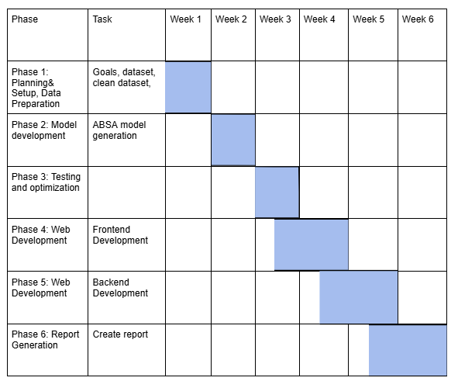

# Conclusion

1. **Bibliography**
   * Gupta, V., Viswesh, V., Cone, C., & Unni, E. (2019). Qualitative Analysis of the Impact of Changes to the Student Evaluation of Teaching Process. American Journal of Pharmaceutical Education, 84(1), 7110. <https://doi.org/10.5688/ajpe7110>
   * Hajrizi, R., & Nuçi, Krenare Pireva. (2020). Aspect-Based Sentiment Analysis in Education Domain. ArXiv.org. <https://arxiv.org/abs/2010.01429>