SENTIVIEW: TRANSFORMING STUDENT FEEDBACK INTO INSIGHTFUL VISUAL NARRATIVES WHILE PRESERVING SENTIMENTS

Idea Proposal Report

GenAI Semester Project

Presentation Link

<https://drive.google.com/open?id=1r4-eDaa9IgnHlQi7QQxSbMjKCQpJPzij&usp=drive_fs>

Authors: Nimra, Lareb and Zahira

Supervisor: Dr. Sher Muhammad Doudpota

# Introduction

Student feedback plays a crucial role while evaluating and improving teaching quality and course delivery. The evaluation process of faculty performance heavily relies on student opinions through feedback (Hajrizi & Nuçi, 2020). With the rise of digital learning platforms, vast amounts of textual reviews are collected, offering valuable insights if analyzed effectively. Traditional methods are time-consuming and prone to bias, highlighting the need for automated sentiment and aspect analysis (Gupta, Viswesh, Cone, & Unni, 2020). Most existing methods focus on identifying overall sentiment independently without recognizing aspects such as teaching methods or subject knowledge within individual reviews (Shaik et al., 2023). In addition to that, direct sharing of harsh or aggressive comments with teachers can be discouraging that may hinder constructive reflection (Hill, 2024). To address these issues, it is important to not only extract useful insights from the feedback but also to present it in a tone that promotes growth and dialogue.

Advancements in Natural Language Processing (NLP) and Large Language Models (LLMs) enable aspect-based sentiment analysis in various fields. These techniques can also be used in student feedback to extract the aspects and related sentiments and also paraphrase overly negative or aggressive feedback while preserving the core sentiment and aspects. By integrating these capabilities into an interactive web interface, our project offers a comprehensive solution that improves both the analysis and delivery of student feedback. while removing the harsh tone. The interactive website provides visualizations that allow users to explore teachers' reviews per subject by just using one click while improving both faculty assessment procedures and educational results.

# Problem Statement

Despite the availability of vast data for student feedback, institutions often lack efficient tools to process and visualize these responses in a format that highlights the most important aspects of teaching. Manual analysis fails to capture specific aspects and their related sentiments such as teaching quality, clarity, and engagement. In addition, the direct sharing of overly harsh feedback may be discouraging for teachers. Hence, there is a clear need for an automated system that leverages LLMs to analyze student reviews and presents the results in an accessible and actionable format through an intuitive GUI.

# Methodology

In this project we propose a novel approach that leverage the potential of Large Language Models (LLMs) such as GPT, Gemini, and Llama for Aspect based sentiment analysis (ABSA). The proposed methodology is presented in Figure 1. We begin by data acquisition for student feedback from sources such as SIBA by (Sindhu et al., 2019), AOH-Senti by (Kathuria, Gupta, & Singla, 2023) , and other relevant datasets. The text data is preprocessed through normalization (e.g., lowercasing, punctuation removal) and standardization of aspect categories (e.g., teaching pedagogy, behavior, exam assessment). Next, we will perform experiments with Large Language Models (LLMs) such as LLaMA and Gemini using prompt engineering to extract aspects and their associated sentiments from the feedback. Outputs are refined using regular expressions and Python scripts to structure responses into aspect-sentiment pairs. Finally, the extracted data is visualized using a GUI-based tool for result analysis.

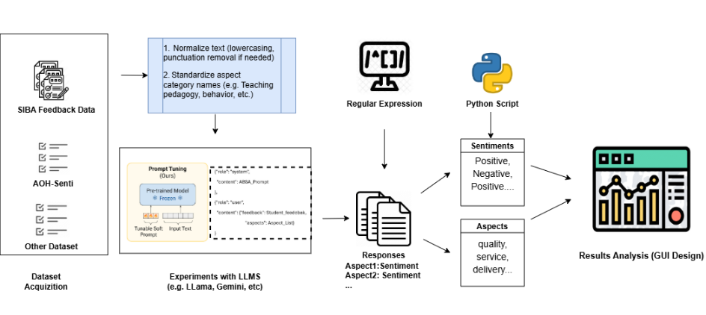

Figure Proposed Methodology

The proposed GUI workflow has been demonstrated in Figure 2. Student reviews are uploaded in Excel/csv format via a React/streamlit frontend. The data is sent as JSON to a Flask backend, where LangChain or Ollama connects with an LLM to extract sentiments and key aspects. Finally, results are returned and visualized in the frontend through bar charts and word clouds for quick interpretation. enabling insights into sentiment trends and feedback themes across various categories. A part from this, we will also enable a functionality that minimize the harsh tone of the reviews.

|  |  |
| --- | --- |
| Figure proposed GUI workflow | Figure proposed Prompt Template |

# Dataset Discussion

The data that we aim to utilize was proposed by (Sindhu et al., 2019) that contains 5,015 sentences extracted from 2,180 student reviews. Each review statement carries labels for six aspect types, including *teaching pedagogy, knowledge, experience, assessment, behavior, and general*, alongside one of three sentiment evaluations: *positive, negative, and neutral*.

## Statistical Overview

Number of Review: 2,180

Number of sentences: 5,015

Number of aspects: 6 (Teaching Pedagogy, Knowledge, Experience, Assessment, Behavior, General)

Number of Orientation Categories: 3 (Positive, Negative, Neutral)

# Major Outcomes

The outcomes of proposed methodology are:

* Aspect-level sentiment analyzer system (e.g., teaching methods, knowledge) using large language models, preserving original meaning.
* Qualitative feedback analysis, overcoming manual challenges
* An interactive website for one-click exploration of teacher reviews by subject.
* Improved faculty assessment with detailed, actionable insights.

# Project Timeline

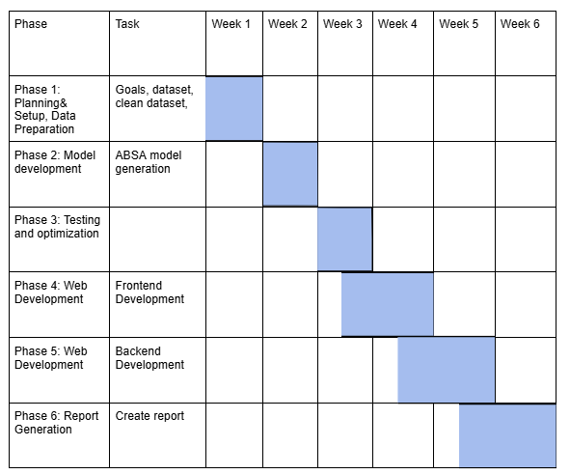

# Conclusion

This project presents a novel approach to analyzing student feedback using advanced NLP techniques and LLMs. By automatically extracting aspect-based sentiments and paraphrasing harsh feedback while preserving its meaning. The system ensures that insights are both accurate and constructive. The integration of these capabilities into an interactive, user-friendly web interface allows stakeholders to explore feedback efficiently, supporting more informed and empathetic faculty evaluations. Ultimately, this solution enhances the feedback process, encourages reflective improvement, and contributes to better teaching outcomes and educational quality.

# References

Gupta, V., Viswesh, V., Cone, C., & Unni, E. (2020). Qualitative analysis of the impact of changes to the student evaluation of teaching process. *American Journal of Pharmaceutical Education, 84*(1), 7110.

Hajrizi, R., & Nuçi, K. P. (2020). Aspect-based sentiment analysis in education domain. *arXiv preprint arXiv:2010.01429*.

Hill, J. (2024). An in-depth review of the two most common feedback forms in English undergraduate programs: The connection of their consequential academic damages to students’ perceptions of their teachers, and how video-recorded feedback can combat these effects.

Kathuria, A., Gupta, A., & Singla, R. K. (2023). AOH-Senti: aspect-oriented hybrid approach to sentiment analysis of students’ feedback. *SN Computer Science, 4*(2), 152.

Shaik, T., Tao, X., Dann, C., Xie, H., Li, Y., & Galligan, L. (2023). Sentiment analysis and opinion mining on educational data: A survey. *Natural Language Processing Journal, 2*, 100003.

Sindhu, I., Daudpota, S. M., Badar, K., Bakhtyar, M., Baber, J., & Nurunnabi, M. (2019). Aspect-based opinion mining on student’s feedback for faculty teaching performance evaluation. *IEEE Access, 7*, 108729-108741.