| **Assignment # 9**  ***Session*: Spring 2022 *Total marks*: 100**  ***Name*** : ***____________________ Roll number* : _____________** |
| --- |

***Submission:***

• *Email instructor or TA if there are any questions. You cannot look at others’ solutions or use others’ solutions, however, you can discuss it with each other. Plagiarism will be dealt with according to the course policy.*

*• Submission after due time will not be accepted.*

**There should be a Report explaining your code and highlighting results. Follow this naming convention for your report RollNumber_Assignment#.pdf e.g BSEE21001_Assignment7.pdf.**

**TASK:**

Write a C++ program that implements the given class hierarchy.

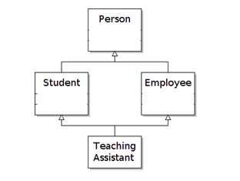

A Teaching Assistant is an employee and a student. Both employee and student are persons.

Person is an abstract class. Person has a name, age, gender, education, language he speaks, etc. Since Person is an abstract class so make virtual functions.

Students have gpa, semester, field, etc.

Employees have salary, rank( like HOD or dean or assistant professor) etc.

Following methods should be implemented:

- Copy constructor

- Deep copy constructor

- Dectructor

- Function overriding

- Initializer List

- Deleting pointers

- Display() and setter/getter

- Make a menu driven code.

**Note:** Do not use strings. User char pointers instead.

|  |
| --- |