Simple calculator app

Go to app and then java in MainActivity.java

Code for input:

public class MainActivity extends AppCompatActivity {  
 EditText etfirstvalue,etsecondvalue;  
 Button btnadd,btnsub,btnmultiply,btndivide;  
 Double num1,num2;  
 TextView tvresult;  
  
 @Override  
 protected void onCreate(Bundle savedInstanceState) {  
 super.onCreate(savedInstanceState);  
 setContentView(R.layout.*activity_main*);  
 etfirstvalue=findViewById(R.id.*etfirstvalue*);  
 etsecondvalue=findViewById(R.id.*etsecondvalue*);  
 btnadd=findViewById(R.id.*btnadd*);  
 btnsub=findViewById(R.id.*btnsub*);  
 btnmultiply=findViewById(R.id.*btnmultiply*);  
 btndivide=findViewById(R.id.*btndivision*);  
 tvresult=findViewById(R.id.*tvresult*);  
 Clicklistener();  
 }  
  
 public void Clicklistener()  
 {  
 btnadd.setOnClickListener(new View.OnClickListener() {  
 @Override  
 public void onClick(View v) {  
 num1=Double.*parseDouble*(etfirstvalue.getText().toString());  
 num2=Double.*parseDouble*(etsecondvalue.getText().toString());  
 Double result=num1+num2;  
 tvresult.setText(String.*valueOf*(result));  
  
 }  
 });  
 btnsub.setOnClickListener(new View.OnClickListener() {  
 @Override  
 public void onClick(View v) {  
 num1=Double.*parseDouble*(etfirstvalue.getText().toString());  
 num2=Double.*parseDouble*(etsecondvalue.getText().toString());  
 Double result=num1-num2;  
 tvresult.setText(String.*valueOf*(result));  
  
 }  
 });  
  
 btnmultiply.setOnClickListener(new View.OnClickListener() {  
 @Override  
 public void onClick(View v) {  
 num1=Double.*parseDouble*(etfirstvalue.getText().toString());  
 num2=Double.*parseDouble*(etsecondvalue.getText().toString());  
 Double result=num1*num2;  
 tvresult.setText(String.*valueOf*(result));  
 }  
 });  
 btndivide.setOnClickListener(new View.OnClickListener() {  
 @Override  
 public void onClick(View v) {  
 num1=Double.*parseDouble*(etfirstvalue.getText().toString());  
 num2=Double.*parseDouble*(etsecondvalue.getText().toString());  
 Double result=num1/num2;  
 tvresult.setText(String.*valueOf*(result));  
 }  
 });  
 }  
}

Go to res and then layout make activity_main :

Write this code

<?xml version="1.0" encoding="utf-8"?>  
<LinearLayout xmlns:android="http://schemas.android.com/apk/res/android"  
 xmlns:app="http://schemas.android.com/apk/res-auto"  
 xmlns:tools="http://schemas.android.com/tools"  
 android:layout_width="match_parent"  
 android:layout_height="match_parent"  
 android:orientation="vertical"  
 tools:context=".MainActivity">  
 <TextView  
 android:layout_width="match_parent"  
 android:layout_height="wrap_content"  
 android:text="Simple Calculator"  
 android:textSize="25sp"  
 android:gravity="center"  
 android:layout_margin="10dp"  
 />  
  
 <EditText  
 android:id="@+id/etfirstvalue"  
 android:layout_width="match_parent"  
 android:layout_height="wrap_content"  
 android:hint="Enter First Value"  
 android:layout_margin="10dp"  
 android:inputType="number" />  
  
 <EditText  
 android:id="@+id/etsecondvalue"  
 android:layout_width="match_parent"  
 android:layout_height="wrap_content"  
 android:hint="Enter Second Value"  
 android:layout_margin="10dp"  
 android:inputType="number" />  
 <TextView  
 android:id="@+id/tvresult"  
 android:layout_width="match_parent"  
 android:layout_height="wrap_content"  
 android:text="Result"  
 android:textSize="20sp"  
 android:layout_margin="10dp"  
 android:gravity="center"  
 android:textColor="@color/black"  
  
 />  
 <LinearLayout  
 android:layout_width="match_parent"  
 android:layout_height="wrap_content"  
 android:orientation="horizontal"  
 android:layout_marginVertical="10dp"  
 android:layout_marginHorizontal="10dp"  
 android:weightSum="2">  
  
 <Button  
 android:id="@+id/btnadd"  
 android:layout_width="0dp"  
 android:layout_height="wrap_content"  
 android:layout_weight="1"  
 android:layout_marginHorizontal="10dp"  
 android:text="ADD"  
 android:backgroundTint="@color/grey"  
 />  
  
 <Button  
 android:id="@+id/btnsub"  
 android:layout_width="0dp"  
 android:layout_height="wrap_content"  
 android:layout_weight="1"  
 android:layout_marginHorizontal="10dp"  
 android:text="Sub"  
 android:backgroundTint="@color/grey"  
 />  
  
  
 </LinearLayout>  
 <LinearLayout  
 android:layout_width="match_parent"  
 android:layout_height="wrap_content"  
 android:orientation="horizontal"  
 android:layout_marginVertical="10dp"  
 android:layout_marginHorizontal="10dp"  
 android:weightSum="2">  
  
 <Button  
 android:id="@+id/btnmultiply"  
 android:layout_width="0dp"  
 android:layout_height="wrap_content"  
 android:layout_weight="1"  
 android:layout_marginHorizontal="10dp"  
 android:text="Multiply"  
 android:backgroundTint="@color/grey"  
 />  
  
 <Button  
 android:id="@+id/btndivision"  
 android:layout_width="0dp"  
 android:layout_height="wrap_content"  
 android:layout_weight="1"  
 android:layout_marginHorizontal="10dp"  
 android:text="Divid"  
 android:backgroundTint="@color/grey"  
 />  
  
  
 </LinearLayout>  
</LinearLayout>

Output shows addition:

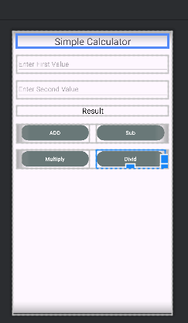

I add this code in color.xml for button color:

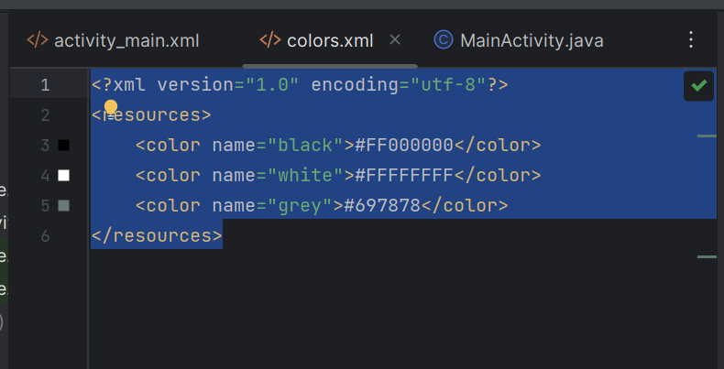

<?xml version="1.0" encoding="utf-8"?>  
<resources>  
 <color name="black">#FF000000</color>  
 <color name="white">#FFFFFFFF</color>  
 <color name="grey">#697878</color>  
</resources>