**Use case**

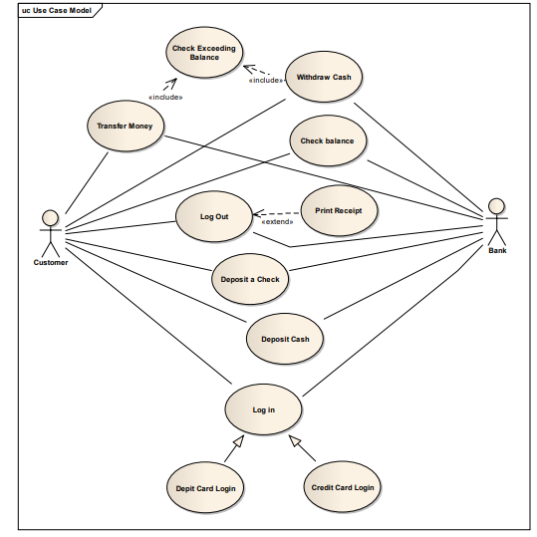

**Class diagram**

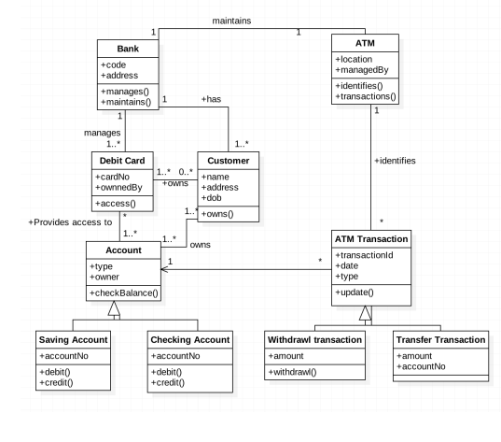

**Sequence diagram**

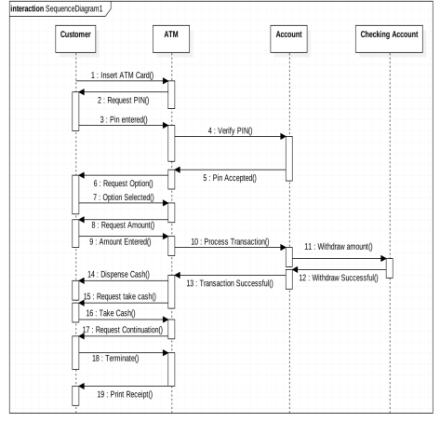

**Fully dressed use case:**

|  |  |
| --- | --- |
| **Use case elements** | **Description** |
| **Use Case Name** | Issue Book to Member |
| **Actors** | Primary Actor: Librarian,Secondary Actor(s): Library Member, Library Database |
| **Stakeholders and Interests**: | **Librarian**: Wants to ensure the book issue process is smooth and keeps accurate records.  **Member**: Wants to borrow books without complications and return them in a timely manner.  **library Administrator**: Needs to maintain an up-to-date record of books issued, returned, and available.  **Library System**: Needs accurate data for book inventory and member borrowing records. |
| **Preconditions:** | * The librarian must be logged into the system. * The member must be registered with the library and have a valid membership. * The book must be available (i.e., not already issued or reserved by another member). |
| **Postconditions:** | * The due date for the return is recorded. * The member's borrowing limit is updated. |
| **Main Success Scenario**: | * Librarian selects 'Issue Book' option on the library management system interface. * System prompts the librarian to enter the member’s ID. * Librarian inputs the member’s ID into the system. * The system verifies the member's eligibility (e.g., no overdue books, membership is active, borrowing limit not reached). * Librarian scans or enters the book’s ISBN or title into the system. * The system checks the availability of the book (ensures it is not already issued or reserved). * If available, the system marks the book as issued to the member and records the due date. * The system updates the member’s borrowing limit and book inventory. * System confirms the successful issue of the book. * Librarian hands the book to the member and informs them of the due date. |
| **Assumptions:** | * The system is connected to an up-to-date database. * The librarian has the necessary permissions to issue books. |

**Communication diagram:**

