Biomedical Image-Analysis Pipeline: Nuclei Segmentation & Description
Student ID: 24142732 | Student Name : Nimra Khizar

1. Task 1 Data Preparation, EDA & Multimodal LLM Description
Eighty 256x256 RGB training images were shrunk to 256x256 and converted to grayscale. Sparse, normal, dense, and clustered density regimes are seen across the dataset.

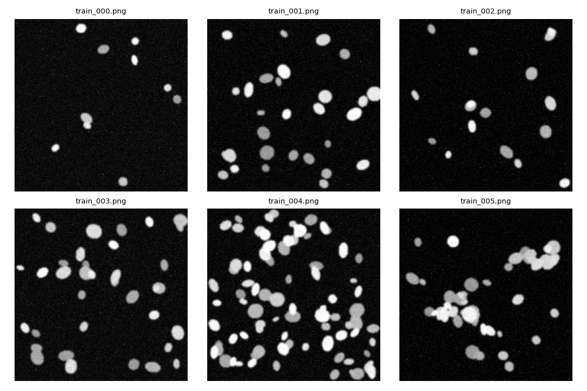
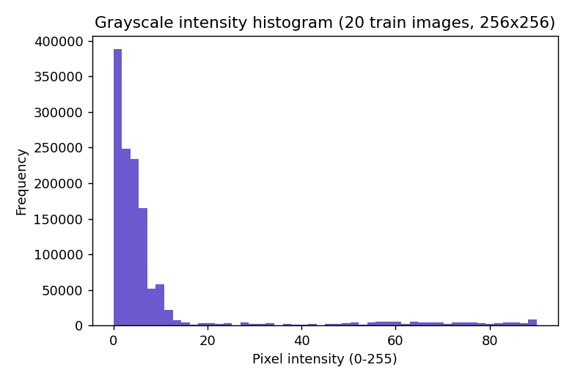
A 20-image sample's mean pixel intensity was 9.14 (std 18.15, 0-255 scale). Bright nuclei and an almost black background are consistent with fluorescence microscopy.
Optimized Structured Prompt (as used):
I used a structured prompt to make the model focus only on what could actually be seen in the microscopy image. The prompt also made it clear that the model was not being used for diagnosis and should not guess any disease or treatment. If the model was unsure about something, it was instructed to write “uncertain” instead of making a guess. The response also had to follow the given JSON format exactly.
Naive prompt (as used):
“What do you see in this microscopy image?”
Model note: Initially, I tried to use llama3.2-vision through Ollama, but it could not load because of the “unknown model architecture: 'mllama'” error. Because of this, the pipeline automatically switched to llava, which was compatible with the Ollama setup. Therefore, the three vision-model calls below were produced using llava.
Naive prompt output (llava):
The model described the image as having regularly arranged circular objects and suggested that they could be cells with nuclei. It also interpreted the blue colour as being related to fluorescent staining and mentioned possible microscopy techniques such as immunostaining or FISH. However, these interpretations went beyond what could be confidently confirmed just by looking at the image.
Structured prompt – Run 1 (llava):
The first structured run identified the modality as fluorescence microscopy but marked the tissue type and image quality as uncertain. It described bright blue dots distributed across a dark background and did not identify any clear nuclei or other distinctive structures.
Structured prompt – Run 2 (same image and same prompt):
The second run again identified the image as fluorescence microscopy and the tissue type as uncertain. However, this time it described the blue spots as having a regular pattern and gave the image quality as “good” instead of “uncertain.”
Comparison of the two runs:
The two outputs were not exactly the same, even though I used the same image and the same structured prompt. In the first run, the image quality was marked as “uncertain”, while in the second run it was marked as “good.” The second run also added a statement about a regular pattern that was not mentioned in the first response.
This shows that the VLM can produce slightly different interpretations from repeated calls. Both outputs followed the required JSON structure, but the differences mean that a single VLM response should not automatically be treated as ground truth.

2. Task 2: Classical Numbers & Features：
I applied Otsu thresholding first and then used morphological opening and closing to reduce speckle noise. After that, the connected components were labelled, and I created a feature table for each detected object using regionprops_table. The table included measurements such as area, eccentricity, solidity, mean intensity, perimeter, and the major and minor axis lengths.

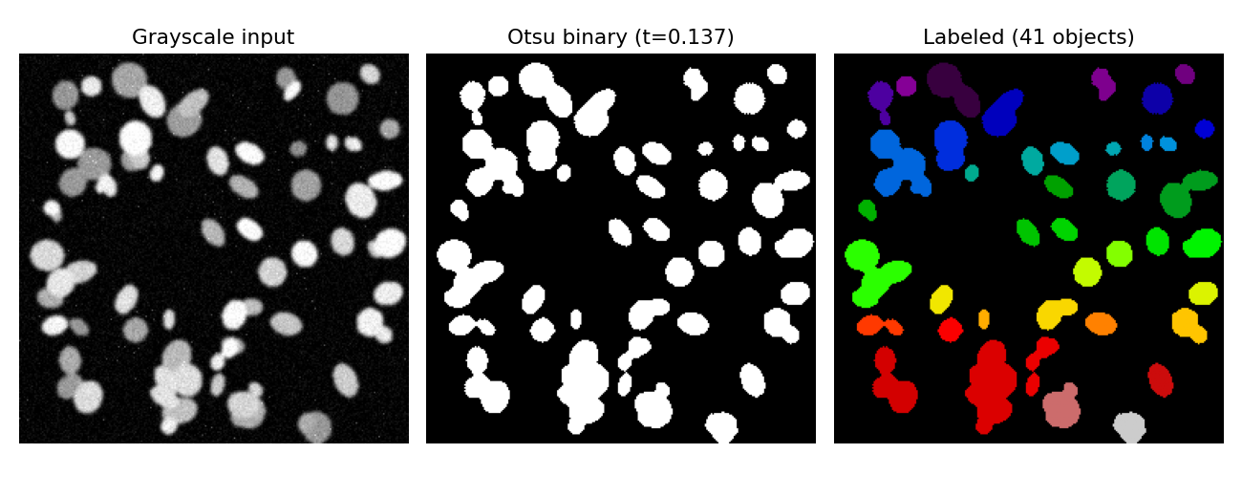
The LLM (test_004) received a summary of simply numbers; the model only saw this text and never the image:
"Image test_004: 41 linked components were found using Otsu thresholding and morphological cleanup. The median object area is 244.0 px^2, whereas the mean is 344.0 px^2. The mean solidity is 0.92 (1.0=fully convex, no dents), while the mean eccentricity is 0.65 (0=circle, 1=line). On a scale of 0 to 1, the mean intensity inside objects is 0.26.
Response to llama3.2 (text model):
"The object population is probably made up of small, uniform, and convex objects based on the dimensions given. While the mean solidity of 0.92 suggests that the objects are not substantially dent-free, the mean object area of 344.0 px^2 and median of 244.0 px^2 reflect a relatively small size. The items appear to be dark in hue based on their low mean intensity (0.26).
JSON: { "n_objects": 41, "density_class": "dense", "shape_regularity": "regular", "quality_flag": "reliable" }
3. Task 3: U-Net Segmentation:
Using a Colab T4 GPU, a compact 3-level U-Net (PyTorch, base=16 channels, BCE+Dice loss, Adam, lr=1e-3) was trained from start for 15 epochs on the 80-image train split at 128x128 resolution (10.4s total training time).
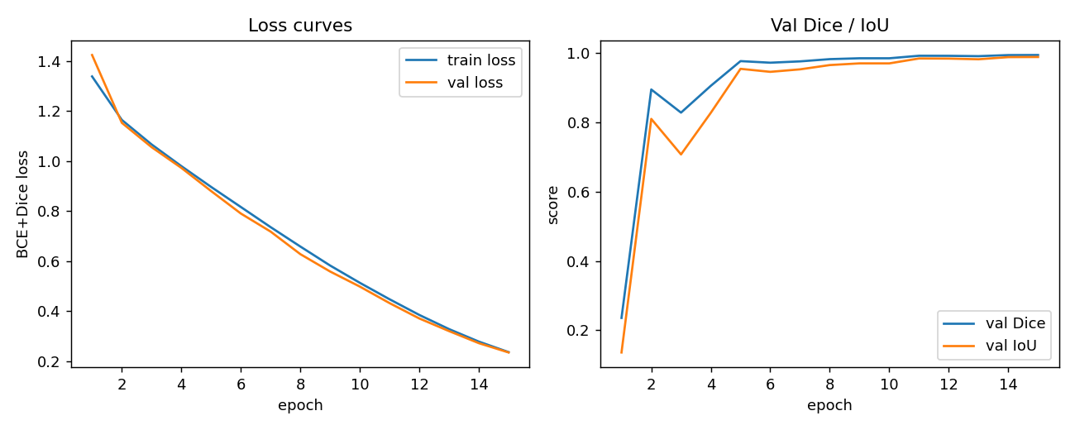
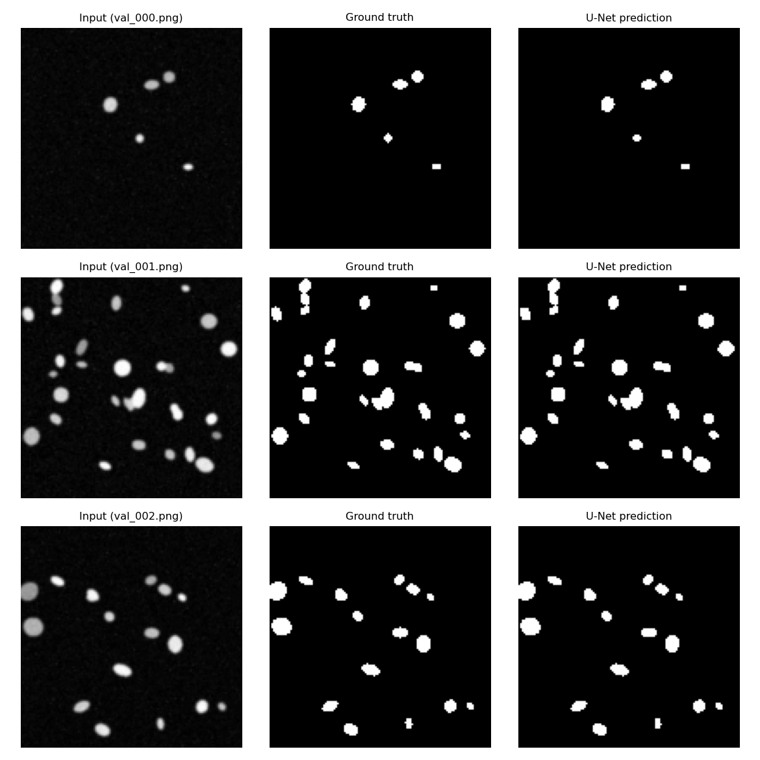
IoU: 0.9885 (20-image val split, thresholded at 0.5); final validation Dice: 0.9942. Training steadily converged: val_dice was 0.828 by epoch 3 and 0.905 by epoch 4, leaped to 0.977 by epoch 5, then grew gradually (with a brief plateau around epochs 9–10) to 0.9942 by epoch 15, with train and val loss tracking closely throughout (no overfitting was observed). U-Net versus Otsu+morphology, assessed against ground-truth masks on the same 12 held-out TEST image：
Metric | U-Net (mean) | Otsu+morph (mean)
Dice | 0.9951 | 0.9384
IoU | 0.9902 | 0.8841

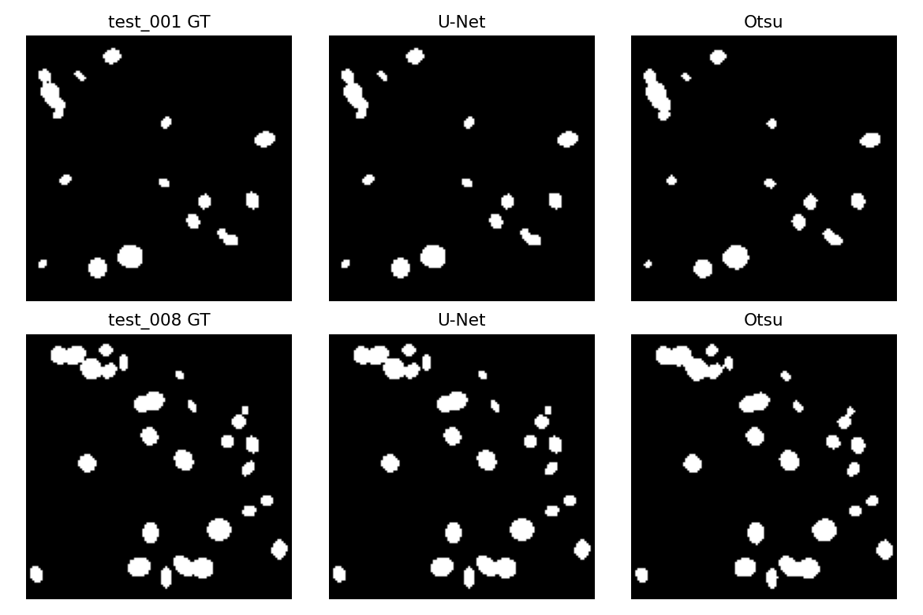
Across all 12 test images, the U-Net model performed better than Otsu. The Dice score improvement ranged from +0.0474 to +0.0761. The largest difference was seen in Test_001, where U-Net achieved a Dice score of 0.9957 compared with 0.9196 for Otsu, giving a difference of +0.0761. The smallest improvement was found in Test_008, with scores of 0.9964 for U-Net and 0.9490 for Otsu. Overall, U-Net gave the better result on every test image, while Otsu did not outperform it on any image in this synthetic dataset.
4. Task 4: Using Unseen Test Images in a Hybrid Pipeline:
The U-Net was first used to generate the masks, and then regionprops was applied to extract the main features into a table. From these measurements, the density_class was calculated using a fixed deterministic rule. We then used Llama 3.2 to phrase and organize these results into a structured JSON record. Finally, a short paragraph was produced for each of the twelve test images. The full outcomes are shown below:
image_id | n_objects | mean_area | density_class | quality_flag
test_000 | 8 | 47.0 | sparse | reliable
test_001 | 14 | 49.6 | sparse | reliable
test_002 | 25 | 56.7 | normal | reliable
test_003 | 19 | 51.7 | normal | reliable
test_004 | 43 | 81.9 | dense | reliable
test_005 | 15 | 108.1 | normal | reliable
test_006 | 8 | 50.0 | sparse | reliable
test_007 | 23 | 50.4 | normal | reliable
test_008 | 23 | 60.2 | normal | reliable
test_009 | 21 | 44.9 | normal | reliable
test_010 | 35 | 93.7 | dense | reliable
test_011 | 19 | 48.3 | normal | reliable
Example narration (llama3.2, actual output for every image): test_000 (sparse) "This image contains 8 distinct objects with relatively uniform areas, suggesting a sparse density class." For example, image_004 is classified as dense and contains 43 distinct regions. The mean area per region is 81.9 pixels². The quality flag for all 12 images was "reliable". The full table of 12 narratives is saved in outputs/task4_hybrid_records.csv.

Extension Robustness
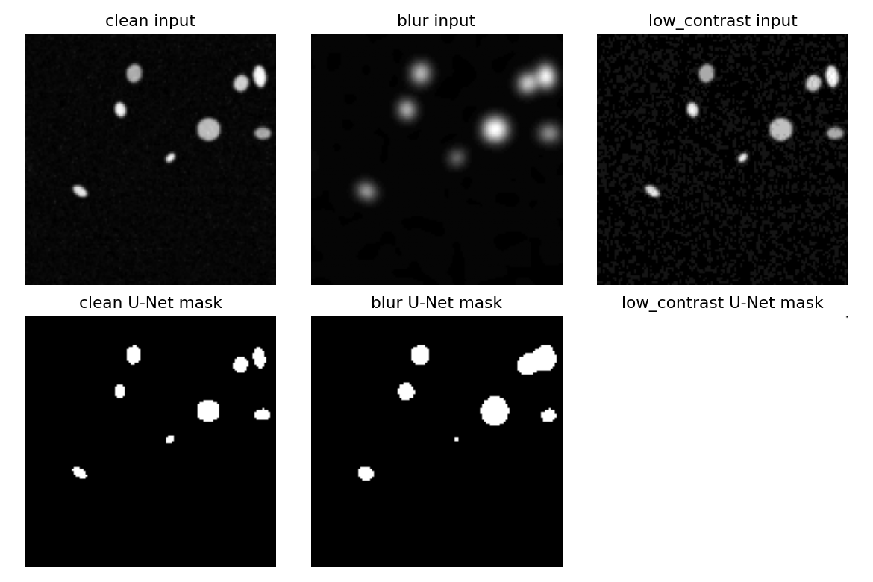
Variant | n_objects (U-Net) | mean_area
clean | 8 | 47.0
blur | 7 | 86.7
low_contrast | 1 | 16383.0
We also tested what happens if the mask is corrupted before feature extraction. A segmentation collapse is the worst case. In this case, the mask collapses into one giant region covering almost the whole 128x128 frame, with an area of 16,383 pixels instead of the normal 47.0 pixels. In contrast, blur is handled much better. Under blur, the object count only dropped from 8 to 7, and the mean area increased slightly as blobs merged, but the shapes remained roughly circular. This shows that the U-Net mask itself is the first place where such contamination can and should be detected, before any features or LLM output are generated.

5. Critical Analysis Answers to Set Questions

1. Which description is more useful, and which is more trustworthy, the direct VLM description (Task 1) or the numbers-first description (Task 2) and why?

The direct VLM description from Task 1 is more useful for rich visual details because it describes features directly from the image. The numbers-first description from Task 2 is more trustworthy because it uses deterministic measurements from Otsu and regionprops, making results auditable and consistent. The reason VLM is less trustworthy is that repeated runs on the same image gave different outputs for image_quality, showing variability. In contrast, numbers are reproducible because they come from fixed image processing steps. Therefore, VLM is better for description, but numbers-first is better for reliability.

2. Did the U-Net improve on classical Otsu segmentation for your modality? Give one example image where each approach did better.

Yes, U-Net performed better than Otsu on all 12 test images. The mean Dice score was 0.9951 for U-Net, compared with 0.9384 for Otsu. The biggest improvement was on test_001, where U-Net achieved a Dice score that was 0.0761 higher than Otsu. The smallest difference was on test_008, with an improvement of 0.0474. In this case, the image was already relatively clean, so Otsu also performed reasonably well. There was no test image where Otsu gave a better result than U-Net. Overall, the results show that U-Net was more effective for this dataset.
3. Report your U-Net’s Dice and IoU. What do these numbers mean, and where does the model tend to make its mistakes (which images or regions)?

Validation: Dice = 0.9942, IoU = 0.9885.

Test: Dice = 0.9951, IoU = 0.9902.

Dice and IoU measure overlap between prediction and ground truth, with values closer to 1 indicating better agreement. These high scores mean the model learned the synthetic dataset very well. Most mistakes occurred around small or dim objects because they have low contrast and fewer pixels for the model to learn from. However, since the dataset is small and synthetic, these results may not generalize to real clinical images with more noise and variation.
4. Where in the pipeline can the LLM hallucinate, and what design choices reduce that risk? Why does keeping the structured JSON as the “source of truth” help?

The LLM could produce unsupported information at several stages of the pipeline. In Task 1, for example, it could make assumptions about the tissue or suggest information that cannot actually be confirmed from the image. In Tasks 2 and 4, it could also misunderstand or incorrectly describe the numerical measurements provided to it.

I reduced this risk by using a more controlled prompt, preventing diagnostic claims, and allowing the model to use “uncertain” when it was not confident. I also calculated the numerical features before sending them to the LLM, rather than asking the model to calculate them itself. This means that the LLM mainly has to summarise information that has already been measured.

Keeping the structured JSON as the source of truth is also useful because important values such as n_objects and mean_area can be checked against the segmentation results. Even if the generated narrative is not completely accurate, the original numerical measurements remain available for verification.
5. Considering accuracy, auditability, and the limits of your dataset, would you trust any part of this system in a real clinical setting? What single change would most improve trustworthiness?

No, I would not trust the complete system in a real clinical setting in its current form. The main reason is that the dataset is relatively small and synthetic, so it does not represent all the noise, staining differences, and biological variation that could occur in real clinical images.

One important problem appeared with the low-contrast images. In that case, the segmentation produced one very large object, but the pipeline still marked the result as “reliable.” This suggests that the system needs a better way of detecting abnormal segmentation results.

The single change I would make first is to add a mask-level quality-control step immediately after U-Net segmentation. For example, the system could check whether the object count or total mask area falls outside an expected range. If something looks abnormal, the result could be flagged before the feature extraction and LLM stages. This would reduce the chance of an incorrect segmentation result being passed through the rest of the pipeline.

References
Ronneberger, O., Fischer, P. and Brox, T. (2015) 'U-Net: Convolutional Networks for Biomedical Image Segmentation', in Medical Image Computing and Computer-Assisted Intervention (MICCAI 2015). Springer, pp. 234–241.
Otsu, N. (1979) 'A Threshold Selection Method from Gray-Level Histograms', IEEE Transactions on Systems, Man, and Cybernetics, 9(1), pp. 62–66.
van der Walt, S. et al. (2014) 'scikit-image: image processing in Python', PeerJ, 2, e453.
Milletari, F., Navab, N. and Ahmadi, S.-A. (2016) 'V-Net: Fully Convolutional Neural Networks for Volumetric Medical Image Segmentation', in Proceedings of the Fourth International Conference on 3D Vision (3DV). IEEE, pp. 565–571. [Dice loss formulation used in this pipeline's BCE+Dice loss.]
Ollama (2024) Ollama documentation. Available at: https://ollama.com (Accessed: August 2026). [Local model runtime for llama3.2, llama3.2-vision and llava.]
Kingma, D.P. and Ba, J. (2015) 'Adam: A Method for Stochastic Optimization', in Proceedings of the 3rd International Conference on Learning Representations (ICLR).
Nickolay-K (2026) Assingnment-3-dataset [synthetic DAPI-like fluorescence-microscopy nuclei dataset]. Available at: https://github.com/Nickolay-K/Assingnment-3-dataset (Accessed: August 2026).

