Biomedical Image-Analysis Pipeline: Nuclei Segmentation & Description
Student ID: 24142732 | Student Name : Nimra Khizar
GitHub link: https://github.com/nimrakhizar9822-droid/Nimra-Khizar
1. Task 1 Data Preparation, EDA & Multimodal LLM Description
Eighty training images of 256x256 RGB images have been reduced to 256x256 grayscale images. The dataset includes a range of density regimes – sparse, normal, dense and clustered.

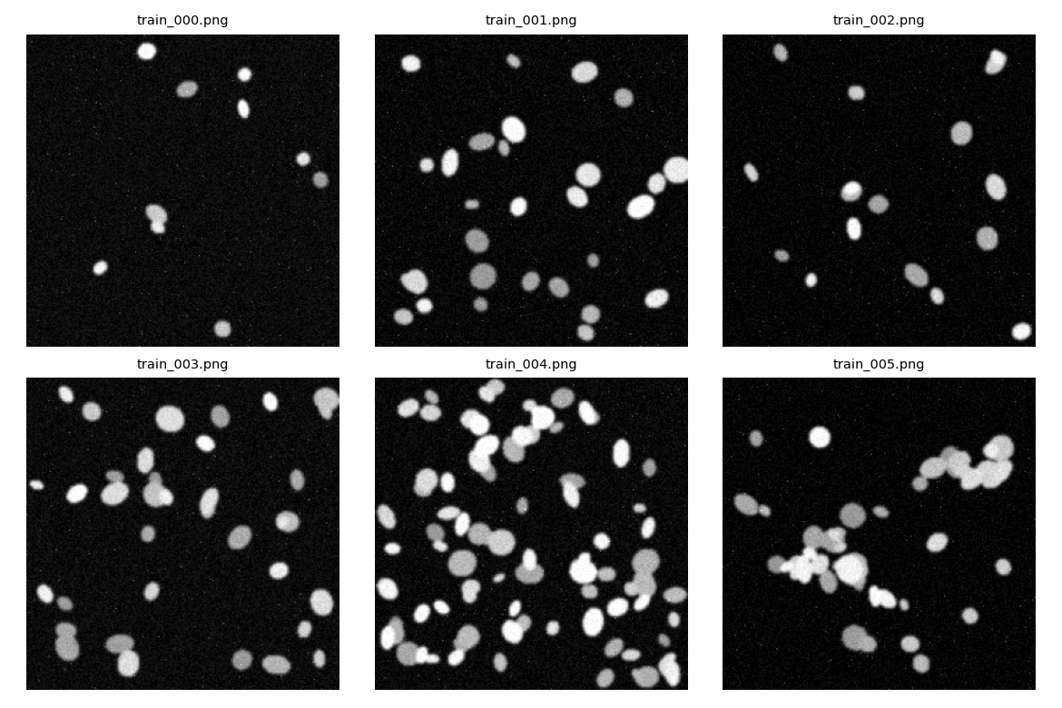
Figure 1: A sample of 256 x 256 grayscale training images covering the density regimes of sparse, normal, dense, and clustered nuclei.
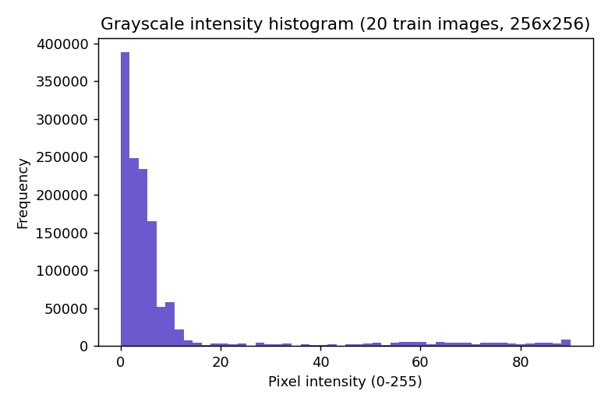
Figure 2: Pixel intensity histogram over a sample of 20 images, displaying a brilliant nuclei tail on a very dark background.
A 20-image sample's mean pixel intensity was 9.14 (std 18.15, 0-255 scale). The bright nuclei and the almost black background are typical for fluorescence microscopy. (Figure 1, Figure 2)
Optimized Structured Prompt (as used):
You are a description image assistant which assists a research pipeline. You are not a diagnostic tool, nor are you to make clinical diagnoses, disease names or treatment recommendations. Describe the content of the image only if it is visible on the image. Explain this image and provide only a single key/value pair in the following format: { modality, tissue_type, notable_features, image_quality }. Do not guess at a field if you do not know the answer, instead put in “uncertain.” There should be no text before or after the JSON object.
Naive prompt (as used):
What can you see in this microscopy image? Model note: I had the error that `mllama' is an unknown model architecture when I attempted to use the model llama3.2-vision with Ollama. Thus, the pipeline automatically reconfigured to use llava, which could be used with the Ollama setup. Thus the following three vision-model calls have been created with the help of llava. The Naive prompt output (llava): The model was the picture of a regularly arranged circular objects which might look like cells with nuclei. Also, it was interpreted that the blue colour is associated with fluorescent staining and that there are possible microscopy techniques (e.g. immunostaining or FISH). But these interpretations were more than could be confidently accepted from a mere visual inspection of the picture.
Structured prompt – run 1 (llava):
The first structured run was for modality but it was not certain as to the tissue type or image quality. It said there were numerous bright blue dots spread out on a darker background, but saw no definite nuclei or other distinguishing features.
Rewrite the structured prompt from Run 1, but with the image the same, but the prompt different:
During the second run, the image was once again identified as a fluorescence microscopy image, and the tissue type as 'unable to categorize'. However, this time it described the blue spots as having a regular pattern and gave the image quality as “good” instead of “uncertain.” Comparison of the two runs: While both answers were based on the same image and structured prompt, they were not identical. The image quality for the first run was “uncertain” and the image quality for the second run was “good”. The second run was also a statement about a regular pattern that wasn't mentioned in the first run. This demonstrates that different interpretations can be obtained from repeated calls with the VLM. Both outputs were in the required JSON format, but there were differences in the output that meant that a single VLM response should not be assumed to be a ground truth response.
2. Task 2: Classical Numbers & Features：
I performed Otsu's thresholding followed by morphological opening and closing to remove speckle noise. Then the connected components were labelled and a table with features for each component was generated from regionprops_table. The tables contained the following data: area, eccentricity, solidity, mean intensity, perimeter and length of major and minor axis. (Figure 3)
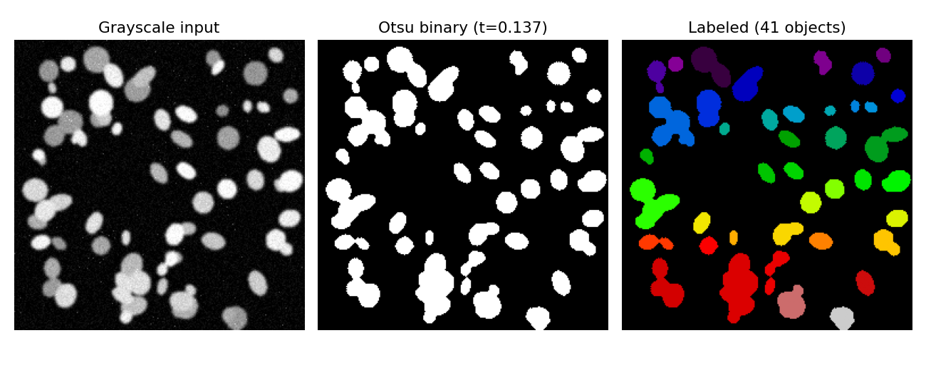
Figure 3 shows the binary segmentation mask (right) and grayscale input (left) of the Otsu thresholding pipeline on test_004.
The LLM (test_004) received a summary of simply numbers; the model only saw this text and never the image:
"Image test_004: 41 linked components were found using Otsu thresholding and morphological cleanup. The median object area is 244.0 px^2, whereas the mean is 344.0 px^2. The mean solidity is 0.92 (1.0=fully convex, no dents), while the mean eccentricity is 0.65 (0=circle, 1=line). On a scale of 0 to 1, the mean intensity inside objects is 0.26.
Response to llama3.2 (text model):
"The object population is probably made up of small, uniform, and convex objects based on the dimensions given. While the mean solidity of 0.92 suggests that the objects are not substantially dent-free, the mean object area of 344.0 px^2 and median of 244.0 px^2 reflect a relatively small size. The items appear to be dark in hue based on their low mean intensity (0.26).
JSON: { "n_objects": 41, "density_class": "dense", "shape_regularity": "regular", "quality_flag": "reliable" }
3. Task 3: U-Net Segmentation:
Using a Colab T4 GPU, a compact 3-level U-Net (PyTorch, base=16 channels, BCE+Dice loss, Adam, lr=1e-3) was trained from start for 15 epochs on the 80-image train split at 128x128 resolution (10.4s total training time).
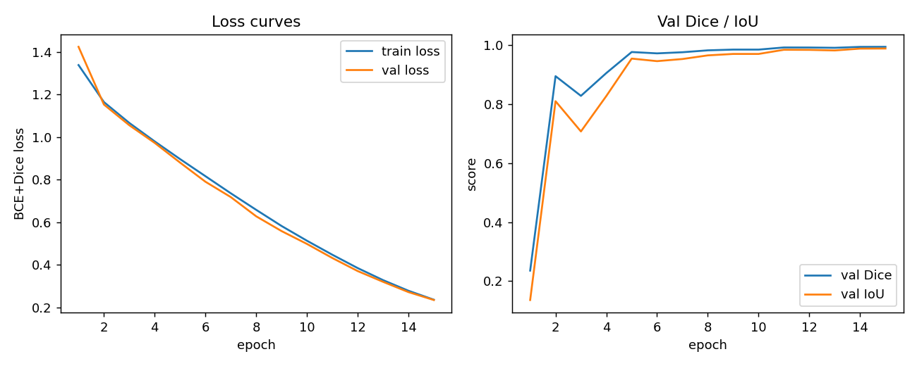
Figure 4 shows the validation Dice/IoU (right) and U-Net training/validation loss curves (left) over a period of 15 epochs.
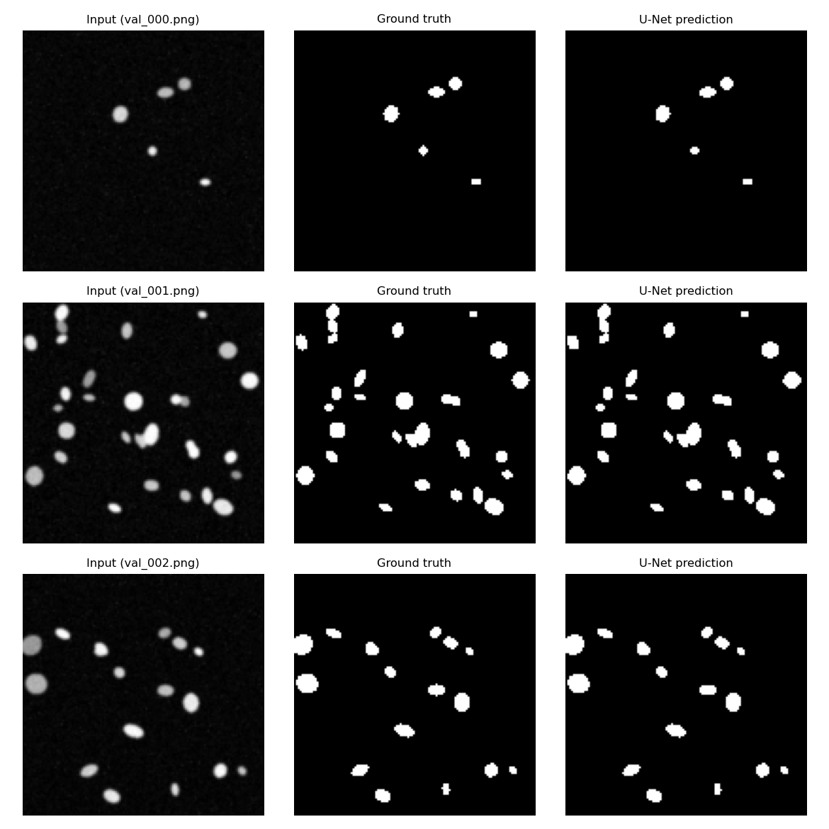
Figure 5: Three validation images (val_000–val_002) with U-Net input, ground-truth mask, and predicted mask.
IoU: 0.9885 (20-image val split, thresholded at 0.5); final validation Dice: 0.9942. (Figure 4) Training steadily converged: val_dice was 0.828 by epoch 3 and 0.905 by epoch 4, leaped to 0.977 by epoch 5, then grew gradually (with a brief plateau around epochs 9–10) to 0.9942 by epoch 15, with train and val loss tracking closely throughout (no overfitting was observed). (Figure 5) U-Net versus Otsu+morphology, assessed against ground-truth masks on the same 12 held-out TEST image：
Metric | U-Net (mean) | Otsu+morph (mean)
Dice | 0.9951 | 0.9384
IoU | 0.9902 | 0.8841

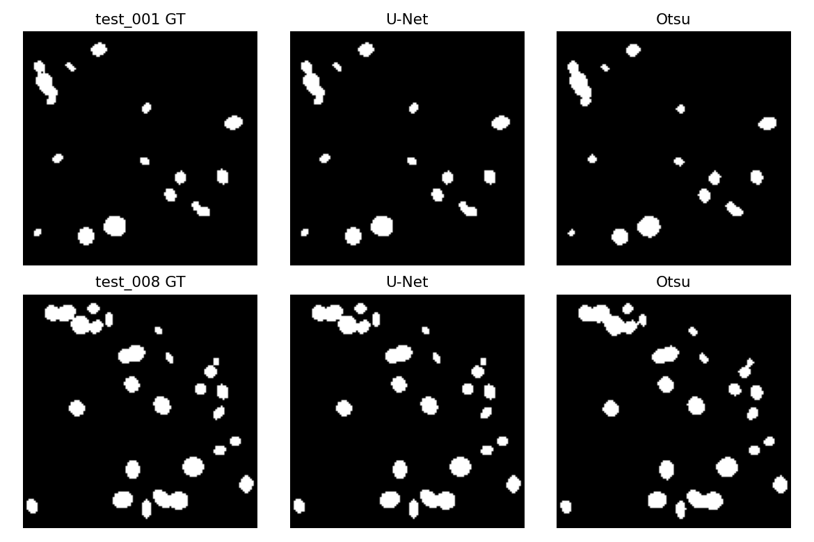
Figure 6: U-Net vs. Otsu+morphology segmentation; test_008 has the smallest margin and test_001 has the highest U-Net margin.
In all 12 test photos the U-Net model performed better than Otsu. The improvement in the dice score varied between +0.0474 and +0.0761. The difference between the scores of Otsu and U-Net was the largest for Test_001, with Otsu's score at 0.9196 and U-Net's at 0.9957, giving a difference of +0.0761. The Test_008 exhibited the lowest performance, with Otsu having 0.9490 and U-Net having 0.9964. It is worth noting that overall, Otsu did not outperform U-Net on any image in our synthetic data set while U-Net did perform better on all test images. (Figure 6)
4. Task 4: Using Unseen Test Images in a Hybrid Pipeline:
U-Net was used to create the masks and the regionprops was used to obtain main features as a table. Using a fixed deterministic rule the density_class was calculated from these measurements. We then took these results and shaped them into a structured JSON record using Llama 3.2. Lastly, the short paragraph was written for each of the twelve test images. The complete results are presented below:
image_id | n_objects | mean_area | density_class | quality_flag
test_000 | 8 | 47.0 | sparse | reliable
test_001 | 14 | 49.6 | sparse | reliable
test_002 | 25 | 56.7 | normal | reliable
test_003 | 19 | 51.7 | normal | reliable
test_004 | 43 | 81.9 | dense | reliable
test_005 | 15 | 108.1 | normal | reliable
test_006 | 8 | 50.0 | sparse | reliable
test_007 | 23 | 50.4 | normal | reliable
test_008 | 23 | 60.2 | normal | reliable
test_009 | 21 | 44.9 | normal | reliable
test_010 | 35 | 93.7 | dense | reliable
test_011 | 19 | 48.3 | normal | reliable
Example narration (llama3.2, actual output for every image): test_000 (sparse) "This image contains 8 distinct objects with relatively uniform areas, suggesting a sparse density class." For example, image_004 is classified as dense and contains 43 distinct regions. The mean area per region is 81.9 pixels². The quality flag for all 12 images was "reliable". The full table of 12 narratives is saved in outputs/task4_hybrid_records.csv.

Extension Robustness
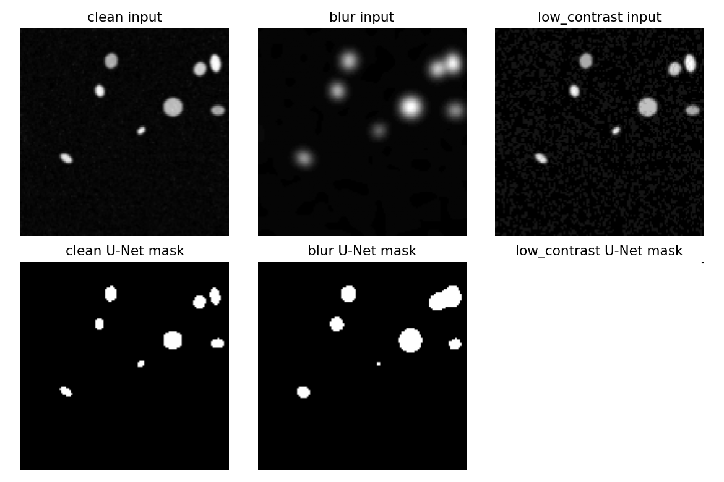
Figure 7: Robustness extension: low-contrast corrupted, blurry, and clean masks for test_000.
Variant | n_objects (U-Net) | mean_area
clean | 8 | 47.0
blur | 7 | 86.7
low_contrast | 1 | 16383.0
We also tested what happens if the mask is corrupted before feature extraction. A segmentation collapse is the worst case. In this case, the mask collapses into one giant region covering almost the whole 128x128 frame, with an area of 16,383 pixels instead of the normal 47.0 pixels. In contrast, blur is handled much better. Under blur, the object count only dropped from 8 to 7, and the mean area increased slightly as blobs merged, but the shapes remained roughly circular. This shows that the U-Net mask itself is the first place where such contamination can and should be detected, before any features or LLM output are generated. (Figure 7)

5. Critical Analysis Answers to Set Questions

1. Which description is more useful, and which is more trustworthy, the direct VLM description (Task 1) or the numbers-first description (Task 2) and why?

The VLM description is more helpful for rich visual detail, the numbers-first description is more reliable since the measurements are repeatable, reproducible and auditable. The output of VLM may be different each time. Thus, VLM is more descriptive, numbers-first is more reliable.

2. Did the U-Net improve on classical Otsu segmentation for your modality? Give one example image where each approach did better.
Yes, U-Net outperforms Otsu for all 12 test images.Yes, U-Net works better than Otsu in all 12 test images. The mean Dice score was 0.9951, which was higher than the mean Dice score of Otsu 0.9384. The greatest improvement was on test_001 and the smallest improvement was on test_008. Overall, U-Net was more effective.
3. Report your U-Net’s Dice and IoU. What do these numbers mean, and where does the model tend to make its mistakes (which images or regions)?

Validation: Dice = 0.9942, IoU = 0.9885.

Test: Dice = 0.9951, IoU = 0.9902.

Overlap in dice and IoU is near 1, indicating the accuracy. The most frequent errors were with small and/or dim, low-contrast objects. It is important to note, however, that the small synthetic dataset might not be representative of actual clinical images.
4. Where in the pipeline can the LLM hallucinate, and what design choices reduce that risk? Why does keeping the structured JSON as the “source of truth” help?
The LLM might hallucinate by including information that isn't supported or by misunderstanding the measurements. This risk is mitigated by controlled prompts, which reduces the risk to “uncertain”, and calculating features prior to the LLM. Having a structured JSON as the source of truth enables a guarantee on all numerical results.
5. Considering accuracy, auditability, and the limits of your dataset, would you trust any part of this system in a real clinical setting? What single change would most improve trustworthiness?

No, not completely sure because it's a small synthetic dataset. The low contrast images indicated that incorrect segmentation might still be considered reliable. Recommendation: Implement quality control for the U-Net after the segmentation step, to identify objects or use of wrong sized mask and report unreliable results.

References
Ronneberger, O., Fischer, P. and Brox, T. (2015) 'U-Net: Convolutional Networks for Biomedical Image Segmentation', in Medical Image Computing and Computer-Assisted Intervention (MICCAI 2015). Springer, pp. 234–241.
Otsu, N. (1979) 'A Threshold Selection Method from Gray-Level Histograms', IEEE Transactions on Systems, Man, and Cybernetics, 9(1), pp. 62–66.
van der Walt, S. et al. (2014) 'scikit-image: image processing in Python', PeerJ, 2, e453.
Milletari, F., Navab, N. and Ahmadi, S.-A. (2016) 'V-Net: Fully Convolutional Neural Networks for Volumetric Medical Image Segmentation', in Proceedings of the Fourth International Conference on 3D Vision (3DV). IEEE, pp. 565–571. [Dice loss formulation used in this pipeline's BCE+Dice loss.]
Ollama (2024) Ollama documentation. Available at: https://ollama.com (Accessed: August 2026). [Local model runtime for llama3.2, llama3.2-vision and llava.]
Kingma, D.P. and Ba, J. (2015) 'Adam: A Method for Stochastic Optimization', in Proceedings of the 3rd International Conference on Learning Representations (ICLR).
Nickolay-K (2026) Assingnment-3-dataset [synthetic DAPI-like fluorescence-microscopy nuclei dataset]. Available at: https://github.com/Nickolay-K/Assingnment-3-dataset (Accessed: August 2026).

