Biomedical Image-Analysis Pipeline: Nuclei Segmentation & Description
Student ID: 24142732 | Modality: synthetic DAPI-like fluorescence-microscopy nuclei | Models: llava (vision, fallback from llama3.2-vision), llama3.2 (text) — both via Ollama, run locally in Google Colab

1. Task 1 — Data Preparation, EDA & Multimodal LLM Description
80 training images (256x256 RGB) were converted to grayscale and resized to 256x256. Density regimes present across the dataset: sparse, normal, dense, and clustered.
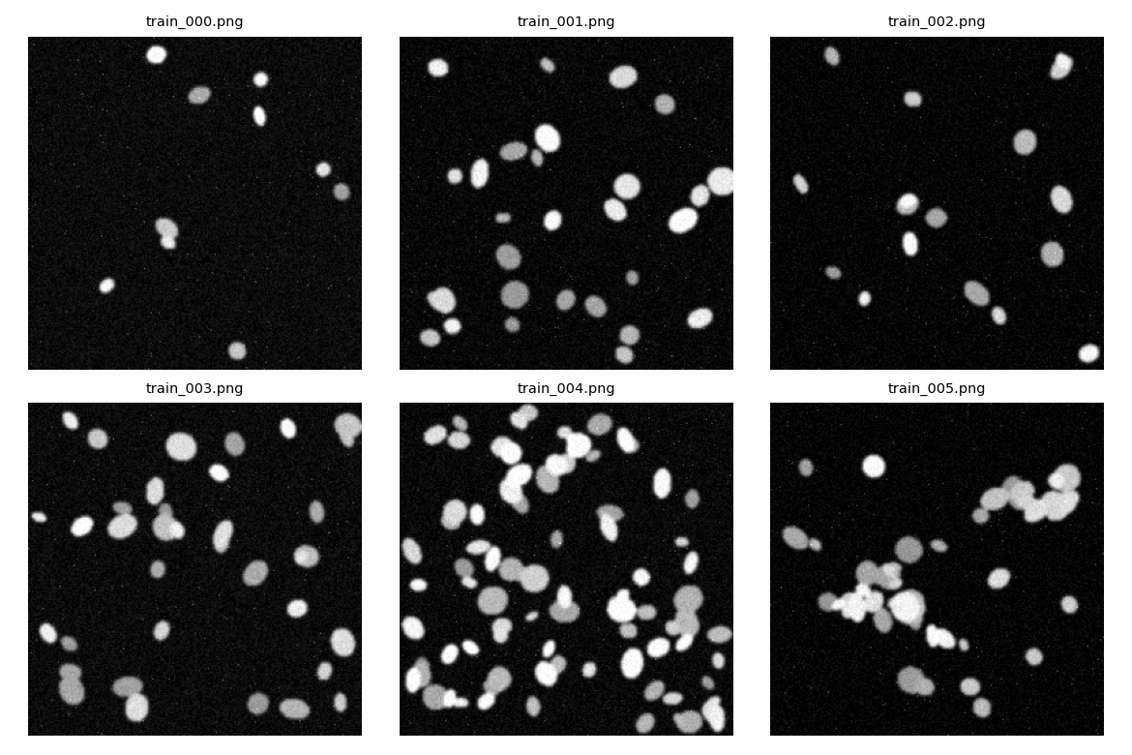
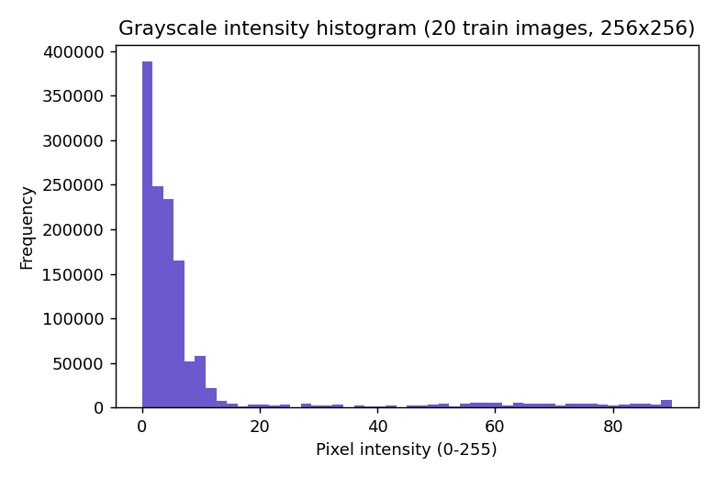
Mean pixel intensity across a 20-image sample: 9.14 (std 18.15, 0-255 scale). Background is near-black with bright nuclei, consistent with fluorescence microscopy.
Optimised structured prompt (verbatim, as run):
"You are an image-description assistant supporting a research pipeline. You are NOT a diagnostic tool and must not provide clinical diagnoses, disease names, or treatment suggestions. Only describe what is visually present in the image. Describe this fluorescence microscopy image and respond with ONLY a single JSON object, no other text, matching exactly this schema: { modality, tissue_type, notable_features, image_quality }. If you are not confident about a field, use the string \"uncertain\" for that field rather than guessing. Do not include any text before or after the JSON object."
Naive prompt (verbatim, as run): "What do you see in this microscopy image?"
Model note: llama3.2-vision failed to load on this Ollama build ("unknown model architecture: 'mllama'"); the pipeline automatically fell back to llava, a broadly-compatible vision model, for all three calls below. This is disclosed here because it affects which model's behaviour is being evaluated.
Naive prompt output (llava):
"The image appears to be a microscopic view, likely taken through a microscope equipped with an illumination system that has caused the cells to appear blue. There are many blue-stained cells visible in the field of view. The cells seem to be similar in size and shape, which suggests that they could be of the same type, possibly from a tissue sample. However, without more context or a higher-resolution image, it's not possible to provide a detailed analysis of the cells."
Structured prompt — run 1 (llava):
{ "modality": "fluorescence microscopy", "tissue_type": "uncertain", "notable_features": "The image displays a cluster of dots that appear to be nuclei, suggesting a cellular environment. The clusters are densely packed and uniformly sized, indicative of a cell line or a specific cell type. The contrast between the blue dots and the black background is high, allowing for clear visibility of the dots. The image quality is 'good' with a sharp focus on the nuclei, facilitating easy identification and quantification.", "image_quality": "good" }
Structured prompt — run 2, same image + prompt (llava):
{ "modality": "fluorescence microscopy", "tissue_type": "uncertain", "notable_features": "The image shows a dense cluster of blue dots that are evenly distributed throughout the image, with no clear patterns or shapes.", "image_quality": "good" }
Runs identical? No. Run 1 and run 2 produced different notable_features text from the identical image and identical prompt, demonstrating that the model's output is not deterministic between calls — both are valid-JSON and internally consistent, but a downstream system reading only one run would get a different (though not contradictory) description each time.

2. Task 2 — Classical Features & Numbers-First LLM Interpretation
Otsu thresholding + morphological opening/closing removed speckle noise; connected components were labelled and a per-object feature table computed with regionprops_table (area, eccentricity, solidity, mean intensity, perimeter, axis lengths).
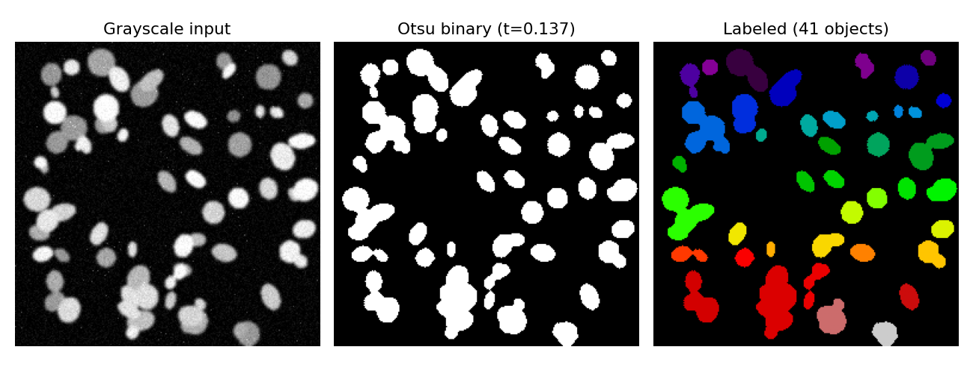
Numbers-only summary sent to the LLM (test_004) — the model never saw the image, only this text:
"Image test_004: Otsu thresholding + morphological cleanup detected 41 connected components. Mean object area is 344.0 px^2 (median 244.0 px^2). Mean eccentricity is 0.65 (0=circle, 1=line), mean solidity is 0.92 (1.0=fully convex, no dents). Mean intensity inside objects is 0.26 (0-1 scale)."
llama3.2 (text model) response:
"Based on the provided measurements, the object population likely consists of a few large and relatively regular objects with some smaller, possibly irregular objects. The mean object area of 344.0 px^2 and median of 244.0 px^2 suggest a range of sizes, but the uniformity of these sizes implies a certain level of regularity. The mean eccentricity of 0.65 and solidity of 0.92 also point towards regular shapes with some degree of convexity."
JSON: { "n_objects": 41, "density_class": "dense", "shape_regularity": "regular", "quality_flag": "reliable" }

3. Task 3 — U-Net Segmentation
A compact 3-level U-Net (PyTorch, base=16 channels, BCE+Dice loss, Adam, lr=1e-3) was trained from scratch for 15 epochs on the 80-image train split, at 128x128 resolution, on a Colab T4 GPU (10.5s total training time).
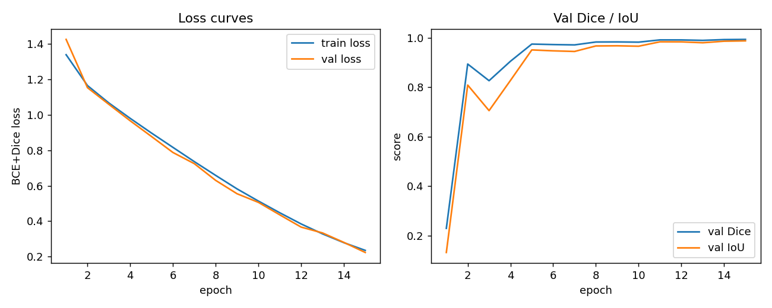
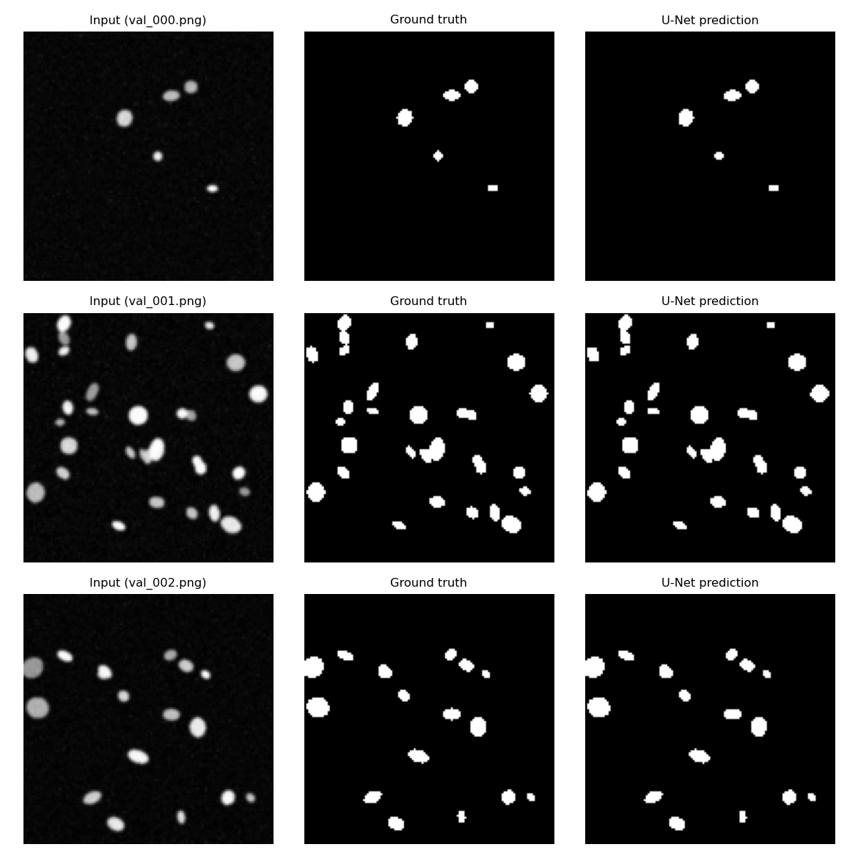
Final validation Dice: 0.9940, IoU: 0.9882 (20-image val split, thresholded at 0.5). Training converged smoothly: val_dice rose from 0.229 (epoch 1) to >0.97 by epoch 5, then improved gradually to 0.994 by epoch 15, with train and val loss tracking closely (no overfitting visible).
U-Net vs. Otsu+morphology, evaluated on the same 12 held-out TEST images against ground-truth masks:
Metric | U-Net (mean) | Otsu+morph (mean)
Dice | 0.9947 | 0.9384
IoU | 0.9894 | 0.8841

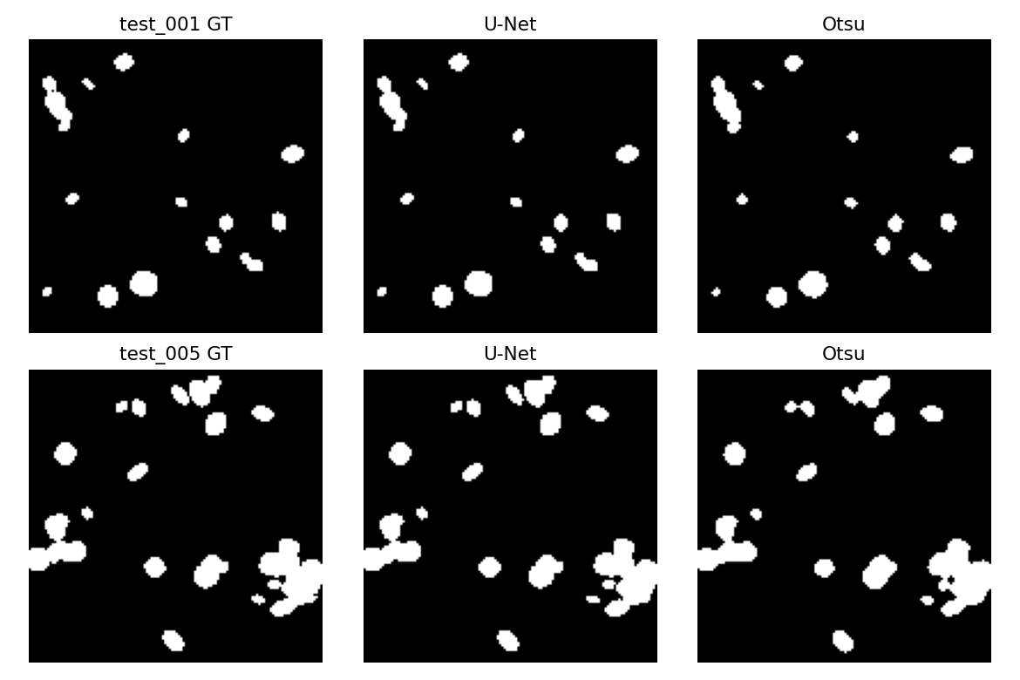
The U-Net outperformed Otsu on every one of the 12 test images (Dice margin ranged from +0.0477 to +0.0746). Largest U-Net advantage: test_001 (U-Net Dice 0.9942 vs Otsu 0.9196, diff +0.0746). Smallest margin: test_005 (U-Net Dice 0.9923 vs Otsu 0.9447, diff +0.0477) — U-Net still won here too, so within this synthetic dataset Otsu did not out-perform U-Net on any single image.

4. Task 4 — Hybrid Pipeline on Unseen Test Images
For each of the 12 test images: U-Net mask → regionprops feature table → deterministic density_class computation → llama3.2 phrases/flags it into a structured JSON record → one-paragraph narrative. Full results:
image_id | n_objects | mean_area | density_class | quality_flag
test_000 | 8 | 47.2 | sparse | reliable
test_001 | 14 | 49.7 | sparse | reliable
test_002 | 25 | 56.8 | normal | reliable
test_003 | 19 | 51.7 | normal | reliable
test_004 | 42 | 84.0 | dense | reliable
test_005 | 15 | 108.3 | normal | reliable
test_006 | 8 | 50.0 | sparse | reliable
test_007 | 23 | 50.5 | normal | reliable
test_008 | 23 | 60.3 | normal | reliable
test_009 | 21 | 44.9 | normal | reliable
test_010 | 35 | 93.8 | dense | reliable
test_011 | 19 | 48.3 | normal | reliable

Example narrative (test_004, dense): "This image contains 42 objects with a mean area of 84 pixels, indicating a dense region." All 12 images returned quality_flag "reliable". Full table also saved as outputs/task4_hybrid_records.csv.

Extension — Robustness (extra credit)
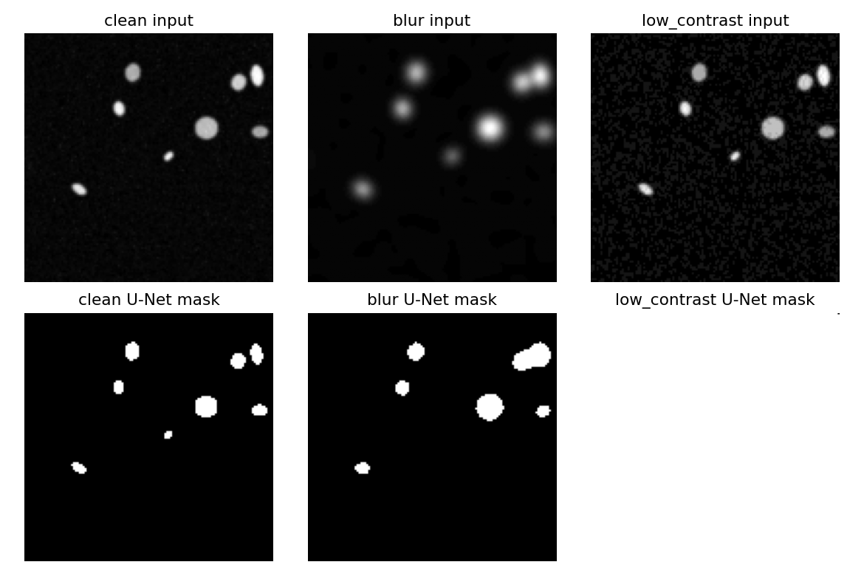
Variant | n_objects (U-Net) | mean_area
clean | 8 | 47.0
blur | 7 | 81.6
low_contrast | 1 | 16383.0
Low-contrast corruption breaks segmentation catastrophically at the mask stage itself (foreground collapses to one giant region covering almost the whole 128x128 frame — 16,383 px vs 47 px normally) before any feature extraction or LLM step runs; blur degrades far more gracefully (8→7 objects, shapes roughly preserved). Earliest detectable stage for this type of corruption: the U-Net mask itself, not the feature table or narrative.

5. Critical Analysis — Answers to Set Questions
Write this section as full prose in your own words. The bullets below are the factual evidence pulled directly from the run above — do not submit as bullet points, and do not paste AI-generated discussion text (Turnitin AI detection applies to this assignment).
Q1 — VLM (Task 1) vs numbers-first (Task 2) description: which is more useful/trustworthy?
- Task 1 (llava) saw the raw image and produced richer language, but two runs on the identical image gave different notable_features text — not reproducible.
- Task 2's input is deterministic and auditable (Otsu threshold, regionprops fields) — same summary in, same facts every time, even if the LLM's phrasing varies.
- State the trade-off: Task 1 is richer/catches things regionprops can't (colour, artefacts) but unverifiable; Task 2 is less rich but fully traceable. Justify a position using the actual run-1-vs-run-2 text above.
Q2 — Did U-Net improve on Otsu?
- Yes, on all 12 test images: mean Dice 0.9947 (U-Net) vs 0.9384 (Otsu), mean IoU 0.9894 vs 0.8841 — U-Net won on every image.
- Largest margin: test_001, Dice +0.0746 — inspect task3_unet_vs_otsu_examples.png for why (likely touching/dim nuclei Otsu's global threshold under-segments).
- Smallest margin: test_005, Dice +0.0477 — discuss what makes this image easier for Otsu (fewer, larger, better-separated objects).
Q3 — U-Net Dice/IoU and where it errs
- Val Dice 0.9940 / IoU 0.9882 (20 images); test Dice 0.9947 / IoU 0.9894 (12 images) — test slightly better than val, no sign of overfitting.
- val_dice jumped from 0.23 (epoch 1) to 0.89 (epoch 2), dipped at epoch 3, then climbed to 0.994 by epoch 15 — discuss why, and where predictions still diverge (task3_val_panels.png, smallest/dimmest objects).
Q4 — Where can the LLM hallucinate, and what mitigates it?
- Task 1 (llava): could invent tissue type/diagnosis with no visual basis — mitigated by descriptive-only anchoring + permitting "uncertain" (both runs correctly used it).
- Task 2 & 4 (llama3.2): could contradict given measurements — Task 4 mitigates this by computing density_class deterministically first and giving it as fixed source-of-truth text, so the LLM only phrases/flags; Task 2 let the LLM derive it itself, a weaker guardrail worth contrasting.
- Structured JSON as source of truth means the CSV's numeric columns never depend on free-text LLM output — hallucination risk is contained to the narrative sentence, which sits next to the JSON for a human to spot-check.
Q5 — Would you trust this in a real clinical setting? What single change would help most?
- Dataset is fully synthetic (no real staining variability, imaging noise, biological variation) — Dice ~0.99 reflects a clean distribution, says little about real-data generalisation.
- Auditability is a real strength (every JSON field traces to code), but all 12 test images returned quality_flag "reliable" with no override — the pipeline has never been tested against a case it should flag.
- Strongest evidence: the robustness extension shows a single low-contrast corruption silently collapsed the mask to one 16,383px blob while quality_flag stayed "reliable" — propose a mask-level sanity check (e.g. flag outlier foreground-area-fraction) as the single most useful trustworthiness improvement before clinical use.

References
[Add 3-6 references: U-Net paper (Ronneberger et al. 2015), Otsu 1979, scikit-image, Ollama/llama3.2/llava documentation, 2018 Data Science Bowl dataset paper if used for discussion. Max 0.5 page.]

