Rental Pro
Semester-Project-6th

SESSION 2023-2027
BACHELOR OF SCIENCE
IN
SOFTWARE ENGINEERING
SUBMITTED BY
Nimra Tanveer 23-NTU-CS-1201
Eemaan Fatima 23-NTU-CS-1146
SUPERVISED BY
Sir Rehan Sarwar
CO-SUPERVISED BY
Mr. Adbullah
Department of Computer Science
National Textile University, Faisalabad

CERTIFICATION

This document has been prepared by Nimra Tanveer and Eemaan Fatima under the supervision of Sir Rehan Sarwar and co-supervision of Mr. Abdullah. It is submitted in partial fulfillment of the requirements for the degree of BS Software Engineering at the Department of Computer Science, National Textile University, Faisalabad.

Supervisor |  | Co-Supervisor
Date |  | Date

DECLARATION

We hereby declare that this document is completely written by us, and it is totally our effort and none of anyone from outside of our group has copied it. This Report is purely written in a technical way in accordance with our project.

Group Members:

Nimra Tanveer  23-NTU-CS-1201  E-Mail:  nimratanveer1201@gmail.com  Eman Fatima  23-NTU-CS-1146  E-Mail: | Signature | Date
emanf14210@gmail.com | Signature | Date

Acknowledgement

First, In the Name of ALLAH ALMIGHTY, the Most Beneficent, the Most Merciful. All the praises and thanks be to ALLAH. A lot of love for our beloved Holy Prophet MUHAMMAD (S.A.W), his guidance always helps us to get the right path. After that, we also proudly declare that the success parameters of this project are the endless prayers and support of our parents. We also want to acknowledge the efforts of our supervisor, who helped us a lot with the project, especially with the documentation. Every time we want to meet him, he is always there for us with great ideas, discussions, and suggestions that help us complete our project and documentation. We sincerely thank our supervisor Sir Rehan Sarwar and co-supervisor Mr. Abdullah for their guidance, encouragement, and valuable suggestions throughout the project.

ABSTRACT

Rental Pro is a Flutter-based property rental mobile application designed to simplify the process of searching, managing, and uploading rental properties. The system provides a modern digital solution for renters and landlords.
The application allows users to search for properties using filters such as property type, location, price range, and area size. Landlords can upload and manage property listings, while renters can view property details and contact owners easily.
The system focuses on user-friendly design, secure authentication, smooth navigation, and modern UI/UX principles. Google Maps integration is also used for property location visualization.
The application improves accessibility, saves time, and provides a centralized rental management platform.

TABLE OF CONTENTS
Contents
CERTIFICATION i
DECLARATION ii
Acknowledgement iii
ABSTRACT iv
TABLE OF CONTENTS v
CHAPTER 1 1
1. PROJECT INITIATION 2
1.1 Introduction 2
1.2 Background of the Study 2
1.3 Project Scope 2
1.4 Stakeholders 4
1.5 Existing System 5
1.6 Limitations of Current System 6
1.7 Problem Statement 6
1.8 Objectives 7
1.9 Project Goals 7
1.10 Risks 7
1.11 Project Scheduling 8
CHAPTER 2 9
2.LITERATURE REVIEW 10
2.1 Introduction 10
2.2 Background of Property Rental Systems 10
2.3 Related Work in Property Rental Industry 11
2.3.1 Online Property Listing Platforms 11
2.3.2 Real Estate Management Systems: 11
2.3.3 Mobile Rental Applications: 11
2.3.4 Google Maps Integration in Real Estate: 11
2.4 Need for a Modern Rental Management System 11
2.4.1 Centralized Property Management 11
2.4.2 Improved User Experience 12
2.4.3 Better Communication 12
2.4.4 Time Saving and Accessibility 12
2.4.5 Smart Search and Filtering 12
CHAPTER 3 13
3. METHODOLOGY AND REQUIREMENTS 14
3.1 Introduction 14
3.2 Existing Methodologies 14
3.3 General Requirements 15
3.3.1 Interviews and Discussions 15
3.3.2 Study of Existing Applications 15
3.3.3 Literature Review 16
CHAPTER 4 18
4.SYSTEM DESIGN ANALYSIS, IMPLEMENTATION AND TESTING 19
4.1 Introduction 19
4.2 Use Case Diagram 19
4.3 Activity Diagram 25
4.4 Class Diagram 28
4.5 Sequence Diagram 30
4.6 Database Design 34
4.7 Network Diagram 36
4.7 Implementation 36
4.8 Testing 38
4.9 Results, conclusions and Recommendations 39
REFERENCE: 40

LIST OF FIGURES
Figure 1: Problems in Manual Rental Pro 15
Figure 2: Project Scheduling 17
Figure 3: Agile Model 24
Figure 4: User use case Diagram 32
Figure 5 :Administrator Use case diagram 33
Figure 6: Rental Pro Assistant Use Case Diagram 34
Figure 7: User Activity Diagram 38
Figure 8: Activity Diagram 39
Figure 9: Class Diagram 41
Figure 10: Sequential Diagram 44
Figure 11: Entity Relationships Diagram 46
Figure 12: Networking Diagram 47

LIST OF TABLES
Table 1: Stakeholders Involved in the Rental Pro 13
Table 2:User Requirements 25
Table 3:Functional Requirements 25
Table 4: Non-Functional Requirements 26
Table 5:Login Use Case 33
Table 6: Customers Use Case 34
Table 7: Visualization Use Case 34

CHAPTER 1

PROJECT INITIATION

1.1 Introduction
Rental Pro is a Flutter-based mobile application developed for users who want to search, rent, and upload properties easily. The application helps renters find houses, shops, upper portions, and different property sizes using filters and map features. The application also allows landlords to post properties with complete details including title, location, description, area size, price, and contact information. The system provides a simple, modern, and user-friendly interface for both renters and landlords.

1.2 Background of the Study
Property rental services are becoming an important part of modern urban living. People frequently search for houses, apartments, shops, and other rental properties according to their budget, location, and personal requirements. Traditionally, property searching and rental management are handled manually through newspaper advertisements, property dealers, social media posts, or personal contacts. This manual approach is time-consuming, inefficient, and often creates communication problems between landlords and renters. The system also improves communication between renters and landlords through contact features and map integration. By digitizing the rental process, the application reduces manual effort, saves time, improves accessibility, and provides a better user experience.

1.3 Project Scope
The scope of Rental Pro includes the design, development, and implementation of a mobile-based property rental management system that helps renters and landlords manage rental activities digitally. The project covers the following major modules and functionalities:

1.3.1 User Authentication Module

The system provides secure user authentication features including signup, login, and role-based access. Users can register either as renters or landlords.This all is done by Firebase Authentication.

Property Search Module
This module helps users quickly find suitable rental properties according to their preferences. Users can search rental properties using different filters such as:
- Property type
- Location
- Area size
- Price range

Property Management Module
Landlords can:
- Add property listings
- Upload property images
- Edit property details
- Delete listings
- Manage active and inactive properties
- Search property

Property Details Module
The system displays detailed information about each property including:
- Property images
- Price
- Description
- Location
- Area size
- Facilities and amenities

1.3.5 Map Integration Module
Google Maps integration is used to help users:
- View property locations
- Navigate property areas visually

1.3.6 User Interface and Experience
The project also focuses on:
- Responsive UI design
- Easy navigation
- Modern layouts
- User-friendly experience

Stakeholders
Stakeholders are individuals or groups who are directly or indirectly connected with the Rental Pro application. They play an important role in the development, management, and usage of the system. Identifying stakeholders helps ensure that the application fulfills user requirements and supports efficient property rental operations.

Primary Stakeholder
The primary stakeholders of Rental Pro are renters and landlords because they directly interact with the system daily. Renters use the application to search for suitable rental properties according to their needs, budget, location, and preferences. They expect the system to provide accurate property information, easy search options, secure communication, and smooth user experience. Landlords are also important stakeholders because they use the application to upload, manage, edit, and advertise their properties. The system helps landlords reach a larger number of potential tenants and simplifies the overall property management process.

1.4.2 Secondary Stakeholders
Secondary stakeholders include developers, system administrators, property dealers, and future business investors. Developers are responsible for designing, developing, testing, and maintaining the Rental Pro application. They ensure that the application functions properly and provides a secure and responsive experience. System administrators manage the technical operations of the system including database management, security maintenance, user management, and server monitoring. Their role is important for maintaining system reliability and performance. Property dealers may also use the application to advertise multiple properties and expand their business operations digitally. Future investors or business owners may support the future expansion and commercialization of the application.

1.5 Existing System
Currently, many property rental businesses and users rely on traditional manual methods for searching and managing rental properties. Most people use newspaper advertisements, property dealers, social media posts, and personal contacts to find houses, apartments, shops, or offices for rent.
In the existing system, renters often face difficulties in finding accurate and updated property information. They have to spend a lot of time contacting multiple property dealers or visiting different locations physically. Similarly, landlords face challenges in advertising their properties to a large audience.

Table 1: Stakeholders Involved in the Hair Treatment Assistant
Stakeholder | Interest | Importance
Renters | Search rental properties, contact landlords, and find suitable houses according to their budget and preferences | High
Landlords | Upload, manage, and advertise rental properties to potential tenants | High
Property Dealers | Manage multiple property listings and expand business reach | Medium
Developers | Design, develop, test, and maintain the RentalPro application | High
System Administrator | Manage database, maintain security, and monitor system performance | High

1.6 Limitations of Current System
The existing manual property rental system has several limitations that affect both renters and landlords. Property information is often scattered across newspapers, social media, and property dealers, making it difficult for users to find suitable rental options quickly. The system also lacks proper filtering and centralized management features. Communication between renters and landlords is often slow and inefficient as it dosenot involve the direct messaging to landlord.

1.7 Problem Statement
People face many difficulties while searching for rental properties using traditional methods. Renters spend a lot of time searching through advertisements, contacting property dealers, and visiting locations physically. Landlords also struggle to advertise their properties to a large audience efficiently. Existing systems lack centralized management, proper filtering, secure communication, and updated property information. Therefore, there is a need for a modern, user-friendly, and mobile-based rental management system that simplifies property searching, property listing, and communication between renters and landlords.

\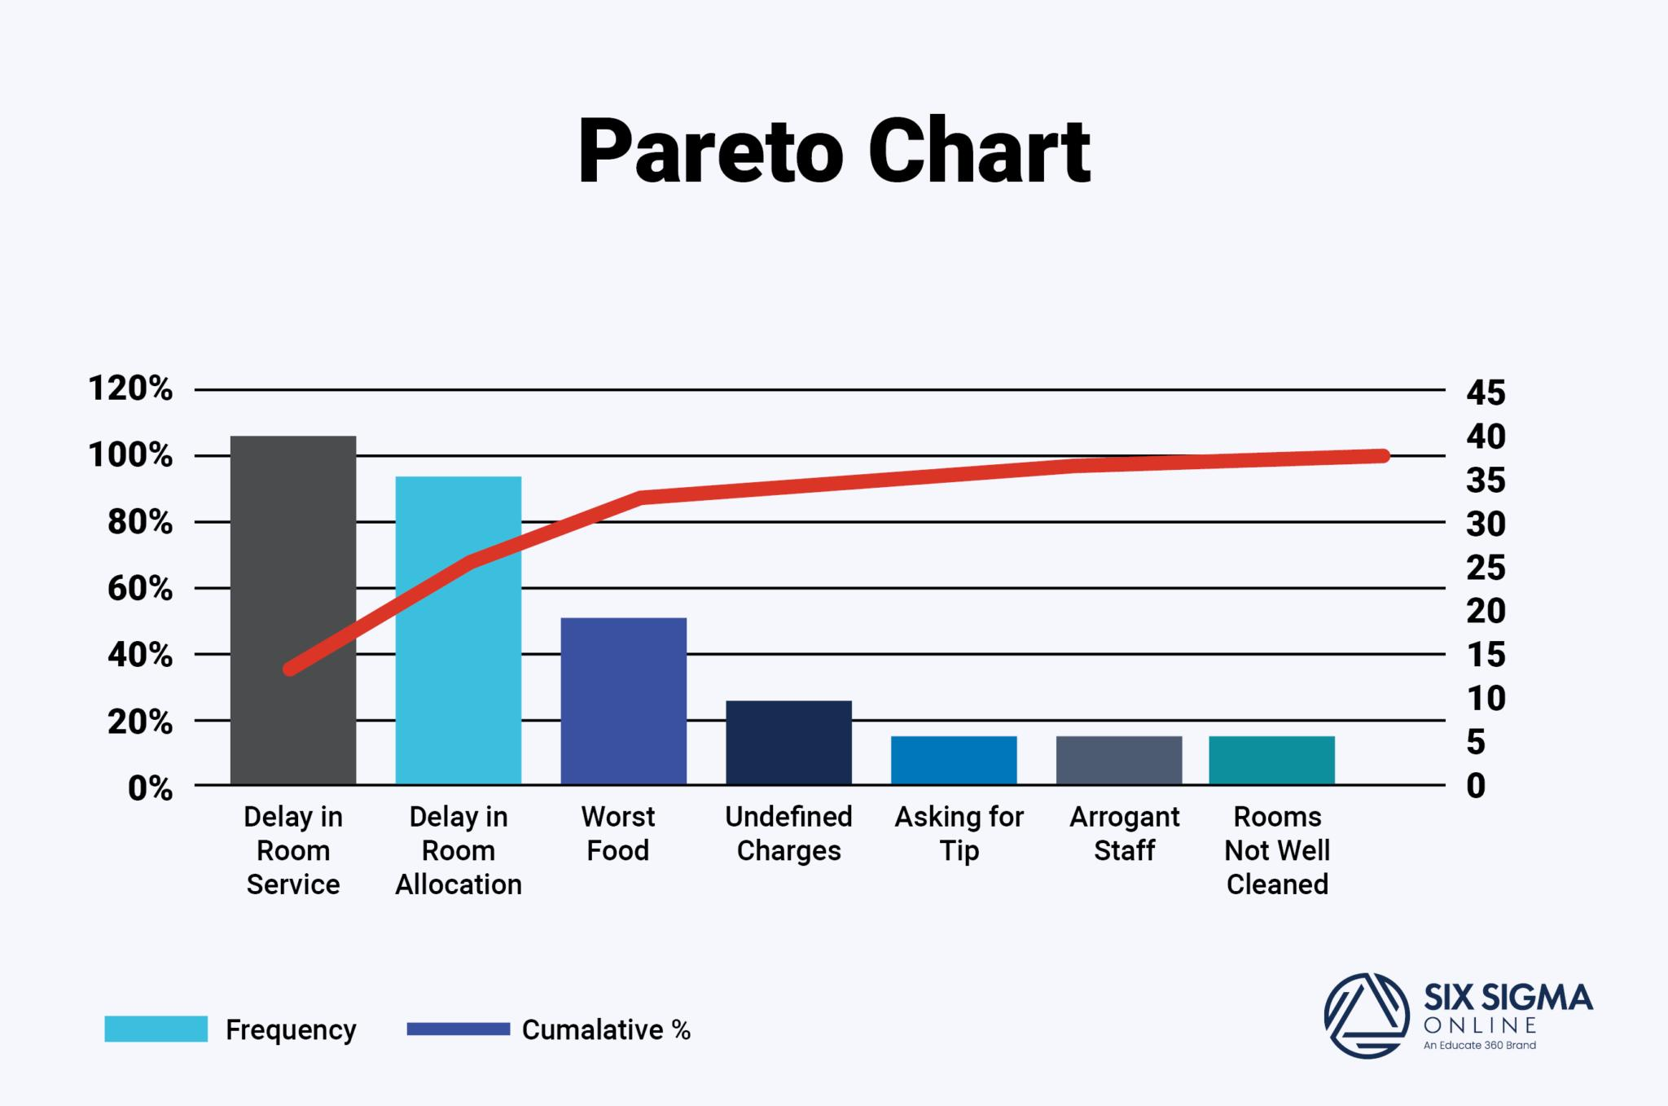
Figure 1: Problems in Manual Rental Pro

1.8 Objectives

The objectives of this project are:
- To develop a mobile-based property rental application.
- To simplify the property searching process for renters.
- To provide secure and easy property listing management for landlords.
- To allow users to search properties using filters such as location, price, and property type.
- To improve communication between renters and landlords.

1.9 Project Goals
- To reduce manual effort and time in property searching.
- To improve accessibility of rental property information.
- To provide better user experience through modern UI/UX design.
- To support landlords in advertising properties effectively.
- To improve efficiency and convenience in rental operations.
- To support future scalability and additional smart features.

1.10 Risks
Some risks associated with the Rental Pro project are:
- Internet connectivity issues may affect application performance.
- Security risks related to user data and authentication.
- Possibility of outdated or incorrect property information uploaded by users.
- Technical bugs and application crashes during development.
- Resource and budget limitations during project implementation.

1.11 Project Scheduling
The Rental Pro App development follows a structured timeline including requirement gathering, system design, development, testing, and deployment to ensure successful completion of the Rental Pro Application.

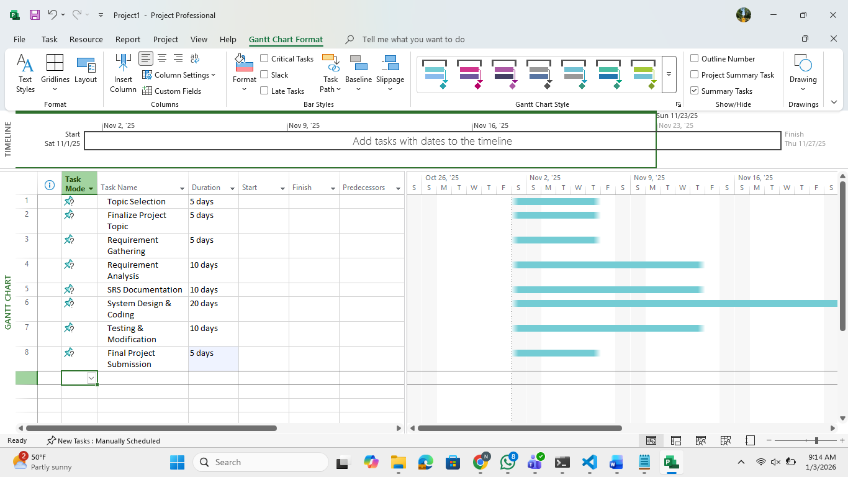
Figure 2: Project Scheduling Gantt Chart of Rental Pro

CHAPTER 2

2.LITERATURE REVIEW

2.1 Introduction
A literature review provides an overview of existing systems, technologies, and research related to property rental and real estate management applications. It helps in understanding the limitations of traditional rental systems and identifies the need for a modern digital platform.
The real estate and property rental industry has rapidly evolved with the advancement of mobile applications and online services. People now prefer digital platforms that allow them to search, manage, and communicate easily regarding rental properties.

2.2 Background of Property Rental Systems
Property rental systems are designed to help users search, advertise, and manage rental properties efficiently. Traditionally, people relied on newspapers, brokers, banners, and personal contacts to find rental houses, apartments, shops, or offices.
These manual systems created many problems such as lack of updated information, communication delays, limited property accessibility, and time-consuming searching processes.
With the rapid growth of smartphones and internet technologies, digital rental applications have become more popular. Modern rental systems provide online property listings, map integration, search filters, image galleries, and communication features.

2.3 Related Work in Property Rental Industry
Several property rental applications and real estate management platforms already exist in the market. These systems provide different features for property searching and management.

2.3.1 Online Property Listing Platforms
Applications such as Zameen, Graana, and Airbnb provide property listing and searching services. Users can search for rental properties using filters such as price, location, and property type.

2.3.2 Real Estate Management Systems:
Real estate management systems help landlords manage properties, tenants, and rental information digitally. These systems often include property management dashboards, analytics, and customer communication tools.

2.3.3 Mobile Rental Applications:
Modern mobile applications provide better user experience through responsive UI design, property images, location services, and mobile notifications. Most applications focus on user convenience and allow quick communication between renters and landlords.

2.3.4 Google Maps Integration in Real Estate:
Many modern rental applications use Google Maps API to display property locations visually. Map integration helps users understand nearby areas, roads, and available facilities. Location-based services improve the overall user experience and make property searching easier.

2.4 Need for a Modern Rental Management System
The Rental Pro application is developed to overcome the limitations of traditional and existing rental systems.

2.4.1 Centralized Property Management
Rental Pro provides a centralized platform where renters and landlords can manage rental activities efficiently.

2.4.2 Improved User Experience
The system focuses on clean UI/UX design, easy navigation, and user-friendly mobile layouts.

2.4.3 Better Communication
The application improves communication between renters and landlords through direct contact features such as WhatsApp and calling options.

2.4.4 Time Saving and Accessibility
Users can search properties anytime and anywhere without visiting multiple locations physically.

2.4.5 Smart Search and Filtering
The application allows users to search properties using filters such as:
- Location
- Property type
- Price range
- Area size

CHAPTER 3

3. METHODOLOGY AND REQUIREMENTS

3.1 Introduction
This chapter explains the methodology and system requirements used for the development of the Rental Pro application. It describes the software development process, selected development model, and the functional and non-functional requirements of the system.
The purpose of this chapter is to explain how the system was planned, designed, and developed to meet the needs of renters and landlords. Different development methodologies were studied before selecting the most suitable model for the project.

3.2 Existing Methodologies
Different software development methodologies are used in modern application development. Each methodology has its own advantages and is selected according to project requirements.
Some commonly used methodologies are:
- Agile Methodology
- Waterfall Model
- Spiral Model
- Rapid Application Development (RAD)
- Scrum Model
- Extreme Programming (XP)
These methodologies differ in terms of planning, flexibility, testing, and user involvement.

3.2.1 Selected Model
For the Rental Pro project, the Agile methodology was selected as the most suitable software development approach. Agile methodology focuses on iterative development, continuous testing, regular feedback, and flexibility. The Rental Pro application contains different modules such as authentication, property listing, searching, filtering, map integration, and communication features.
Using Agile methodology allowed the project to be divided into small development phases. Each module was developed and tested separately before integration.
Agile methodology also supports changing requirements and improvements during development. This approach helped in improving UI/UX design and application performance based on testing and feedback. Due to flexibility, faster development, and better user involvement, Agile methodology was considered ideal for Rental Pro

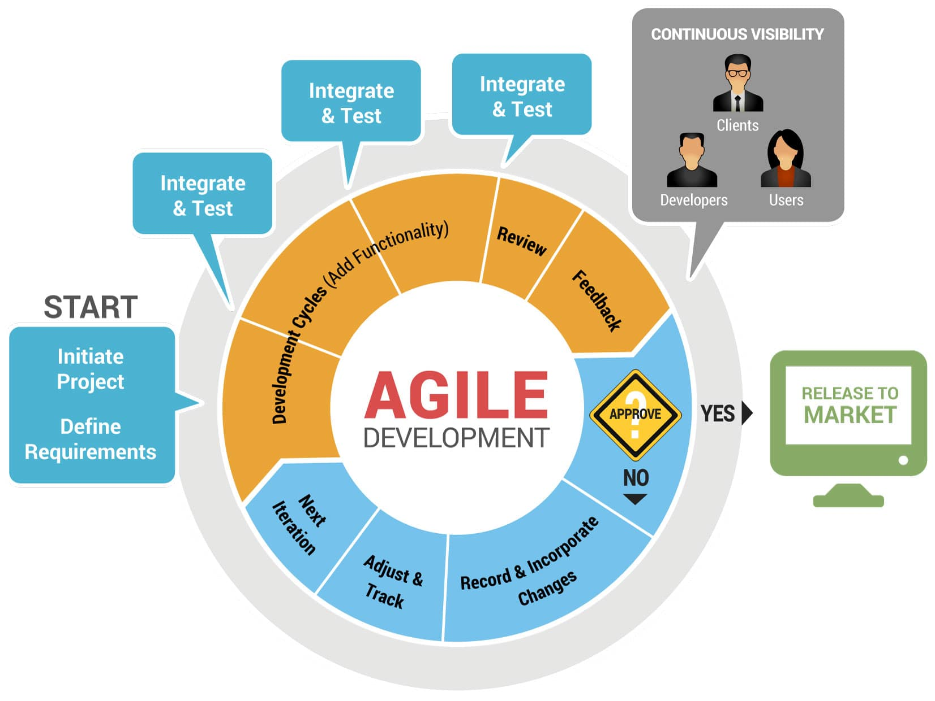
Figure 3: Agile Model

3.3 General Requirements
Different techniques were used to gather system requirements for the RentalPro application.

3.3.1 Interviews and Discussions
Discussions were conducted with users to understand common problems faced during property searching and rental management.

3.3.2 Study of Existing Applications
Existing property rental applications such as Zameen and Airbnb were studied to analyze useful features and system limitations.

3.3.3 Literature Review
Research articles, online resources, and mobile application case studies were reviewed to improve system design and functionality.

3.3.2.1 User Requirements

User requirements define what the users expect from the system. The system should be simple, efficient, and easy to use for customers. The system should improve the efficiency of storing and retrieving customers and information.

Table 2:User Requirements
Requirement ID | Users Requirement
UR-01 | The system should provide a simple and user-friendly interface.
UR-02 | Users should be able to search for properties easily.
UR-03 | The system should reduce manual effort and save time.
UR-04 | The application should support secure user authentication.

3.3.2.2 Functional Requirements
Functional requirements describe the specific functions and services that the system must perform.
Table 3:Functional Requirements
Requirement ID | Functional Requirements
FR-01 | The system shall allow users to register and log in securely.
FR-02 | The system shall allow landlords to add and manage properties.
FR-03 | The system shall display property details and images.
FR-04 | The system shall provide search and filter functionality.
FR-05 | The system shall integrate Google Maps for location viewing.
FR-06 | The system shall allow users to contact landlords directly.
FR-07 | The system shall allow editing and deleting property listings.

3.3.2.3 Non-Functional Requirements (NFR)
Non-functional requirements define the quality attributes of the system such as performance, security, usability and reliability.
Table 4: Non-Functional Requirements
Requirement ID | Quality Attributes | Non-Functional Requirements
NFR-01 | Performance | The system should provide high performance and fast response times.
NFR-02 | Usability | The interface should be user-friendly and easy to navigate.
NFR-03 | Security | The system should comply with data protection and privacy regulations.
NFR-04 | Reliability | The system should be reliable and available with minimal downtime.
NFR-05 | Scalability | The system be scalable to support more users and services in the future.

CHAPTER 4

4.SYSTEM DESIGN ANALYSIS, IMPLEMENTATION AND TESTING

4.1 Introduction
System design analysis explains how the Rental Pro application is structured and how different modules interact with each other. This phase focuses on converting user requirements into a complete system design using diagrams, workflows, and database structures.
The main purpose of this chapter is to explain the architecture, implementation process, and testing techniques used during the development of Rental Pro. Different UML diagrams are used to visually represent system behavior, user interactions, and application flow.

4.2 Use Case Diagram
A case diagram uses represents the interaction between users and the Rental Pro application. It identifies the actors of the system and the functionalities they can perform.
The main actors in the system are:
- Renter
- Landlord
- System Administrator
The major use cases of the system include:
- User Registration
- User Login
- Search Property
- View Property Details
- Add Property
- Edit/Delete Property
- Contact Landlord
- View Property on Map
Components of Use Case Diagram
- Actors
Actors are the users who interact with the Rental Pro system such as renters and landlords.
- Use Cases
Use cases represent the functionalities and services provided by the system.
- System Boundary
The system boundary defines the scope of the Rental Pro application.
- Associations
Associations show the relationship between actors and system functionalities.

Use Case Diagram Log in And Sign Up

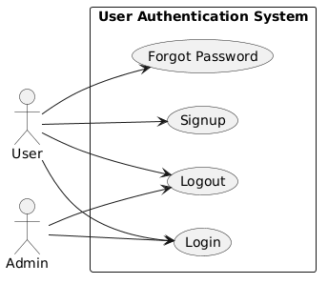
Figure 4: User use case Diagram

Authentication Use Case Diagram

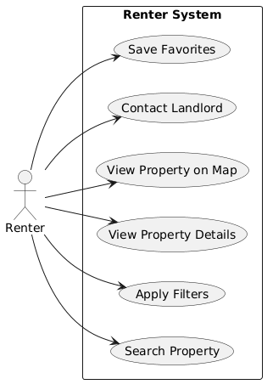
Figure 5 :Renter Use case diagram

Renter system Use Case Diagram

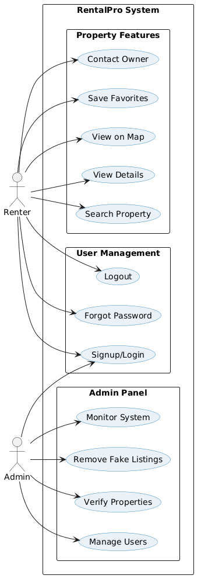
Figure 6: System Use Case Diagram

Table 5:Login Use Case
Use Case ID | UC1
Use Case Name | Login
Priority | High
Actor | Administrator, Customer
Pre-Condition | User is registered in the system
Basic Path | - User opens the system.  - Enters username and password.  - System validates credentials.  - User is redirected to dashboard.
Description | Allow registered users to securely access the system based on their role.
Post- Condition | User is successfully logged into the system.

Table 6: Manage Customers Use Case
Use Case ID | UC3
Use Case Name | Manage Customers
Priority | High
Actor | Administrator
Pre-Condition | User logged in to system
Basic Path | - Selects Manage Customers.  - Views customer list.  - Adds or updates customer details.  - Stores history.
Description | Allow administrators to manage customer profiles and records.
Post- Condition | Customer data is successfully managed.

Table 7: Visualization Use Case
Use Case ID | UC6
Use Case Name | Visualization
Priority | Medium
Actor | Customer
Pre-Condition | User logged in to system
Basic Path | - Selects house type.  - Chooses other properties.  - System generates visual preview.  - User reviews and confirms selection.
Description | Allows users to preview expected results of app visually before finalizing.
Post- Condition | selection is confirmed.

4.3 Activity Diagram
Activity diagrams are used to represent workflows and processes of the Rental Pro application step by step.
These diagrams explain how users interact with the system during operations such as:
- User Signup
- Property Searching
- Uploading Property
- Contacting Landlords
Components of Activity Diagram
Initial Node
Represents the starting point of the activity.
Actions
Actions represent tasks performed by the user or the system.
Decision Node
Decision nodes represent conditions or choices during workflows.
Final Node
Represents the completion of the activity.

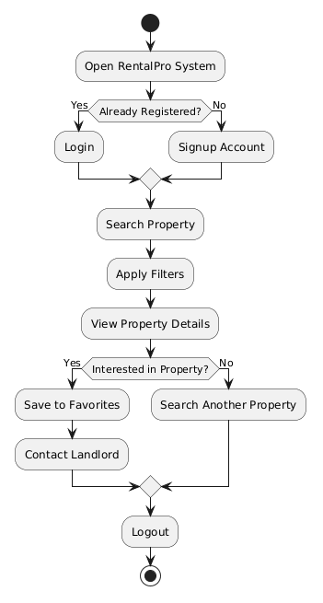

Figure 7: User Activity Diagram

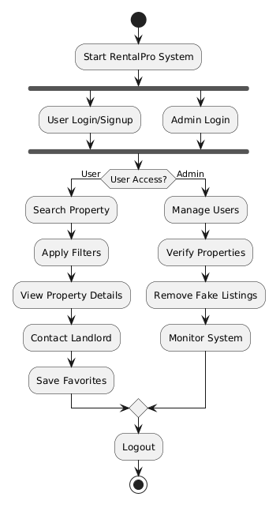

Figure 8: Activity Diagram

4.4 Class Diagram
A class diagram represents the static structure of the Rental Pro application. It shows classes, attributes, methods, and relationships between different objects. The major classes in the system include:
- User
- Renter
- Landlord
- Property
- Property Details
- Location
The class diagram helps in understanding how system entities communicate and share data with each other.

Class

Relationship

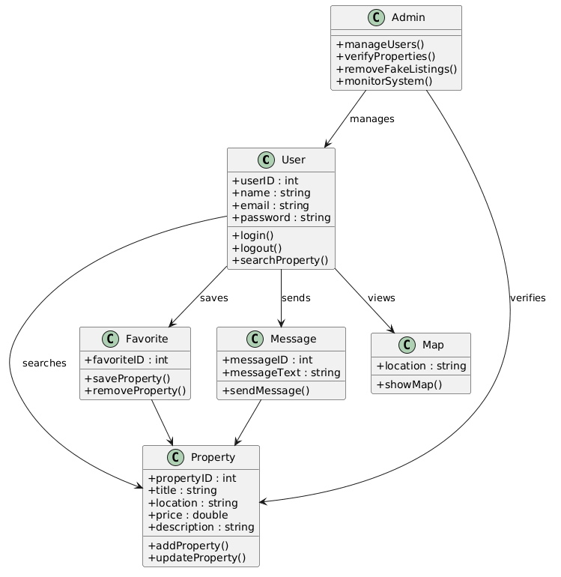

Figure 9: Class Diagram

4.5 Sequence Diagram
Sequence diagrams represent the interaction between objects in a sequential order.
The Rental Pro sequence diagrams explain operations such as:
- Login Process
- Property Search Process
- Add Property Process
- Contact Landlord Process

Components of Sequence Diagram

Lifelines: A lifeline represents an individual participant in the sequence diagram, such as Customer, Salon Staff, or System.

Messages: Messages are represented by arrows and show communication between objects. These messages may be synchronous or asynchronous.

Execution Occurrence: An execution occurrence is shown as a thin rectangle on a lifeline and indicates the time during which an object is performing an operation.

Self-Message: A self-message represents a situation where an object calls one of its own methods, such as system validation processes.

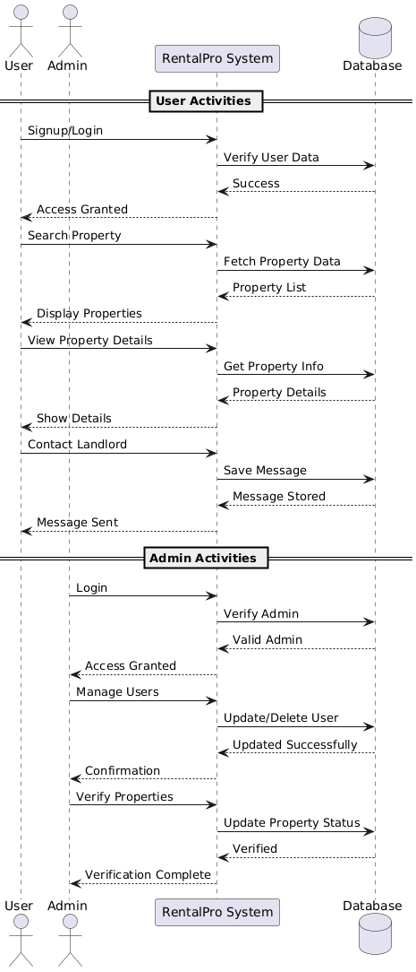
Figure 10: Sequential Diagram

4.6 Database Design
Database design is an important part of the Rental Pro application. Firebase Cloud store database is used to store and manage application data.

4.6.1 Entity Relationship Diagram (ERD)
An Entity Relationship Diagram (ERD) visually represents the database structure of the Rental pro application. It shows the relationship between the main entities involved in the property rental management system.
The ERD helps in understanding how data is stored, connected, and managed within the application. It includes the core entities required for property searching, property management, user authentication, and communication between renters and landlords.

4.6.2 Building Blocks of ERD
The ERD of the Hair Treatment Assistant system is based on the following components:

Entities
- User: Stores user account information for renters, landlords, and administrators.
- Property: Stores property details uploaded by landlords.
- Property Location: Stores location and map-related information of properties.
- Favorites: Stores saved or favorite properties selected by renters.
- Property Images: Stores images uploaded for rental properties.

4.6.3 Types of Relationships
- One-to-Many Relationship: One record of an entity is connected with only one record of another entity.

- Many-to-One Relationship: one entity can be connected with multiple records of another entity.

- Many-to-Many Relationship: Multiple records of one entity are connected with multiple records of another entity.

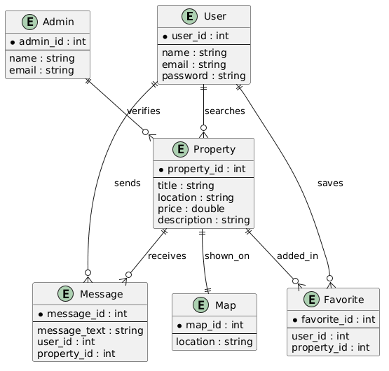

Figure 11: Entity Relationships Diagram

4.7 Network Diagram
The network diagram represents communication between the frontend application, Firebase backend, and Google Maps API.
The Flutter frontend communicates with Firebase services for authentication and database operations.
Google Maps API is integrated to display property locations visually on maps.

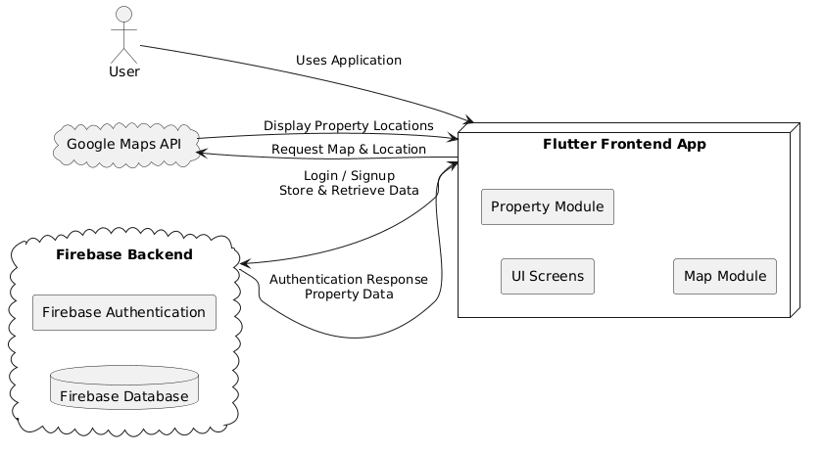

Figure 12: Networking Diagram

4.7 Implementation

4.7.1 Introduction
Implementation refers to converting system design into a working mobile application. The Rental Pro application was implemented using Flutter framework and Dart programming language.

4.7.2 Implementation Approach
The Rental Pro application was developed using an Agile implementation approach. The project was divided into small modules such as authentication, property management, searching, filtering, and map integration.

4.7.3 Frontend Implementation

The frontend was developed using Flutter widgets and responsive UI layouts.

Frontend screens include:

Splash Screen

Login Screen

Signup Screen

Home Screen

Search Screen

Property Detail Screen

Add Property Screen

Map Screen

4.7.4 Backend Implementation

Firebase was used as the backend service for:

Authentication

Cloud Firestore Database

Image Storage

The backend securely manages user accounts and property information.

4.7.4.1 Features of Project’s Backend:

- Authentication
Users can securely Signup, Login, and Logout using Firebase Authentication.
- Management
The system stores, updates, and manages property details in the database.
- FilterSystem
Users can search properties and apply filters like location and price.
- Integration
Property locations are displayed visually using Google Maps API.
- Verification
Admin can verify properties and remove fake listings for system security.

4.7.5 Hardware and Software Requirements
• Processor: Intel Core i3 or above
• RAM: 4GB minimum
• Android Mobile Device
• Stable Internet Connection
• Flutter SDK
• Dart SDK
• Firebase
• Android Studio
• VS Code

4.7.6 System Requirements:
- User Signup/Login
- Search Property
- View Property Details
- Contact Landlord
- Admin Verification System

4.8 Testing
Once the coding phase is completed, the next step is testing. This ensures that the Rental Pro results are accurate and the progress tracker works correctly.

4.8.1 Types of Testing

- Unit Testing: Each module was tested individually.
- Integration Testing: Frontend and backend integration was tested.

- Functional Testing: The main functionalities such as login, searching, and property uploading were tested.
Table 4: Sample Test Case
Test Case ID | Description | Results
TC-01 | Valid User Login | Login Successful
TC-02 | Property Search | Search Results Displayed
TC-03 | Add Property | Property Uploaded Successfully
TC-04 | View Property Details | Property Information Displayed
TC-05 | Map Integration | Property Location Displayed

4.9 Results, conclusions and Recommendations

4.9.1 Conclusions
The RentalPro application was successfully developed and implemented. The system provides a user-friendly and efficient platform for rental property management.
Users can easily search properties, manage listings, and communicate with landlords through the application.
.

4.9.1.1 Strengths:
- Provides a simple and user-friendly interface for renters and landlords.
- Saves time through online property searching and filtering.
- Supports property management and map integration.
- Improves communication between renters and landlords.
- Mobile-based system provides easy accessibility anytime and anywhere..

4.9.1.2 Weaknesses:
- Requires stable internet connectivity for proper functionality.
- No online payment system is currently available.
- Limited to uploaded property information only.
- Security and fake listing verification may require further improvements.
- Advanced AI recommendation features are not implemented yet.

4.9.2 Recommendations and Future enhancement
Future improvements may include:
- Online Payment Integration
- AI-based Property Recommendations
- Push Notifications
- In-app Chat System
- Property Reviews and Ratings

CHAPTER 5

5.Figma Designs

5.1 Overall Figma Designs:

5.1.2 Figma link : https://www.figma.com/design/T1ppbH19pTzfRbS2zzZxM1/Untitled?node-id=0-1&t=nRih4ZZmNo8kJTbJ-1

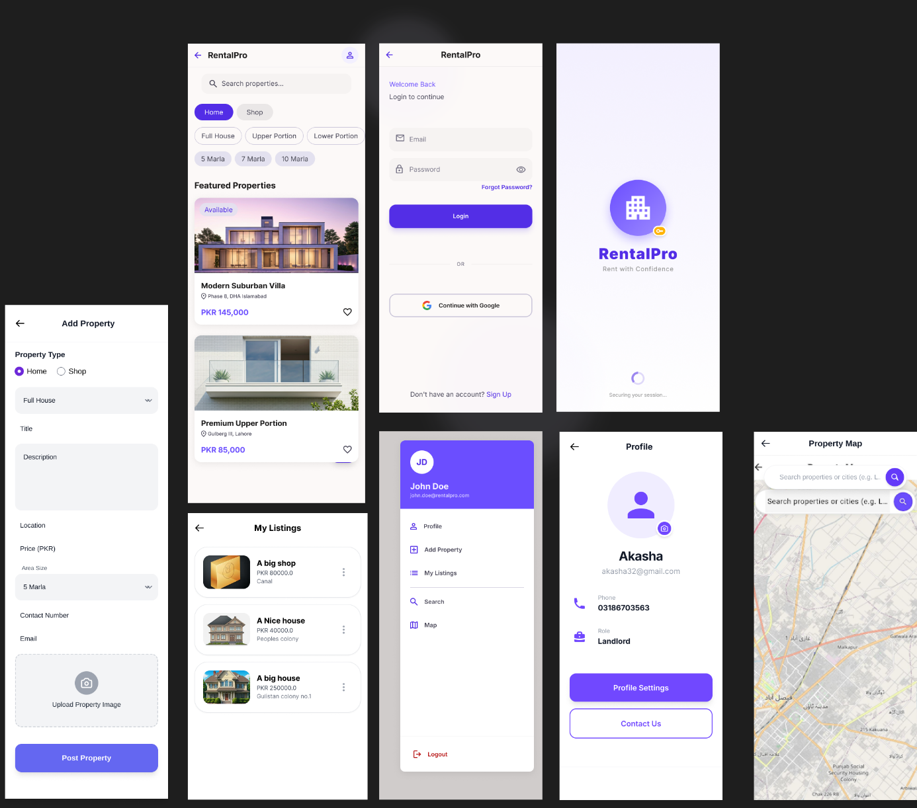

5.2 Splash Screen:
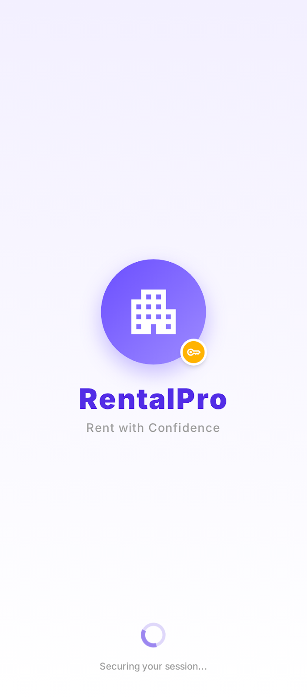

5.3 Login /Sign up Screen:

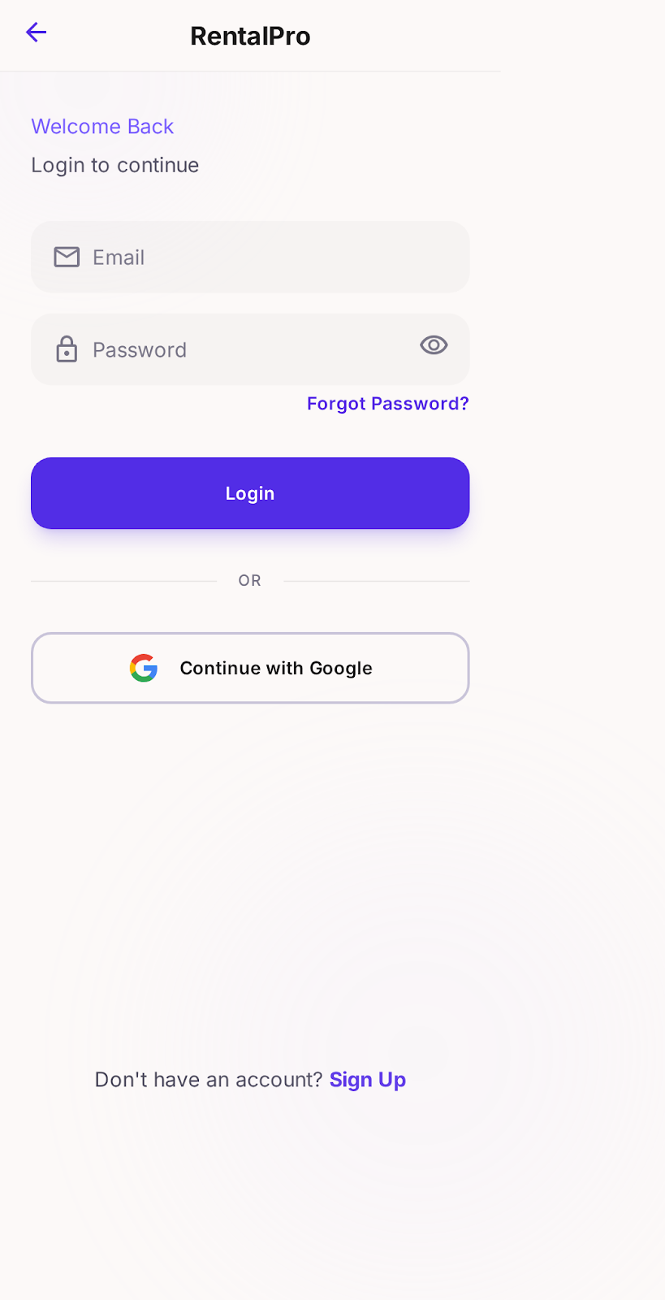

5.4 Home Screen:
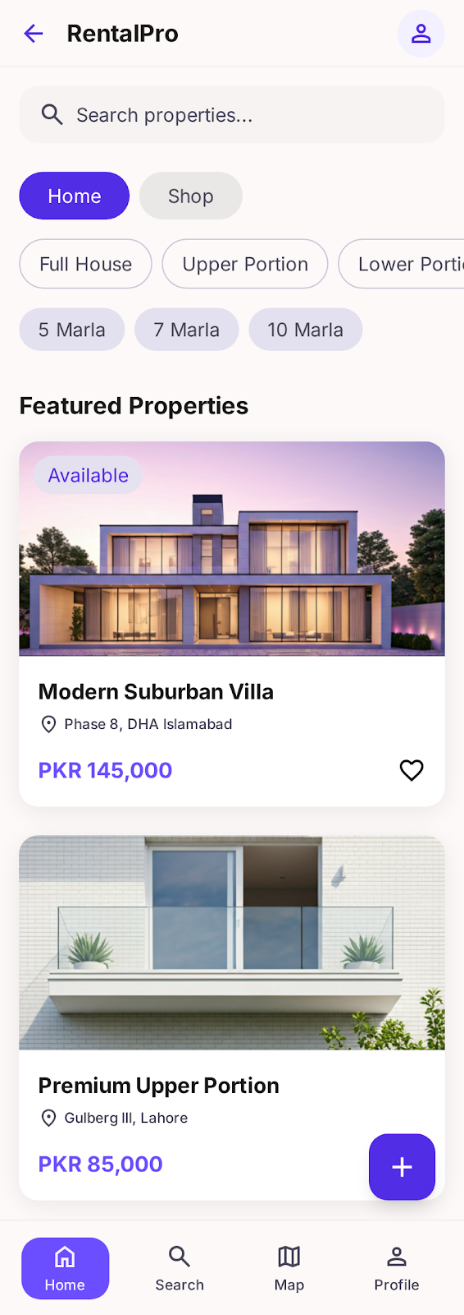

5.5 Menue:
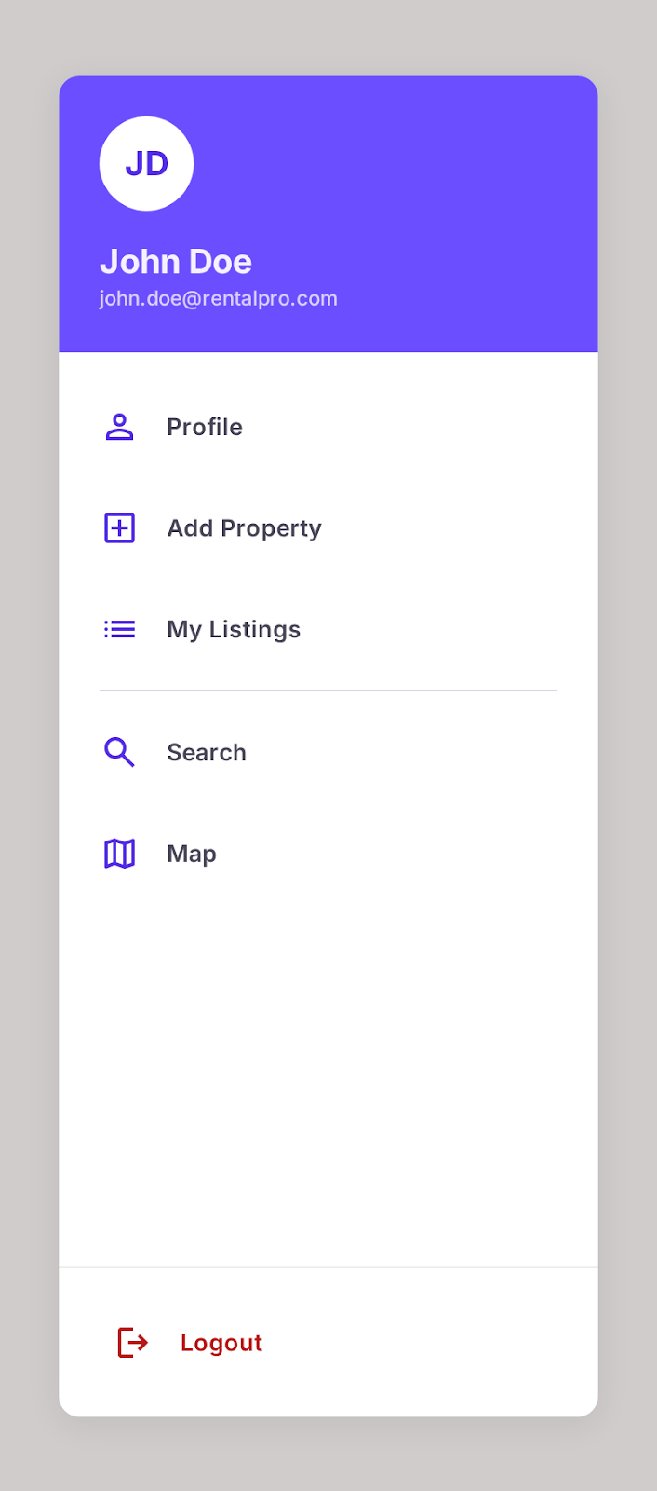

5.6 Listing :

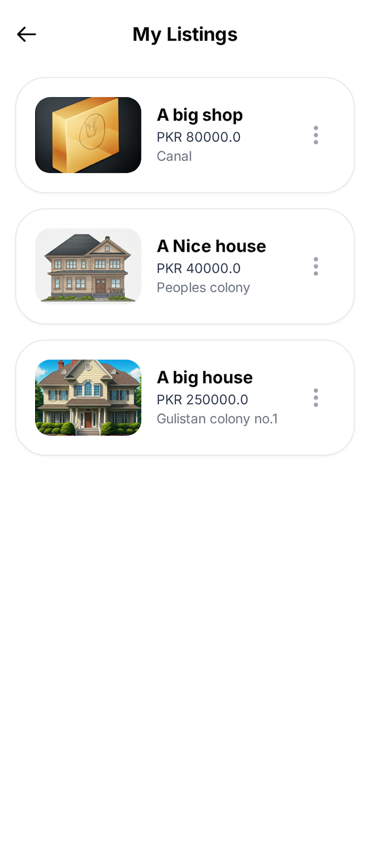

5.7 Profile Screen:
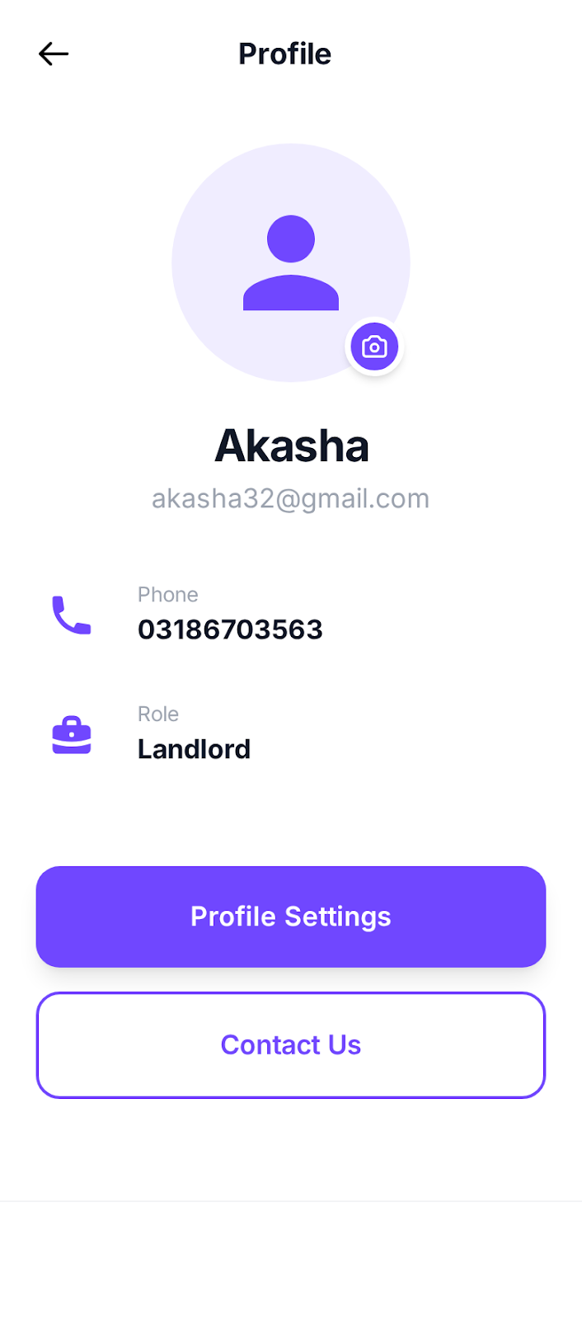

5.8 Add Property :
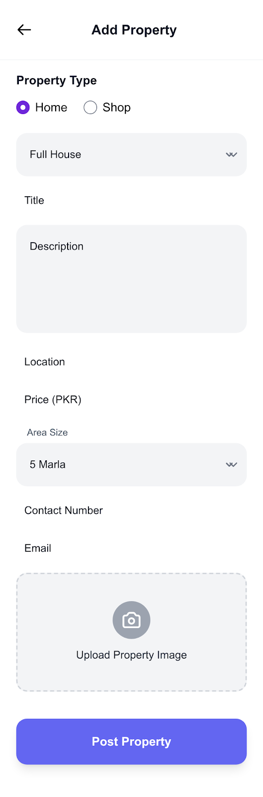

5.9 Map Screen:

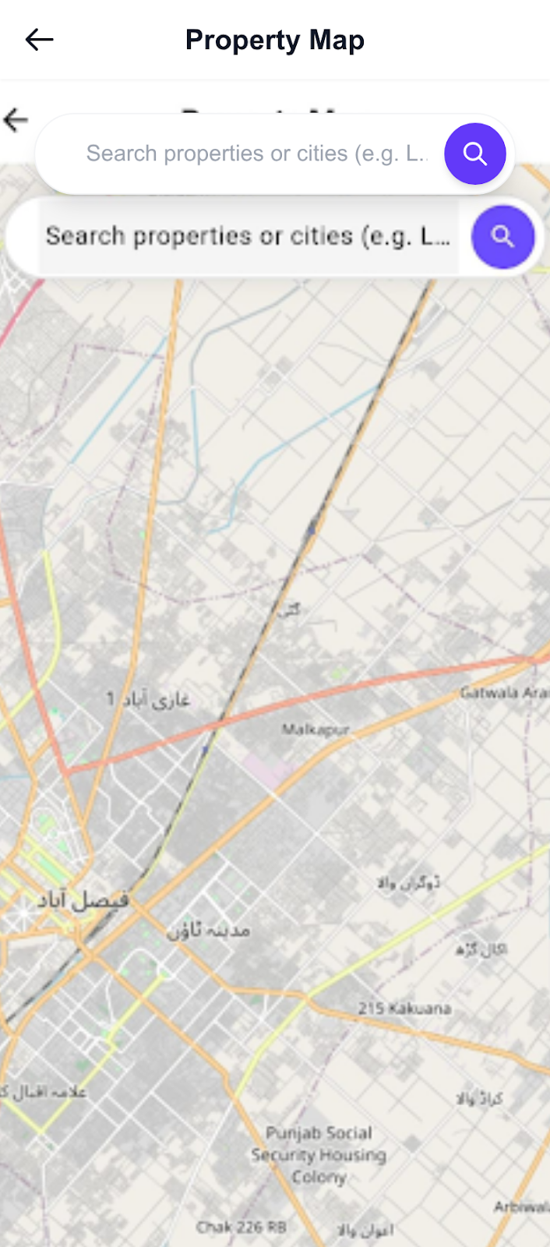

REFERENCE:
[1] I. Sommerville, Software Engineering, 10th ed. Boston, MA, USA: Pearson Education, 2016. (For Software Development Life Cycle and Agile Methodology).
[2] R. S. Pressman and B. R. Maxim, Software Engineering: A Practitioner’s Approach, 8th ed. New York, NY, USA: McGraw-Hill, 2015. (For System Implementation and Testing Strategies).
[3] J. Dennis, A. Wixom, and D. Tegarden, Systems Analysis and Design: An Object-Oriented Approach with UML, 5th ed. Hoboken, NJ, USA: Wiley, 2015. (For Use Case, Class, and Activity Diagrams).
[4] M. Fowler, UML Distilled: A Brief Guide to the Standard Object Modeling Language, 3rd ed. Boston, MA, USA: Addison-Wesley, 2004. (For Sequence Diagrams and ER Diagrams).
[5] Firebase Documentation, 2024. (For Authentication, Firestore Database, and Cloud Storage Integration).
[6] Flutter Official Documentation, 2024. (For Flutter Mobile Application Development).
[7] Dart Programming Language Documentation, 2024. (For Dart Programming Concepts and Application Logic).
[8] Google Maps Platform Documentation, 2024. (For Map Integration and Location Services).
[9] Figma Documentation, 2024. (For UI/UX Design and Prototyping).
[10] E. Gamma, R. Helm, R. Johnson, and J. Vlissides, Design Patterns: Elements of Reusable Object-Oriented Software. Boston, MA, USA: Addison-Wesley, 1994. (For Modular System Architecture and Application Design).
[11] OWASP Foundation, 2024. (For Application Security and User Data Protection).
[12] Android Developers Documentation, 2024. (For Android Application Deployment and Mobile Device Compatibility).

