CSCI 6951 Advanced Database Design and Administration

# Lab 1 – KimTay Pet Supplies

Use SQL to complete the following exercises.

1. Create a table named kimREP. The table has the same structure as the SALES_REP table shown in Figure below except the LAST_NAME column should use the VARCHAR data type and the COMMISSION and RATE columns should use the NUMERIC data type. Execute the command to describe the layout and characteristics of the REP table.

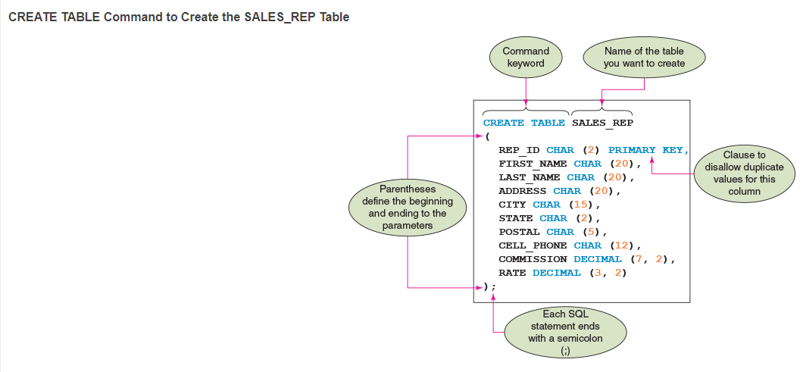

**Solution:**

CREATE TABLE KIM_REP (

REP_ID CHAR(2) PRIMARY KEY,

FIRST_NAME CHAR(20),

LAST_NAME VARCHAR(20),

ADDRESSS CHAR(20),

CITY CHAR(15),

STATE CHAR(2),

POSTAL CHAR(5),

CELL_PHONE CHAR(12),

COMMISSION NUMBER,

RATE NUMBER

);

**Output:**

Table KIM_REP created.

DESCRIBE KIM_REP;

**Output:**

Name Null? Type

---------- -------- ------------

REP_ID NOT NULL CHAR(2)

FIRST_NAME CHAR(20)

LAST_NAME VARCHAR2(20)

ADDRESSS CHAR(20)

CITY CHAR(15)

STATE CHAR(2)

POSTAL CHAR(5)

CELL_PHONE CHAR(12)

COMMISSION NUMBER

RATE NUMBER

1. Add the following row to the REP table: rep ID: 35, first name: Fred; last name: Kiser; address: 427 Billings Dr.; city: Cody; state: WY; postal: 82414; cell phone: 307-555-6309; commission: 0.00; and rate: 0.05. Display the contents of the REP table.

**Solution:**

INSERT INTO KIM_REP VALUES

('35', 'Fred', 'Kiser', '427 Billings Dr.', 'Cody','WY','82414', '307-555-6309', 0.00,0.05);

SELECT*FROM KIM_REP;

**Output:**

1. Delete the REP table.

**Solution:**

DROP TABLE KIM_REP;

**Output:**

Table is dropped

1. Run the script file kimtay.sql for the KimTay Pet Supplies database to create the five tables and add records to the tables. Confirm that you created each table correctly by describing each table and listing all their records.

**Solution:**

1. DESCRIBE KIMCUSTOMER;

**Output:**

Name Null? Type

------------ -------- ------------

CUST_ID NOT NULL CHAR(3)

FIRST_NAME VARCHAR2(20)

LAST_NAME VARCHAR2(20)

ADDRESS VARCHAR2(20)

CITY VARCHAR2(15)

STATE CHAR(2)

POSTAL CHAR(5)

EMAIL VARCHAR2(30)

BALANCE NUMBER

CREDIT_LIMIT NUMBER

REP_ID CHAR(2)

1. DESCRIBE KIMINVOICE_LINE;

**Output:**

Name Null? Type

------------ -------- -----------

INVOICE_NUM NOT NULL CHAR(5)

ITEM_ID NOT NULL CHAR(4)

QUANTITY NUMBER(38)

QUOTED_PRICE NUMBER(7,2)

1. DESCRIBE KIMINVOICES;

**Output:**

Name Null? Type

------------ -------- -----------

INVOICE_NUM NOT NULL CHAR(5)

INVOICE_DATE DATE

CUST_ID VARCHAR2(3)

1. DESCRIBE KIMITEM;

**Output:**

Name Null? Type

----------- -------- ------------

ITEM_ID NOT NULL CHAR(4)

DESCRIPTION VARCHAR2(30)

ON_HAND NUMBER(38)

CATEGORY CHAR(3)

LOCATION CHAR(1)

PRICE NUMBER(7,2)

1. DESCRIBE KIMSALES_REP;

**Output:**

Name Null? Type

---------- -------- ------------

REP_ID NOT NULL CHAR(2)

FIRST_NAME VARCHAR2(20)

LAST_NAME VARCHAR2(20)

ADDRESS VARCHAR2(20)

CITY VARCHAR2(15)

STATE CHAR(2)

POSTAL CHAR(5)

CELL_PHONE CHAR(12)

COMMISSION NUMBER(7,2)

RATE NUMBER(3,2)

1. DESCRIBE SALGRADE;

**Output:**

Name Null? Type

----- ----- ------

GRADE NUMBER

LOSAL NUMBER

HISAL NUMBER

1. Write the SQL query to list the item ID, description, and price for all items.

**Solution:**

SELECT ITEM_ID, DESCRIPTION,PRICE FROM KIMITEM;

**Output:**

ITEM DESCRIPTION PRICE

---- ------------------------------ ----------

AD72 Dog Feeding Station 79.99

BC33 Feathers Bird Cage (12x24x18) 79.99

CA75 Enclosed Cat Litter Station 39.99

DT12 Dog Toy Gift Set 39.99

FM23 Fly Mask with Ears 24.95

FS39 Folding Saddle Stand 39.99

FS42 Aquarium (55 Gallon) 124.99

KH81 Wild Bird Food (25 lb) 19.99

LD14 Locking Small Dog Door 49.99

LP73 Large Pet Carrier 59.99

PF19 Pump & Filter Kit 74.99

ITEM DESCRIPTION PRICE

---- ------------------------------ ----------

QB92 Quilted Stable Blanket 119.99

SP91 Small Pet Carrier 39.99

UF39 Underground Fence System 199.99

WB49 Insulated Water Bucket 79.99

1. Write the SQL query to list all rows and columns for the complete INVOICES table.

**Solution:**

SELECT*FROM KIMINVOICES;

**Output:**

INVOI INVOICE_D CUS

----- --------- ---

14216 15-NOV-21 125

14219 15-NOV-21 227

14222 16-NOV-21 294

14224 16-NOV-21 182

14228 18-NOV-21 435

14231 18-NOV-21 125

14233 18-NOV-21 435

14237 19-NOV-21 616

1. Write the SQL query to list the first and last names of customers with credit limits of $1,000 or more.

**Solution:**

SELECT FIRST_NAME,LAST_NAME

FROM KIMCUSTOMER

WHERE CREDIT_LIMIT >= 1000;

**Output:**

FIRST_NAME LAST_NAME

-------------------- --------------------

James Gonzalez

Leslie Smith

1. Write the SQL query to list the order number for each order placed by customer number 125 on 11/15/2021.

**Solution:**

SELECT x.INVOICE_NUM

FROM KIMINVOICES x,KIMINVOICE_LINE y

WHERE x.CUST_ID ='125' AND x.INVOICE_DATE = '15-NOV-21';

**Output:**

INVOI

-----

14216

14216

14216

14216

14216

14216

14216

14216

14216

14216

14216

INVOI

-----

14216

1. List the number and name of each customer represented by sales rep 10 or sales rep 15.

**Solution:**

SELECT CONCAT(CONCAT(FIRST_NAME,' '), LAST_NAME) as NAME, CUST_ID AS NUM FROM KIMCUSTOMER WHERE REP_ID=10 OR REP_ID=15;

**Output:**

NAME NUM

----------------------------------------- ---

Billy Rufton 182

Sandra Pincher 227

Samantha Smith 294

Tom Rascal 314

James Gonzalez 435

Elmer Jackson 492

Sally Cruz 616

Leslie Smith 721