Graylog DNS RPZ Correlator Deployment Guide

Version 0.1 [Draft]

Project: https://github.com/nimrodkr/graylog-dns-rpz-correlator
Maintained by: Nimrod Kravicas
Graylog DNS RPZ Correlator Deployment Guide
This guide describes how to configure Graylog to collect A10 Networks DNS and RPZ syslog messages, enrich RPZ events with the originating client IP using the Graylog DNS RPZ Correlator project, and visualize the results using dashboards and alerts.
Prerequisites
• Graylog 6.x • OpenSearch 2.x • Python 3.8+ • A10 Networks DNS appliance sending syslog • Git installed • Graylog DNS RPZ Correlator installed

Architecture
A10 DNS
│
▼
Graylog
│
▼
OpenSearch
▲
│
Python Correlator
▲
│
Lookup Table
▲
│
Pipeline Rule
│
▼
Enriched RPZ Events

Index:

Step 1: Inputs 1
Step 2: Rules 1
Step 3: Streams 2
Step 4: Lookup Tables 3
Step 5: Dashboard 4
Step 6: Alerts 4

Step 1: Inputs

Create an input for SYSLOG collection under “System” “Inputs”, as an example “A10_Syslog”
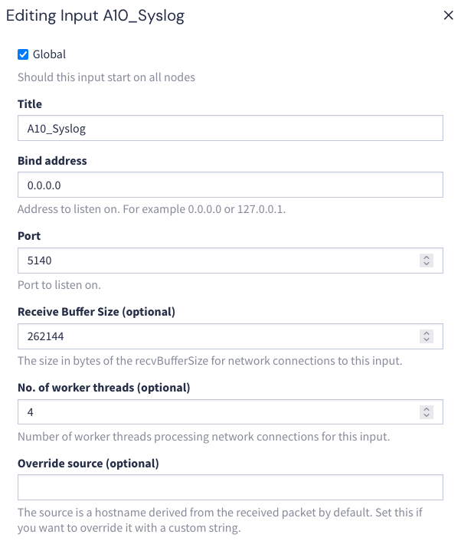
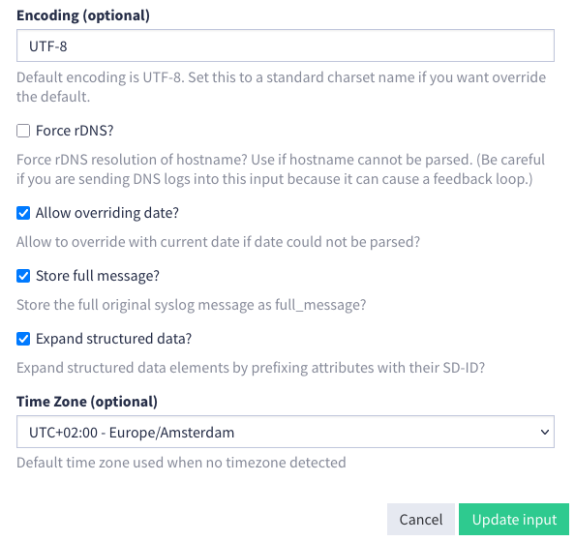

Step 2: Pipeline Rules

Create a data rule under “System” “Pipelines Rules” “Manage rules”: as an example “process_rpz_rule”, change to “use source code editor” and paste the code from the git repo:
/graylog-dns-rpz-correlator/graylog_config/process_rpz_policy.rule
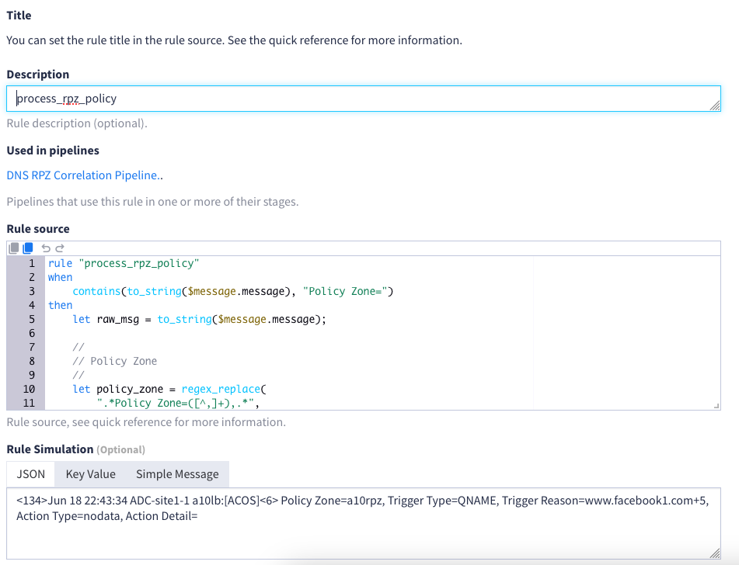

Step 3: Streams
Create a stream under “Streams”: as an example “RPZ Policy Log”, edit the stream “manage rules” and add: “message must contain Policy” and “message must contain Trigger”
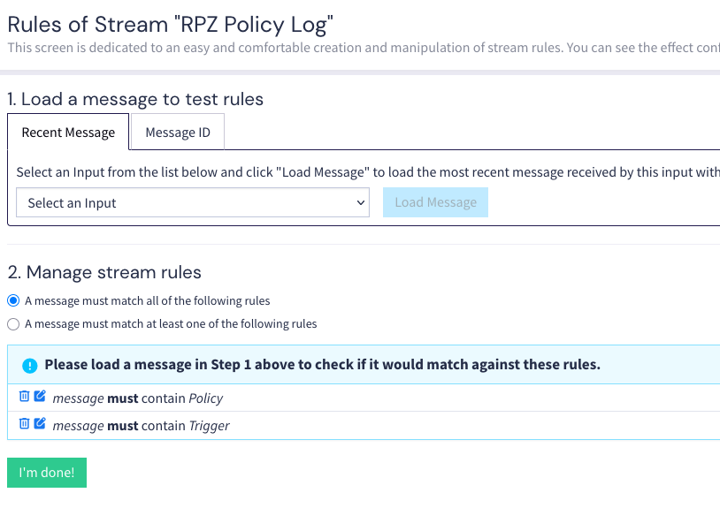

Step 4: GIT project
Install the Graylog DNS RPZ Correlator project by following the instructions in the project's README.
https://github.com/nimrodkr/graylog-dns-rpz-correlator/

Step 5: Lookup Tables
The Lookup Table queries the DNS RPZ Correlator service to retrieve the client IP associated with a recently observed DNS query.
Build a Lookup table under “System” “Lookup tables” as follow:
- Create a “Data adapter” as an example “DNS Lookup Service”:
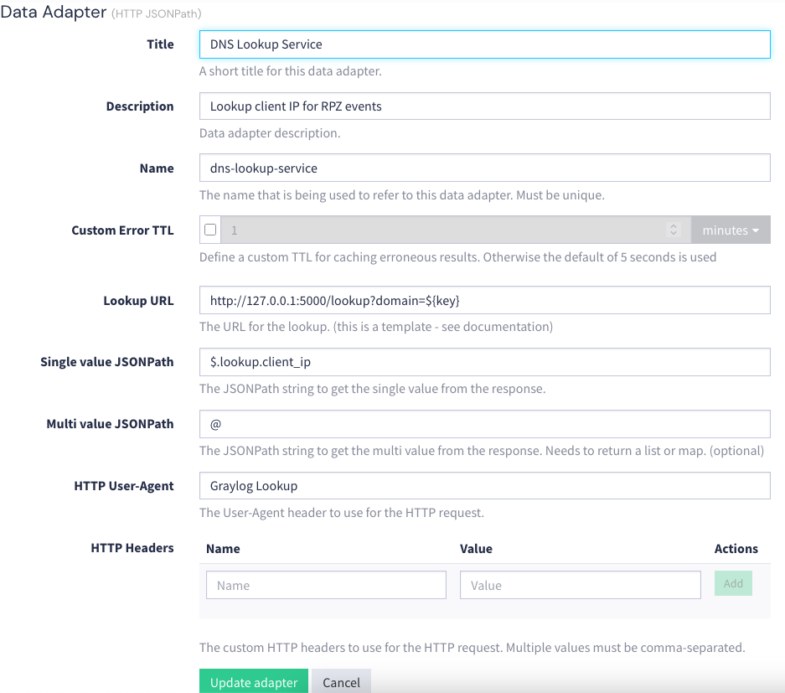
- Create a cache config under “Caches” as an example “A10_RPZ_Cache”:
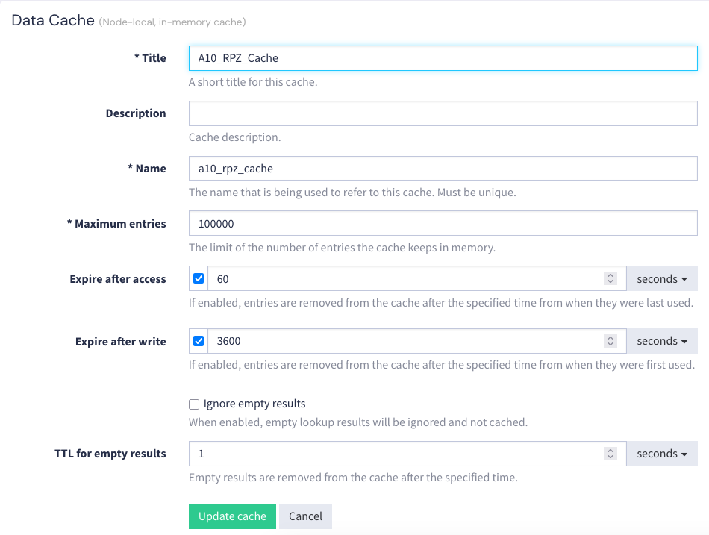

- Create the lookup table under “Lookup tables”, as an example “dns_lookup”:

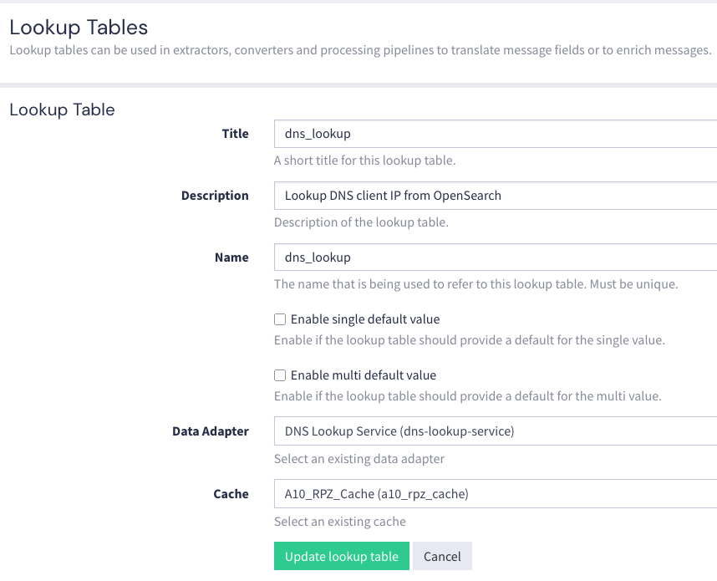

Step 6: Alerts
Whenever an RPZ policy event is detected, Graylog generates an event that can be forwarded via email, Slack, Teams, Syslog, or other supported notification channels.
Create an alert to collect and push RPZ alerts under “Alerts” “Event Definitions” as an example “RPZ Policy Hit":

- Title: RPZ Policy Hit
- Priority: High
- Condition Type: Filter and Aggregation
- Search Query: domain:*
- Streams: RPZ Policy Log
- Search within last: 2
- Enable it!
- Create Events for Definition if... Filter has results
Add the following fields:
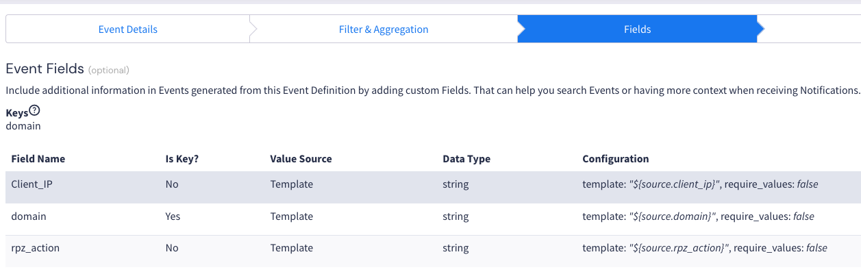
And create the event

Step 7: Dashboard

The dashboard can display different information such as:
- Top blocked domains
- Top client IPs
- RPZ action distribution
- Recent policy hits
- Message timeline
- ETC..
Create a dashboard to display the RPZ events, as an example “DNS RPZ Dashboard”:
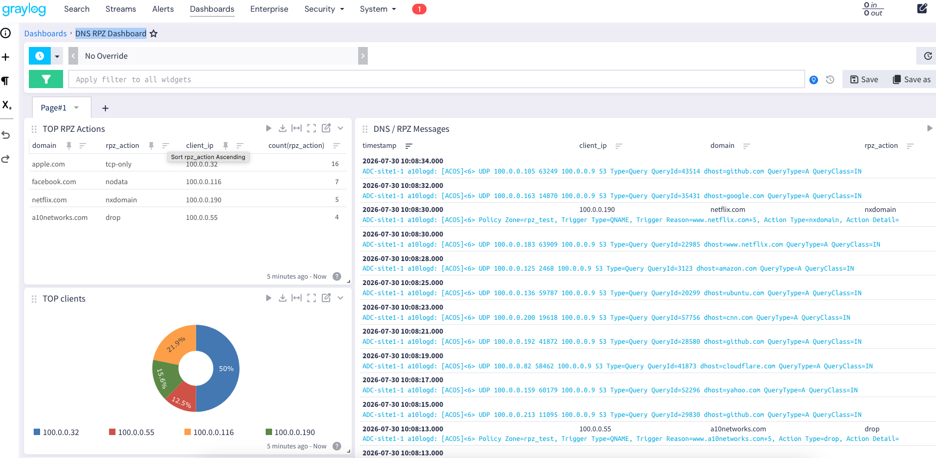

You can see the collected RPZ information on the left-hand side:
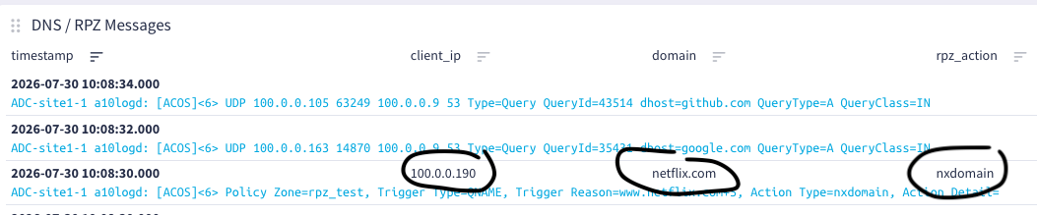

You can customize the dashboard widgets to suit your requirements, in the example above you can see TOP RPZ actions, TOP Client IP, and SYSLOG message details

