4COSCOO2W MATHEMATICS FOR COMPUTING

Week 7 Seminar Tasks

Graph Theory

READING
Lecture 5 Notes (available on Blackboard)
Chapters 10-11. Grossman, P., 2017. Discrete mathematics for computing. Bloomsbury Publishing.

TASK 1. GRAPH NOTATION. GRAPH TYPES

Task 1.1. For each of the following graphs represented in the diagrams below do the following:
- form set V of all its nodes and set E of all its edges
- determine if it is a directed or undirected graph
- determine if it is a cyclic or acyclic graph, for a cyclic graph give an example of a cyclic path in it
- is there a pattern a graph can represent?

a.
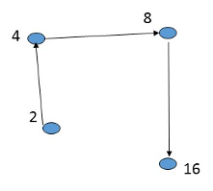

b.
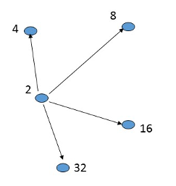
c.
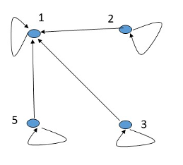
d.
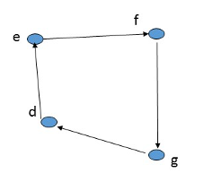

e.
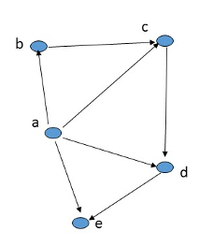

Solution:

- V={2,4,8,16}; E={(2,4), (4,8), (8,16)}.
Directed acyclic graph. The pattern: E (2,y), y=2x
- V={2,4,8,16,32}; E={(2,4), (2,8), (2,16), (2,32)}.
Directed acyclic graph. The pattern: E (x,y), x=2, y=2n
- V={1,2,3,4,5}; E={(1,1), (2,2), (3,3), (5,5), (2,1), (3,1), (5,1)}.
Directed cyclic graph. The pattern: E (x,y), x is divisible by y
- V={d,e,f,g}; E={(d,e), (e,f), (f,g),(g,d)}.
Directed cyclic graph. Example of the cyclic path: e,f,g,d,e
- V={a,b,c,d,e}; E={(a,b), (a,c), (a,d), (a,e), (b,c), (c,d), (d,e)}.
Directed acyclic graph (pay attention to the directions of the edges).

Task 1.2. For each of the following graphs defined by the given set of nodes, V, and set of edges, E, do the following:
- draw its representation corresponding to the definition of V and E
- determine if it is a directed or undirected graph
- determine if it is a cyclic or acyclic graph, for a cyclic graph give an example of a cyclic path in it.
- calculate the sum of the degrees of all vertices

- V={d,e,f,g}; E={{d,e}, {e,g}, {f,g}, {f,d}}
- V={a,b,c,d,e}; E={{a,b}, {a,c}, {a,d}, {a,e}, {b,c},{c,d}, {d,e}}
- V={a,b,c}; E={(a,a), (a, b), (b,b), (b,a), (b, c), (c,c), (c,b), (a,c),(c,a)}

NB: Pay attention to the bracket types!

Solution:

Graph A

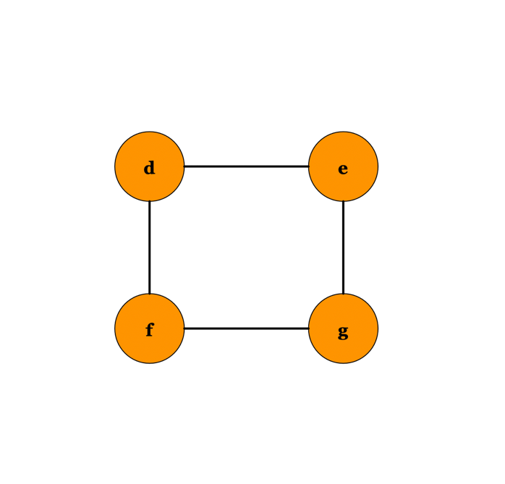

This graph is undirected since the edges do not have a direction – { }.
This graph is cyclic. Example of a cyclic path: $d→e→f→g→d$.
Sum of degrees = 2 + 2 + 2 + 2 = 8 (4 edges):
- d: 2
- e: 2
- f: 2
- g: 2

Graph B

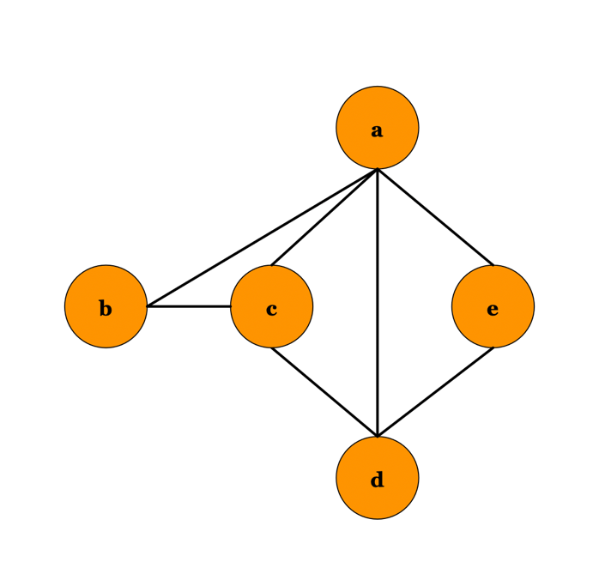

This graph is undirected since edges have no direction – { }.
This graph is cyclic. Example of a cyclic path: $a→b→c→d→a$.
Sum of degrees = 4 + 2 + 3 + 3 + 2 = 14 (7 edges):
- a: 4
- b: 2
- c: 3
- d: 3
- e: 2

Graph C

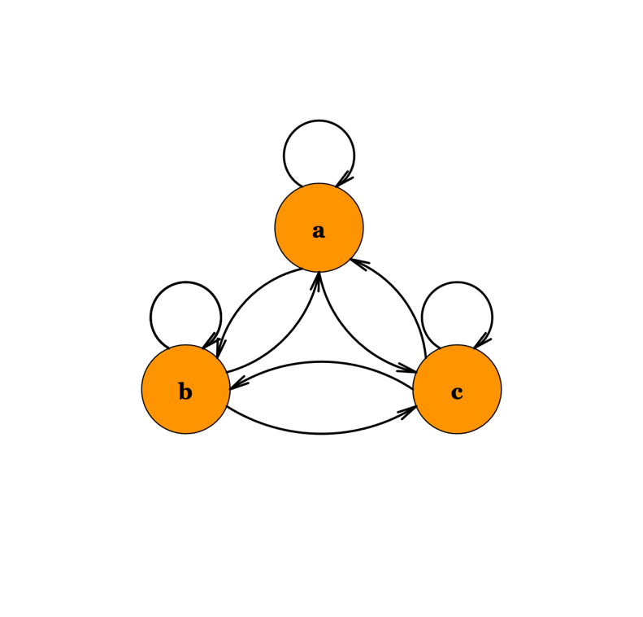

This graph is directed since the edges have specific directions – ( ).
This graph is cyclic (loop is also a cycle).
Sum of degrees = 6 + 6 + 6 = 18 (9 edges):
- a: 6 (out-degrees 3: self-loop, edge to b, edge to c; in-degrees 3: self-loop, edge from b, edge from c)
- b: 6
- c: 6

NB: In a directed graph, the degree splits into in-degree and out-degree, while in an undirected graph, the degree counts all edges connected to the node without direction.

TASK 2. WEIGHTED GRAPHS

In a distributed database system, several servers (nodes) store parts of a database and are connected via direct data transfer links (edges) with specific costs, representing the time or resources needed to transfer data between servers.

Weighted Graph:

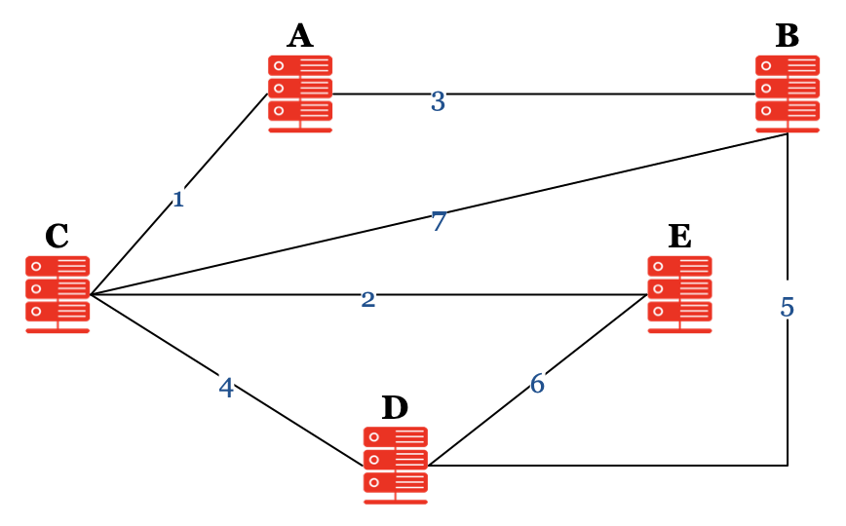

Servers (Nodes): A, B, C, D, E
Connections (Edges) and Transfer Costs (in milliseconds):
- A-B: 3
- A-C: 1
- B-C: 7
- B-D: 5
- C-D: 4
- C-E: 2
- D-E: 6

Tasks:
- Identify Key Connections for Fastest Transfers:
  - Which connections have the lowest and highest data transfer costs?
  - How do these connections impact overall transfer efficiency?
- Calculate Average Transfer Cost Across the Network:
  - What is the average data transfer cost between servers in the system?
  - Interpret what this average means in terms of overall system efficiency.
- Find Alternative Paths for Reliability:
  - If the connection between B and C becomes unreliable, list alternative paths for data transfer between B and C, and calculate the total transfer costs for each path.
  - Which alternative path is the most efficient?
- Data Balancing Optimisation:
  - Assuming that servers can occasionally be reconfigured to reduce transfer costs, analyse which server-to-server connections could be optimised (i.e., connections with the highest costs that could be improved).
  - Suggest a way to distribute data or reorganise connections to improve data transfer efficiency without losing the direct connectivity between all servers.
- Determine Server Load Based on Node Degree:
  - Calculate the degree of each server in the network.
  - Based on the degree, identify which server(s) could be experiencing the highest load due to a large number of direct data transfers.
  - Provide suggestions for balancing the load by analysing the degree of connectivity.

Solution:

Task 1

Identify Key Connections for Fastest Transfers:
- Lowest Cost Connection: A-C with a cost of 1.
- Highest Cost Connection: B-C with a cost of 7.

Interpretation:
The A-C connection is optimal for fast data transfers and should be prioritised for data routing when involving these servers.
The high cost of B-C may indicate potential inefficiencies when B and C need frequent data exchanges. Reducing this cost could benefit the system.

Task 2

Calculate the Average Transfer Cost Across the Network:
Total cost of all connections = 3 + 1 + 7 + 5 + 4 + 2 + 6 = 28
Number of connections = 7
Average Cost: $\text{Average Transfer Cost}=\frac{28}{7}=4$

Interpretation:
An average transfer cost of 4 ms suggests that, while some connections are fast, others are relatively slower, which could impact data synchronization across the system.

Task 3

Find Alternative Paths for Reliability if B-C is Unreliable:
Alternative Paths from B to C:
- Path 1: B-D -> D-C, with a total cost of 5 + 4 = 9
- Path 2: B-A -> A-C, with a total cost of 3 + 1 = 4

Most Efficient Alternative:
The B-A-C path is more efficient, with a transfer cost of 4 ms. This path should be used as an alternative route if B-C is unavailable or if load balancing is required to avoid using the high-cost B-C link.

Task 4

Data Balancing Optimisation:
Connections with Highest Transfer Costs: B-C (7) and D-E (6) are the highest cost connections. Reducing these could improve efficiency.

Suggested Reorganisation:
Option 1: If possible, reconfigure data routing so that data exchanged between B and C is redirected through A, leveraging the lower-cost path B-A-C (3 + 1 = 4).
Option 2: For D-E, consider redistributing data to reduce the dependency on this high-cost link by increasing direct data routing through D-C-E if feasible.

Use A-C as a primary path for faster transfers.
If B-C is a frequent bottleneck, re-route data through B-A-C.
Consider reconfiguring data near D and E to reduce reliance on the high-cost D-E connection.

Task 5

Analysing Server Load Using Node Degree
In the context of this distributed database network, the degree of a node (server) represents the number of direct connections it has with other servers. A higher degree indicates a higher potential for data transfer, which can signify a more central role in data distribution but may also lead to higher load and resource use on that server.

Determine Server Load Based on Node Degree:
Calculate the Degree of Each Server:
- Server A: Connected to B, C → Degree = 2
- Server B: Connected to A, C, D → Degree = 3
- Server C: Connected to A, B, D, E → Degree = 4
- Server D: Connected to B, C, E → Degree = 3
- Server E: Connected to C, D → Degree = 2

Identify High Load Servers:
Server with the Highest Degree: Server C has the highest degree (4), meaning it has direct connections with four other servers (A, B, D, and E). This indicates that server C is central to data distribution, potentially leading to higher processing and resource demands.
Suggestions for Load Balancing:
Optimise Data Routing. To reduce the load on Server C, consider routing some data exchanges indirectly when feasible. For example, data from B to E could potentially go through D instead of C if resource costs or load on C become excessive.
Introduce Redundant Connections. Adding a direct connection between A and E could help distribute data more evenly, potentially relieving some of the load on C by creating alternative paths.

By understanding the degree of each server, we can see that Server C is central and likely experiences the most load. Redirecting certain data paths or adding redundant connections can help balance the data flow across the network.

TASK 3. TREES.

In the figures below, you will see attempts to draw rooted trees. Justify if the graphs drawn are trees.
For those cases where you established trees, identify:
- All the leaves of a tree
- Depth of a tree
- If a tree is a binary tree

a.
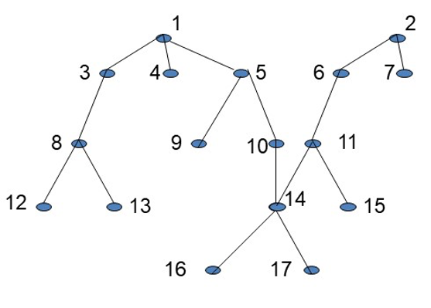
b.
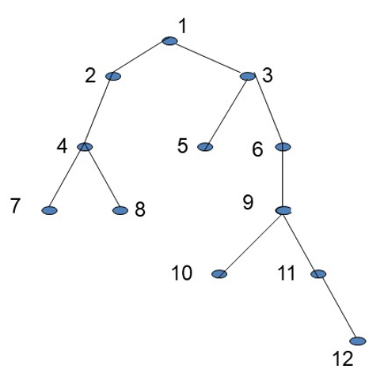
c.
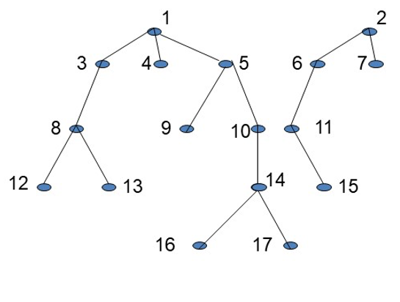
d.
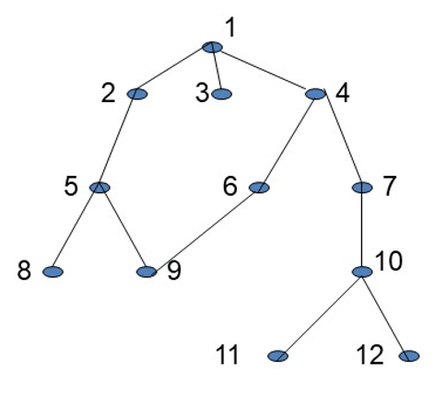
e.
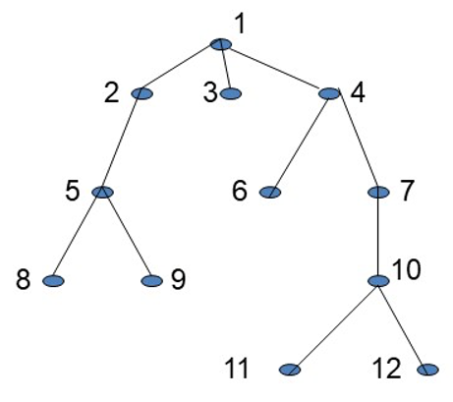
f.
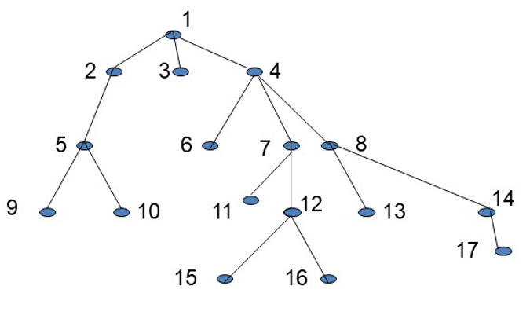

Solution:
- Not a single-rooted tree – it should be only one root in a tree.
- Yes, conditions were met. We have a tree with root 1 and its subtree with root 3 (a child of 1). Leaves are 7, 8, 5, 10 and 12; this is a binary tree because every node has at most two children. (Pay attention that nodes 2, 6 and 11 have only one child each, which satisfies the binary tree condition for a node to have at most two children). The depth of this tree is 5 – the distance between the lowest leaf – 12 and the root.
- This is not a connected graph – there is no path between nodes 1 and 2, so it cannot meet the given conditions of a single tree with root 1 and its subtree with root 2.
- This is not a tree because node 9 has two parents.
- Yes, it is a tree; its leaves are 8, 9, 3, 6, 11, and 12, and the depth is 4 (number of edges from the lowest node – 11 or 12 to the root). It IS NOT a binary tree – node 1 has three successors (three children).
- Yes, it is a tree. Its leaves are 9, 10, 6, 11, 15, 16, 13, and 17. Depth of the tree – 4. It is not a binary tree as the root has three children (the other node with more than two children is 4)

TASK 4: CRITICAL PATH ANALYSIS IN PROJECT MANAGEMENT

Task A
The provided diagram represents a project schedule using a network graph, where each node (or box) represents a task within the project. The edges represent activity and are labelled with letters, and the duration of each task is given below. The arrows indicate the sequence of tasks, demonstrating which tasks must be completed before others can begin.

Activity | Description | Start Point | End Point | Duration (Days)
A | Requirement Analysis | 1 | 3 | 11
B | Database Setup | 1 | 2 | 33
C | Data Integration | 2 | 5 | 154
D | Testing Module | 5 | 7 | 22
E | Deployment Preparation | 6 | 7 | 1
G | System Testing | 7 | 8 | 11
H | User Interface Design | 5 | 6 | 11
I | Security Protocol Design | 3 | 4 | 22
J | Load Balancing Setup | 4 | 7 | 143
K | API Development | 3 | 4 | 1

Network Graph:

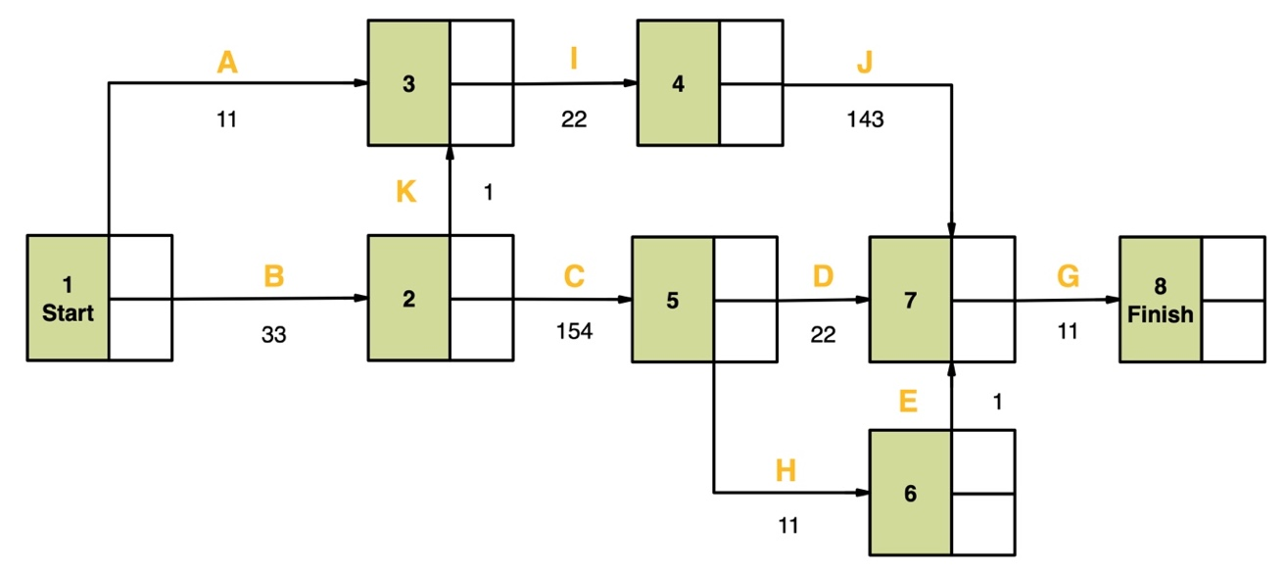
Using the provided network graph, your objective is to perform a critical path analysis. This will involve identifying the longest path through the network, which determines the shortest time in which the project can be completed.
NB: The critical path is the sequence of stages with no slack time; if any of these stages are delayed, the entire project will be delayed.

For your analysis, follow these steps:
- Calculate the Earliest Start Time (EST) and Latest Start Time (LST) for each task.
- Determine the Total Float (or Slack) for each task, which is the difference between the LST and EST.
- Identify the critical path, which is the path from Start to Finish that has zero slack for all tasks.

Task B
The provided diagram represents a project schedule using a network graph, where each node (or box) represents a task within the project. The edges represent activity and are labelled with letters, and the duration of each task is given below. The arrows indicate the sequence of tasks, demonstrating which tasks must be completed before others can begin.

Network Graph:

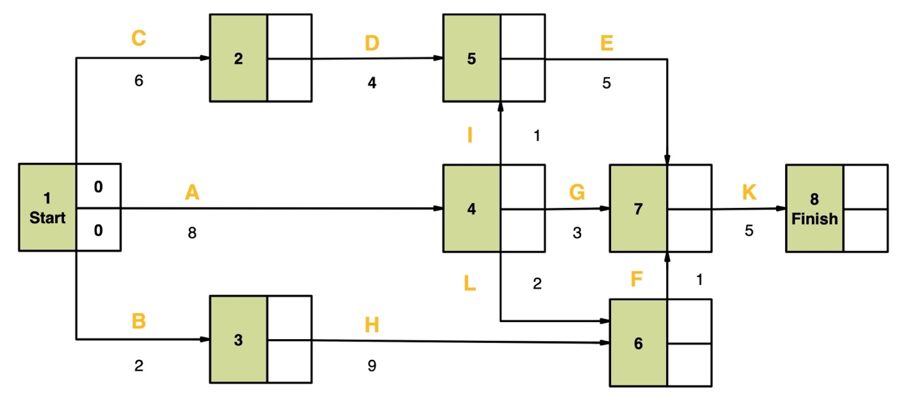

Using the provided network graph, your objective is to perform a critical path analysis. This will involve identifying the longest path through the network and determining when the project can be completed.

For your analysis, follow these steps:
- Fill in all the empty cells (EST and LFT) for each node.
- Provide detailed calculations of the Earliest Start Time (EST, the upper empty cell of the node) and the Latest Finish Time (LFT, the lower empty cell of the node) for tasks 4 and 6 only.
- Identify the critical path, which is the path from Start to Finish that has zero slack for all tasks. Show the critical path on your drawn graph.

Solution:

Task A
To calculate EST and LST, we start from the beginning of the graph and work forward to calculate EST, then start from the end and work backwards to calculate LST.
Use the Formulae from Lecture 5 Notes, slide 18.
Node | EST Calculation | LFT Calculation | Calculated EST | Calculated LFT | Slack (LFT - EST)
1 (Start) | 0 | Min (44-11, 33-33) = 0 | 0 | 0 | 0
2 | 0 + 33 = 33 | Min (44-1, 187-154) = 33 | 33 | 33 | 0
3 | Max (0 + 11, 33 + 1) = 34 | 66-22 = 44 | 34 | 44 | 10
4 | 34+22=56 | 209-143 = 66 | 56 | 66 | 10
5 | 33 + 154 = 187 | Min (209-22, 208-11) = 187 | 187 | 187 | 0
6 | 187+11 = 198 | 209-1 = 208 | 198 | 208 | 10
7 | Max (56+143, 187+22, 198+1 ) = 209 | 220-11 | 209 | 209 | 0
8 (Finish) | 209 + 11 = 220 | 220 | 220 | 220 | 0

The critical path is the path with tasks that have zero slack. This path dictates the project duration. To find the critical path, you look for the longest duration path from the Start to the Finish. It is the path where, if any task is delayed, the entire project will be delayed.
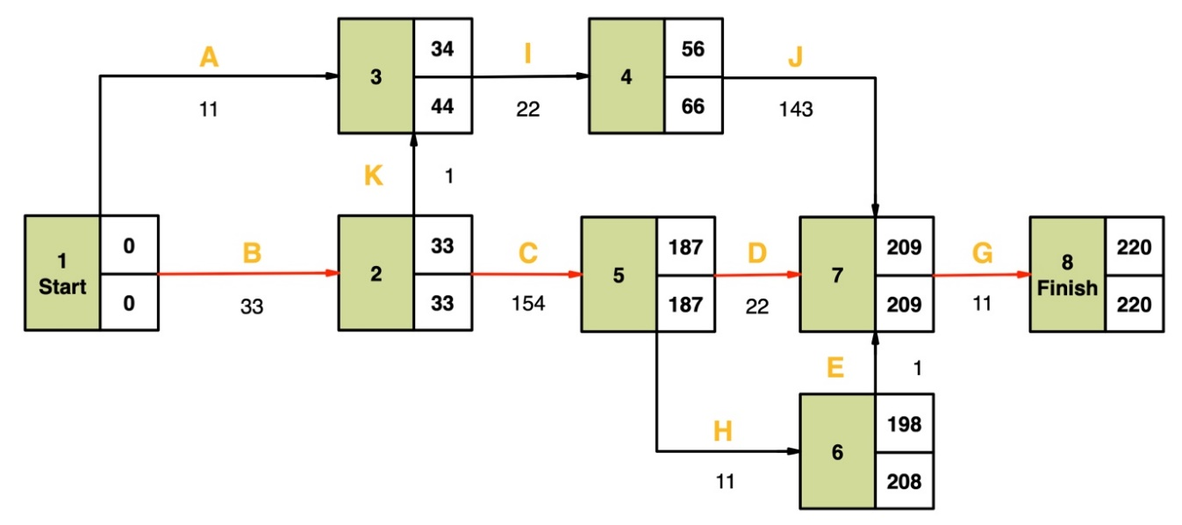

Assuming that the numbers alongside the arrows are the durations and considering that the Start has a value of 0, we can calculate the EST for all paths:
- Start -> A -> I -> J -> G -> Finish
- Start -> B -> K -> I -> J -> G -> Finish
- Start -> B -> C -> D -> G -> Finish (Critical Path)
- Start -> B -> C -> H ->E-> G -> Finish

Task B
A.
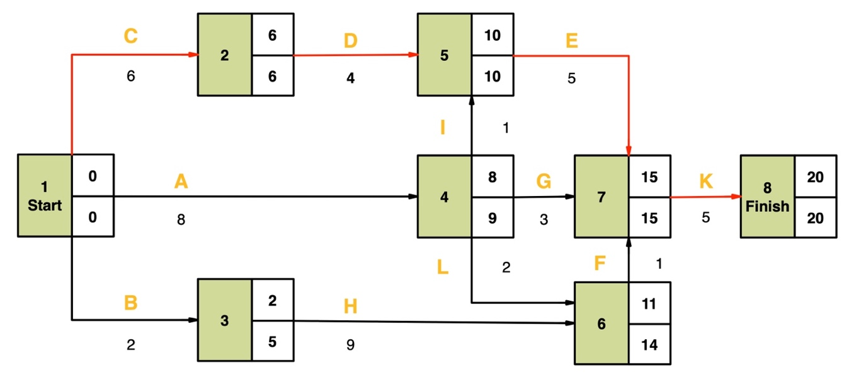

B.
Node | EST | LFT
4 | 0+8 = 8 | MIN (10-1, 15-3, 14-2) = 9
6 | MAX (9+2, 2+9) = 11 | 15-1=14

C.
There is one critical path in this network graph: C-D-E-K.

