Operation Manual For

The Silent Timer™

Timing Matters…

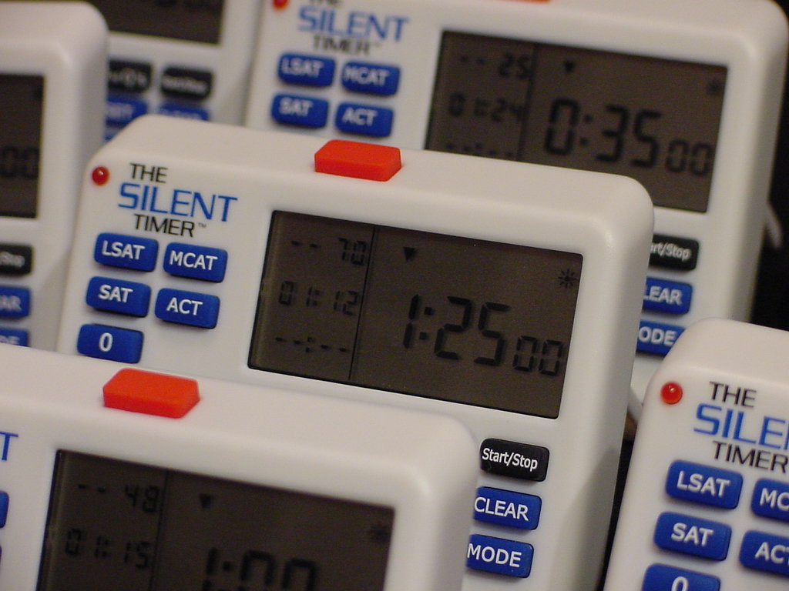

www.SilentTimer.com

TABLE OF CONTENTS

- Overview Diagram 2
- Cool Features 3
- Set Up 4
  - Activating the Battery 4
  - Preparing the LCD Screen 4
  - Set Up 4
  - Turning the Timer Off 5
- Introduction/Quick Directions 6
  - Overview 6
  - Quick Timer Setup 6
  - Quick Timer Setup for ACT, LSAT, MCAT, or SAT 7
  - Additional Options 7
- Feature Definitions 8
  - LCD Screen 8
  - Control Button 9
  - Numeric Keypad 12
  - Preset Memory Buttons 13
  - User-defined Memory Buttons 14
  - Answer Button 14
  - Auto Mode Button 15
  - Passage Mode Button 16
  - Light 16
  - Reset Button 17
- Using Your Timer 18
  - Clock Mode 18
  - Test Mode 18
  - Auto Mode 21
  - Passage Mode 21
- Frequently Asked Questions 26
- Caring for Your Timer 28
- Legality 29
- Troubleshooting 30
- Specifications 32
- Warranty 33
- Terms and Conditions 35
- Contact Information 36
I. OVERVIEW DIAGRAM

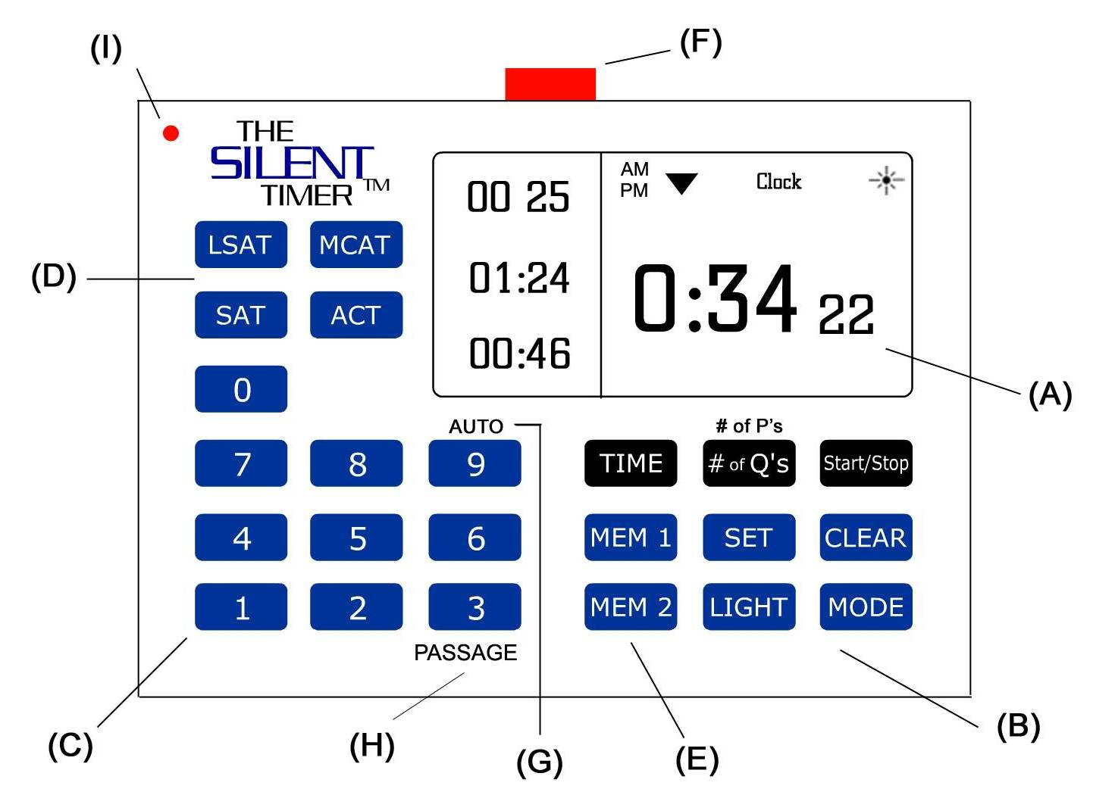

- LCD screen
- Control keypad
- Numeric keypad
- Preset memory buttons
- User-defined memory buttons
- Answer button
- Auto Mode activation button
- Passage Mode activation button
- Light
- Reset Button (on back of timer)

II. COOL FEATURES

Read the manual to find out about these features and more.

The Silent Timer™:

- Is completely silent.

- Has a flashing light that alerts you when:
- you spend too much time on a question
- you are half-way through your test
- you have one minute remaining

- Tells you how many questions you have finished and how many questions you have left.

- Tells you how much time should be spent on one question.

- Allows you to track your time more accurately when you have passages.

- Counts down time for each question.

- Counts down and up, and you can switch between them during your test.

- Allows a clear view of the clock during testing.

- Has time functions that start and stop easily.

- Keeps counting after you have run out of time. When used on practice tests, this function tracks your time improvement until ultimately you finish in the allotted time.

- Has a kickstand, so you can stand the timer on your desk, or lay it flat.

- Has rubber pads on the bottom of the timer to keep it from sliding on your desk.

III. SET UP

A. Activating the Battery

You must activate the supplied CR2032, 3-volt button cell battery before using your Silent Timer™.
- Open the battery compartment on the back of The Silent Timer™.

- Remove the battery from packaging.

- Carefully slide the battery into the compartment between the case and the metal bridge. Writing should be facing up.

- Replace the cover to the battery compartment.

*If the display dims, replace the battery with a fresh one.

Battery Warnings

- Keep button-celled batteries away from children. Swallowing can be fatal.
- Dispose of old batteries promptly and properly. Do NOT burn or bury them.
- Bring an extra battery on test day.

Removing the battery

The battery can be removed by opening the battery compartment, then gently sliding the battery out towards you. You may need to use a fingernail or pen tip to help pry.

B. Preparing the LCD Screen

The LCD screen comes with an adhesive, protective film. This film may be removed by peeling it off. You may want to save the film for use during transportation.

C. Set Up

The Silent Timer™ is built to sit still and sturdy on your writing surface. The angle of the case and the kickstand allow the timer to sit flat, and non-slip rubber pads keep the timer in place.

Using the Kickstand:
- Locate the kickstand on the back of The Silent Timer™.

- Simultaneously pull both edges of the kickstand towards you. Stop pulling when fully released.
Note: Be careful not to pull too hard.

- Place The Silent Timer™ in the upright position on any flat surface.

Alternate Use:

The Silent Timer™ may also be used without the kickstand by laying it flat on any surface.

D. Turning Off The Silent Timer™:

The Silent Timer™ does not have an “OFF” button. However, The Silent Timer™ has been designed to run at low power, and the battery should last approximately nine months to one year. See Chapter X for more information and specifications.
IV. QUICK START INSTRUCTIONS

How to quickly set up your timer for tests.

A. Overview

The Silent Timer™ is a great time management tool for students. It allows students to track their time through their test so that they finish on time.

Basically, you enter your time on the test, and the number of questions you have to answer. The timer calculates the average time you have to answer each question. If you finish each question within the allotted time, you will be able to finish the test on time. If you take too long on a question, you will lose time on the rest of them.

The time-per-question feature does not have to be used. You can set up the timer to simply count up or count down your test time.

A new feature has been added to this model. It involves passages. Some tests have reading passages followed by a series of questions. Passage Mode allows for the time you need to read the passage and then allots to the remaining time to the questions. As with time-per-question, this function does not need to be utilized.

Now that you have a general idea of what the timer is capable of, you can quickly set it up and begin working!

B. Quick Timer Set-up

- Follow the instructions in Chapter III to set up the timer for use (including removing the LCD screen cover and activating the battery).

- Press MODE until you see:
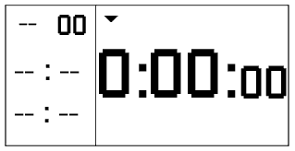

- Press TIME and enter your total test time.

- Press # of Q’s and enter the number of questions on your test.

- Press Start/Stop.

- Press the red button after finishing each question.
*To use as a simple count-down/up timer, skip Step 4 and Step 6.

C. Quick Timer Set Up for ACT, LSAT, MCAT, or SAT:

- Press “MODE” until you see:

- Press TIME.

- While the zeros are flashing, select your test by pressing the button that corresponds with the ACT, LSAT, MCAT, or SAT.

- Continue to press the test button until the correct time for your section appears.

- Press # of Q’s and enter your number of questions.

- Press Start/Stop.

- Press the red button after finishing each question.
*To use as a simple count-down/up timer, skip Step 5 and Step 7.

See Chapter V, Section D for the preset memory times.

D. Additional Options

Auto Mode: automatically changes the question when the average time per question is up. See Chapter VI, Section C for more information.

Passage Mode: allows the user to input how much time he/she wants to spend reading each passage. The timer then calculates how much time should be spent on the questions. See Chapter VI, Section D for more information.
V. FEATURE DEFINITIONS

This section defines the keypad buttons and their function as well as other timer features.

A. LCD Screen

The LCD screen is where all of your time and test data is displayed. This section defines the icons and tells you what the numbers mean.

The diagram on the next page is an example of some of the numbers and icons you might see. You might not see all of the icons at the same time as shown; it depends on which modes and/or functions you are using.

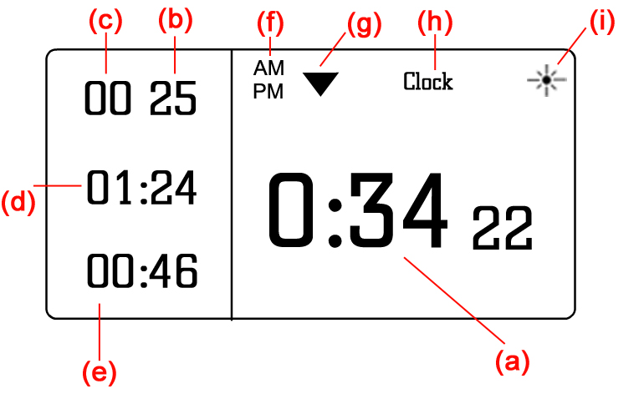
(a) Total Time
If the arrow (g) is pointing downward, then this value is the total amount of time you have remaining on your test. An upward arrow (not shown) shows the time you have spent so far.

(b) Number of Questions Remaining
The value at (b) is the number of questions that have not been answered. As you press the red button (see Section F), this number will decrease.

(c) Number of Questions Answered
The value at (c) is the number of questions you have answered so far. As you press the red button (see Section F), this number will increase.

(d) Average Time per Question
The total time on the test and the total number of questions are divided to give the average time that can be spent on each question. This number updates only after the red button (see Section F) is pressed.

(e) Time Remaining per Question
This value reflects the amount of time you have left on that particular question. When it begins counting the time for that question, it is equal to the Average Time per Question (letter d above). It counts down from there. When it reaches zero, the light flashes three times to indicate that you should move on to the next question. It will continue counting negative time until you press the red button (See Section F).
(f) AM / PM Icons
When in Clock Mode (see Chapter VI, Section A), the AM and PM icons indicate if the hour is in the morning (AM) or in the evening (PM). They cannot appear at the same time when in Clock Mode.

When in Test Mode (see Chapter VI, Section B), the AM indicates that Auto Mode (see Chapter VI, Section C) is active. The PM indicates that Passage Mode (see Chapter VI, Section D) is active. The AM and PM can be visible at the same time.

(g) Downward / Upward Arrow Icon
The downward arrow indicates that the total time (letter a) is counting down. This reflects how much time you have remaining on the test.

The upward arrow (not shown) indicates that the total time is counting up. This reflects how much time has been spent already.

(h) Clock Icon
The clock icon (see Chapter VI, Section A) is visible when you are in Clock Mode. It is not seen in any other mode.

(i) Light Icon
When the Light icon is visible, the light function is on. This means that the light will flash at the preset intervals. When the function is disabled, the icon will not be visible. See Section I for more information on the Light.

B. Control Keypad

The control keypad is where the buttons are that start and stop time, change modes, and perform other functions.
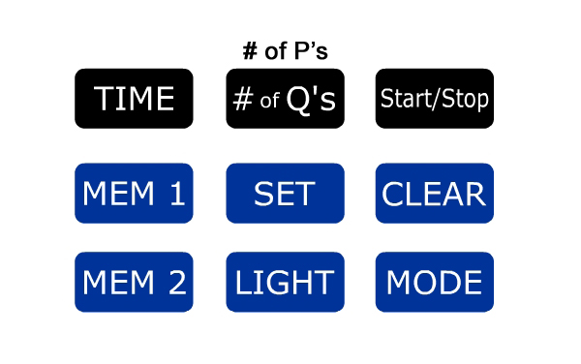
(a) TIME
The TIME button sets the time. When in Test Setup Mode or Passage Setup Mode, pressing TIME allows the user to input the time using the numeric keypad (Section C).

(b) # of Q’s / # of P’s
When in Test Setup Mode, the # of Q’s button allows the user to input the number of questions using the numeric keypad. This button shares functionality with # of P’s when in Passage Setup Mode.

(c) Start/Stop
The Start/Stop button starts the time and then stops it when pressed again. Pressing Start/Stop in Test Setup Mode begins the time counting. Pressing it again pauses the time (all of the current values remain). Pressing Start/Stop a third time, restarts the time and continues where you left off.

(d) MEM 1 and MEM 2
These two buttons are used to store custom times and number of questions. See Section E for more on the user-defined memory buttons.

(e) SET
The SET button has several functions. In Clock Setup Mode, pressing SET allows the user to input the current time. During Test Mode, SET switches between Count Down and Count Up mode (the arrows defined in Section A display the current direction). It is disabled in Passage Mode.

(f) CLEAR
This button allows the user to clear out any data input into the timer so far. While inputting time, pressing CLEAR clears back to zeros. After the time has been running, and you press Start/Stop, pressing CLEAR once resets the time and number of questions to the initial setting. Pressing twice clears the screen to all zeros. It is disabled when the timer is counting down. In Clock Setup Mode, pressing CLEAR resets the time back to 12:00.

(g) LIGHT
The LIGHT button turns the light function on/off. When on, you will see the icon in the upper right corner of the LCD screen (See Section A). You can turn the light on/off only in Test Mode and Passage Mode. See Section I for more info on the light.

(h) MODE
The MODE button changes the set-up mode of the timer. Setup modes allow the user to input information into the Timer. Test Setup Mode looks like this:

Test Mode is when time is running and you are taking your test. The screen may look like this in Test Mode:

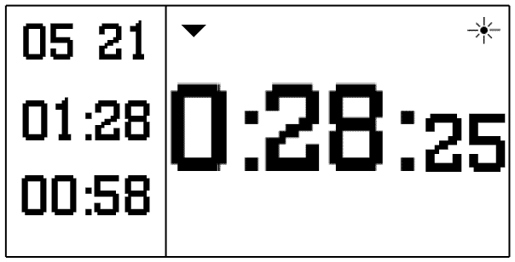

Clock Setup Mode is where you set the time. It looks like this:

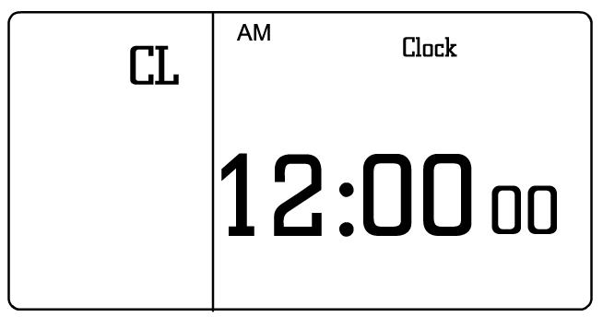

Clock Mode refers to when time is being kept, and it looks like this:

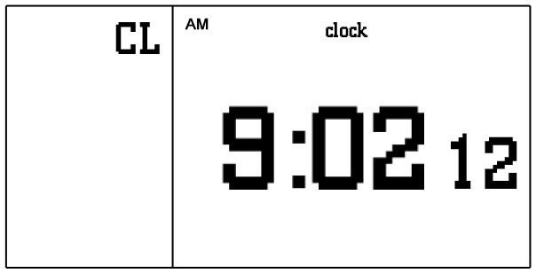

Passage Setup Mode allows the user to input time and the number of passages. The screen looks like this:

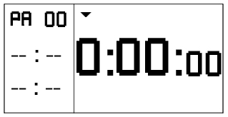

Passage Mode is when you have activated it, and are currently reading a passage. The display may look like this:
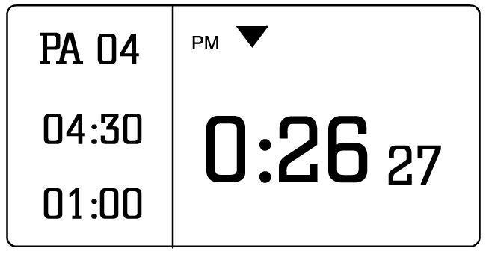

Auto Mode does not have a setup mode; it is either on or off. When Auto Mode is activated, it looks like this:

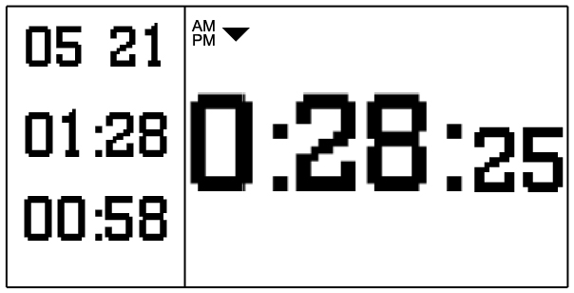

If the time has already started, pressing MODE will display the clock for three seconds, and then return (the timer continues to count). You cannot change modes when you are setting time, passages, questions, or the clock.

For more information on Clock Mode, see Chapter VI, Section A; for Test Mode, see Chapter VI, Section B; for Auto Mode, see Chapter VI, Section C; for Passage Mode, see Chapter VI, Section D.

C. Numeric Keypad

The numeric keypad allows users to input clock time, test time, number of questions or passages, and other numerical values.

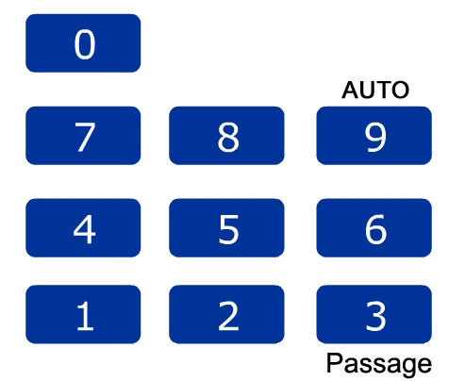

In Test Mode, two of the numbers have other functions. The numbers 3 and 9 double as the Passage Mode activator and the Auto Mode activator respectively.
Pressing 3 while time is running activates Passage Mode (only if data were input, see Chapter VI, Section D for more info on Passage Mode). Pressing 9 activates Auto Mode. Auto Mode automatically counts down the questions for you, so you do not have to press the button after every question (more on Auto Mode in Chapter VI, Section C).

The Passage Mode button 3 can only be enabled when in Test Mode (not Test Setup Mode) and when time is stopped. The Auto Mode button 9 can be pressed in either Test Setup Mode or Test Mode.

D. Preset Memory Buttons

The Silent Timer™ comes with four preset memory buttons for the LSAT, MCAT, SAT and ACT.
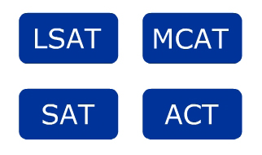
Each of these buttons has the amount of time allotted for each test stored in memory. They do not store numbers of questions, only times. Use these buttons to quickly set up your timer before your test.
- Go to Test Setup Mode (follow instructions in the Test Mode section Chapter VI, Section B).

- Press the TIME button.
- Press the memory button for your test until the correct amount of time appears.

Example: If taking the LSAT, press TIME then LSAT until either 35 minutes or 30 minutes appears on the screen.

- See Chapter VI, Section B for further instructions on the Test Mode.

Note: If your test is not on one of the buttons (e.g. GRE* or GMAT*), you can still use the timer for your test. The preset times are not stored for these tests, but you can store them yourself using the memory buttons MEM 1 and MEM 2. The user-defined memory buttons are discussed in Section E.

Tests* and amounts of time in memory:

ACT | 0:35:00  0:45:00  1:00:00
LSAT | 0:35:00  0:30:00
MCAT | 1:40:00  1:25:00  0:30:00
SAT | 0:20:00  0:25:00  0:35:00

*See Terms and Conditions for legal disclaimers.
E. User-defined Memory Buttons

You can also store your own amount of time and number of questions. The Silent Timer™ has two user-defined memory buttons, MEM 1 and MEM 2.

To store in memory:
- In Test Setup Mode, press TIME. Enter the amount of time.

- Press # of Q’s. Enter the number of questions.

- Press # of Q’s to stop the number of questions from flashing.

- Press and hold either the MEM 1 or MEM 2 button. The screen will flash three times. When the screen stops flashing, release the button.

- The amount of time and number of questions is now stored.

To Recall from Memory:
- In Test Setup Mode, press TIME, until the hour position flashes.

- Press either the MEM 1 or MEM 2 button, depending on which settings you want to recall.

- The stored time and questions will appear on the screen.

- Press Start/Stop to begin.

F. Answer Button

The red button on the top of the timer is used during Test Mode. If you have entered a certain number of questions into the timer, and you have finished the one you are on, pressing this button counts down the total remaining by one, and increases the total answered by one.

Example:

- You have 25 minutes to finish 25 questions. You input these numbers into the timer (see Chapter VI, Section B). When you push Start/Stop, your screen looks like this:
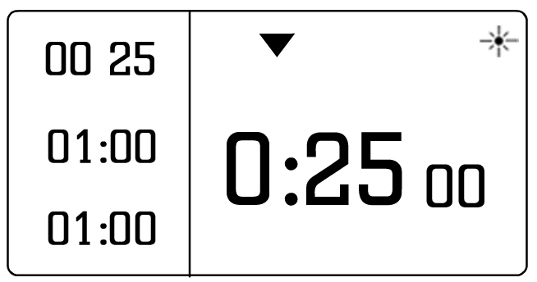
- The screen above shows that you have one minute to answer the questions (on average), you have 25 questions to answer, zero completed so far, and one minute left on the question remaining.

- Now let’s say you answer the first question in 30 seconds, not one minute. Press the red button on top and the screen now shows:

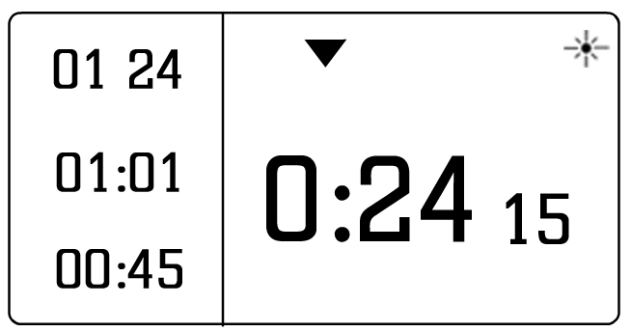

- You have answered one question and have 24 remaining. Your average time per question went up one second to 1:01 because you answered the first one before the minute was up. The remaining 30 seconds from the first question are then distributed among the remaining questions. The screen also shows that you have 45 seconds left on the 2nd question.

- The light flashes when the time on the question runs out. If the 2nd question, takes you longer, and you reach the 1:01 mark, the light flashes 3 times. This serves as a guideline so that you know you are taking too long. Taking too much time on one question leaves less time for the remaining questions.

- If you answer your questions before the time per question is up, then you get more time. One second is not a lot, but the more you answer in faster time, the more time you will have at the end to check your work.

Note: If pushing the button after each question seems distracting, then push it only every five questions. The time will not be accurate until you update it. After you finish the fifth question, push it five times in a row to catch up. You can also activate Auto Mode (see Chapter VI, Section C) where the timer counts down the questions for you.

G. Auto Mode Activation Button

The Auto Mode activation button is shared with the 9 on the numeric keypad.

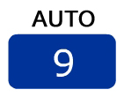

Pressing 9 while time is running (during Test Mode) activates Auto Mode. Auto Mode automatically counts down the questions and passages for you, so you do not have to press the button after every question. More on Auto Mode in Chapter VI, Section C.

H. Passage Mode Activation Button

The Passage Mode activation button is shared with the 3 on the numeric keypad.



Pressing 3 while time is running (during Test Mode) activates Passage Mode. Passage Mode can only be activated if you input the number of passages and the time per passage. If there is nothing there, pressing 3 will have no effect. Go to Chapter VI, Section D for more information on Passage Mode.

I. Light

The red flashing light is the perfect tool to alert you of special times during your test.


The light flashes when:

- You have spent too much time on one question compared to the average amount of time available for each question (i.e. with ten minutes and ten questions remaining, the light will flash after one minute has passed). (flashes 3 times)

- Halfway through your test (i.e. with ten minutes, the light flashes after five minutes). (flashes 5 times).

- When you have only one minute remaining (flashes from one minute all the way to 0:00:0).

- The light stops flashing once the time reaches 0:00:00.

You know the light is on when the  appears in the upper right hand corner of the LCD screen.

Turning On/Off the Light

- To turn on the light, press the LIGHT button until the light icon appears.

- To turn off the light, press the LIGHT button until the light icon disappears.

If you want to turn the light off while it is flashing, press and hold the LIGHT button until the light goes off. Be sure to turn the light back on if you want it to flash during the remainder of your test.

J. Reset Button

The reset button is located in a small hole on the back of the timer, to the left of the battery compartment.

You will want to use the reset button should your timer freeze or malfunction.

To press the button, use the end of a paper clip, mechanical pencil lead, or other long, skinny point to reach inside the hole. The tip of a pen is probably too thick and not long enough.

See troubleshooting in Chapter X if you need more help.
VI. USING YOUR TIMER

A. Clock Mode

Your timer is equipped with a clock. To view the clock, press the MODE button until the clock icon appears on the LCD.

To set the time:

- Go to Clock Setup Mode.

- Press the SET button.

- Enter the time in hours, minutes, and seconds.
- After the seconds are entered, the “AM/PM” will flash. To change AM/PM, press TIME.
- Press SET to store the time.

B. Test Mode

Use Test Mode during your exam. Mastering this mode is the key to better time management. See the diagram in this section for layout.

Using Test Mode without Questions:

- Press the MODE button to access Test Setup Mode. You will see a or a on the LCD screen.

- Press TIME, and the hour position will start flashing.

- Enter the amount of time on the test (or section). Enter the time starting with hours, then minutes, and then seconds.

Example: If you want to enter 35 minutes, you press 0, 3, and 5. If you want to enter 1 hour 35 minutes and 15 seconds, you press 1, 3, 5, 1, and 5.

- Press Start/Stop.
- Switch between count up and count down by pressing SET.

- Turn on the light by pressing the LIGHT button. Ain the upper right corner indicates the LED light is on.

Using Test Mode with Questions:

- Press the MODE button to access Test Setup Mode. You will see a or a on the LCD screen.

- Press TIME, and the hour position will start flashing.

- Enter the amount of time on the test (or section). Enter the time starting with hours, then minutes, and then seconds.

Example: If you want to enter 35 minutes, you press 0, 3, and 5. If you want to enter 1 hour 35 minutes and 15 seconds, you press 1, 3, 5, 1, and 5.

- Press # of Q’s. The first digit of the number of questions will start flashing.

- Enter the number of questions on your test (or section). Input this number starting with the first digit, then the second.

Example: for 28 questions, press 2 then 8.

- Press Start/Stop to start the time.

- Press SET to switch between count up and count down.

- Turn on the light by pressing the LIGHT button. Ain the upper right corner indicates the LED light is on.

- Turn on Auto Mode by pressing the number “9” on the keypad. More information about Auto Mode is found in Section C.

Press the red Answer button located on top of the timer after you finish each question. This updates all values on the left-hand side of the screen. Press the answer button after you answer each question to update the time and questions. Pressing this button allows you to know how much time you should spend on the remaining questions.

Note: If using Auto Mode, you do not need to push the red “Answer” button. The timer will do that for you.

You do not have to press the Answer button after each question. You can press it after every five questions or any other number of questions you choose. Your per question time will not be completely accurate until the timer’s # of Q’s matches the question you are on.
Test Mode LCD Diagram
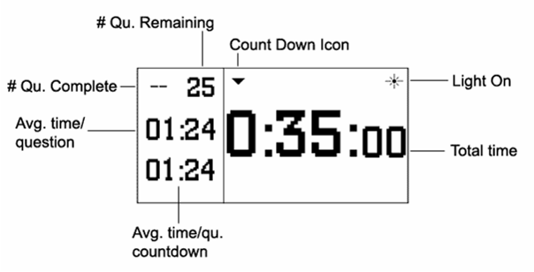

Test Mode LCD Description

The total time counts down on the right side of the screen.

The number of questions answered, number of questions remaining, average time per question, and time per question count down appear on the left side of the screen, as shown.

Stopping and Starting Timer

While in the middle of a test section, you may pause and restart the timer.

Press the Start/Stop button to stop the time and then press the Start/Stop button to resume.

Viewing the Clock

You can view the clock while taking your test. Press the MODE button and the Clock appears for 3 seconds. The Silent Timer™ then automatically returns to the testing screen without disrupting the test.
C. Auto Mode

Auto Mode is a new feature to The Silent Timer™. When activated, the timer automatically counts down the questions and passages for you.

Activating Auto Mode is easy. After you have input your time and questions, press Start/Stop. To activate Auto Mode, press 9 on the numeric keypad while the time is running. The icon AM will appear.

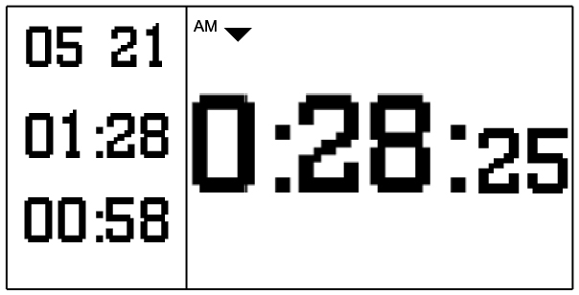

Deactivate by pressing 9 again.

Example:
For example, if you have 25 questions in 25 minutes, then you have, on average, one minute to answer each question. When the time is up on the first question, the timer moves on to the next question automatically. You will always have one minute per question.

However, you can override this feature (while activated) by pressing the red button yourself. It will continue to operate automatically at the end of the next question.

Deactivate Auto Mode at any time during the test by pressing 9 on the numeric keypad.

D. Passage Mode

Passage Mode is a new feature designed for test sections with passages or logic games. These sections include multiple reading passages (or logic games), each followed by a series of questions.

The advantage of this feature is that it takes into account the amount of test time you will spend reading each passage and lets you know exactly how much time you can spend answering each question.

You do not have to use this feature. You can deactivate it when in Test Setup Mode by pressing 3 until the “PM” disappears from the screen. You cannot deactivate Passage Mode while Test Mode is running.

Setting up Passage Mode

In order to use Passage Mode, you need to have an idea of how much time you want or need to spend reading each passage. Sometimes it is recommended to spend three minutes or five minutes per passage (depending on your test).

Choose the amount of time you want to spend reading each passage and then follow the steps below:

Note: The time you input in this step will apply to every reading passage in the section.

- Press MODE until you get to the Passage Setup Mode screen.

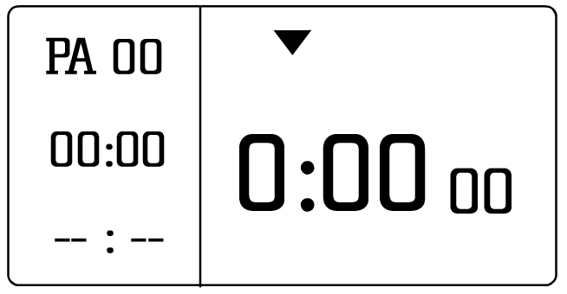

- Press TIME, and the leftmost digit (see red arrow below) will flash.

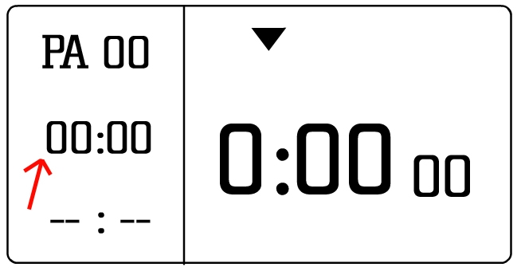

- Enter your time in minutes, then seconds. For example, you want to spend 4 minutes and 30 seconds reading each passage, enter 0, 4, 3, and then 0.

- To enter the number of passages, press the button that says # of P’s right above it. The right digits will flash.

- Enter the number of passages. For four passages, enter 0 then 4.

- Push # of P’s again to make the screen stop flashing.

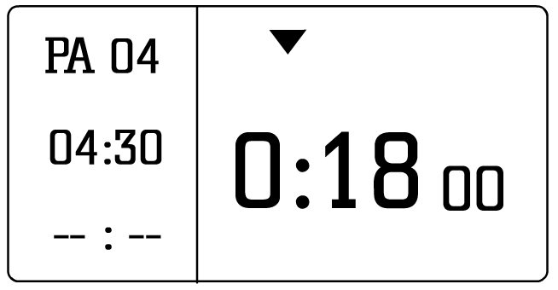

You are now set up to use Passage Mode. In our example, you want to spend 4 minutes and 30 seconds reading each of the four passages. This takes a total of 18 minutes away from your total test time.

Using Passage Mode for a Test:

- After you have set up the Passage Mode values (see steps above), press MODE to get to Test Setup Mode.

- Press TIME and enter the amount of time you have to finish the entire section (all questions and passages). Continuing from our previous example, let’s say you have 30 minutes for the four passage reading section.

- Press # of Q’s and enter the number of questions you have total (not for each passage). For our example, we have 20 questions total on the test (5 questions per passage).

Note: Notice how the timer says you have 1 minute and 30 seconds per question. This would be true if you did not have reading passages.

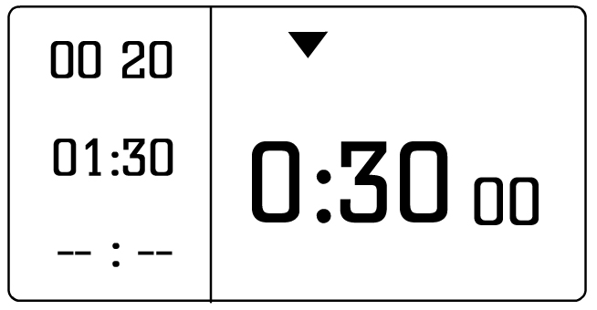

- Press # of Q’s again to make the digits stop flashing.

- Now activate Passage Mode by pressing 3.

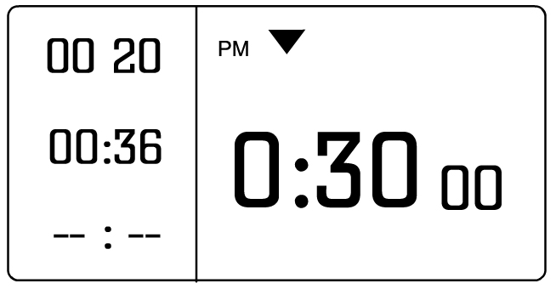

The time per question changes to 36 seconds per question (instead of 1 minute, 30 seconds) because you have to spend 18 minutes of your total test time of 30 minutes on reading the passages. You know Passage Mode has been activated when “PM” appears to the left of the count down (or up) arrow.

Now you are set up to take the test. The next part describes how to tell the timer when you are finished with a passage and when you are finished with a question.

Remember that a typical reading passage section has a reading section followed by questions, then another reading section, followed by more questions, and so on.

- Press Start/Stop and immediately press # of P’s. Pressing # of P’s takes you to the Passage Count Down screen, which allows you to see how much time you have remaining to finish reading the passage you are on.

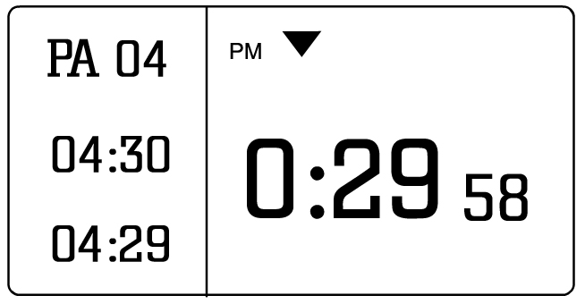

Note: When you press Start/Stop, the timer starts counting down for the first question. You are not ready for the first question because you have not read the passage first. That is why you switch to the Passage Count Down.

- Now read your passage. When you are finished reading the passage, you are ready to answer the questions. Quickly switch back to Question Count Down by pressing # of Q’s. Pressing # of Q’s takes you to the Question Count Down screen, which allows you to see how much time you have remaining to answer the questions that follow the passage you just read.

You do NOT press the red button when finished with reading a passage. Going to Question Count Down automatically changes the number of passages remaining from four to three. Any extra time is distributed among the remaining questions on the test.

Back to our example, let’s say you finished the reading passage one minute early. When you go back to Question Count Down, you now have 39 seconds instead of 36 seconds per question. The remaining minute from the first passage is distributed among the remaining questions (it does not add more time to the remaining passages).

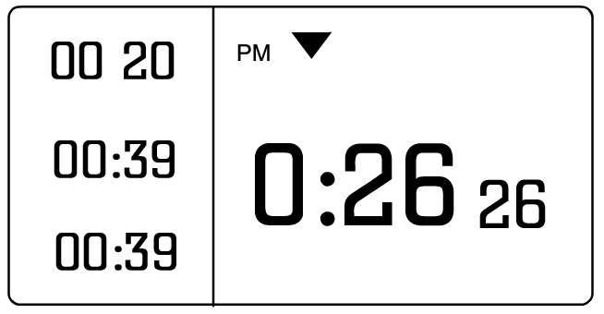

- Begin answering your questions normally, pressing the red button as you finish each question.

For our example, let’s say the first passage had 5 questions, and you finished them on time (each within 39 seconds).

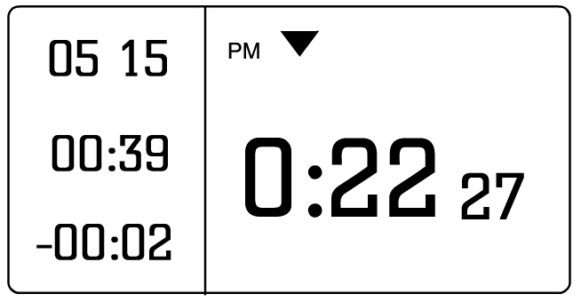
- When you finish the questions for that passage, go back to Passage Count Down by pressing # of P’s again. You are now ready to read the next passage.

- Now you will see that the number of passages has been reduced to 3, and that you still have 4 minutes and 30 seconds per passage.

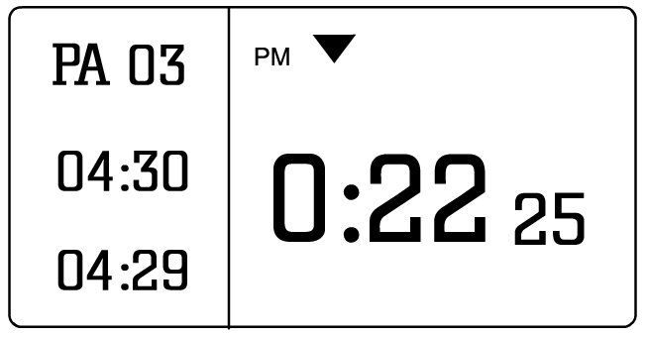

- When finished with the second passage, press # of Q’s to go back to the Question Count Down screen.

- This process is repeated until you are finished with your test.

Tips and Advice:

- It may seem complicated at first, but practice will make you comfortable with the process.

- When you go faster on the Passages and do not use your full time, the extra time is distributed among the remaining questions, not passages. You always have the same amount of time to read each passage.

- The Silent Timer™ Time Management Guide has more tips on how to effectively utilize the timer for tests. Go to www.SilentTimer.com to get your copy.
VII. FREQUENTLY ASKED QUESTIONS

Functionality

- Can I switch between count down and count up while time is running?
Yes. When time is running, press SET. This will toggle between count down and count up. If you did not enter a total time, and started in count up mode, then you cannot switch to count down because there is nothing to count down from.

- What is the maximum time I can input?
The maximum time is 19 hours, 59 minutes, and 59 seconds (19:59:59). The trick is inputting 9:59:59 first, and then a flashing ‘1’ will appear before the ‘9’. Press 1, and then you will have 19 hours, 59 minutes, and 59 seconds.

- What is the maximum number of questions I can input into the timer?
The maximum number of questions is 99. If your test has more than 99 questions, you might have to be creative with how you track your time.

- Do the preset test buttons (LSAT, MCAT, SAT, and ACT*) store number of questions?
No, they only store the times that are used during the test. The number of questions varies, so it cannot be predicted how many there will be. If you want to store times and questions, use the user-defined memory buttons MEM1 and MEM2.

- Can I turn The Silent Timer™ off?
No. However, it has been designed to use minimal power during Clock Mode. If you wish to conserve battery power, leave the timer in Clock Mode when idle.

- Can I view the clock during a test?
Yes, you can. While time is running (during Test Mode), press MODE. The current time will display on the screen for 3 seconds and then return without interrupting the test session.

- How do I set the clock?
It is very easy to set the clock. See Chapter VI, Section A.

- How do I turn the light on/off?
Use the LIGHT button on the bottom left corner of the control keypad. A light icon appears above the total time if the light is on, and disappears when off.

- Is The Silent Timer™ completely silent?
Yes, it is incapable of making any noise.

Specifications
- How long does the battery last?
The battery should last nine months to one year, but it can vary depending on use. Heavy use involving the LED light can drain the battery faster. Leave the timer in Clock Mode when not in use to conserve the battery.

- Where do I buy a new battery?
The timer uses a CR2032 button cell battery. This type of battery can be found on our website and at most major grocery stores and Wal-Mart.
- How big is The Silent Timer™?
The Silent Timer™ is as wide and tall as a playing card. See Chapter XI for dimensions and weight.

Legality
- Can I use it on a test other than the ACT, LSAT, MCAT and SAT*?
The Silent Timer™ can be used for any test. The preset memory buttons are for the major tests, but you can set your own times. Custom times and number of questions can be stored in the user-defined memory buttons MEM1 and MEM2.

- Is it legal on test day?
The Silent Timer™ is legal for any test that allows such devices in the test. It does not make any noise to distract other test takers. We include a proctor card on the back of the Quick Start Card that can be shown to skeptical proctors. It is best to check with your test or testing center before bringing it in, so you will not be surprised. We cannot be responsible for proctors or tests that do not allow a timing device in their testing centers.

General
- How should I transport my timer?
Safe transport of your timer is a key concern. If you have space, keep it stored in its original box. If you are worried about scratching the LCD screen, keep the LCD decal and use it during transportation. Do not allow the timer to be loose in your backpack or purse where it can be bumped or crushed. These types of damage are not covered by our warranty. The idea is to protect the screen and the buttons from being damaged. Protecting internal components is achieved by keeping the timer from being tossed about harshly.

- What is the Proctor Card and where is it?
The Proctor Card is a special card that tells proctors or other test administrators that The Silent Timer™ is completely silent, and that it is not a calculator, camera, communication, data recording or computing device. It is found on the back of the Quick Start Card that was included with the manual in your Silent Timer box.

- My timer is having trouble. How do I find out how to fix it?
Check out Chapter X for Troubleshooting tips. If you still have questions, please contact us. We will be glad to help you. Call 800-552-0325 or email info@silenttimer.com.

- I have a question that is not answered in this manual. What do I do?
Contact us with any other questions or suggestions. We are glad to help, and always glad to hear your reviews on how The Silent Timer™ helped you. Offer suggestions on anything you think might be helpful.

*See Terms and Conditions for legal disclaimers.
VIII. CARING FOR YOUR TIMER

Proper care of your Silent Timer™ will keep it in good working order.

- Keep The Silent Timer™ dry. (If it gets wet, wipe it dry immediately and allow to air dry thoroughly.)

- Use and store the timer within normal temperature ranges. Do not leave in a hot car.

- Handle the timer carefully; do not drop it.

- Keep the timer away from dust and dirt. You may wipe it with a damp cloth to keep it looking new.

- Be careful not to allow foreign objects to get beneath the buttons.

- Modifying or tampering with The Silent Timer™’s internal components may cause a malfunction and will invalidate its warranty.

IX. LEGALITY

Test companies vary in their rules and regulations concerning the use of timing devices during tests. Know the rules of your test, what you can and cannot bring, and what sorts of timing devices will be allowed in the test room.

We provide a card to present to any proctor who might question the functionality of The Silent Timer™. It may appear to be a calculator or some other device not allowed in the test. If questioned, show the proctor the disclaimer printed on the back of The Silent Timer™ and present this card. This card is found on the reverse side of the Quick Start Card.

For example, during the SAT* test, students are not allowed to have a calculator that stands up on the desk. Some proctors might not allow The Silent Timer™ to stand up on the desk for fear is it a calculator or that information can be shared with other students. Use The Silent Timer™ flat on the desk in this case.

Silent Technology LLC or its representatives are not responsible for timers taken up by proctors or disallowed in tests. It is important that you check with test or test administrators before test day just to be sure.

*See Terms and Conditions for legal disclaimers.
X. TROUBLESHOOTING

This section provides guidance if you have a problem with your timer. If you need further assistance, call us at 800-552-0325 or email info@silenttimer.com.

Please check the warranty section (Chapter XII) for details on product replacement. Here is a summary:

- We do not replace your timer if the damage or failure is caused by or attributable to acts of God, abuse, accident, misuse, improper or abnormal usage, failure to follow instructions, improper installation or maintenance, alteration, lightning or other incidence of excess voltage or current.

- We will replace the timer if the problem is caused by manufacturing defects in material and workmanship under normal use.

- The warranty is good six (6) months after the purchase date. If your problem occurs after this date, you will need to buy a new timer.

Possible problems and solutions:

- My timer froze.
If your timer is frozen, there are two ways to fix it. You can remove the battery for 30 seconds, and then replace it. You can also press the RESET button on the back of the timer next to the battery compartment. A paper clip or mechanical pencil lead will fit in the small hole.

- The screen flickers when the light goes off.
This is usually an indication that the battery is low or there is a bad connection. First, try removing the battery and wiping it with a dry cloth. Then wipe the inside of the battery compartment. Put the battery back in. Sometimes a film or static electricity builds that prevents a good connection. If this does not work, try replacing the battery with a new one. You can find the CR2032 button cell battery on our website and at most major grocery stores.

- The digits on the screen are faint and hard to see.
This is an indication that the battery is low. You will need to replace it with a new one. You can find the CR2032 button cell battery on our website and at most major grocery stores.

- Some segments in my LCD screen are missing.
If the screen is missing some segments, you will need a replacement timer. There are no home remedies that can fix it. If it does not bother you, you can keep the same timer. This does not affect its functionality.

- The battery is stuck in the compartment.
Using a fingernail or slim prying device (small knife, small screwdriver, stiff piece of paper), gently try to get your nail or device in the small crack between the battery and the case. The goal is to slide the battery forward. Once you have it loose, use your finger to slide the battery from the case. Call if you are still having trouble.

- I lost one of the non-slip pads.
There are two options: ignore it or get a replacement pad. If you feel that the timer is sliding on the desktop or is off balance, we can send you a new non-slip pad. Just contact us about it.

- The LCD screen is scratched.
If the scratch does not hinder your use of the timer, it is probably okay to leave it. If it is bothersome, we can replace it if it arrived in this condition. If the scratch was a result of improper use, you will need to purchase a new timer.

- The timer will not turn on.
There are several reasons why this might be happening. First, check that you have inserted the battery correctly. The writing should be face up, and the battery slides into the battery compartment between the case and the metal bridge. If this is not the problem, try pressing the RESET button on the back of the timer using a paper clip or mechanical pencil lead. You may need to replace the battery. The CR2032 button cell battery is found on our website and at most major grocery stores.
XI. SPECIFICATIONS

Operating Voltage | 3 Volts
Power Source | CR2032 Button Cell
Battery Life (approx.) | 9-12 months
Dimensions  (H-W-D) | 3.5” x 2.75” x 0.5”
Weight | 2.6 ounces

XII. WARRANTY

Limited Six-Month Warranty
Silent Technology LLC warrants this product against manufacturing defects in material and workmanship under normal use for six (6) months from the date of purchase from SilentTimer.com or other authorized Silent Technology LLC retailers. EXCEPT AS PROVIDED HEREIN, SILENT TECHNOLOGY LLC, MAKES NO EXPRESS WARRANTIES AND NO IMPLIED WARRANTIES, INCLUDING THOSE OF MERCHANTABILITY AND FITNESS FOR A PARTICULAR PURPOSE, ARE LIMITED IN DURATION TO THE DURATION OF THE WRITTEN LIMITED WARRANTIES CONTAINED HEREIN. EXCEPT AS PROVIDED HEREIN, SILENT TECHNOLOGY LLC WILL HAVE NO LIABILITY OR RESPONSIBILITY TO CUSTOMER OR ANY OTHER PERSON OR ENTITY WITH RESPECT TO ANY LIABILITY, LOSS OR DAMAGE CAUSED DIRECTLY OR INDIRECTLY BY USE OR PERFORMANCE OF THE PRODUCT OR RISING OUT OF ANY BREACH OF THIS WARRANTY, INCLUDING, BUT NOT LIMITED TO ANY DAMAGES RESULTING FROM INCONVENIENCE, LOSS OF TIME, DATA, PROPERTY, REVENUE, OR PROFIT, OR ANY INDIRECT, SPECIAL, INCIDENTAL, OR CONSEQUENTIAL DAMAGES, EVEN IF SILENT TECHNOLOGY LLC HAS BEEN ADVISED OF THE POSSIBILITY OF SUCH DAMAGES.

Some states do not allow limitations on how long an implied warranty lasts or the exclusion or limitation of incidental or consequential damages, so the above limitations or exclusions may not apply to you.

In the event of a product defect during the warranty period, call us at 800-552-0325 or email info@silenttimer.com. You must be the original purchaser, and have your Order Number and sales receipt to receive warranty service. All instructions for warranty process are found on the web site. Silent Technology LLC will, at its option, unless otherwise provided by law:
(a) correct the defect by product repair without charge for parts and labor;
(b) replace the product with one of the same or similar design; or
(c) refund the purchase price.

All replaced parts and products, and products on which a refund is made, become the property of Silent Technology LLC. New or reconditioned parts and products may be used in the performance of warranty service. Repaired or replaced parts and products are warranted for the remainder of the original warranty period. You will be charged for repair or replacement of the product made after the expiration of the warranty period.

This warranty does not cover: (a) damage or failure caused by or attributable to acts of God, abuse, accident, misuse, improper or abnormal usage, failure to follow instructions, improper installation or maintenance, alteration, lightning or other incidence of excess voltage or current; (b) any repairs other than those provided by a Silent Technology LLC Authorized Facility; (c) consumables such as fuses or batteries; (d) cosmetic damage; (e) transportation, shipping or insurance costs; or (f) costs of product removal, installation, set-up service adjustment or reinstallation.

This warranty gives you specific legal rights, and you may also have other rights, which vary from state to state.

Silent Technology LLC
Customer Relations
3415 Greystone Drive
Suite 103
Austin, TX 78731

March 2005
XIII. TERMS AND CONDITIONS

The Silent Timer™ is a Trademark of Silent Technology LLC.

The Silent Timer™ is patent pending with the United States Patent and Trademark Office. No reproduction of this product or any other similar testing product may be produced without the express consent of Silent Technology LLC. All violations will be persecuted to the fullest extent of the law.

LSAT, MCAT, SAT, ACT, GMAT and GRE are all trademarks of their respective holders and have no connection with Silent Technology LLC or The Silent Timer™. They do not specifically endorse this product.

LSAT is a registered trademark of the Law School Admission Council, Inc.

MCAT is a registered trademark of the Association of American Medical Colleges.

SAT is a registered trademark of the College Entrance Examination Board.

ACT is a registered trademark of the ACT.

GMAT is a registered trademark of the Graduate Management Admission Council.

GRE is a registered trademark of Educational Testing Service.

XIV. CONTACT INFORMATION

Address:

Silent Technology LLC

3415 Greystone Drive

Suite 103

Austin, TX 78731

Phone Number:

(800) 552-0325

Website:

http://www.SilentTimer.com

Email:

info@SilentTimer.com

AOL Screen Name:

Silent Timer

