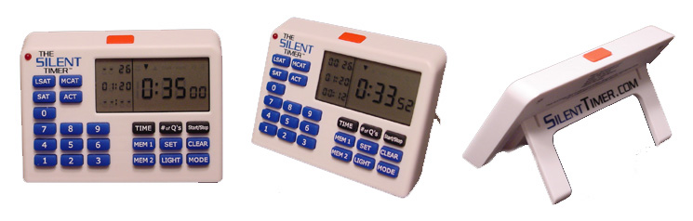

FRONT DESK INSTRUCTIONS

Students order The Silent Timer™ online at www.SilentTimer.com. We accept Visa, MasterCard, and American Express.

On the order form, there is a blank for the office code. The office code is “tpraus.” The deadline is October 24, 2003.

The timers are sent in bulk to the office three to five business days after the deadline. Students will pick them up at the front desk.

When the student comes to pick up his/her timer, it is important to keep track who picked up their timer. We have a very convenient and easy process for tracking the timers. The process for tracking the timers is as follows:

- Go to http://www.silenttimer.com/tpr
- Click on “Log In” on the left menu bar.
- Enter the office code, “tpraus”.
- The password is “password”.
- Click on “Student List” to view the students who purchased timers.
- Click on the student’s name, and then press “Picked Up.” The system will now show that the student picked up their timer, and their name will be removed from the student list.
- If you or a student has any questions, please contact us at info@silenttimer.com or 512-542-9981.

The check for your office is included in the box with the timers.

Please let Erik or Christina at Silent Technology LLC know if you have any questions, concerns, or even suggestions on how we may serve you better. We may be reached at info@silenttimer.com or 512-542-9981. Thank you very much!



