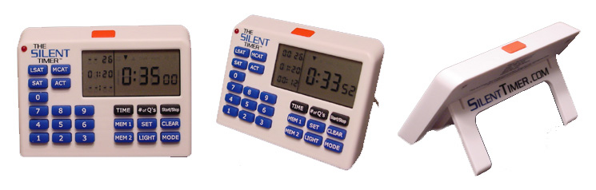

MEMO

ATTENTION: Princeton Review Teachers and Office Personnel
DATE: October 10, 2003
FROM: Silent Technology LLC
RE: The Silent Timer™ for upcoming class

In the welcome packet that your students receive on the first day of class is a flier describing The Silent Timer™ and how it can help them on their test.

The Silent Timer™ is completely silent and has several other features. It not only counts your time up or down, but it can also show you how much time you have spent on a per question basis. It is a great timing tool for practice and test day.

There are several office samples that you may use to demo in your class, ask the front desk about testing one out.

How to Order
Send your students to www.SilentTimer.com and on the order form they need to enter your office code “tpraus”. They may use Visa, MasterCard, and American Express.

The timers will be shipped in bulk to your office three to five business days after the deadline posted, which is October 24, 2003 at 5:00pm. Make sure to let your students know the deadline. Students may pick them up at the front desk when they arrive.

They are charged the price of the timer $24.95 plus tax for a total of $27.01.

If you have any questions, __________ is our Princeton Review contact person, or you may contact us directly at info@silenttimer.com or 512-542-9981. Also, check out the website for more information and an online demo.

