THE SILENT TIMER will tell you everything you need to know about your test time:
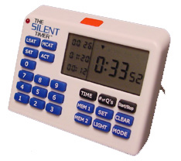
- Count your time up or down
- Average your time per question
- Allot the time you can spend on each question
- Best of all – it is silent!

Price | Office Code | Deadline
$24.95 | tpraus | 10/24/2003

Orders Received Online, enter your office code.
Visa, MasterCard, American Express

© 2003 Silent Technology LLC. All rights reserved. Patent Pending.

THE SILENT TIMER will tell you everything you need to know about your test time:
- Count your time up or down
- Average your time per question
- Allot the time you can spend on each question
- Best of all – it is silent!

Price | Office Code | Deadline
$24.95 | tpraus | 10/24/2003
Orders Received Online, enter your office code.
Visa, MasterCard, American Express

© 2003 Silent Technology LLC. All rights reserved. Patent Pending

