Student Number: 200015399

**SCHOOL OF GEOGRAPHY AND SUSTAINABLE DEVELOPMENT**



Module Title: Spatial Analysis with GIS

Deadline Date: 3rd April 2023

In submitting this assignment, I hereby confirm that:

I have read the University's statement on Good Academic Practice; that the following work is my own work; and that significant academic debts and borrowings have been properly acknowledged and referenced.

Regional Inequality within the EU and COVID-19

**1 Introduction**

Economic shocks are usually associated with increasing inequality, as well as poverty. The COVID-19 pandemic is a recent example of a recent such major shock. The public health crises spilled over to most segments of the economy adversely affecting both the supply and demand side. Economic downturns tend to disproportionally affect the more vulnerable segments of society through more adverse losses of income and employment. Additionally, the more impoverished areas are likely to be affected by a greater disease burden due to more challenging implementation of precautionary measures. All the above suggests that the COVID-19 pandemic could have significantly contributed to an increase in income inequality. On the other hand, however, the developed countries experienced higher death which would imply an equalizing effect on the global income distribution. We investigate the evolution of regional inequality within the EU over the past few years with a reference to the recent pandemic using the most common measure of income inequality, the Gini index.

**2 Methods**

*2.1 Data*

To analyse the changes of regional income inequality in the EU, we use datasets available at Eurostat on the territorial level NUTS-2 of the European regional classification system. The NUTS system represents a 4-level hierarchical classification of regions of the EU, where the first level (NUTS 1) represents the highest-level regional division which is then subdivided into smaller and smaller administrative units (Dunford, 2009). We consider territorial units on the level of NUTS-2 areas which provides are good balance between sufficient precision and data availability (many indicators are not available on the level of NUTS-3 and NUTS-4 areas).

Our primary indicator to measure inequalities is annual GDP per inhabitant adjusted for purchasing power standards (PPS) to eliminate price differences between countries (Eurostat, 2023b). This is one of the most widely used indicators for calculating regional income inequality which can be interpreted as differences in living standards (Dunford, 2009). We obtain these data from Eurostat database for period from 2010 to 2021, but we primarily focus on the last three years. Additionally, we obtain a similar dataset also from Eurostat, with the only difference that it expresses regional GDP per inhabitant in terms of the percentage of the EU average (Eurostat, 2023c). we merge the dataset on regional GDP per inhabitant with a shapefile which contains the geometry attribute for each territorial unit which allows us to create maps and effective visualizations. The details on geospatial attributes of NUTS areas are available at GISCO (Eurostat, 2023a).

*2.2 Measures of Inequality: The Gini Coefficient*

The simplest most used measures of inequality include the standard deviation, Gini coefficient and Theil index. The most popular and best understood measure of income inequality is the Gini index. The Gini coefficient is closely related to the concept of the Lorenz curve which plots the cumulative distribution of income against the cumulative percentage of population (Rey, et al. 2020). The 45° diagonal line represents perfect equality, where the share of income is exactly proportional to the proportion of population that owns that income. Visually, the Gini coefficient is the area between the line of perfect equality and the Lorenz curve, standardized by the area under the line of perfect equality.

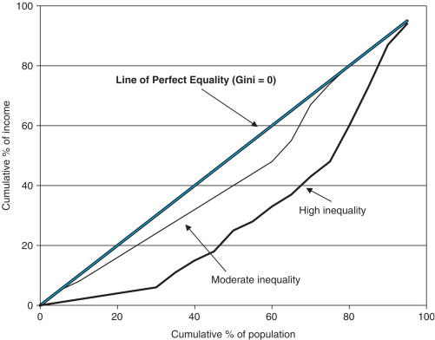

Fig 1. The Lorenz curves. Source: DeVerteuil, G. 2009

Mathematically, the Gini coefficient is defined as the mean absolute difference between all pairs of individuals for a given measure, in this case, income (Dunford, M. 2009). Gini can be expressed by the following formula:

Obrázok, na ktorom je diagram

Automaticky generovaný popis

where represents the mean value (in this case, mean income). The minimum value of the Gini coefficient is 0 which indicates perfect equality and 1 perfect inequality. Although the Gini coefficient is a popular and widely used measure of inequality, it fails to capture all nuances of economic inequality. The same holds for other measures of inequality all of which should be interpreted with caution.

Another important issue in analysing any kind of inequality is the distinction between in inequality between countries (or regions) and interpersonal inequality (Rey, et al. 2020). Although measuring inequality on the level of individuals represents the most accurate approach, it requires enormous data on income for all individuals (usually from household surveys) which is often not available on international scale (Dauderstädt, 2022). Therefore, to investigate income inequality on international or interregional level, the first approach is most used. This approach requires the assumption that the inequality within regions is zero which may not seem very plausible but does not represent a problem since the indicator we are interested in are interregional differences.

*2.3 Empirical approach*

Our analysis focuses on the evolution of regional income inequality within the EU with the focus the past few years affected by the COVID -19 pandemic. We first provide some context by graphically exploring the income distribution of the regions of the EU using the Eurostat data on GDP per inhabitant and GDP per inhabitant as the percentage of the EU average and then we calculate the Gini coefficient for the period of interest.

**3 Results**

Fig 2 illustrates GDP per inhabitant across regions of the EU as the percentage of the EU average. Although the EU is often considered to have a relatively high degree of income equality, the GDP per inhabitant in highest income regions is ten times the income per inhabitant in the most impoverished regions. There is a strong geographic component of regional income distribution within the EU, as Fig 2 demonstrates the highest income areas are concentrated in the north-western part of the continent. Even three decades after the Iron Curtain and the dissolution of the Soviet Union, the economic footprints of the East-West divide remain present in Europe. Eastern part of the continent still economically lags behind the traditionally industrialized economies of Western Europe. GDP per inhabitant in most regions of post-socialist countries does not exceed 75% of the EU average. Another important dimension of interregional income disparities within the EU is the urban-rural divide, as Fig 2 shows, metropolitan areas of capital cities tend substantially exceed the EU average income per inhabitant.

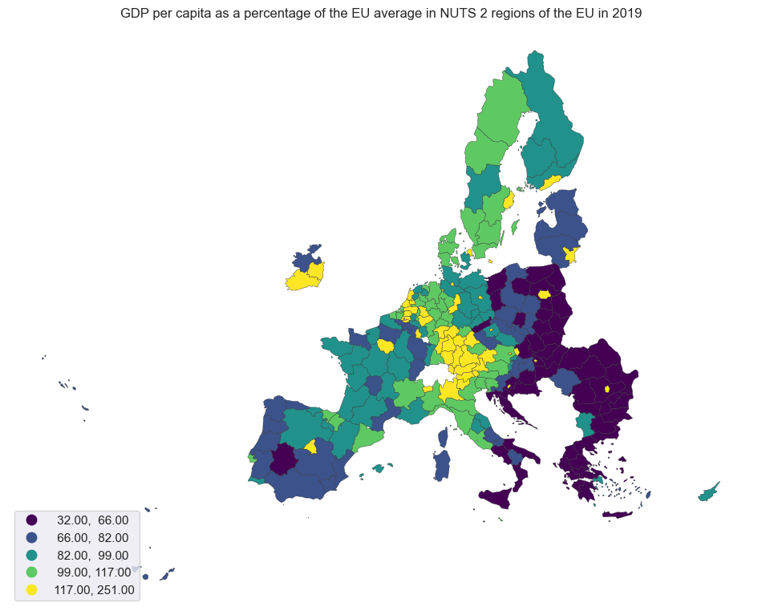

Fig 2. GDP per inhabitant of the regions of the EU as the percentage of EU average in 2019

The question we aim to investigate is whether the recent pandemic exacerbated this divide or instead had an equalizing effect on regional income distribution within the EU. Before proceeding to the analysis of inequality measures, Fig 3 illustrates the change of regional GDP per inhabitant across regions of the EU between pre-pandemic year 2019 and the year 2021. Just eyeballing this figure suggests that the COVID-19 had unequal impact on the GDP growth across the EU. While the western and southern part of the continent experienced a contraction of income per capita, the eastern part was less adversely affected by the economic shock triggered by the pandemic. This observation is consistent with the argument of Deaton (2021) who pointed out the developed countries that experienced higher death toll tended to also witness larger economic contraction. This line of argument supports the thesis that pandemic acted as an equalizer. However, taking a closer look, the differences in change in GDP over this period were relatively small and even for countries which experienced positive change in GDP, the growth rates were below steady-state growth rate.

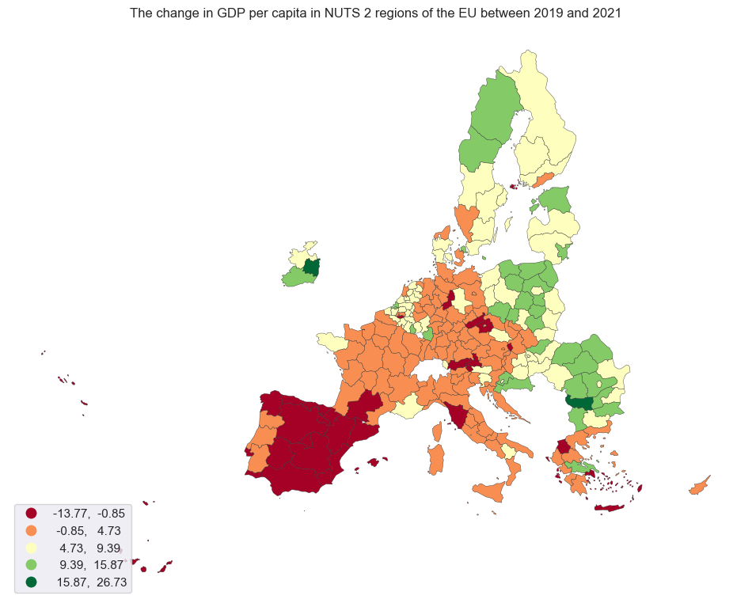

Fig 3. The percentage change in GDP per inhabitant in regions of the EU between 2019 and 2021.

To explore the trends in inequality more rigorously we calculate the most used measure of inequality, the Gini index. Fig 5 displays the associated Lorenz curve for pre-pandemic year 2019 and 2021. Lorenz curves suggest that inequality did not change much during the pandemic as the two Lorenz curves almost entirely overlap. The evolution of the Gini coefficient for regional income inequality provides more insight. Fig 6 illustrates the changes of Gini coefficient from 2010 to 2021 which had been relatively stable until 2016 when it started to fall which continued until 2019. In 2020, the Gini coefficient suddenly increased which coincided with the COVID-19 outbreak. It is worth noting though, that these changes were relatively subtle and this is only one of possible measures of income inequalities on only one territorial level. Nonetheless, it might indicate that the pandemic was associated with a deepening of income inequalities.

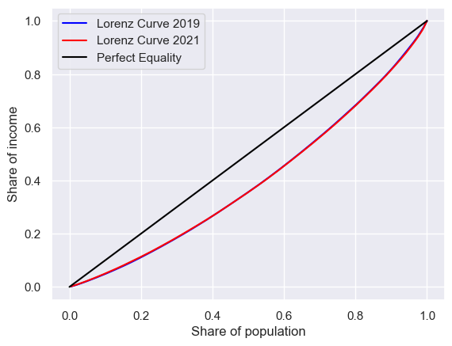

Fig 4. Lorenz curve of regional income distribution within the EU for 2019 and 2021

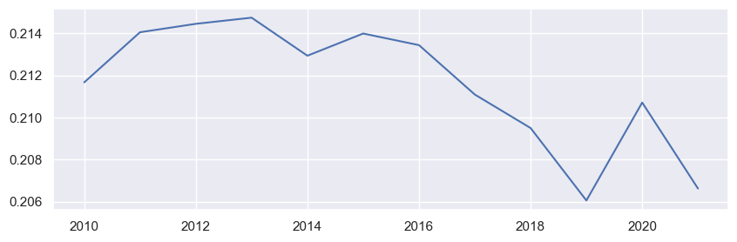

Fig 5. The evolution of the Gini coefficient of regional income inequality within the EU (2010 – 2021).

**4 Discussion**

The recent pandemic and its associated lockdowns resulted in a substantial disruption of supply side of the economy, as well as in contraction of the aggregate demand though the fall of disposable incomes (Murshed, 2022). Theoretically, the contraction of demand of services disproportionally affects the less educated and lower-income employees rather than higher income knowledge workers who can work remotely. Indeed, a large body of evidence from previous pandemics (e. g. Furceri, et al. 2022) indicates that pandemics tend to have negative distributional consequences. The response of income inequality to pandemics also depends on several factors including fiscal policy which affected countries, industries, and different segments of society to different degrees (Dauderstädt, 2022). Sectoral bias led to differential economic contractions across countries which also had substantial effect on interregional income distribution (Dauderstädt, 2022). A good example is Southern Europe heavily reliant on tourism which experienced a particularly severe economic contraction as the result of the pandemic (see Fig.3). Although the theoretical argument is unambiguous, the actual impacts of the pandemic on income distribution represent a much more nuanced and multifaceted issue.

First, we consider the dynamics of short run consequences of the COVID-19 outbreak. There is a wealth of literature Deaton (2021) has shown that the economic contractions associated with the pandemic more adversely affected the developed economies resulting in a decrease in unweighted international inequality but an increase in population weighted inequality.

The changing trends in regional income inequalities over recent years potentially associated with the COVID-19 pandemic be considered in broader context of the evolution of regional income disparities. There remain ongoing debates in economic growth literature whether regional incomes tend to converge or on the contrary, diverge over time. Neoclassical economics suggest that regional disparities are unlikely to be persistent if there are no substantial barriers to the operation of market forces and regions are reasonably similar (Martin, and Sunley, 2015). On the other hand, New Growth Theories emphasise the process of concentration of economic activity through agglomeration, scale economies and knowledge spill overs leading to deepening disparities (Barrios, and Strobl, 2009). But ultimately, this is an empirical question and evidence suggest that technological change and globalisation the agglomeration forces prevailed over the past couple of decades (Iammarino, et al. 2019). The question becomes what

Importantly, as noted above, there is no one single measure of inequality which could capture all nuances of income distribution. We do not attempt to establish a causal relationship here

**5 Conclusions**

Our focus is on regional inequality within the EU, in other words, the dispersion of income per inhabitant between regions taking each region as one unit.

**6 References**

Barrios, S. and Strobl, E. 2009. The dynamics of regional inequalities. Regional Science and Urban Economics. Volume 39, Issue 5, September 2009, Pages 575-591. DOI: https://doi.org/10.1016/j.regsciurbeco.2009.03.008

Dauderstädt, M. 2022. International Inequality and the COVID-19 Pandemic. Intereconomics, 2022, 57(1), 40-46

DeVerteuil, G. 2009. Inequality. International Encyclopedia of Human Geography, 2009, Pages 433-445. DOI: https://doi.org/10.1016/B978-008044910-4.00963-9

Dunford, M. 2009. Regional inequalities. International Encyclopedia of Human Geography 2009, Pages 236-245. DOI: <https://doi.org/10.1016/B978-008044910-4.00874-9>

Eurostat. 2023a. NUTS. Available at: https://ec.europa.eu/eurostat/web/gisco/geodata/reference-data/administrative-units-statistical-units/nuts#nuts21

Eurostat. 2023b. Regional gross domestic product (PPS per inhabitant) by NUTS 2 regions. Available at: <https://ec.europa.eu/eurostat/databrowser/view/TGS00005/default/table>.

Eurostat. 2023c. Regional gross domestic product (PPS per inhabitant in % of the EU27 (from 2020) average) by NUTS 2 regions. Available at: https://ec.europa.eu/eurostat/databrowser/view/TGS00006/default/table?lang=en&category=na10.nama10.nama_10reg.nama_10r_gdp

Furceri, D. et al. 2022. Will COVID-19 Have Long-Lasting Effects on Inequality? Evidence from Past Pandemics. The Journal of Economic Inequality (2022) 20:811–839. DOI: https://doi.org/10.1007/s10888-022-09540-y

Iammarino, S., Rodriguez-Pose, A. and Storper, M. 2019. Regional inequality in Europe: evidence, theory and policy implications, Journal of Economic Geography, Volume 19, Issue 2, March 2019, Pages 273–298, DOI: https://doi.org/10.1093/jeg/lby021

Martin, R. and Sunley, P. 2015. Slow Convergence? The New Endogenous Growth Theory and Regional Development. Economic Geography. Volume 74, 1998 - Issue 3

Murshed, S. 2022. Consequences of the Covid-19 Pandemic for Economic Inequality, In: Papyrakis, E. (eds) COVID-19 and International Development. Springer, Cham. <https://doi.org/10.1007/978-3-030-82339-9_5>

Narayan, A. et al. 2022. COVID-19 and Economic Inequality: Short-Term Impacts with Long-Term Consequences. World Bank Group. Poverty and Equity Global Practice & Development Data Group, January 2022. Policy research working paper 9902

Rey, S. J. et al. 2020. Spatial Inequality Dynamics. In: Geographic Data Science with Python. https://geographicdata.science/book/notebooks/09_spatial_inequality.html