

ExecRelay
Automated Trade Execution Platform
User Guide & Help Manual
Version 1.0 • August 2026
Rey Capital — Smart Investments
CONFIDENTIAL
Proprietary information of Rey Capital. Do not distribute outside the organisation.

Confidentiality Notice
This document and the systems it describes are the confidential and proprietary property of Rey Capital (“the Company”). It is provided solely for the use of authorised personnel and licensed users of the ExecRelay platform.
By receiving or reading this document you agree to the following:
- You will not reproduce, distribute, publish, or disclose any part of this document to any third party without prior written consent from the Company.
- You will not share credentials, license keys, bot tokens, webhook URLs, or public tunnel links that appear in your deployment with anyone outside your organisation.
- You will use the platform only on accounts you own or are authorised to trade, and in compliance with the terms of your broker and applicable regulations.
- On termination of your engagement with the Company you will destroy or return all copies of this document.

Risk disclosure
Automated trading involves substantial risk. Signals relayed by ExecRelay originate from third-party sources (TradingView strategies, Telegram channels) that the platform does not author or vet. Past performance of any signal provider is not indicative of future results.
Rey Capital strongly recommends validating every new signal source on a demo account, using the platform's dry-run mode, before enabling live execution. Nothing in this document constitutes financial advice.

Contents

Tip: if page numbers show as “Error!” or look outdated, right-click the table and choose “Update Field” → “Update entire table”.

1. Introduction

1.1 What is ExecRelay?
ExecRelay is Rey Capital's low-latency trade execution platform. It sits between your trading signal sources and your broker account, turning alerts into real orders automatically — within milliseconds, around the clock, without anyone needing to be at a screen.
Two kinds of signal sources are supported out of the box:
- TradingView alerts — any Pine script strategy or indicator alert can fire a webhook that ExecRelay executes.
- Telegram signal channels — messages from VIP/premium signal groups are read, parsed, sanity-checked and executed, with a confirmation sent back to your Telegram.
Orders are executed on MetaTrader 5 (MT4 and DXTrade are also supported by the platform) through a persistent connection, and every step of the journey — from the incoming message to the broker's fill — is validated, logged, and auditable.

1.2 Who this guide is for
This guide is written for the operator of an ExecRelay deployment: the person who starts and stops the system, connects signal sources, and monitors trading activity. No programming knowledge is required for day-to-day use; anything technical is limited to copying configuration values into a settings file.

1.3 What makes ExecRelay different
- Speed: the hot path from webhook to broker order targets a 95 ms p99 latency — no databases or human steps in between.
- Safety-first design: strict signal grammar, price sanity checks, fixed lot sizing, dry-run mode, a demo-only test executor, and duplicate suppression are all built in.
- Transparency: every signal, order and fill is written to daily transaction logs, and Telegram notifications confirm each order the moment it is placed.
- An optional AI filter: an XGBoost model can score every TradingView signal and skip statistically weak ones — or just observe in shadow mode.

2. How ExecRelay Works

2.1 The big picture
The diagram below shows the complete journey of a trading signal through the platform.
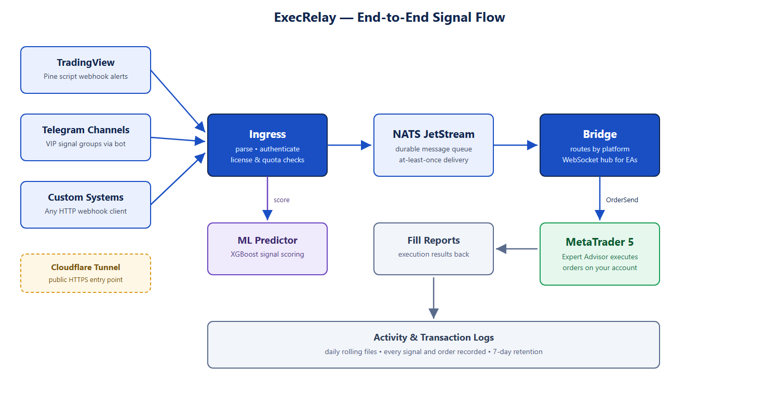
Signals enter through the Ingress service, which authenticates them (license + secret), checks quotas, and publishes them to a durable message queue. The Bridge picks them up and routes them over a persistent WebSocket to the Expert Advisor attached to your MT5 terminal, which places the actual order. Fills flow back through the same pipe and are recorded.

2.2 The services at a glance
Component | What it does | Port
Ingress | Receives webhooks, authenticates, applies quotas and the kill switch | 8081
NATS JetStream | Durable queue — no signal is lost even if a downstream service restarts | 4222
Bridge | Routes signals to the right trading platform; hub for EA connections | 8082
ML Predictor | Optional AI scoring of TradingView signals (shadow or enforce) | 8080
Telegram Ingest | Reads allowlisted Telegram chats, parses signals, sends notifications | 8089
EA / Execution shim | Places orders in the MT5 terminal and reports fills | —

2.3 Key concepts
Term | Meaning
License | Your identity to the platform: a license ID plus a secret that every signal must carry.
Instance | One connected trading terminal (e.g. your MT5). A license maps to an instance.
Signal | A parsed, validated trade instruction: side, symbol, entry, SL, TP, lot.
Fill | The broker's confirmation that an order was executed (or rejected).
Trace ID | A unique id stamped on every signal, printed in logs and notifications, so any trade can be followed end to end.
Dry-run | A mode where signals are parsed and logged but no order is sent — the recommended first step for any new signal source.

3. Getting Started

3.1 What you need
- A Windows machine (server or desktop) with the ExecRelay folder installed (default: C:\ExecRelay).
- MetaTrader 5 installed, running, and logged into your trading account. For testing, always use a demo account.
- Python 3.11+ (the installer normally sets this up for you).
- For Telegram trading: a Telegram bot token (from @BotFather) — covered in section 5.
- For public TradingView delivery: the free cloudflared tool — covered in section 7.

3.2 Starting the platform
Open PowerShell in the ExecRelay folder and run:
scripts\start-local-stack.ps1

# or, to also publish a public webhook URL for TradingView:
scripts\start-local-stack.ps1 -Tunnel
The script builds the services, starts everything in the right order, waits for each component to report healthy, and prints where each log file lives. A successful start ends with:
stack is up. EA connects to 127.0.0.1:8082 (instance: test-instance).

3.3 Stopping the platform
scripts\stop-local-stack.ps1
This stops every service the start script launched — including the public tunnel, whose link file is removed so a dead URL is never left behind.

3.4 Checking status
scripts\local-stack.ps1 status
ml-predictor: up (http://127.0.0.1:8080/readyz)
ingress: up (http://127.0.0.1:8081/health)
bridge: up (http://127.0.0.1:8082/health)
telegram-ingest: up (http://127.0.0.1:8089/health)
ea-shim: running (pid 9308)
public tunnel: https://example-name.trycloudflare.com

Good to know
The MT5 terminal must be running and logged in before you start the stack — the execution component attaches to the running terminal.
If a component shows DOWN, look at its log file in .local-stack\logs (see section 8) — the reason is almost always on the last few lines.

4. Trading from TradingView

4.1 How it works
TradingView fires a webhook (an HTTP message) every time your alert triggers. ExecRelay receives it, authenticates it against your license, and executes it. There are two webhook endpoints:
Endpoint | Use for
/webhook | Simple text commands — buy, sell, close, pending orders.
/webhook/ml | JSON alerts carrying indicator features, scored by the AI filter before execution.

4.2 The simple command format
A plain-text alert body, one line, comma-separated:
<license>,<command>,<symbol>,vol_lots=0.01,sl=4200,tp=4140,secret=<secret>
Supported commands:
Command | Effect
buy / sell | Market order, executed immediately.
buylimit / selllimit | Pending limit order at entry_price=... — waits for price to come to you.
buystop / sellstop | Pending stop order at entry_price=... — enters on a breakout.
closelong / closeshort | Closes open positions in that direction.
closelongopenshort | Flip: close longs, then open a short (and vice-versa).

Example — a complete TradingView alert message that sells gold with stop-loss and target:
60000000001,sell,XAUUSD,vol_lots=0.01,sl=4200,tp=4140,secret=my-secret

4.3 Smart pending-order fallback
If a pending order's price is already on the wrong side of the market when it arrives (price moved past the entry before the signal reached the broker), ExecRelay does not fail the trade: it executes at market instead and tags the order comment with “_M” so you can always see this happened in your MT5 history.

4.4 Connecting TradingView to your machine
TradingView's alerts fire from its cloud, so it needs a public URL for your ExecRelay. Start the stack with the tunnel switch (section 7) and use the printed URL in your TradingView alert settings:
Webhook URL: https://<your-tunnel-name>.trycloudflare.com/webhook
Tip — test without exposure
You can also test alerts without any public URL: create the alert with no webhook, copy the fired alert text from TradingView's alert log, and send it to the local endpoint yourself. Section 11 shows the exact command.

5. Trading from Telegram

5.1 How it works
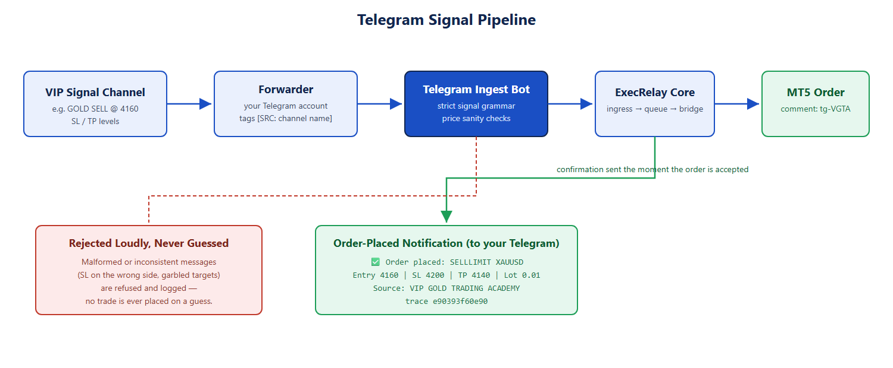
Many premium signal providers publish through Telegram channels. ExecRelay reads those messages, understands them, checks that the numbers make sense, and turns them into orders — then messages you back to confirm.
Because Telegram bots cannot read channels they are not members of, a small “forwarder” runs under your own Telegram account: it watches the channels you follow and re-posts the text of each signal into a private chat that the bot does read. Each relayed message is tagged with the channel it came from.

5.2 Supported message formats
Two widely-used signal styles are understood. Anything that does not exactly match is ignored (ordinary chatter) or rejected loudly (a signal whose numbers don't add up).

Format A — explicit entry
GOLD SELL @ 4160
SECOND SELL LIMIT @ 4180
SL @ 4200
TP @ 4140
The optional SECOND line places an additional pending order at a better price, sharing the same SL/TP bracket. Both legs are placed automatically.

Format B — breakout trigger with target ladder
XAUUSD Sell Trigger only Below 4792 📉
🛑 SL 4808 ⚠️
🎯 Target 4790 4788 4784 4770+ 🎯
The Above/Below wording tells ExecRelay exactly which pending order type to use (stop vs limit). Emoji, promo links and disclaimers are ignored automatically.

5.3 Choosing entry and take-profit behaviour
Setting | Options | What it controls
ENTRY_MODE | limit (default) / market | Whether the stated entry price becomes a resting limit order, or the first leg executes immediately at market.
TP_MODE | first (default) / last / ladder | Which target from a multi-target message is used: nearest, furthest, or one order per target.

5.4 Knowing where each trade came from
Every order placed from a Telegram signal carries the source channel's initials in its MT5 comment field. A signal from “VIP GOLD TRADING ACADEMY” produces orders commented tg-VGTA; one from “Dr Devendra's Crypto Advisory” produces tg-DDCA. When you review your account history you can always tell which channel produced which trade.

5.5 Order confirmations in Telegram
The moment an order is accepted and routed to the broker, the bot messages you:
✅ Order placed: SELLLIMIT XAUUSD
Entry 4160
SL 4200 | TP 4140 | Lot 0.01
Source: VIP GOLD TRADING ACADEMY
trace e90393f60e90
The trace id lets you find the exact same trade in the logs (section 8). Note this confirms the order was placed — pending orders fill later, when price reaches the entry.

5.6 Built-in protections
- Fixed lot size: position size is set in your configuration, never taken from the channel message.
- Price sanity: the stop-loss must be on the losing side of entry and every target on the winning side — otherwise the whole message is rejected and logged, and nothing is traded.
- Duplicate suppression: the same message can never trade twice.
- Allowlist: only chats you have explicitly listed are ever read.
- Dry-run first: with dry-run on, everything is parsed and logged but nothing is sent — watch a few days of a new channel's signals before going live.

5.7 Setup checklist
- Create a bot with @BotFather in Telegram; put its token in the configuration (section 10).
- Send your bot any message, then add your chat id to the allowlist setting.
- For channel forwarding: log the forwarder into your own Telegram account (one-time), then list the source channel names.
- Start in dry-run, review the transaction log, then set dry-run to false to go live.

6. The AI Signal Filter (ML Predictor)
For TradingView strategies that send indicator features with each alert, ExecRelay includes an XGBoost machine-learning model that estimates each signal's probability of success before it is executed.

6.1 Modes
Mode | Behaviour
Shadow (default) | Every signal is scored and the score is logged, but all trades execute normally. Use this to build confidence in the model without changing behaviour.
Enforce | Signals scoring below the threshold are skipped (entries only — closes always execute). The webhook response tells you a trade was skipped and why.

6.2 Fail-open by design
If the predictor is down or times out, trading does not stop: the signal executes anyway and the response notes that scoring was unavailable. The AI is a filter, never a single point of failure.

6.3 Position-aware decisions
When the alert includes your current position, the model's decision is richer than pass/fail: it can ignore same-direction repeats, flip a position on a strong opposite signal, or close-only when the re-entry looks weak. Every decision and its reasoning is included in the webhook response and the logs.

7. Public Access — Cloud Tunneling
Your ExecRelay runs on your own machine, behind your firewall. TradingView's cloud cannot reach it there. The built-in Cloudflare tunnel solves this with one switch — no router configuration, no port-forwarding, no static IP:
scripts\start-local-stack.ps1 -Tunnel
starting Cloudflare quick tunnel for ingress...
public ingress URL: https://example-name.trycloudflare.com
webhook endpoints: .../webhook and .../webhook/ml
- The public URL is also saved as a double-clickable shortcut: .local-stack\Public-Ingress-Link.url.
- Each start gets a fresh random URL; update your TradingView alert when you restart with a tunnel.
- The tunnel is stopped — and the shortcut removed — automatically when you stop the stack.

Security note
While the tunnel is up, your ingress is reachable from the internet. Trades still require your license and secret, but treat the URL itself as sensitive: don't post it anywhere public, and stop the stack when you are done testing.
For a permanent production deployment, use a named Cloudflare tunnel or the platform's full server install with your own domain instead of quick tunnels.

8. Logging & Audit Trail
Everything the platform does is written to disk, in two layers, under .local-stack\logs.

8.1 Service activity logs — daily files
Each service writes to a date-stamped file, e.g.:
bridge-2026-08-05.log
ingress-2026-08-05.log
telegram-ingest-2026-08-05.log
ea-shim-2026-08-05.log
- A new file per day per service — easy to find “what happened on Tuesday”.
- Files older than 7 days are deleted automatically on every start.

8.2 Transaction logs — the trading audit trail
The transactions subfolder holds the record that matters for money: one line per event, machine-readable, rotated at midnight UTC, 7-day retention:
File | Records
telegram-signals.log | Every Telegram message that parsed as a signal: the channel, the parsed values, the command sent, and the outcome (posted / dry-run / rejected + reason).
mt5-fills.log | Every order the execution side placed: account, symbol, command, order id, status, and any error.

A sample fill record:
{"ts": "2026-08-05T08:55:18Z", "account": 52634101, "command": "buy",
"symbol": "BTCUSD", "volume": "0.01", "status": "filled",
"broker_order_id": "1841877677", "trace_id": "744bbb72...", "error": ""}
Because both files carry the trace id, you can follow one trade from the Telegram message (or webhook) that caused it, through the order placement, to the broker's fill — and match it to the confirmation you received in Telegram.

9. Safety Features
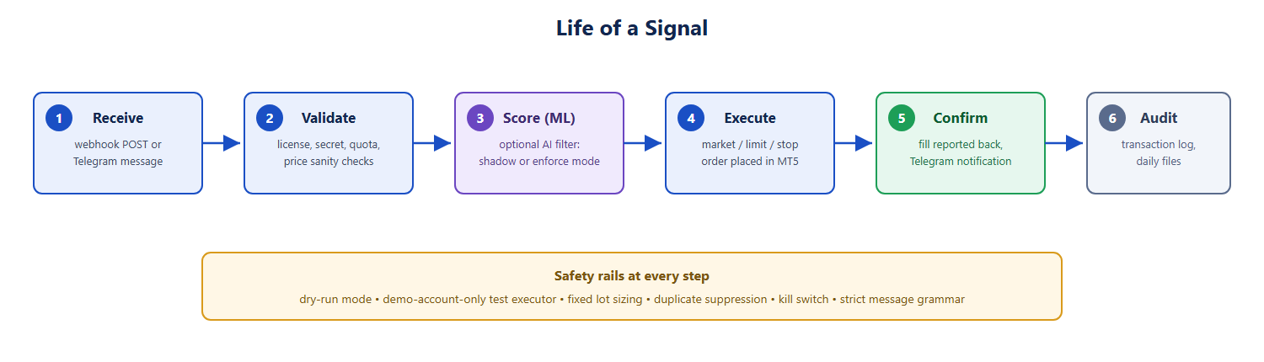
Protection | What it prevents
Strict signal grammar | Trading on chatter, promos, or half-understood messages — if it doesn't parse exactly, it doesn't trade.
Price sanity checks | Trading a garbled message — SL/targets on the wrong side of entry reject the whole signal.
Fixed lot sizing | A channel message ever deciding your position size.
Dry-run mode | Going live before you've watched what a new source would have done.
Demo-only test executor | The bundled test executor refuses to run against a real-money account.
Duplicate suppression | The same message or webhook double-trading.
Daily quotas & rate limits | A runaway strategy flooding your account with orders.
Kill switch | One setting halts all new trading instantly while you investigate.
AI filter (optional) | Statistically weak entries — skipped in enforce mode, logged in shadow mode.

10. Configuration Reference
All settings live in one file: .env in the ExecRelay folder. Edit it with Notepad, save, and restart the stack for changes to take effect. The most important settings:
Setting | What it does
EXECRELAY_LICENSES | Your license entries: id, secret, instance, platform.
TELEGRAM_INGEST_BOT_TOKEN | Your bot's token from @BotFather.
TELEGRAM_INGEST_ALLOWED_CHAT_IDS | Comma-separated chat ids the bot is allowed to read. Empty = read nothing.
TELEGRAM_INGEST_LICENSE_ID / _SECRET | The license the Telegram pipeline trades under.
TELEGRAM_INGEST_FIXED_LOT | Lot size for every Telegram-driven order (default 0.01).
TELEGRAM_INGEST_SYMBOL_MAP | Channel jargon → broker symbol, e.g. GOLD=XAUUSD.
TELEGRAM_INGEST_ENTRY_MODE | limit (rest at stated entry) or market (execute first leg now).
TELEGRAM_INGEST_TP_MODE | first / last / ladder — which target(s) to trade.
TELEGRAM_INGEST_DRY_RUN | true = log only, never trade. Set false to go live.
TG_FORWARDER_SOURCE_CHAT | Channel name(s) your account forwards from.
ML_ENFORCE / ML_THRESHOLD | AI filter mode and its pass mark (0–1).
INGRESS_TRADING_HALTED | true = kill switch on: all new signals refused.

11. Troubleshooting
Symptom | Likely cause & fix
A service shows DOWN in status | Read the last lines of its dated log in .local-stack\logs. Most common: the previous run didn't fully stop — run the stop script, then start again.
“port already in use” on start | An orphaned process is holding the port. Run the stop script; if it persists, find the process with netstat -ano | findstr :<port> and end it in Task Manager.
Orders not appearing in MT5 | Check the terminal is running and logged in, then that ea-shim shows “REGISTERED with bridge” in its log. Restarting the stack re-attaches it.
Telegram signals ignored | The chat id isn't in the allowlist, or the message doesn't match a supported format — rejected messages appear in telegram-signals.log with the reason.
Telegram bot conflict (409) | Two systems are polling the same bot token. Give each system its own bot.
TradingView alert does nothing | The tunnel URL changed on restart — update the alert's webhook URL; confirm the alert body includes your license and secret.
Pending order became a market order | Intended: price had already passed the entry, so the smart fallback executed at market (comment tagged _M).
No Telegram notifications | Notifications go to the same chat the signal came from; the bot can only message chats where it has been started (send it /start once).

Quick self-test (places a real order on the connected account — use a demo account):
curl -X POST http://127.0.0.1:8081/webhook -H "Content-Type: text/plain" ^
-d "<license>,buy,BTCUSD,vol_lots=0.01,secret=<secret>"

12. Best Practices & Suggestions

12.1 Rolling out a new signal source
- Week 1 — dry-run: add the channel with DRY_RUN=true. Read telegram-signals.log daily; check the parsed values match what the channel meant.
- Week 2 — demo: switch dry-run off against a demo account. Compare fills and notifications against the channel's own posted results.
- Only then consider live — with the smallest lot size, and review the transaction logs weekly.

12.2 Operating routine
- Daily: glance at the Telegram confirmations — they are your heartbeat that the pipeline is alive.
- Weekly: skim the transactions logs; reconcile order comments (tg-XXXX) against each channel's claims.
- After any restart with -Tunnel: update the TradingView webhook URL.
- Keep MT5 and the machine running — ExecRelay executes only while the terminal is connected.

12.3 Security
- Treat the .env file like a password vault: it holds your license secret and bot token. Never send it to anyone.
- Use a dedicated bot per system — never share one bot token between two applications.
- Stop the tunnel when not needed; prefer a named tunnel/domain for permanent setups.
- Keep the kill switch in mind: INGRESS_TRADING_HALTED=true stops all new trades in one restart.

12.4 Suggested defaults
Setting | Suggested value | Why
ENTRY_MODE | limit | Enters at the channel's stated price — no chasing.
TP_MODE | first | Nearest target = highest hit-rate, smallest exposure.
FIXED_LOT | 0.01 | Smallest size while validating any new source.
DRY_RUN | true → false | Always observe before you trade.

Appendix A — Signal Format Quick Reference

Telegram — Format A (explicit)
SYMBOL BUY|SELL @ price
[SECOND BUY|SELL LIMIT|STOP @ price]
SL @ price
TP @ price

Telegram — Format B (trigger)
SYMBOL Buy|Sell Trigger only Above|Below price
SL price
Target p1 p2 p3+ (or TP1: p1 TP2: p2 ...)

Webhook — flat command
license,command,symbol[,entry_price=..][,vol_lots=..][,sl=..][,tp=..][,comment=..],secret=...

Recognised symbols (Telegram trigger format)
Gold/metals (XAUUSD, GOLD, SILVER), major & cross FX pairs, indices (US30, NAS100, US500…), crypto (BTCUSD, ETHUSD…), oil (USOIL, UKOIL, WTI, BRENT). Channel jargon is normalised automatically (GOLD → XAUUSD) and your SYMBOL_MAP has the final say.

Rey Capital — Smart Investments
ExecRelay User Guide v1.0 • CONFIDENTIAL • © 2026 Rey Capital. All rights reserved.

