Video Transcript Extractor — Architecture
Offline transcription architecture and diagrams.

Technology stack
Desktop UI: Tauri 2 + React + TypeScript.
Worker: Python + faster-whisper (CTranslate2).
Media decode: FFmpeg.
Persistence: SQLite (job history, segments JSON).
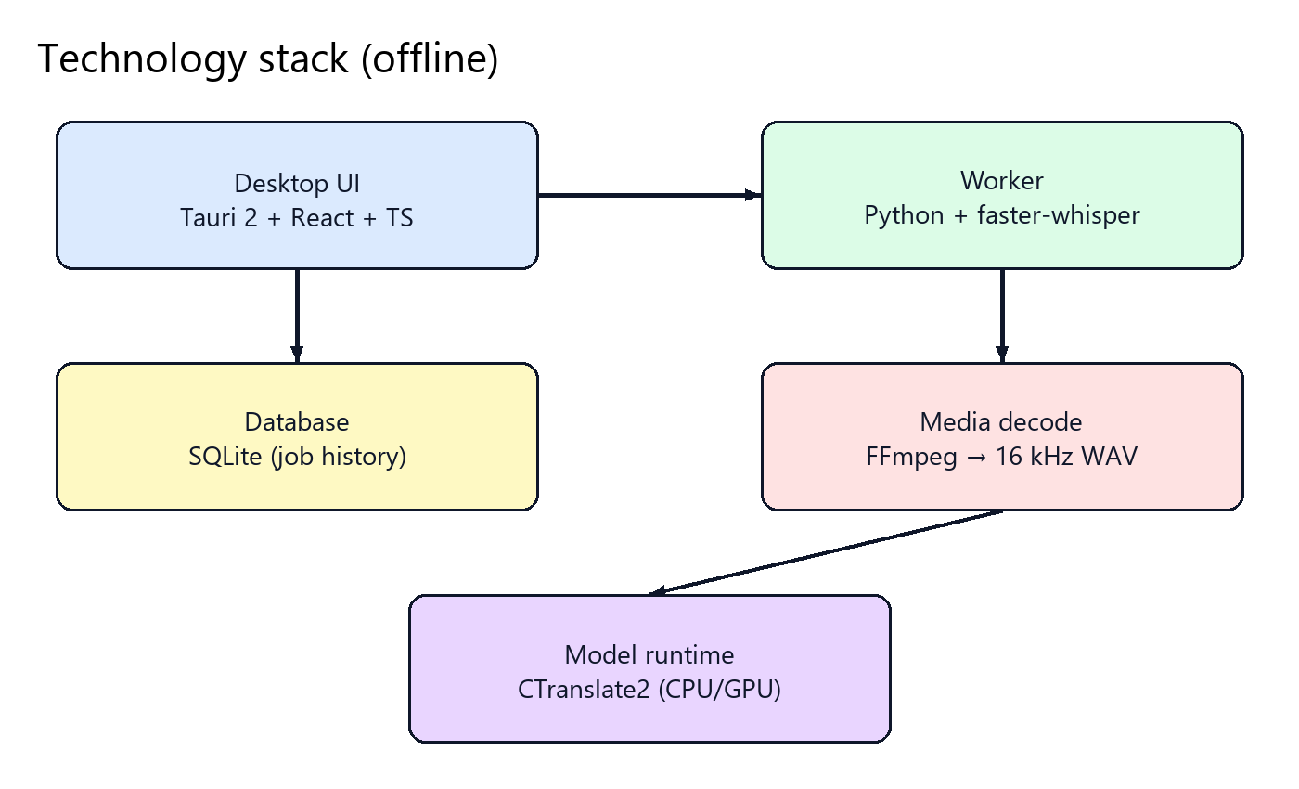

Dataflow
Files are selected in the UI and processed by the worker; progress and results are stored and displayed.
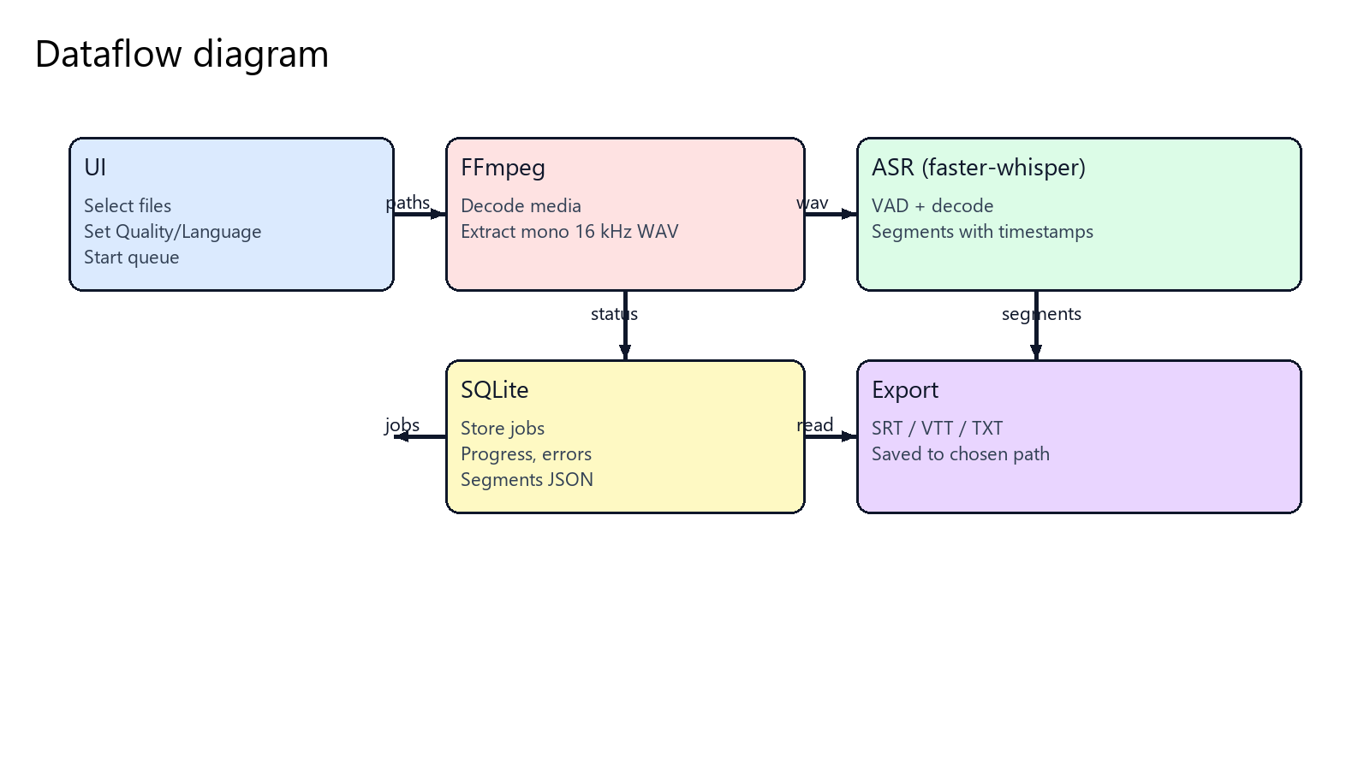

Notes
Draft uses distil-large-v3; Final uses large-v3.
All processing is performed on-device; no audio is uploaded.

