Video Transcript Extractor — User Guide
This document describes how to use the app to extract transcripts offline.

1. Install prerequisites
Install Python 3.10+, FFmpeg, and (for Windows) Visual Studio Build Tools + C++ workload.
Install Node.js + npm to run the desktop UI during development.

2. Add videos and start the queue
Click “Add videos”, choose one or more files, then click “Start queue”.
Use Quality: Draft for speed, Final for best accuracy.
Language hint: Auto is recommended for Hinglish; use Hindi/English hints for edge cases.
Illustrative UI screenshot:
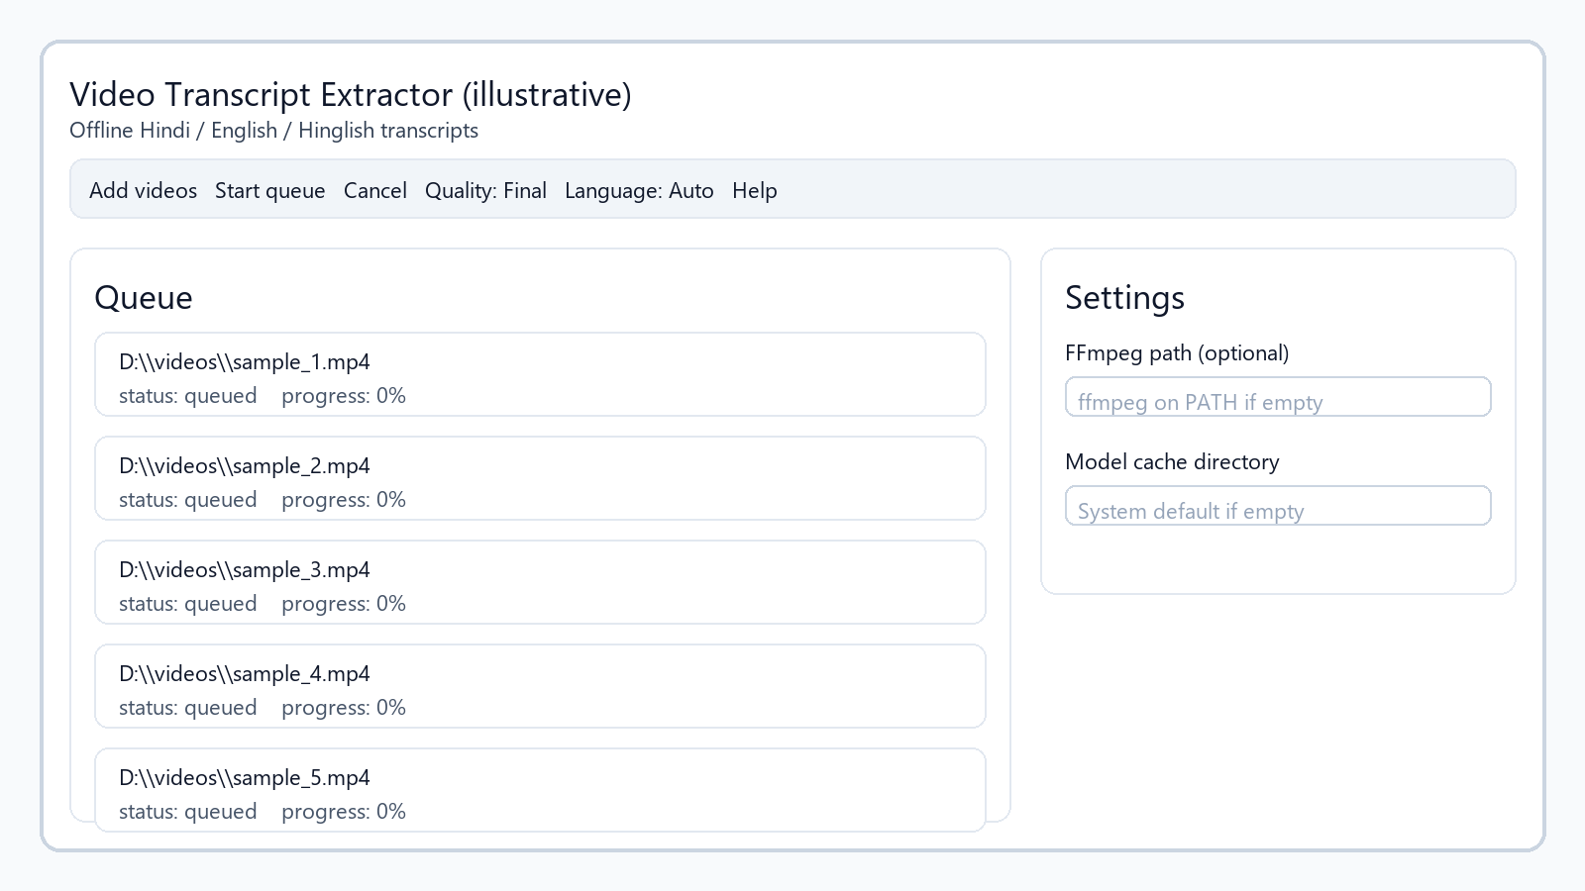

3. Review and export
After completion, review segments and export SRT, VTT, or TXT.

Troubleshooting
If FFmpeg is not found, set its path in Settings.
If you see CUDA out-of-memory, switch to Draft or free VRAM.

Help menu
Use Help → User guide from the app menu to open the in-app Help screen.

