ASSIGNMENTS

1. Create a storage account with the naming convention: yournameyourCTempID. (no spaces. Example: karthikct2153)

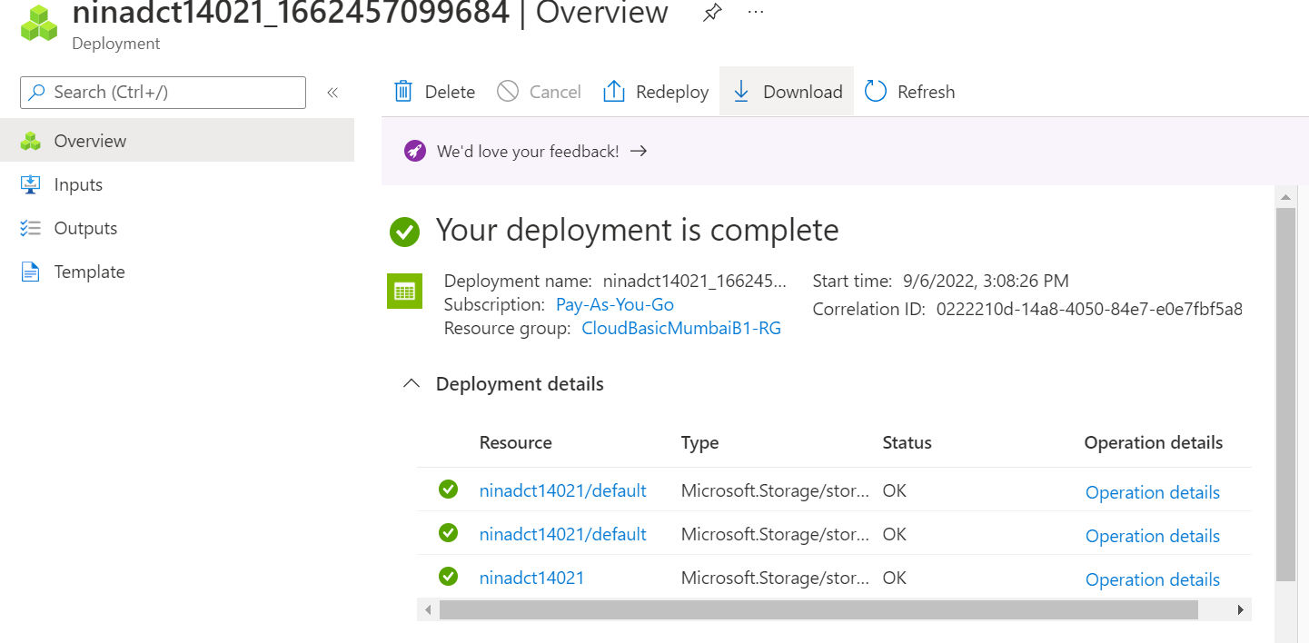

1. Create a blob container named photos.

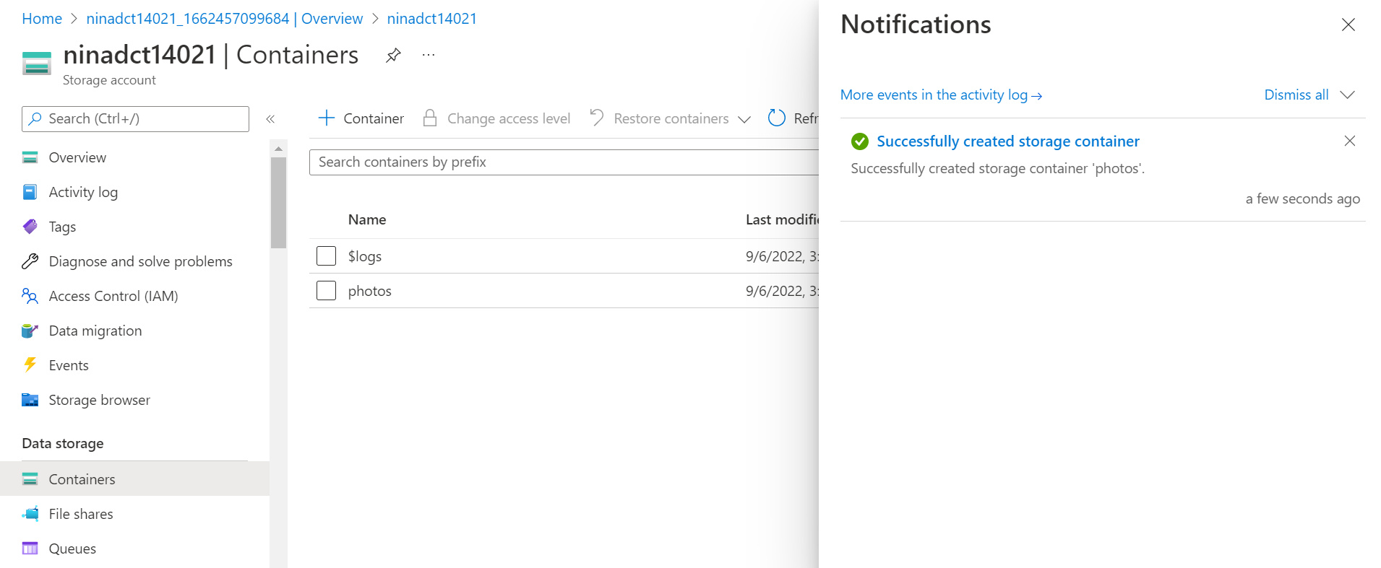

1. Upload some images in the container.

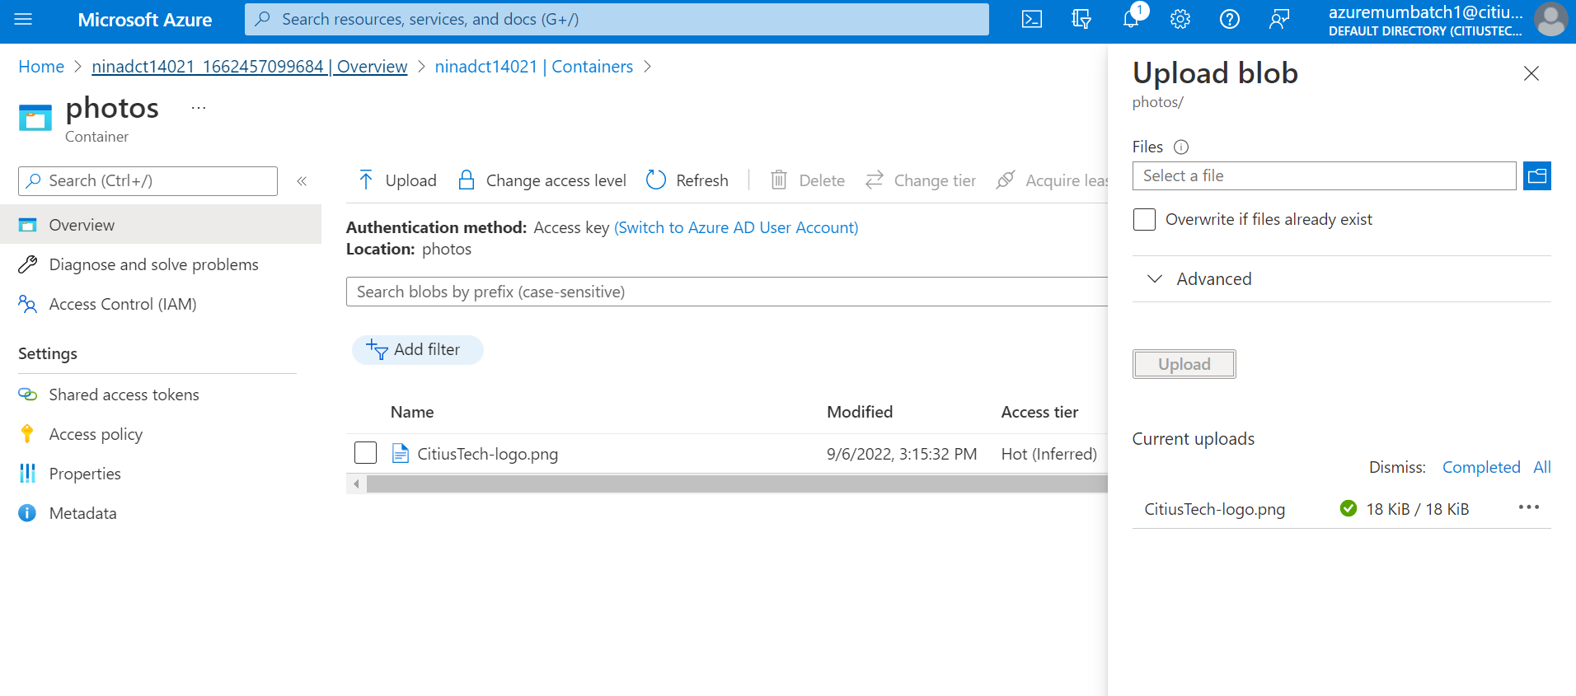

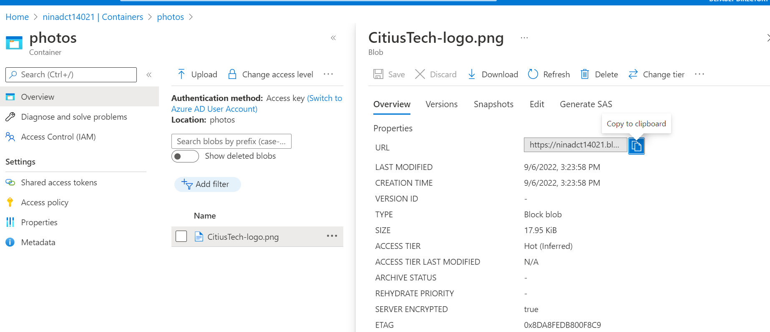

1. Access each image from your laptop browser using its URL.

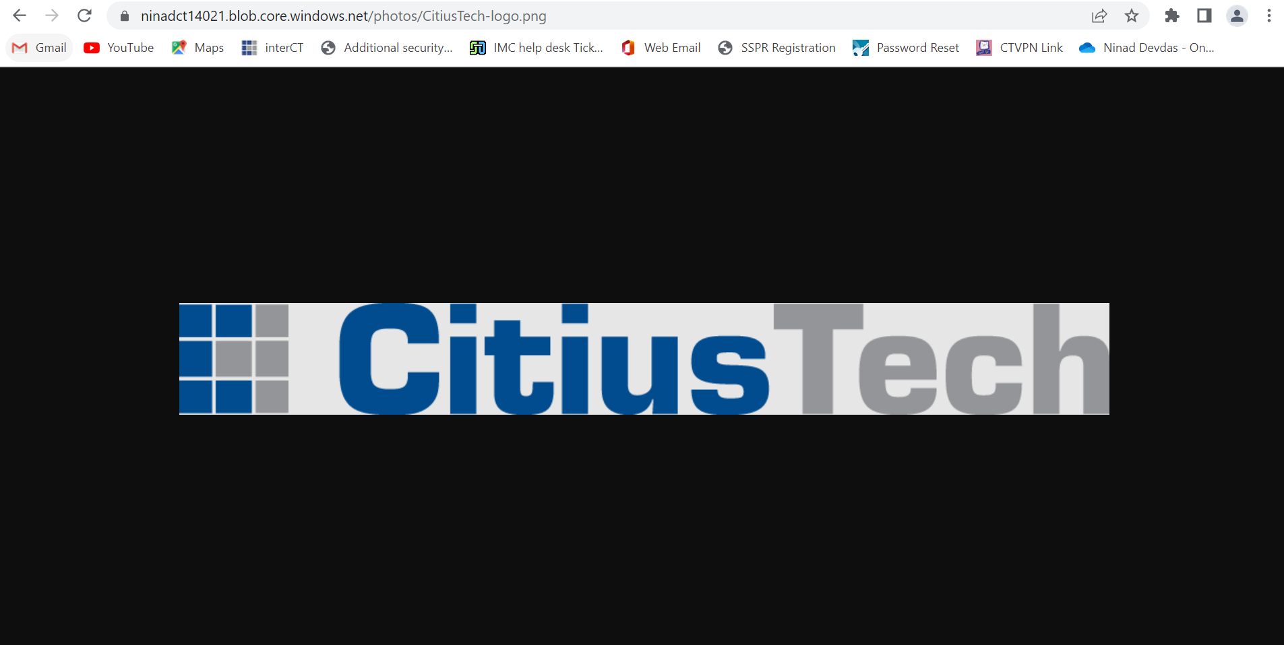

1. Delete the storage account.

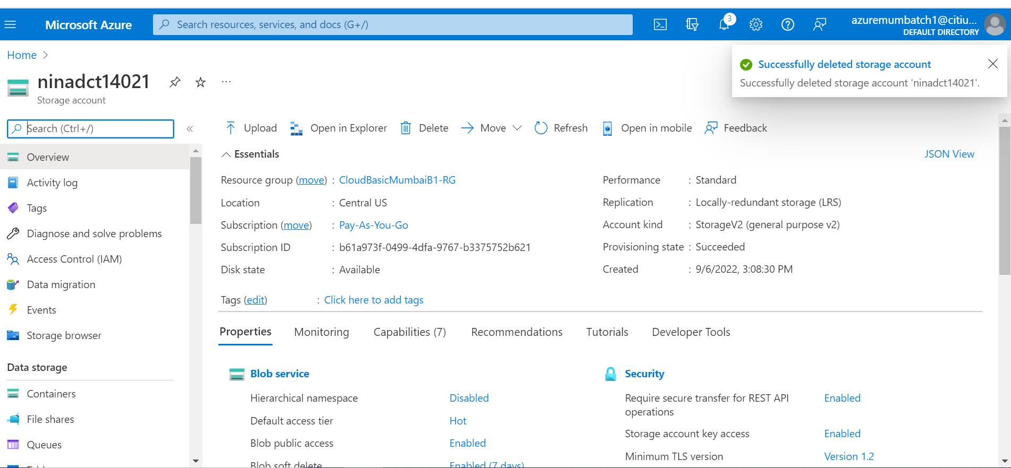

1. Create an app service.
   1. Deploy one of the HTML5 pages you might have created earlier into the app service.
   2. Access the app service from your laptop browser.
   3. Make some changes to the HTML5 page and re-deploy to the app service. o Access the app service again from your laptop browser & check if the changes are reflected.