Final Research Paper

Nina-Dawn B. McConkey
Colorado State University Global
MIS 581: Capstone: Business Intelligence and Data Analytics
Dr. Justin Bateh
July 26, 2026

Abstract
Retail companies rely on data analytics to improve decision-making, optimize inventory management, and forecast future demand. This study seeks to evaluate whether historical sales data can support accurate sales forecasting and to assess relationships between selected variables and sales performance using a retail sales dataset. This project follows a quantitative research design with structured sales transaction data. Descriptive statistics evaluated data quality, identified trends, and assessed relationships among variables. Predictive analytics techniques, including independent samples t-tests and regression analysis, evaluated the research hypotheses, while time series forecasting was used to determine the predictive capability of historical sales data. The forecasting model achieved a mean absolute percentage error (MAPE) of 10.74%, indicating that historical sales can create reasonably accurate forecasts for future sales. However, the statistical analyses did not find significant relationships between the selected explanatory variables and sales performance, suggesting that additional factors may influence customer purchase behavior. These findings demonstrate the importance of data quality, variable selection, and comprehensive data collection when developing predictive analytics models. Future research could incorporate additional internal and external data sources, including customer demographics, marketing activities, inventory information, and economic information, to improve forecasting performance and better understand the factors that influence retail sales.

Introduction
Companies and organizations have access to massive amounts of data, and this has changed how businesses operate and make strategic decisions. Using predictive analytics, organizations are able to forecast future outcomes and improve operational performance rather than relying only on historical trends or intuition. Sales forecasting through predictive analytics supports inventory management, budgeting, and long-term strategic planning. As companies and organizations continue to collect massive amounts of transactional data, advanced analytics techniques can be used to identify patterns that improve forecasting accuracy and support evidence-based decision-making (Habel et al., 2023; Ahaggach et al., 2024).
Many organizations recognize the value of predictive analytics, but are unable to produce reliable sales forecasts because customer purchase behavior can be influenced by external factors that the organization cannot control. Traditional forecasting methods relied on historical averages or subjective judgment, which do not take into account changing customer behavior or market conditions. Recent advances in statistical modeling and machine learning have helped organizations improve the ability to analyze extremely large datasets, identify meaningful or nonlinear relationships among variables, and create more accurate sales forecasts (Bauskar, 2022; Morsi, 2020).
This research project seeks to determine if historical retail sales data can be used to accurately predict future sales events and support business decision-making. This study will apply descriptive statistics, correlation analysis, regression analysis, analysis of variance (ANOVA), and time-series forecasting on a retail sales dataset to examine relationships among variables and develop predictive models. The findings will demonstrate how predictive analytics can improve forecasting accuracy, while also providing companies and organizations with actionable business insights for inventory management and strategic planning.
Objectives
The primary objective of this study is to evaluate how predictive analytics can improve sales forecasting and business decision-making. To accomplish this goal, the historical information in the dataset will be examined to identify trends or seasonal purchase patterns. Relationships among the variables will be evaluated to determine if any are strongly correlated. Once these variables are identified, predictive models will be developed that are able to forecast future sales. The predictive models will be evaluated for accuracy using statistical performance measures, such as mean absolute error (MAE) and root mean square error (RMSE). Meeting these objectives will give organizations insight into the value of predictive analytics and show how statistical analysis can improve business forecasting and support data-backed management practices. These objectives support the business goals of improving sales forecasting and data-based management practices. Once these objectives are achieved, organizations will be able to optimize inventory management, effectively allocate resources, and support efficient strategic planning. This study seeks to demonstrate how predictive analytics can provide companies with actionable insights to improve sales performance and contribute to more informed business decisions.
Overview of Study
This research applies predictive analytics to a retail sales dataset using historical transaction information. Originally, a dataset from the website Kaggle was used for consideration, however, it did not contain sufficient information for full analysis. A new dataset that contains information about sales across multiple locations will be used for further analysis (Excelx, n.d.). This project will focus on finding statistical relationships between sales variables and creating predictive models that are capable of accurately predicting future sales performance. It is essential that sales forecasting be accurate, as organizations rely on data-driven decision-making more frequently when planning for inventory management, budgeting, and strategic planning.
The first step in the process is exploratory data analysis (EDA). This will help determine the structure and quality of the dataset, as well as identify any missing values or outliers. Using descriptive statistics and visualizations (such as graphs or boxplots), trends or anomalies in the data can be identified. This will provide an initial view of the spread and distribution of sales performance. Outliers will also be evaluated to determine if there are any potential data entry errors, measurement errors, or if the outliers are the result of unusually large purchases or seasonal sales spikes. If the outliers are determined to be errors, or disproportionately affect sales performance, other methods (such as removal, transformation, or Winsorizing) may be considered (Dash et al., 2023). The Winsorizing method reduces the effect of extreme values by replacing them with less extreme values to minimize the impact on statistical analysis (Dash et al., 2023). However, if the extreme values are legitimate observations, they will be retained to preserve the integrity of the dataset to reflect real-world sales behavior.
After the data has been prepared, correlation analysis, regression analysis, and ANOVA testing will be conducted to evaluate the relationships among variables and identify if any statistically significant differences exist within the data. Then, time-series forecasting techniques will be applied to predict future sales based on historical observations and seasonal trends. The accuracy of the forecasting model will be determined by evaluating the MAE and RMSE. The model will then be adjusted to increase accuracy. Structured Query Language (SQL) will be used to perform data extraction, preparation, cleaning, and aggregation, while RStudio will be used to perform statistical analysis, create visualizations, and develop forecasting models.
This study will also address any potential limitations of the dataset and ethical considerations relating to the responsible use of business data and predictive analytics. The findings of the statistical analysis will support each business question, and provide information on whether the null hypotheses can be rejected or fail to be rejected. The paper will end with recommendations on how companies or organizations can improve forecasting accuracy, as well as reinforce how predictive analytics can support informed business decision-making.
Research Questions and Hypotheses
RQ1: Can future sales be accurately predicted based on historical information?
H_{o}: Predictive analytics cannot accurately forecast future sales.
H_{a}: Predictive analytics can accurately forecast future sales.
RQ2: Is there a significant seasonal pattern in sales throughout the year?
H_{o}: There is no significant difference in sales patterns throughout the year.
H_{a}: There is a significant difference in sales patterns throughout the year.
RQ3: Do discounted items generate higher sales than non-discounted items?
H_{o}: Discounted items do not create higher sales than non-discounted items.
H_{a}: Discounted items create higher sales than non-discounted items.
Research Design
This study uses a quantitative research design with secondary data obtained from a publicly available retail sales dataset. The original dataset for this study had several limitations, such as limited variables and insufficient information to support the proposed analyses. A different dataset was then found to better align with the research questions and objectives. The new dataset still contains retail transaction information, but includes more variables and information to serve as a stronger foundation for descriptive and predictive analysis. The dataset that was used for analysis improved the ability to evaluate the factors that influence sales performance. The goals of this study are to determine if historical retail sales information can be used to accurately forecast future sales events and to support business decision-making through predictive analytics. This research analyzes public historical sales data and does not manipulate or control variables through experimentation, and instead measures variables and the relationships among them, making this study descriptive and correlational with a predictive component to estimate future sales performance.
The project follows a quantitative research design because the focus is on numerical data using statistical techniques to objectively answer the business questions. The sales dataset contains measurable variables (including quantity, unit price, total price, and discount information) that will be used to find trends and forecast future sales outcomes. Using this existing dataset allows for the evaluation of sales information, while avoiding the time and costs associated with collecting primary data.
This research will begin with data preparation and EDA before applying predictive analytics techniques. SQL will prepare, clean, and organize the data into a standardized format to allow for statistical analysis. The dataset will be reviewed for missing values, duplicate records, inconsistent formatting, and outliers that could impact the results of statistical analysis. As stated previously, outliers will be evaluated for legitimacy and managed using an appropriate method. Once the data is prepared, descriptive statistics and visuals will be generated using RStudio. Correlation analysis will identify strong relationships within the data, then linear regression will be conducted to determine explanatory power for each variable identified. ANOVA will determine if there is a statistically significant difference between variable means. By combining statistical analysis with predictive analytics, forecasting accuracy is improved, and organizations are able to make more informed, data-driven decisions (Ahaggach et al., 2024; Bauskar, 2022).
Methodology
Because this study seeks to objectively analyze numerical data to answer the business questions, it uses a quantitative research methodology. Quantitative research is well-suited for predictive analytics because it allows researchers to measure relationships among variables using statistical techniques and objectively test hypotheses. Qualitative research, on the other hand, seeks to understand opinions, perceptions, or experiences. Quantitative research can analyze variables to find relationships and evaluate the significance and predictive power of those relationships.
As previously stated, this study uses secondary data obtained from a publicly available retail sales dataset. The dataset contains historical transaction information, such as purchase quantity, price, and product information. Secondary datasets are useful in predictive analytics because they can provide large amounts of historical observations that can be efficiently analyzed without the time and costs associated with collecting primary data (Polonsky & Waller, 2019). Historical information also serves as a foundation for forecasting models because they can capture patterns in customer purchase behavior over time. Predictive models built on historical data can improve forecasting accuracy and provide valuable business insights for strategic planning (Morsi, 2020; Bauskar, 2022).
Descriptive, correlational, and predictive analytics approaches are used in this study to address the research objectives. Descriptive analytics will provide a summarization of the dataset and create an initial understanding of sales trends and overall purchase behavior. Correlation analysis will examine the strength and direction of the relationships among variables, and determine if meaningful relationships exist. Predictive analytics will build on these by using historical observations to estimate future sales performance through statistical techniques. These approaches will create an understanding of both historical sales behavior and future sales outcomes.
A quantitative methodology was chosen because it aligns with the purpose of the study as well as with the structure of the dataset. The objective is to evaluate measurable business outcomes using statistical evidence, not to understand customer opinions or organizational perceptions. By using quantitative methods on historical transactions, the study will create objective findings that can support accurate forecasting and informed business decision-making. This approach aligns with current research in demonstrating that predictive analytics enables organizations to move from describing what happened, to what might happen next, and finally to how to apply the findings in a business setting (Habel et al., 2023; Buddula et al., 2023).
Methods
As stated previously, the analytical process will begin with data preparation using SQL to clean, organize, and validate the dataset. Duplicate records will be identified, variable formatting will be verified, and missing or inconsistent values will be addressed. This step will ensure the model produces reliable statistical results and reduces forecasting error.
After data preparation, descriptive statistics will calculate the measures of central tendency and variability. Histograms, boxplots, scatterplots, and line charts will provide visualizations of these measures and can help to identify seasonal trends and outliers. Correlation analysis will be conducted to determine the strength and direction of relationships among the variables, while multiple linear regression will evaluate the contribution of these variables when predicting sales revenue. ANOVA will determine if there is a statistically significant difference in sales across different months. Finally, time-series forecasting will be used to estimate future sales performance based on historical observations. These statistical methods are effective approaches to improve forecasting accuracy and support business decision-making (Buddula et al., 2023; Uddin, 2025; Ahaggach et al., 2024). To evaluate forecasting accuracy, the model will be evaluated using MAE and RMSE. MAE measures the average difference between predicted and actual values to provide an understandable measure of the overall performance of the model. MAE does not give more weight to larger errors, but treats all prediction errors equally and gives an indication of how far, on average, the forecasted value deviates from the actual value. RMSE calculates the square root of the average squared prediction errors, with a harsher penalty for larger errors. Because of this, RMSE is useful in identifying models that may occasionally create greater prediction errors, since these larger errors have a stronger effect on the final metric. Ideally, the final model will produce lower MAE and RMSE to indicate better predictive performance and greater forecasting accuracy. These metrics are commonly used in predictive analytics because they allow for comparing forecasting models and determining effectiveness when supporting business decisions (Bauskar, 2022).
Limitations
The first limitation to be considered is the dataset. The current dataset allows for increased predictive analytics, but still contains simulated information, making it difficult to apply future findings to a specific company or organization. The dataset contains useful information related to sales transactions, discounts, customer information, and transaction dates, but it does not include external factors that may have a significant influence on sales performance. Variables like customer demographics, economic trends, or weather conditions are not included and may reduce the overall predictive capability of the forecasting models.
This leads to another limitation, predictive models use historical observations to estimate future outcomes. Having no information regarding outside market conditions (such as economic changes, supply chain issues, or international factors) creates a predictive model that assumes data will continue under conditions similar to the historical data. It is important that forecasting models be used as tools to estimate outcomes, rather than guarantee a certain future performance.
This study is also limited by the selection of statistical techniques chosen to analyze the dataset. Multiple linear regression, correlation analysis, ANOVA testing, and time-series forecasting are all useful methods to analyze data, however, they are not as effective at capturing nonlinear relationships as other machine learning methods (such as Random Forests or Neural Networks). Machine learning techniques are capable of improving forecasting performance, but also require computational resources that are currently not available for this study. The selected analytical methods have predictive capability and are statistically sound.
The findings may also be limited because the research only uses a single retail sales dataset. The analysis results may not be applicable to different markets, industries, or geographic regions. Future research could incorporate multiple datasets, additional business variables, or more advanced forecasting techniques to improve model performance. Combining larger datasets with machine learning approaches can significantly improve forecasting performance and support more accurate organizational decision-making (Ahaggach et al., 2024; Bauskar, 2022).
Ethical Considerations
The intended dataset does not contain any identifiable customer information, and all analyses will be conducted using the anonymized data. No attempt will be made to identify individual customers, businesses, or organizations represented in the data. Findings will be reported in aggregate form to ensure confidentiality is maintained.
This study will also make every attempt to avoid introducing bias into the analytical process. Data preparation, variable selection, model development, and results will be based on established statistical principles and will not be altered to produce desired outcomes. Any limitations with the dataset or the predictive models will be acknowledged to provide a transparent assessment of the findings.
Another ethical consideration is the responsible use of predictive analytics in an organization. Predictive models are intended to support decision-making by identifying patterns and estimating outcomes, and should not replace professional judgment or expertise. Companies and organizations should implement predictive results with industry knowledge and current market conditions when making strategic decisions. Organizations can face challenges when implementing predictive analytics, such as user trust, understanding of model outputs, and effective integration of predictive tools into decision-making processes (Habel et al., 2024).
The next phase of the project focuses on applying the methodology listed in this paper to the retail sales dataset. This will include the results of the descriptive analytics, visualizations, correlation analysis, regression modeling, ANOVA, and time-series forecasting. These findings will support answers to the business questions and determine whether to reject or fail to reject the null hypotheses, and assess the capability of predictive analytics when forecasting future sales.
Data Analysis
After describing the research design and methodology, data analysis was conducted using RStudio. Initially, SQL was considered for part of the data preparation process, and was used to ensure the data did not contain duplicates, but the dataset was a single, well-structured table that did not require data extraction or integration, and the information was all from one data source. Because of this, most data preparation, statistical analysis, and predictive modeling were completed within RStudio. Though SQL did not have a major role in this project, it remains a necessary tool for business analytics when working with relational databases or data warehouses, where data must be joined, filtered, and aggregated across multiple tables prior to analysis. In large companies or organizations, R and SQL can be used together, with SQL to prepare the data and R to perform statistical analysis and modeling.
Findings
Before conducting any statistical analysis, the dataset was evaluated for missing or incomplete values to ensure the quality of the data (Figure 1). Null or missing values can affect the results of statistical analysis and reduce the accuracy of hypothesis testing and predictive models, so it is important to identify variables with missing values first. Figure 1 shows that there are no missing values in any of the variables, but Promotions has 370 blank values. This indicates that 370 transactions were made when no promotions were active. This variable is not used for this project, but maintaining this information allows companies and organizations to analyze this variable in the future. Overall, the dataset appears complete and did not require imputation or removal of observations due to missing values.
Figure 1
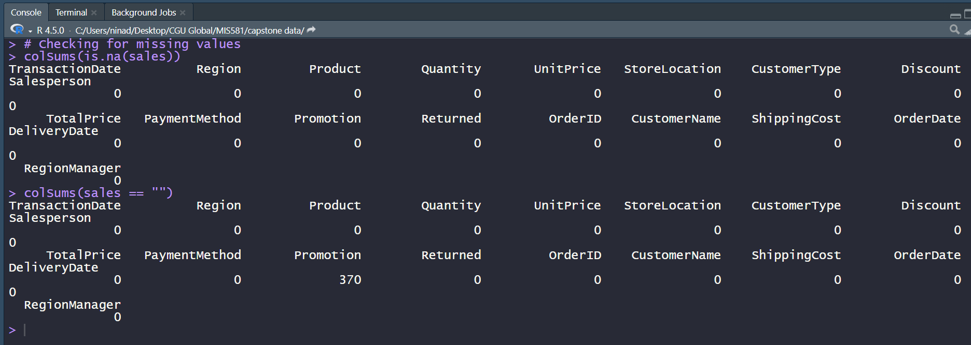
Missing or Incomplete Values

Summary Statistics
After reviewing the data for missing values, the numerical variables (Quantity, UnitPrice, Discount, TotalPrice, Returned, and ShippingCost) were isolated in a subset for descriptive statistics and measures of variability. Summary statistics (Figure 2) provided a general overview of the distribution, central tendency, and spread of the data. The average purchase quantity was 10.14 (standard deviation 5.74) with purchases ranging from 1 to 20 items. Unit prices averaged at $298.83 (standard deviation 169.10), while the total price per transaction averaged $2,919.99 (standard deviation 2,522.79). The standard deviations for these variables indicate substantial variability in customer spending. Discounts ranged from 0 to 0.15, with the average discount being 7.31% (standard deviation 0.056). The Returned variable used 0 to indicate an item not returned, and 1 to indicate a return, with approximately 24.8% (standard deviation 0.432) of transactions involving returned items. Shipping costs averaged $27.51 (standard deviation 13.09). These results indicate reasonable variability in transaction values, while also suggesting consistent discount and purchases quantities throughout the dataset.
Figure 2
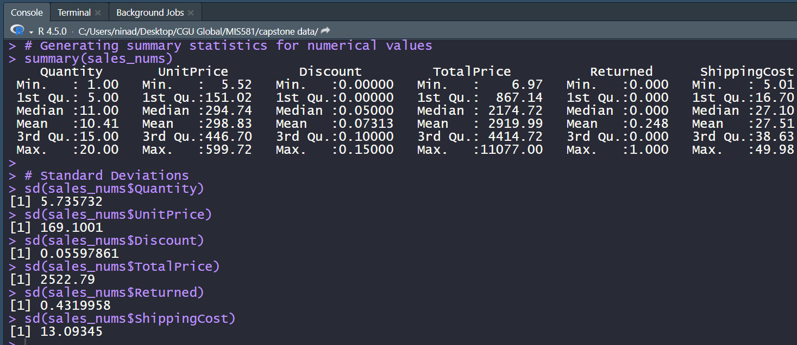
Summary Statistics

Distribution of Total Price
The histogram in Figure 3 shows the distribution of transaction values in the dataset. The TotalPrice variable is right-skewed (or positively skewed), with the majority being concentrated at lower total purchase values and a few larger purchases pulling the mean to the right. This visual shows that most purchases are of moderate value, while there were a small number of purchases that were of significantly higher value. These high-value purchases are less common, with frequency dropping below 25.

Figure 3
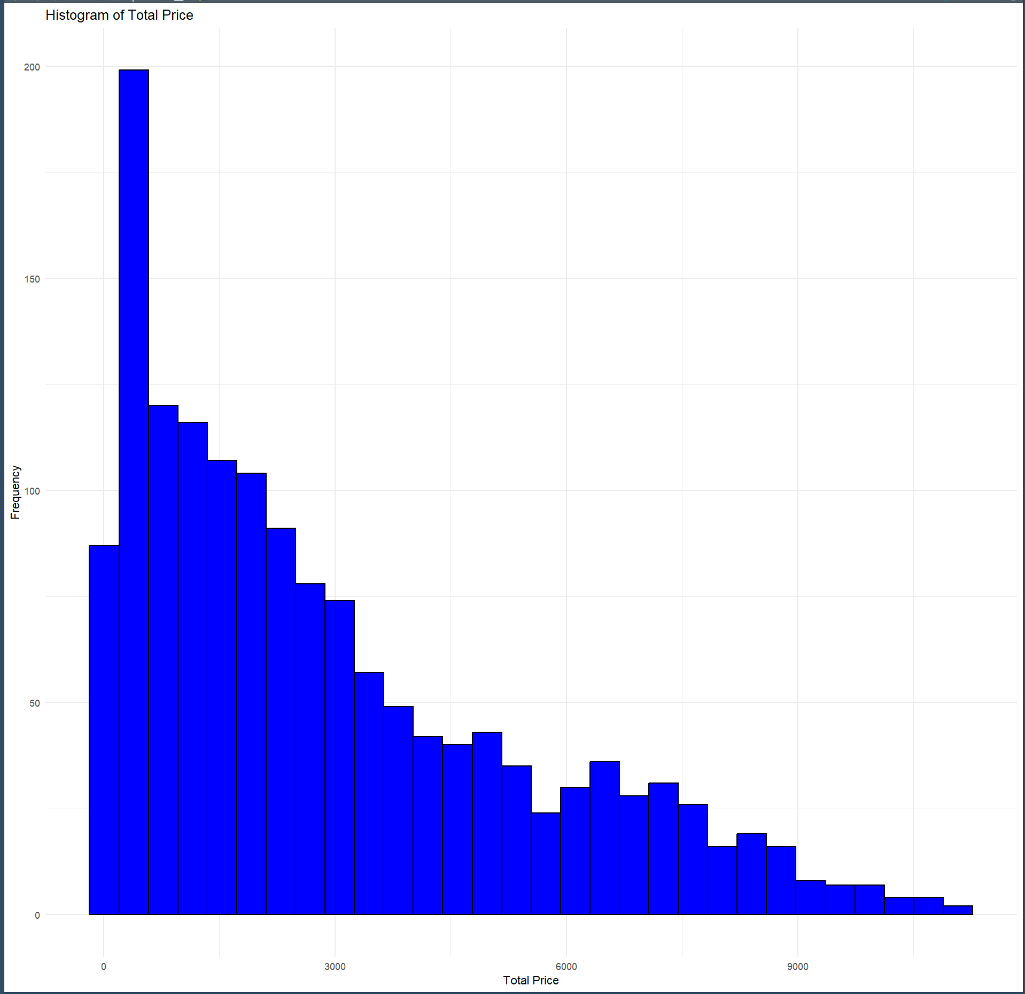
Histogram for TotalPrice
The boxplot in Figure 4 provides an additional visual of the spread of total transaction values. The interquartile range in this image appears wide, indicating variation among the middle 50% of transactions. Also notable are the outliers above the upper whisker. These outliers are also indicative of a right-skewed distribution, also observed in the histogram in Figure 3. These outliers were kept for analysis because they likely represent unusually large customer purchases, rather than data entry errors. Unexpectedly large transactions can be expected in retail sales data, and the outliers preserve the accuracy and real-life representation of this information. The presence of outliers can affect the variability in total purchase price, but they also reflect realistic purchase behavior that can be valuable for understanding customer spending patterns.

Figure 4
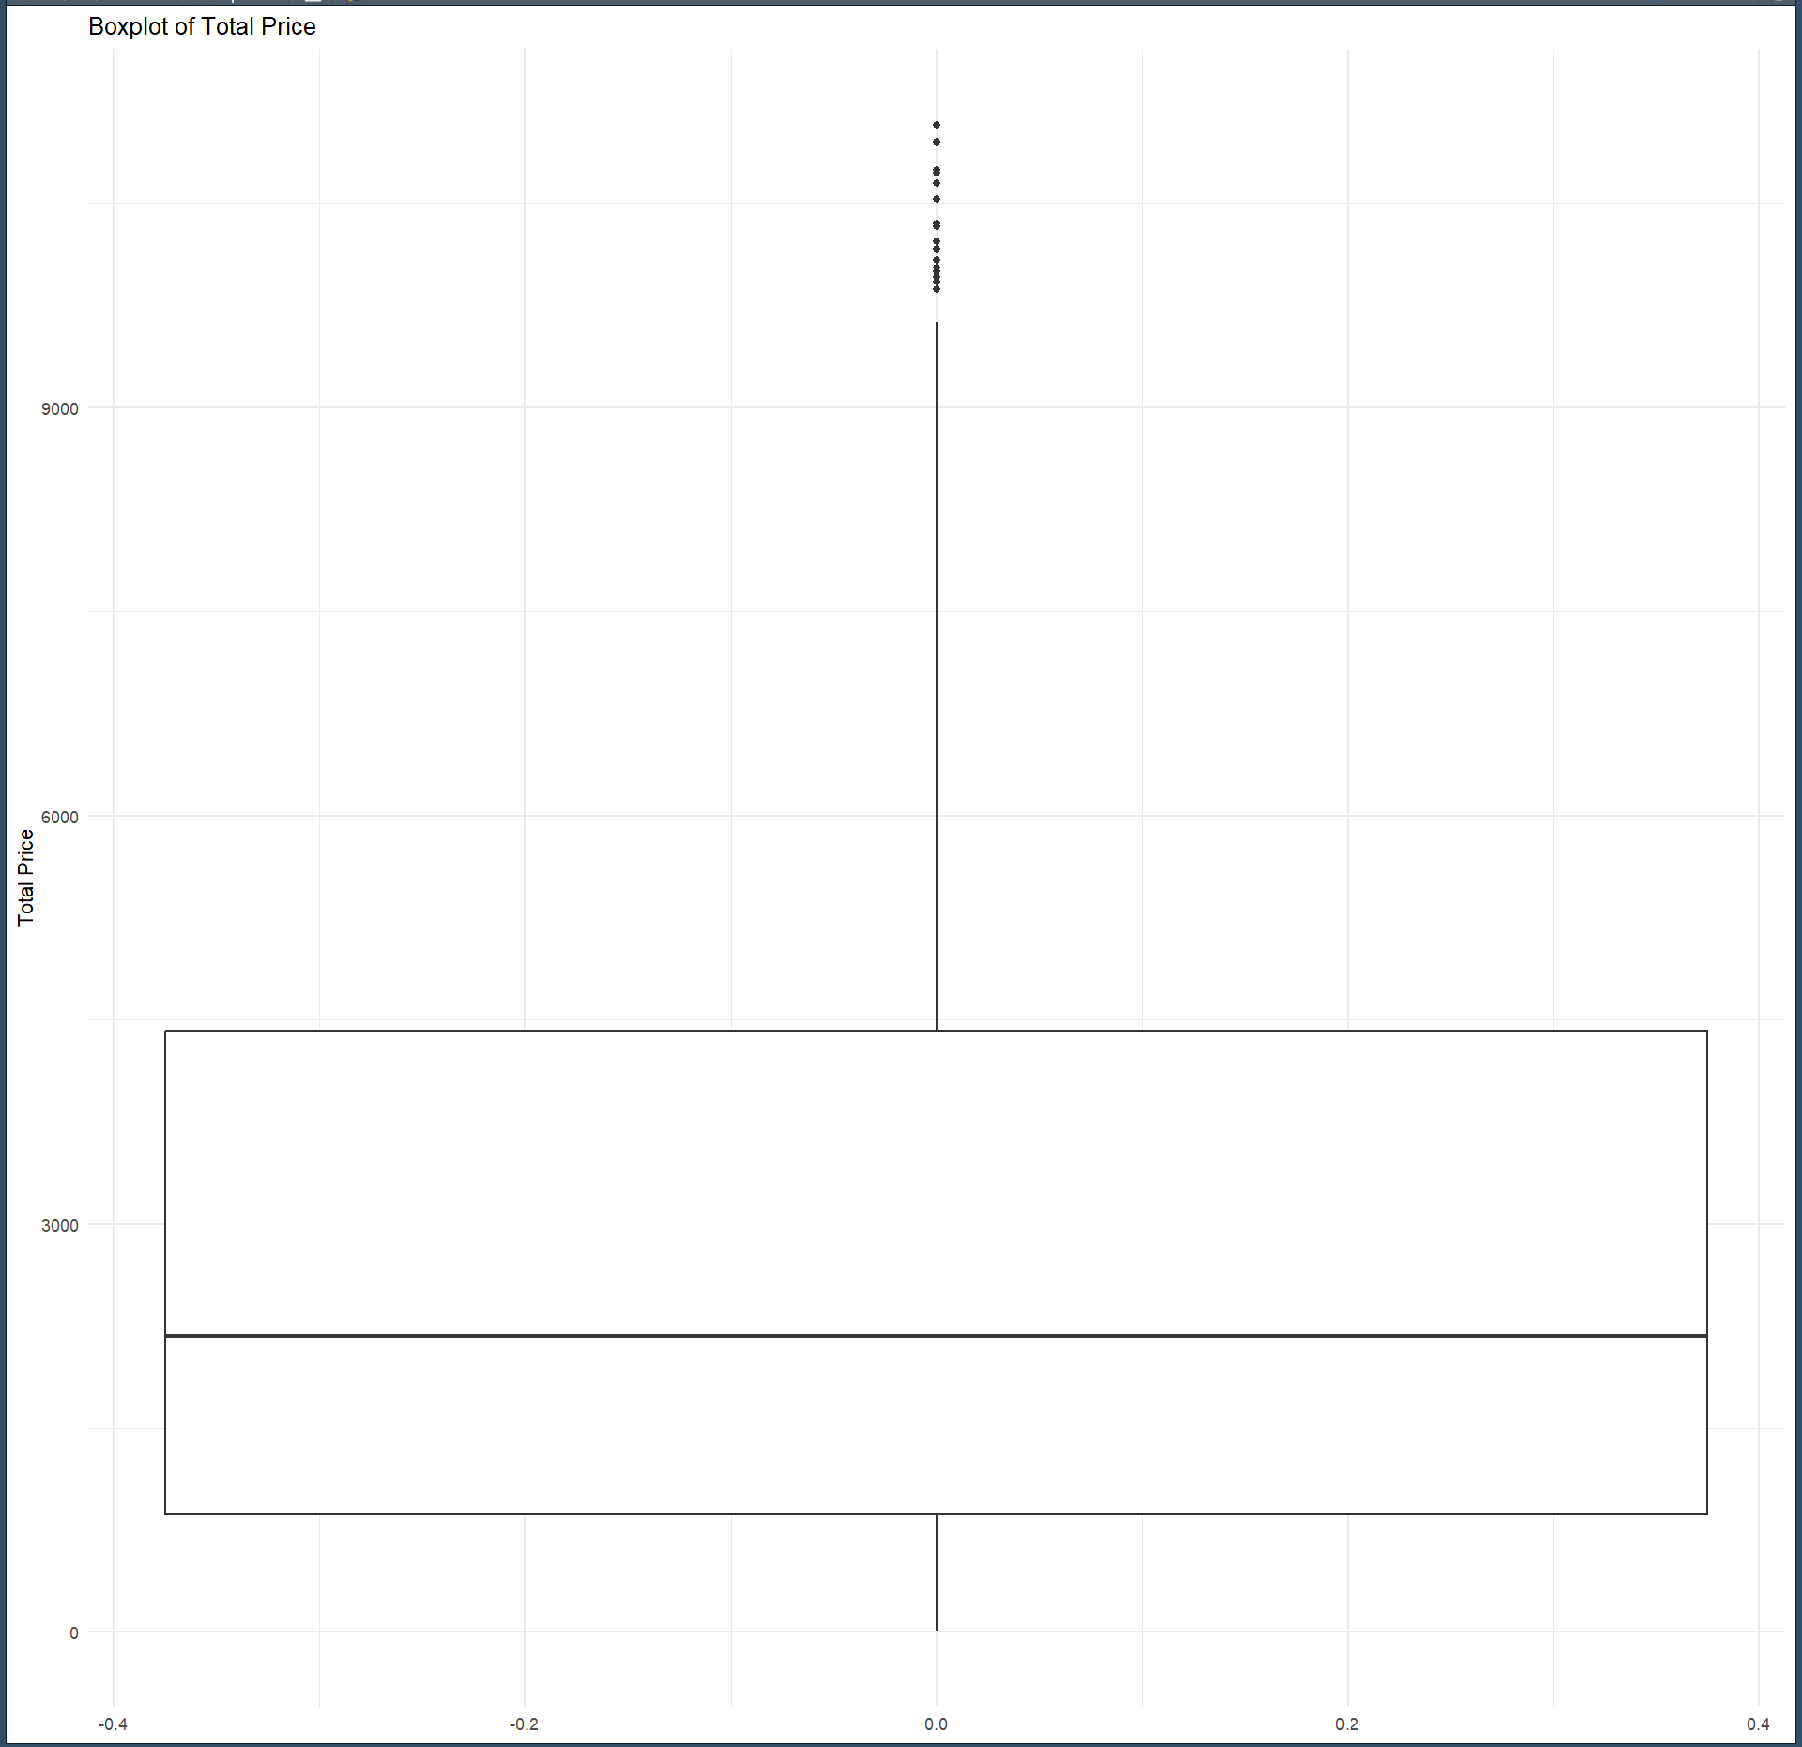
Boxplot for TotalPrice

Monthly Sales Trends
The monthly total sales can be seen in Figure 5, and demonstrates fluctuations in sales from month to month, with periods of increased sales followed by declines. The data does not show a consistent upward or downward trend, however, the rise and fall of sales trends suggest there may be seasonal variation in customer purchase behavior. These observations support the use of forecasting techniques and seasonal analyses to determine if these fluctuations represent patterns within the data. Additional testing was also conducted to determine the accuracy and significance of these apparent seasonal patterns.

Figure 5
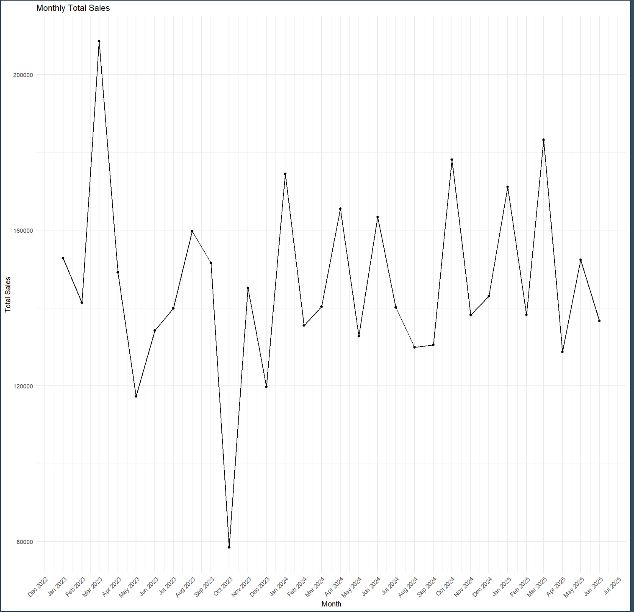
Monthly Total Sales

Numerical Values Correlation
A correlation matrix was also generated to determine the relationships among the numerical variables. Correlation analysis provides an idea of the strength and direction of linear relationships between variables and helps to find patterns that may be worth further analysis. Figure 6 shows that TotalPrice had a moderate positive relationship with the variables Quantity (0.666) and UnitPrice (0.677). This suggests that items with higher prices and larger purchase quantities are associated with larger transaction values. TotalPrice had weak negative relationships with the variables Discounts (-0.06) and ShippingCost (-0.010), and a weak positive relationship with Returned (0.015). These weak relationships indicate that these variables had little linear relationship with TotalPrice.
Figure 6
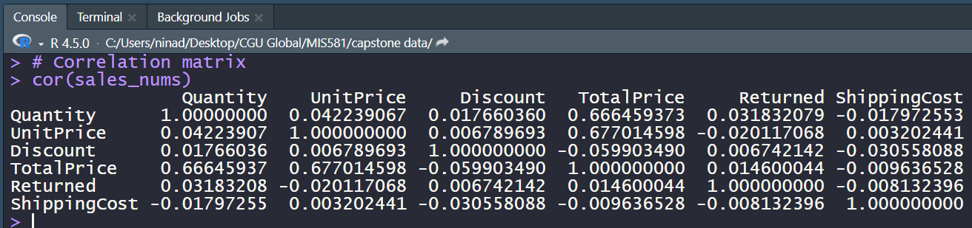
Correlation Analysis

Categorical Values
The distribution across categorical variables was assessed through frequency tables (Figure 7). These tables provide a better understanding of the composition of the dataset. These results show that the data is spread fairly evenly across the five geographic regions, with the difference between East (311) and West (284) being less than 30. Product categories also had a fairly balanced distribution, with tablets being the largest group (240) and phones being the smallest (195). Customer transactions were also reasonably distributed across store locations, with Store D having the most (400) and Store B having the least (363). Sales activity was also fairly evenly distributed across salespeople (Carlos having the most at 270 transactions, and Eva the least at 236). These tables suggest that the dataset is well-balanced across the categorical variables, and that a single category does not disproportionately contribute to total sales.
Figure 7
Frequency Tables
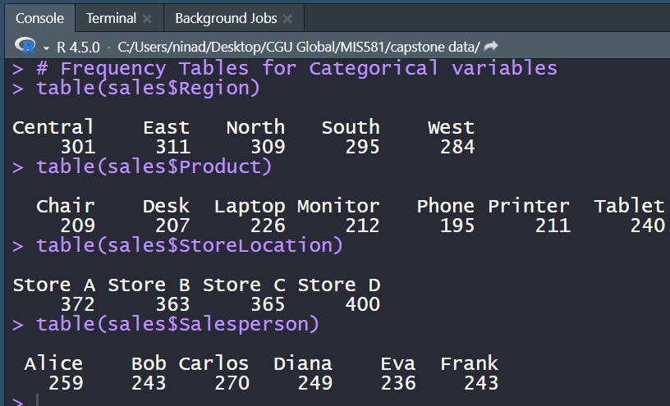
RQ1 Analysis
The first research question is: Can future sales be accurately predicted based on historical information? To address this question, historical monthly sales data was converted into a time series and divided into training and testing sets. A seasonal naïve forecasting model was developed first to create a baseline of predictive performance. Then, an exponential smoothing (ETS) model was created to determine if a more advanced forecasting method could improve predictive accuracy. The ETS model automatically selected the configuration ETS(A,N,N), including additive errors with no trend or seasonal component (Hyndman, 2018). Accuracy for both models was evaluated with a focus on RMSE and MAE.
Figure 8 contains the accuracy measures for both models. The naïve model produced a test RMSE of 26,791.19 and an MAE of 21,993.76. In comparison, the ETS model produced a test RMSE of 20,861.00 and an MAE of 17,185.88. These results indicate that the ETS model outperformed the seasonal naïve model, demonstrating higher predictive accuracy and lower forecasting error.
Figure 8
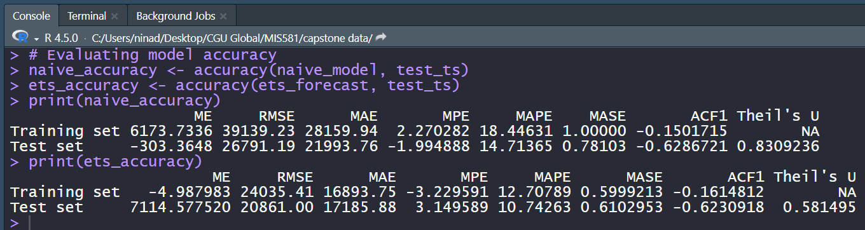
Model Accuracy Comparison

Figure 9 compares the forecasted monthly sales (using the ETS model) and the actual sales for the training and testing periods. The forecasting results demonstrate that historical data can be used to produce generally accurate predictions of future sales. The ETS model also achieved a Mean Absolute Percentage Error (MAPE) of 10.74%, which is indicative of good forecasting accuracy (Montaño Moreno et al., 2013). Based on the ETS model performance, the results support rejecting the null hypothesis in favor of the alternative that predictive analytics can accurately forecast future sales.

Figure 9
Forecasted Sales vs Actual Sales
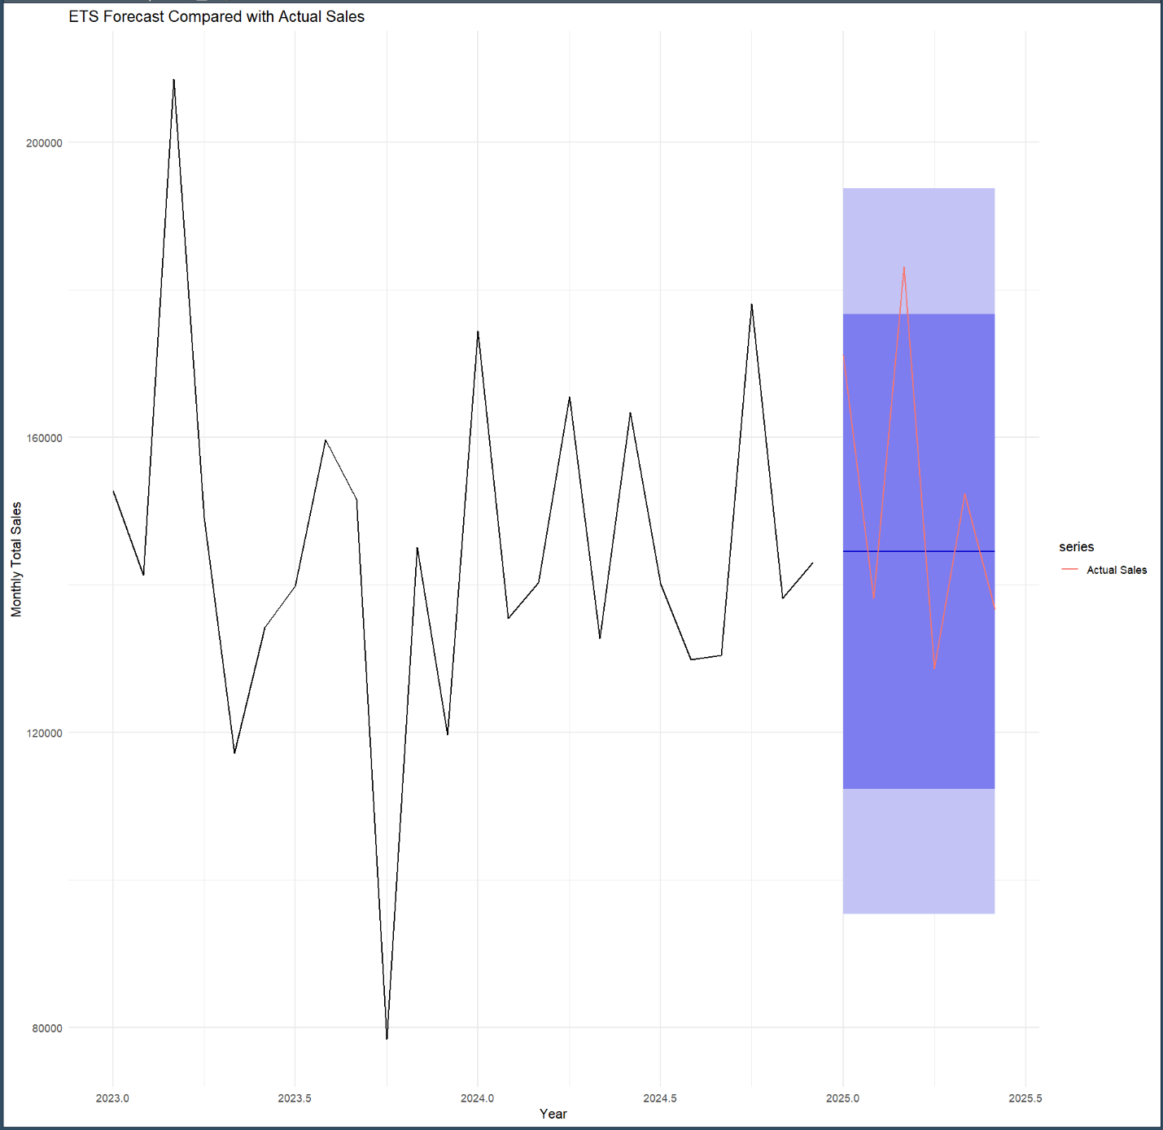

RQ2 Analysis
The second research question is: Is there a significant seasonal pattern in sales throughout the year? To evaluate this question, monthly sales were decomposed into observed, trend, seasonal, and random components using an additive decomposition model (Abdullah, 2024). After the visual assessment, a one-way ANOVA test was conducted to determine if the differences in monthly sales are statistically significant. Figure 10 displays the decomposition of the monthly sales time series.
Figure 10
Decomposition of Monthly Sales
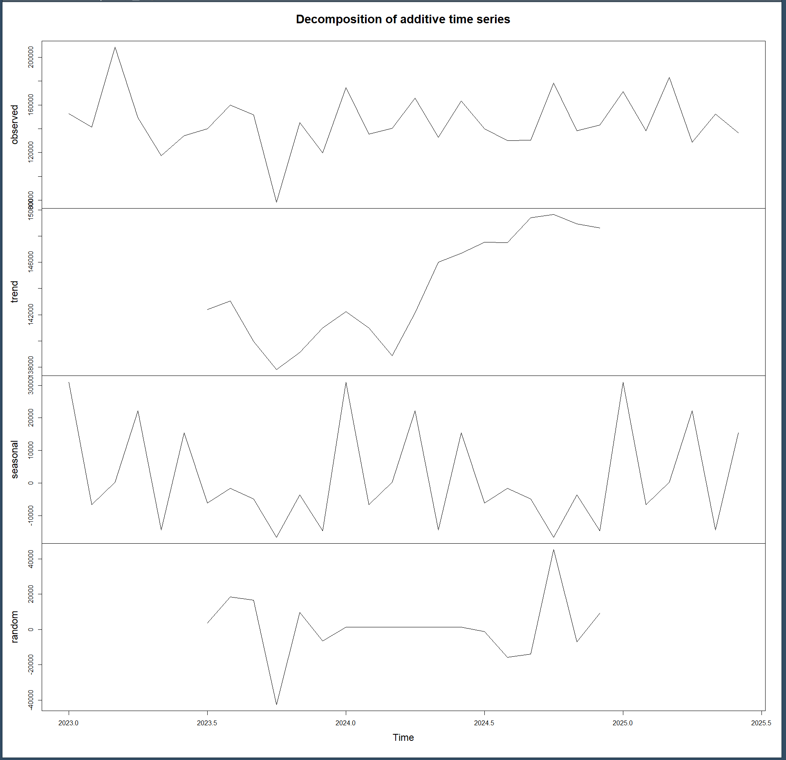
This plot shows that the observed series demonstrates fluctuations in sales, while the trend section shows a moderate increase in sales toward the end of the observation period. The seasonal component seems to suggest recurring monthly fluctuations, while the random component indicates that a substantial portion of the variability in monthly sales is due to irregular fluctuations rather than seasonal effects (Abdullah, 2024).
Visually, there appear to be seasonal fluctuations in the data, however, the results of the ANOVA test indicate that these differences are not statistically significant. Figure 11 shows that the p-value for the ANOVA test is higher than the threshold (0.05) at 0.988. There is insufficient statistical evidence to conclude that average monthly sales significantly differed throughout the year.
Figure 11
ANOVA Results
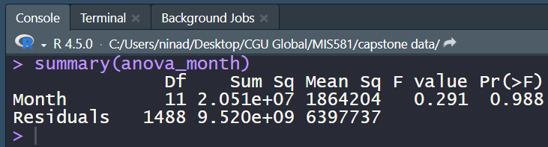
Based on these findings, the null hypothesis fails to be rejected. The results indicated that there was no statistically significant difference in sales patterns throughout the year.
RQ3 Analysis
The final research question focuses on the impact of discounts on total price: Do discounted items generate higher sales than non-discounted items? To determine if discounted items create higher sales than non-discounted items, a Welch two-sample t-test was conducted to compare the mean total sales between the two groups. The Welch t-test does not assume equal variances between groups, which is appropriate for comparing the average transaction values of discounted and non-discounted sales (Ahad & Yahaya, 2014). Before conducting statistical analysis, a boxplot was created to visually compare the sales for both groups.
Seen in Figure 12, both groups appear to have similar distributions, with comparable median sales, interquartile ranges, and overall variability. High-value outliers were observed in both groups, suggesting that large transactions occur whether discounts are applied or not. This visual provides little evidence to suggest that discounted transactions result in higher sales than non-discounted transactions.
Figure 12
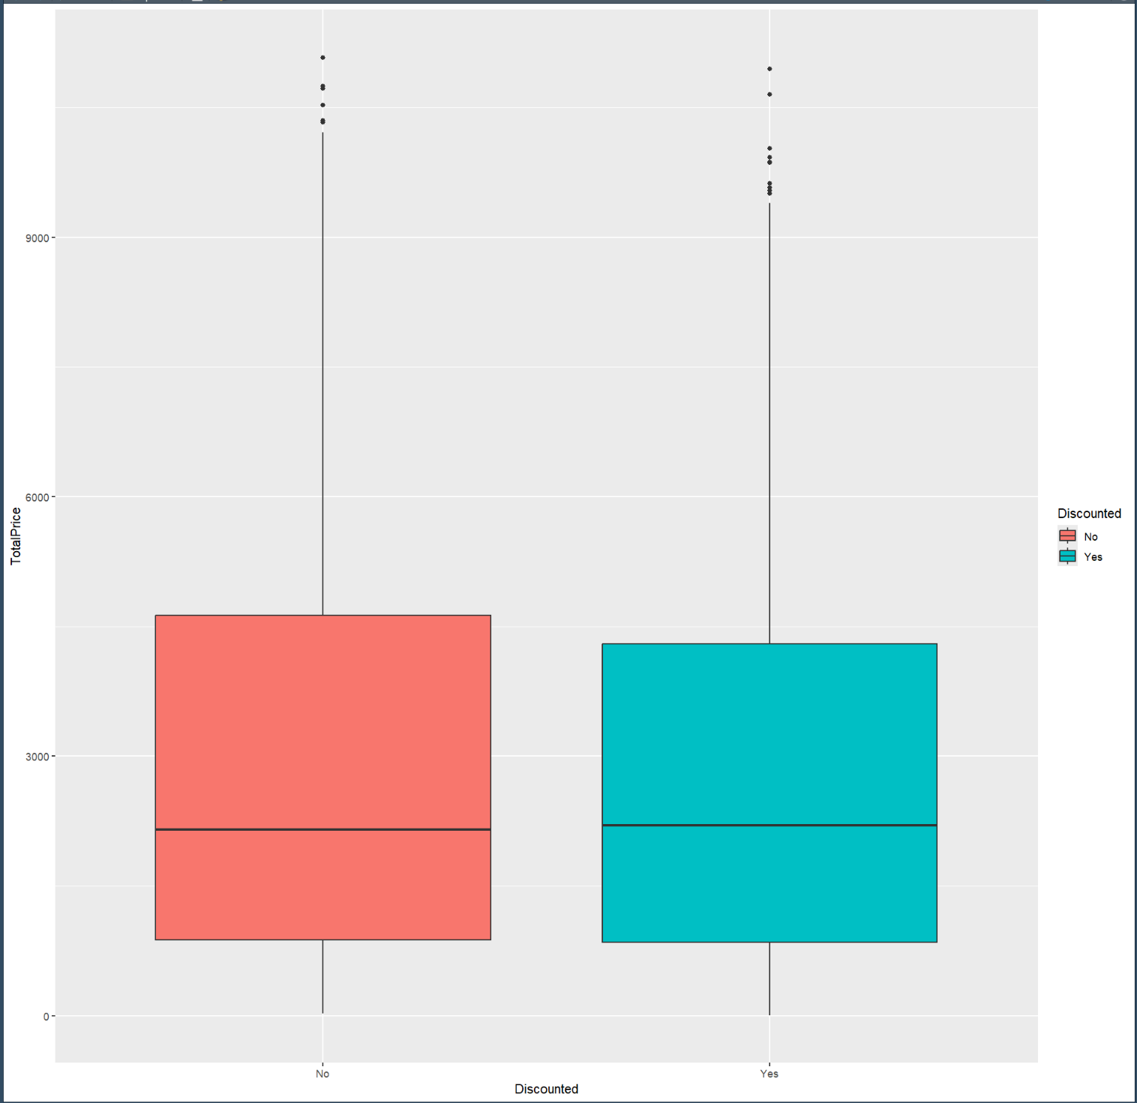
Boxplots for Discounted and Non-Discounted Transactions

To determine if these slight visual differences were statistically significant, a Welch two-sample t-test was conducted. Figure 13 shows that the analysis produced a t-value of 1.2804 and a p-value of 0.2009. Because the p-value is greater than the significance level (0.05), there is insufficient evidence to conclude that discounted items generated significantly different sales than non-discounted items.
Figure 13
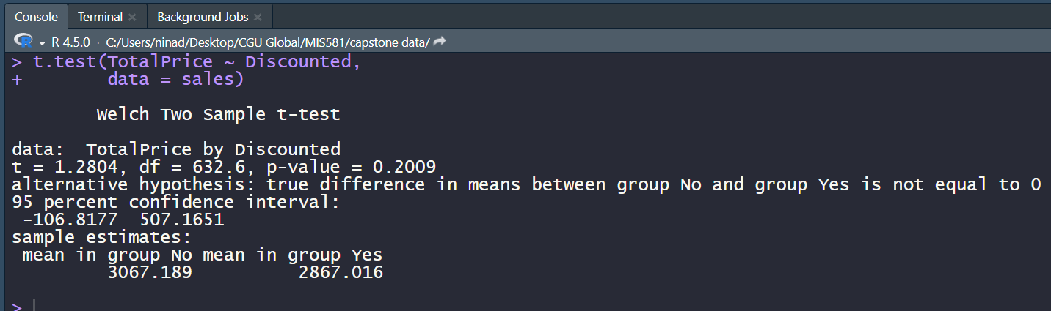
Welch Two-Sample t-Test

Based on these findings, the null hypothesis fails to be rejected. The results indicated that discounted items do not generate significantly larger sales than non-discounted items within the dataset.
Conclusions
This study used descriptive and predictive analytics to evaluate retail sales performance and answer research questions related to sales forecasting, seasonality, and discount effectiveness. Descriptive statistics provided an overview of the dataset and checked for missing values, ensuring that analysis was conducted on clean data. Visualizations and summary statistics identified variability in the dataset, as well as any outliers. Correlation analysis and frequency distributions gave insights into the characteristics of the data.
For the first research question, forecasting models were developed using historical sales data. Model evaluation concluded that the ETS model outperformed the seasonal naïve model and produced lower RMSE, MAE, and MAPE values. The MAPE value of the ETS model was approximately 10.74%, indicating that historical sales data can be used to create generally accurate sales forecasts. Therefore, the null hypothesis can be rejected and it can be concluded that predictive analytics can accurately forecast future sales.
The second research question addressed the existence of seasonality within the dataset. The time series decomposition identified fluctuations in the seasonal component, however, the one-way ANOVA test indicated that there is no statistically significant difference in monthly sales. This analysis failed to reject the null hypothesis, and suggests that monthly variations were not sufficient to conclude that a consistent seasonal pattern exists in the dataset.
The last research question examined if discounted items generated higher sales than non-discounted items. The Welch two-sample t-test produced a p-value of 0.2009, indicating that the differences in average sales between discounted and non-discounted items are not statistically significant. These results suggest that, while discounts may be an effective retail strategy, discounts alone are not a significant driver for higher transaction values. The null hypothesis fails to be rejected.
The second and third research questions failure to reject the null hypotheses could suggest that the dataset may not have contained enough information to detect the relationships, or that additional variables influence sales performance. Factors such as holiday shopping trends, economic conditions, or competitor pricing may contribute to variations in sales that could be considered for future analysis. Further research may also benefit from longer observation periods, as this dataset only contained information for two years.
From a business perspective, the forecasting model is the most valuable outcome of this study. Accurate sales forecasts can enable companies or organizations to improve inventory management, purchasing schedules, budgeting, and financial planning. Although seasonality and discounting were not found to be statistically significant in this dataset, the forecasting results demonstrate that historical sales patterns provide meaningful information when predicting future sales performance.
Recommendations
Based on the results of this project, several recommendations are proposed to provide companies and organizations with a better understanding of the factors that influence retail sales. Future analysis should incorporate additional internal and external data sources to improve model performance and business insights. It may also be worth creating predictive models using other variables in the dataset with higher correlation coefficients. Historical sales data was sufficient to develop an effective forecasting model, but the absence of statistically significant relationships for seasonality and discounting suggests that other variables may better explain fluctuations in sales. Compaies could also look specifically into March 2023 and October 2023 as these represent the highest and lowest sales months. Incorporating additional factors into this analysis, such as promotions or highest-selling products, could help determine what had the biggest impact on sales and apply these findings to future sales or pricing strategies.
Organizations should also avoid relying only on discounting strategies to increase sales. The findings of this study concluded that discounted transactions do not generate significantly higher sales than non-discounted items and could be a potential loss in revenue for the company. Companies should evaluate the effectiveness of promotional strategies using data analytics to identify products or customers that produce the greatest return on investment.
Transaction data should be regularly evaluated using ongoing analytics techniques. Forecasting should not be done only once, but continuously. Forecasting models should be monitored, evaluated, and retrained as necessary to improve performance. Companies should continue using accuracy measures such as MAE, RMSE, and MAPE to ensure that predictive models are reliable and support effective business decision-making.
Organizations should integrate predictive analytics with business intelligence dashboards to improve managerial decision-making. Presenting forecasting results through dashboards allows company leadership to monitor sales performance, evaluate forecasting accuracy, and respond quickly to changing market conditions. Combining these tools creates a decision-support system that can improve strategic planning and day-to-day operations.

References
Abdullah, M. M. (2024). Using the single-exponential-smoothing time series model under the additive Holt-Winters algorithm with decomposition and residual analysis to forecast the reinsurance-revenues dataset. Pakistan Journal of Statistics and Operation Research, 20(2), 311–340. https://doi.org/10.18187/pjsor.v20i2.4409
Ahad, N. A., & Yahaya, S. S. S. (2014). Sensitivity analysis of Welch's t-test. AIP Conference Proceedings, 1605, 888–893. https://doi.org/10.1063/1.4887707
Ahaggach, H., Abrouk, L., & Lebon, E. (2024). Systematic mapping study of sales forecasting: Methods, trends, and future directions. Forecasting, 6(3), 502–532. https://doi.org/10.3390/forecast6030028
Bauskar, S. (2022). Predictive analytics for sales forecasting in enterprise resource planning (ERP) systems using machine learning technique. International Research Journal of Modernization in Engineering Technology and Science, 4(6), 4607–4618. https://doi.org/10.56726/IRJMETS26271
Buddula, D. V. K. R., Patchipulusu, H. H. S., Vattikonda, N., Polu, A. R., Narra, B., & Gupta, A. K. (2023). Predictive analytics in e-commerce: Effective business analysis through machine learning. JOETSR–Journal of Emerging Trends in Scientific Research, 1(1), 41–49. https://doi.org/10.5281/zenodo.15209435
Dash, C. S. K., Behera, A. K., Dehuri, S., & Ghosh, A. (2023). An outliers detection and elimination framework in classification task of data mining. Decision Analytics Journal, 6, Article 100164. https://doi.org/10.1016/j.dajour.2023.100164
Excelx. (n.d.). Retail sales sample dataset. https://excelx.com/practice-data/sales-retail/
Habel, J., Alavi, S., & Heinitz, N. (2023). A theory of predictive sales analytics adoption. AMS Review, 13(1–2), 34–54. https://doi.org/10.1007/s13162-022-00252-0
Habel, J., Alavi, S., & Heinitz, N. (2024). Effective implementation of predictive sales analytics. Journal of Marketing Research, 61(4), 718–741. https://doi.org/10.1177/00222437221151039
Hyndman, R. J. (2018). State space models [Lecture slides]. Forecasting: Principles and practice, NYC 2018. https://talks.robjhyndman.com/nyc2018/1-5-StateSpace.pdf
Montaño Moreno, J. J., Palmer Pol, A., Sesé Abad, A., & Cajal Blasco, B. (2013). Using the R-MAPE index as a resistant measure of forecast accuracy. Psicothema, 25(4), 500–506. https://doi.org/10.7334/psicothema2013.23
Morsi, S. (2020). A predictive analytics model for e-commerce sales transactions to support decision making: A case study. International Journal of Computer and Information Technology, 9(1), 17-24.
Polonsky, M. J., & Waller, D. S. (2019). Designing and managing a research project: A business student's guide (4th ed.). SAGE Publications.
Uddin, H. M. M. (2025). Impact of predictive analytics on sales forecasting accuracy in B2B financial services: A quantitative evaluation. ASRC Procedia: Global Perspectives in Science and Scholarship, 1(1), 2653–2702. https://doi.org/10.63125/g9fvv860

