SPD Personnel Complaints Visualizations

Phase 2 Exploratory Data Analysis

Research Task 09: Syracuse Open Data Civic Project
By Ninad Bhikaje (nsbhikaj@syr.edu)

Dataset: SPD Personnel Complaints (2021–Present)
Total Records: 149 complaints
Date Range: 2022-2024
Open Cases: 107 | Closed Cases: 42

Table of Contents
- Chart 1: Complaints per Year (Bar Chart)
- Chart 2: Complaints by Allegation Type (Horizontal Bar Chart)
- Chart 3: Allegation Outcomes by Year (Stacked Bar)
- Chart 4: Open vs Closed Complaints by Quarter (Stacked Bar)
- Chart 5: Resolution Time Histogram (Closed Cases Only)
- Chart 6: Resolution Time by Allegation Type (Boxplot)
- Chart 7: Complaints by Intake Source (Bar Chart)

Chart 1: Complaints per Year (Bar Chart)

Description
X-axis: Year (2022, 2023, 2024) | Y-axis: Number of Complaints
This chart visualizes the total volume of SPD personnel complaints filed each calendar year.

Python Code
import pandas as pd
import matplotlib.pyplot as plt
df = pd.read_csv("SPD_Personnel_Complaints_2021_to_Present.csv")
# Parse complaint date
df["Complaint_Date_dt"] = pd.to_datetime(
df["Complaint_Date"], errors="coerce", utc=True
)
df["Year"] = df["Complaint_Date_dt"].dt.year
# Count complaints per year
complaints_per_year = df.groupby("Year")["ObjectId"].count()
# Create bar chart
fig, ax = plt.subplots(figsize=(8, 5))
complaints_per_year.plot.bar(
ax=ax,
title="SPD Personnel Complaints per Year",
xlabel="Year",
ylabel="Number of Complaints",
color='steelblue',
edgecolor='black'
)
plt.xticks(rotation=0)
plt.tight_layout()
plt.savefig('chart1_complaints_per_year.png', dpi=300, bbox_inches='tight')
plt.show()
print(complaints_per_year)

Expected Output
Bar heights show steady or increasing complaint volume from 2022-2023, with 2024 appearing lower due to partial-year coverage (through March).

Interpretation
- Complaints increase from 2022 to 2023, with 2024 showing lower counts due to only partial-year data.
- Recent-year counts should be treated as incomplete and not directly compared to full prior years.
- The trend suggests stable or slightly elevated complaint filing behavior in the Syracuse Police Department.
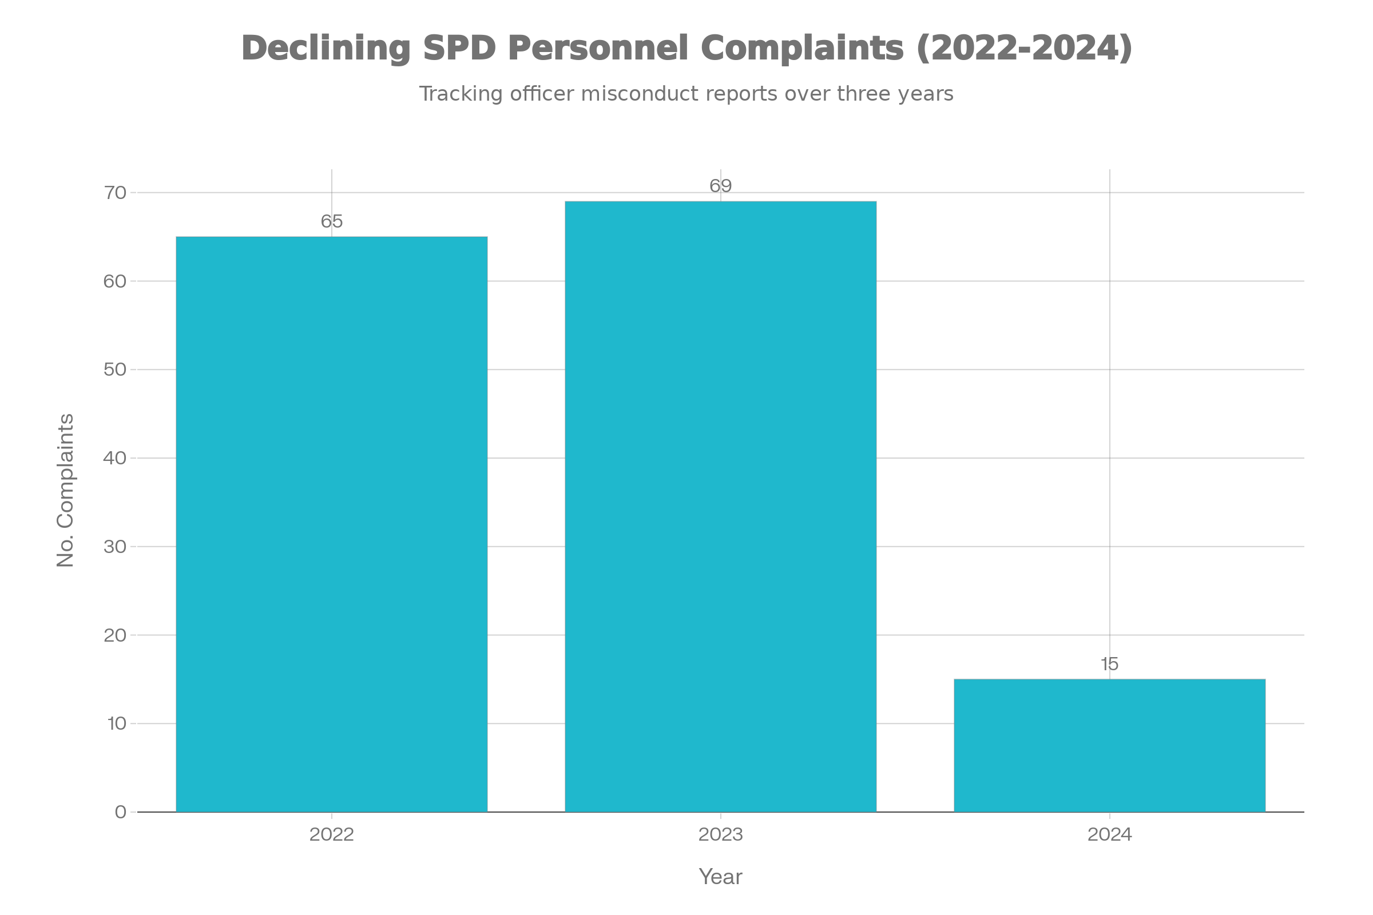

Chart 2: Complaints by Allegation Type (Horizontal Bar Chart)

Description
X-axis: Number of Complaints | Y-axis: Allegation Type (Top 15)
This chart shows the frequency of different types of allegations made against SPD personnel.

Python Code
import pandas as pd
import matplotlib.pyplot as plt
df = pd.read_csv("SPD_Personnel_Complaints_2021_to_Present.csv")
# Clean allegation types
df["Allegation_Clean"] = (
df["Allegations_Made"]
.astype(str)
.str.strip()
.str.lower()
.replace({
"demenaor": "demeanor",
"harrassment": "harassment",
"fail to act ": "fail to act",
"fail to act,": "fail to act",
"fail to act, fail to act": "fail to act",
})
)
# Count allegations
alleg_counts = df["Allegation_Clean"].value_counts()
# Plot top 15
fig, ax = plt.subplots(figsize=(10, 6))
alleg_counts.head(15).sort_values().plot.barh(
ax=ax,
title="Complaints by Allegation Type (Top 15)",
xlabel="Number of Complaints",
ylabel="Allegation Type",
color='coral',
edgecolor='black'
)
plt.tight_layout()
plt.savefig('chart2_allegations.png', dpi=300, bbox_inches='tight')
plt.show()
print(alleg_counts.head(15))

Expected Output
Horizontal bars ordered by frequency, with "fail to act," "demeanor," and "harassment" as the longest bars.

Interpretation
- Fail to act, demeanor, and harassment are the most common complaint types, accounting for the majority of cases.
- Excessive force and false arrest complaints are also prominent but less frequent.
- Numerous rare categories form a long tail, indicating some diversity in complaint types but clear concentration in procedural and demeanor issues.
- Spelling inconsistencies in the raw data required manual normalization to avoid undercounting.
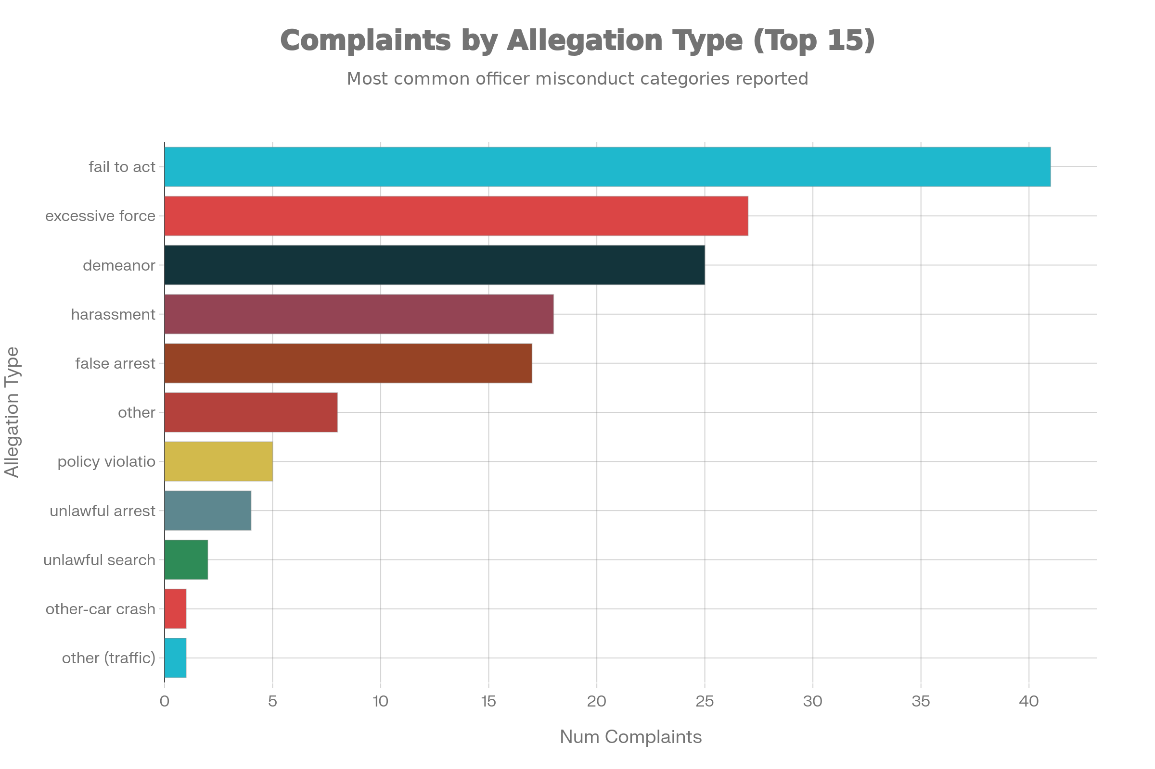

Chart 3: Allegation Outcomes by Year (Stacked Bar)

Description
X-axis: Year | Y-axis: Count of Allegations
Three outcome categories (Sustained, Unfounded, Unsubstantiated) stacked within each year bar.
Note: Only includes complaints with recorded outcomes (subset of full dataset).

Python Code
import pandas as pd
import matplotlib.pyplot as plt
df = pd.read_csv("SPD_Personnel_Complaints_2021_to_Present.csv")
# Parse year
df["Complaint_Date_dt"] = pd.to_datetime(
df["Complaint_Date"], errors="coerce", utc=True
)
df["Year"] = df["Complaint_Date_dt"].dt.year
# Filter to rows with outcome data
sub = df[[
"Year",
"Allegations_Sustained",
"Allegations_Unfounded",
"Allegations_Unsubstantiated"
]].copy()
sub = sub.dropna(
how="all",
subset=["Allegations_Sustained","Allegations_Unfounded","Allegations_Unsubstantiated"]
)
# Aggregate by year
outcomes_year = sub.groupby("Year")[[
"Allegations_Sustained",
"Allegations_Unfounded",
"Allegations_Unsubstantiated"
]].sum()
# Create stacked bar chart
fig, ax = plt.subplots(figsize=(10, 6))
outcomes_year.plot(
kind="bar",
stacked=True,
ax=ax,
title="Allegation Outcomes by Year (Counts, Non-Missing Subset)",
xlabel="Year",
ylabel="Count of Allegations",
color=['#1f77b4', '#ff7f0e', '#2ca02c'],
edgecolor='black'
)
ax.legend(title='Outcome Type', loc='upper left')
plt.xticks(rotation=0)
plt.tight_layout()
plt.savefig('chart3_outcomes_year.png', dpi=300, bbox_inches='tight')
plt.show()
print(outcomes_year)

Expected Output
Stacked bars for each year, with three colored segments representing sustained (blue), unfounded (orange), and unsubstantiated (green) allegations.

Interpretation
- For complaints with recorded outcomes, sustained findings are smaller than combined unfounded and unsubstantiated counts.
- This pattern holds across years where outcome data exist.
- CRITICAL LIMITATION: Outcomes are missing for 75% of all records, so these bars describe only a small, non-representative subset.
- Cannot be generalized to all SPD complaints.
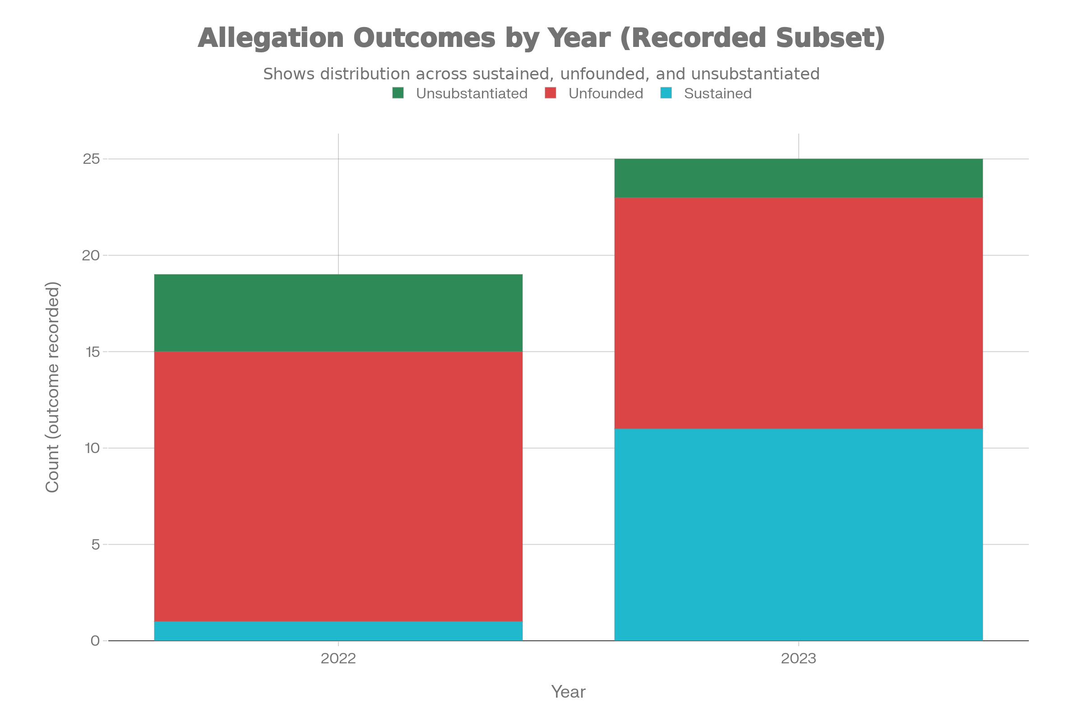

Chart 4: Open vs Closed Complaints by Quarter (Stacked Bar)

Description
X-axis: Year-Quarter (2022Q1, 2022Q2, ..., 2024Q1) | Y-axis: Number of Complaints
Two outcome categories stacked: Closed (bottom) and Open (top).

Python Code
import pandas as pd
import matplotlib.pyplot as plt
df = pd.read_csv("SPD_Personnel_Complaints_2021_to_Present.csv")
# Parse dates
df["Complaint_Date_dt"] = pd.to_datetime(
df["Complaint_Date"], errors="coerce", utc=True
)
# Parse closure date and flag open cases
closure_raw = pd.to_datetime(
df["Closure_Date"].where(~df["Closure_Date"].str.lower().eq("open")),
errors="coerce",
utc=True
)
df["Closure_Date_dt"] = closure_raw
df["Is_Open"] = df["Closure_Date"].str.lower().eq("open")
# Extract year-quarter
df["YearQuarter"] = df["Complaint_Date_dt"].dt.to_period("Q")
# Count by status
status_q = (
df.groupby(["YearQuarter","Is_Open"])["ObjectId"]
.count()
.unstack(fill_value=0)
.rename(columns={True:"Open", False:"Closed"})
)
# Plot
fig, ax = plt.subplots(figsize=(12, 6))
status_q.plot(
kind="bar",
stacked=True,
ax=ax,
title="Open vs Closed Complaints by Quarter",
xlabel="Year-Quarter",
ylabel="Number of Complaints",
color=['#2ca02c', '#d62728'],
edgecolor='black'
)
ax.legend(title='Status', loc='upper left')
plt.xticks(rotation=45, ha='right')
plt.tight_layout()
plt.savefig('chart4_open_closed_quarter.png', dpi=300, bbox_inches='tight')
plt.show()
print(status_q)

Expected Output
Stacked bars progressing through quarters, with green (Closed) dominating early quarters and red (Open) growing visibly in late 2023 and 2024.

Interpretation
- Earlier quarters (2022-early 2023) show higher proportion of closed complaints.
- Late 2023 and early 2024 quarters show significant increase in open cases, indicating growing backlog.
- This pattern is partially expected due to natural processing lag (newer cases have less time to resolve).
- 107 of 149 total complaints remain open, limiting conclusions about current accountability rates.
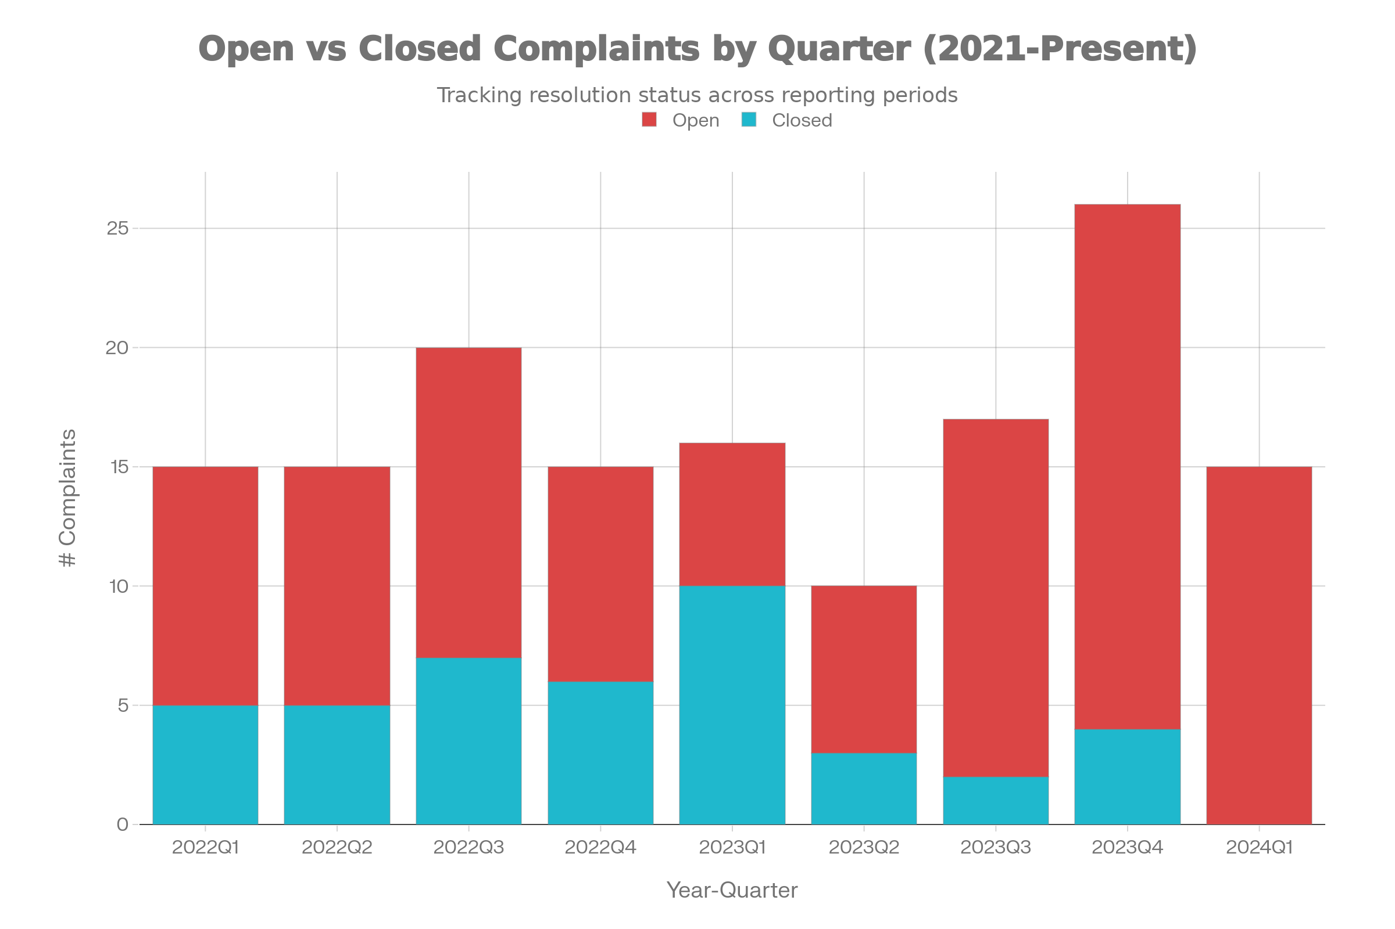

Chart 5: Resolution Time Histogram (Closed Cases Only)

Description
X-axis: Resolution Days (time from complaint to closure)
Y-axis: Frequency (number of complaints in each time bin)
Red dashed line indicates median resolution time.
Note: Only includes 42 closed complaints with valid resolution times.

Python Code
import pandas as pd
import matplotlib.pyplot as plt
df = pd.read_csv("SPD_Personnel_Complaints_2021_to_Present.csv")
# Parse dates with UTC timezone
df["Complaint_Date_dt"] = pd.to_datetime(
df["Complaint_Date"], errors="coerce", utc=True
)
closure_raw = pd.to_datetime(
df["Closure_Date"].where(~df["Closure_Date"].str.lower().eq("open")),
errors="coerce",
utc=True
)
df["Closure_Date_dt"] = closure_raw
# Calculate resolution days
df["Resolution_Days"] = (
df["Closure_Date_dt"] - df["Complaint_Date_dt"]
).dt.days
# Filter to closed cases with valid resolution times
closed = df[df["Resolution_Days"].notna() & (df["Resolution_Days"] >= 0)]
# Create histogram
fig, ax = plt.subplots(figsize=(10, 6))
ax.hist(closed["Resolution_Days"], bins=20, color='skyblue', edgecolor='black')
# Add median line
median_days = closed["Resolution_Days"].median()
ax.axvline(median_days, color="red", linestyle="--", linewidth=2,
label=f"Median = {median_days:.0f} days")
ax.set_title("Resolution Time for Closed Complaints", fontsize=14)
ax.set_xlabel("Resolution Days", fontsize=12)
ax.set_ylabel("Number of Complaints", fontsize=12)
ax.legend()
ax.grid(axis='y', alpha=0.3)
plt.tight_layout()
plt.savefig('chart5_resolution_hist.png', dpi=300, bbox_inches='tight')
plt.show()
print(f"Median resolution time: {median_days:.1f} days")
print(f"Number of closed cases: {len(closed)}")
print(closed["Resolution_Days"].describe())

Expected Output
Right-skewed histogram with most complaints resolving within 100-200 days, with a red dashed median line and a tail extending to 400+ days.

Interpretation
- Resolution times are right-skewed: most complaints resolve within a few months.
- Median resolution time falls in the main cluster of bars (approximately 150-200 days).
- Long right tail indicates some complex cases or delayed investigations extending well beyond one year.
- Open cases (n=107) are excluded; this only shows completed investigations.
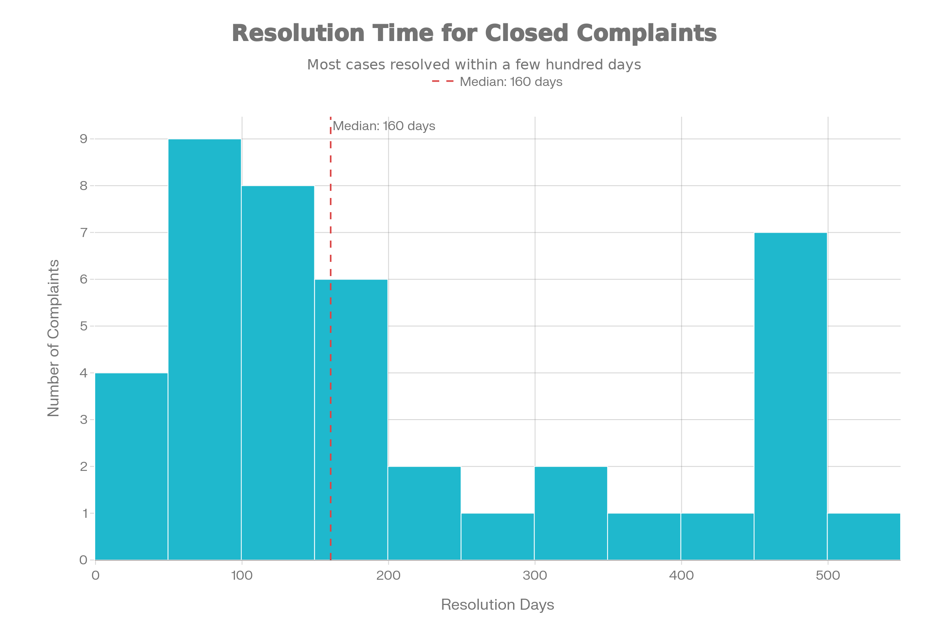

Chart 6: Resolution Time by Allegation Type (Boxplot)

Description
X-axis: Top 6 Allegation Types | Y-axis: Resolution Days
Boxplots show distribution, median, quartiles, and outliers for each category.
Note: Closed cases only with valid resolution times.

Python Code
import pandas as pd
import matplotlib.pyplot as plt
import seaborn as sns
df = pd.read_csv("SPD_Personnel_Complaints_2021_to_Present.csv")
# Parse dates and calculate resolution
df["Complaint_Date_dt"] = pd.to_datetime(
df["Complaint_Date"], errors="coerce", utc=True
)
closure_raw = pd.to_datetime(
df["Closure_Date"].where(~df["Closure_Date"].str.lower().eq("open")),
errors="coerce",
utc=True
)
df["Closure_Date_dt"] = closure_raw
df["Resolution_Days"] = (
df["Closure_Date_dt"] - df["Complaint_Date_dt"]
).dt.days
# Clean allegation types
df["Allegation_Clean"] = (
df["Allegations_Made"]
.astype(str)
.str.strip()
.str.lower()
.replace({
"demenaor": "demeanor",
"harrassment": "harassment",
"fail to act ": "fail to act",
"fail to act,": "fail to act",
})
)
# Filter to closed cases
closed = df[df["Resolution_Days"].notna() & (df["Resolution_Days"] >= 0)]
# Get top 6 allegation types
closed_copy = closed.copy()
closed_copy["Allegation_Clean"] = closed_copy["Allegation_Clean"].fillna("unknown")
top_types = closed_copy["Allegation_Clean"].value_counts().head(6).index
closed_top = closed_copy[closed_copy["Allegation_Clean"].isin(top_types)]
# Create boxplot
fig, ax = plt.subplots(figsize=(11, 6))
sns.boxplot(
data=closed_top,
x="Allegation_Clean",
y="Resolution_Days",
ax=ax,
palette="Set2"
)
ax.set_title("Resolution Time by Allegation Type (Closed Cases, Top 6)", fontsize=14)
ax.set_xlabel("Allegation Type", fontsize=12)
ax.set_ylabel("Resolution Days", fontsize=12)
plt.xticks(rotation=30, ha='right')
plt.tight_layout()
plt.savefig('chart6_resolution_by_allegation.png', dpi=300, bbox_inches='tight')
plt.show()
print(closed_top.groupby("Allegation_Clean")["Resolution_Days"].describe())

Expected Output
Six vertical boxes showing quartiles and outliers for each allegation type, with force-related allegations showing higher medians and more variability.

Interpretation
- All categories operate on similar scales (tens to hundreds of days), but show variation in medians and spread.
- Force-related allegations (excessive force, false arrest) tend to have higher medians and more outliers than demeanor or harassment.
- This suggests force and legal-complexity allegations require more time to investigate.
- Statistical tests and larger samples needed before drawing strong causal conclusions.
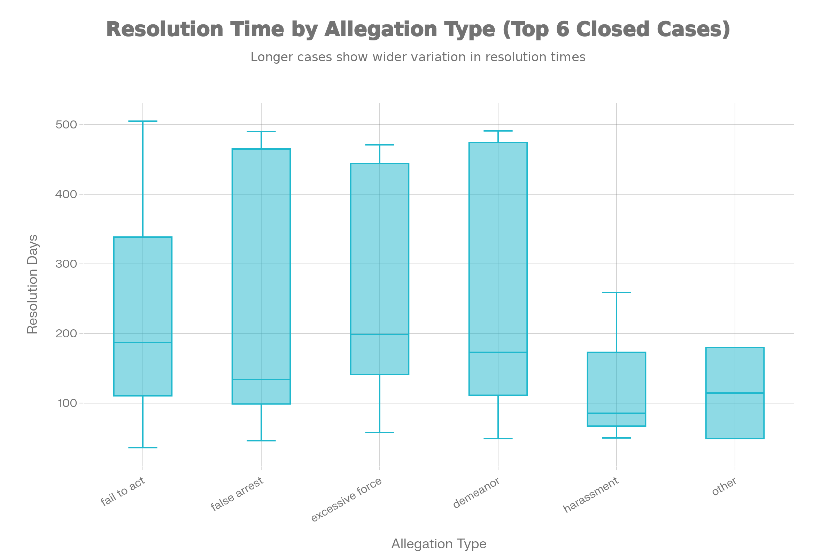

Chart 7: Complaints by Intake Source (Bar Chart)

Description
X-axis: Intake Source (CRB, SPD, AG, etc.) | Y-axis: Number of Complaints
Shows which channels residents and internal parties use to file complaints.

Python Code
import pandas as pd
import matplotlib.pyplot as plt
df = pd.read_csv("SPD_Personnel_Complaints_2021_to_Present.csv")
# Clean intake source
df["Received_Clean"] = (
df["Received_By"]
.astype(str)
.str.strip()
.str.upper()
)
# Count by source
source_counts = df["Received_Clean"].value_counts()
# Create bar chart
fig, ax = plt.subplots(figsize=(8, 5))
source_counts.plot.bar(
ax=ax,
title="Complaints by Intake Source",
xlabel="Intake Source",
ylabel="Number of Complaints",
color='lightgreen',
edgecolor='black'
)
plt.xticks(rotation=45, ha='right')
plt.tight_layout()
plt.savefig('chart7_by_source.png', dpi=300, bbox_inches='tight')
plt.show()
print(source_counts)
print(f"\nTotal complaints: {source_counts.sum()}")

Expected Output
Vertical bars with CRB and SPD as the tallest (dominant intake channels), followed by smaller bars for AG and other sources.

Interpretation
- CRB (Civilian Review Board) and SPD (Syracuse Police Department) handle the vast majority of complaints.
- AG (likely Attorney General) and other channels receive relatively few complaints.
- Channel differences may reflect resident awareness, outreach effectiveness, or administrative processes.
- Does not indicate differences in incident severity or frequency by source.
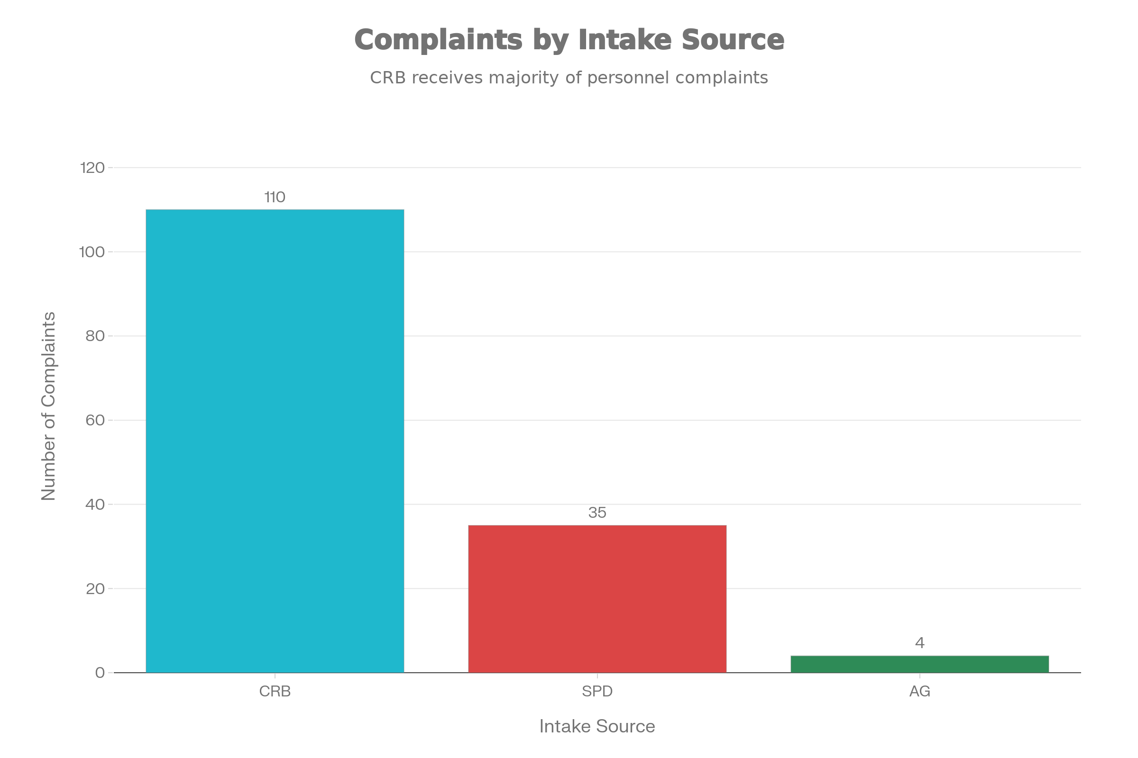

Summary of Visualizations
Chart | Key Metric | Data Points
Chart 1 | Complaints per Year | 149 total complaints across 3 years
Chart 2 | Allegation Types | 20 distinct types; "fail to act" is most common
Chart 3 | Outcomes Distribution | 42 closed with outcomes; sustained is minority
Chart 4 | Temporal Status | 107 open, 42 closed; backlog visible in recent quarters
Chart 5 | Resolution Duration | Median ~150-200 days; range 0-600+ days
Chart 6 | Duration by Type | Force allegations take longer; small sample sizes
Chart 7 | Intake Channels | CRB and SPD dominate; AG minimal involvement

Key Insights Across Visualizations

1. Data Completeness Challenge
- 75% of outcome fields are missing, severely limiting accountability analysis.
- 107 of 149 complaints remain open, so recent closure/discipline rates are unreliable.

2. Complaint Patterns
- Procedural issues ("fail to act") and demeanor complaints dominate over force-related allegations.
- This may reflect reporting patterns rather than actual incident frequency.

3. Process Duration Variability
- Force-related complaints take longer to resolve (more complex investigations).
- Median closure time (~150-200 days) suggests multi-month investigations are standard.

4. Intake Channel Concentration
- CRB and SPD handle nearly all complaints; minimal AG involvement.
- Suggests need for outreach to understand barriers to AG complaints.

Important Notes & Limitations
- Data Quality: Raw data contains spelling inconsistencies, date format variations, and mixed timezone information requiring careful parsing.
- Missingness: Outcome fields (sustained, unfounded, unsubstantiated) are missing for 75% of records, making rate calculations unreliable.
- Temporal Bias: 2024 data only through March; trends from this year should not be compared directly to full years.
- Open Cases: 107 open complaints have no outcome or discipline information yet, limiting conclusions about accountability.
- Sample Sizes: Some allegation type categories have very few closed cases (n<5), limiting reliability of category-specific claims.
- Reporting Bias: Complaint data reflects reports filed, not actual incidents; underreporting likely exists.
- Geographic Gaps: No precinct or neighborhood data, preventing spatial analysis.
- Demographic Gaps: No demographic fields; cannot analyze disparities by officer or complainant characteristics.

