Career

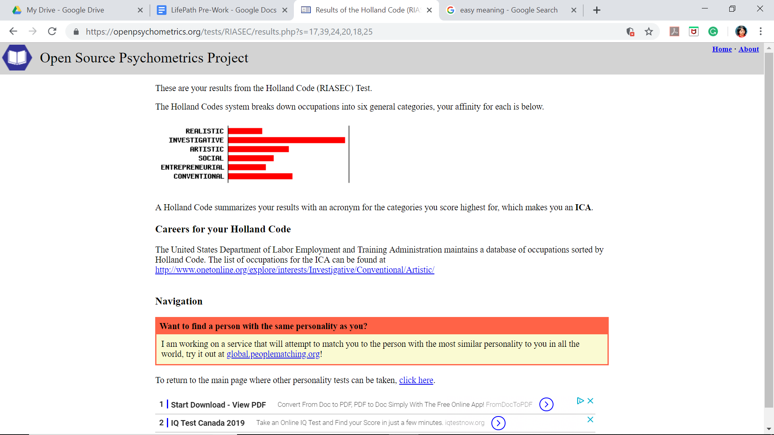

6 accomplishments:

1. Finishing high school with high marks
2. Being admitted to a public university with free tuition fee
3. As a result I am debt-free
4. Finished my master’s degree in Canada
5. Moved to Canada alone
6. Being independent and able to support myself so far!