Freight Rate Prediction
Spotter Machine Learning Engineer assessment

Summary
Predicting posted_rate for 12,000 loads in November and December 2025 from 48,000 labelled loads spanning January to October. Backtested over five two-month-ahead folds, the model averages 1.39% MAPE.
Two properties of this dataset decide the outcome, and both are invisible to standard practice. One feature reproduces the target almost exactly in half the training months and is worthless in the other half, with the validation window falling in the worthless half. Separately, the equipment premium ramps into quarter end, and Q4's ramp is the one quarter that carries no labels. Random cross-validation rewards getting both of these wrong.

1. Data quality
Four defects, all repaired on the inference path rather than only in training, because validation is roughly twice as dirty as training:
- 677 corrupted labels (1.41%). 340 scaled up 2.2-5.4x, 337 scaled down 0.17-0.44x. Residuals form a clean core, then an entirely empty gap, then two symmetric lobes, so the 5-sigma cut point is unambiguous. Removed before training.
- Sign-flipped weights. 292 training and 145 validation rows carry negative weight. Absolute values fall in the normal range and then price like their peers, so abs() is the correct repair.
- Missing values. weight and market_index only, missing completely at random. market_index is imputed from the same-day mean rather than a global median, because it is effectively a daily series: daily means explain 98% of its variance.
- Defect rates double at the boundary. market_index missing goes from 0.8% in training to 2.0% in validation, as a discrete step rather than a drift, so the validation rate cannot be extrapolated from a training trend.
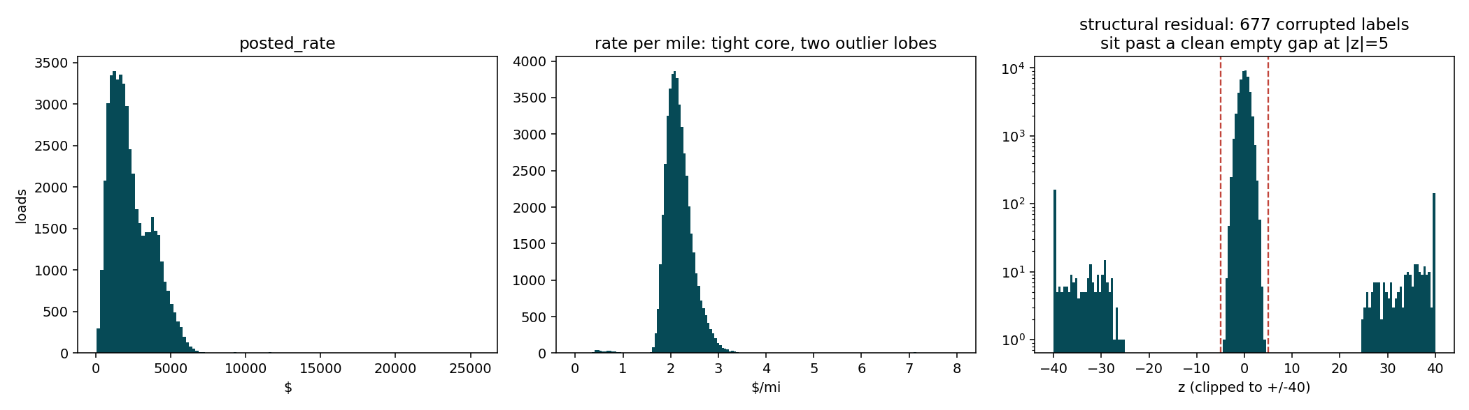
Figure 1. The corrupted labels sit past an empty gap, making the cut point unambiguous.

2. The quote_signal trap
quote_signal reproduces the target's rate-per-mile almost exactly in January, February, March, June and September, and is worthless in the other five months.
Months | Loads within 2% of actual $/mi | Correlation with target
Jan, Feb, Mar, Jun, Sep | 92-94% | 0.95
Apr, May, Jul, Aug, Oct | 7-10% | ~0.00

Under random cross-validation this looks like a jackpot, because half the training rows carry the answer. On the real holdout it is worthless.
Which regime the validation window sits in is determinable without labels, because the degraded months have a distinct marginal shape. A KS test of validation against each training month separates it decisively:
Feature | Best-matching month | Next best
quote_signal | August 0.009 | January 0.052
market_index | January 0.039 | October 0.152
distance | 0.007 | all months under 0.017
weight | 0.008 | all months under 0.027
all four coordinates | 0.010-0.024 | no shift

August is a degraded month, and the match is six times tighter than the runner-up. The feature is excluded from the model entirely. It cannot be rescued row-wise either: gating on rows where it agrees with a model prediction leaves residual sd at 0.0230 against a 0.0231 baseline.
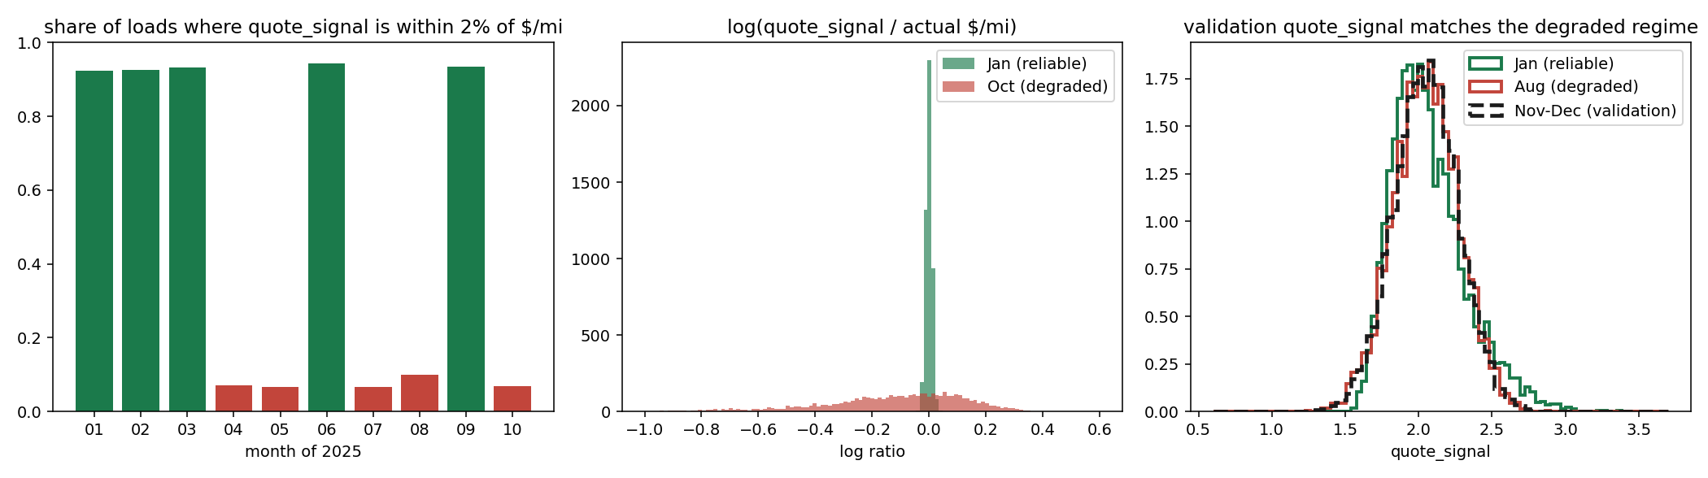
Figure 2. Right panel: validation's quote_signal distribution overlays August, a degraded month.

3. The quarter-end trap
Fitting the model separately per month, distance, weight and coordinates are stable to within a few percent. Equipment is not: Flatbed and Reefer premiums jump in March, June and September, and only those months. The cause is that the equipment premium is flat for the first 60 days of a quarter and then ramps.
 | Day 0-59 | Day 84-92
Flatbed premium | +0.068 | +0.140
Reefer premium | +0.113 | +0.160
Dry Van (general ramp) | 0.000 | +0.022

It repeats identically in Q1, Q2 and Q3, and modelling it cuts residual sigma from 0.0321 to 0.0238, a 26% reduction.
The trap is coverage. Training stops on 31 October, day 30 of Q4, so November falls entirely before the ramp and December entirely inside it. Half the holdout is an extrapolation into a region with no training coverage. Unlike quote_signal this is not leakage, so the response is an explicit day-of-quarter feature rather than a feature to drop.
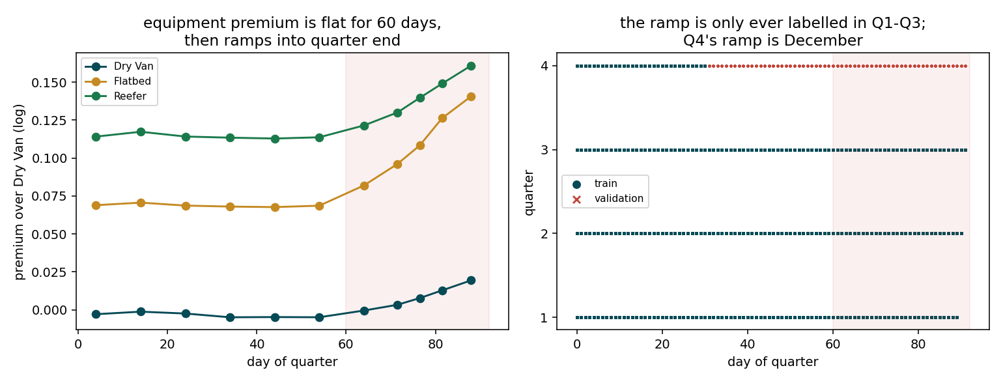
Figure 3. The ramp, and the Q4 coverage gap that is exactly December.

4. Validation approach and data split
The real task trains through day 30 of a quarter and predicts days 31 to 91 of that same quarter, two months forward. That exact shape occurs twice inside the training data, so the split is not a generic time cut but a structural replica of the task:
Split | Train | Holdout | Quarters covering the ramp
Q2 replica | 1 Jan - 30 Apr | 1 May - 30 Jun | Q1 only
Q3 replica | 1 Jan - 31 Jul | 1 Aug - 30 Sep | Q1, Q2
Real task | 1 Jan - 31 Oct | 1 Nov - 31 Dec | Q1, Q2, Q3

Both replicas are slightly harder than the real task, since each has fewer prior quarters from which to learn the ramp. The Q3 replica additionally lands on degraded-quote_signal months, matching the validation regime.
Where two folds were too thin to choose a hyper-parameter, this was widened to five rolling-origin folds, each still predicting two months forward.

Why not random cross-validation
- It rewards the trap. Half the training rows carry the answer in quote_signal, and a random split puts those rows on both sides.
- It hides the extrapolation. Random folds contain December-like rows in training, so the Q4 ramp gap never appears.
- It measures the wrong error. The task is forward in time; random folds interpolate.

The diagnostic that mattered
Average bias hides the failure that matters. A gradient-boosted model's bias grows across the holdout, from +0.0022 in week 1 to +0.0322 in week 8 on the Q2 replica, while the chosen model stays flat at +0.0022 to +0.0040. December is the far end of the holdout, so bias growth is what to select on.
That failure is trees being piecewise constant. Training covers day-of-year 1 to 304 and the holdout is 305 to 365, so every holdout row falls in the top bin and inherits the last training days' value. Its cost is not fixed: 3.2% on the Q2 replica where the market was moving, 0.24% on Q3 where it was flat. Which case December resembles is not knowable in advance, so the trend is carried by a parametric term that can extrapolate.
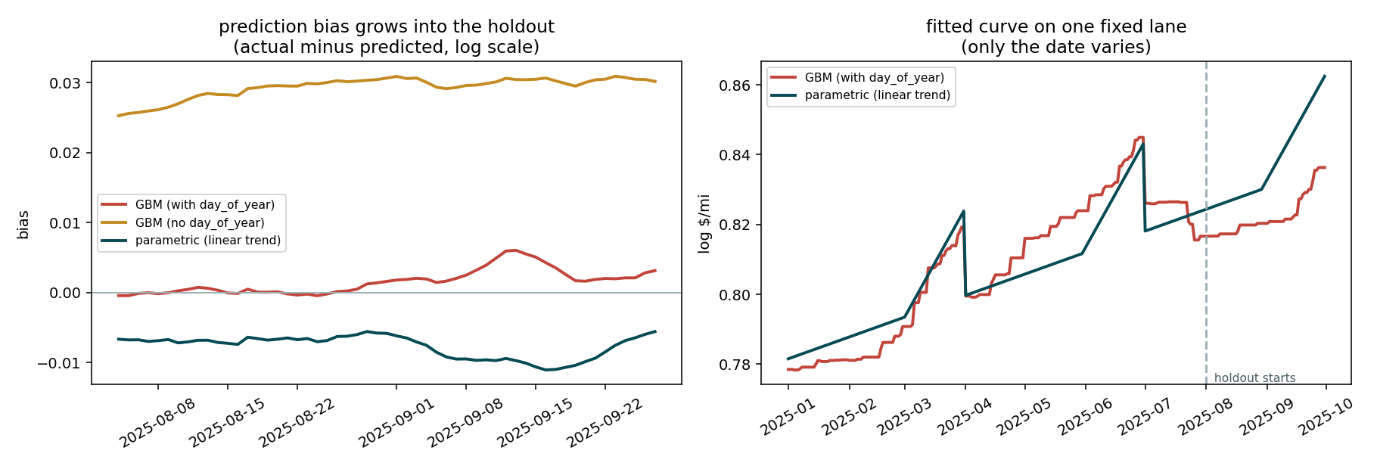
Figure 4. Left: bias growing into the holdout. Right: the fitted curve flattening past the boundary.

5. The model
Four stages, each fitted on the residual of the one before, on log(rate/mile):
- Parametric core. Linear splines on log(distance) and weight, equipment dummies, market_index, a linear day-of-year trend, and a quarter-end ramp interacted with equipment. The trend is linear deliberately, so it extrapolates.
- City premium. One symmetric premium per city applied at both ends of the lane. A load pays the full premium at origin and at destination (regression slopes 1.013 and 1.015), and reversing a lane does not change the price. Empirical-Bayes shrunk, with kNN on lat/lon for the eight cities that appear only in validation.
- Lane effect. Per-lane, shrunk by volume.
- Gradient-boosted correction. On what remains, with day-of-year withheld.
Stage 4 is worth only about 1.4%. Once the structure is explicit the trees have little left to find, so this is effectively a well-specified GLM with shrunk fixed effects. That was not the starting assumption; it is where the replica splits led.

Geography and the eight unseen cities
Allentown, Charlotte, Chicago, Jackson, Knoxville, Laredo, Norfolk and San Diego appear only in validation, touching 12.1% of rows. The city premium is a smooth latitude gradient, so coordinates interpolate to them and a city-name encoding cannot. Leave-one-city-out puts kNN on lat/lon at R2 0.889 for a held-out city, against 0.708 for a global plane.

Seasonality
The spring produce season is present: market_index averages 1.248 across April to July against 0.944 for August to October. It needs no explicit modelling, because market_index is already a feature and its November and December values are supplied in validation.csv. A retail peak is absent from this data; August to October is the annual trough. Adding an annual harmonic was tested and rejected, taking mean MAE from 0.0140 to 0.0177, since extrapolating a cycle fitted on a partial year is unstable.

6. Results
Fold | n test | MAE (log) | RMSE (log) | MAPE
Q2 replica (May-Jun) | 9,571 | 0.0126 | 0.0158 | 1.26%
Jun-Jul | 9,567 | 0.0131 | 0.0164 | 1.31%
Jul-Aug | 9,538 | 0.0163 | 0.0201 | 1.65%
Q3 replica (Aug-Sep) | 9,297 | 0.0137 | 0.0172 | 1.38%
Sep-Oct | 9,379 | 0.0137 | 0.0170 | 1.36%
Mean |  | 0.0139 | 0.0173 | 1.39%

Trained on 47,323 rows after removing the corrupted labels.

Output checks
Check | Result
Predicted rate distribution | median $2,072 against $2,031 in training
Predicted $/mi | median 2.177 against 2.145 in training
December vs November $/mi | 2.206 vs 2.146, the quarter-end ramp
Equipment premium, Nov (pre-ramp) | Flatbed +7.1%, Reefer +12.0%
Equipment premium, Dec (in ramp) | Flatbed +10.3%, Reefer +13.9%
The eight unseen cities | $/mi median 2.181 against 2.177 for the rest
Format | 12,000 unique ids, all positive, no NaN; scorer passes

The November and December equipment premiums land on the values measured in section 3, which confirms the quarter-end interaction is genuinely applied to the unlabelled Q4 ramp rather than merely described.

7. The December chart
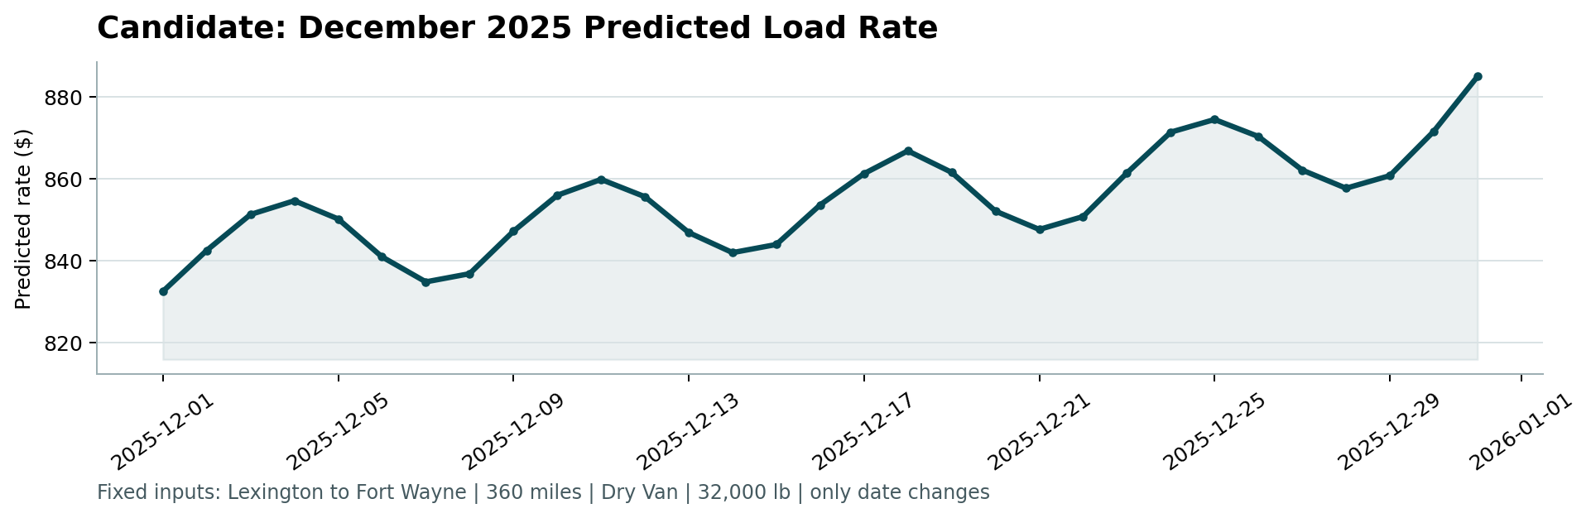
Figure 5. Produced by the provided score.py. Lexington to Fort Wayne, 360 miles, Dry Van, 32,000 lb; only the date changes.
The rate rises from $832 on 1 December to $885 on 31 December, up 6.3% across the month, with a weekly ripple.
- The rise is the quarter-end ramp. December sits entirely at days 61 to 91 of Q4, inside the ramp region that Q4 itself never labels.
- The ripple is the market_index weekly cycle, peaking Thursday near 1.03 and troughing Sunday near 0.83, which at an elasticity of 0.131 is roughly a 1.3% swing.
Two independent checks. The shape was predicted from the exploratory analysis alone, before any model existed, at $837 to $900. And the 32 real Lexington to Fort Wayne loads in training span $758 to $974, so the curve sits inside the observed range for this lane.
A flat line here would have meant the time structure was missed.

8. Limitations
The model sits within roughly 20% of an optimistic noise floor, estimated by fitting in-sample with saturated lane fixed effects. Remaining error is concentrated in three places, none of which look reducible with this data:
- Trend uncertainty, about 1% at the December horizon. Bias alternates sign across folds, so this is genuine uncertainty about an unobservable future rather than a correctable bias. Tuning the trend window was tested on five folds and made it worse.
- Unseen lanes. 12.2% of validation rows sit on lanes absent from training and receive no lane effect.
- Unseen cities. About 0.6% residual on the part of a new city's premium that coordinates cannot recover.
With more time I would quantify December uncertainty by bootstrapping the trend across folds and reporting an interval on the chart, rather than a single line.
Full analysis, including the negative results, is in FINDINGS.md in the repository.

