# Problem Statement:

Using ARMA time series modelling to create prediction models for forecasting power generated by Solar Photovoltaic (PV) arrays using the Diamond Solar data. Developing and evaluating ARMA prediction models for various time scales of the Diamond Solar Data. Finally, evaluating the effect of different estimation techniques used to estimate the parameters of the ARMA models on the performance of prediction models.

# Aims and Objectives:

* Transforming the given Diamond Solar Data (5min Resolution) to different time scales – 15 min, 60 min, 120 min, 180 min, Daily and Monthly resolution data.
* Using MATLAB’s Econometrics Toolbox to develop ARMA models for the above-mentioned time scales and predict solar power generation.
* Developing ARMA estimation models based on Least Squares (LS), Maximum Likelihood Estimation (MLE) and Yule Walker Equations (YWE) to develop solar power generation models at different time scales using the appropriate model orders obtained previously from the Econometrics Toolbox.
* For intra-day time scales training data of one week and two weeks will be used respectively for training the above-mentioned models and a forecast of one week into the future will be generated.
* Comparing the accuracy of the generated forecasts from the MATLAB’s Econometrics Toolbox and the developed ARMA Estimation models, different developed ARMA estimation models, different amount of training data and different time scales will be done.
* Evaluating the effect of different ARMA parameter estimation models on the forecast accuracy.
* Evaluating the effect of amount of training data on the forecast accuracy.
* Evaluating the effectiveness of ARMA prediction on different time scales

Fig. Objectives Schematic

# Method

## Data Transformation:

The data file Diamond_Solar_data.csv consists of three different time series at 5 minutes resolution corresponding to Diamond300, Diamond304 and Diamond306 contiguously arranged in a single column. This file is processed to give individual files corresponding to Diamond300, Diamond304 and Diamond306 at different time resolutions of 5 min, 15 min, 60 min, 2 hours (120 min), 3 hours (180 min), daily and monthly.

Fig. Data Transformation Schematic

## ARMA Model Development using MATLAB’s Econometrics Toolbox:

The ARMA model development is done using Box-Jenkins Method [], which has the following steps as illustrated in the Fig();

1. Model Identification: The univariate time series is checked for stationarity and if not, stationary it has to be converted into a stationary series by applying differencing. The Auto-Correlation Function (ACF) and the Partial Auto-Correlation Function (PACF) of the stationary univariate time series are checked for determining the order of the AR and MA process generating the series.
2. Model Creation: On the basis of the Model Identification a number of models around the determined AR and MA orders are created.
3. Model Estimation: These models are then estimated to give the appropriate coefficients.
4. Model Fitness Check: The estimated models are then evaluated using Akaike Information Criterion (AIC) and Bayesian Information Criterion (BIC). Lower the AIC and BIC better the model.
5. Model Forecast: The best model determined from the previous step is used to forecast the series.

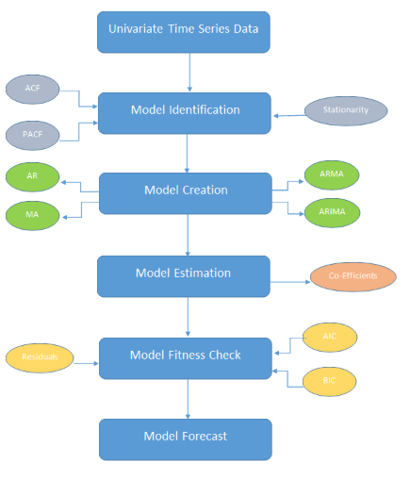

Fig. ARMA Model Development Schematic

## ARMA Parameter Estimation Techniques:

### Least Squares Method:

### Maximum Likelihood Estimation Method:

### Yule Walker Equations Method: