On The Development of Solar & Wind Energy Forecasting Application Using ARIMA, ANN and WRF in MATLAB

Solar & Wind Energy Forecasting Application

Ninad K. Gaikwad1

Renewable Energy Research Wing,

Gujarat Energy Research And Management Institute,

Gandhinagar, Gujarat

ninad.g@germi.res.in1

Sagarkumar M. Agravat2

Renewable Energy Research Wing,

Gujarat Energy Research And Management Institute,

Gandhinagar, Gujarat

sagar.a@germi.res.in2

***Abstract*— The work presented focuses on the developing an application eco-system for performing intra-hour, intra-day and day-ahead generation forecasting for Solar Photovoltaic and Wind Turbine grid connected power plants. The generation forecasting has been divided into two parts: Weather Variable Forecasting (As they are the stochastic component of the problem) and the Energy Estimation of Solar and Wind power plants (as the energy estimation becomes deterministic once the input weather variables have been forecasted). Artificial Neural Networks (ANN), Auto-Regressive Integrated Moving Average Models (ARIMA) and Weather Research and Forecasting Software (WRF) are used for intra-hour, intra-day and day-ahead generation forecasting respectively. For running the WRF software in a distributed-memory and parallel fashion, a 4-Node Raspberry-Pi2 cluster has been developed. The entire application eco-system is developed in MATLAB using its GUI feature, which makes generation forecasting very user-friendly. Five applications with their sub-modules have been designed and developed for this purpose: Data Pre-Processing Application, Solar Energy Estimation Application, Wind Energy Estimation Application, ARIMA Forecasting Application, ANN Forecasting Application, and the WRF-NETCDF Visualization & Extraction Application. The solar energy estimation application is tested with data from Backbone 5MW and GSEC 1MW solar photovoltaic power plants, whereas the wind energy estimation application is tested with a hypothetical wind power plant (due to lack of real wind power plant data). Moreover, the ANN forecasting application is test to produce intra-hour generation forecasts for GSEC 1MW plant in conjugation with the solar energy estimation application. Finally, the WRF software running on the developed Raspberry-Pi2 cluster is used to produce day-ahead generation forecasts for GSEC 1MW plant in conjugation the WRF-NETCDF Visualization & Extraction Application and solar energy estimation application.**

Keywords— RE Energy Estimation, RE Forecasting, MATLAB Application, Solar, Wind, Forecasting, ARIMA, ANN, WRF, Raspberry-Pi Cluster

# Introduction

The world population is growing at an exponential rate, so is the energy requirement. Conventional energy sources like fossil-fuel based generators, nuclear power plants and hydro power plants have served us good so far, but at an environmental and climatic cost. With green-house emissions from thermal power plants there has been a considerable climate change. The radioactive cores of the nuclear power plants are highly toxic waste; moreover, the right of way for hydro power stations is becoming more and more difficult owing to the regional ecological damage it causes. In addition the fossil-fuels are being depleted at an alarming rate. Hence, governments and industries all around the world are taking initiatives to replace conventional energy sources with green energy sources like solar and wind; for e.g. India's Solar Policy states for a 100 GW solar generation capacity by end of year 2022.

However, there is a fundamental difference between the conventional and renewable energy generation. The renewable energy generation cannot be precisely planned as it is weather dependent. Solar energy generation is dependent on irradiance, temperature, wind speed and cloud cover; whereas wind energy generation is dependent on wind speed, temperature, pressure and humidity. This causes high variability and seasonal deviations in energy generation; moreover, it does not follow the load demand profile. Thus, integration of large amounts of solar and wind generators in the power grids can lead to lowered reliability and stability.

In order to increase the penetration of renewable energy generators in the conventional power grid, forecasts at multiple time horizons can play an important role; as good forecasts can make possible effective planning of renewable energy generation. Also, highly accurate forecasts can help in grid regulation, power scheduling, unit commitment and load-following. In short, a good forecast can help us model renewable energy generation as in the conventional sense, making the system operators work easy. Therefore, the study of different forecasting methodologies for solar and wind energy generation is a seminal step in developing a power grid which has renewable generation as its largest component.

From Ref [45] “Moreover, with the aim to gain energy independence and reduce the carbon foot-print India is actively pursuing an unprecedented expansion of its renewable energy sector (especially Solar and Wind energy sector). The Indian goal for massive expansion of its renewable energy sector will be a paradigm shift in its otherwise conventional energy dependent energy infrastructure.

As of 31st November, 2015 India has a total of 275.9GW of electrical energy capacity installed of which only 76.57GW (27.75%) [1] comes from renewable resources (includes all, Biomass, Small Hydro, Waste to Power, Wind and Solar). Wind Energy accounts for 24.76GW (8.9%) and Solar Photovoltaic (SPVP) accounts for 4.68GW (1.69%) [2].

India has set target of year 2022 when it will have an additional 100GW from SPV and an additional 60GW from Wind Farms [3]. Hypothetically, if every other conventional energy source and renewable energy sources (except Solar and Wind) remains constant till 2022, then we will have a total installed capacity of 435.9GW (58% increase in installed capacity in 7 years), SPV and Wind together will contribute about 189.44GW (43.5%). That is a tremendous increase in the renewable energy installed capacity.

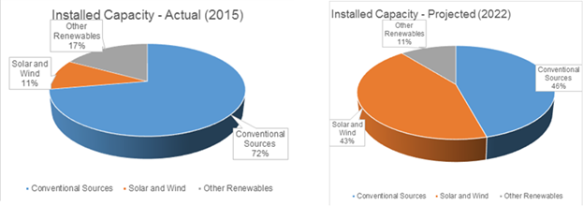

1. Actual and Projected Installed Electricity Generation Capacity Distribution

The Indian electricity grid is working in an archaic mode, where it’s operational practices and control mechanisms are tuned to serve a grid dominated by Thermal Power Stations (Fossil Fueled and Nuclear) which provide for base load and Hydro Power Stations providing for peak load. The energy output of these two kinds of power plants is deterministic and hence are easier to schedule.

But, the energy output of Solar and Wind Power Plants depends on the weather conditions and is stochastic and not deterministic and on most occasions delivers power lower than its installed capacity, which is a real problem for grid operators. Only an accurate forecast of power can solve the problem of efficient renewable energy scheduling [1].”

At the moment there have only been two pilot projects for wind energy forecasting; one in Gujarat that completed in February 2015 with 30% inaccuracy of forecasts; not due to the inefficiency of the participating companies (all were foreign private companies) but due to the lack of data; the other one has started in Tamil Nadu by a company called Vortex in cooperation with NIWE (National Institute of Wind Energy). There is no forecasting pilot project for solar yet [4].

Hence development of an indigenous renewable energy/power forecasting application for solar photovoltaic and wind power plants is of paramount importance. So that, by 2022 when almost 43% of the installed generation capacity will consist of SPVP and Wind Turbine power plants (WTPP), we will have a robust renewable generation forecasting application to take care of the intermittent nature of energy generation.

# METHODOLOGY

The process of generation forecasting of SPVP and WTPP includes: Data acquisition, Data pre-processing, Selection of appropriate mathematical forecasting model (i.e. ARIMA, ANN or WRF), Forecast model development, Forecast model testing and finally the Forecast model implementation. All these steps require different softwares and/or Application Programming Interfaces (API's) to work as a cohesive unit to get forecasting done. The work done in this thesis tries to bring together all the aforementioned steps under one umbrella, to make the forecaster's job a little lucid. The Fig. 2 shows the block diagram of forecasting model developed, here the stochastic weather variables are forecasted using the different mathematical models, and these forecasted weather variables are fed as inputs to the deterministic energy estimation models for SVPP and/or WTPP to get the energy/power forecasts as desired.

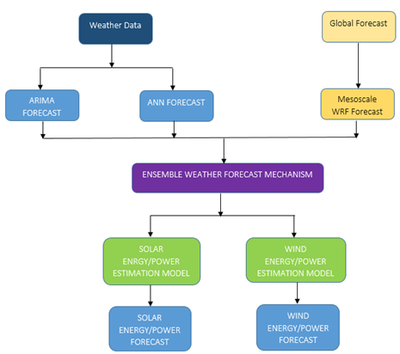

1. Block Diagram – Ensemble Solar/Wind Power Forecasting

The Fig. 3 illustrates the application structure developed in MATLAB using its GUI feature (Screen Shots of the Application GUIs are illustrated in the Appendix). The application performs all the steps mentioned earlier to get the generation forecast through an easy to use GUI interface. Moreover, the application has been coded with modularity at the heart of its design; which makes it easy to upgrade, change and debug as desired by the forecaster.

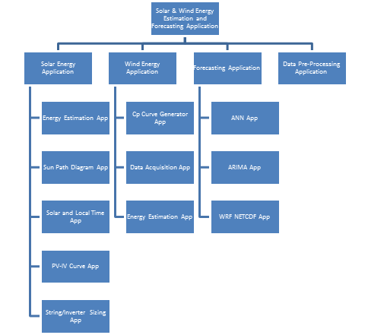

1. Organization Structure of Application

The application can act as a complete software package for energy estimation and generation forecasting for SVPP and WTPP, and be a solid foundation for developing a real-time generation forecasting system.

## Solar Energy Estimation

The Fig. 4 shows the energy/power conversion algorithm used in Solar Estimation App, derived from [5].

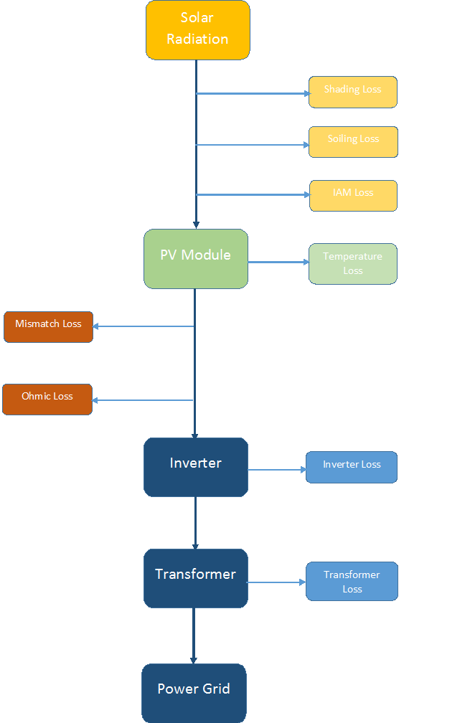

1. Solar Energy Estimation App Algorithm

## Wind Energy Estimation

The Fig. 5 shows the energy/power conversion algorithm used in Wind Energy Estimation App, inferred from [5] [6].

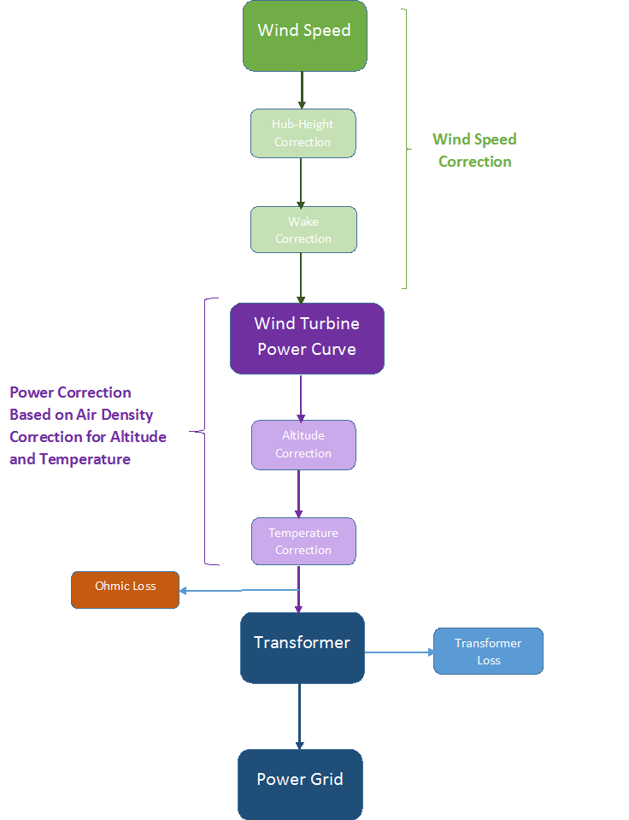

1. Wind Energy Estimation App Algorithm

## ARIMA Forecasting

The classical method of time series modelling propagated by the statisticians Box and Jenkins in the 70’s, and still used today. Their models of ARMA (Autoregressive Moving Averages, for stationary time series) and ARIMA (Autoregressive Integrated Moving Averages, for non-stationary time series) provide building blocks for creating the most basic statistical forecasts based on the time series’ mean and variance values. ARIMA models for weather forecasting are developed by examining Auto-Correlation Function (ACF) and Partial Auto-Correlation Function (PACF), the best models are selected based on the lowest values of Akalike Information Criterion (AIC) and Bayesian Information Criterion (BIC) [12]. Hybrid models consisting of Multi-Linear Regression (MLR) and ARIMA outperform usual ARIMA and ANN models for weather prediction [13]. ARIMA and Artificial Neuro Fuzzy Inference System (ANFIS) are compared for weather forecasting, it is observed that AFIS performs better than ARIMA, as it is a hybrid system [14]. ARIMA and ANN both are good for time series weather forecasting, however hybrid ARIMA-ANN outperforms both techniques by reducing model uncertainty [15]. For short-term irradiance forecasting ARIMA models outperform NWP, and predict accurately in the time frame of 5 minutes to 4 hours, but NWP perform superiorly better for day-ahead irradiance forecasting [16] and [17]. ARIMA models have been developed using Box-Jenkins methodology for predicting accurately monthly values for temperature, rainfall and relative humidity in Ahvaz, Iran and districts of Sri Lanka [18], [19] and [20]. Non-Linear Autoregressive Exogenous Artificial Neural Network (NARX) performs better than ARIMA being a non-linear model for wind speed time series one-step ahead prediction [21]. Hence, ARIMA models have been applied successfully for short-term forecasting of irradiance, temperature and wind speed, using the ACF and PACF examination approach in combination with AIC and BIC for selecting the best model; moreover, hybrid models of ARIMA with other techniques are superior but complex as compared to usual ARIMA models for weather variable prediction. The Fig. 6 shows step-wise algorithm for the ARIMA App.

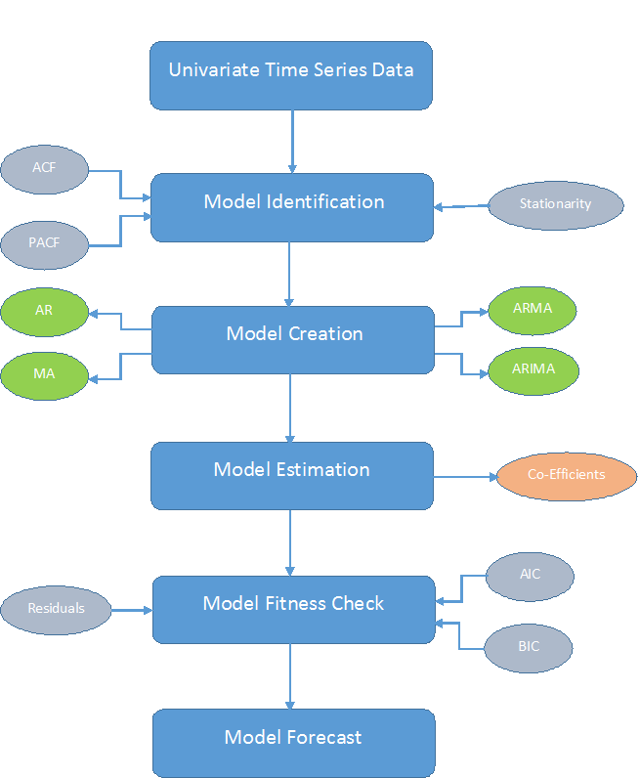

1. ARIMA App Step-Wise Algorithm

## ANN Forecasting

The modern technique of Artificial Neural Networks, which are inspired from biological neural networks. They work on the principle of interconnected neurons forming a network between inputs and outputs; the neurons consists of a mathematical function, biases and weights. This network of neurons is made to learn the data during training phase using appropriate learning methods. ANN’s can be trained to do a variety of jobs; namely Clustering, Classification and Regression. For weather variable forecasting we need to develop a neural network for solving a regression problem. ANN trained with back propagation (BP) algorithm can approximate large class of non-linear functions; hence, it can be used in weather prediction, the only requirement for good predictions being good quality historical data [22]. Multi-Layer Perceptron model (MLP) has the potential to be successfully applied to weather forecasting [23]. MLP with BP is an ideal solution for predicting dynamic and non-linear weather processes, it is better than traditional numerical methods [24]. Various weather variables like rainfall, wind speed, irradiance and temperature can be forecasted accurately using MLP and Radial Basis Function Network (RBFN) [25]. When MLP RBFN, Elman Recurrent Neural Network (ERNN) and Hopfield Model (HFM) are compared, MLP and RBFN perform weather accurate weather forecasts comparatively [26]. A hybrid model using ARIMA which is a linear model and ANN which is a non-linear model, irradiance can be predicted accurately for both clear and cloudy days [27]. To improve irradiance forecasts further additional inputs of irradiance derivatives can be used, which improves irradiance forecast under changeable weather conditions [28]. For a shot-term irradiance forecast ANN outperforms NWP [29]. Also, temperature prediction with greater accuracy can be done by training one ANN model for each season [30]. Ensemble ANN model for temperature forecasting improves accuracy to a great extent [31]. ANN outperforms ARIMA model for short-term wind speed forecasting [32]. Hence, incorporating ensemble and hybrid modeling strategy with ANN can help predict irradiance, temperature and wind speed to a high accuracy for a short-term forecast. The Fig. 7 shows step-wise algorithm for the ANN App.

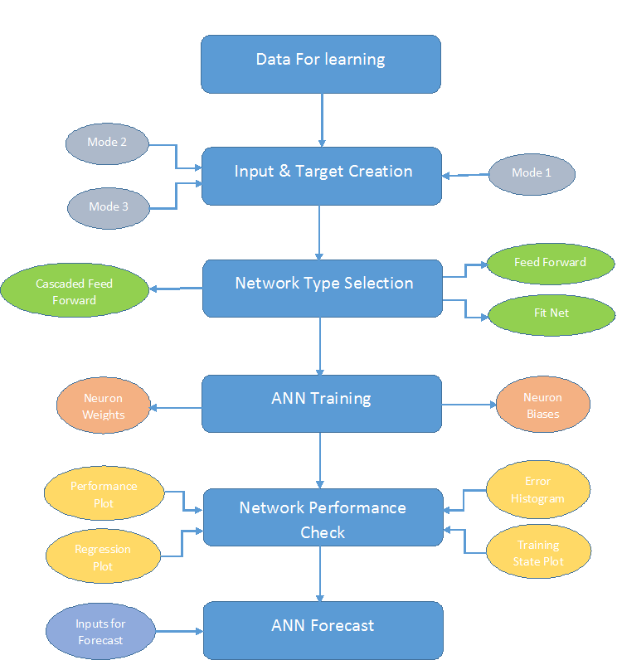

1. ANN App Step-Wise Algorithm

## WRF Forecasting

The Numerical Weather Prediction Models (NWP’s) like ECMWF and WRF they produce good weather forecasts up to 1km spatial and about 3min temporal resolution. NWP’s are quite different from the first two forecasting techniques as they depend on accurate physical descriptions of the atmospheric processes and tend to give highly accurate forecasts. But, the problem here is these softwares require supercomputers to run them as they require a lot of computing power and memory. The WRF is a next generation NWP with efficiency, portability, maintainability and extensibility at its core architecture; being open source and community driven, it has fostered communication, cooperation, collaboration within WRF working groups specializing in regional climate, air quality simulation, and NWP research [33]. WRF model was used for forecasting energy production of a SPVP, WRF weather variables and the historical plant power production data was used to train a Quantile Regression Forest forecast model; it is observed that accuracy of daily energy forecasts is greater than hourly predictions [34]. Improved power forecast for SPVP and WTPP is carried out using a hybrid model of linear regression of forecasted outputs of the WRF model, this model outperforms the usual WRF model [35]. The GHI prediction from WRF are not accurate, but are usually over-estimated due to WRF’s inability to model clouds, aerosols, ozone properly also the radiation models used in WRF are good drivers for atmospheric processes but not so much for precise surface solar irradiances; hence post processing of GHI is required for accurate prediction, some methods are: Spatial Averaging, Incorporating Ozone and Aerosols using satellite retrievals, Kalman Filters, and Recursive method and Assimilating cloud cover data into the WRF initialization using GOES satellite imagery; as mentioned in [36], [37], [38], [39] and [40] respectively. Another method to improve the GHI forecasts from the WRF, an ensemble WRF model is suggested where linear combination of one or more WRF runs for the same location with different initial and boundary conditions is done, this improves the GHI forecast by reducing the uncertainty associated to the initial and boundary meteorological conditions [41]. The land surface schemes responsible for computing heat and moisture fluxes over the land surface overestimate, for improving the temperature and wind speed forecast from WRF model a good post-processing system has to be used [42]. The YSU scheme in WRF with an ensemble mean with a GFS (Global Forecast System) initialized WRF model is the best for wind speed prediction [43]. The comparison of the two dynamic solvers within WRF which are the Advanced Research WRF (ARW) and the Non-hydrostatic Mesoscale Model (NMM), shows that there is no difference in the WRF output with the change in the dynamic solvers [44]. Hence, WRF is proved to be a great tool for mesoscale weather prediction and it has been used successfully for day-ahead weather forecasting in relation to SPVP and WTPP generation forecasting; moreover, with good parameterization of the WRF model options, appropriate post-processing systems and ensemble models the WRF system can be used for very accurate day-ahead forecast of the SPVP and WTPP generation. The Figure. 8 shows step-wise algorithm developed in [46] for running the WRF software for customized real cases. Bash scripts have been developed to build the entire WRF software package on a UNIX based system; moreover bash scripts for running both WPS and WRF have been developed to expedite the process of model initialization.

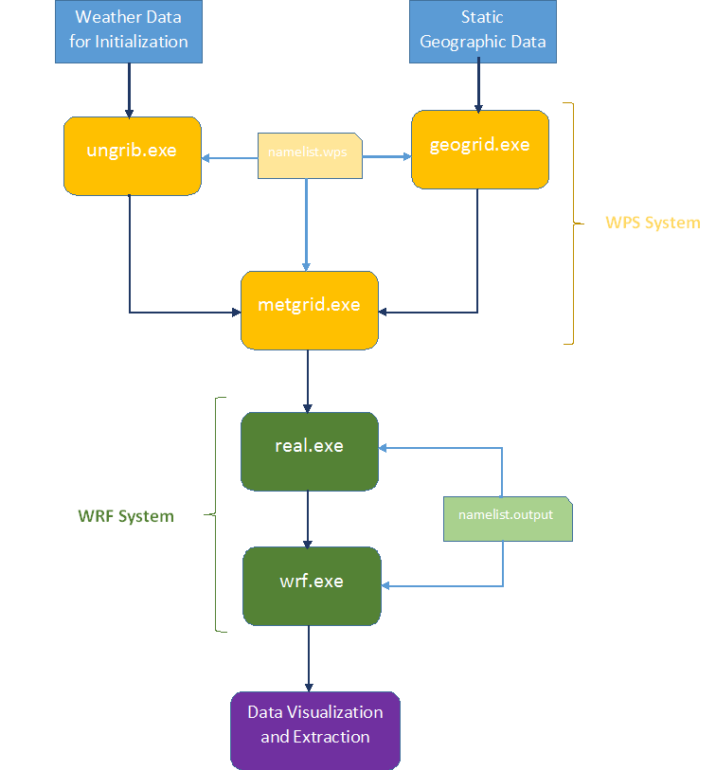

1. Step-Wise Schematic of WRF Software Run for Real Case

# RESULTS

Some results obtained from the different app and their sub-modules have been illustrated in this section.

The Fig. 9 and Fig. 10 illustrate the PV and IV curves plotted at different temperatures (-25, 0, 25, 50 and 75 ºC) and different irradiances (200, 400, 600, 800 and 1000 W/m2) respectively for Polycrystalline 235W LANCO Module using the PV & IV Curve Generator App (Based on the algorithm given in [14]) (sub-module of the Solar Energy Estimation App).

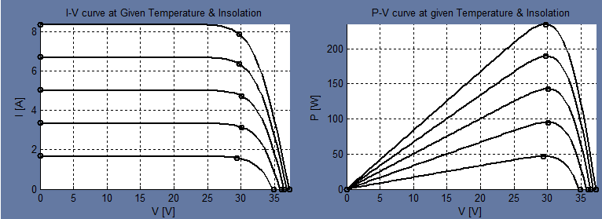

1. PV-IV Curves of Polycrystalline Module at different Irradiances

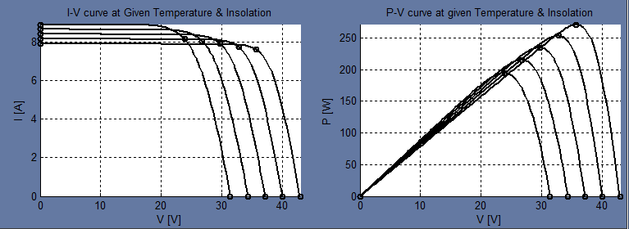

1. PV-IV Curves of Polycrystalline Module at different Temperatures

Fig. 11. shows a comparison between the energy estimation of the Backbone 5MW SPV, with its actual orientation of single axis east-west tracker computed using PVsyst (E-W1) and Solar Energy Estimation App (E-W2); the X-axis units are Months (Time) and the Y-axis units are MWh (Energy).

1. Comparison of PVsyst and Solar Energy Estimation App

The Fig. 12 shows the monthly energy output to the grid obtained from the four different types of wind turbines present in the type four category of the hypothetical wind power plant as computed in the Wind Energy Estimation App. The wind speed data was randomly generated and the temperature data was taken from Meteonorm, both at the temporal resolution of 60 minutes.

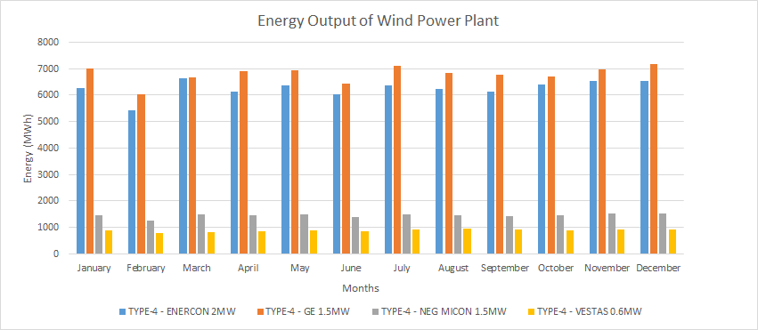

1. Hypothetical Wind Plant Month Wise Energy Estimation for Different Wind Generator Types

The results for generation forecasting using ARIMA have been produced for the GSEC 1MW SPVP. The data utilized for estimating the ARIMA coefficients is the WRF weather variables generated for the same plant for the month of June 2016. The forecasted weather variables form the ARIMA models have been fed as inputs to the solar energy estimation application to generate the intra-hour generation forecast. The energy generation forecast for the GSEC plant is computed using the ARIMA forecasted weather variables using the solar energy estimation application. The forecast is generated from 10.25 (Decimal Time), 4th June, 2016 to 10.00 (Decimal Time), 5th June, 2016. The weather data series of WRF used are from 0.00 (Decimal Time), 1st June, 2016 to 10.00 (Decimal Time), 4th June, 2016. The results are illustrated in Fig. 13.

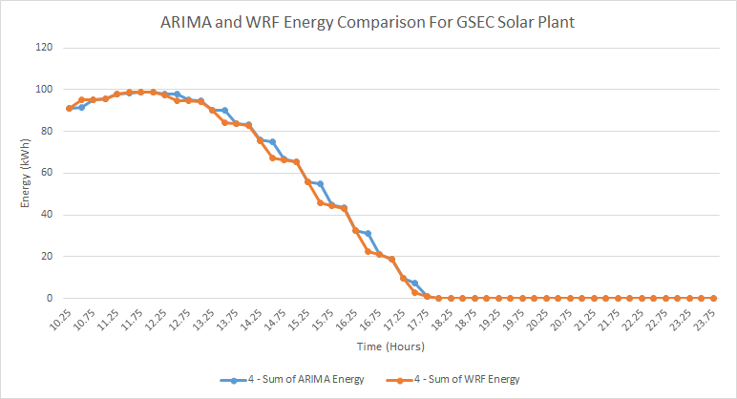

1. Comparison of Energy Prediction using ARIMA with Original Data Series obtained from WRF

The results for generation forecasting using ANN have been produced for the GSEC 1MW SPVP. The training data is of 11 months from November 2014 to September 2015. The ANN models trained on this data have been used to generate intra-hour weather variable forecasts for the month of October 2015. The ANN models have been developed using three different types of input data (Mode1, Mode2 and Mode3) with three different network architectures (Fitnet [FN], Feedforward Net [FF] and Cascaded Feedforward Net [CFF]) and five different hidden network configurations (5-Neurons, 10-Neurons, 15-Neurons, 10-10- Neurons and 10-10-10-neurons). All the results in the subsequent sections are for the 2nd of October 2015 for all the modes, architectures and the hidden network configuration. The forecasted weather variables form the ANN models have been fed as inputs to the solar energy estimation app to generate the intra-hour generation forecast. The Fig. 14 illustrates intra-day energy forecasting comparison of the three different network architectures for a hidden neuron configuration of 10-10-10 in three hidden layers with X-axis units in hours (Time) and Y-axis units in kWh (energy).

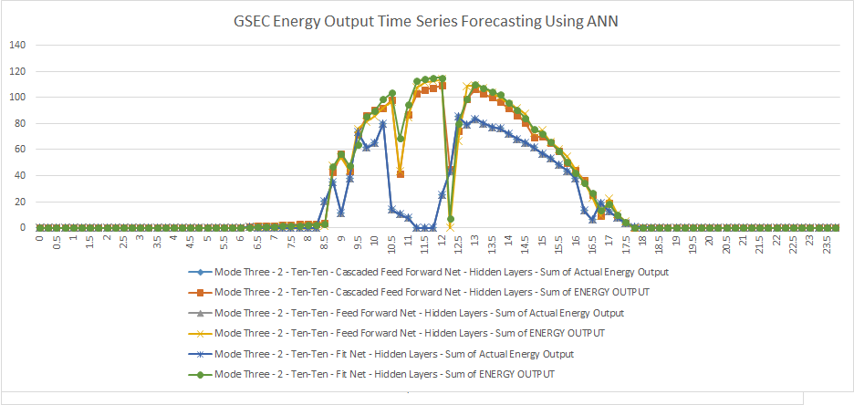

1. Comparison of Different ANN Architectures (FN, FF, CFF) For Forecasting Of Intra-Hour Energy in Mode 3 with Network [10-10-10]

Fig. 15. shows the short-wave downward flux superimposed on the latitude-longitude grid of the WRF run for the GSEC 1MW SPVP on the 1st of June, 2016 at 06:15:00 UTC, this colour map is generated using the WRF-NETCDF Visualization & Extraction App.

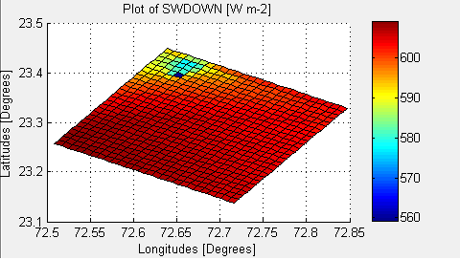

1. GSEC 1MW WRF Simulation- Short Wave Downward Flux Grid

The WRF software has been run for the entire month of June, 2016 with initialization data acquired from NCEP FTP server for the region consisting of the GSEC 1MW SPVP, Gandhinagar, Gujarat at a spatial resolution of 1km and a temporal resolution of 15 minutes. The results thus obtained have been extracted from the NETCDF wrf.out files into excel files for the latitude and longitude of the GSEC SPVP using the WRF-NETCDF Visualization and Extraction App. The Fig. 16 shows the day-ahead energy forecast generated by using weather variables from the WRF output files as input to the Solar Energy Estimation App for the 15th, June 2016.

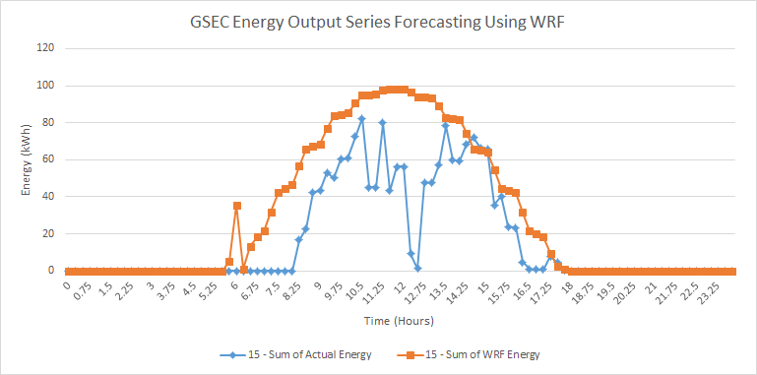

1. Comparison of Actual and WRF Generated Energy For 15th June

# DISCUSSION

The effect of decreasing irradiance with temperature at kept constant at 25ºC can be observed in Fig. 9. It is clearly seen that the photovoltaic module current output and power are directly proportional to the irradiance level, however the module voltage increases by very small values with decreasing irradiance levels. This concurs with the theory that module current is a direct function of the solar irradiance. The effect of increasing temperature with irradiance level kept constant at 1000 W/m2 can be observed in Fig. 10. It is clearly seen that the module voltage and power output are inversely proportional to the temperature, however the module current increases very slightly with increase in temperature. This concurs with theory that diode voltage is inversely proportional to temperature.

From Fig. 11 we can compare the performance of the PVsyst and Solar Energy Estimation App with actual plant data. It is observed that PVsyst overestimates the energy production with an average error percentage of 26% (absolute values of errors), whereas the MATLAB application estimates the energy with an average error of 10% (absolute values of errors). Hence, the developed MATLAB application performs better than PVsyst for energy estimation of the given plant.

From Fig. 12 can clearly see that the energy output of the Enercon and GE compared to Neg Micon and Vestas is higher, as the number of these turbines is higher (Neg Micon[1.5MW]=5, Vestas[0.6MW]=10, ENERCON [2MW]=15 and GE [1.5MW]=20), the visually flat profile of the monthly energy generation is due to use of randomly generated wind speeds.

All the ARIMA models used are of seasonal type with seasonality of 96 as the data series has a resolution of 15 minutes. Moreover, it has been observed that the ARIMA models with both AR and MA components forecast better. All the original data series have been differenced twice. From the Fig. 13 we see that the ARIMA models have been able to predict the energy output with a good degree of accuracy.

From Fig. 14 we can see that the neural network models using hidden layer configuration of 10-10-10 neurons and of all the FF, FN and CFF are able to predict the one-step (15 minute block) ahead fairly accurately with the training done with input data in mode 3 (with date- time, and step previous values and their rate of change).

The Fig. 16 shows that the WRF is able to compute the weather variables approximately for the desired SPVP location. It is not able to model the sharp dips in the irradiances which are caused by cloud movement (prediction of cloud movements is poor in WRF). However, when the actual irradiance graphs have no significant sharp dips i.e. clouds are not present, then the WRF irradiance is slightly over estimated (due to poor modeling of aerosols). Overall, WRF shows potential for a day-ahead forecast which can be improved further by improved parameterization and appropriate physics option selection based on the region of forecast.

# SCOPE AND LIMITATIONS

The research presened in the paper has been conducted in the Renewable Energy Research Wing (RERW) at Gujarat Energy Research And Management Institute (GERMI), Gandhinagar, Gujarat, India. The research objective has been to automate the forecasting techniques and energy estimation of wind and solar in an interactive User Interface (UI) fashion. The entire application code from the data processing codes to Graphical User Interface (GUI) code has been developed in MATLAB. The plat, weather and generation data set has been acquired from Gujarat State Electricity Corporation Limited (GSECL) 1MW Ash-Dyke Solar Power Plant at Gandhinagar, Gujarat and from BACKBONE 5MW Solar Plat at Samakhiyali, Kutch, Gujarat. The forecasting techniques dveloped are based on Artificial Neural Networks (ANN), Autoregressive Integrated Moving Average Models (ARIMA) and Weather Research and Forecasting System (WRF) for intra-hour, intra-day and day-ahead weather variable forecasting.

The research has been limited to use the basic energy estimation models for solar and wind energy as given in [5] and [6]. The ANN forecasting model utilizes on the Multi Layer Perceptron Model which is most basic ANN architecture available. ARIMA modelling has been utilisd to its core. Moreover, the WRF system parameterization and physics schemes have been kept to the default states, and only a single nested run has benn utilised. Also, the Input/Output (IO) of the application are Microsoft Excel Files. With a lot of human intervention necessary from data pre-processing to post processing of results the automation of the application at this stage is good enough to be used as research benchwork for Renewable Energy (RE) Forecasting. With introduction of more sophisticated energy estimation models, automated training of ANN & ARIMA, customization of WRF as per geographical location of interest, reduced human intervention to the minimum and development of advanced real-time IO will lead to Real-Time Forecasting Architecture which can be deployed in the industry.

# CONCLUSION

A complete application framework has been developed for the energy/power forecasting of SVPPs and WTPPs in MATLAB using its GUI feature. The results obtained thus far are promising. More work has to be done in fine tuning the ARIMA and ANN models; by introducing ANN-ARIMA Hybrid and RBFs (Radial Bias Functions) & RNNs (Recurrent Neural Networks) more accurate intra-hour and intra-day generation forecasts can be computed respectively; also parameterization of WRF for a particular location has to be done to obtain more reliable day-ahead generation forecasts. The developed application forms a solid foundation for further research and development in the field of RE generation forecasting. But, for it to be functioning as an independent software with minimum human interference, and generating intra-hour, intra-day and day-ahead forecasts for multiple RE Power plants in real time, efforts are being taken at GERMI.

Acknowledgment

We thank authorities of 5 MW BackBone and 1 MW GSECL Solar Power Plants for providing necessary data for developing and enhancing the energy estimation and forecasting models. We also thank Prof T. Harinarayana, DG, GERMI to have faith in our research and supporting us at every step.

References

1. "Electricity sector in India," [Online]. Available: <https://en.wikipedia.org/wiki/Electricity_sector_in_India>.
2. "Renewable energy in India," [Online]. Available: <https://en.wikipedia.org/wiki/Renewable_energy_in_India>
3. "Blog: Big Data Improves Renewable Power Forecasts. Will It Help India?," 2015. [Online]. Available: <http://www.wri.org/blog/2015/09/big-data-improves-renewable-power-forecasts-will-it-help-india>.
4. C. Richts, P. Strauß and D. Heinemann, "Report on Forecasting, Concept of Renewable Energy Management Centres and Grid Balancing," Deutsche Gesellschaft für Internationale Zusammenarbeit (GIZ) GmbH, New Delhi, 2015.
5. G. M. Masters, Renewable and Efficient Electric Power Systems, Hoboken, New Jersey.: John Wiley & Sons, 2004.Y
6. M. R. Patel, Wind and Solar Power Systems Design, Analysis, and Operation, Kings Point, New York, U.S.A.: CRC Press, Taylor & Francis Group, 2006.G
7. H. M. Diagna, M. David, P. Lauret, J. Boland and N. Schmutz, "Review of solar irradiance forecasting methods and a proposition for small-scale insular grids," *Renewable and Sustainable Energy Reviews, Elsevier,,* pp. 65-76, 2013.
8. K. . G. Upadhyay, A. K. Choudhary and M. M. Tripathi, "Short-term wind speed forecasting using feed-forward back-propagation neural network," *International Journal of Engineering, Science and Technology,* vol. 3, no. 5, pp. 107-112, 2011.
9. S. Saroha and S. K. Aggarwal, "A Review and Evaluation of Current Wind Power Prediction Technologies," *WSEAS TRANSACTIONS on POWER SYSTEMS,* vol. 10, 2015.
10. X. Zhu and M. G. Genton, "Short-Term Wind Speed Forecasting for Power System Operations," *International Statistical Review,* vol. 80, no. 1, pp. 2-23, 2012.
11. W.-Y. Chang, "A Literature Review of Wind Forecasting Methods," *Journal of Power and Energy Engineering,* vol. 2, no. 1, pp. 161-168, 2014.
12. S. A. Shamsnia, N. Shahidi, A. Liaghat, A. Sarraf and S. F. Vahdat, "Modeling of Weather Parameters Using Stochastic Methods (ARIMA Model)(Case Study: Abadeh Region, Iran)," *International Conference on Environment and Industrial Innovation,* vol. 12, no. 1, pp. 282-285, 2011.
13. M. A. Sharma, PhD Thesis-COMPARATIVE STUDY OF FORECASTING MODELS BASED ON WEATHER PARAMETERS, Meerut: SHOBHIT INSTITUTE OF ENGINEERING & TECHNOLOGY, 2012.
14. M. Tektas, "Weather Forecasting Using ANFIS and ARIMA MODELS. A Case Study for Instanbul," *Environmental Research, Engineering and Management,* vol. 1, no. 51, pp. 5-10, 2010.
15. P. G. Zhang, "Time series forecasting using a hybrid ARIMA and neural network model," *Neurocomputing,* vol. 50, no. 1, pp. 159-175, 2003.
16. S. K. Prajapati and K. B. Sahay, "A Survey Paper on Solar Irradiance Forecasting Methods," *International Journal of Engineering Research & Technology,* vol. 5, no. 03, pp. 536-541, 2016.
17. I. Kaushik and S. M. Singh, "SEASONAL ARIMA MODEL FOR FORECASTING OF MONTHLY RAINFALL AND TEMPERATURE," *Journal of Environmental Research And Development,* vol. 3, no. 2, pp. 506-514, 2008.
18. A. Sarraf, S. F. Vahdat and A. Behbahaninia, "Relative Humidity and Mean Monthly Temperature Forecasts in Ahwaz Station with ARIMA Model in time Series Analysis," *International Conference on Environment and Industrial Innovation,* vol. 12, pp. 149-153, 2011.
19. K. Partheepan and P. Jeyakumar, "Development of a Time-Series Model to Forecast Climatic Data in the Batticaloa District, Sri Lanka," in *Water Professionals' Day Symposium*, 2005.
20. A. H. Nurry, M. Koch and M. B. Alam, "Time Series Analysis and Forecasting of Temperatures in the Sylhet Division of Bangladesh".
21. E. Cadenas, W. Rivera, R. Campos-Amezcua and C. Heard, "Wind Speed Prediction Using a Univariate ARIMA Model and a Multivariate NARX Model," *energies,* vol. 9, no. 109, 2016.
22. S. P. B. Reddy, J. C. Devi, V. K. Kumar, M. B. Reddy and R. N. Nayak, "ANN Approach for Weather Prediction using Back Propagation," *International Journal of Engineering Trends and Technology,* vol. 3, no. 1, pp. 19-23, 2012.
23. N. Kumar and G. K. Jha, "A Time Series ANN Approach for Weather Forecasting," *International Journal of Control Theory and Computer Modeling (IJCTCM),* vol. 3, no. 1, pp. 19-25, 2013.
24. P. Malik, S. Singh and B. Arora, "An Effective Weather Forecasting Using Neural Network," *International Journal of Emerging Engineering Research and Technology,* vol. 2, no. 2, pp. 209-212, 2014.
25. G. Shrivastava, S. Karmakar, M. K. Korwar and P. Guhathakurta, "Application of Artificial Neural Networks in Weather Forecasting: A Comprehensive Literature Review," *International Journal of Computer Applications,* vol. 51, no. 18, p. 0975 – 8887, 2012
26. I. Maqsood, M. R. Khan and A. Abraham, "An ensemble of neural networks for weather forecasting," *Neural Comput & Applic, Springer-Verlag London Limited,* pp. 112-122, 2004.
27. C. Voyant, M. Muselli, C. Paoli and M.-L. Nivet, "Hybrid methodology for hourly global radiation forecasting in Mediterranean area".
28. W. Wang, C. Bruyere, M. Duda, J. Dudhia, D. Gill, M. Kavulich, K. Keene, H.-C. Lin, J. Michalakes, S. Rizvi, X. Zhang, J. Berner and K. Fossel, WRF ARW - Version 3 Modelling System User's Guide January 2016, Boulder, Colorado, USA: National Center for Atmospheric Research, 2016.
29. C. Cornaro, F. Bucci, M. Pierro, F. Del Frate, S. Peronaci and A. Taravat, "SOLAR RADIATION FORECAST USING NEURAL NETWORKS FOR THE PREDICTION OF GRID CONNECTED PV PLANTS ENERGY PRODUCTION (DSP PROJECT)".
30. M. Hayati and Z. Mohebi, "Temperayure Forecasting Based on Neural Network Approach," *World Applied Sciences Journal,* vol. 2, no. 6, pp. 613-620, 2007.
31. P. P. Kadu, K. P. Wagh and P. N. Chatur, "Temperature Prediction System Using Back propagation Neural Network : An Approch," *International Journal of Computer Science & Communication Networks,* vol. 2, no. 1, pp. 61-64.
32. J. P. S. Catalao, H. M. I. Pousinho and V. M. F. Mendes, "An artificial neural network approach for short-term wind power forecasting in Portugal," *Engineering Intelligent Systems,* vol. 17, no. 1, 2009.
33. J. MICHALAKES,, J. DUDHIA, D. GILL, T. HENDERSON, J. KLEMP, W. SKAMAROCK and W. WANG, "THE WEATHER RESEARCH AND FORECAST MODEL:SOFTWARE ARCHITECTURE AND PERFORMANCE," 2005.
34. M. P. Almeidaa, O. P. Lamigueirob and L. Narvarte, "PV Power Forecast Using a Nonparametric PV Model," *Elsvier.*
35. E. Avolio, R. C. Torcasio, T. L. Feudo, C. R. Calidonna, D. Contini and S. Federico, "Improvement of Solar and Wind forecasting in southern Italy through a multi-model approach: preliminary results," *Advances in Science & Research,* vol. 13, pp. 69-73, 2016.
36. D. P. Larson, L. Nonnenmacher and C. F. Coimbra, "Day-ahead forecasting of solar power output from photovoltaic plants in the American Southwest," *Renewable Energy,* vol. 91, pp. 11-20, 2016.
37. V. Lara-Fanego, J. A. Ruiz-Arias, D. Pozo-Va´zquez, F. J. Santos-Alamillos and J. Tovar-Pescador, "Evaluation of the WRF model solar irradiance forecasts in Andalusia (southern Spain)," *Solar Energy,* 2011.
38. A. Rincón, O. Jorba, J. M. Baldasano and L. D. Monache, "Assessment of short-term irradiance forecasting based on post-processing tools applied on WRF meteorological simulations," in *ES1002 : Workshop*, 2011.
39. P. Mathiesen, C. Collier, J. Parkes, L. Landberg, . J. Kleissl and G. G. Hassan, "Improved Solar Power Forecasting Using Cloud Assimilation into WRF," in *Proceedings of the 52nd Annual Conference, Australian Solar Energy Society*, Melbourne, 2014.
40. D. Heinemann, E. Lorenz and M. Girodo, "Forecasting of Solar Radiation".
41. D. Díaz, J. A. Souto, A. Rodríguez, S. Saavedra and J. J. Casares, "An ensemble-in-time forecast of solar irradiance," in *International Conference on Renewable Energies and Power Quality*, Santiago de Compostela, 2012.
42. D. V. Khvorostyanov, L. Menut, J. C. Dupont, Y. .. Morille, and M. Haeffelin, "The Role of WRF Land Surface Schemes on Weather Simulations in Paris Area".
43. S . L. Rabideau, "Analysis of WRF Model Ensemble Forecast Skill for 80 m Winds over Iowa".
44. L. Bernardet, J. Wolf, L. Nance, A. Loughe, B. Weatherhead, E. Gilleland and B. Brown, "Comparison between WRF-ARW and WRF-NMM objective forecast verification scores".
45. N. K. Gaikwad, "On the Forecasting of Solar & Wind Power?," 2016. [Online]. Available: https://ninadkgaikwad.wordpress.com/2016/03/18/on-the-forecasting-of-solar-wind-power/.

APPENDIX

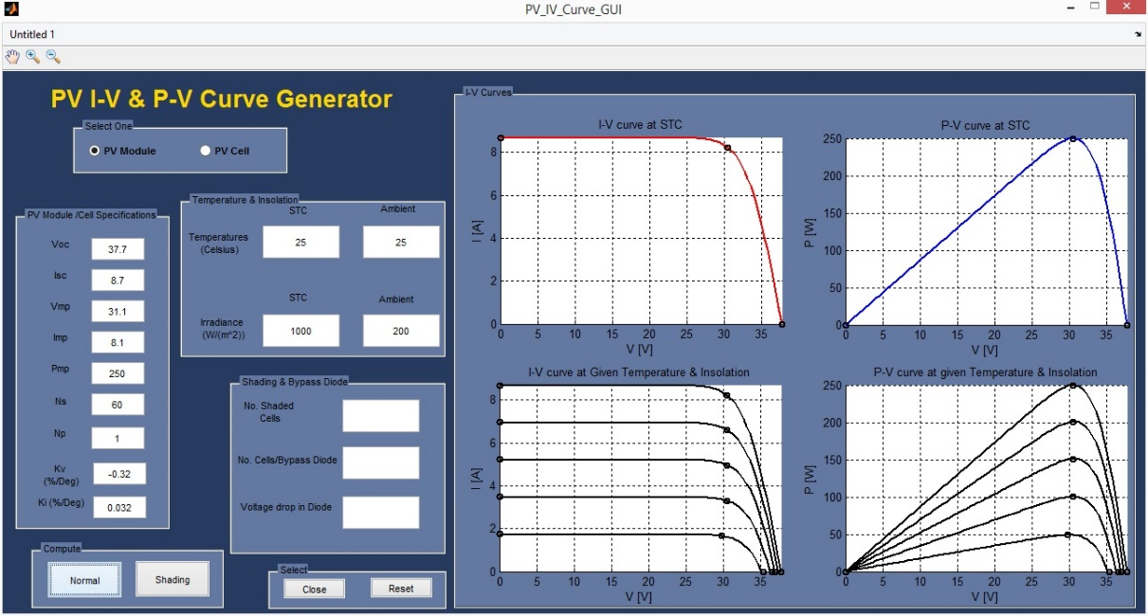

1. A1: PV I-V & P-V Curve Generator App GUI

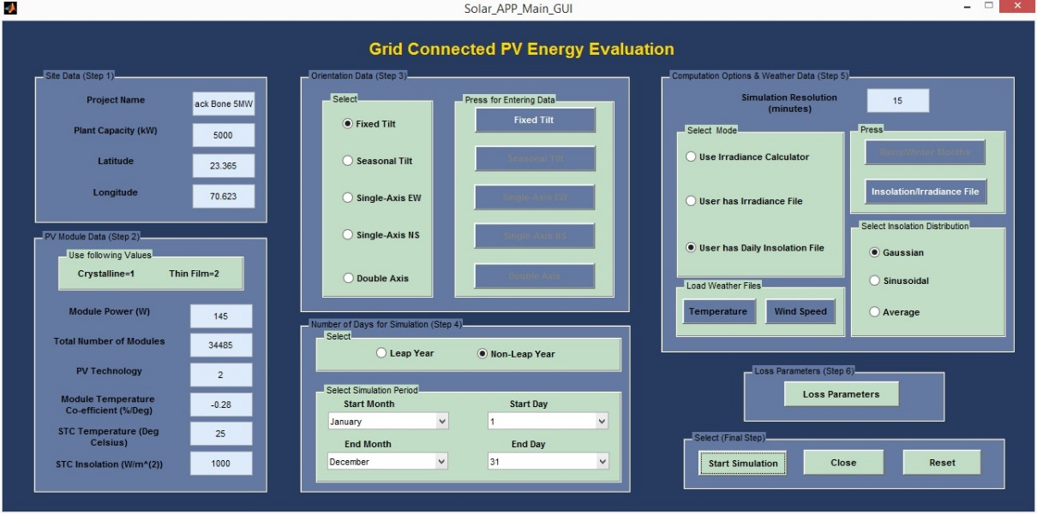

1. A2: Solar Energy Estimation App GUI

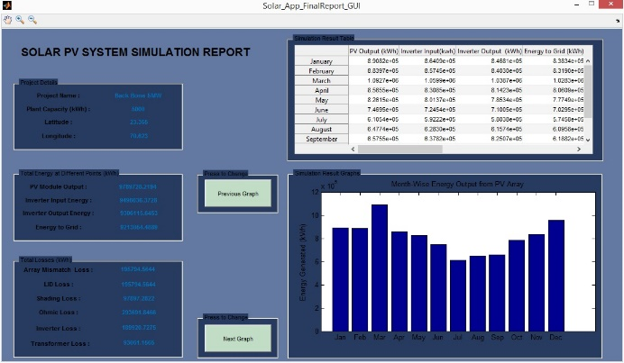

1. A3: Solar PV System Energy Simulation Report GUI

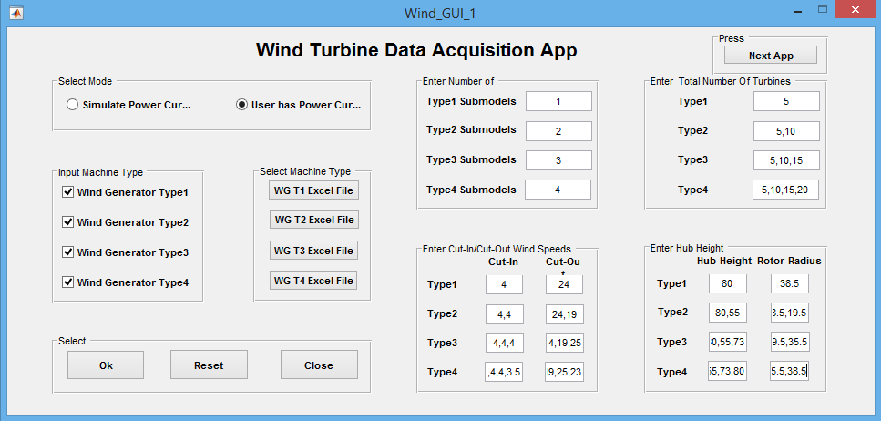

1. A4: Wind Energy Data Acquisition App GUI

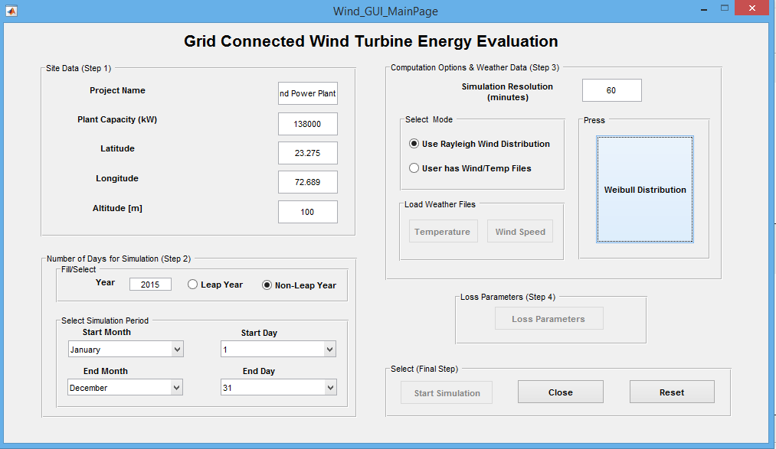

1. A5: Wind Energy Estimation App GUI

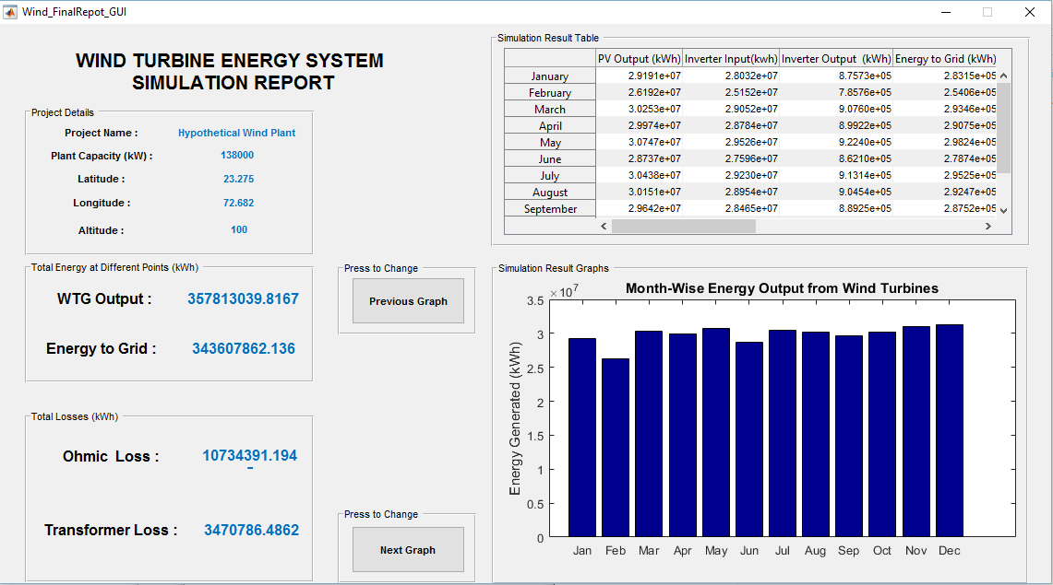

1. A6: Wind Energy Simulation Report GUI

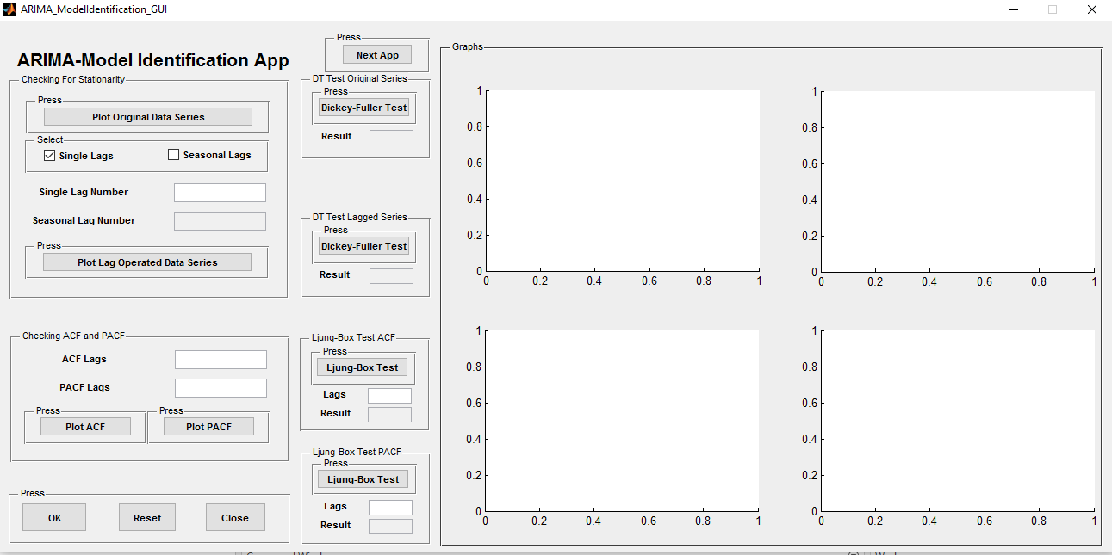

1. A7: ARIMA Model Identification GUI

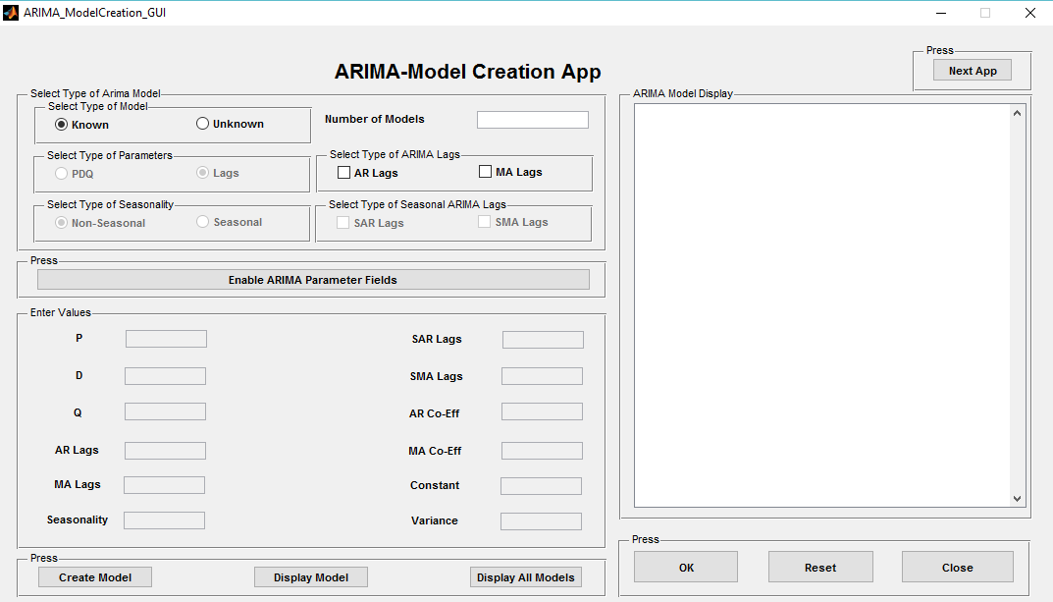

1. A8: ARIMA Model Creation GUI

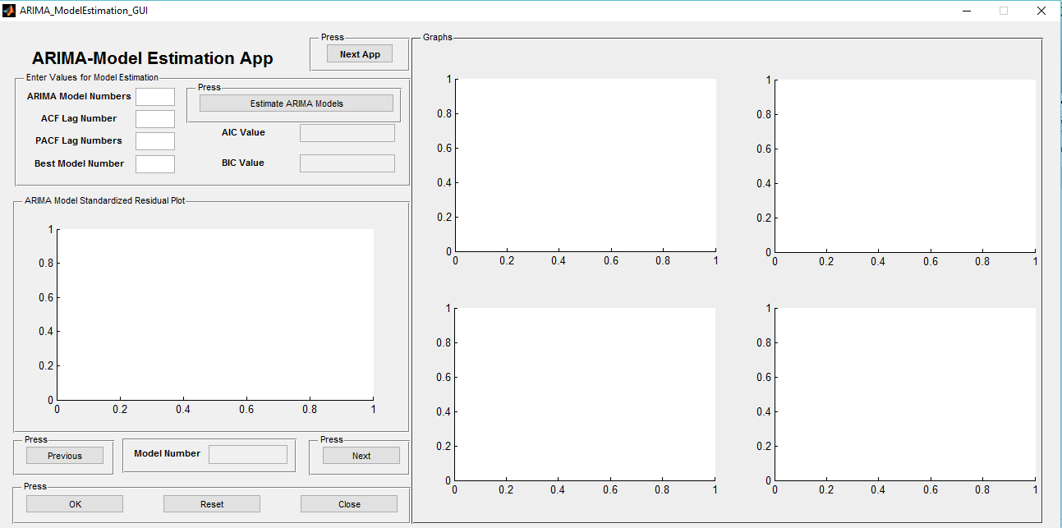

1. A9: ARIMA Model Estimation GUI

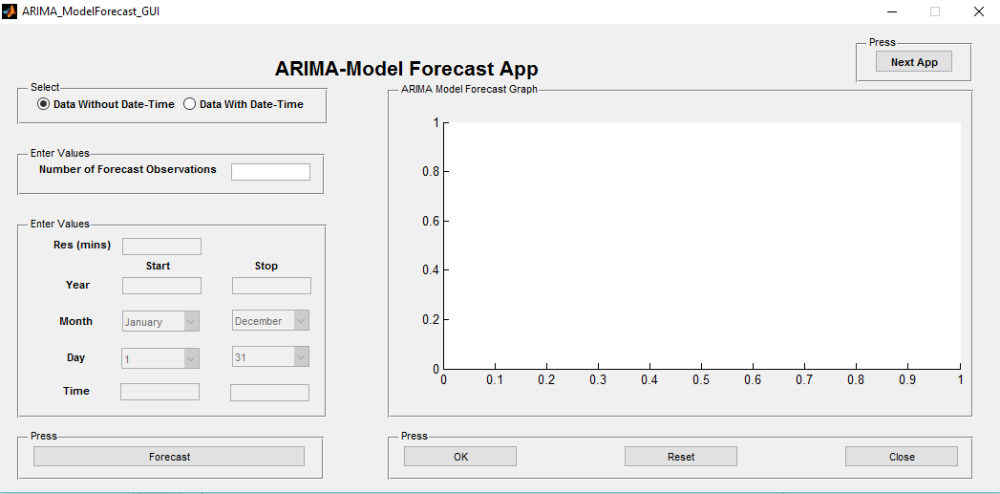

1. A10: ARIMA Model Forecast GUI

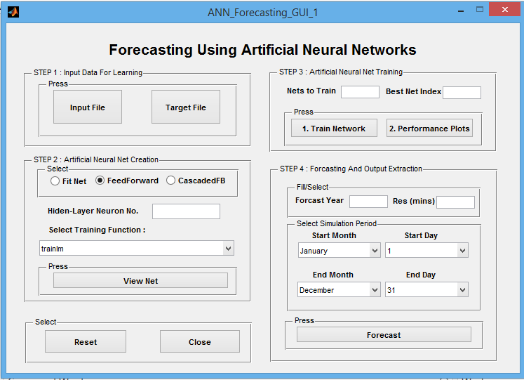

1. A11: ANN Forecasting Application GUI

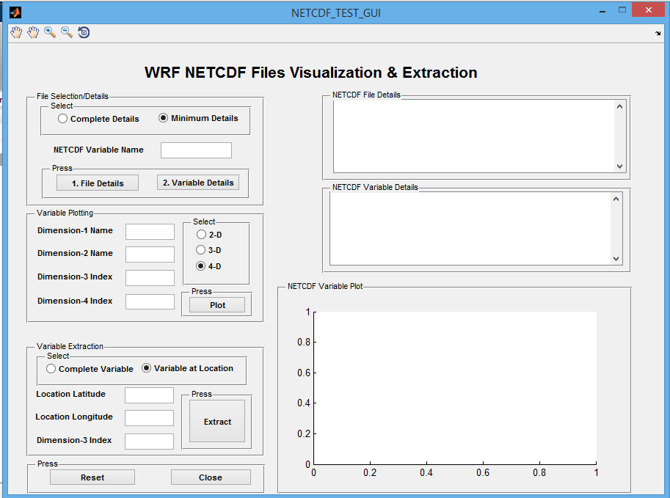

1. A12: WRF-NETCDF Visualization & Extraction GUI

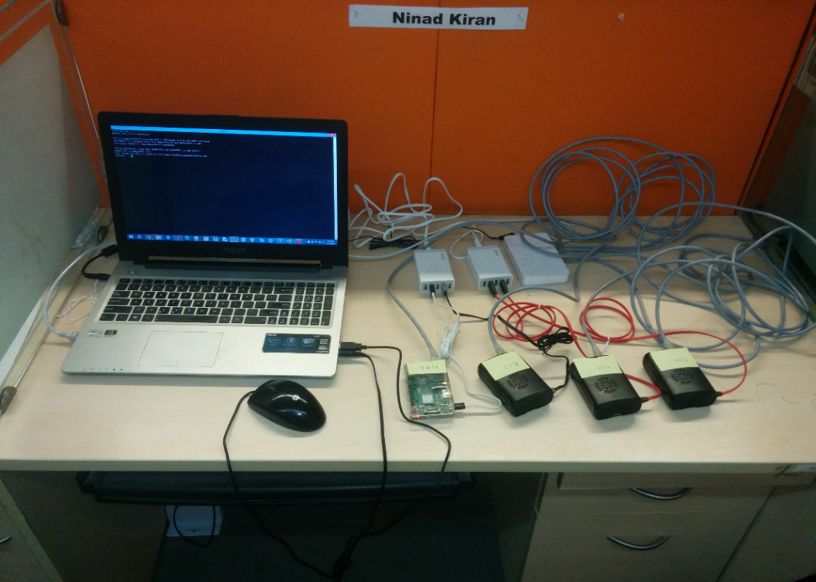

1. A13: 4-Node Raspberry-Pi2 Cluster for running WRF software

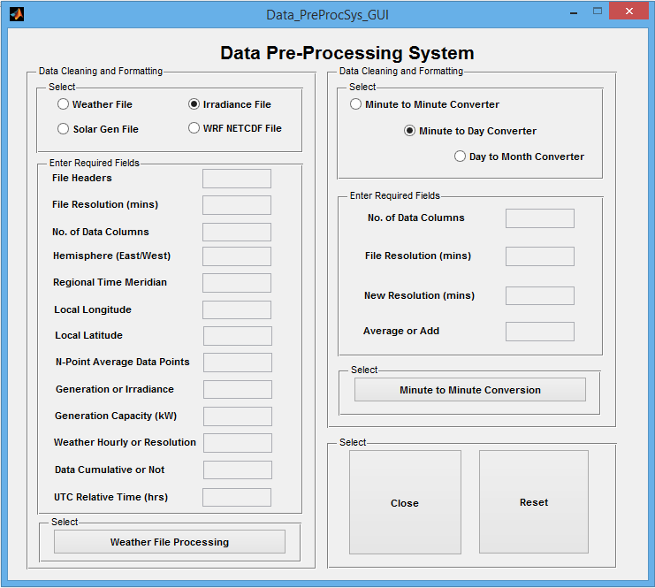

1. A14: Data Pre-Processing System App GUI