
Core Cloud and Networking Skills

Exercise Guide


Learner Name:
Date:

Core Cloud and Networking Skills – Part 1

Activity 1: Research into problem solving

- What are the most effective problem-solving frameworks used in various industries?

- How does the choice of problem-solving methodology affect the efficiency and success of outcomes?

- How has technology transformed traditional problem-solving methods?

Activity 2: Task tracking systems

- What features are most commonly used in task tracking systems?

- How do task tracking systems improve individual productivity and team collaboration?

- What are the most significant barriers to the adoption of task tracking systems in organisations?

Activity 3: Maintenance approaches

- What are the key differences between reactive, preventive, and predictive maintenance approaches?

- How do organisations determine which maintenance approach is most suitable for their operations?

- How do maintenance practices contribute to sustainability goals, such as waste reduction and energy efficiency?

Activity 4: CIA Triad

- What is the importance of the CIA Triad in modern information security frameworks?

- What are the most effective methods for ensuring confidentiality in data transmission?

- What are the most common threats to data integrity, and how can they be mitigated?

- What are the impacts of distributed denial-of-service (DDoS) attacks on availability, and how can they be prevented?

Activity 5: IAAA

- How do the components of IAAA (Identity, Authentication, Authorisation, and Accounting) interact to secure access to systems and data?

- What are the most reliable methods for verifying user identity in digital systems?

- How do multi-factor authentication (MFA) methods improve the security of authentication systems?

- How does the principle of least privilege (PoLP) enhance the authorisation process?

- How do organisations effectively monitor and log user activities as part of accounting?

Activity 6: Defining malware
Complete the table below.
Terms | Define attack method
Viruses
Worms
Trojans
Ransomware

Spyware

Adware

Rootkits

Bots/botnets

Keyloggers

Logic bombs

Backdoors

Malware

Scareware

Exploit kits

Activity 7: Malware

- What are the key motivations behind the creation and deployment of malware?

- What are the most effective techniques for detecting malware in real-time?

- How can organisations implement proactive measures to prevent malware infections?

- What are the short-term and long-term impacts of malware attacks on businesses?

Activity 8: OTP
Scenario:
You are an operative for a highly secretive spy agency, and your mission is to intercept and decode a message broadcasted over a number station. The message, encrypted using a One-Time Pad (OTP), is critical to uncovering a plot that threatens national security.
The number station broadcasts the following encrypted message in groups of five digits:
19022516 00 11130221 00 2312 00 06071513222605
Your field team has provided you with the following One-Time Pad (OTP key):
07190311 00 25042216 00 0923 00 14020821170612

Decrypt the message:
Using modular arithmetic (subtraction mod 26), decode the message by subtracting the OTP key from the intercepted message. If the result of any digit subtraction is negative, add 26 to adjust it back into the 0–9 range (use Excel to help you).

Example:
- Encrypted digit: 02
- Key digit: 19
- Decrypted digit: ((02 - 09) = -17) +26= 9
Interpret the decoded message
Once decrypted, the resulting sequence of numbers represents an alphanumeric message encoded in a numeric cipher (e.g., A=1, B=2, ..., Z=26, and 0=space).
A | B | C | D | E | F | G
1 | 2 | 3 | 4 | 5 | 6 | 7
H | I | J | K | L | M | N
8 | 9 | 10 | 11 | 12 | 13 | 14
O | P | Q | R | S | T | U
15 | 16 | 17 | 18 | 19 | 20 | 21
V | W | X | Y | Z | Space
22 | 23 | 24 | 25 | 26 | 0

Example:
- Decrypted sequence key:
8 | 15 | 12 | 16 | 0
H | E | L | P | Space

What is the fully decrypted message?
Encrypted Key | 19 | 2 | 25 | 16 | 0 | 11 | 13 | 2 | 21 | 0 | 23 | 12 | 0 | 6 | 7 | 15 | 13 | 22 | 26 | 5
OTP | 7 | 19 | 3 | 11 | 0 | 25 | 4 | 22 | 16 | 0 | 9 | 23 | 0 | 14 | 2 | 8 | 21 | 17 | 6 | 12
Decrypted Key
Decrypted message

Activity 9: Encryption Q&A

- What are the key differences between symmetric and asymmetric encryption, and how do they impact performance and security?

- How does encryption differ when applied to data at rest, in transit, and during processing?

- How does full disk encryption (FDE) help protect sensitive data in the event of theft or loss of devices?

- How do encryption technologies support multi-factor authentication (MFA) and secure access controls in enterprise environments?

Activity 10: Cloud models

- What are the key differences between the three primary cloud service models: IaaS, PaaS, and SaaS?

- How does a private cloud model compare to public cloud in terms of cost, control, and security?

- What are the security risks associated with public cloud models, and how can these be mitigated?

Activity 11: Cloud Q&A

- What does ‘cloud computing’ mean, and how does it work?

- What are the key differences between public, private, and hybrid clouds?

- How does a private cloud differ from a public cloud?

- What is cloud storage, and how is it different from traditional storage methods?

- What are the advantages of using cloud technology for businesses?

Activity 12: Virtualisation Q&A

- How does virtualisation differ from traditional computing methods?

- What are the two types of hypervisors, and how do they differ?

- What are some popular virtualisation software solutions?

- What is a virtual machine (VM), and how is it created and managed?

Activity 13: Storage and backup Q&A

- What are the different types of data backups?

- How does a full backup differ from an incremental backup?

- What is a differential backup, and when is it most useful?

- What are the advantages and disadvantages of each backup type?

- What is the 3-2-1 backup strategy, and why is it recommended?

Activity 14: Wireless practical
Open Packet Tracer along with the ‘Activity 14 Packet Tracer Troubleshooting a Wireless Connection.PKA’ file and apply your resolution. Identify and correct the configuration in a wireless network.

Introduction
One of the wireless clients is unable to access the network. All PCs are configured automatically with DHCP. Try to identify and resolve the issue.
Note: Remember to save any files once your activity is complete.
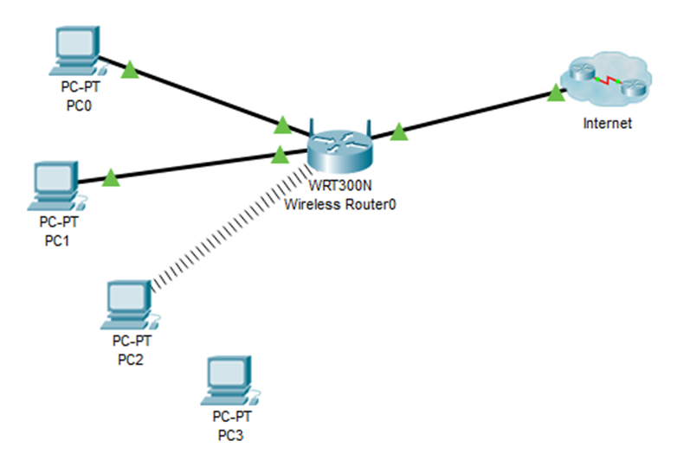
- Verify connectivity
- Access the Desktop > Web Browser of each PC and type www.qa.com into the URL. Identify any PCs that are not connecting to the web server.
Note: All devices require time to complete the boot process. Please allow up to one minute before receiving a web response.
- Which PCs are unable to connect to the web server?

- Examine the IP configuration of the PCs
- On a PC that is unable to connect, access the Command Prompt from the Desktop tab.
- Type the ipconfig /all command.
- What IP addressing information is available?
- Examine the Wireless Settings on the Wireless Client
- On the Desktop tab of any PC that is unable to connect. Click PC Wireless to access the wireless configurations.
- Click Connect tab and record the associated SSID.

- Examine the Wireless Settings on the Wireless Router
- Access the Wireless Router from the web browser of a wired PC.
Use the username: admin and password: admin to access the wireless router.
What IP address did you use? (Hint: Default Gateway).
- On the Basic Setup page, examine the DHCP Server Setting configuration.
Is DHCP enabled?
- Click the Wireless tab.
- Examine the setup information under the Wireless tab:
What is the SSID?
Does it match the SSID configured on the client?
- Click the Wireless Security submenu.
- Examine the security settings:
What is the wireless security mode?
What is the passphrase?

- Make any necessary configuration changes on the Wireless Clients
- On the Desktop tab of any PC that is unable to connect, click PC Wireless to correct the wireless configurations.
- Click Connect tab. Select the Learning wireless network and click Connect.
- Enter the Passphrase (Pre-shared Key) recorded from the wireless router. Click Connect.
- Using the Web Browser within the Desktop tab, connect to www.qa.com to verify that the configuration changes have resolved the problem.

Activity 15: IPv4 practical
Open Packet Tracer along with the ‘Packet Tracer IPv4.PKA’ file and apply your resolution.

Introduction
In this activity you will configure devices with their IP Address and Subnet Mask. You will learn how the Default Gateway provides the path to other destinations beyond the local network.
Note: Remember to save any files once your activity is complete.
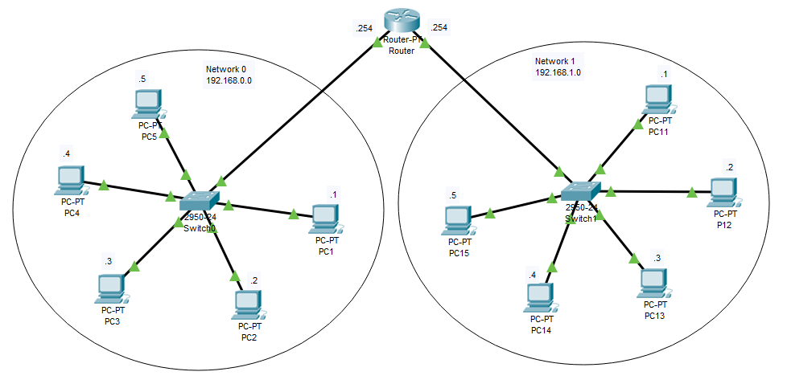

- Configure the devices with an IP address
The diagram in the Packet Tracer Logical workspace shows two networks connected by a router:
- Network 0: 192.168.0.0
- Network 1: 192.168.1.0
The first 24 bits in the IP address define the network and the remaining 8 bits define the host.
The network/host bits are defined by the subnet mask: 255.255.255.0
All devices in Network 0 share the same network address but must have a unique host address within that network.
Likewise, all devices in Network 1 share the same network address but again, must have a unique host address.

The table below shows the addressing scheme:
Network 0 |  | Network 1
Device | IP address and subnet mask | Device | IP address and subnet mask
PC1 | 192.168.0.1  255.255.255.0 | PC11 | 192.168.1.1  255.255.255.0
PC2 | 192.168.0.2  255.255.255.0 | PC12 | 192.168.1.2  255.255.255.0
PC3 | 192.168.0.3  255.255.255.0 | PC13 | 192.168.1.3  255.255.255.0
PC4 | 192.168.0.4  255.255.255.0 | PC14 | 192.168.1.4  255.255.255.0
PC5 | 192.168.0.5  255.255.255.0 | PC15 | 192.168.1.5  255.255.255.0

In Network 0, click PC1>Desktop>IP Configuration.
- Select Static.
- Using the above table for reference, enter the IP address and subnet mask.
- Close the IP Configuration window.
- Repeat steps 1 to 4 for the remaining 4 PCs in Network 0.
- Continue with the five PCs in Network 1.
Note: Remember, the network address for these devices is slightly different.

- Configure the router ports
Some of the router configuration has already been configured for this activity, but you will need to configure the Interfaces. Just like the PCs, each Interface needs a network ID and a unique host number. The last IP address in the range 1 to 254 has been allocated:
Router
Network 0 |  | Network 1
FastEthernet0/0 | IP address and subnet mask | FastEthernet1/0 | IP address and subnet mask
 | 192.168.0.254  255.255.255.0 |  | 192.168.1.254  255.255.255.0

- Select Router>Config>FastEthernet0/0.
- In the IP Configuration window, enter the IP address and subnet mask (from the table above).
- Turn the interface on by selecting the Port Status check box.
- Repeat steps 1 to 3 for FastEthernet1/0.
- Close the Config window.

- Introducing the Default Gateway
All device interfaces are now connected and configured.
- Ping PC1 to PC5
Successful: Yes/No?
- Ping PC1 to Router
Successful: Yes/No?
- Ping PC11 to PC15
Successful: Yes/No?
- Ping PC11 to Router
Successful: Yes/No?
- Ping PC1 to PC11
Successful: Yes/No?
You appear to be able to connect to devices within each network, but you were not successful when trying to connect to the other network.
All devices are aware of their connections, but they have no idea where they should go, or who they should ask when trying to connect to another network.
This is where the Default Gateway can help. It opens the door to other networks. Therefore, every device needs to know where the entrance/exit can be found.
Let’s see what happens when you configure each device with the Default Gateway. Only the PCs in Network 0 and Network 1 need this information.

- Configure a device with the Default Gateway
- Select PC1>Desktop>IP Configuration.
- In the IP Configuration window, enter the value of the Routers FastEthernet0/0 IP address:
Default Gateway: 192.168.0.254
- Close the window.
- Repeat steps 1 to 3 for PCs 2 to 5.
- Again, repeat steps 1 to 3 for PCs 11 to 15 making sure you use the value of the routers FastEthernet1/0 IP address.
If your configuration settings are all correct, you should see the following score:
Investigate and resolve any issues before continuing.

- Verify the connections
In the lower right corner of the Packet Tracer interface are tabs to toggle between Realtime and Simulation mode.
- Select the Simulation mode icon to switch from Realtime mode to Simulation mode.
- Toggle the Show All/None check box to set the visible filters list to none.
- Select Edit Filters, select ICMP, which can be found under the IPv4 tab.
- Close the Edit ACL Filters window. The Visible Events should now display ICMP only.
- Open the PDU List Window by clicking on the left arrow at the very bottom of the screen.
- Select the Delete button to remove any existing PDUs from the list.
- Select a simple PDU by selecting the closed envelope on the top horizontal toolbar. Move your cursor to the display area of your screen.
- Select PC1 to establish the source. Move your cursor to PC11 and select to establish the destination.
- Select Auto Capture / Play from the Play Controls area of the Simulation Panel and observe the traffic generated by the Ping request.
- Repeat the test for the following:
  - Source: PC12
  - Destination: PC2
- Summarise your observations.

Activity 16: IPv6 Q&A

- What is IPv6, and why was it developed?

- How does IPv6 differ from IPv4?

- What are the main advantages of IPv6 over IPv4?

- What is the structure of an IPv6 address?

- How many bits are in an IPv6 address?

- What are the different types of IPv6 addresses?

- What is the purpose of the link-local address in IPv6?

Activity 17: DNS practical
Open Packet Tracer along with the ‘Packet Tracer DNS Server.PKA’ file and apply your resolution.
This simulation activity will introduce you to DNS, where you will create a DNS record to point to a web server and verify the functionality. You will then use Packet Tracer Simulation mode to examine the associated PDUs.

Topology:
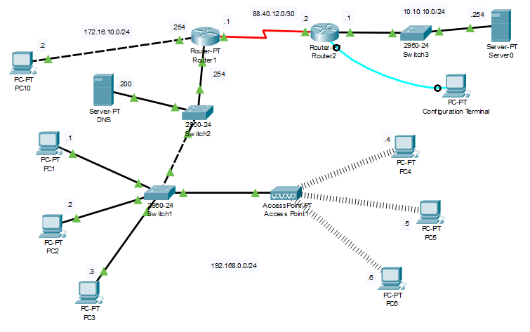
A. Add and connect the sever to the network
- Select End Devices from the options in the bottom left-hand corner. Drag and drop a Server  into your network.
- Rename the Server: DNS
- Select the correct cable and connect it to FastEthernet0/21 on Switch2.
- Select Server>Desktop>IP Configuration.
- Select Static and add the following IP address details:
IP Address: 192.168.0.200
Subnet Mask: 255.255.255.0
Default Gateway: 192.168.0.254
DNS Server: 192.168.0.200
- You should be able to ping the Server from other hosts in the network.

B. Create a DNS record
- Select Server>Services>DNS.
- In the Resource Records window, enter www.qa.com
- In the Type dropdown select A Record. Make a note of the other Record Types.
- The qa.com website is hosted on Server0. Establish the IP address for Server0 and enter the value into the Address field.
- Select Add.
- Notice that the DNS Service is currently switched Off. Select On to activate the service.
- Close the DNS window.

C. Verify the functionality from a web browser on a PC
- Open the web browser on PC1.
- Select PC1>Desktop>Web Browser.
- Enter www.qa.com into the URL field, then click Go.
- You have probably received a response: ‘Host name unresolved’ - Why do you think this has happened?
- Select PC1>Desktop>IP Configuration.
What is the current value for the DNS server? What do you think this value should be?
- Enter your answer into the DNS Server field and repeat the above from step 1.
- Hopefully you should have connected to the website and received a response. If not, try to resolve the problem
- Once PC1 can successfully access the web page on Server0, check/modify the DNS IP Address configuration on the remaining PCs on network 192.168.0.0/24.
- Before continuing, confirm that all PCs on network 192.168.0.0/24 can access the qa.com website.

D. Modify a simple html webpage on a web server
- Select Server0>Services>HTTP.
- Find the index.html file name and select Edit.
- Here you will find the html code for the web page. Try making some subtle changes to the text, then select Save and Yes to overwrite the file. Note that the positioning, font size and text colour are also defined in the script.
- Access the web page again from one of the PCs on network 192.168.0.0/24 to observe the result from the changes you made.
E. Observe the DNS communication between devices
As you have already used Simulation Mode in Packet Tracer:
- Select Edit Filter. Select DNS under IPv4 tab.
Remember: You can toggle Show All/None to deselect all filters first, before selecting DNS.
- Select PC1>Desktop>Web Browser.
- Enter www.qa.com into the URL field, then click Go.
- Use the Play Controls in the Simulation Panel to view the results.
Provide a summary of your observations and creations.

Activity 18: DHCP practical
Open Packet Tracer along with the ‘Packet Tracer DHCP Enabled Router.PKA’ file and apply your resolution.
This simulation activity will introduce you to the GUI (Graphical User Interface) on the Linksys-WRT300N Router. The configuration process on this Packet Tracer device is a little different to others you may already be familiar with.
Note: Remember to save any files once your activity is complete.

Topology
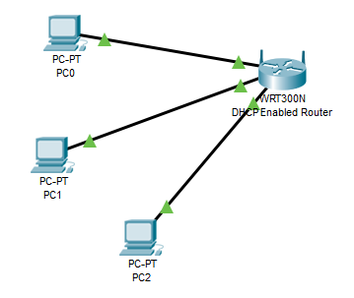

- Observe the default DHCP settings
- Add three PCs to the Packet Tracer workspace and a WRT300N router.
- Connect each PC to the router using Copper Straight-Through cables as per the table below:
Device | Interface | WRT300N interface
PC0 | FastEthernet0 | Ethernet 1
PC1 | FastEthernet0 | Ethernet 2
PC2 | FastEthernet0 | Ethernet 3

- Select the Linksys-WRT300N Router to open the configuration window.
- Select the Config tab and change the Display Name to DHCP Enabled Router.
- Select the GUI tab - this navigates to the Setup / Basic Setup page within the Linksys GUI.
- Assign an IP address to the Linksys device.
- In the Network Setup>Router IP section, assign the following IP address to the Linksys device: 192.168.5.1.
- Scroll to the bottom of the GUI page and select Save Settings.
- Scroll back up to the Router IP section to ensure the change is made.

- Change the default DHCP range of addresses
Notice that the starting IP address in the DHCP Server Setting has been updated to match the same network as the IP address of the Linksys device: 192.168.5.100.
- Change the Starting IP Address from 192.168.5.100 to 192.168.5.30.
- Change the Maximum Number of Users to 40.
- Scroll to the bottom of the GUI page and select Save Settings.
- Scroll back up to the DHCP Setting section to ensure the change is made. Notice the range of address available to clients has updated to reflect the change.
- Close the Linksys configuration window.

- Enable DHCP on the client workstations
- Select PC0.
- Select the Config tab. Go to Interface FastEthernet0.
- Enable DHCP by selecting the DHCP button in the IP Configuration panel.
Notice that an IP address and subnet mask are automatically assigned.
- Close the configuration window.
- Observe the IP configuration of a client that does not have DHCP enabled.
- Select PC1.
- Select Desktop tab > Command Prompt.
- Type ipconfig and press enter. Notice that all settings are set to 0.0.0.0. No IP address is assigned statically, and the PC has not obtained an address automatically from DHCP.
- Enable DHCP on PC1 and PC2, using the Config tab as outlined previously. Notice that a different IP address from the one assigned to PC0 is automatically assigned to PC1 and PC2.
- Close the configuration window.

- Verify connectivity
- Select PC0 and select the Desktop tab > Command Prompt.
- Type ipconfig to view the IP configuration of PC0.
- Type ping 192.168.5.1 to ping the Linksys Router.
- Type ping 192.168.5.31 to ping PC1.
- You should receive a reply from both devices.
- Close the configuration window.

- Observations
- Using ipconfig, which IP address is common for all three PCs?
- Close the configuration window.

- Accessing the GUI from a PC
- Open a Web Browser on one of the PCs
- Enter the IP address of the default gateway recorded earlier into the URL field.
When prompted, enter the username: admin and password: admin. You now have access to the GUI from the PC.

Activity 19: Troubleshooting practical
Open Packet Tracer along with the ‘Packet Tracer Troubleshooting Activity.PKA’ file and apply your resolution.
A customer has reported the following issue and is looking for a speedy resolution: Users on Network1 unable to communicate with Network2.
Troubleshoot and resolve this issue.
Note: Remember to save any files once your activity is complete.

Topology
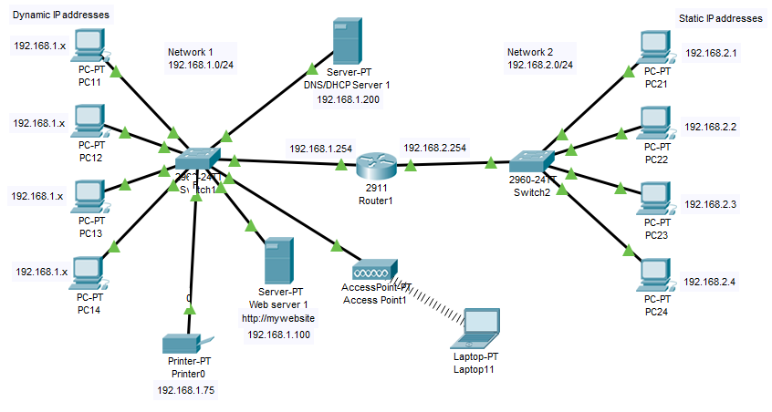
Consider the probable cause of failure (discuss possible scenarios that would create this problem):

List all the actions that could have helped you to solve the problem:

Verify the solution by repeating the tests from the above ticket.

Record your solution to the problem. (Your notes can prove invaluable if you encounter a similar issue again.):

Verify the solution by repeating the tests from the above ticket.
(If the issue persists, undo any changes and return to your list):
Verify the solution by repeating the tests from the above ticket.
(If the issue persists, undo any changes and return to your list):



