**Nuclei detection, segmentation in biomedical images**

Cheng Jin

CSYE 7245 , Spring 2018, Northeastern University

# **ABSTRUCT**

In this paper managed 3 CNN models to find the location of each nuclei in a histopathological image which has multiple cells. The principle is to divide each pixel into two categories—inside the cell and the background. By predicting each pixel inside or outside(background), it can generate a run length encoding file and read into image to indicate the location of a certain cell. This method reduces the manual work to mark out the individual cell nucleus in a microscope picture. Then calculated the accuracy of the prediction of location of the cell nucleus.

I applied the CNN to the medical image dataset, built different architectures and tuned the parameters to have a higher score of the model value and better precision of the location.

# **Link to Project**

Github with MIT license:

shttps://github.com/addabbyjin/7245NNuclei

# **INTRODUCTION**

Pathology is the microscopic study of the cell morphology supplemented with molecular information. The tissue sample is placed under the electron microscope. Tissue sample is removed form human body and used some fixative reagent to prevent cells to decay [1]. Quantitative analysis of pathological images is an important step in pathologists’ decision. The quantitative analysis can support medical decisions about the presence or the absence of a disease, and also to help in disease progression evaluation. In addition, quantitative characterization is important, not only for clinic usage (e.g., to increase the diagnostic reliability), but also for research applications (e.g., drug discovery and biological mechanisms of disease). As a consequence, the use of computer-aided diagnosis (CAD) in pathology can substantially enhance the efficiency and accuracy of pathology decisions, and overall benefit the patient.

Nuclei detection is usually the first step in the cancer detection and grading applications [1], including brain, breast, cervix, liver, lung and prostate cancer grading.

Among the various studies, automated nuclei segmentation and classification is a recurring task, particularly difficult on pathology images. Indeed, the detection and segmentation of nuclei in cytopathology images are generally facilitated due to the well-separated nuclei and absence of complicated tissue structures. In contrast, the segmentation of nuclei on histopathological images (tissue preserving its original structure) is more difficult since most of the nuclei are often part of histological structure presenting complex and irregular visual aspects.

Many researches have been done on the problem in the past and how the presenting experiment will help to clarify or expand the knowledge in this general area.

# **BACKGROUD RESEARCH OF RELATED WORK**

1. Deep Learning for Identifying Metastatic Breast Cancer[5].

The author built four classification models GoogLeNet, AlexNet, VGG16 and FaceNet and applied them to the Camelyon16 Dataset. And compared the classification accuracy of the four, then generated and post-processed the tumor heatmaps to compute slide-based and lesion-based probabilities.

1. Cell Detection in Microscopy Images with Deep Convolutional Neural Network and Compressed Sensing [6]

In this article, the author trained a CNN to work as a multi-label regression model. He also employed the image rotation on the training sets to make the system more robust. The cells are annotated by a dot or cross at the center by pixel-level labels. So, for mark out cells, we need to encode the location of cells. This article put forward two encoding schemes (Encoding by Reshaping and Encoding by Signed Distance). The creative method in this article is using Compressed Sensing in the signal acquisition and reconstruction. [2], [3]. Then the author did experiment with different datasets and with different encoding schemes, and applied the compressed sensing into the output encoding.

1. U-Net: convolutional Networks for Biomedical Image Segmentation [7]

The author built a U-net architecture several conv and max pooling layers. He did the experiments in different datasets in the segmentation challenges, and compared his results with different proposals and models in the competition. It need to be mentioned specially is that the evaluation is done by thresholding the map at 10 different levels and computation of the “warping error”, the “Rand error” and the “pixel error”.

1. Methods for Nuclei Detection, Segmentation and Classification in Digital Histopathology: A Review—Current Status and Future Potential[8]

This is a relatively comprehensive article in the field of nuclei detection. It concluded the current challenges and methods as well as the basic conception in the nuclei detection and segmentation field.

1. Keras documentation examples [9]

# **DATASET**

The training dataset has 678 samples. Each sample has a folder to hold two holders. One file folder is to place the digital histopathology picture (RGB or gray scale images). One file folder contains the black and white images to indicate the location of each cell in a multiple cells image, every image has a location of one cell. We call the label images as “mask”. In the pre-processing stage, the Run Length Encoding file is used to encode the masks, to encode each pixel in the “mask” into a row of numbers.

# **NETWORK ARCHITECTURE**

Convolution Neural Network is an effective deep learning model widely used in the image recognition and classification. The CNN does best most of the time in the image classification compared to other models. So I built the CNN model first.

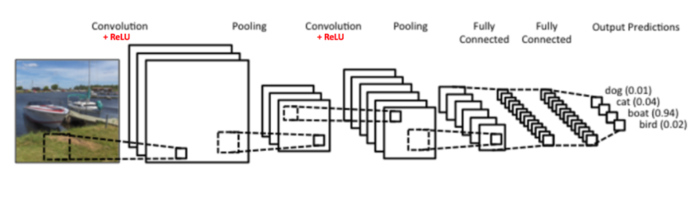

Figure 1: A simple ConvNet.

1. CNN model 1

This CNN model consists: BatchNormalization🡪Conv2D 🡪 Conv2D 🡪 Conv2D(dilation) 🡪 Conv2D (dilation)🡪 Conv2D (dilation)🡪MaxPooling2D🡪 Conv2D🡪 Conv2D

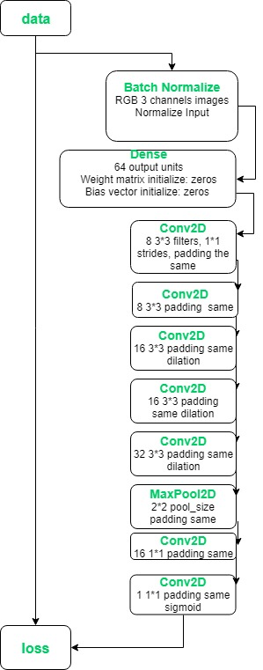2. CNN model 2

This CNN model consists: BatchNormalization🡪Conv2D🡪MaxPooling2D🡪 Conv2D🡪Dropout🡪 Conv2D(dilation)🡪Dropout🡪 Conv2D (dilation)🡪 Conv2D (dilation)🡪MaxPooling2D🡪 Conv2D🡪 Conv2D

3. CNN model 3

This CNN model consists:

BatchNormalization🡪 Dense 🡪 Conv2D🡪MaxPooling2D🡪 Conv2D🡪Dropout🡪 Conv2D(dilation)🡪Dropout🡪 Conv2D (dilation)🡪 Conv2D (dilation)🡪MaxPooling2D🡪 Conv2D🡪 Conv2D

In the field of image classification, it is typical to use the convolutional neural network where the output to am image is a single class label. However, in many biomedical image processing, the desire output should include the localization, such as a class label is supposed to be assigned to each pixel [4]. In some cases, when the boundaries between the cell and the background is vague, there are three classes of the pixels—inside the cell, the boundaries, background. In some cases, there are two classes—inside cell, the background. So through the training of the model, the model learns to identify or classify each pixel into different classes, and predict the class label of each pixel in the testing images.

# RESULTS

The result of the location of cells are shown in two-colors pics:

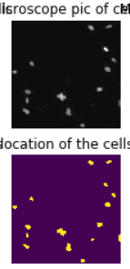

The result of the CNN model 1 is:

The lowest loss is 0.0424, the highest accuracy is 0.9494, the mean square error is 0.0424.

The result of the CNN model 2 is:

The lowest loss is 0.0935, the highest accuracy is 0.8952, the mean square error is 0.0935.

The result of the CNN model 3 is:

The lowest loss is 0.0394, the highest accuracy is 0.9538, the mean square error is 0.0394.

# **COCLUSIONS**

This study is based on the public kernels in the Kaggle 2018 Data Science Bowl and papers mentioned in the related background research part in this article.

During the training process of each epoch, the accuracy raised and reached a summit then dropped down to 86.61. It is a weird, If I keep the model1 main body unchanged and only changed the activation function to relu in the last convolutional layer, accuracy of each epoch will be 86.61. The reason is that, the relu filtered all the negative value and keep the positive value as themselves, in this example, it need to classify pixels into two classes, so the value in every pixel is either be filtered out or keep unchanged. So, if we input the image into the epoch again, the results of the pixels classification will be unchanged. If we use the sigmoid as the activation function, the value will not be projected as themselves, it will change.

# **REFERENCES**

[1] Humayun Irshad, Antoine Veillard, Ludovic Roux, Daniel Racoceanu. Nuclei Detection, Segmentation and Classification in Digital Histopathology: A Review—Current Status and Future Potential.

[2] David L. Dnoho. Compressed sensing. IEEE Transactions on Information Theory, 2006.

[3] Justin Romberg Emmanuel Candes. Practical signal recovery from random projections. IEEE Transactions on Signal Process, 2005.

[4] U-net: Convolutional Networks for Biomedical Image Segmentation <https://arxiv.org/abs/1505.04597>

[5] <https://arxiv.org/abs/1606.05718>

[6] <https://arxiv.org/abs/1708.03307>

[7] <https://arxiv.org/abs/1505.04597>

[8] <https://ieeexplore.ieee.org/document/6690201/references>

[9] <https://github.com/keras-team/keras/blob/master/examples/README.md>

[10] code reference <https://www.kaggle.com/kmader/nuclei-overview-to-submission>