**PREDICTION OF NEW USER’S DESTINATION ON AIRBNB DATASET**

**Ayush Jain, Shweta Pathak, Ramya Sri Gujjari**

{jain.ayu, pathak.sh, gujjari.r} @husky.neu.edu

INFO 7390, Spring 2018, Northeastern University

1. **Abstract**

Airbnb is a trusted community marketplace for people to list, discover and book unique accommodations around the world. For Airbnb, the enormous user data that they have been inherently maintaining is a mine of gold. Performing data mining based on customer’s historical behavior statistics can reveal a lot of hidden information that wasn’t paid attention to in the past. Maneuvering this data can help to effectively enhance user experience and increase the total booking of Airbnb.

In this paper, we develop a model to predict the destination city of a new user on Airbnb based on their demographics. The original dataset was taken from Kaggle competition and after performing comprehensive analysis, we enhanced it by adding new predictors related to the user’s demographics and existing customer’s data. Since this is a classification problem, we deployed a number of methodologies like Multinomial Naive Bayes Classifier (MNB), Multilayer perceptron classifier (MLP), Random Forest Classifier (RFC), Support Vector Machine Algorithm (SVM) and Recurrent Neural Networks (RNN) and tested the dataset on each of them. After comparing each of these models and their accuracies with Kaggle’s competitions models, we found that for Random Forest Classifier, we are able to achieve accuracy of 68% which is better than Kaggle’s 66% after adding additional features.

This report contains an introduction to the problem and comprehensive analysis on the dataset followed by feature engineering. Then we applied several classification models and after comparing each of their results, we proposed the best model which is RNN with an accuracy of *99.7%.*

1. **Introduction**

Airbnb is an American company which operates an online marketplace and hospitality service for people to lease or rent short-term lodging including holiday cottages, apartments, homestays, hostel beds, or hotel rooms, to participate in or facilitate experiences related to tourism such as walking tours, and to make reservations at restaurants. [1] By predicting the destination of a new user accurately, Airbnb can enhance user experience and fasten the average time taken for first bookings. Since Airbnb is a common and a famous portal that is used on a daily basis, we thought of this topic to be both interesting and useful in providing more insight for personalization of the content according to the various users.

The dataset used in this project is provided by Airbnb and contains a list of users along with their demographics. We used 2 of the CSV files namely, train_users_2 and test users as our dataset. Unlike Kaggle, we have chosen to predict the new user’s first booking destination at the granularity of city rather than the country. There are 10 destination cities to choose from, including, Dubai, Paris, Mumbai, Washington DC, Las Vegas, Shanghai, Rio De Janeiro, Chicago, Singapore, London and all the rest are labelled as “others” and users who have not made a booking are categorized with “NDF” label in the destination field. In the dataset, Airbnb provides a labelled training set of 213451 entries with 16 properties and a test set of 62097 with 15 properties to predict. Based on user’s behavior and the general factors that affect the planning of a trip to a destination, we added few features to the dataset such as ‘Personality’, ‘Types of Trips’, ‘Budget’, ‘Length of Trip’ and ‘Preferred Month’.

As the dataset contained number of inconsistent and null values which could have hampered the prediction, we performed data cleaning and dropped the irrelevant entries. Further Exploratory Data Analysis (EDA) was performed, resulting into statistical insights and visualizations on the trained dataset. For model selection, we started with supervised learning algorithms, and then narrowed the category down to utilize the classification methods. By modeling the data with different classifiers like Naive Bayes, Multilayer perceptron classifier, Random Forest Classifier, Support Vector Machine Algorithm and Recurrent Neural Networks; we are convinced that *RNN* seems to work the best for this prediction.

1. **Code with Documentation**

Since our entire dataset is filled with categorical labels, which are the destination cities of users’ fist booking, each data entry is basically a pair of an input vector and a desired output value. As our prediction is also a categorical value which is discrete, we identify this problem to be a supervised learning classification problem that can be best solved using classification methods.

* 1. **Exploratory Data Analysis**

Exploratory data analysis (EDA) is an approach to analyzing data sets to summarize their main characteristics, often with visual methods. A statistical model can be used or not, but primarily EDA is for seeing what the data can tell us beyond the formal modeling or hypothesis testing task. [12]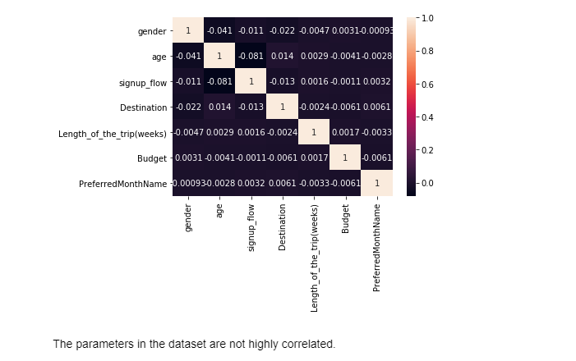  
To understand the correlation between different parameters present in our dataset, we plotted a heat map and discovered that the correlation between the different parameters is not very strong.   
  
We then plotted gender of the users by splitting them in two classes ‘male’ and ‘female’ (in percentage) on X-axis against the destination cities on Y-axis using a bar chart.

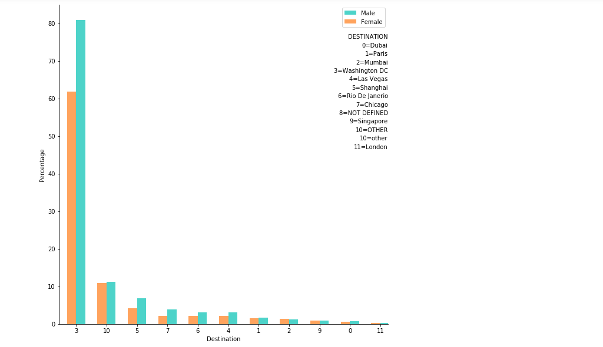  
The graph portrays that about 80% of the travelers are male and maximum travelers travel to Washington DC, thus making it the most visited city. The least travelled city, according to the graph is London.  
  
We then conducted analysis on the ‘age’ of the users mentioned and decided to split them into 2 sections: one with age above 45 as ‘Olders’ and the one with age below 45 as ‘Youngers’. This analysis gives us an insight into what category of people want to travel to which country.  
The graph describes that over 70% of ‘younger’ and about 67% of ‘older’ people travel to Washington DC which again proves that Washington DC is the most visited destination city. Again, the least preferred destination by both the age categories is ‘London’.

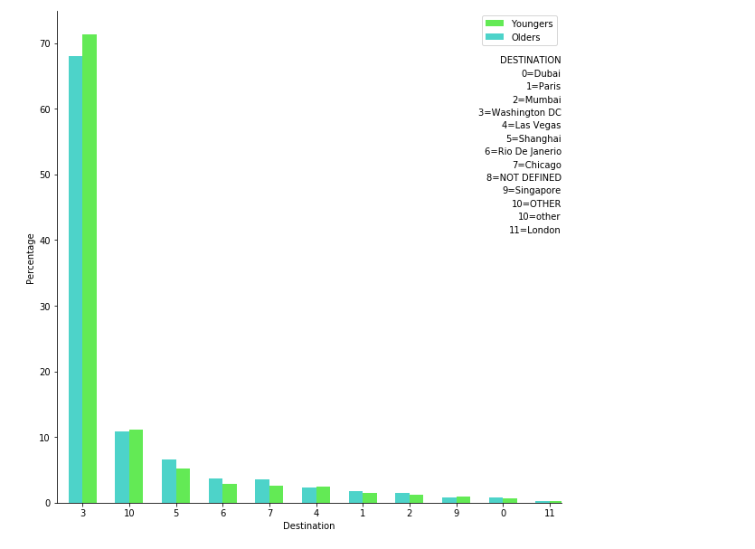  
  
Another analysis shows that the preferred ‘Type of Trip’ is a ‘Group’ type followed by ‘Solo’ trips and the last being ‘Couple’ ones. The most preferred destination city is again Washington DC and the least preferred is ‘London’ again. This bar chart uses Types of Trips in percentage on Y-axis and Destination City on the X- axis.

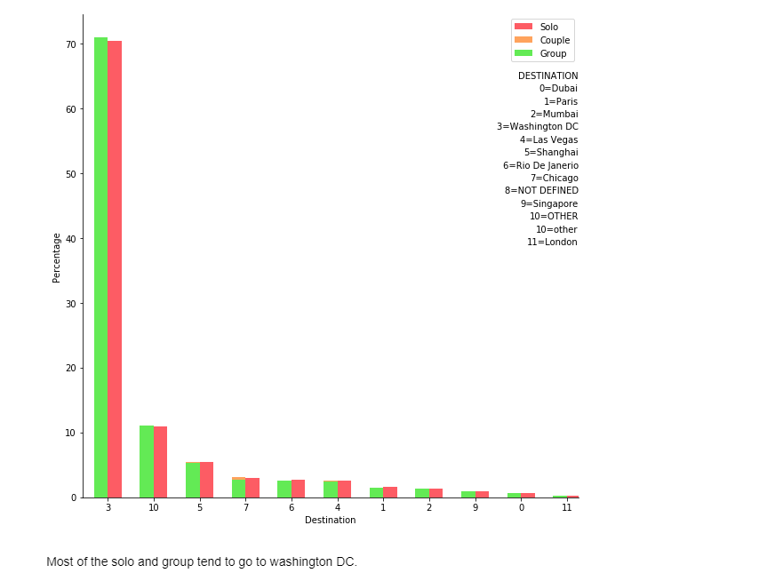

* 1. **Feature Parsing**

After performing EDA, we noticed that most of the features in the *train_users_2.csv* are in string format. However in order to make the model work effectively they needed to be in a numerical format. We used *‘one-hot encoding’* to give some features with values between ‘1’ and ‘n’ classes which is the number of types of this feature. This process could result into *overfitting* due to the increased number of features and thus we progress with feature selection as a solution to this problem. [2]

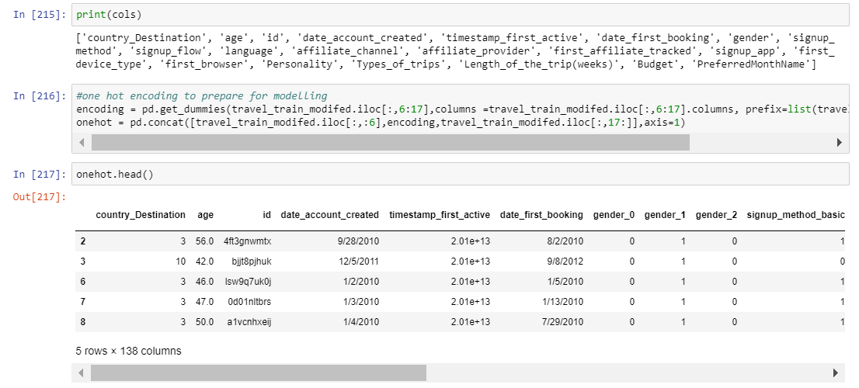

**3.3 Feature Selection**  
After one-hot-encoding’, the number of features in our data set increased to 138 which could have contributed to over-fitting. To tackle this problem, we performed feature selection which is a process where you automatically select those features in your data that contribute most to the prediction variable or output in which you are interested. [3]  
  
Feature importance scores can be used for feature selection in scikit-learn.[4] We used 2 ways for feature selection, namely XGBoost and Extra Trees Classifier as they automatically provide the estimates of feature importance from a trained predictive model. The reason we used both the ways is to validate the results of each of the methods and use the best of the features for prediction.

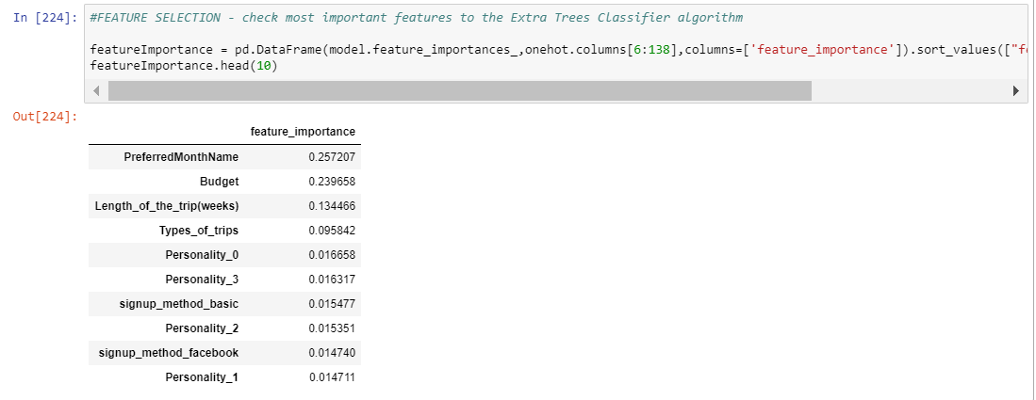

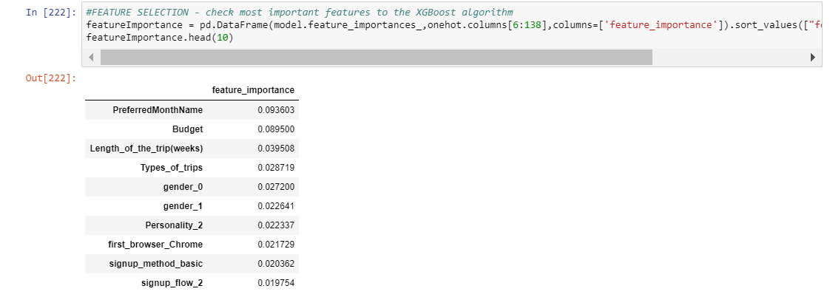

* 1. **Random Forest Classifier (RFC)**

Random Forest Classifier creates a set of decision trees from randomly selected subset of training set. It then aggregates the votes from different decision trees to decide the final class of the test object. [5]

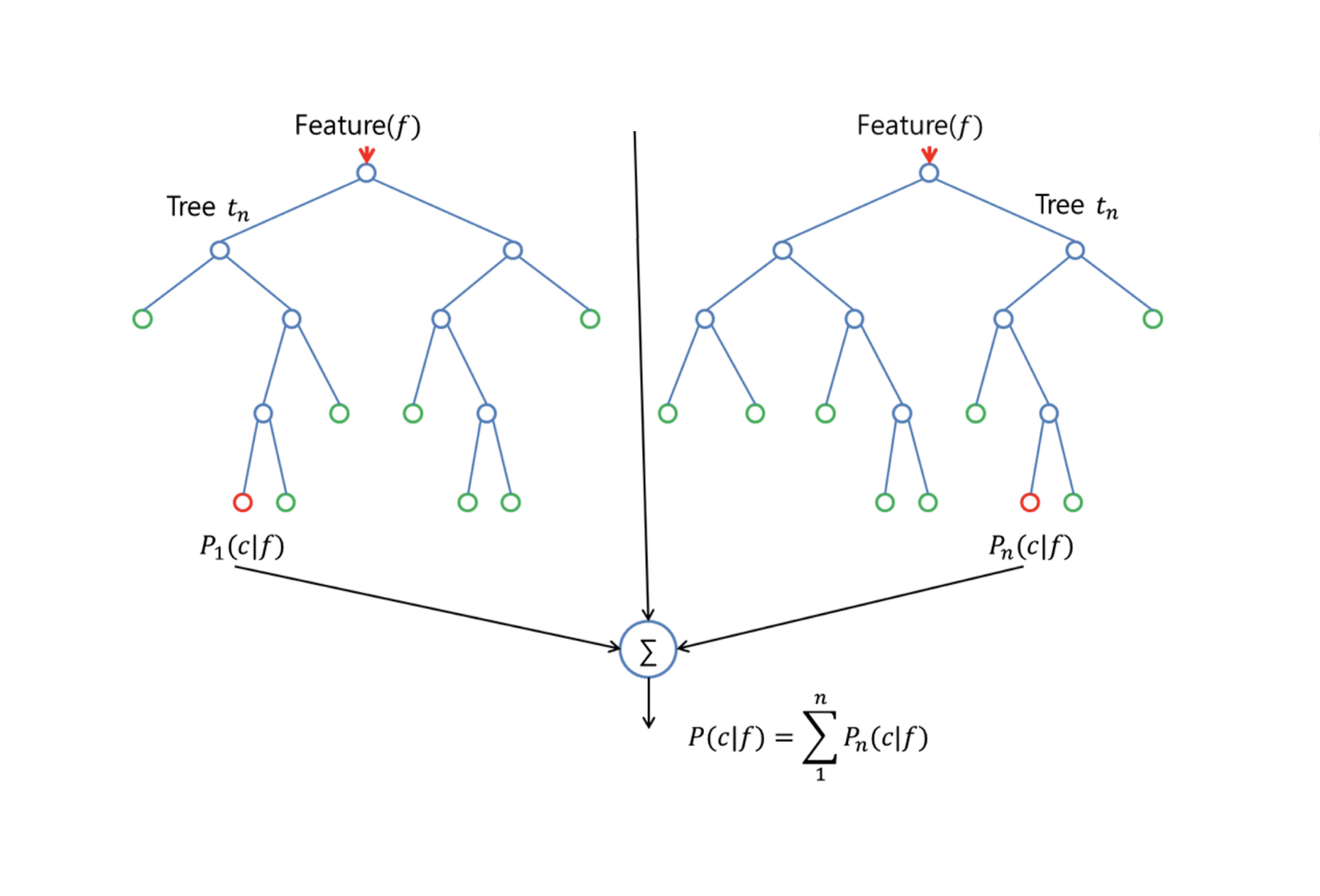  
The reasons we chose Random Forest Classifier for our dataset are:

* As most of the features in our data set are categorical values and can be handled using RFC
* RFC deals with classification tasks which align with our problem
* RFC is known to handle missing values

***Before Feature Selection:***

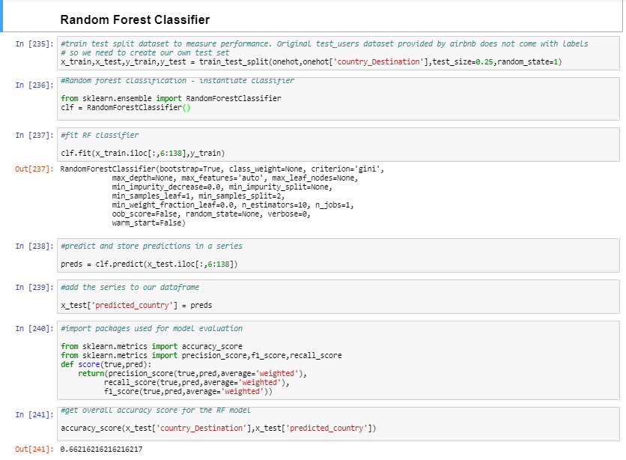

***After Feature Selection:***

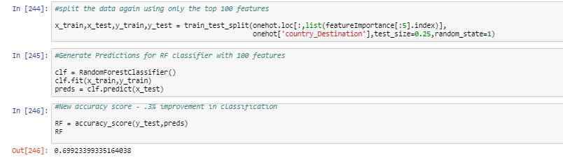

Using RFC, we were able to achieve an *accuracy rate of 70%* as compared to the accuracy of *62% provided by Kaggle.*We validated the model’s accuracy using *Cross Validation*.   
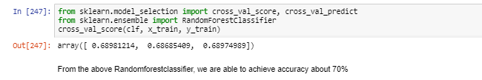

* 1. **Multinomial** **Naive Bayes Classifier**

Naive Bayes methods are a set of supervised learning algorithms based on applying Bayes theorem with the naive assumption of independence between every pair of features. The classification result replies on the prior probability of classes and the posterior probability of features given labels. [8]

Multinomial Naive Bayes classifier is a specific instance of a Naive Bayes classifier which uses a multinomial distribution for each of the features. Factors that influence the performance of Naive Bayes classifier are: *even distribution of nodes in each feature vector* and *even dependence distribution of feature vectors*.

With a multinomial event model, feature vectors represent the frequencies with which certain events have been generated by a multinomial (p1, p2, ...pn) where pi is the probability that event *i* occurs. A feature vector x=(x1, x2, ...xn) is then a histogram, with xi counting the number of times event *i* was observed in a particular instance. The likelihood of observing a histogram **x** is given by [9]



Our feature selection criteria guaranteed that our feature set satisfy both of the requirements. We started by splitting the dataset into *training(75%)* and *testing(25%)* and tried out different values for parameters:  
 a) *alpha*(Additive smoothing parameter)  
 b) *fit_prior* (Whether to learn class prior probabilities or not)  
 c) class_prior **(**Prior probabilities of the classes)  
We were able to achieve a better accuracy of *81.3%* when ‘*alpha=1.0, class_prior=None, fit_prior=True’* was used.

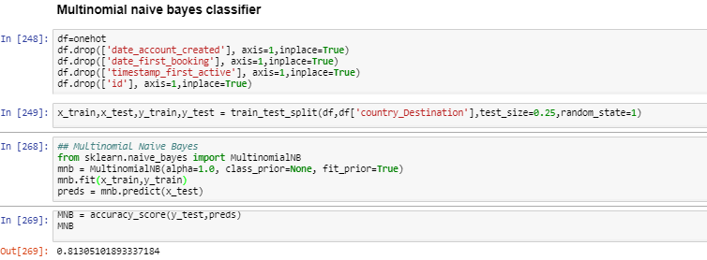

We used *10-fold cross validation* for checking the performance of model and concluded that a better performance was achieved as compared to Random Forest model(70%).

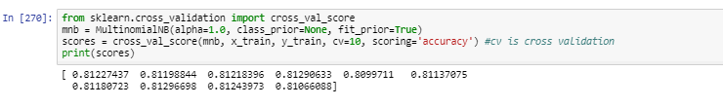

* 1. **Multi-layer Perceptron classifier (MLP)**

An MLP (or Artificial Neural Network - ANN) with a single hidden layer can be represented graphically as follows:

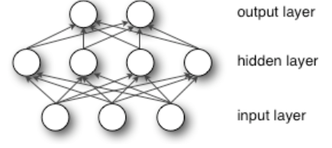[10]

The supervised learning problem of the MLP can be solved with the *back-propagation algorithm*. The algorithm consists of two steps.

* In the *forward pass*, the predicted outputs corresponding to the given inputs are evaluated.
* In the *backward pass*, partial derivatives of the cost function with respect to the different parameters are propagated back through the network.

The chain rule of differentiation gives very similar computational rules for the backward pass as the ones in the forward pass. The network weights can be adapted using any gradient-based optimization algorithm. The whole process is iterated until the weights have converged. [11]  
MLP Classifier trains iteratively since at each time step the partial derivatives of the loss function with respect to the model parameters are computed to update the parameters.  
  
As with every model, we started by splitting into train and test datasets and experimented the MLP Classifier with different values for parameters like:

1. hidden_layer_sizes (The ith element represents the number of neurons in the ith hidden layer)
2. max_iter (Maximum number of iterations. The solver iterates until convergence)
3. alpha (L2 penalty (regularization term) parameter)
4. solver (The solver for weight optimization)
5. verbose (Whether to print progress messages to stdout)
6. random_state (If int, random_state is the seed used by the random number generator)
7. tol (Tolerance for the optimization)

Better results are obtained with parameter values like: *hidden_layer_sizes=(100,100,100) with 3 hidden layers, max_iter=500, alpha=0.0001, solver='sgd', verbose=10, random_state = 21, tol=0.000000001*.   
  
The accuracy achieved using this model is 88.6% which is better than results achieved using *multinomial naive bayes(81.3%)*

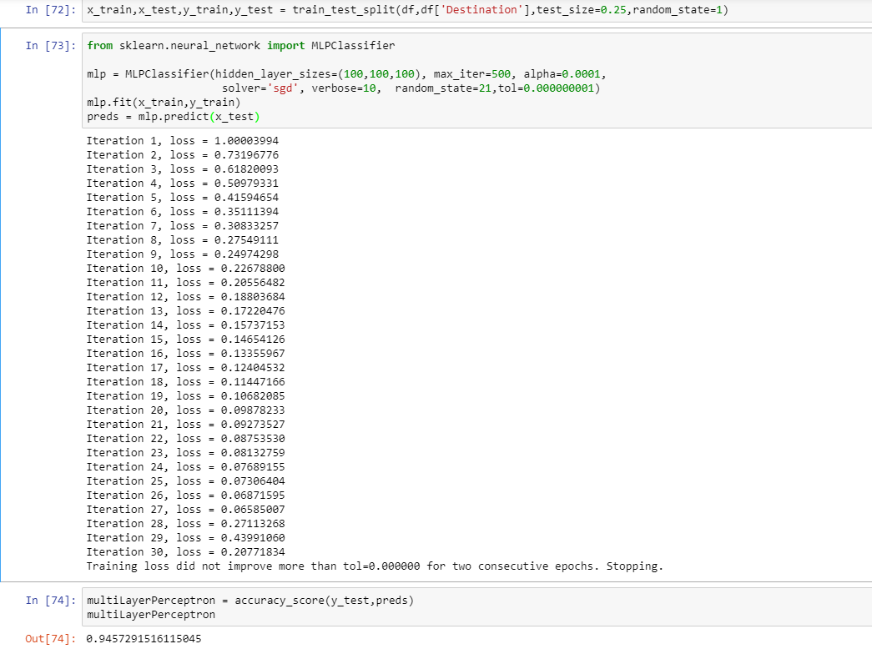

Again, we cross-validated the accuracy of this model to confirm its working.

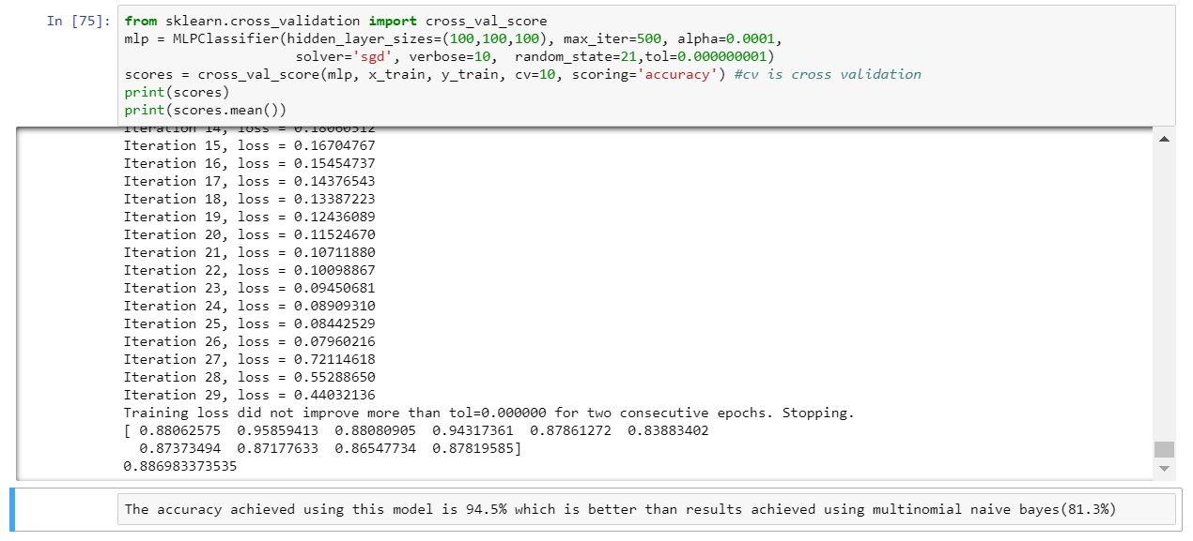

* 1. **Recurrent Neural Network (RNN)**

Recurrent neural networks (RNNs) are connectionist models with the ability to selectively pass information across sequence steps, while processing sequential data one element at a time. Thus, they can model input and/or output consisting of sequences of elements that are not independent. [7]

As every row of our dataset together made complete sense as a sentence, we used Recurrent Neural Network on it. This is because it would provide more accuracy, since we can include information about the sequence of words (*every word will be a feature (column) of the row*). We used *Long Short-Term Memory (LSTM*), a specific recurrent neural network (RNN) architecture that was designed to model temporal sequences and their long-range dependencies more accurately than conventional RNNs. The architecture of LSTM cell is composed of a memory cell, an input gate, an output gate and a forget gate as shown below. [13]

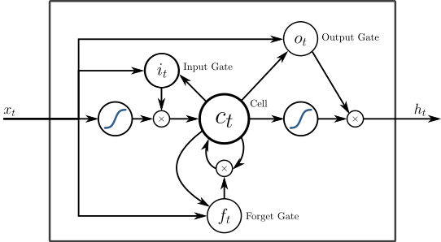

Here, we passed words to an embedding layer (we need an embedding layer because we have tens of thousands of words, so we'll need a more efficient representation for our input data than one-hot encoded vectors) as it is good to have an embedding layer and let the network learn the embedding table on it's own. From the embedding layer, the new representations will be passed to LSTM cells. These will add recurrent connections to the network so we can include information about the sequence of words in the data. The output layer will just be a single unit then, with a *ReLU* activation function.

A Graph is built using the hyperparameters such as *lstm_size*(Number of units in the hidden layers in the LSTM cells), *lstm_layers*(Number of LSTM layers in the network), *batch_size*(The number of feature to feed the network in one training pass), *learning_rate* with 256, 1, 100, 0.001 as values respectively. For the network, we have passed our feature vectors and each batch will be batch_size vectors.

To create a basic LSTM cell for the graph, *tf.contrib.rnn.BasicLSTMCell* was used and *dropout* was added to the cell with *tf.contrib.rnn.DropoutWrapper* to wrap the cell in another cell. In order for network to have better performance, we added more layers to create multiple layers of LSTM cells with *tf.contrib.rnn.MultiRNNCell.*

In order to run the data through the RNN nodes, RNN cell (multiple layered LSTM cell) is passed through *tf.nn.dynamic_rnn* along with the inputs to the network.[14]  
  
We created an initial state to pass to the RNN and this is the cell state that is passed between the hidden layers in successive time steps. *tf.nn.dynamic_rnn* is also used to add the forward pass through the RNN and vectors are passing in from the embedding layer. We played with different hyperparameters such as *activation function, cost function, Gradient Estimation, Epochs, Network Architecture, network initialization* and concluded that using *Rectified linear unit (ReLU)* as Activation function, *Quadratic cost (mean-square error)*  as Cost function, *AdamOptimizer* as Gradient Estimation, *Epochs* = 5.   
With these parameters we are able to achieve accuracy of *99.7%* using RNN.

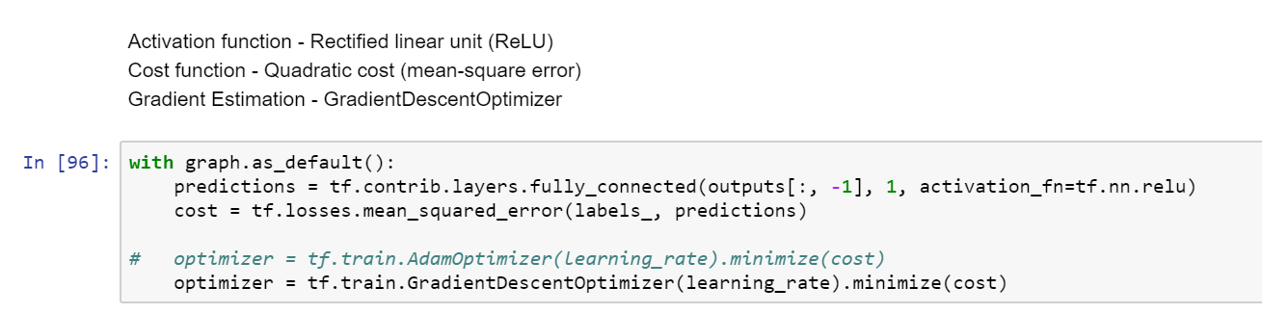

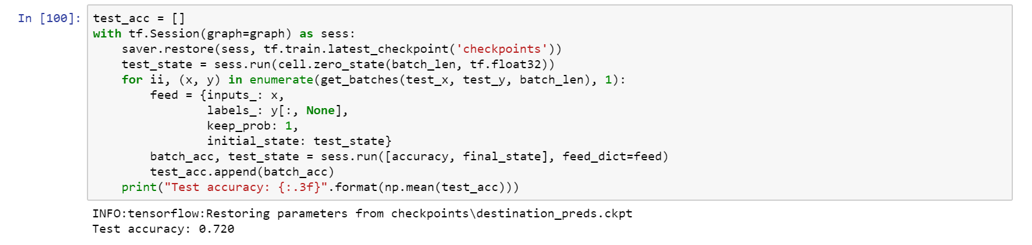

* 1. **Support Vector Machine (SVM)**

In this algorithm, we plot each data item as a point in n-dimensional space (where n is number of features you have) with the value of each feature being the value of a particular coordinate. Then, we perform classification by finding the hyperplane that differentiate the two classes very well. [6]

In SVM, training involves the minimization of the error function:



subject to the constraints:



where C is the capacity constant, w is the vector of coefficients, b is a constant, and  represents parameters for handling non- separable data (inputs). The index i labels the N training cases. Note that  represents the class labels and xi represents the independent variables. The kernel  is used to transform data from the input (independent) to the feature space. It should be noted that the larger the C, the more the error is penalized. Thus, C should be chosen with care to avoid overfitting [13].

The dataset is split into *train (75%)* and *test dataset (25%)* to measure performance. Initially we trained the data and were able to achieve an accuracy of 99.1% using default hyperparameters: *(C=1.0*, *kernel=’rbf’*, *degree=3*, *gamma=’auto’*, *coef0=0.0*, *shrinking=True*, *probability=False*, *tol=0.001*, *cache_size=200*, *class_weight=None*, *verbose=False*, *max_iter=-1*, *decision_function_shape=’ovr’*, *random_state=None).*When different parameters are tried by changing *C value, kernel, degree* and *gamma,* accuracy of 96.8%was achievedusing *kernel = 'rbf', C = 3, gamma = 0.1.* 98.7% accuracy is achieved while using *kernel='poly' with SVM.*

To validate our model, we used *10-fold cross validation* and checked its performance.

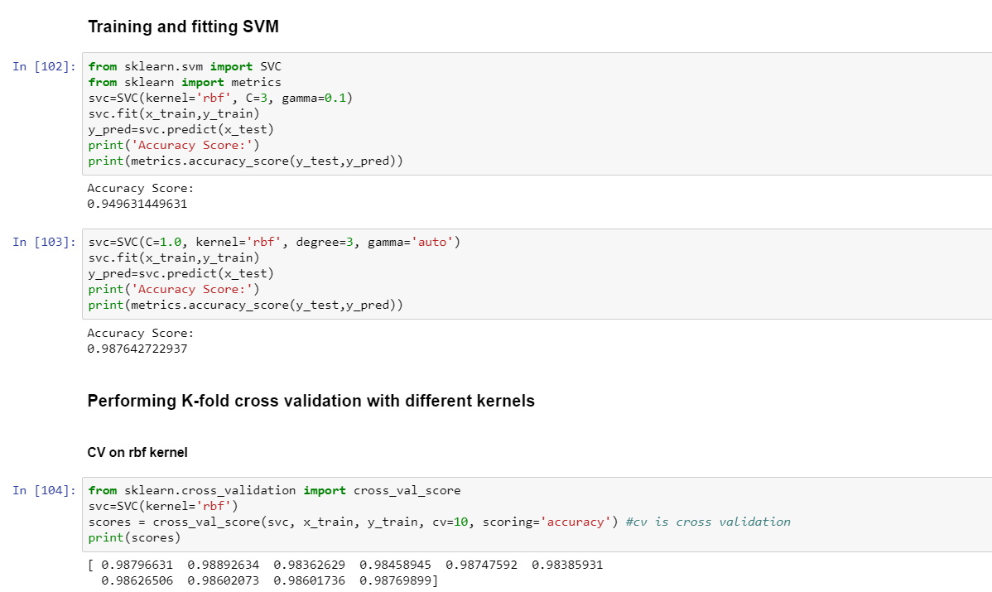

1. **Results**

Since this is a classification problem, we worked on our dataset with multiple classifier models and their hyperparameters. The accuracy from each of the methods along with the hyperparameters used is mentioned in the table below

|  |  |  |  |
| --- | --- | --- | --- |
| **#** | **Method** | **Hyperparameters** | **Accuracy** |
| 1 | Random forest | n_estimators=10, criterion=’gini’, min_samples_split=2, min_samples_leaf=1, min_weight_fraction_leaf=0.0, min_impurity_decrease=0.0, bootstrap=True, n_jobs=1 | 70% |
| 2 | Multinomial naive bayes classifier | alpha=1.0, class_prior=None, fit_prior=True | 81.30% |
| 3 | Multi-layer Perceptron classifier (MLP) | hidden_layer_sizes=(100,100,100), max_iter=500, alpha=0.0001, solver='sgd', verbose=10, random_state=21,tol=0.000000001 | 94.50% |
| 4 | RNN | epochs = 5, Activation function =ReLU,  Cost function=Quadratic cost (mean-square error),  Gradient Estimation =AdamOptimizer **Network Architecture** lstm_size = 256, lstm_layers = 1, batch_len = 100,  learning_rate = 0.001 | 99.7% |
| 5 | SVM | kernel='rbf', C=3, gamma=0.1 | 95% |
| C=1.0, kernel='rbf', degree=3, gamma='auto' | 98.70% |

With the above working models and the comprehensive analysis performed on the dataset, we conclude that *RNN provides us with the best accuracy results* and hence provides an apt solution to our classification problem.

1. **Discussion**

From EDA, we were able to conclude that Washington DC is the most visited destination among the users with respect to age and gender of the users. The features that are most helpful to this prediction task are PreferredMonthName, Budget, Length_of_the_trip(weeks), gender, Types_of_trips, Personality, first_browser, sign_up and first device time.

In this paper, we implemented five different supervised classifier models to provide solution for our classification problem of predicting new user’s destination booking. We experimented with various hyperparameters of all the models to achieve a better accuracy score. As compared to Kaggle’s best accuracy score of 66%, we have achieved accuracy score of 99.7% with Recurrent Neural network.

In the future, we can further enhance this project by reducing its prediction granularity to specific famous locations in the city and also to design a strategy to deal with the imbalanced classes by determining whether some NDFs in the training dataset are hosts on AirBnB on the basis of their web activity.

1. **Citations**

[1] <https://en.wikipedia.org/wiki/Airbnb>

[2] <https://cseweb.ucsd.edu/~jmcauley/cse255/reports/fa15/045.pdf>

[3] <https://machinelearningmastery.com/feature-selection-in-python-with-scikit-learn/>

[4] <https://machinelearningmastery.com/feature-importance-and-feature-selection-with-xgboost-in-python/>

[5] <https://medium.com/machine-learning-101/chapter-5-random-forest-classifier-56dc7425c3e1>

[6] <https://www.analyticsvidhya.com/blog/2017/09/understaing-support-vector-machine-example-code/>

[7] <https://arxiv.org/pdf/1506.00019.pdf>

[8] <https://cseweb.ucsd.edu/~jmcauley/cse255/reports/fa15/045.pdf>

[9] <https://en.wikipedia.org/wiki/Naive_Bayes_classifier>

[10] <http://deeplearning.net/tutorial/mlp.html>

[11] <http://www.helsinki.fi/~ahonkela/dippa/node41.html>

[12] <https://en.wikipedia.org/wiki/Exploratory_data_analysis>

[13] <http://www.statsoft.com/Textbook/Support-Vector-Machines>

[14]<https://www.kaggle.com/lusob04/titanic-rnn>

[15] Stuart J. Russell and Peter Norvig. 2003. Artificial Intelligence: A Modern Approach (2 ed.). Pearson Education. *See p. 499 for reference to "idiot Bayes" as well as the general definition of the Naive Bayes model and its independence assumptions*

[16]<http://scikit-learn.org/stable/modules/generated/sklearn.naive_bayes.MultinomialNB.html>

[17]<http://scikit-learn.org/stable/modules/generated/sklearn.neural_network.MLPClassifier.html>